Content
Blog 1: Introduction to Qualitative Methods 2
Appendix 1: References 5
Blog 2: Becoming Ethical Researchers 6
Appendix 1: References 8
Blog 3: Focus Groups 10
Appendix 1: References 13
Appendix 2: Figures and frameworks 15
Blog 4: Interviewing 18
Appendix 1: References 21
Appendix 2: Figures and frameworks 23
Blog 5: qualitative writing 25
Appendix 1: References 28
Blog 6: Data Analysis and Coding 29
Appendix 1: References 32

Blog 1: Introduction to Qualitative Methods
Word count: 699
Let’s start with the definition of qualitative research. The definition of qualitative research has also been constantly evolving. Qualitative research is to locate the observer in the whole world, study things in the natural environment, and try to understand or explain the phenomenon. It includes a set of interpretive, world - visible practices. Researchers used interviews, field observations, audio recordings, photographs and memos (Denzin & Lincoln, 2011). According to Creswell (2013), qualitative research can provide information to solve problems attributed to society or human beings by individuals or groups. Qualitative research usually involves collecting data in the natural environment, summarizing and deducing the data, and finally in the form of written reports or statements. It mainly reflects different voices of participants, reflexivity of researchers and interpretation of complex problems.
the key characteristics of qualitative research
From the definition, we can see that the research process is from the perspective of philosophical assumptions to interpretation, and then to the process of social or human problems (Creswell ,2013). The characteristics of qualitative research evolve with the passage of time and the research of different researchers (LeCompte and Schensul ,1999; Hatch,2002; Marshall and Rossman,2015; Ravitch and Carl,2016)
- natural setting
Qualitative researchers collect relevant information by directly observing or talking to people directly (LeCompte and Schensul ,1999).
- open-ended questions
Qualitative researchers usually conduct interviews with open-ended questions, observe behaviors and check documents. They collect data through multiple methods (Hatch,2002).
- Listen to different voices
Qualitative researchers expect to reflect different perspectives on the same topic, reflecting multiple perspectives of participants (LeCompte and Schensul ,1999).
- Context background.
The background of the research problem is that researchers fully understand the characteristics of context and its impact on participants’ experience. Specific environments enable researchers to understand events, behaviors, and meanings shaped by unique environments (Maxwell, 2013).
- Reflexivity.
Researchers communicate their background information, interpret the information, and express what they gain from the study. Readers have a right to know what prompted us to do this research, to whom our findings will be reported, and what we personally learned from the research (Wolcott ,2010).
- Holistic
Qualitative researchers are not constrained by causality, but rather elaborate on the complex interrelationship between various elements in any case (Marshall and Rossman,2015; Ravitch and Carl,2016).
why they are important for the social sciences？
Qualitative research can provide a variety of information and special understanding needs for social research. The function of social investigation mainly includes four aspects: contextual, explanatory, evaluative and generative (Ritchie, et al, 2013). The study of context is mainly to describe the form or nature of existing things. Some scholars call it descriptive or exploratory research (Marshall and Rossman, 1999). Explanatory research is mainly to examine the cause of existence or the relationship between the two. Because qualitative research can delve into the object, it provides a special tool for studying the reasons behind the strategy, behavior or phenomenon (Giddens, 1984; Layder, 1993). Evaluation research is mainly to evaluate the effectiveness of existing projects. Evaluation research is primarily concerned with assessing the effectiveness of existing programs (Patton,1988). It is qualitative research's flexible approach to investigation that makes it particularly good at looking at how things work, and by identifying the different types of effects or consequences that policies are likely to have, and the different ways in which those consequences occur (Rist,2000).Generative research is primarily concerned with the development of a theory, strategy, or action.
In a word, qualitative research is helpful to understand the social phenomenon and its background. Qualitative research questions are basically about how, why and what. For example, qualitative expectations are used to answer similar questions, such as why people behave the way they do, how attitudes and opinions are formed, how people are influenced by events around them, how cultures develop, and what are the differences between social groups.

Many researchers regard qualitative research as a process of exploration (Rosaldo, 1989), or even a process of adventure (Willig, 2001). Before the research journey begins, there is no fixed, definitive idea of its content, and you may be surprised, confused, and excited along the way. Despite all the uncertainty along the way, it remains enticing (Finlay, 2002).

Appendix 1: References
Creswell, J. W. (2013). Qualitative inquiry & research design: Choosing among the five approaches (3rd ed.). Thousand Oaks, CA: Sage.
Denzin, N. K., & Lincoln, Y. S. (Eds.). (2011). The Sage handbook of qualitative research. sage.
Finlay, L. (2002). Negotiating the swamp: the opportunity and challenge of reflexivity in research practice. Qualitative research, 2(2), 209-230.
Finlay, L. I. N. D. A. (2006). Going exploring”: The nature of qualitative research. Qualitative research for allied health professionals: Challenging choices, 3-8.
Hatch, J. A. (2002). Doing qualitative research in education settings. Albany: State University of New York Press.
Layder, D. (1993). New strategies in social research: An introduction and guide. Polity Press.
LeCompte, M. D., & Schensul, J. J. (1999). Designing and conducting ethnographic research (Ethnographer’s toolkit, Vol. 1). Walnut Creek, CA: AltaMira Press.
Marshall, C., & Rossman, G. B. (2015). Designing qualitative research (6th ed.). Thousand Oaks, CA: Sage.
Maxwell, J. A. (2013). Qualitative research design: An interactive approach (3rd ed.). Thousand Oaks, CA: Sage.
Ravitch, S. M., & Mittenfelner Carl, C. N. (2016). Qualitative research: Bridging the conceptual, theoretical, and methodological. Thousand Oaks, CA: Sage.
Ritchie, J., Lewis, J., Nicholls, C. M., & Ormston, R. (Eds.). (2013). Qualitative research practice: A guide for social science students and researchers. sage.
Willig, C. (2001). Qualitative research in psychology: A practical guide to theory and method. Buckingham: OUP.
Wolcott, H. F. (2010). Ethnography lessons: A primer. Walnut Creek, CA: Left Coast Press.

Blog 2: Becoming Ethical Researchers
Word count:539
The relevant ethical research principles
According to Orb and other’s relevant research (2001), established ethical principles can alleviate the difficulties in qualitative research, namely autonomy, justice and beneficence (Orb, et al., 2001). Some author like Capron claims that any type of research should be conducted in accordance with the principles of justice, respect for people and beneficence. He believes that respecting people means recognizing the rights of participants, which are embodied in the right of participants to know about the research situation, the right to participate in the research freely and voluntarily, and the right to withdraw from the research at any time without being punished(Capron ,1989).
Wiles et al. (2006) proposed three major aspects of the ethical issues for researchers, specifically informed consent, confidentiality, and anonymity. The rules of informed consent vary widely in different areas. Some researchers use very formal consent procedures, including approval from the relevant ethics committee, written consent forms, information sheets, letters, etc., involving all information. Some researchers in specific fields have never used these forms. Confidentiality is sometimes understood as privacy (Oliver, 2003). Specifically related to the research of confidentiality commitment, data ownership, data use principles, etc. The ownership of data has always been a focus for researchers. There has always been a debate about the extent to which it is reasonable to modify data. The researchers modified the data to avoid identification of the participants (Corden and Sainsbury, 2004). However, Thomson and Bzdel (2004) think that the higher degree of anonymity will deviate from its original context, making the data untrue and valid. However, Grinyer (2002) thinks the identity of the study participants is evolving and they don't always want to be hidden.
Ethical challenges in qualitative research
In qualitative research, compared with quantitative research, there is no statistical analysis. The researcher needs to evaluate and interpret what he observed during the research process. Based on the researcher’s role in qualitative research, researchers face greater ethical challenges. From the beginning to the end of the study, from the design of the study to the interview, analysis, interpretation and presentation, researchers face ethical challenges at every stage (Fink,2000). Details include anonymity, informed consent, confidentiality, and the researchers’ potential impact on participants. This also makes it necessary for specific practical guidelines and operational programmes. Under the guidance and supervision of these guidelines, researchers can better extract reliable information (Sanjari, et al.,2014).
In qualitative research, researchers usually collect data through in-depth interviews and narratives, so as to obtain a description of experience. The researchers mediated between the subjects’ experiences and those of the people involved (Bloor and Wood,2006). Data collection should be as open as possible and survey results should be recorded. What needs to be noted is the ethnographic research method. From an ethical perspective, researchers are trying to understand the culture of certain people and live among them, and they need to seek their informed consent. Culture clashes and risks need to be considered (Li ,2008).

Research needs to be based on an appropriate ethical perspective. In this way, researchers can not only obtain external support and improve the research, but also promote more organizations, individuals, groups, funds to join our research (George, 2016). Ethical standards should be considered as routine research considerations.

Appendix 1: References
Bloor M, Wood F. Keywords in Qualitative Methods: A Vocabulary of Research Concepts. Sage Publication; 2006.
Capron, A.M. (1989). Human experimentation. In R.M. Veatch (Ed.), Medical ethics (125-172). Boston: Jones & Bartlett.
Corden, A. and Sainsbury, R. (2005) ‘Findings from a Study of Use of Verbatim Quotations in Research Reports from Applied Social Research’ , Presentation at: ESRC Dissemination Event, ‘Participation and Representation: Implications for Ethical Research Practice’, 26 May.
Department of Health, E. (2014). ‘The Belmont Report. Ethical principles and guidelines for the protection of human subjects of research’. The Journal of the American College of Dentists, 81(3), 4.
Fink AS. The role of the researcher in the qualitative research process: a potential barrier to archiving qualitative data. Forum Qual Soc Res 2000; 1(3): 4. 13
George, A. J. (2016). Research ethics. Medicine, 44(10), 615-618.
Grinyer, A. (2002) ‘The Anonymity of Research Participants: Assumptions, Ethics and Practicalities’ , Social Research Update Issue 36, Department of Sociology, University of Surrey.
Kirk, S. (2007). ‘Methodological and ethical issues in conducting qualitative research with children and young people: A literature review’. International journal of nursing studies, 44(7), 1250-1260.
Li J. Ethical challenges in participant observation: a reflection on ethnographic fieldwork. Qual Report 2008; 13(1): 10015.
Miller, T., Birch, M., Mauthner, M., & Jessop, J. (Eds.). (2012). Ethics in qualitative research. Sage.
Oliver, P. (2003) The Student's Guide to Research Ethics. Maidenhead: Open University Press.
Orb, A., Eisenhauer, L., & Wynaden, D. (2001). Ethics in qualitative research. Journal of nursing scholarship, 33(1), 93-96.
Padgett, D. K. (2011). Qualitative and mixed methods in public health. Sage publications.
Sanjari, M., Bahramnezhad, F., Fomani, F. K., Shoghi, M., & Cheraghi, M. A. (2014). Ethical challenges of researchers in qualitative studies: The necessity to develop a specific guideline. Journal of medical ethics and history of medicine, 7.
Thomson, D. and Bzdel, L. (2004) ‘Central Issues of Anonymisation’ , Paper presented at the Sixth International Conference on Social Science Methodology, Amsterdam, August.
Wiles, R., Charles, V., Crow, G., & Heath, S. (2006). Researching researchers: lessons for research ethics. Qualitative Research, 6(3), 283-299.

Blog 3: Focus Groups
Beginning in the 1980s, interest in focus groups increased (Morgan,1996). And the use of this group approach in in a variety of business and management disciplines is increasingly common, mainly reflected in information systems (Stahl et al., 2011), marketing (Kehoe & Lindgren, 2003) etc. This approach takes data from a group of purposefully selected individuals rather than from a statistically representative sample of the larger population (Nyumba et al.,2017).

Strengths and weaknesses of focus groups
Comparing focus groups with other research methods, such as surveys and individual interviews, we can get a deeper understanding of their advantages and disadvantages. According to Morgan and Krueger (1993), the advantage of focus groups is not just to study and explore what people have to say, but also to gain insight into their complex behaviors and motivations. They also argue that this advantage is a direct result of the interaction that occurs in focus groups. This is what Carey and Smith call “the group effect” (Carey 1994, Carey & Smith 1994). It is this interaction, in which participants discuss, question and explain each other, that makes focus group discussions more important than the sum of all the individual interviews. It can better reflect some consensus and diversity of participants and provide rich data for research (Morgan&Krueger,1993). It also places a certain requirement on participants to compare their own experiences, opinions and attitudes. For the researchers, the personal data of all the participants are not aggregated, and they need to speculate whether and why the participants are different. The weakness of the focus group is also inseparable from its interactive process, namely the role played by the moderator in the whole discussion and data generation, as well as the influence of the group's own choices on the data.
Many researchers have studied the role of moderator. According to Agar and MacDonald (1995), in some interviews, the informant explained to the interviewer that he was under great burden, while the group discussion led by the moderator might destroy the important interaction among the group members. The moderator decides on the nature and form of the discussion, and the moderator's behavior will have a direct impact on the nature of the group interview (Saferstein ,1995). They advocate a more moderate style (Agar & MacDonald ,1995; Saferstein,1995).
In addition, researchers have also studied the influence of groups on the discussion itself. For example, Sussman et al (1991) studies whether people have consistent attitudes and views by conducting questionnaires before and after focus groups. As a result, it is unlikely to distort the results of most focus group studies. It is important to note that some studies on sensitive topics also use focus groups (Jarrett 1993; Kitzinger 1994a, b).
The steps of the focus group discussion
According to Morgan et al. (1998), the focus group discussion consists of four steps: research design, data collection, analysis and results reporting. Start with the research objectives and develop a script to guide the discussion of the entire focus group. Individuals tend to express themselves in a natural and comfortable environment( Casey,2000）. For research, it takes trust and effort. More effective data can only be produced when participants are fully involved in the discussion.
In the research design phase, a script is prepared to guide the discussion of the whole focus group from the research objective. Individuals tend to express themselves in a natural and comfortable environment. For research, it takes trust and effort. More effective data can only be produced when participants are fully involved in the discussion. Then identify and recruit participants to ensure homogeneous composition, such as gender, education, language background, etc. within the same group, colleagues to determine the recruitment of an assistant, determine the number of focus groups, the number of participants, etc. Finally, decide on a comfortable location and choose a location that is easy to reach, the right size, and away from distractions. Also be prepared with recording equipment, consent forms, name tags, etc. Data collection stage: in the preparatory stage before data collection, familiarize yourself with scripts, group dynamics, seat preferences, equipment, etc., and document the entire meeting process. During the discussion, it is necessary to introduce relevant details. During the discussion, it is necessary to record and observe the discussion, track the issues and follow up the topic of the discussion, and finally make a summary.
Focus group analysis
When we conduct focus group data analysis, we need to consider the participants' words and meanings and their similarity, and also need to consider the context, because many times the participants’ answers are triggered by a trigger point, we need to interpret them according to the previous discussion and the tone and intensity. Sometimes the participants’ speed, tone, or emphasis may indicate some intensity. And each person may have some differences in the way they express their emotions. Internal consistency is also a concern, and some researchers may change their thinking and positions after interacting with others. If changes occur, we need to track the entire flow of the conversation for clues that might explain the changes (Krueger and Casey,2002).

Appendix 1: References
Byers P.Y. and Wilcox, J.R. (1991) ‘Focus groups: A qualitative opportunity for researchers’, The Journal of Business Communication, 28(1): 63–78. Calder, B.J. (1977) ‘Focus groups and the nature of qualitative marketing research’, Journal of Marketing Research, 14(3): 353–64.
Coule, T.M. (2013) ‘Theories of knowledge and focus groups in organization and management research’, Qualitative Research in Organizations and Management: An International Journal, 8(2):148–62.
Creswell, J. W., & Creswell, J. D. (2017). Research design: Qualitative, quantitative, and mixed methods approaches. Sage publications.
Cunningham-Burley, S., Kerr, A. and Pavis, S.(1999) ‘Theorizing subjects and subject matter in focus group research’, in R.S. Barbour and J. Kitzinger (eds.), Developing Focus Group Research: Politics, Frankland, J. and Bloor, M. (1999) ‘Some issues arising in the systematic analysis of focus group materials’, in R.S. Barbour and J. Kitzinger (eds.), Developing Focus Group Research: Politics, Theory & Practice. Thousand Oaks, CA: Sage.
Krueger, R. A., & Casey, M. A. (2002). Designing and conducting focus group interviews.
Kitzinger, J. (1995). Qualitative research: introducing focus groups. Bmj, 311(7000), 299-302.
Krueger, R. A. (2014). Focus groups: A practical guide for applied research. Sage publications.
Morgan, D. L. (1996). Focus groups. Annual review of sociology, 22(1), 129-152.
Morgan, D. L. (1996). Focus groups as qualitative research (Vol. 16). Sage publications.
Morgan, D. L. (1997). Focus groups as qualitative research (2nd ed). Thousand Oaks, CA: Sage.
Morgan, D. L., & Krueger, R. A. (1993). When to use focus groups and why. Successful focus groups: Advancing the state of the art, 1, 3-19.
Morgan, D. L. (1996). Focus groups as qualitative research (Vol. 16). Sage publications.
Nyumba, T. O., Wilson, K., Derrick, C. J., & Mukherjee, N. (2018). The use of focus group discussion methodology: Insights from two decades of application in conservation. Methods in Ecology and evolution, 9(1), 20-32.
Stewart, D. W., & Shamdasani, P. N. (1990). Focus groups: Theory and practice. Newbury Park, CA: Sage.
Stewart, K., & Williams, M. (2005). Researching online populations: The use of online focus groups for social research. Qualitative Research, 5, 395–416. doi:10.1177/1468794105056916
Stewart, D. W., & Shamdasani, P. N. (2014). Focus groups: Theory and practice (Vol. 20). Sage publications. Theory and Practice. Thousand Oaks, CA: Sage, pp.186–99.
Webb, C. and Kevern, J. (2008) ‘Focus groups as a research method: A critique of some aspects of their use in nursing research’, Journal of Advanced Nursing, 33(6): 798–805.

Appendix 2: Figures and frameworks
Figure 1. A model of group phases (Based on: Tuckman and Jenson, 1977)
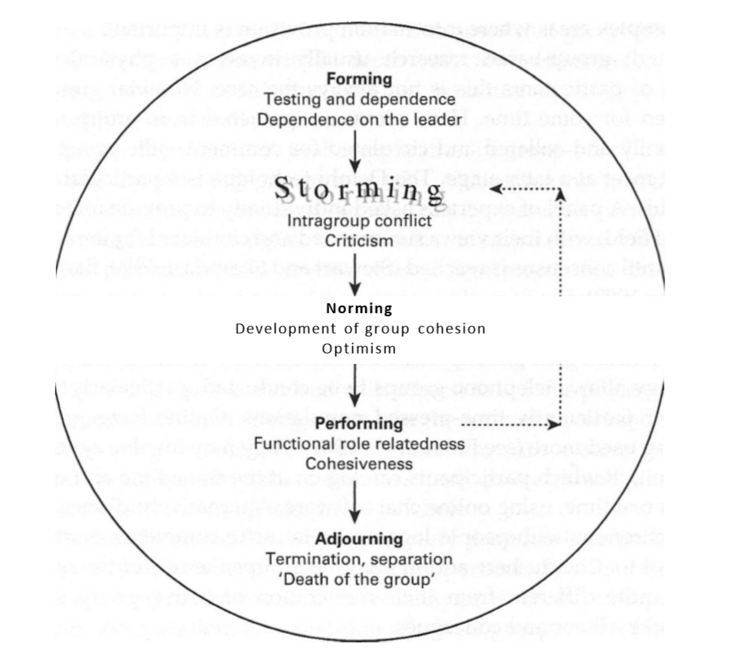
Figure 2. Recommended Strategy for Program, Policy, or Service Development
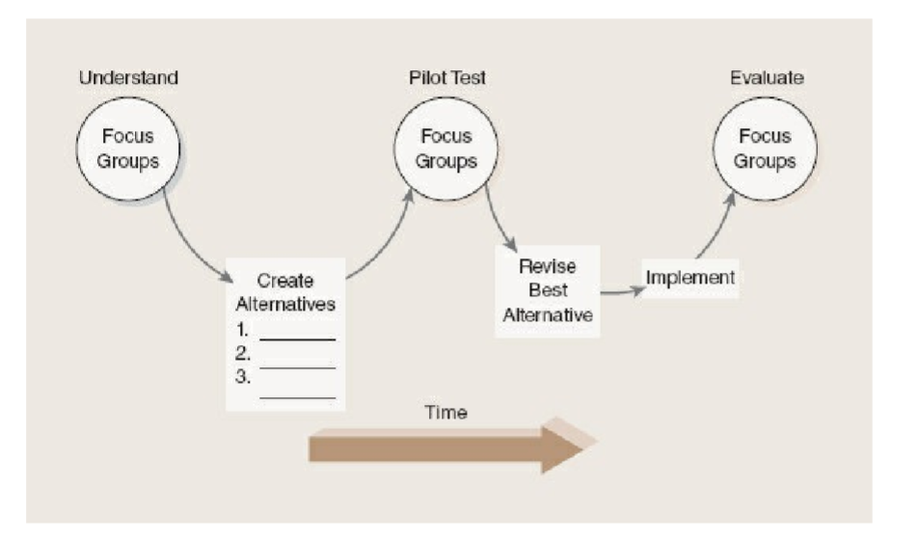
Figure 3. ORGANISING A FOCUS GROUP: A CHECKLIST OF PRACTICALITIES
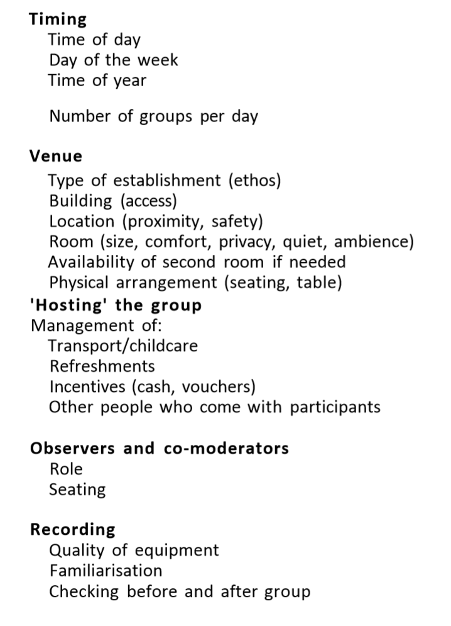

Figure 4. Flow chart of the steps of the focus group discussion technique (Morgan et al., 1998).
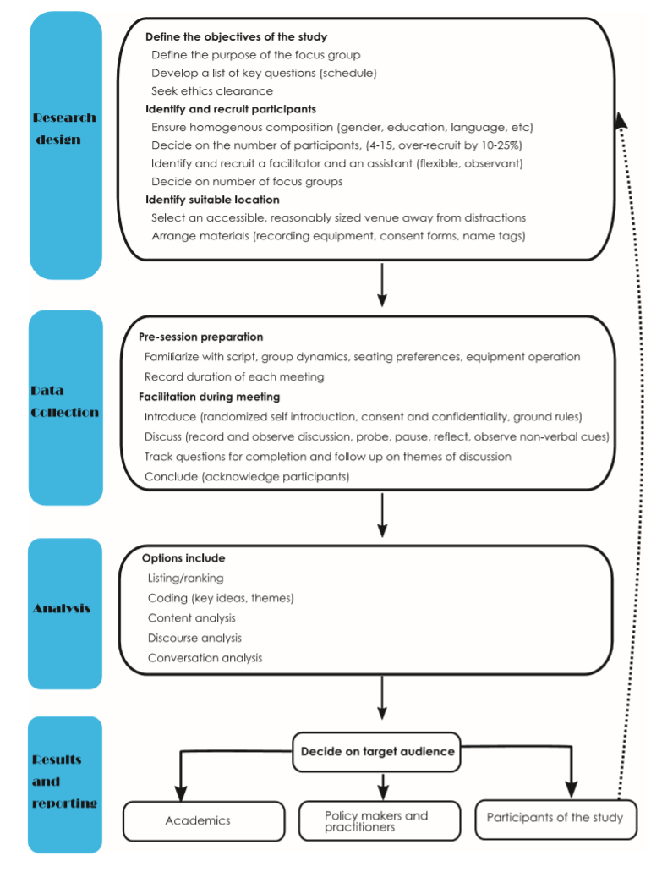

Blog 4: Interviewing
An interactive social interaction based on conversation patterns is called an interview (Rubin & Rubin, 2012; Warren & Xavia Karner, 2015). The purpose of interview is to obtain information, attitude, and belief from interviewees (Maccoby,1954). The generation of knowledge is constructed in the interaction between the interviewee and interviewee (Brinkmann and Kvale,2015). The choice of interview type is related to the process of interaction, some of which are one-to-one interview at the same place, or interviews via Internet(James and Busher,2012), email, phone (Shuy,2002), etc. Some are conducted in focus groups (Creswell,2016). Either way, the researcher need to pay more attention to create as comfortable and relaxed an environment as possible, and to encourage all interviewees to participate fully in the conversation, and to supervise the individuals who may lead the interview(Denzin and Lincoln, 2017).
Types of interviews
According to Lune and Berg (2016), there are three main types of interviews: the standardized (formal or highly structured) interview, the unstandardized (informal or nondirective) interview, and the semistandardized (guided-semistructured or focused) interview. Understanding the differences between these types of interviews can help researchers better choose the right type.
A standardized interview usually uses a formal structured interview schedule with the same questions for each subject. This is based on the ideal situation where each subject receives approximately the same stimulus and their responses will be comparable (Babbie, 2007). But Denzin (1978) argues that the researchers' hypothesis about each question's contribution to the subject is an untested belief. He questioned the questions arranged by the researchers in the interview to obtain relevant information about the research topic. The standardized interview is suitable for some relatively simple facts. It can also be regarded as a kind of survey interview (Lune and Berg ,2016). Gather specific information, such as when did you start your first job? What is the job? How long did you last at your first job? What was your second job? It is also often used in very large research projects. The unstandardized interview is the opposite of a standardized interview, which is loosely structured and does not require a script with specific questions that will vary based on each subject's actual conversation. Just prepare some interview guides that will guide the conversation in the right direction (Lune and Berg ,2016). The semistandardized interviews fall somewhere in between the standardized and unstandardized interviews that precede them. Interview questions that allow individuals to understand the world, facts, or phenomena in different ways (Gubrium & Holstein, 2003). Respondents may answer questions that exceed the researcher’s expectations and are not included in the interview guidelines (Berg et al., 2004). Researchers will also ask more questions based on the new elements.

how to design, conduct, and transcribe qualitative interviews
The first step is to determine what type of data collection tool you want to use. The choice of tool depends on the type of problem being studied and the type of data required. When it comes to interviewing projects, researchers need to make sure that the tools they choose are appropriate for the research question. For example, if you want to collect the frequency of sensitive topics such as marijuana use or sex, you might use anonymous surveys to make it easier for respondents to respond (Becker,1963).When it comes to specific feelings about marijuana use, open interviews may be more appropriate (Mutechnick & Berg1996).Some studies on women's emotional experience may be more suitable for interactive, unstructured interviews (Ellis et al., 1997). Then, the researchers determined the appropriate interviewees and interview patterns and developed interview guidelines to guide the interview (Brinkman &Kvale, 2015). Then do a pilot test to collect data and refine the plan (Sampson,2004; Yin,2014). Sign a consent form of voluntary participation with the interviewee. During the interview, follow that a good interviewer is a good listener.

First, the researchers determined the research questions that were answered by the interview. Then, the researchers determined the appropriate interviewees and interview patterns. To determine which type of data collection tool to use. The choice of tool depends on the type of problem being studied and the type of data required. When it comes to interviewing projects, researchers need to make sure that the tools they choose are appropriate for the research question. For example, if you want to collect the frequency of sensitive topics such as marijuana use or sex, you might use anonymous surveys to make it easier for respondents to respond (Becker,1963).When it comes to specific feelings about marijuana use, open interviews may be more appropriate (Mutechnick & Berg1996).Some studies on women's emotional experience may be more suitable for interactive, unstructured interviews (Ellis et al., 1997).During the interview, the equipment can be used to record and collect data. Researchers also need to develop interview guidelines to guide interviews (Brinkman &Kvale, 2015). Then do a pilot test to collect data and refine the plan. Sign a consent form of voluntary participation with the interviewee. At the beginning of the interview, explain to the interviewer the purpose of the research, the time required for the interview, the power they have to derive at any time, and the power to use the interview results. During the interview, follow that a good interviewer is a good listener (Creswell & Poth, 2016).

Appendix 1: References
Babbie, E. (2007). The Practice of Social Research (11th ed.). Belmont, CA: Wadsworth.
Berg, B., Sañudo, F., Hovell, M., Sipan, C., Kelley, N., & Blumberg, E. (2004). The use of indigenous interviewers in a study of Latino men who have sex with men: A research note. Sexuality and Culture 8(1), 87–103.
Brinkmann, S., & Kvale, S. (2015). InterViews: Learning the craft of qualitative research interviewing (3rd ed.). Thousand Oaks, CA: Sage.
Creswell, J. W., & Poth, C. N. (2016). Qualitative inquiry and research design: Choosing among five approaches. Sage publications.
Denzin, N. K. (1978a). The Research Act (5th ed.). New York: McGraw-Hill. Denzin, N. K. (1978b). Sociological Methods: A Source Book (2nd ed.). New York: McGraw-Hill.
Denzin, N. K., & Lincoln, Y. S. (2000). Preface. In N. K. Denzin & Y. S. Lincoln (Eds.), The SAGE handbook of qualitative research (2nd ed.). London: Sage.
Ellis, C., Kiesinger, C. E., & Tillmann-Healy, L. M. (1997). Interactive interviewing: Talking about emotional experiences. In R. Hertz (Ed.), Reflexivity and Voice (pp. 119–149). Thousand Oaks, CA: Sage.
Gubrium, J. F., & Holstein, J. A. (2003). Postmodern Interviewing. Thousand Oaks, CA: Sage.
James, N., & Busher, H. (2012). Internet interviewing. In J. F. Gubrium, J. A. Holstein, A. B. Marvasti, & K. D. McKinney (Eds.), Handbook of interview research: The complexity of the craft (pp. 177–192). Thousand Oaks, CA: Sage.
Lune, H., & Berg, B. L. (2016). Qualitative research methods for the social sciences. Pearson Higher Ed.
Shuy, R. W. (2002). In-person versus telephone interviewing. In J. F. Gubrium & J. A. Holstein (Eds.), Handbook of interview research: Context & method (pp. 537–555). Thousand Oaks, CA: Sage.

Appendix 2: Figures and frameworks
Figure 1. Qualitative interviews（Source: Berg,2004)
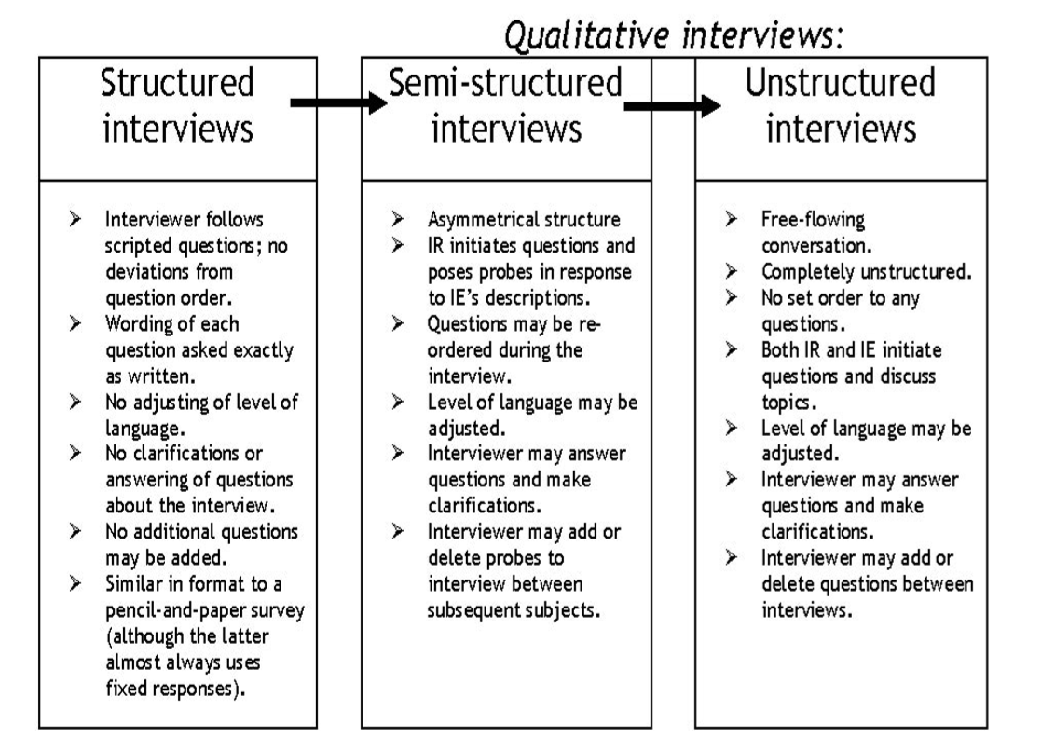

Figure 2. Interview Structure Continuum of Formality (Source: Lune and Berg ,2017)
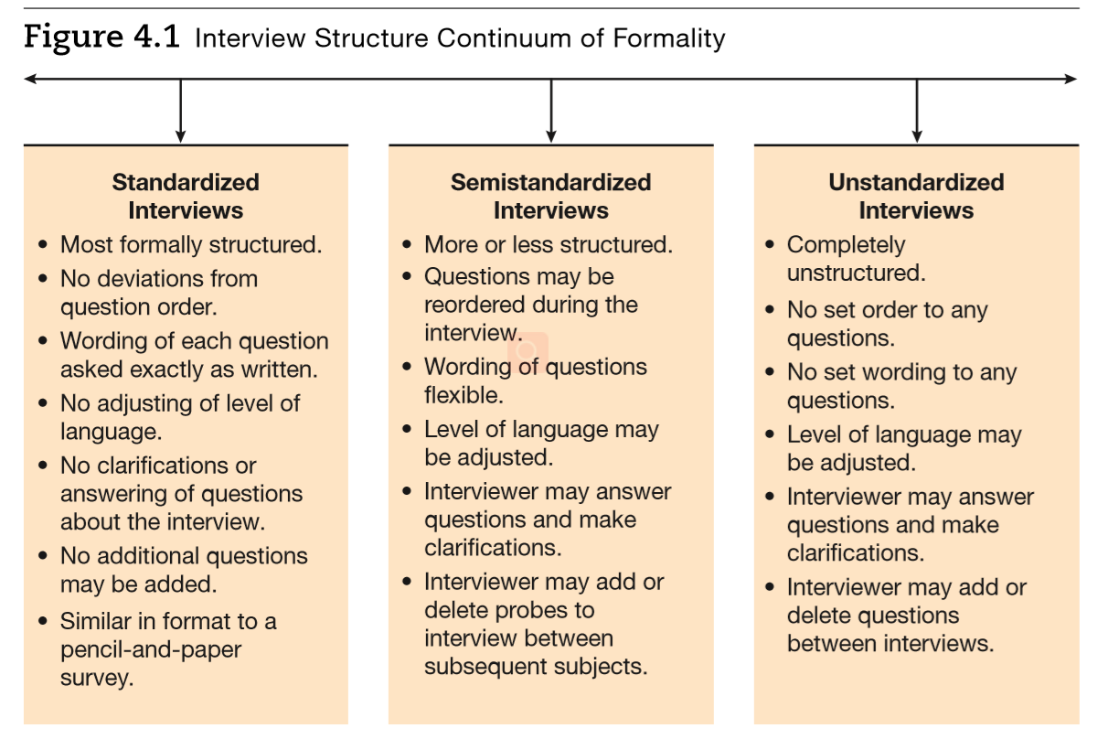
Figure 3. Procedures for Preparing and Conducting Interviews
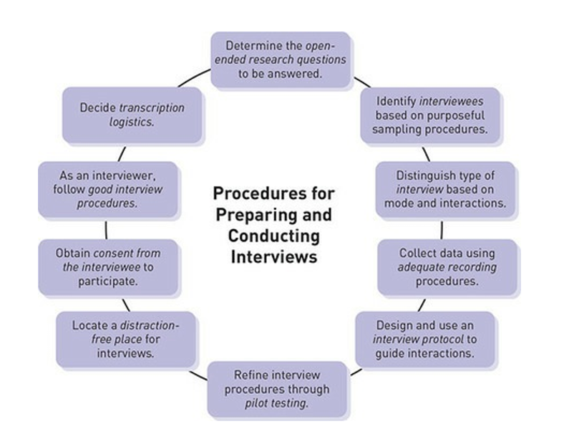
(Source: Creswell and Poth,)

Blog 5: qualitative writing
Writing is an indispensable part of any research project (Wolcott, 1990). Most of your research is presented to others in text form. Sometimes, though, you may talk about your findings in the form of seminars or lectures. But you'll find that only the people who attend the workshop know about your research (Myers, 2013), but it's only for a short time, and their memories won't be very deep, and they won't last forever. What you have written is the objective reality (Myers,2019). Many researchers have their own ideas about how to write articles. For example, Caulley (2008) talks about how to combine creative writing skills to make articles more interesting. Ely et al. (1997) proposed how to make articles credible, interesting and useful. The process of writing is the process of telling a story. Decide what to say and what not to say. The style of presentation that someone puts forward depends on the audience they are addressing (Van Maanen 1988).

Strategies for qualitative writing
Creswell and Poth (2016) proposed four strategies for qualitative research writing, specifically reflexivity and representation, audience, encoding, and quotes.
Reflexivity refers to the positioning of the researcher in the work (Hammersley & Atkinson, 1995). The way researchers write reflects their understanding of society, politics, culture, gender, race, class, etc. Every work of writing is based on specific positional characteristics, such as specific time, place, environment, culture, history, and so on (Richardson ,1994). The experience of the researcher may also influence the interpretation of the phenomenon. At the core of reflection, researchers review and summarize the impact of personal experience, values, and biases on interpretation and research outcomes. In phenomenological research, it is very common for researchers to state their personal background and position (Brown et al.,2016). In ethnographic studies, he often talks about his own position in an introduction, discovery, or topic (Mac et al.,2015). In fact, the process of writing is a reflection of the interaction between researchers and subjects. People also pay more and more attention to the influence of writing on the researchers. What do they think of this article or story? Did the subjects participate in the post-review of the material and express their own opinions, whether they agree or question or oppose it (Weis & Fine, 2000)?
Knowing the target audience for our work is an important principle of writing because we write for our readers (Richardson, 1990). Identifying the target audience helps you choose during the writing process. The output of writing varies with different target audiences (Myers,2019). For example, different audiences, different research outputs. For academics, you are expected to demonstrate your unique expertise and familiarity with qualitative research literature. Their preferred output forms are journal papers, conference papers, books, etc. For students, especially graduate students, they also need to read relevant academic articles. For business professionals, they want your results to be less theoretical and more practical. They tend to read magazine articles, so case studies may be more to their taste. For institutions and organizations, they usually prefer the reporting type. For the public, they are also more likely to read stories, and case studies may be the best approach. The researcher should think about what audience this study was written for. What do they hope this story will bring them? What kind of writing style and structure does your target audience expect? How should the writing of your research adapt to the needs of other audiences (Carl,2016)?
Language plays an important role in qualitative texts. The report is encoded with words to make the work interesting and fascinating and unforgettable (Gilgun,2005). Some works can be vivid in the reader's mind (Richardson, 1994), because writing can bring the reader into the research world.

The quotes in the works should be contextualized, interpreted and combined as much as possible, and should be as illustrative and targeted as possible (Brinkmann & Kvale, 2015). Richardson has identified three of the most effective types of quotes: short and engaging quotes, embedded quotes, and longer, more complex quotes.

To be familiar with these writing strategies is to make one's works more attractive and to truly reflect the objective facts.
.

Appendix 1: References
Brinkmann, S., & Kvale, S. (2015). InterViews: Learning the craft of qualitative research interviewing (3rd ed.). Thousand Oaks, CA: Sage.
Cassell, C., Cunliffe, A. L., & Grandy, G. (Eds.). (2017). The SAGE Handbook of Qualitative Business and Management Research Methods. Sage.
Caulley, D.N. (2008) Making qualitative research reports less boring: The techniques of writing creative nonfiction, Qualitative Inquiry 14(3): 424–49.
Gilgun, J. F. (2005). “Grab” and good science: Writing up the results of qualitative research. Qualitative Health Research, 15, 256–262.
Hammersley, M., & Atkinson, P. (1995). Ethnography: Principles in practice (2nd ed.). New York, NY: Routledge.
Myers,M.D. (2019) Writing for Different Audiences.
Paulus, T. M., Lester, J. N., & Dempster, P. G. (2014). Writing and Representing Findings.
Penrod, J. (2003). Getting funded: Writing a successful qualitative small-project proposal. Qualitative health research, 13(6), 821-832.
Ravitch, S. M., & Mittenfelner Carl, C. N. (2016). Qualitative research: Bridging the conceptual, theoretical, and methodological. Thousand Oaks, CA: Sage.
Richardson, L. (1990). Writing strategies: Reaching diverse audiences. Newbury Park, CA: Sage.
Richardson, L. (1994). Writing: A method of inquiry. In N. K. Denzin & Y. S. Lincoln (Eds.), Handbook of qualitative research (pp. 516–529). Thousand Oaks, CA: Sage.
Sinclair, A., & Ladkin, D. (2017). Writing through the Body: Political, Personal, Practical. The SAGE Handbook of Qualitative Business and Management Research Methods: History and Traditions, 415.
Weis, L., & Fine, M. (2000). Speed bumps: A student-friendly guide to qualitative research. New York, NY: Teachers College Press.

Blog 6: Data Analysis and Coding
Approaches to Data Analysis
Qualitative research and quantitative research are substantially different in terms of objectives, research questions, assumptions, data collection types, data collection methods, etc., so are differences in data analysis. According to Maxwell (2018), data analysis is probably the most difficult to understand in qualitative analysis. Qualitative research on data analysis to a greater extent to retain its narrative and contextual characteristics. Any data collected should be analyzed.
One of the first recognized qualitative research methods for data analysis is analytic analysis It was invented by Florian Znaniecki. Analytic analysis attempts to generalize categories, related concepts and theories from the data. Its ultimate goal is to develop explanatory theories of the phenomena under study. Sortation and classification of coded data is an important feature of qualitative analysis strategy.
Glaser and Strauss（1967) developed the most influential qualitative analysis strategy, which is also widely used, specifically grounded theory. The similarity between grounded theory and inductive analysis lies in its emphasis on the inductive development of the theory, but grounded theory establishes a more flexible and systematic method. Constant comparison method is a typical concept in grounded theory. It organically combines data coding with theoretical development and hypothesis generation, not only testing existing theories and simple proposed data generation theories. In addition, the two have introduced the use of memos as a data analysis strategy. The use of memos plays an important role in writing research methods, data, or other aspects of thinking. Later, Strauss also developed axial and selective coding. The code he's using here is not what we would normally call a code.
According to Miles and Huberman（1984）, they emphasize visual data representation and analysis. They propose the use of matrix tables and network flowcharts to analyze the data. The matrix takes the form of a cross-category list in which cells contain qualitative data, not just Numbers, but summaries of verbatim references or field comments, or summaries of data.
Data analysis with software
Qualitative research has a variety of data analysis methods. Tesch (1990), one of the first to discuss data analysis software, has determined 26 qualitative methods and explained how the software supports these analyses. Saldana (2013) discussed 25 first-period coding methods and six second-period coding methods. Data analysis methods are ideally based on a specific methodology. Creswell (2013) proposes five approaches to qualitative research: narrative, phenomenology, grounded theory, ethnography, and case study. In the 1980s, qualitative researchers developed relevant software to assist data analysis, and many scholars also conducted comprehensive studies on the history of software use (Fielding ,2008; Crofts et al.,2008). And, in recent years, many other researchers have published analyses of how software supports them, mostly phenomenological or comparative, with sometimes contradictory results. Of course, there has been controversy about the use of computer-supported analysis, especially the software CAQDAS for phenomenological analysis. Globe et al. (2012) believed that it was not suitable for phenomenological analysis, but Nvivo was more suitable. Although many scholars have published phenomenological studies using this software (Mitchell, Silver and Ross, 2012; Mitchell and Kuczynski, 2010).
Although some scholars recommend the use of non-specialist analytical tools (Hahn, 2008), such as spreadsheets (Meyer and Avery, 2009) and word processors（LaPelle，2004）. Paulus et al. (2015) think it is worthwhile for researchers to take time to master commercial software packages, which are updated regularly and can provide data analysis support for users, so that you can reap a lot. At present, the commonly used qualitative data analysis software are Atlas.ti 7, MAXQDA 11 and NVivo 10. Through these software packages, we can retrieve specific words in all data, apply code to data and display encoded text, create links and relationships between codes, and create network structure (Paulus et al. ,2020). That is, we produce what we usually call word Cloud Map, Word Tree Map and Mind Map.
Coding is the core of data analysis. Encoding is the meaningful tagging of specific parts of data. With software packages, you can easily create code and assign it to data, retrieve all data that has been assigned to specific code, rename code, delete code, merge code, create hierarchies, and so on.

Appendix 1: References
Creswell, J.W. (2013) Qualitative Inquiry and Research Design: Choosing Among Five Approaches (3rd edition). London, UK: SAGE.
Fielding, N. (2008) ‘The Role of Computer-Assisted Qualitative Data Analysis: Impact on Emergent Methods in Qualitative Research’, in Edited by: S.Hesse-Biber and P.Leavy (eds) Handbook of Emergent Methods. New York, NY: The Guilford Press, pp. 655–73.
Goble, E., Austin, W., Larsen, D., Kreitzer, L. and Brintnell, S. (2012) ‘Habits of mind and the split-mind effect: When computer-assisted qualitative data analysis software is used in phenomenological research’. FORUM: Qualitative Social Research, 13(2), Article 2.
Hesse-Biber, S. and Crofts, C. (2008) ‘User-Centered Perspectives on Qualitative Data Analysis Software: Emergent Technologies and Future Trends’, in Edited by: S.Hesse-Biber and P.Leavy (eds) Handbook of Emergent Methods. New York, NY: The Guilford Press, pp. 655–74.
LaPelle, N.R. (2004) ‘Simplifying qualitative data analysis using general purpose software tools’. Field Methods, 16(1), 85–108.
Meyer, D.Z. and Avery, L.M. (2009) ‘Excel as a qualitative data analysis tool’. Field Methods, 21(1), 91–112.
Mitchell, M.B. and Kuczynski, L. (2010) ‘Does anyone know what is going on? Examining children's lived experience of the transition into foster care’. Children and Youth Services Review, 32(3), 437–44.
Mitchell, M.B., Silber, C.F. and Ross, C.F.J. (2012) ‘My hero, my friend: Exploring Honduran youths' lived experience of the God-individual relationship’. International Journal of Children's Spirituality, 17(2), 137–51.
Paulus, T. M., Lester, J. N., & Dempster, P. G. (2015). Analyzing textual data. Digital tools for qualitative research, 114-141.
Maxwell, J. A. (2018). Qualitative Data Analysis. The SAGE Encyclopedia of Educational Research, Measurement, and Evaluation, 1335-1339
Saldana, J. (2013) The Coding Manual for Qualitative Researchers, 2nd edn.London: SAGE Ltd.
Tesch, R. (1990) Qualitative Research: Analysis Types and Software Tools. London, UK: Routledge.

