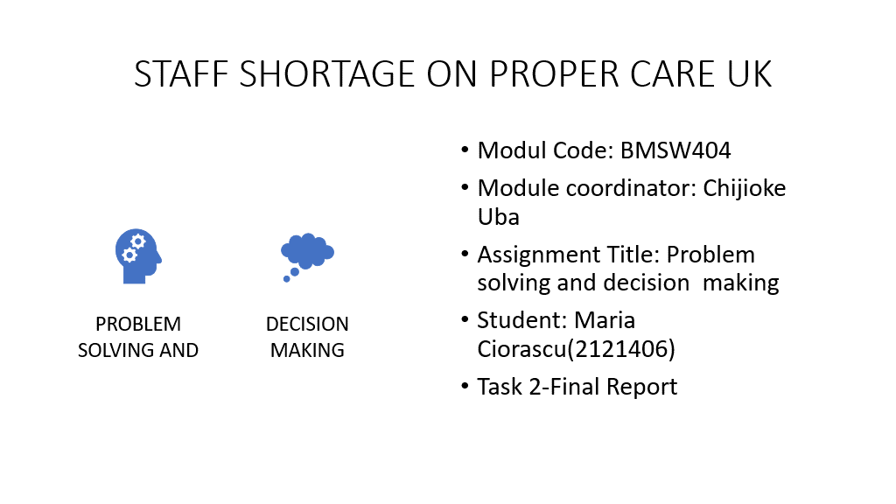

THE SHORTAGE ON PROPER CARE

TABLE OF CONTENT
SUMMARY:
Introduction on shortage staff on Proper Care........................................2

2.Understanding the factors linked to problem, using Fishbone Diagram,
Pestle analysis, PMI analysis. The nature, impact, cause........................4
2.1. Pestle analysis.................................................................................5/6
2.2. Fishbone Diagram............................................................................6/7
2.3 PMI analysis.........................................................................................7
Solution A...............................................................................................7/8
Solution B...............................................................................................7/8
Solution C...............................................................................................7/8
Solution D...............................................................................................8/9
3. Option will be implemented based on PMI Analysis solution D.............9
4.Evaluation of solution to find the most appropriate.................................9
5. Possible solution to solve the problem staff shortage for Proper Care-training proposed....................................................................................................9
6. Action plan.........................................................................................9/10
7. Monitoring …........................................................................................10
8 Evaluation /Implementation..............................................................10/11
9.Conclusion ............................................................................................11
9. Reference.............................................................................................12/13

STAFF SHORTAGE ON PROPARE CARE UK

Introduction on shortage staff on Proper Care
The main reason of this report is to find the solution on shortage staff on Proper Care UK problem. The role of professionals nursing is to provide the high-quality care for every patient, but this can happen only if:
have decent work condition, are enough motivated to do it, are enough like a number (sometimes is increase of patient's number more they can handle), are happy with the wage, they have not stress, no working under pressure, no missing adequate technology, and overtime paid.
Many times, they must rush to can complete their schedule and like that all this together led to mistakes and big medicals errors. In Great Britain now there is a deficit of over 100 000 assistants, if we consider the deficit of 50 000 before the Pandemic, and there is no question of this being reduced. Nurse surveys from January (2021) by Nursing Times, indicated that patient safety is being compromised precisely because of this understaffing
Cite:” Researchers are trying hardly to solve the retention problem of NHS”. (Newman and Maylor, 2000)
1. UNDERSTANDING THE FACTORS LINKED TO THE PROBLEM-USING FISHBONE /PESTLE
The nature and impact of the complex problem on NHS Organization and its employee​
Research –informed about nature and impact of the complex problem on NHS Organization.​ The problem of the shortage of nursing has numerous factors that influence registered nurses and the demand for nursing services. This has a
Cite
"Negative impact both on the retention of licensed nurses and on the skills of recruiting students for this profession. “Cheryl A. Peterson, MSN, RN (2001, vol6, no1, jan2001), Abstract.
1. The nature of problem /Identify de problem is the shortage staff, affecting the NHS and adult care providers in the UK, leading to reduce the quality of Helth Care delivery/services (hospitals, helth care houses, NH in generally). Can be Internal and External factors which are contributing on shortage
2. The Impact of shortage nursing staff on national level is reflected on the population, hospital. and older peoples from Houses Medical Care .
Long waiting term list increasing continue to grow, deterioration of the future sustainability of the organization, affecting mental helth, increasing stress, leading to less people to join care house as nurses or career. In this report we try to set out serious policy actions that evidence suggest, should be the heart of implementation plan. The focus should be on nursering and general practice where really the workforce problem is very severe, statistically Uk need increasing nursering number, could be cover by NIHs with the nurse in training and reducing the drop-out rate during the training by third and motivate more the nurses to enjoy once qualify.

Cite,

“Data published by NHS Digital reveals, 93,806 full-time equivalent vacancies across the NHS in England at the end of June this year. This is up 23% from the 76,082 vacancies at the end of March 2021, Nursing notes, 27 August 2021 “
3 Cause/factor contributing on staff shortage:
Factors driving the shortage are present nursing shortages include the increasing age of the working nurse and the potential for retirement, Cheryl A Peterson (2001, vol 6).
Other factor contributing on shortage is the nurses are always stressed;
Why are they stressed? For well understanding the cause of shortage, to solve a problem, the main cause must be identified using the Pestle Analysis and Fishbone Diagram. What is Pestle?

PESTLE ANALYSIS
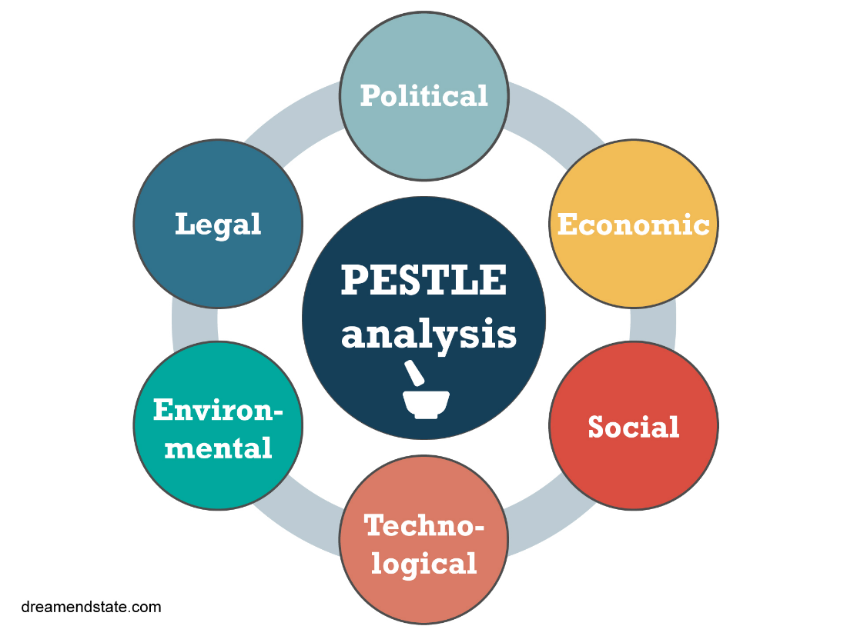
http://www.changefactory.com.au/our-thinking/articles/developing-aged-care-strategy/
PESTLE analysis is an acronym for tool used to identify the macro (external) force facing an organization the letters stand for Political, Social, Technological, Environmental, Legal. (What is Pestle https://blog.oxfordcollegeofmarketing.com/.)
From PESTLE analysis we can see relevant information:
Political:
- Reduce government funding for training of nurse, mean less people interested in being trained in this profession
-Brexit Wich stopped the influx of staff from UE
According with, A., Nielsen, R. & Norris, E. (01March, 2021), in a Qualitative analysis of free-text questionnaire comments, Brexit and European doctors’ decisions to leave the United Kingdom says:

Cite from results
“Brexit was reported by most participants to have a profound impact, although some respondents felt it was too soon to assess the potential consequences. Five themes emerged including: feeling unwelcome in the UK, Brexit as racism, uncertainty on legal ability to work, strain on relationships, and in contrast, a current lack of concern about Brexit.”

-Lack of professionalism leader at national and local level. Example wrote by GBM UNION on” Hospital staff shortages disaster waiting to happen'” (20 Feb 2020).

-Change National low. Procurement and competition low. During the Brexit,

Cite” the EU Low has been incorporated into Uk Low, the Gouvernement must repeal or amend the low if they wish to reverse the current arrangement, release the financial pressure which the Sistem is facing with in this moment " (Hellen McKenna, 30 June 2016)

Social
-Career attitude that can favour training to enjoy the nursing profession. With the diploma of medical assistance, due to the stress and the crowding of patients, some of the nurses can look for other work opportunities, educators, midwives, anaesthesiologists, and administrators, according with Daniel Bal (March 2, 2022) Modified on August 2, 2022 ·
Economic
- The wage, which causes nurses stress and leading them to look for other jobs opportunity
Environmental factor
- Weather, especially on winter, difficulty of transport, lack of ambulance.

Fishbone analysis
Fishbone analysis is a visualization tool which categorising the potential causes of problem, typically used for root Couse. The Fishbone is presented and discussed next and used to identity other causes not covered in Pestle.

=

=

From Fishbone diagram, we can find out more causes for the factors we mentioned in Pestle and not mentioned:

Brexit factor: has impact on Pharmaceutical Industry and increase in level of skills among the workforces.
Wages factor: low payment /hour
Covid factor: too many patience, too much staff in isolation
Work increase factor: more work for individual, skill shortages are higher for establishment that use advanced technology
Stress factor: over low wage, people incompetent, missed appointment, unexpected patient

To identify the most appropriate managerial options, possible solution identified from PESTLE ANALISYS AND FISHBONE DIAGRAM, will use PMI ANALISYS.

PMI ANALISYS (Plus, Minus, Interesting) is important decision-making tool to use to check if a decision / opportunity is worth taking. Is a weighing of PROS and CONS of a decision, Cite
“to improve the thinking avoid the Intelligence Trap, exploring the positive, negative and interested ideas” developed by dr..E. De Bono, from source: How to use the PMI Technique to think Better.

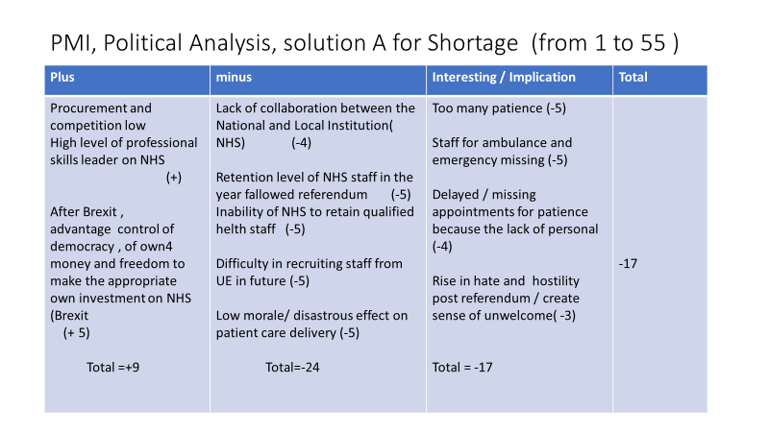

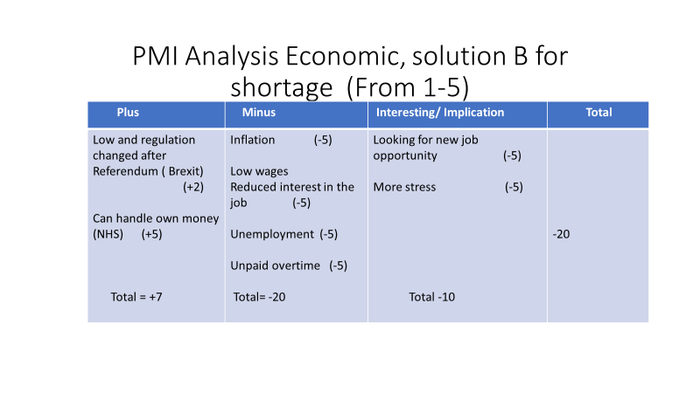
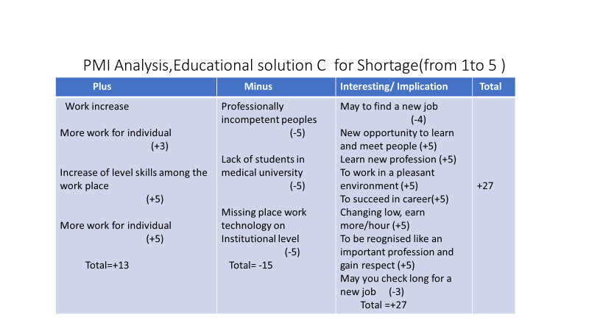

Outcome from PMI Analysis:
Political: Plus: Total: +9 Economic: Plus: Tota +7 Minus: Total -24 Minus: Total -20
Interesting: Total: -17 Interesting: -10

Educational: Plus: Total +13
Minus: Total –15
Interesting: Total +27

Possible Shortage solution, solution D which will be implemented.
From PMI analysis, the positive indicator outcome is Interesting +27. This suggesting that can be one solution in education. To Identify the potential of the educational factor,” the solution of Shortage staff on NHs may come out of close collaboration of managerial leader of Governmental Institution,” according with Nevidjon and Erikson (2001, 31 January).
The most efficiency solution in our case to increase the nurses' staff is focus on training more student and the people which are already in medical system, give them motivation (good wage, decent work condition, nice environment, rewords). For this need one program well-structured and well organised.
The program for nurses training has 3 stages,
1 Action Plan mean to decide in advance what to do, haw to do, when to do it, and who is to do it. Keats and O Donnel (1955)
2. Monitoring and review the implementation; mean haw you are going to have information, to see haw thinks are going, monitoring means the data collection and use information against plan, use that information to improve the situation through the developed plan according with CES GUIDE TO IMPLEMENTATION
https://implementation.effectiveservices.org/enablers/monitoring-and-evaluation#:~:text=Implementation%20Enablers%20%E2%80%94%20Monitoring%20and%20Evaluation
3.Communication of decision/evaluation, something (like feedback) that can indicate how successful the implemented solution has been, this happens after THE IMPLIMENTATION - HAW SUCCESSFUL IS. The first step is to identify communicating and reporting challenges, and, in turn, to learn from the results. This what will do next steps. Patton (1997); Torres et al (2005).
ACTION PLAN FOR STAFF TRAINING
THE PROBLEM LOW CUSTOMER SATISFACTION
SOLUTION STAFF TRAINING PLANNING
What /  Specific action | How/ of action of what | When/  Timeline | Who/Staff responsible
Need find trainer/ make a survey | Speak to Dept. Managerial for the need's documents for trainees | Time will star happening  July 15, 2022, to August,  1st, 2022 | Manager HR
Identify the staff which need training completing a survey/quiz | Talk to managers/identify the staff which gave incorrect answer on survey/quiz | 1st August,2022 to 5August,2022 | Manager HR
Identify trrainer | Discuss to Manager to decide if the trainer will be in house or external | 5August/ 7August 2022 | Trainer Committee
Create training schedule | Deciding dates, rooms, lengths of training, hours writing etc... and then communicate to line manager via email | 7August/ 20August, 2022 | HR
Notified the trainer about all schedule | Notified the line manager of all schedules can fix the date start of test of training | 1st September/15 December 2022 | HR

PLAN TO MONITORING
Action | Description | Timeline | Staff responsible
Attendance | Register to determine % of staff that attended training | Every trainee day | HR/trainer
Participation | Use chat, answer to questions, (using scale from 1 to 10), online | Every trainee day | Trainer
understanding | Using scale from 1to 10 | Every trainee day | Trainer

The implementation/ this last stage /tool of program when is the outcome of training. Is when the potential is already identified after all training is the success of the program, we reduced the unexperimented staff lead to success, may to career, to performance and with this shortage, included in this profession other people's which can enjoy it but this not only, without collaboration of the Governmental Institutions.
This is the most appropriate managerial possible solution identified from this simple analyses tools made: Pestle, Fishbone, PMI analysis.
Conclusions of report and recommendation
As the conclusion of this report, is that from the analysis of the data made with Pestle Analysis, Fishbone Diagrams and PMI, the problem of shortage can have a solution, finding the method to keep the existing medical staff, rerouting students and to be motivated to study as after finishing the medical courses, to embrace this job. Also, the Government Institutions involved in the realization of this project, to collaborate with each other.

Reference
Provide a list of references referred to in the report.
The UK healthcare crisis – 2021 and beyond | Nursing Times.www.nursingtimes.net/clinical-archive/healthcare-it/the-u…
Abstract, Nevidjon, B., Erickson, J. (January 31, 2001). "Lack of nursing: short- and long-term solutions". Online journal of nursing problems. Vol. 6 No. 1, Manuscript
According to the Health Workforce Migration Advisory Committee's analysis, “the available wage for…
ABSTRACT AuthorCheryl A. Peterson, MSN, RNcpeterso@ana.org Volume 6 - 2001No1Jan01Shortage Problem Answer

Abstract/factorsnswershttps://ojin.nursingworld.org/MainMenuCategories/ANAMarketplace/ANAPeriodicals/OJIN/TableofContents/Volume62001/No1Jan01/ShortageProblem.html#Answers Cheryl a. Peterson, MSN, RN Volume 6 - 2001No1Jan01Shortage Problem Answers Daniel Bal (March 2, 2022) Modified on August 2, 2022, 10 Nursing Jobs Nurses Can Work Instead of Bedside
CES GUIDE TO IMPLEMENTATION https://implementation. effectiveservices.org/enablers/monitoring-and-evaluation#:~:text=Implementation%20Enablers%20%E2%80%94%20Monitoring%20and%20Evaluation
Hellen McKenna 2016https://www.kingsfund.org.uk/publications/articles/brexit-and-nhs?dm_i=21A8%2C4WAWB%2CFMB8T9%2CIJVE2%2C1
How To Use the PMI Technique to Think Better https://sourcesofinsight.com › avoid-the-intelligence-trap Ho
Newman and Maylor (2000) Strategies for tackling staff shortages in the NHS https://ukdiss.com › examples › qualified-nurses-the 8 biggest problems of UK hospitals,
The UK healthcare crisis – 2021 and beyond | Nursing Times.www.nursingtimes.net/clinical-archive/healthcare-it/the-u…
A., Nielsen, R. & Norris, E. (01March 2021) Brexit and European doctors’ decisions to leave the United Kingdom: a qualitative analysis of free-text questionnaire comments. BMC Health Serv Res 21, 188 (2021). https://doi.org/10.1186/s12913-021-06201-0xPublished: 01 March 2021

Evaluation reporting menu, p 5, Communicating and Reporting on an Evaluation, Sources: Patton 1997; Torres et al 2005. https://www.crs.org/sites/default/files/short-cuts-communicating-and-reporting-on-an-evaluation.pdf#:~:text=In%20planning
GM Union Hospital staff shortages 'disaster waiting to happen' | GMB

Nursing note( 27 august ,2021) https://nursingnotes.co.uk/ data Worsening shortage of nurses and other NHS workers ‘paints a bleak picture’, warn health leaders,The NHS in England is currently short of 38,952 registered nurses.Daniel Bal (March 2, 2022 ) Modified on August 2, 2022 10 Nursing Jobs Nurses Can Work Instead of Bedside
What is Pestle https://blog.oxfordcollegeofmarketing.com/2016/06/30/pestel-analysis/#:~:text=A%20PESTEL%20analysis https://blog.oxfordcollegeofmarketing.com/.

