Module Title: Employability and Career Development
Module Code: LCLM 4005
Assessment: Component 1 - Job Interview
Student Name: Muhammad Mustafa Ali
Student Number: 2519128
Lecturer’s Name: Dian Mayasari

Job advertisement
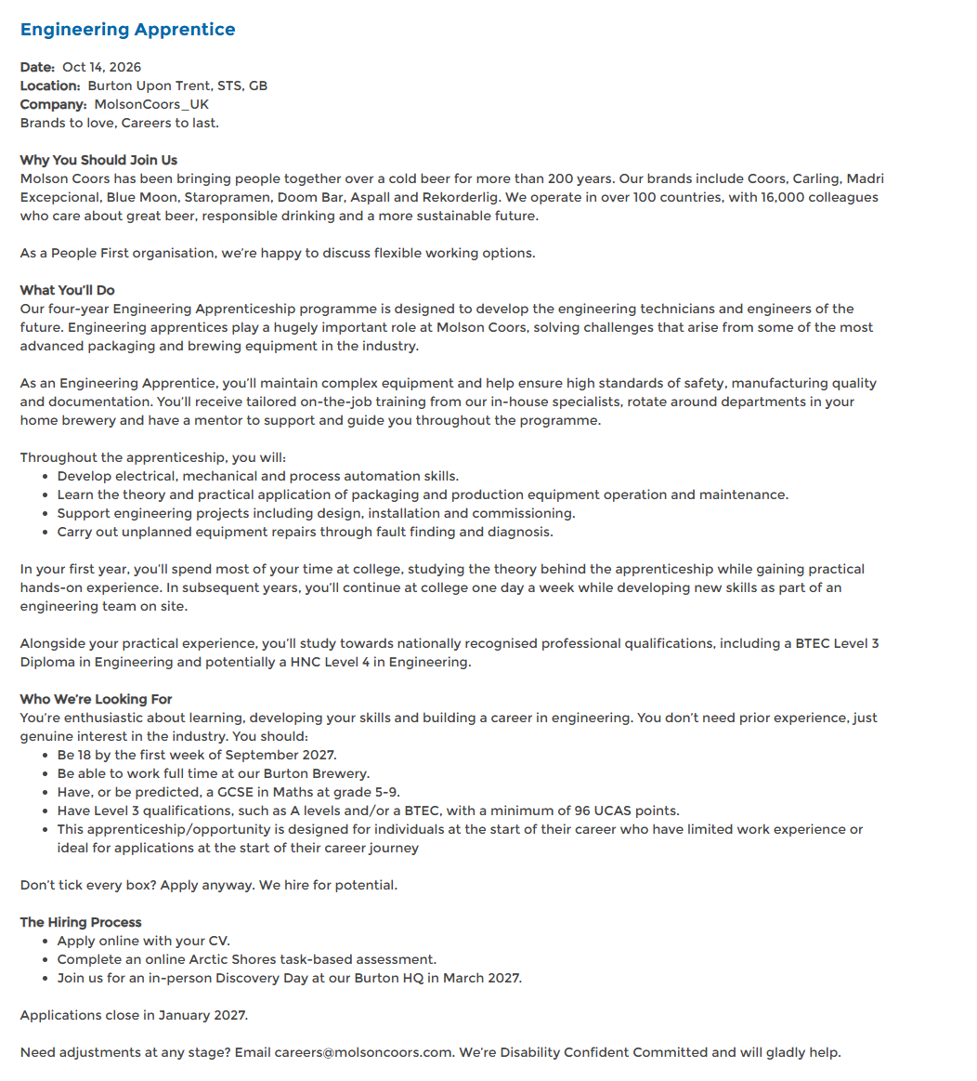

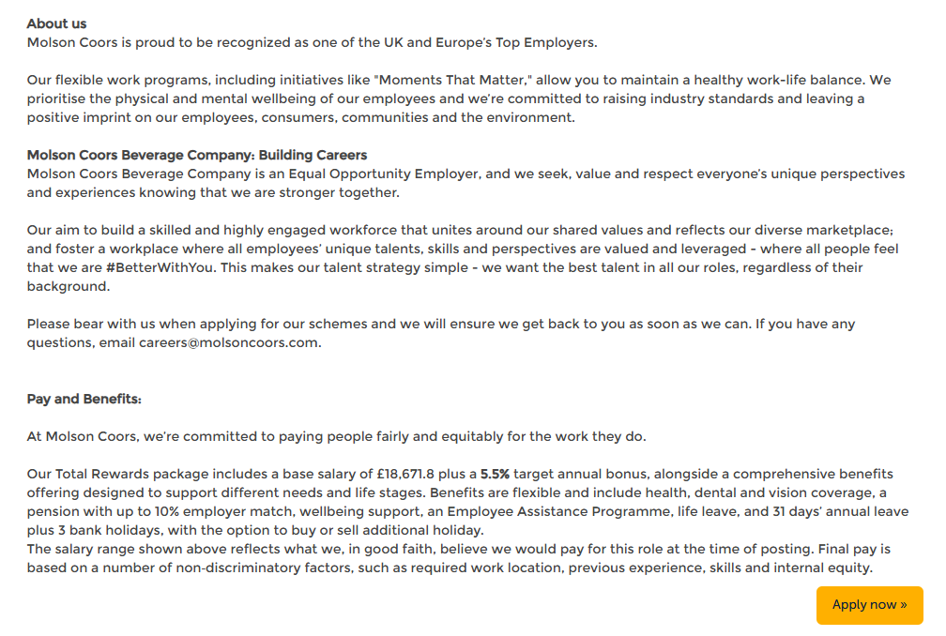

CV
Muhammad Mustafa Ali
Personal profile:
Motivated candidate with BTEC Applied Science at D*DD and GCSE Maths at grade 6, seeking to develop a career in electrical and mechanical maintenance engineering. I bring a methodical approach to practical problems, experience following safety procedures and an organised approach to study and work. Keen to learn equipment maintenance and fault diagnosis through the Molson Coors Engineering Apprenticeship.
Relevant skills:
- Problem-solving: investigated an unexpected boiling-point result by reviewing calculations, the experimental method and possible influencing factors.
- Numeracy and accuracy: used scientific calculations, formulas and data analysis throughout Applied Science studies.
- Safe practical work: followed procedures and organised equipment and materials carefully during college investigations.
- Teamwork and initiative: allocated group practical tasks, coordinated progress and encouraged safe working.
- IT and organisation: advanced IT skills, independent research and effective management of coursework and deadlines.
- Communication: professional customer service, teamwork and discussions with engineering employers at careers events.

Education and qualifications:
Joseph Chamberlain College, Birmingham
2025 BTEC Applied Science: D*DD
2025 GCSE English Language: grade 4
Small Heath Leadership Academy, Birmingham
2023 GCSE Maths: 6; English Literature: 4; Combined Science: 4–4
2023 Creative iMedia: Level 2 Distinction
Work experience
Pharmacy Assistant work experience | Mohammedi Pharmacy, Birmingham | 2022
- Assisted customers politely and supported pharmacists and pharmacy staff with daily tasks.
- Checked invoices, organised stock, handled products carefully and maintained tidy work areas.
- Followed workplace procedures and completed duties with accuracy, reliability and attention to detail.

Education and career development:
Birmingham | 2023 to present
- Completed further education and developed practical, analytical, time-management and independent study skills.
- Attended Make UK, Midlands Tomorrow’s Leaders and Thinktank STEM activities; explored engineering careers and spoke with employers.
- Participated in team STEM projects, coordinated group assignments and completed CPR training.

References available on request.

Cover Letter
I have applied for Engineering Apprenticeship in Burton-on-Trent as I wish to pursue a career in Electrical & Mechanical Maintenance Engineering. This combination of study included DDD in Applied Science (BTEC) and grade 6 in Maths and 4 in English language. My studies have assisted me in the development of the practical, nu or anal skills that I would like to bring to the programme.

You might be interested in what interests me, I want to learn the maintenance of the equipment, as well as diagnosis and repair of faults. Looking to learn relation of electrical and mechanical systems and skills with experienced engineers. Workplace training and a rotation within departments and engineering qualifications provide me with the structure that I am seeking to develop.

In a college practical the boiling point of a product was not found as it was expected in the industry. To check for the reason of the discrepancy I tried to review the experimental method, research the influence that there might have been on the result and did some calculations. This deepened my curiosity with regards to unexpected results and methodical exploration of issues, which I used later in developing my skill in learning about fault finding in engineering.

In Group Practical work I have also been responsible, such as organising practical set-up, overseeing materials and recording of results. Observed and supported safety of the work undertaken by the group. I had to be well organised and keep myself disciplined and attentive when handling coursework and assignments to keep them up to a high standard.

It was my pharmacy experience that has helped build my reliability and professional communication. Used to help customers, to support staff, to request invoices and arrange stock following work procedures. I also had the opportunity to attend Make UK, Midlands Tomorrow's Leaders and Thinktank STEM events, which helped me to explore engineering careers and gain insight from employers first-hand.

I would come with a positive attitude; I would be willing to ask questions and strive to learn within that setting safely. I would be glad to discuss with your engineering team about my background as a team player, problem solver, and an academic. I appreciate your consideration of my application.

References

Molson Coors (2026) Engineering apprentice. Available at: https://jobs.molsoncoors.com/MolsonCoors_UK/job/Burton-Upon-Trent-Engineering-Apprentice-STS/1447570833/ (Accessed: 17 October 2026).

