Student Named: Saeed Ahmad
Student ID: 2027769
Module: Understanding and Engaging in the Customer Experience.
Module Code: BMSW5103
Lecturer: Dr Richmond Lamptey

Executive Summary
This report is about the experience of customers and the quality process of a retail company through a principal researcher. This research is based on the customer’s new themes and experience in the Automobile industry and also how it impacts the customer relationship system either positively or negatively. The report will cover the customer experience and touchpoints and brand experience and the recommendations of the analysis. This report also covers two quality models: total quality management and KAIZEN to support automobile company to promote quality at workplace.

Table of Contents
Introduction 3
Part-01 4
A. Customer Experience of Mercedes-Benz 4
B. Customer experience and brand experience 6
C. Findings and recommendations based on the analysis 8
Part:02 10
I. Two quality models link with the automobile industry 10
Conclusion 16
Reference 17

Introduction
Customer Relationship Management (CRM) concept has been developed a lot in the last twenty years. Lots of significant changes are noticed over the past few years. CRM is a process of evaluating customer needs through different kinds of surveys to generate customer information for using purpose automatically through a cloud-based service named – ‘A Software as a Service (SaaS). It means the use of software or technology used on pay-per consume basis (Hitka et al., 2019).
CRM is used to maintain a positive relationship with the customer through a continuous process of discovering the company’s purchasing products and sales services and generating value to the customers. There are various types of CRM to communicate with the customer. Now, CRM is the largest revenue-generating scope for an organization. To continuously promoting success and growth in business in different countries CRM is essential. In the past time, it was thought that CRM was only used as an after-sales service but now it is used as data analytics, and artificial intelligence (Hitka et al., 2019).
In this certain report the significant, the customers experiences development, brand experiences and customers touch point services are key focused point that cover throughout this report as part of the CRM practices. Additionally, the report measure two core quality management theories or models are applied by Mercedes-Benz to promote their products and services quality as part of their customer relationship development policy.

Part-01
This part is about the experience of customers and the quality process of a retail company through a principal researcher. This research is based on the customer’s new themes and experience in the Automobile industry and also how it impacts the customer relationship system. Now, in part A the customer experience of Mercedes-Benz will be discussed based on a few themes.

Customer Experience of Mercedes-Benz
Mercedes-Benz is a German luxury vehicle automobile brand. Mercedes- Benz established in 1926. It is developing a total worldwide sales chain based on the individual customer need as the customer wants a strong relationship anywhere at any time (Hitka et al., 2019).



Customer touchpoints:
Mercedes-Benz follows a continuous global sales chain based on customer needs at the high level of the brand. Because the customer always wants to be in contact with the brand. The customer expert team always tracks the customer’s journey. There is a team who tracks those customers who want their Mercedes cars for the first time. Then they track that journey and keep updated on the customer. In the pre-sale section, the team tracks a customer by the question’ what car should I have?’. Then after this selection, the information is sent to the marketing department and they discreet customer position whether they are in the position to have cars (Hitka et al., 2019). Again, the customer also searches for the automobile company options. In the mapping section, many touchpoints are uncovered as the customers sometimes moved from brand awareness to choose a product in the stage of pre-sales.
This team tracks the purchases and post purchases contact situation. Then they identify customer reactions, their pain, and inconvenience and review all the processes of business, and determine the needs of the customer. Mercedes-Benz continues this process on a circular basis and they do cross-functional scalable solutions which will emit the pain and inconvenience and gain customer satisfaction. Mercedes- Benz is a strategic partner of Salesforce and they use a management process that increases the sales growth of the company. V2MOM means Vision, Value, Methods, Obstacles, and Measures. Then Mercedes-Benz uses also Sales Customer 360 to combine the sales team, the service team, and the dealer. They all share their customer review (Hitka et al., 2019).

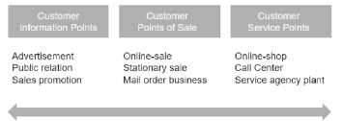
Figure: Customer Review (Hitka et al., 2019).
To ensure sustainability, Mercedes- Benz has a substantial development. They have a regular monitor and adapted the system to improve sustainability. That’s why they all with their stakeholders on the format of the main issues and points. Mercedes- Benz has always focused on their technical innovation, safety, and achievements. Now they also focus on sustainability. They target a commitment to maintaining production sustainability. They plan to create a zero-carbon environment. They have taken good measures to ensure a sustainable future. As to fulfill the target of zero- carbon, they have switched to CO2- neutral plants in the world from 2022 (Jayachandran et al., 2005).
They have also a plan for an electric EQ lineup. They have shaped the mobility of a secure future. They have considered a few questions and developed their brand with these themes and used them as a benefit of their brand that why the customer will purchase this brand. At first, they maintained low-maintenance cars. Then, they developed a 100% green charging station. Mercedes- Benz developed their cars to use as best for long distances. They made driving fun, comfortable, quiet, and convenient. Mercedes- Benz has to take driving to a new dimension. By maintaining these factors Mercedes- Benz will keep their sustainability for their customer which will increase the satisfaction of the customer, and the revenue makes for the company (Jayachandran et al., 2005).

The impact of importance and sustainability of customer touchpoints on customer relationship management:
The idea of sustainability and importance is vast. Without customer touchpoints the business will completely fail. Customer touchpoints are a continuous process of business development without this process the business will fail to attract current and potential customers. Mercedes- Benz follows a continuous process of CRM to maintain customer satisfaction. Sustainable customer touchpoints develop the main theme and system of the business. So, customer touchpoints are very important for customer relationship management (Jayachandran et al., 2005).

Customer experience and brand experience

Importance and sustainability of customer experience and brand experience of Mercedes-Benz:
Mercedes-Benz has promised a compelling brand to maintain each dealer and each employee with better relationship and service. To set this environment a good company culture is very important where Mercedes- Benz is well ahead compare to its rival. In the showroom, Mercedes-Benz showed its new brand. The company provides a complete focus on the experience-based business. So, customer will have a better experience. Customers are always eager to try a new experience, where the renowned company is developing how it will be possible to experience both virtually and physically. Mercedes- Benz keeps updating the exterior and interior designs of their cars to have a good customer experience as well as having better brand experience. It has a great impact on the customer experience with the marketing sales and strategy. In doing this Mercedes- Benz emphasizes the demand of their customer (Jayachandran et al., 2005).
Mercedes- Benz is very much sustainable with its customer experience and brand experience. They focus on sustainability rather than showcasing products. They participate in the IAA MOBILITY to take advantage of the new model of the international motor show as part of their brand awareness. development. Mercedes- Benz is also focusing on the zero-carbon consumption environment in Europe. The digital future of the company also depends on the sustainability of customer experience and brand experience. The company target the lead electronic mobility because the premier and luxury cars are mostly electronic almost 7 out of 10. They are also developing a social interaction area where the customer can share their experience. Mercedes- Benz is also creating a comprehensive and modern brand experience for the customer which is environment friendly, solutions for future issues
(Al-Gasawneh et al., 2022).

Impact of importance and sustainability of customer experience and brand experience of Mercedes-Benz on customer relationship management:
The impact of the importance and sustainability of customer experience and brand experience of Mercedes-Benz on customer relationship management is very much important. Digitization creates new challenges for business sales. CRM is used to minimize this problem. From a survey, it is visible that customer experience and brand experience are the key success factors for any business. At first, they target to gather the customer experience.



All the experiences that customers gathered from the services of Mercedes- Benz are considered customer experience. The touchpoints are considered verbal and nonverbal and it is a continuous process of observation of the company. The long-term observation of customer experience and brand experience expands the business which is the main goal of the company. It creates the vision for the company which helps to target achievement. It is a continuous process of engaging and messaging to improve (Al-Gasawneh et al., 2022). Then there come the changes for the problems and it works as an updated solution for problems. By removing customer complaints the customers may have positive view about the services of Mercedes- Benz that surely increase the brand value. It helps Mercedes-Benz to maintain a good connection with products of lifestyle that are innovation, success, and safety. It can help to maintain the band’s value, tradition, and prestige. It creates a craving for branded products. Mercedes-Benz car’s test drive and purchase gap are just an hour which is the result of customer experience and brand experience of Mercedes- Benz customer relationship management.

Findings and recommendations based on the analysis
Customer satisfaction is the result of continuous and cognitive asses. The customer experience is the overall reliability and modification (Al-Gasawneh et al., 2022).

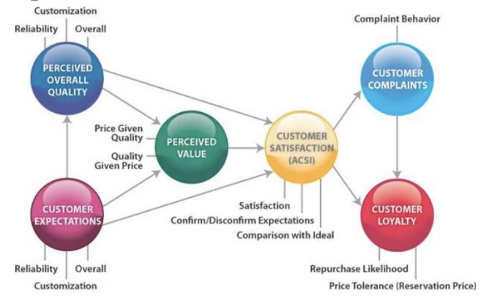
Figure: Customer reliability, loyalty and complaints (Al-Gasawneh et al., 2022).
The above figure shows that customer reliability, loyalty and complaints. Customer expectations are affected by the competition, promises, and expertise of the brand. The overall quality and customer expectations impacted the brand value and customer satisfaction. The customer not only pays for the physical parts of the cars but they also pay for the brand value, their expectation, and brand value (Al-Gasawneh et al., 2022). Therefore, Mercedes- Benz must develop better CRM which can be ensured through better customers services, ensure passionate and luxurious types automobiles and create unique value for vehicles lovers.
The brand value can be increased by giving the best cars at the lowest price with the best after-sales service. The company can engage the customer more in the brand by creating a satisfied customer. ECO efficiency and good product quality, economic price, good after-sales services, and giving a qualified engine are the main points through which the company can achieve customer satisfaction.
Product overall quality is an important factor to consider to attract the customer. Mercedes- Benz provide its best product to the customer. They focus on the updated models of the cars and updated various aspects of the engine with the ECO system, the zero-carbon environment in Europe, etc. product is the main attraction of the customer (Al-Gasawneh et al., 2022).
Customer expectations are the main concerning for any company. Therefore, Mercedes- Benz work continuously on the expectation of customers through their SaaS management system (Muller, 2014). To meet customer expectations, they work on a different stage but it needs more collaboration between the department as it is an international brand.
Perceived value depends on the price given quality and Quality given price and vice versa. It means that what you pay you will get the thing. The customer not only gives the payment for the product but also the brand and after-sales service. All the actions and decisions must be taken by keeping perceived value to the centre of Mercedes- Benz’s strategic planning.
Customer satisfaction is the main concern of the company. To maintain customers’ satisfaction and repeated, they follow a continuous process (Al-Gasawneh et al., 2022). They follow from the first track of pre-sales conditions. But they should keep the process more updated as Mercedes- Benz is an international brand. Then they follow that trip and keep the customer informed. The pre-sale crew keeps track of customers by asking them, "What car should I have?" Following this decision, the data is forwarded to the marketing division, where it is discreetly asked of the consumer whether they are eligible to own cars. Once more, the consumer looks at choices for the automaker (Muller, 2014). Numerous touchpoints are found in the mapping section as buyers occasionally transitioned from brand awareness to product selection in the pre-sales stage.
Customer complaints should also monitor with care. They should try to give a complaint less service. Then if there is any complaint they should try to fix it as soon as possible. They should keep in contact with the customer if the problem is fixed or not. He is facing any other problems or not.
Customer loyalty is the main concern of the company (Muller, 2014). They always try to keep their loyal customer on a repeated basis. They should follow the customer service management system. To make loyal customers they should promote a few unique features of the cars. Price tolerance should also be considered a feature of customer loyalty. They should try to read out the customer behavior to improve customer loyalty.

Part:02
This discussion will cover the customer experience and touchpoints and brand experience and the recommendations of the analysis (Muller, 2014). This section will also cover two quality models: total quality management and KAIZEN.

Two quality models link with the automobile industry
Two quality models link to Mercedes- Benz will be discussed in this section. The discussion is as follows:

Concept of quality:
Mercedes- Benz creates a link between innovation and tradition with progress. Every model has independently assigned aspects and features considering the highly specific style. For these reasons a Mercedes- Benz will be the best car in the automobile industry. Because they have interested to keep the tradition and modern needs. They focus on the customer’s needs and merged them with the customer’s tradition. They have a striking feature of GLA which forward its upward thinking for quality maintenance (Muller, 2014). They have merged with much emotional appeal with as much purity as needed, and the defined surfaces that convey force and tranquility.
The new GLA is considered the SUV of the future as it blends the traditional and modern design. All the designs are the fundamental design of Mercedes-Benz which are hallmarked designs. Most of the designs are the image of youthfulness and depicts subtle drama.

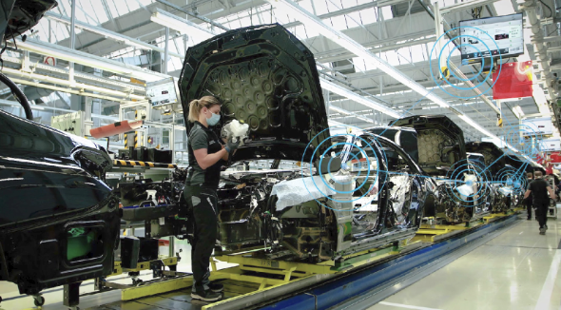

They follow operations 360 to maintain the quality and efficiency of car production. They maintain a new standardized ecosystem through software programs connected by the standardized user and shared interfaces (Muller, 2014). All applications are real-time data. This MO360 combines high-quality and effective tools into a single functional unit. They follow the transparency in the digital manufacturing process.
They use important software applications worldwide. They follow a KPI-based production control system. They also follow need-based production with special demand. They use the software named Integra to maintain a real-time worldwide control production. This brand is already a proven quality for safety and comfort. Again, it provides aerodynamics, high quality, and innovative production. For this Mercedes- Benz received E-Class Saloon’s body and EuroCarBody trophy in 2009.

Link of quality on Customer Relationship management:
The low quality of Mercedes-Benz was once alarming with the technical quality of cars highly degraded. So, the customer did not get the same quality of cars which increased customer dissatisfaction and defection (Muller, 2014). So, the customer complained about the communication that they received and the service delivered. So, the service customer received was not sufficient. The communications that customers sometimes received were not always coordinated by the dealers of Mercedes-Benz. Such kind of communication sometimes may not fulfill customer needs in time with their purchase cycle and creates conflicting messages. Different dealers have different database systems which create problems and inaccuracy in the information (Muller, 2014). Sometimes the salesman doesn’t record the exact information which creates misinformation for the customers.
Sometimes customers change their address and much other information but they don’t inform the company. So, they cannot be contacted if there is any change or update in the company. Even Mercedes-Benz buyers are hard to track. As they are rich and very confidential to share their information.
In 2000, they adopted a new distribution system. They divided the market into 35 new geographical areas and create a new agreement to enter into a new retailer agreement which is the new territories for the different geographical areas. Then a project management unit was established. Then they started to follow the CRM process which developed the service system of the company. Then the new retail plan started working and became fruitful for the company (Muller, 2014).

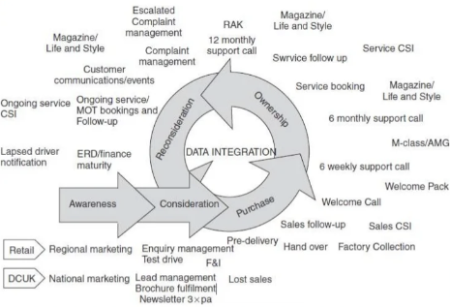
Figure: Quality Management (Muller, 2014).

This figure shows the process of customer relationship management through product quality. The cross-selling and up-selling show the process in the figure that relationships with customers rely upon and are extended. The incorporation of a CRM system developed the customer experience and create a strong relationship with the customers.

Total Quality Management:
Total quality management is the process of managing long-term success by satisfying the customer (Wilson et al., 2012). In TQM, all the employee participates in product improvement, service, and custom of the working place.
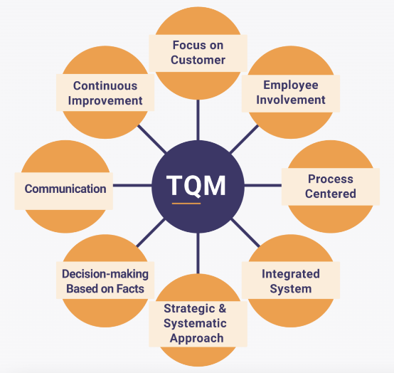
Figure: TQM (Wilson et al., 2012).

The figure describes elaborately the TQM process. It helps a lot to develop the product quality. It can help develop employee and organizational development. It works on the quality management of the company. Using TQM can help in fewer product defects as it increases the quality of the product. Using TQM can also satisfy customers with the high-quality products they can produce. Using TQM can minimize the cost of production and the price of the product. The use of TQM can create a good environment and culture.
The TQM system can be reversed in the case of customer relationship management. TQM takes care of the long-term relationship of the customer (Wilson et al., 2012). The 4P factors can be developed for customer relationship management through TQM.
Toyota, the automobile manufacturer is an example of TQM. When Toyota started following TQM they improved product quality and office environment and all aspects of the company. After that in 1965, Toyota won the award of Deming Application for quality improvement (Wilson et al., 2012). Then in 1994, Toyota introduced a training named, “Toyota Group Executive TQM Training Course” which provided training on TQM for the new employees. That improvement due to adopting TQM is continued till today. However, Mercedes- Benz may here apply this TQM approaches to promote the quality of its goods and services, increase the performance of staffs and brining quality to its products and services that surely increase the brand image and revenues of the company.

KAIZEN model for continuous improvement:
KAIZEN is a model which maintains continuous development depending on the small ideas, and onward positive changes that can produce important improvements.

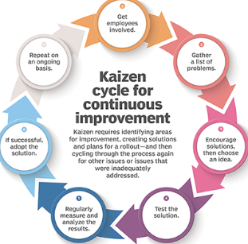
Figure: KAIZEN Cycel (Guha et al., 2018).

This figure shows that KAIZEN is a continuous process of development. It is a cycle-based process. It is a strategy where all the employees of an organization work together for the development of the company. The main objective of KAIZEN is to develop the quality of products, reduce wastage, delete unnecessary hard work and create a good working place. KAIZEN can make the plan for the utilization of resources at the level best, improve efficiency, employee satisfaction, and safety which can improve the quality of products and lifestyle.
KAIZEN is the perfect customer relationship management for a better result. It helps in increasing sales, updated in data information, supporting the whole business, etc. It identifies the problems of the CRM system, then creates solutions, finds out the solution, implements it, makes adoption, analyzes results, and supports them (Guha et al., 2018).
In 2010, Mercedes- Benz adopted KAIZEN which changed the total scenario of the company. At that time 25% of Mercedes- Benz employees had quit their job then they adopted KAIZEN. They focused on the increase of production and it cause great devastation in employee reaction then they follow production management and human resource management which led to problem-solving. Then they realize that the company needs to rely on KAIZEN so that it can promote the business by continuously improving the operation, strategy, process, products and strategy of the company.

Conclusion

This report is about customer relationship emerging themes. It shows the customer’s new themes and experiences which is very important for an organization. The impact of customer relationship management is huge. The touchpoints, customer experience, brand experience, and the application of TQM and KAIZEN, all of these are important for an organization.

Reference

Al-Gasawneh, J.A., AlZubi, K.N., Anuar, M.M., Padlee, S.F., ul-Haque, A. and Saputra, J., 2022. Marketing Performance Sustainability in the Jordanian Hospitality Industry: The Roles of Customer Relationship Management and Service Quality. Sustainability, 14(2), p.803.
Beldi, A., Cheffi, W. and Dey, P.K., 2010. Managing customer relationship management projects: The case of a large French telecommunications company. International Journal of Project Management, 28(4), pp.339-351.
Boulding, W., Staelin, R., Ehret, M., and Johnston, W.J., 2005. A customer relationship management roadmap: What is known, potential pitfalls, and where to go. Journal of Marketing, 69(4), pp.155-166.
Frow, P.E. and Payne, A.F., 2009. Customer relationship management: a strategic perspective. Journal of business market management, 3(1), pp.7-27.
Gil-Gomez, H., Guerola-Navarro, V., Oltra-Badenes, R. and Lozano-Quilis, J.A., 2020. Customer relationship management: digital transformation and sustainable business model innovation. Economic research-Ekonomska istraživanja, 33(1), pp.2733-2750.
Guha, S., Harrigan, P. and Soutar, G., 2018. The application of KAIZEN Cycle at SMEs. Journal of Small Business & Entrepreneurship, 30(3), pp.193-214.
Hitka, M., Pajtinkova-Bartakova, G., Lorincova, S., Palus, H., Pinak, A., Lipoldova, M., Krahulcova, M., Slastanova, N., Gubiniova, K. and Klaric, K., 2019. Sustainability in marketing through customer relationship management in a telecommunication company.
Jayachandran, S., Sharma, S., Kaufman, P. and Raman, P., 2005. The role of relational information processes and technology use in customer relationship management. Journal of Marketing, 69(4), pp.177-192.
Müller, A.L., 2014. Sustainability and customer relationship management: current state of research and future research opportunities. Management Review Quarterly, 64(4), pp.201-224.
Parvatiyar, A. and Sheth, J.N., 2001. Customer relationship management: Emerging practice, process, and discipline. Journal of Economic & Social Research, 3(2).
Parvatiyar, A. and Sheth, J.N., 2001. Relationship Management. Customer relationship management: Emerging concepts, tools, and applications, p.1.
Payne, A. and Frow, P., 2005. A strategic framework for customer relationship management. Journal of Marketing, 69(4), pp.167-176.
Piercy, N.F., 2009. Strategic relationships between boundary-spanning functions: Aligning customer relationship management with supplier relationship management. Industrial Marketing Management, 38(8), pp.857-864.
Romano Jr, N.C. and Fjermestad, J., 2001. Electronic commerce customer relationship management: An assessment of research. International Journal of Electronic Commerce, 6(2), pp.61-113.
Saarijärvi, H., Karjaluoto, H. and Kuusela, H., 2013. Customer relationship management: the evolving role of customer data. Marketing intelligence & planning.
Vogt, C.A., 2011. Customer relationship management in tourism: Management needs and research applications. Journal of Travel Research, 50(4), pp.356-364.
Wang, P. and Swanson, E.B., 2008. Customer relationship management as advertised: Exploiting and sustaining technological momentum. Information Technology & People.
Wang, X.L., 2012. Relationship or revenue: Potential management conflicts between customer relationship management and hotel revenue management. International Journal of Hospitality Management, 31(3), pp.864-874.
Wilson, H., Daniel, E. and McDonald, M., 2012. Factors for success in customer relationship management (CRM) systems. Journal of marketing management, 18(1-2), pp.193-219.
Zablah, A.R., Bellenger, D.N. and Johnston, W.J., 2004. An evaluation of divergent perspectives on customer relationship management: Towards a common understanding of an emerging phenomenon. Industrial marketing management, 33(6), pp.475-489.

