Anna Misiak-Ali (2311228)

University of Wales Trinity Saint David
Recommendation for TechInnovate HR Department
People Management

Contents
1.0 Introduction 2
2.0 TechInnovate background and current challenges 3
3.0 Skills of the manager to successfully manage performance 3
4.0 Good people management and employee engagement 6
5.0 Good people management and company performance 8
6.0 Appendices 10
7.0 Conclusion 11
8.0 Reference List 12

Introduction

TechInnovate is a company in a South Wales that was founded five years ago by a small team of software engineers and data scientists. At the beginning of the company existence all hiring and HR matters were handled by the owners. The focus was to bring top technical talents. Over the past two years TechInnovate experienced massive growth, expanding from fifty employees to two hundreds. The company hired HR manager eighteen months ago, unfortunately all management team has been overwhelmed trying to manage recruiting, onboarding, benefits.
,,HR is responsible for the process of managing people in organizations and includes all the techniques employed to manage people and keep them up to date, qualified, and aligned according to the expectations of stakeholders; there is also focus on activities related to the professional qualification, learning, and training of individuals. It also includes outlining the organizational structure, improving communication, and developing ethical and social principles’’ said da Silva, L.B.P. el at. (2022).
The report was written to analyse problems and find solutions which will match the company dynamics. HR suggested changes to company culture and provide opportunities for management training which will help with many problems company is facing.

2.0 TechInnovate background and current challenges

TechInnovate is a fast-growing software company in South Wales. Over the last two years, with the company expansion, the number of employees growth from fifty employees to two hundreds. At the beginning of company existence, all hiring and HR matters were handled by the founders. Over the time its became too overwhelming and first HR manager was employed. It has been proved that handling recruitment, onboarding, benefits and other HR functions are difficult to process by new HR manager. There are many issues company is facing now. TechInnovate is lacking structure, too many inexperienced employees have been promoted to management roles without any training how to manage people, and it has impact on the company performance.

3.0 Skills of the manager to successfully manage performance

Workforce planning is strategic process of human resource management. It ensures that the company has the appropriate amount of workers with the relevant skills, at the right time and place to meet current and future business needs. (CIPD, 2024). HRM should look for specific skills candidate for a manager have, to make sure company is well manage and thrive. Managers are required to have skills according to Coursera (2024) which can help company to perform better and contribute to growing its employees. Those skills are:
- Ability to delegate, a good leader recognizes the strengths of the team members and transfer responsibility to them (Grayson Riegel, 2023).
- Ability to inspire and motivate, the leader should be able to inspire, mobilize and engage team members to act (Wooll, 2022).
- Conflict-management, a feature of a good manager is the ability to put himself on each side of the conflict to constructively solve it (Cote, 2023).

- Decision-making, process is a method that aims to make informed decisions. It includes the collection of information, checking alternative solutions and making the final choice (McKinsey&Company, 2023).
- Effective communication, the ability to clearly and effectively provide information that are crucial for building trust and understanding in a team. It is also worth being able to listen and be open to the opinions and suggestions of others (Taylor, 2024).
- Emotional intelligence, empathy is a foundation for all important competences at work. Empathic behaviour is a careful hearing of the other person Pouncey, 2023).
- Flexibility- is a skill that allows to efficiently find a way in the new realities caused by the dynamic environment (The Upwork Team, 2023).
- Organisation is a technical skill that allows managers to help people manage their time, priorities tasks and achieve goals (Indeed Editorial Team, 2024).
- Problem solving, the ability to define the problem so that it can be divided into fractions, potential solutions are easier to identify (Indeed Editorial Team, 2024).
- Strategic thinking is a skill that allows management to set clear goals, improve planning. Changing environment requires new ideas to survive and thrive in a competitive envirotment (Digital Leadership, 2024).

There are six common leadership styles according to Knight (2024) which include:
- Coercive leadership style, which requires rapid obedience.
- Authoritative leadership style, managers motivate employees to realize vision of a corporation.
- Pacesetting leadership style, which expect completeness and independence.
- Affiliative leadership style, which focuses on building devotion.
- Democratic leadership style, which requires the construction of harmony.
- Coaching leadership style that focuses on the development of employee for the future.

To achieve above skills candidate for a manager must be motivated and ready to change his/her life and life of coworkers. Motivation is one of the forms that is explained in Maslow’s hierarchy of needs (1943). Those need are as followed:
- Physiological needs: food, water, shelter, and rest.
- Safety needs: security, stability, and freedom from fear.
- Social and belonging needs: friendship, intimacy, and acceptance.
- Esteem needs: respect, recognition, and status.
- Self- actualisation needs: achieving one’s full potential and creativity.

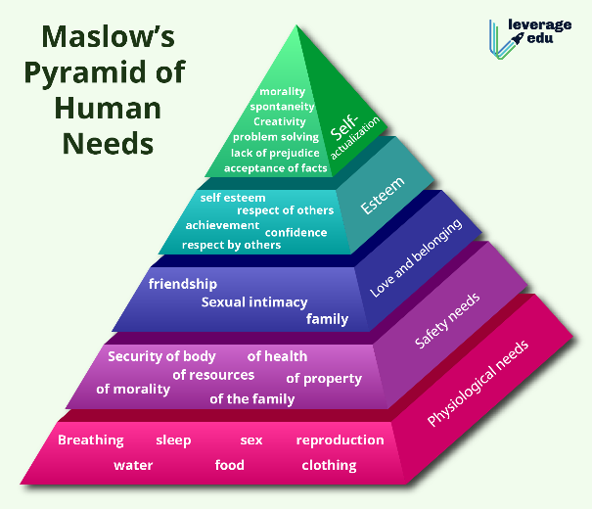

This is simple but powerful message: for different people different needs are important, there are basic needs and non-basic needs (Rojas, Mendez and Watkins-Fassler, 2023). The use of the Maslow concept in management is very beneficial:
- The hierarchy of needs shows to the managers what needs are important for the employees so they can better understand what motivates their employees.
- Planning for the task to be completed is easier due to hierarchy of needs as they can implement task for the employee with different levels of hierarchy.
- Personal and professional development determine what skills, knowledge and competence employee has to enhance support for his development.
- Expectations and needs are communicated between managers and employees.
- Organizational climate is built due to positive atmosphere at work.
However, ,,Maslow's concept has not been without criticism. Chief among the long-held objections is that needs don't follow a hierarchy: While some research has shown support for Maslow's theories, most of the research has not been able to substantiate the idea of a needs hierarchy’’ said Cherry (2024). But with proper company construction it can be manage. The most important thing is to provide basics for the employees. If their needs are met it is easier for them to focus on achieving more, continue development. As for newly chosen managers, they need time to adapt to a new role, they need more guidance and training. TechInnovate should get in touch with companies that offer training for management, without it , it will be difficult to continuously look for solutions and employees will have enough and leave job for competition where they will be recognize.

4.0 Good people management and employee engagement

Performance management is aimed at monitoring and assessing employees' work. The reason for which the company needs performance management is to generate a condition that people can work as best they can and adjust themselves to the company objectives (Tardi, 2024). There are many means of measuring performance. One of them is KPI in performance management as a key indicator for assessing the efficiency of employees and departments. Key performance indicators (KPIs) are measurable, and company can determine continuing performance (Twin, 2024). By setting clear and specific KPIs, employees know what to do and what is expected from them and how they will achieve that. This helps to adapt their efforts to organisational goals, ensuring that they work for the desired business result. KPIs are also the basis for assessing the results and feedback. Regular browsing and discussing the employee's progress towards KPI allows constructive feedback and coaching to help improve individual results and stay on the right track. It also gives the opportunity to distinguish and reward employees for their achievements and successes. Every employee in TechInnovate is assigned to project. When the project is completed management team can define how much member of the team was involved in the project and reward that person with extra day off or voucher to a favourite restaurant, or shop. Attracting employees through pay and benefits are important, it can help to retain employees. There are many options, possibilities to reward workers and recognise their offering (CIPD, 2024).
There are factors that will influence employee satisfaction. Herzberg two-factor theory (1966) explains how satisfaction and dissatisfaction at work can have an impact on employee engagement. According to Peramatzis and Galanakis (2022) ,,the two factors that influenced job satisfaction were divided into two sets of categories. The first category was associated with “The need for growth or self-actualization” and became known as the motivation factors. Motivation factors included achievement, recognition, the work itself, responsibility, advancement, and the possibility for growth. The other category of factors was related to “the need to avoid unpleasantness” and was known as hygiene factors. Hygiene factors included company policies and administration, relationship with supervisors, interpersonal relations, working conditions, and salary’. In other words, motivators are achievement and recognition, increase job satisfaction and are associated with work. As for hygiene factors, things that can make employee unhappy if not provided, like salary and work environment. Employee engagement is one option to keep professional engineers in work, TechInnovate must do a lot of changes with how people are managed to make sure that satisfaction and motivation increase company performance.

5.0 Good people management and company performance

Good management performance is a key to a company performance. TechInnovate can benefit by ensuring all new and existing managers have attended training required by HR. Those trainings can help to realise that company performance depends on how they can motivate their employees, and how those employees are treated while starting new job. It is important for the company to provide sufficient onboarding so new hires feel welcomed, understood and their needs met. From information collected by HR and performed SWOT Analysis (Appendices, Table 1) it is proven that many new hires left work due to lack of formal performance in place and decrease in employee satisfaction. In well organised company, planning achieve company goal, motivates and direct its employees, control and execute tasks allocated to the coworkers, and when needed change them (Coursera, 2024). McKinsey 7S model is a device that analyses company design by looking at 7 key internal elements: strategy, structure, systems, shared values, style, staff and skills, to recognize if the objectives are effectively aligned (Jurevicius, 2023).

McKinsey 7S Framework
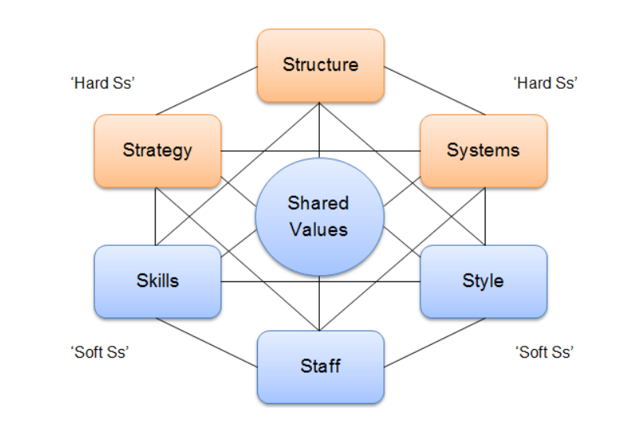
Source: (Jurevicius, 2023)

6.0 Appendices

Table 1. SWOT Analysis
STRENGHTS | WEAKNESSES
- Fast-growing software company,  - Innovatations,  - Artificial intelligence,  - Machine learning solutions. | - Not enough qualified engineers and data scientists,  - New hires are not getting sufficient onboarding,  - Turnover in staff,  - No formal performance in place,  - Decrease in employee satisfaction,  - Employees promoted to managers without training,  - Lack of diversity.
OPPORTUNITIES | THREATS
- Training for managers, | - Competition,  - Problems not solved on time,
Source: Case study

7.0 Conclusion

In conclusion TechInnovate need to provide changes to the management team, to ensure that training for new managers and new hires will be provided. Those changes are crucial for employee engagement and performance management. The goal to keep company going is to change company’s culture that is welcoming, helpful, and motivating. The importance of self-actualisation to improve and achieve more. Equality for every employee to be able to get training and achieve promotion as a sigh of trust towards them. Due to changes provided by HR team, every coworker should feel that they belong and want to stay with the company for longer. It is important that the changes will take place immediately after receiving this report.
Engaged employees stand out by taking initiatives that go beyond their basic duties. If they encounter difficulties on the way to achieving specific goals, they do not give up. Could be said that they look for solutions, not problems. They feel that they belong to the company because they identify with its mission and values. They believe in the quality of the products manufactured and the services provided. An employee engaged in professional life is the opposite of a representative of quiet resignation, a phenomenon of limiting work activities to an absolute minimum.

8.0 Reference List

- CIPD. (2024). Workforce planning. [Online]. CIPD. Last Updated: 26 July 2024. Available at: https://www.cipd.org/uk/knowledge/factsheets/workforce-planning-factsheet/ [Accessed 6 December 2024].
- CIPD. (2024). Reward: an introduction. [Online]. CIPD. Last Updated: 1 October 2024. Available at: https://www.cipd.org/uk/knowledge/factsheets/reward-factsheet/ [Accessed 9 December 2024].
- Cherry, K. (2024). Maslow's Hierarchy of Needs Maslow believed that physiological and psychological needs motivate our actions. [Online]. verywell mind. Last Updated: 2 April 2024. Available at: https://www.verywellmind.com/what-is-maslows-hierarchy-of-needs-4136760 [Accessed 8 December 2024].
- Cote, C. (2023). 5 Strategies for Conflict Resolution In The Workplace. [Online]. Harvard Business School online. Last Updated: 7 September 2023. Available at: https://online.hbs.edu/blog/post/strategies-for-conflict-resolution-in-the-workplace [Accessed 13 December 2024].
- Coursera. (2024). 10 Essential Managerial Skills and How to Develop Them. [Online]. Coursera enterprise. Last Updated: 12 June 2024. Available at: https://www.coursera.org/enterprise/articles/essential-managerial-skills [Accessed 6 December 2024].
- da Silva, L.B.P. et al.,. (2022). Human resources management 4.0: Literature review and trends. Computers & Industrial Engineering. 168(1), p.1. [Online]. Available at: https://pdf.sciencedirectassets.com/271420/1-s2.0-S0360835222X00053/1-s2.0-S0360835222001814/main.pd [Accessed 8 December 2024].
- Digital Leadership. (2024). Strategic Thinking Definition, Skills, Examples, and Steps. [Online]. Digital Leadership. Last Updated: 29 January 2024. Available at: https://digitalleadership.com/glossary/strategic-thinking/ [Accessed 13 December 2024].
- Grayson Riegel, D. (2023). 8 Ways Leaders Delegate Successfully. [Online]. Harvard Business Review. Last Updated: 16 November 2023. Available at: https://hbr.org/2019/08/8-ways-leaders-delegate-successfully [Accessed 13 December 2024].
- Indeed Editorial Team. (2024). Problem-solving skills: definitions and examples. [Online]. Indeed. Last Updated: 17 May 2024. Available at: https://uk.indeed.com/career-advice/career-development/problem-solving-skills [Accessed 13 December 2024].
- Indeed Editorial Team. (2024). 10 Examples of Organization in the Workplace. [Online]. Indeed. Last Updated: 16 August 2024. Available at: https://www.indeed.com/career-advice/career-development/organization-examples [Accessed 13 December 2024].
- Jurevicius, O. (2023). McKinsey 7S Model. [Online]. Strategic Management Insight. Last Updated: 3 December 2023. Available at: https://strategicmanagementinsight.com/tools/mckinsey-7s-model-framework/ [Accessed 6 December 2024].
- Knight, R. (2024). 6 Common Leadership Styles — and How to Decide Which to Use When. [Online]. Harvard Business Review. Last Updated: 9 April 2024. Available at: https://hbr.org/2024/04/6-common-leadership-styles-and-how-to-decide-which-to-use-when [Accessed 8 December 2024].
- McKinsey &Company. (2023). What is decision making?. [Online]. McKinsey &Company. Last Updated: 13 March 2023. Available at: https://www.mckinsey.com/featured-insights/mckinsey-explainers/what-is-decision-making [Accessed 13 December 2024].
- Peramatzis, G. and Galanakis, M. (2022). Herzberg’s Motivation Theory in Workplace. Psychology Research. 12(12), pp.971-978. [Online]. Available at: https://www.davidpublisher.com/Public/uploads/Contribute/63c8ac817a47d.pdf [Accessed 6 December 2024].
- Pouncey, P. (2023). Empathy and Emotional Intelligence: Understanding the Connection. [Online]. LinkedIn. Last Updated: 20 March 2023. Available at: https://www.linkedin.com/pulse/empathy-emotional-intelligence-understanding-patricia-pouncey [Accessed 13 December 2024].
- Rojas, M., Mendez, A. and Watkins-Fassler, K. (2023). The hierarchy of needs empirical examination of Maslow’s theory and lessons for development. World Development. 165(1), p.1. [Online]. Available at: https://www.sciencedirect.com/science/article/pii/S0305750X23000037 [Accessed 8 December 2024].
- Tardi, C. (2024). Performance Management: Definition, Purpose, Steps & Benefits. [Online]. Investopedia. Last Updated: 4 September 2024. Available at: https://www.investopedia.com/terms/p/performance-management.asp [Accessed 9 December 2024].
- Taylor, E. (2024). What is Effective Communication: Principles and Importance. [Online]. The Knowledge Academy. Last Updated: 11 December 2024. Available at: https://www.theknowledgeacademy.com/blog/what-is-effective-communication/ [Accessed 13 December 2024].
- The Upwork Team. (2023). The Importance of Flexibility in Business. [Online]. Upwork. Last Updated: 14 August 2023. Available at: https://www.upwork.com/resources/flexibility-in-business [Accessed 13 December 2024].
- Twin, A. (2024). KPIs: What Are Key Performance Indicators? Types and Examples. [Online]. Investopedia. Last Updated: 22 August 2024. Available at: https://www.investopedia.com/terms/k/kpi.asp [Accessed 13 December 2024].
- Wooll, M. (2022). Inspire others and support their growth. 10 ways to make it happen. [Online]. BetterUp. Last Updated: 8 March 2022. Available at: https://www.betterup.com/blog/how-to-inspire-others [Accessed 13 December 2024].

