PORTFOLIO EMERGENT LEADERSHIP SKIILS IN THE WORKPLACE
STUDENT: MARIANA GRIGORITA (2014974)
LECTURER: SUJEEWA HERATH
MODULE CODE: BMSW6101

Table of Contents
Part 1: Academic Report 1
Introduction 1
Leadership versus management 2
Effective leadership skills 3
Effective leadership styles 5
Critical analysis of barriers to leadership in the workplace 9
Ethical leadership 11
Conclusion 13
Introduction 14
Learning regarding emergent leadership skills 14
Conclusion 16
References 17
Appendix 20

Part 1: Academic Report

Introduction
Leadership is constituted of the fact of making a team or organization deliver performance as required. However, effective leadership establishes the perspective of building a smooth and prominent operation of the team or the organization in order to achieve the goal. In certain aspects leadership has also been counted to be skills or ability that a person has as the effective leadership can place an integrated program and leading to sustainable development of the system. In the workplace synchronization is highly obliged and in view of methodological agenda leadership plays a crucial role in building synchronized format of work structure.
By encouraging team members to interact with one another and work together, leaders contribute to the creation of a successful environment, encourage and inspire employees to achieve the company's goals, and provide direction through vision. In a nutshell, effective management and top leadership are essential for any organization that hopes to achieve its objectives. In a detailed perspective it can be stated that the leadership within a workplace enables the system to build its cognitive role and its orientation to meet the project requirements of the business. The present study has been vested with analysing the effective leadership skills required within a workplace. Apart from that, detailed analytical perspectives have been taken into virtue where the styles which are effective for the workplace are also discussed in this study. Apart from that analysis has been drawn on the barriers associated with leadership along with the ethical form of leadership.

Leadership versus management
The relationship between management and leadership has resulted in a lot of discussion in leadership literature. There is also a great deal of ambiguity, both in classrooms and in production departments, because the phrases "leadership" and "management" are both deemed extremely distinct and very similar.
Leadership is the capacity to persuade others to act. The capacity to influence people's conduct is directly tied to leadership (Silva, 2016). The manager, on the other hand, is the person who guarantees the attainment of organizational goals by planning, organization, and work orientation towards completion (Griffin, 2021).
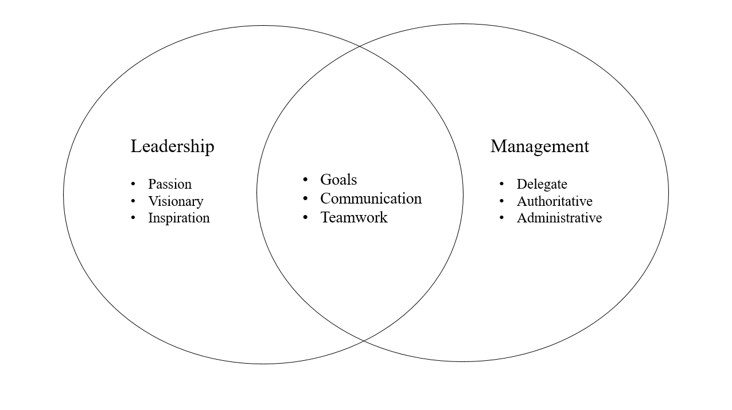
Figure 1: Leadership- management correlation

Effective leadership skills
Leadership skills are essential for anyone in a position of control. Understanding the various leadership skills can help you improve your own abilities and become a more effective leader.
The classification resulting from the split of leadership skills into multiple groups or categories is referred to as types of leadership skills; each category includes several skills that work together to help you lead effectively.

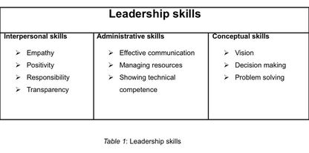

Empathy
Compassion is a necessary quality for leaders to possess. This involves grasping the cravings, needs, and stresses of others. Likewise, this will bring about a cheerful working association, however it will likewise gain the certainty and profound respect of partners and labourers. Using empathy, leaders can establish a meaningful connection with their subordinates and other leaders which entails strong relationship establishment in order to gain an effective performance base (Owen, 2021, p.62).
Effective communication
As with everyone else, leaders must be effective communicators. It has been stated by Saputra (2021) that as leaders have been the company's voice in multiple capacities, it is essential for them to be able to communicate effectively with their team and employees. Based on that, leaders need to be efficient in communication that entails an effective and coordinated approach towards building a strong grip within the employee performance segment.
Vision
In order to ensure the success of their businesses, leaders must have a crystal-clear vision. This suggests that they are motivated and capable of anticipating the future and thinking beyond the present. As reported by Men et al. (2020), leaders need to be well versed with the vision of the company that delivers the subordinates or the employees an established understanding through following the leaders' perspectives. Thus, leaders need to be aware of the vision and it acts as a skill of the leaders where the effectiveness is used to instigate the requirements of the business.
Positivity
Positive attitudes have the potential to improve morale and overall workplace conditions. During their daily activities, leadership must be upbeat. When employees see others being positive, they are more likely to be optimistic. Managers who act as leaders go about as pioneers ought to endeavour to move individuals by keeping a decent disposition. Positivity provides orientation and it acts to be one of the effective skills that meet the prejudiced format of skill deliverance for better orientation of the organization (Owen, 2021, pp 7-8).
Responsibility
As leaders are going to be accountable for a variety of responsibilities, leaders must be accountable in their positions. This requires them to prioritize their duties and concentrate on what needs to be done for the company's benefit (Demir and Budur, 2019). Responsibility enables the leaders to meet the projected role and build a strong fact of association that is required within a workplace to meet the goal of the organization or the company.
Transparency
Leaders should be open about the state of the company, its goals, and more. They should also be open, honest, and good communicators with everyone in the organization. Based on the views of Gierlich-Joas et al. (2020), the employees will have more faith in the leader in the future if the leader leads with more honesty. Transparency enables the leader to be more productive in enhancement of engagement among the employees leading to encrypt higher and efficient performance with utmost efficiency. Thus, transparency is one of the effective skills ranges that leaders need to possess in order to develop workplace culture and integrity.

Effective leadership styles
Democratic leadership
Democratic leadership, also known as participatory management, actively involves those being managed. Democratic leaders frequently ask their subordinates for feedback and advice. They encourage participation in discussion and decision-making. As per the views of Nanjundeswaraswamy and Swamy (2014), in the workplace, the manager helps the team by collecting feedback, encouraging teamwork by recognizing each team member's expertise. Each team member also participates in the decision-making process. The benefits of using democratic leadership style are improved format of employee engagement and increased form of job satisfaction along with employee experience as well as boost employee morale.
Autocratic leadership
Another name for autocratic leadership is authoritarian leadership, which means that a supervisor uses this method to have complete control over a group, including the decisions made by that group. On the other hand, Briker et al. (2021) stated that an authoritarian leader rarely solicits suggestions or feedback from their staff. An approach to management known as autocratic leadership is one in which one individual makes all decisions with only a limited amount of input from others in the group. Leaders who are autocratic rely solely on their own convictions to make decisions or choices and do not solicit suggestions or advice from others. However, the basic benefits that autocratic leadership role players within an organization can gain are a fast or rapid decision process while reaching the goals unambiguously and with a versatile and clear chain of command.

Democratic leadership versus autocratic leadership
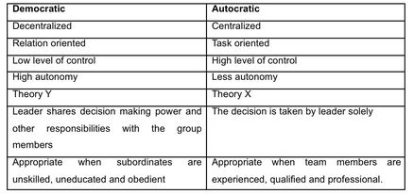
Table 2: Democratic versus autocratic
Laissez-Faire leadership
Laissez-faire leaders allow their subordinates to manage their own workspaces and make their own decisions. They give their team support, direction, advice, and training whenever they need it, but they leave the specifics of their tasks and projects up to them to carry out. In a workplace, the manager would listen to the employee and then invite them to an informal meeting so they could freely discuss the issue (Robert and Vandenberghe, 2021). The person in charge doesn't tell the group how to deal with the problem this way and lets them figure it out on their own. The advantages of this form of leadership style are higher retention of employees with high accountability of the subordinates with utmost creative working culture.
Strategic leadership
Using a variety of management methods, strategic administration allows companies to adapt to or remain competitive in a competitive economic and technological environment (Ozer and Tinaztepe, 2014). A key advantage of strategic leadership is the ability to create an innovative, dynamic and adaptable working environment if necessary to stay competitive in the market.
Task oriented leadership versus people-oriented leadership
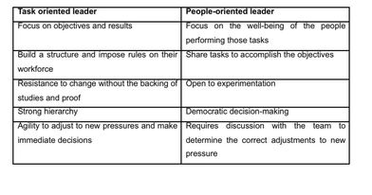
Table 3: Task oriented leader versus people-oriented leader
Transformational leadership
People are motivated to go above and beyond the call of duty in order to achieve a common goal by transformational leadership, whereas transactional leadership emphasizes extrinsic incentive for specific work duties (Leithwood and Jantzi, 2005). Leaders can achieve their full potential with the ability to strike a balance between these two characteristics. In context to transformational leadership the people can get a wider perspective and leader style of approach is democratic in nature.

Transactional leadership
According to Odumeru and Ogbonna (2013), transactional leadership is centred on organisation, supervision and group performance. This type of leadership is beneficial at times of crisis and emergency, as well as when projects must be finished precisely.
Transactional leaders use an exchange paradigm in which excellent effort or positive outcomes are rewarded. Individuals with this leadership style, on the other hand, may penalise poor performance by responding adversely until the issue is remedied. To transactional leaders, process is more essential than smart ideas. These leaders are concerned with the possibility of contingent reward or punishment.

Transactional leadership versus transformational leadership

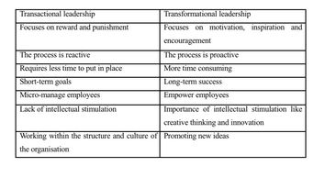
Table 4: Transactional leadership versus transformational leadership

Critical analysis of barriers to leadership in the workplace

Figure 2: Groups of barriers (CIPD, 2014).

Lack of clear vision
Leaders must be able to convincingly present their vision to others. As a result, the leader must explain the significance of success for the company, team, or department. If the person in charge doesn't have a clear vision, it won't be easy to do anything. In this context Schweiger et al. (2020) stated that ineffective or unrealistic vision is sometimes less feasible for the leader to deliver their utmost role. In the same aspect it can be stated that the lack of clear vision is one of the core barriers to leadership within a workplace.
Lack of belief
Having a clear goal and being able to communicate it to others is pointless unless the person in charge is completely convinced that the goal can be relinquished. It has been reported by Oberg and Andenoro (2019), formerly, when a leader could craft well-crafted remarks and believe that no one understood their concerns. The fuel that propels the business, particularly during difficult times, is the confidence of the person in charge.

Absence of goal
A specific destination is defined by goals or results. Leaders are in control when they concentrate on goals. When in charge, managers focus on results, and when managers focus on results, their businesses accomplish more. The attainment of higher and better outcomes is encouraged and reinforced by results. Lack of such attributes like goals can relatively lower the performance level and can lead the organization to a less productive aspect to be obtained in a significant manner (Schweiger et al, 2020).
Lack of functional credibility
When executives oversee an organizational unit, they need to be competent enough in that area to be believable, especially when they are working with someone new or in a new position (Basir et al. 2021). People feel a great deal of unease when a manager does not understand the fundamentals of the job. The lack of basic understanding also limits the effective leadership role and the trust on the leader gets lower with time leading to less productive approach of the leaders.
Lack of leadership process credibility
A higher leadership position does not necessitate or allow for departmental expertise. The management process, which includes the selection and organization of teams as well as the definition of objectives, priorities, choices, resources, transparency, and options, must be highly effective to meet this requirement (Lu, 2020). Managers need to be able to see the big picture. In this context the lack of process understanding can also be a serious issue for the leaders to meet the projected aspect of the business.
Inability to hold back the power dynamics of leadership.
Many leaders are observed to be uncomfortable with their position of power. Leaders of all qualities may be forced to resist fully accepting their responsibilities by this duty's responsibilities. Leaders who are dissatisfied with their elevated position as administrators must confront their discomfort and learn how to use authority ethically and effectively.
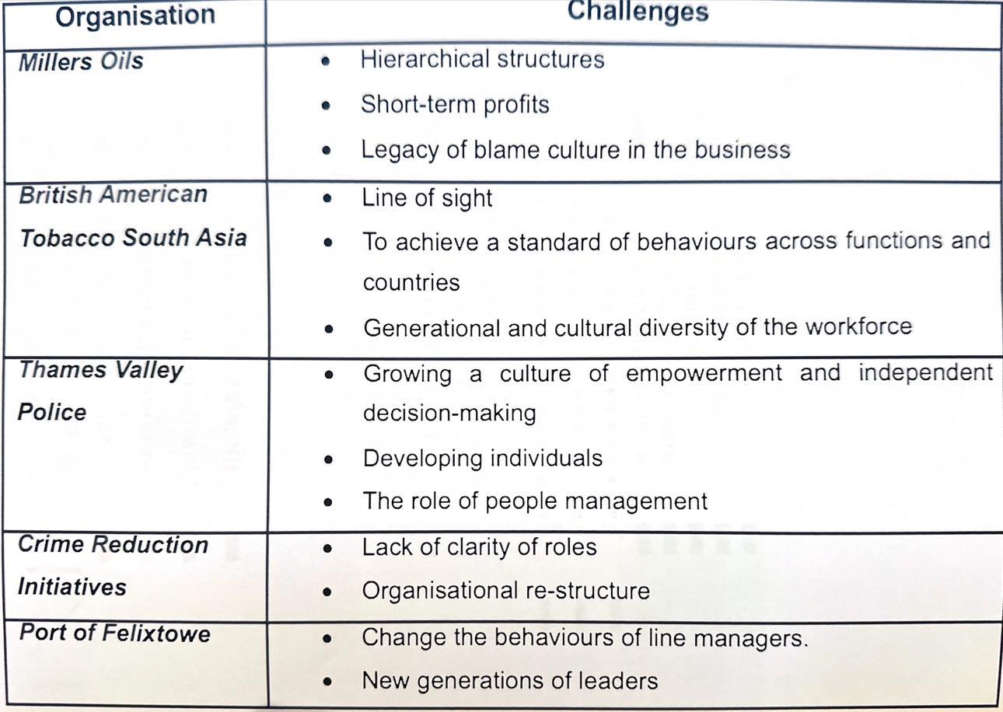
Table 5: Tackling the barriers to leadership (case study)

Ethical leadership
Leadership that exemplifies and promotes normatively appropriate behaviour through private conduct and interactions with others is referred to as ethical leadership. As per the views of Lin et al. (2020), morality is becoming an increasingly important part of business today and a topic of conversation. As a result, ethical leadership is essential in business and must be understood, developed, and recognized.
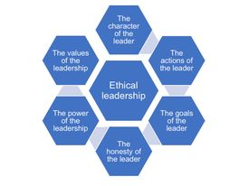

Figure 2: Ethical leadership
There are many reasons behind ethical leadership's importance, including the company, employees, and customers. Skills in leadership are necessary for fostering an ethical workplace culture. Investors may be helped to believe the organization is reputable and trustworthy by its leaders. Based on Zaim et al. (2021), customers are more likely to stay with a company if they see leadership in action. Positive press is more likely to come from an organization whose executives are ethical. On the other hand, according to new researches (Quade et al, 2019) ethical leadership can have and a negative impact such as an employee deviance and turnover because of stress.
People will believe, have confidence, and work successfully with the organization when they perceive ethical leadership from partners and suppliers. Ethical leaders may be able to boost employee morale and inspire enthusiasm for leadership and work soon. It may make everyone happy to be there and improve teamwork and happiness in the workplace. Conversely Drysdale and Gurr (2017) stated that ethical leadership may, over time, prevent corporate crises, ethical quandaries, and ethical challenges. Additionally, it may assist businesses in acquiring additional customers and collaborators, which may ultimately result in increased revenue. A company's long-term success is also heavily influenced by employee loyalty. A type of leadership known as ethical leadership is one in which individuals act in a manner that is acceptable and appropriate for the benefit of everyone in all aspects of their lives. It comprises the three primary ethical characteristics. Employees are held to a high standard of integrity and accountability by an ethical leader, who also inspires and motivates them.
By maintaining team spirit, businesses may be able to significantly increase staff productivity. Some of the core identified traits of ethical leaders are potentiality and willingness to evolve and providing respect to every person in equal context and making communication in open order along with management of stress in effective order (Chima and Gutman, 2020). These are the core attributes of traits associated with an ethical leader that has pertained to build a storing integrated perception for business to develop its feasibility. In a detailed context ethical leadership has been developed based on five core principles which are respect and service as well as honesty and justice along with community. These provide a strong figure to the system and provide a systematic orientation for the leaders to build its core feasibility agenda towards the business aspects (Blake & Mouton, 1985). In detailed context ethical leaders are vested with the perspectives of building their own integrated perspectives that meet the norms and regulations of the system. Thus, it can be stated that the ethical leaders are vested with the approach of building a wider and prejudiced format of system that has entitled a systematic and development agenda of business.

Conclusion
Leadership is counted to be one of the facts of organized dealing of teamwork within a specified orientation and periphery. It has been clearly identified that the leaders are the core developer of business which is developed through utmost teamwork. The rules and regulations associated with the role of leaders are vested with the perspective attainment policy as developed by the organization itself. Though there is no such effective leadership role, situations and perceptions determine the style and the traits of the leader. In that context, detailed study has revealed that communication and empathy and positivity as well as ethics are the core skills that make a leader to be well versed with the system itself. It has been notified by the whole segment that a leader is vested with the core fundamental aspects where the various perspective ranges are considered. Thus, it can be stated that the effective skills of the leaders are based on its role and personal menace as well as the style being followed. On the other hand, leadership orientation can be contrasted with the growth of a child based on mentorship. The real fact lies in the aspect that the level of mentorship is vested with the agenda or the ways through which the child is imbibing the good. In the same context leaders can be democratic and transformational as well as autocratic in nature and many more, but in effective leadership style is versed with the idea of various associated and contingency facts associated with the position and requirements.

Part 2: Reflective Essay

Introduction
Throughout the Emergent Leadership Skills course, I was exposed to a variety of ethical stances and leadership foci, as well as numerous leadership characteristics and approaches. This article is a reflection on my professional experiences in terms of my leadership styles, strengths, and weaknesses. In addition, I will emphasise leadership aspects that the curriculum may or may not have adequately addressed.

Learning regarding emergent leadership skills
Learning about Ethical Perspectives
When confronted with ethical dilemmas, the questionnaire responses I provided regarding my ethical perspectives helped illuminate the path I ultimately chose. Since I scored highest in Duty Ethics [Refer to Appendix 2], it is evident that I place a high value on honouring ethical obligations and abiding by rules. This is consistent with my belief that a leader must remain faithful to their ethical beliefs and fulfil their obligations despite facing challenges. It reflects my sense of responsibility for my team and the entire organisation.
On the other hand, my Utilitarian Ethics score was quite low [Refer to Appendix 2], indicating that I may not always prioritise the welfare of the greatest number of people. Instead, I am more likely to analyse individual situations and prioritise the well-being of specific individuals over the collective good. I believe it is necessary to strike a balance between these contradictory viewpoints in order to make morally sound decisions under pressure.
Personal Leadership Styles and Abilities
I am most effective at work when I combine transformational and democratic leadership approaches. By emphasising the value of collaboration and granting team members greater autonomy, I hope to foster an environment in which everyone's contributions are highly valued [Refer to Appendix 1]. This strategy not only encourages individuals to think outside the box, but also gives them a sense of ownership in the team's success (Baptista et al., 2020).
For instance, I recently observed that a few team members were not carrying out their responsibilities, and as a result, my concerns about them grew. Instead of imposing my own solutions, I convened a team meeting to engage in a free-wheeling discussion of the issues at hand. By working together, we were able to investigate potential responses and determine future actions in an open and collaborative environment. Using this strategy, the team was able to overcome its current obstacles and strengthen its interpersonal bonds.
Moreover, I have a strong preference for leadership that prioritises establishing and maintaining human relationships [Refer to Appendix 1]. I exert a great deal of effort to develop genuine relationships with my colleagues and to learn about their individual skills and career objectives (Barthakur et al., 2022). This has been demonstrated to generate a more positive and cohesive team environment, as well as increase output and morale.
Learning from the Emergent Leadership Skills Module
During the sessions on Emergent Leadership Skills Module, I learned about various leadership emphases, such as attribute emphasis, ability emphasis, skill emphasis, behaviour emphasis, connection emphasis, and process emphasis. I am fully aware that the skill focus model informs most of my leadership approach; therefore, I recognise the importance of investing in one's own personal and professional development. Enhancing one's inherent talents and abilities is, in my opinion, a significant factor in achieving leadership success and enhancing team performance.
Throughout the module, the need for adaptability as a leader was also emphasised. In today's fast-paced, constantly shifting workplace, aspiring leaders must be adaptable and open to new experiences. This is consistent with what I have learned as a leader: if one is willing to attempt new things and cultivate a resilient culture among their staff, they can endure difficult times. This is something I believe in and support.
This module also explored the relationship between emotional intelligence and effective leadership. Understanding and controlling my emotions, as well as the emotions of others, has been of great assistance in resolving conflicts, providing constructive feedback, and motivating my team to reach its maximum potential. Understanding the influence of emotions on decision-making and team dynamics enables me to lead with compassion and cultivate a productive environment.
Unexplored Aspects of Leadership
The interaction between moral values and new workplace technology is a leadership topic that requires additional study (Hanna et al., 2021). As the world's reliance on technology and artificial intelligence (AI) increases, global leaders will be forced to address urgent ethical issues.
The matter of how to protect the privacy of individuals is crucial. The vast amounts of data obtained and processed present a challenge for those in charge of regulating the ethical implications of data usage. To secure private information and protect the right to privacy, leaders must develop comprehensive data governance frameworks and adhere to ethical principles that promote openness, consent, and responsible data processing.
In addition, the integration of AI systems raises concerns regarding the potential for AI bias. AI algorithms are only as objective as the data they are trained on; therefore, decision-makers must be aware that AI systems may reinforce existing biases or introduce new ones (Yu et al., 2022). To combat prejudice, it is not enough to understand how AI functions; one must also engage in critical ethical reflection on the potential effects of biased algorithms on individuals and society.
For those in positions of authority, the increased use of automated technology poses moral challenges. Automation may improve productivity and efficiency, but it may also lead to employment losses and exacerbate economic inequality. Those in positions of authority must evaluate the potential human costs of automation and assist those who may be displaced as a result (Tran and Nghia, 2020). This category encompasses rehabilitation and education initiatives for workers. Ethical leadership entails establishing a balance between embracing technological advancements for the sake of development and protecting the well-being of employees who may be impacted by such innovations.

Conclusion
The Emergent Leadership Skills programme enhanced my understanding of leadership perspectives while emphasising the significance of adaptation and ethical decision-making in my professional life. By answering the questions, I gained a greater understanding of my intended ethical position and manner of leadership. My transformational and democratic leadership style, with an emphasis on relationship development, has helped me establish a positive and productive work environment.
To become a great leader, I will continue to prioritise honing my skills, emotional intelligence, and adaptability as I advance in my career. In addition, I am aware of the need to remain up to date on ethical issues associated with the expanding environment of AI application. My goal is to foster an environment where everyone is frank and helpful, and where everyone is encouraged to advance within the organisation. I intend to accomplish this by maintaining a keen awareness of ethical principles and continuously refining my leadership style.

References
Baptista, J., Stein, M.K., Klein, S., Watson-Manheim, M.B. and Lee, J., 2020. Digital work and organisational transformation: Emergent Digital/Human work configurations in modern organisations. The Journal of Strategic Information Systems, 29(2), p.101618.
Barthakur, A., Kovanovic, V., Joksimovic, S., Zhang, Z., Richey, M. and Pardo, A., 2022. Measuring leadership development in workplace learning using automated assessments: Learning analytics and measurement theory approach. British Journal of Educational Technology, 53(6), pp.1842-1863.
Basir, M., Ali, S. and Gulliver, S.R., 2021. Validating learner-based e-learning barriers: developing an instrument to aid e-learning implementation management and leadership. International Journal of Educational Management, 35(6), pp.1277-1296.
Blake, R. & Mouton, J. (1985). Managerial grid III: The key to leadership excellence. Houston: Gulf Publishing Co.
Briker, R., Walter, F. and Cole, M.S., 2021. Hurry up! The role of supervisors’ time urgency and self‐perceived status for autocratic leadership and subordinates’ well‐being. Personnel Psychology, 74(1), pp.55-76.
Chima, A. and Gutman, R. (2020). What it takes to lead through an era of exponential change. Harvard Business Review. Aavailable at: www.hbr.org
CIPD. (n.d.). CIPD | Tackling Barriers to Leadership Case Studies | Reports. [online] Available at: https://www.cipd.org/uk/knowledge/reports/leadership-barriers-report/ [Accessed 12 Jul. 2023].
Demir, A. and Budur, T., 2019. Roles of leadership styles in corporate social responsibility to non-governmental organizations (NGOs). International Journal of Social Sciences & Educational Studies, 5(4), pp.174-183.
Drysdale, L. and Gurr, D., 2017. Leadership in uncertain times. International Studies in Educational Administration, 45(2), pp.131-159
Gierlich-Joas, M., Hess, T. and Neuburger, R., 2020. More self-organization, more control—or even both? Inverse transparency as a digital leadership concept. Business Research, 13, pp.921-947.
Griffin, R. W. (2021). Management. Cengage Learning.
Hanna, A.A., Smith, T.A., Kirkman, B.L. and Griffin, R.W., 2021. The emergence of emergent leadership: A comprehensive framework and directions for future research. Journal of Management, 47(1), pp.76-104.
Leithwood, K. and Jantzi, D., 2005. Transformational leadership. The essentials of school leadership, pp.31-43.
Lin, W.L., Yip, N., Ho, J.A. and Sambasivan, M., 2020. The adoption of technological innovations in a B2B context and its impact on firm performance: An ethical leadership perspective. Industrial Marketing Management, 89, pp.61-71.
Lu, X., 2020. The barriers, facilitators, and solutions for women in educational leadership roles in a Chinese university. International Journal of Chinese Education, 9(1), pp.5-24.
Men, L.R., Yue, C.A. and Liu, Y., 2020. “Vision, passion, and care:” The impact of charismatic executive leadership communication on employee trust and support for organizational change. Public Relations Review, 46(3), p.101927.
Nanjundeswaraswamy, T.S. and Swamy, D.R., 2014. Leadership styles. Advances in management, 7(2), p.57-58.
Oberg, M.G. and Andenoro, A.C., 2019. OVERCOMING LEADERSHIP LEARNING BARRIERS: A naturalistic examination for advancing undergraduate leader development. Journal of Leadership Education, 18(3).
Odumeru, J. A., & Ogbonna, I. G. (2013). Transformational vs. transactional leadership theories: Evidence in literature. International review of management and business research, 2(2), 355.
Owen, J. (2021). The leadership skills handbook 100 essential skills you need to be a leader. New York Kogan Page Ltd.
Özer, F., & Tınaztepe, C. (2014). Effect of strategic leadership styles on firm performance: A study in a Turkish SME. Procedia-Social and Behavioral Sciences, 150, 778-784.
Robert, V. and Vandenberghe, C., 2021. Laissez-faire leadership and affective commitment: The roles of leader-member exchange and subordinate relational self-concept. Journal of Business and Psychology, 36, pp.533-551.
Quade, M.J., Perry, S.J. & Hunter, E.M. Boundary Conditions of Ethical Leadership: Exploring Supervisor-Induced and Job Hindrance Stress as Potential Inhibitors. J Bus Ethics 158, 1165–1184 (2019). https://doi.org/10.1007/s10551-017-3771-4
Saputra, F., 2021. Leadership, Communication, And Work Motivation In Determining The Success Of Professional Organizations. Journal of Law, Politic and Humanities, 1(2), pp.59-70.
Schweiger, S., Müller, B. and Güttel, W.H., 2020. Barriers to leadership development: Why is it so difficult to abandon the hero? Leadership, 16(4), pp.411-433.
Sethuraman, K. and Suresh, J., 2014. Effective leadership styles. International Business Research, 7(9), p.165.
Silva, A. (2016). What is leadership? Journal of business studies quarterly, 8(1), 1.
Tannenbaum, R. and Schmidt, W.H., 1973. How to choose a leadership pattern. Harvard business review.
Tran, L.T. and Nghia, T.L.H., 2020. Leadership in international education: Leaders’ professional development needs and tensions. Higher Education, 80, pp.479-495.
Toor, S. U. R., & Ofori, G. (2008). Leadership versus management: How they are different, and why. Leadership and Management in Engineering, 8(2), 61-71.
Yu, M., Wen, J., Smith, S.M. and Stokes, P., 2022. Building-up resilience and being effective leaders in the workplace: a systematic review and synthesis model. Leadership & Organization Development Journal, 43(7), pp.1098-1117.
Zaim, H., Demir, A. and Budur, T., 2021. Ethical leadership, effectiveness and team performance: An Islamic perspective. Middle East Journal of Management, 8(1), pp.42-66.

Appendix
- Conceptualizing leadership questionnaire
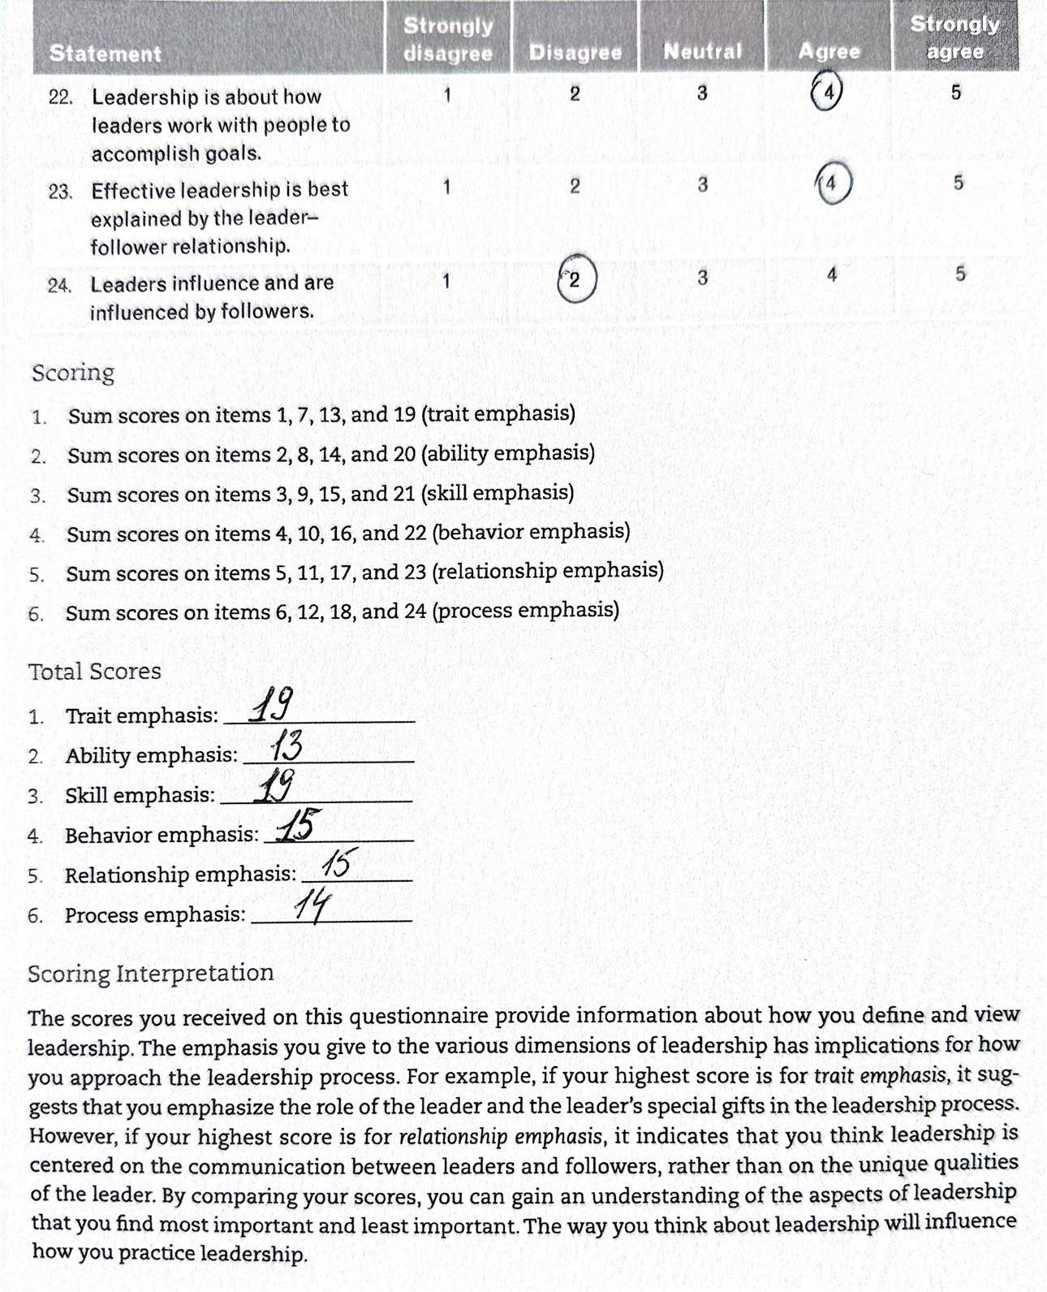

- Ethical leadership style questionnaire



