

Managing People Assignment 1 LCBB5004
Name of student: Elena Miloshevska 2024564
Name of lecturer: Nishi Ramsurrun

Date: 05.05.2022
Table of Contents
Introduction 3
Case 1: 4
Role of HR in promoting diversity and inclusion through flexible working 5
Case 2: 8
Role of HR in addressing the inequality concerns established by flexible working 8
Recommendations for improvement: 11
Conclusion 12
References 14

Introduction
This report aims to elaborate on flexible working related to diversity and inclusion in the workplace. The report analyses the benefits and drawbacks of flexible working in two cases, demonstrating the role of HR in encouraging diversity and inclusion through flexible working and how Marks and Spencer encourage flexible working in their retail business. The report follows the ACAS 2021 survey to understand the concept and need for flexible working in different situations like pandemics and its results on the UK retail organisation (mainly considering Marks and Spencer). Moreover, the report will demonstrate the relationship between inequality and flexible working work in case 2, which picks the example of Marks and spencer. In case 2, the report is based on the role of HR in addressing the issues related to flexible working and related inequality in work.

Case 1:
The word flexible working refers to the working patterns dissimilar from the working standards operated by the employers (Chung et al., 2020). Flexible working promotes organisational success by assisting individuals in managing the requirements of working with their personal lives. Flexible working involves remote working or work from home, weekly working and part-time jobs (Chung et al., 2020). According to the new survey revealed by the Acas that founds" almost half of the employers are expected to increase in demand for the flexible work as the country came out from Covid pandemic" (ACAS,2021). Marks and Spencer currently have 81 thousand employees in the United Kingdom (Marks and Spencer Gov.UK, 2022). The company promotes diversity and inclusion in work by providing an opportunity to the female staff to work part-time for the multinational retailer. According to Gov.UK (20220, the company created a positive culture by offering almost 73percent of females to work remotely as it promotes the women's share level up in the UK based on term-time contracts and the temporary basis employment. CIPD (2021) mentioned that "the increase in arrangements such as Flexi-time, compressed hours or job share empowers people to have control and flexibility in their work life. It will help the organisation foster diversity and inclusion workplace and improve productivity".
Hardcastle, 2020 mentioned in the "Forbes" that "Marks and spencer decided to accelerate their digital plans, through which in the last 8 weeks their online sales contributed 41 per cent of the clothing and home sales to the business" (Hardcastle, 2020). Moreover, it is also mentioned that, “the business is also looking to engage with more flexible working using a store technology package developed with Microsoft”. The retailer is also engaged with Microsoft to provide flexible working for the employees in a pandemic. Using "Microsoft Graph for shifts/ duty", the retailer created an integration that allows the employees to surface their duties and schedules directed to the teams.
The partnership with Microsoft enables the employees to check and swap their shifts with flexibility and customise self-service functions that work best for the workforce (Microsoft, 2021). However, it is a leading business quality that allows employees to work flexibly by swapping and disabling shifts (Microsoft, 2021). during covid 19, the retailer companies' employees continued to work remotely as per the guidance of the UK government; many offices during covid are privileged to work from home with flexible timings and balance their personal lives in a pandemic situation (Jahshan,2020). However, it may be because the government orders regarding work from home in health and safety during the critical situation goes in favour of the employees that make their living standards flexile as they can manage their homes and duty timings by fulfilling the criteria.

Role of HR in promoting diversity and inclusion through flexible working
It is vital to evaluate the contribution of the human resource activities of operations and their effectiveness in service delivery and support to the employees and the organisation's strategic plans (Armstrong and Taylor, 2017). The research conducted by the institute for employment studies Hirsh (2008) mentioned (Armstrong and Taylor, 2014) results that well supported in times of change, positive advice to employees, support and guidance in difficult situations are the factors correlated with the employee satisfaction with HR and the line managers within the organisation
Flexible working refers to the working style that derives from the standards or normal arrangement. It aims to give the operational flexibility, improvised use of employee's skills and capabilities in working, increase performance and reduce employment costs to boost the business, especially in the crucial and hard situations where the business needs to perform well with limited resources and the employees (Armstrong and Taylor, 2014). however, flexible working is the basic requirement nowadays for the business in terms of enhancing operational effectiveness.
Flexible working is a technique that reconsiders the typical method of employment (Armstrong and Taylor, 2014). HR should be responsible for extracting the employees' capabilities and skills by providing them leverage and flexibility in performing duties and improved productivity to give benefits to the business. As shown in figure 1, the determination of the human resource management and the organisational review are interlinked with each other while providing flexibility and the confidence to the employees to give their best for the business by providing the power of decision making, flexible working and sometimes leverage to stay connected with the business with loyalty as an employee. For instance, according to the Gov.UK (2022), "Marks & Spencer has consistently removed barriers to work for all employees by introducing flexible working early and often over and above legal requirements". However, a retail company in 2013 reported a sone of some businesses promoted the right to request flexible working to all employees, of which 73 per cent of them were females who worked part-time.
As a strategy in human resource management, diversity provides an opportunity for the business to start identifying the crucial trends that motivate the staff to reduce absenteeism and give more productivity (Stevenson, 2018). for instance, during the pandemic, Marks and spencer started providing their employees with the flexibility to work in shifts with the help of online scheduling through collaboration with Microsoft, encouraging the staff to get updated on the pandemic situation and stay connected with work. According to Microsoft,(2021), the flexibility benefit of online scheduling helps them coordinate with each other if swapping shifts and denying required work.
Marks and Spencer (2018) mentioned that the role of HR is essential in promoting flexibility in working. The M&S also mentioned that their job advert encourages people to ask about flexible working in a business; they make sure that everyone should be treated equally and valuable in the company culture. Marks and spencer also run internal campaigns to ensure that currently working employees have knowledge about flexible working culture. It promotes the male job shares, part-time work and parental leaves for employee equality.
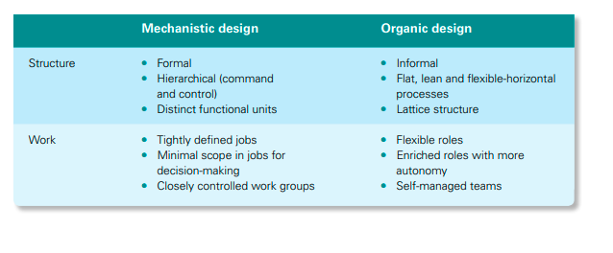
Figure 1 Organisational review
The HRM of the company conducts an inclusive pay review by gender across the retailer business yearly, and that data is reviewed by the human resources leadership team to further decide the pay role according to the role and contribution of employees to the business, whether it is remotely or permanent. Selection and benchmarking are done with transparency and monitoring of the effects of pay decisions on the company and the employees (Marks and Spencer, 2013). Marks and spencer provided flexible working culture by offering part-time vacancies to support career management and help, especially females, to continue their progress (Marks and Spencer, 2013).

Case 2:
"Marks & Spencer chairman Archie Norman has reportedly urged businesses to bring staff back to offices to help give retailers a boost as city centres suffer from footfall declines" (Jahshan,2020). The CIPD reported that analysis of official data ranks UK nations and regions using flexible working arrangements finds that "the use of different flexible working arrangements is unequal across the UK". According to CIPD (2021) However, the analysis results that,” regions where employees are satisfied with better flexibility in hours tend to have low flexibility in their organisations (mentioned as northeast are at the top for flexible hours but in location flexibility, they ranked in the bottom of the list)”. “Regions, where people have high flexibility in means of workplace location, have opposite problems as with less use of flexible hours and informal flexibility (Londoners have the best flexibility around where they work, but many don't have flexibility in their hours or informal flexibility with their employer)".
Besides, the previous study conducted by "CIPD (Use of flexible hours at work dropped during pandemic while home working has soared) found that the use of flexible working hours decreased over the last year and resulted in a significant increase in the work from home in the UK" (CIPD, 2021). The acceleration of the digital strategy and the online working of the business, however, enables the sales through online marketing, but through this," Marks and Spencer suggested cutting 7 thousand jobs through the voluntary departure and early retirement" (Hardcastle, 2020). By promoting online ordering and minimising the job opportunities.

Role of HR in addressing the inequality concerns established by flexible working
HRM policy defines “the organisation's expectations, norms, values, and attitudes concerning how people will be treated and the growth chances within the environment.HR manager is responsible for promoting and respecting the decisions made by the employees that should result in equal and unbiased treatment of all employees” (Armstrong and Taylor, 2017). Sherwood et al. (2022) mentioned that HR should be a keen observer ad a good communicator so that they may have knowledge about the performances and the treatment of employees in the context of the leverage and flexibility work.
HRM policies define “the organisation's attitude, expectations, and values concerning how individuals are treated and still serve as a point of reference for the development of organisational practices and decisions made by people, besides resulting in equal treatment among individuals” (Armstrong, 2009). However, “the workers of marks and spencer for sandwich suppliers are ordered that the retailer pay them less than £100 per week if they get isolated in precautions against coronavirus” (Nazir, 2020). Besides this, flexible working and paid work can also make a business invest a heavy amount for the employee's safety, and it is quite risky in pandemics and other critical situations where the business needs more productivity and money to secure the business stay competitive in the market. In contrast with the HR policies and the plans to overcome absenteeism in employment, according to the Working Time regulations act 1998 in the UK, the employees have the right to get paid leaves and specified rest breaks in the work settings (CIPD, 2022). However, it also may apply to the marks and spencer during a pandemic by providing the paid isolations days standards 7 days for the employed people.
According to the Nicks et al. (2019), the relationship between the roles of job and flexible working is unclear as the senior manager or the senior staff of the organisation have core operational duties on a daily basis in the organisation, and it is hard in a pandemic or while working remotely to resolve the issues of the employees in a one-to-one conversation or in physically. On the other side, the general staff of the organisation may have the same issues as they need to ask and implement the work within the supervisor of the higher authority or the reporting ones.
To foster diversity and inclusion in an organisation, HR plays a vital role to tackle the concerns regarding flexible working and the related inequalities in the workplace. The HR manager's core role is to be clear and specific while developing the strategic plan for flexible working (Davis, 2022). For instance, the HR should be accurate about the expectations and clear goals of the work, transparent communication and dialogue with employees to maintain the professionalism, using the optimisation of the individual productivity times and developing action of the plan and back up support to the employees to ask for guidance and help while working remotely or availing flexible working in offices.
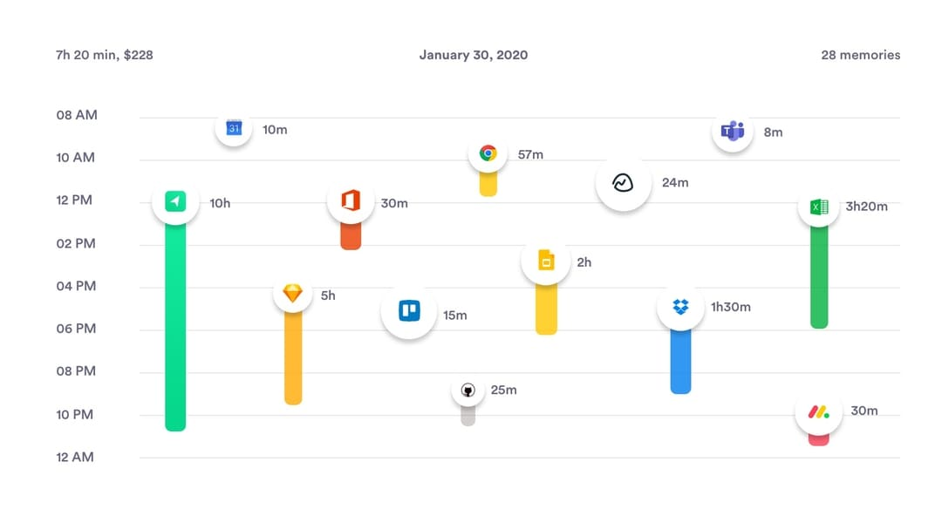
Figure 2 productivity metrics of remote working

Recommendations for improvement:
Flexible working is a need of any business as the company or any organisation should take care of their employee's needs and satisfaction throughout the entire operational system of the organisation; whether it is a multinational retailer or any other retail company, the employers should set criteria of the flexible working to ensure that these standards are neutral and equal for all the employees working within the organisation. The compressed working hours, shift jobs, and especially remotely working often involve a lack of communication between employers and the company. Employers may set the weekly remote work to improve the remote working culture. For instance, the employee can work remotely for 2 days of their choice in a week, so it may encourage their contribution to the workplace. Additionally, the working environment and corporate organisational culture are also important for the employees to stay socialised and connected with the team and the organisation, so it may help maintain a balanced work life. From both case studies, compressed hours and flexible working in shifts and part-time are better than remote working as it has a drawback of the lack of involvement in the organisational settings. For instance, a person prefers working remotely while after covid have more chances to undeveloped corporate and organisational skills and behaviours that are essentials of the professional career.
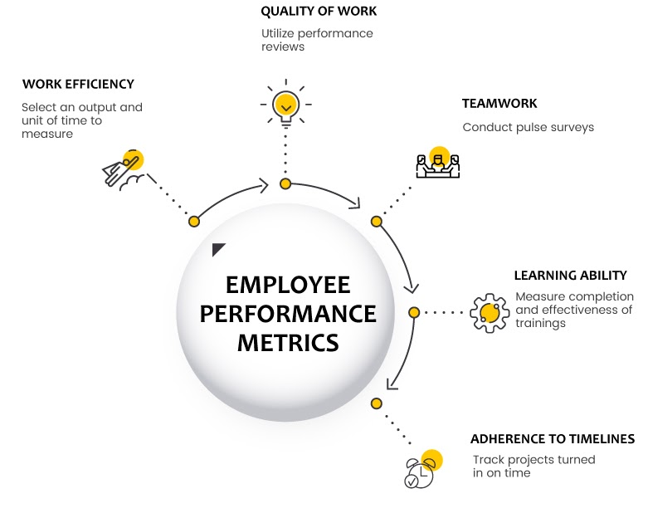
Figure 3 employee productivity metrics
Here the role of HR is to use a reflective approach to understand the reason for the prevalence of remote work and negligence of duty while working from home as a routine habit. The HR may use the productivity metrics strategy to analyse the productivity and the performance of the remote employees, especially those working because of the outbreak or major precautions concerning the health and safety of an individual. The HR may measure the productivity level and the estimated achievement of the goals and targets by the employees. Further, HR must be an effective communicator with a clear interpretation of goals and mission to the employees.

Conclusion
To conclude both cases, flexible working is often necessary to empower the employees and maintain a friendly environment in the organisation, but facilitating the employees with flexible working should be measured and recorded to better understand the productivity and the cost invested in the employee. Summing up case 2, flexible working has more drawbacks in terms of remote working because it needs a long time while working at home. For instance, working in an office environment have only one target and goal that employee has to focus on work and perform a duty, but the remote working may distract the attention of employee as they are carrying both work and personal life together in the same hours. It may impact the employees' productivity if they prefer to work remotely. While working in shifts, compressed hours or remotely, it is a core responsibility of HR to maintain effective communication with the employees to feel that they are supervised by the organisation and management bodies of the business.

References
Armstrong, M. and Taylor, S., 2014. Armstrong's Handbook of Human Resource Management Practice: Edition 13. Kogan Page.
ACAS, 2021. [online] Available at: <https://www.acas.org.uk/new-study-reveals-half-of-employers-expect-more-flexible-working-after-pandemic#:~:text=Acas%20commissioned%20YouGov%20to%20ask,remotely%20part%20of%20the%20week> [Accessed 7 April 2022].
CIPD, 2021. 'Employers must do more to address flexible working inequality' says CIPD, as new analysis highlights 'flexible working notspots' across the UK | CIPD. [online] CIPD. Available at: <https://www.cipd.co.uk/about/media/press/flexible-working-inequality#gref> [Accessed 11 April 2022].
CIPD, 2021. Use of flexible hours at work has dropped during the pandemic while homeworking has soared, CIPD analysis finds | CIPD. [online] CIPD. Available at: <https://www.cipd.co.uk/about/media/press/050521-flexible-hours-dropped-pandemic> [Accessed 11 April 2022].
Chung, H. and Van der Lippe, T., 2020. Flexible working, work–life balance, and gender equality: Introduction. Social Indicators Research, 151(2), pp.365-381.
CIPD, 2022. Working Time Guidance & Regulation | CIPD. [online] CIPD. Available at: <https://www.cipd.co.uk/knowledge/fundamentals/emp-law/working-time#:~:text=Working%20hours%20in%20the%20UK,leave%20and%20specified%20rest%20breaks.> [Accessed 10 April 2022].
Davis, 2022. Box. [online] Ucdavis.app.box.com. Available at: <https://ucdavis.app.box.com/s/0cg1qqtdjib18jd3ulgvm9ahzcsncekp> [Accessed 11 April 2022].
Gov.UK, 2022. Think, Act, Report: Marks & Spencer. [online] GOV.UK. Available at: <https://www.gov.uk/government/case-studies/marks-spencer-recruiting-women-from-different-backgrounds#:~:text=Marks%20%26%20Spencer%20has%20consistently%20removed,over%20and%20above%20legal%20requirements.> [Accessed 10 April 2022].
Gov.UK, 2022. [online] Assets.publishing.service.gov.uk. Available at: <https://assets.publishing.service.gov.uk/government/uploads/system/uploads/attachment_data/file/85563/marks-spencer.pdf> [Accessed 10 April 2022].
Hardcastle, K., 2020. Marks And Spencer Announces 7000 Job Cuts, Vows To 'Never Be The Same Again'. [online] Forbes. Available at: <https://www.forbes.com/sites/katehardcastle/2020/08/18/7000-job-cuts-announced-at-marks-and-spencervows-to-never-be-the-same-again/?sh=57b9c3f28015> [Accessed 9 April 2022].
Jahshan, E., 2020. M&S chair Archie Norman urges businesses to return to offices. [online] Retailgazette.co.uk. Available at: <https://www.retailgazette.co.uk/blog/2020/08/ms-chair-archie-norman-urges-businesses-to-return-to-offices/> [Accessed 10 April 2022].
M&S, 2018. [online] Corporate.marksandspencer.com. Available at: <https://corporate.marksandspencer.com/documents/reports-results-and-publications/gender-pay-gap-reporting/m-and-s-gender-pay-report> [Accessed 10 April 2022].
Marks and Spencer, 2020. [online] Corporate.marksandspencer.com. Available at: <https://corporate.marksandspencer.com/documents/plan-a/m-and-s-response-to-covid19-workers-in-supply-chains> [Accessed 9 April 2022].
Marks and Spencer, 2013. Think, Act, Report: Marks & Spencer. [online] GOV.UK. Available at: <https://www.gov.uk/government/case-studies/marks-spencer-recruiting-women-from-different-backgrounds#:~:text=Marks%20%26%20Spencer%20has%20created%20a,business%20and%20term%2Dtime%20contracts.> [Accessed 9 April 2022].
Microsoft, 2021. Marks & Spencer embraces the future of retail with Microsoft Teams for frontline workers. [online] Microsoft Customers Stories. Available at: <https://customers.microsoft.com/en-us/story/1391910703947116437-marks-and-spencer-retailers-flw-teams> [Accessed 9 April 2022].
Nicks et al., 2019. [online] Assets.publishing.service.gov.uk. Available at: <https://assets.publishing.service.gov.uk/government/uploads/system/uploads/attachment_data/file/790354/Flexible-working-qualitative-analysis2.pdf> [Accessed 11 April 2022].
Nazir, s., 2022. M&S sandwich makers threatened with pay dock if they self-isolated - Retail Gazette. [online] Retailgazette.co.uk. Available at: <https://www.retailgazette.co.uk/blog/2020/08/ms-sandwich-makers-threatened-with-pay-dock-if-they-self-isolated/> [Accessed 10 April 2022].
Stevenson, M., 2018. Diversity: HR's Role. [online] HR Exchange Network. Available at: <https://www.hrexchangenetwork.com/hr-talent-management/articles/diversity-hrs-role> [Accessed 10 April 2022].
Sherwood et al., 2022. Find the Right Words to Communicate Flexibility. [online] Accelerate.uofuhealth.utah.edu. Available at: <https://accelerate.uofuhealth.utah.edu/leadership/find-the-right-words-to-communicate-flexibility> [Accessed 11 April 2022].

