History and Theory 2
Is the term ‘organic architecture’ relevant to architecture today?
Organic Architecture and its definition.

Organic architecture and its definition are argued by many due to its complexity and nature as a subject. Organic Architecture can be perceived to be based on organic forms such as plants and nature. This could be anything from complex forms, buildings reacting to its natural surroundings and the materials used in the construction. Complex forms often found in nature have been found in architecture as far back as records began.

Organic Architecture and its roots.

(Skara Brae - The Discovery and Excavation of Orkney's finest Neolithic Settlement, 2020)

Skara brae is a Neolithic village on Orkney which is an archipelago off the north-eastern coast of Scotland. Found in 1850 after a great storm ripped part of the coast away uncovering the 5000-year-old site. The forms of the Neolithic settlements are very organic in shape showing circular simple structures, these structures are built like this because the people lacked the skills to build more complex structures. These forms were simply made for shelter against the harsh Scottish coast using natural materials like stone of the local area.

Ancient civilisations like the Egyptians and the Mayans were known for responding to their surrounding environment. They would, in some examples, orientate their structures to a north-south alignment studying the stars and using mathematics to respond to the gods they believed in connected to nature and the cosmos. A great example of this is Chichen Itza in Mexico built between 1050 and 1200 CE.
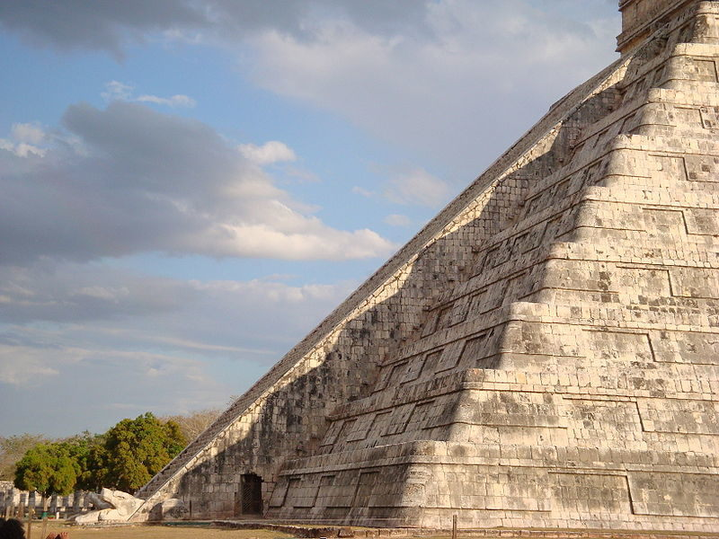
(Atlasobscura, n.d.)

This image shows that on the spring equinox the pyramids orientation casts a shadow on the steps to depict a feathered serpent which is the serpent god Kukulcan in Mayan mythology. This incredible use of alignment shows how the Mayan’s considered its surroundings to pay homage to their serpent god. It is also said that if a person were to clap at the base of the pyramid it “…results in an unusual chirping echo, which is said to replicate the call of the sacred quetzal bird.”(Atlasobscura, n.d.)

Greek architecture also reacted to its surrounding nature and gods. Architecture in this period responded to mathematics and ratios found in nature. One of these ratios was the golden section or the golden ratio. This ratio helped Greek architects calculate proportions and connected the circle, ellipsis, triangle and the rectangle. This golden ratio generated logarithmic spirals, basic curves and growth. The golden ratio is best approximated by the “Fibonacci Numbers” (Society, 2020) which is a never-ending sequence of numbers. The golden ratio and the Fibonacci numbers are usually associated with the number of petals that are on a flower correlating to the ratio.

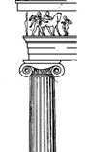
(Greek architectural orders (article) | Khan Academy, 2020)

Greek architecture involved different orders, one of them being the ionic column. Based on natural forms, the ionic column shows elements of the golden section being used to design the scroll like decoration to the top of the columns.

Through this the Etruscan people developed the geometric shapes of the golden ratio to create the arch and the vault. Later the Etruscan civilisation morphed into the Roman civilisation. The Romans, with what they had learnt from the Greeks and the Etruscans, developed these ideas and created the dome. Using these new techniques and ways of construction, the Romans used the structurally stronger arches and domes to create buildings like the Pantheon and the Coliseum.

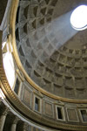
(Rome.info >Roman Pantheon, 2020)

As you can see the Pantheon allows sunlight into the space showing that this is an organic design incorporating the natural environment around the building using the sun to cast light through the space throughout the day. Not to mention the honeycomb like pattern on the inside of the dome, a direct link to nature.

Vitruvis was the Roman author of ‘De Architectura’ or the 10 books of Architecture. He saw architecture as an imitation of nature and compared humans needing shelter to birds and other animals nesting to hide from the elements. “He believed that the body's proportions could be used as a model of natural proportional perfection.” (Vitruvius's theories of beauty, 2020) and he used this theory to show how a human body can fit into a circle and a square, shapes that are present in the golden ratio and therefore the geometric shapes of buildings are in touch with nature.

Organic Architecture in the modern era.

The 10 books of architecture by Vitruvius and the very meaning of organic architecture has been interpreted by architects throughout the ages and a good example of this is the great American Architect Frank Lloyd Wright. He theorised of many things, “A building should appear to grow easily from its site and be shaped as if it was itself created by nature for and from that landscape.” (Organic Architecture and the Sustaining Ecosystem | Frank Lloyd Wright Foundation, 2020). This shows that Wright’s image of organic architecture does not necessarily stem from the golden ratio but the buildings relationship with its natural surroundings.
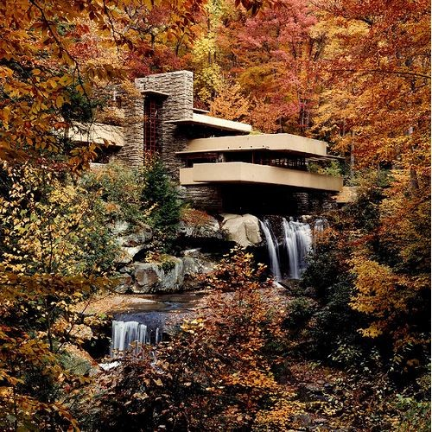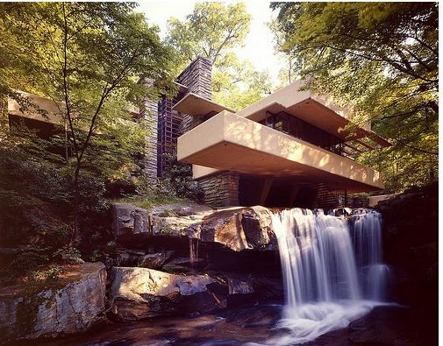
(AD Classics: Fallingwater House / Frank Lloyd Wright, 2020)

Falling Water built between 1936 and 1939, arguably his most famous work, shows this theory excellently as it grows out of the site almost blending in with its surroundings. Truly paying homage to the woodland area that Falling Water resides in.

Antoni Gaudi was a Catalonian Architect with the majority of his work being based in Barcelona. His architectural style is described as very organic working with craftspeople in
order to create organic and curved form taking inspiration from Neo-Gothic architecture.
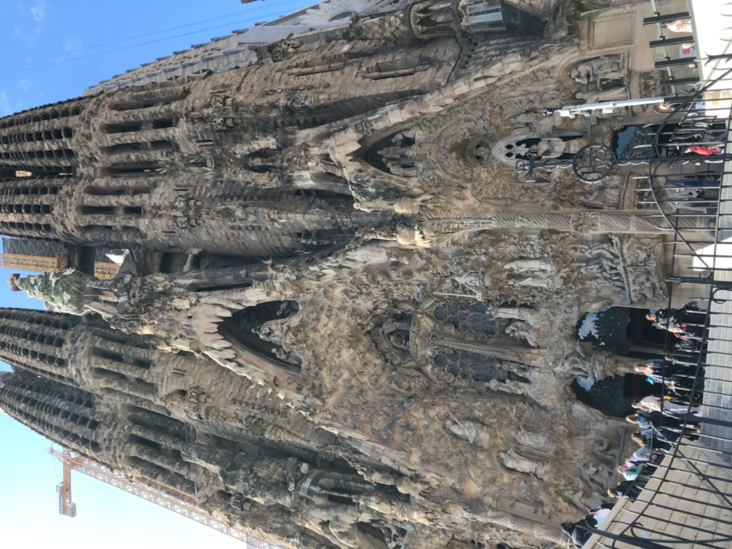
(Raynes, 2019)

Gaudi’s, arguably, most famous work is the La Sagrada Familia and started construction in 1882. The huge cathedral shows organic forms detailed and built in stone truly inspired by nature and religion. This building is still under construction today due to the local government wanting the building to continue to be built as Gaudi would have wanted. But from what has been built it is easy to see Gaudi’s inspiration has been taken from nature and thus making this cathedral a very organic building.

Gaudi’s Park Guell is also another great example of his organic forms. The park was designed by Gaudi and has a tropical essence to it with complex organic detailing combined with flora and fauna. The Park started construction in 1900 and completed in 1914, though not open to the public until 1926 when it was sold to the city council.
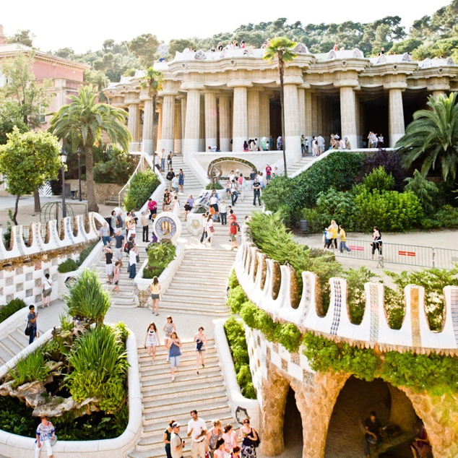
(ArchDaily, n.d.)
Gaui’s Park Guell shows his clear appreciation of nature and its many complex organic forms, combining his ideas of organic structures with the nature that surrounds the park he has achieved a close relationship with nature and structure.

Jorn Utzon was a Danish architect famous for designing the Sydney opera house which stared construction In 1959 and was completed in 1973. Louis Kahn remarked that “the sun did not know how beautiful its light was, until it was reflected off this building.”(Spotlight: Jørn Utzon, 2020). Louis Khan said this in reaction to how well the building reacted with the sun in the Sydney harbour.

(Sydneyexpert, 2020)

The Sydney Opera house is characterised as modern expressionist building taking inspiration from nature. The complex forms of the structure can be described as fins of a school of fish or a fins of a pod of dolphins coming out of the harbour showing a clear connection with nature and the sea.
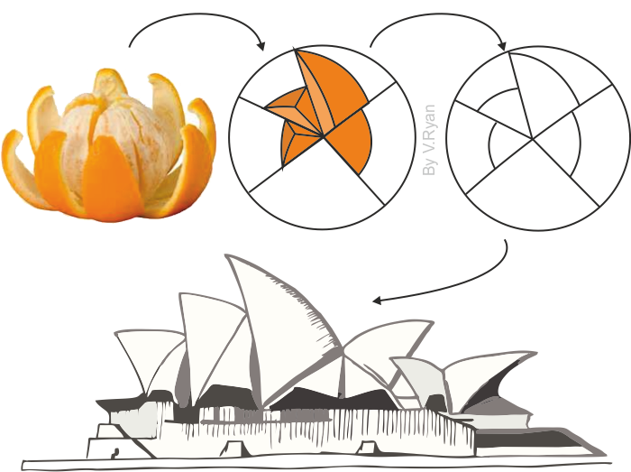
(SYDNEY OPERA HOUSE- INSPIRED BY NATURE, 2020)

This diagram shows the inspiration of Utzon’s design coming to him while eating an orange during his time entering the international competition to win the scheme. This was not his only inspiration behind the final design “Utzon was influenced in his designs by bird wings, the shape and form of clouds, shells, walnuts and palm trees.” (SYDNEY OPERA HOUSE- INSPIRED BY NATURE, 2020) taking his ideas from different components of nature to flesh out his design.

Alvar Alto was a Finnish architect who aimed to design his buildings to be sensitive to their surroundings very much like Frank Lloyd Wright. He theorised extensively over the function of a room and the connection architecture has with the natural environment.
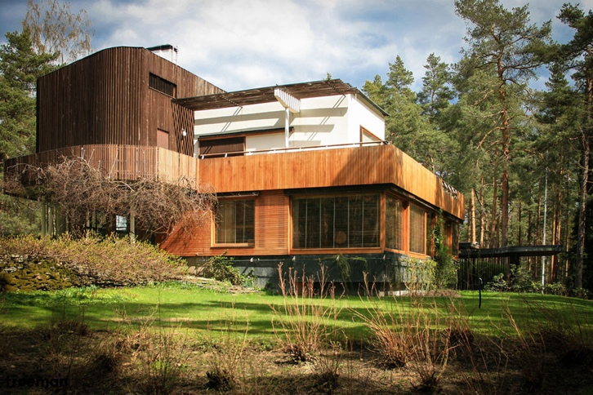
(Villa Mairea in Finland by Alvar Aalto | Archeyes, 2020)

The Villa Mairea was designed by Aalto for a couple called Harry and Maire Gullichsen and
was given the licence to design an experimental house. The Villa was built between 1938 and 1939. This building shows how much he believed in being sensitive to the natural environment surrounding the site by using wood cladding to fit within its woodland context.
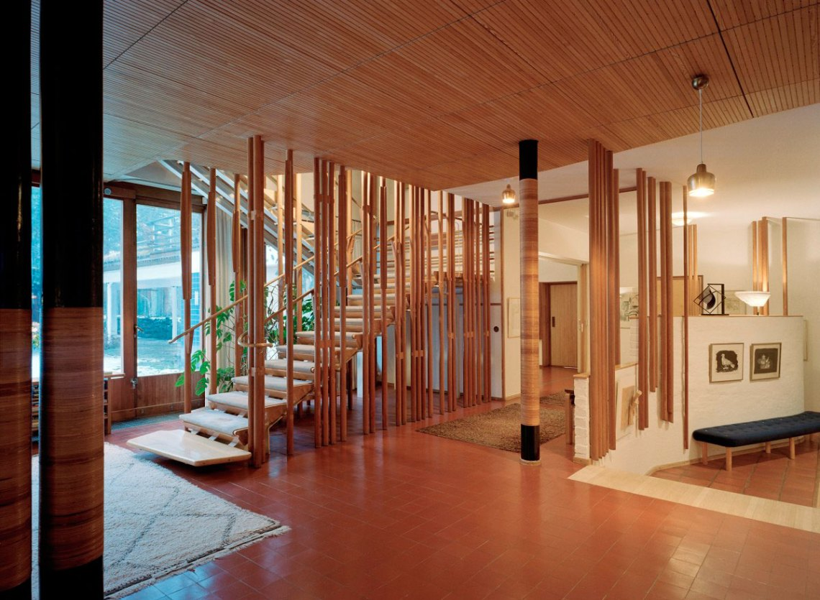
(Villa Mairea in Finland by Alvar Aalto | Archeyes, 2020)

Even inside the Villa he has gone great lengths to show appreciation to the natural environment with this detailed staircase which looks like the steps have been placed among thin trees. This villa truly shows a connection from the inside to the outside and the natural environment around it.

Biomimicry is simply architecture that mimics biology and forms found in nature. Biomimicry finds itself more of a subcategory of extreme Organic Architecture which can focus completely on natural form. The Kunsthaus Graz Art Museum is a cultural art centre in Austria and opened in 2003.

(Lisa and Lisa, 2020)

The building can be seen to mimic the heart with its many valve-like openings on the roof. These valves have been designed to let light into the spaces below at a reasonable brightness. The façade is made from photovoltaic panels which keeps the buildings environmental impact low. The location of this building can be questioned due to its surrounding context, this huge heart-like structure is on the riverbank and does not sit well within its context at all, but it could be argued that this is its purpose to stick out as a monument to nature and art.

Organic Architecture and its many Perceptions

It is important to understand that Organic Architecture can be perceived from many angles. For example, some believe that deep down all architecture is organic because the materials come from the earth which is natural in itself. Using science, we know that planets are remnants of stars that have gone supernova and therefore the materials available to us are and have been there since the beginning of the universe and are therefore natural. In some ways this would question the very term ‘in-organic’.
The very essence of materials like wood and stone being organic and concrete and steel being in-organic could be argued because they are found and morphed on this planet which is nature in itself.

Organic Architecture and its relevance today.

Today, organic forms are still being used across the globe thanks to advancement in technology and computer modelling. Programmes like Sketchup and AutoCAD allow architects to explore complex structures with ease, with precise mathematics the software provides. Architects in our era have a significant advantage over some of the world’s greatest architects with the tools that are available to them today.

The advancements of technology in construction has increased significantly in recent years leading to complex forms being built with ease and precision. With reinforced concrete, complex structures can be built easily being prefabricated off site or even poured and made on site.

In the modern-day high-profile architects have been designing and building organic structures and forms across the globe.

Frank Gehry’s style is not necessarily an organic style but more postmodernist, though the geometrical shapes he uses are quite organic in form. His Barcelona fish sculpture is a prime example of his postmodernist title yet shows the organic forms that he uses. A complex form that “...represented a technological breakthrough for the architect’s studio, which used three-dimensional aeronautical-design software to realize the concept.” (Sokol, 2020) this shows that the development of the fish was helped by design software even in 1992.

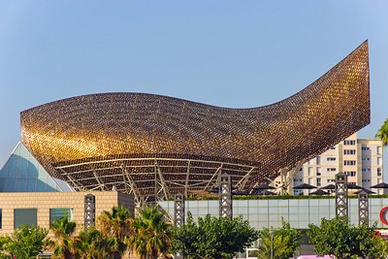
(Sokol, 2020)
Made from steel but made to look like bronze to allow sunlight to interact with the sculpture the Fish Pavilion making this complex organic form sensitive to its site and also the environment that surrounds it. Built for the 1992 Olympic games the Fish Pavilion remains an iconic structure even in the Gaudi rich Catalonian city of Barcelona.

Foster and Partners have created a glass roof for their project on the British museum. The organic geometric form is very impressive “The undulating, minimal steel latticework supports 3,312 unique triangular glass panels. Each one is different in size and shape because of the roof's complex geometric form” (www.fosterandpartners.com, 2020), the geometric roof shows an incredible use of computer aided design and certainly shows how a form of organic architecture can be designed and built in the modern day.

(Foster and Partners, n.d.)

Due to the British museum being a grade 1 listed building a huge sum of money was spent to build the new great court section. Allowing the Foster and partners to go to great lengths to build the geometric glass structure. But in recent years the demand for faster construction has increased leading to design and build procurement routes being favoured over traditional. You could argue design and build contracts suffer in terms of originality of design favouring cheaper options and off the shelf design due to the contractor’s licence to specify design materials.

Certainly, after the first and second world war, skilled tradesmen and their speciality craftsmanship were lost. This means that complex forms and ways of building are difficult to do resulting in clients having to find specialty tradesmen which are hard to come by and comes to a huge sum of money. In short, organic forms and sophisticated buildings are usually more expensive to design, manufacture and build.

Conclusion

Today, organic architecture is still relevant and is seen in work done by famous architects and architectural practices such as Frank Gehry and Foster and Partners. Yet organic forms are more of a rarity in the modern day due to the high cost of designing and constructing these complex forms.
Organic forms and complex structures are found more often in big scale projects like the British museum’s great court or The Fish Pavilion simply because of the skill, vision and the resources the architectural practices possess. Also, it is important to note that the clients of these high-profile projects have huge budgets and are willing to spend money on the designing and construction of these complex structures.

Yet, we must not forget the Architects who follow Frank Lloyd Wright and Alvar Aalto’s philosophies of creating buildings that occupy the site efficiently and sensitively to its surroundings. They may not always have sweeping curves and complex forms, but these architects designed in a way that responded to the nature around them. This philosophy is a form of organic architecture and must be commended, though not as easy to recognise due the buildings usually lacking in the traditional organic forms.

Allowing a structure to interact and coexist with its context is organic in of itself, whether its responding to daylight, topography or the materials used, the interaction of the site is what makes some buildings organic.
“For some, organic is curved, organic is asymmetrical, organic is natural materials, organic is individualistic, organic is holistic.”(Robinson and Scheurer, 1993)
You don’t necessarily need complex forms for a building to be organic and for this very reason modern architects should be striving for this philosophy in every design.

In short Organic Architecture is extremely important to the way we design our buildings and will continue to be important for the rest of time. Whether we take inspiration from natural forms to allowing our buildings to grow from the site, we must accept that all architecture is organic in its own way and certainly will remain relevant even when it seems to be scarce.

Reference List

Ancient-origins.net. 2020. Kukulcan, The Snake God Of The Maya, Remains As A Legacy Of The Once-Powerful Civilization. [online] Available at: <https://www.ancient-origins.net/myths-legends-americas/kukulcan-maya-0010355> [Accessed 3 March 2020].

ArchDaily. 2020. AD Classics: Fallingwater House / Frank Lloyd Wright. [online] Available at: <https://www.archdaily.com/60022/ad-classics-fallingwater-frank-lloyd-wright> [Accessed 20 February 2020].

ArchDaily. 2020. Spotlight: Jørn Utzon. [online] Available at: <https://www.archdaily.com/494535/happy-birthday-jorn-utzon> [Accessed 2 March 2020].

ArchDaily, n.d. Park Guell. [image] Available at: <https://www.archdaily.com/329433/ad-classics-parc-guell-antoni-gaudi/510c5369b3fc4b7d01000074-ad-classics-parc-guell-antoni-gaudi-photo> [Accessed 4 March 2020].

ArchEyes. 2020. Villa Mairea In Finland By Alvar Aalto | Archeyes. [online] Available at: <https://archeyes.com/villa-mairea-alvar-aalto/> [Accessed 20 February 2020].

Atlasobscura, n.d. Descendent Of The Snake God. [image] Available at: <https://www.atlasobscura.com/places/pyramid-kukulcan-chichen-itza> [Accessed 3 March 2020].

Bl.uk. 2020. Vitruvius's Theories Of Beauty. [online] Available at: <https://www.bl.uk/learning/cult/bodies/vitruvius/proportion.html> [Accessed 15 February 2020].

Barcelona.de. 2020. The Parc Güell In Barcelona, Designed By Gaudí. [online] Available at: <https://www.barcelona.de/en/barcelona-parc-guell.html> [Accessed 5 March 2020].

Foster and Partners, n.d. British Museum. [image] Available at: <https://www.fosterandpartners.com/projects/great-court-at-the-british-museum/#gallery> [Accessed 7 March 2020].

Frank Lloyd Wright Foundation. 2020. Organic Architecture And The Sustaining Ecosystem | Frank Lloyd Wright Foundation. [online] Available at: <https://franklloydwright.org/organic-architecture-and-the-sustaining-ecosystem/> [Accessed 23 January 2020].

Historicenvironment.scot. 2020. Skara Brae. [online] Available at: <https://www.historicenvironment.scot/visit-a-place/places/skara-brae/> [Accessed 3 March 2020].

Khan Academy. 2020. Greek Architectural Orders (Article) | Khan Academy. [online] Available at: <https://www.khanacademy.org/humanities/ancient-art-civilizations/greek-art/beginners-guide-greece/a/greek-architectural-orders> [Accessed 10 March 2020].

Lisa, A. and Lisa, A., 2020. Austria’S Blob-Shaped Kunsthaus Graz Art Museum Generates Its Own Solar Power. [online] Inhabitat.com. Available at: <https://inhabitat.com/austrias-blob-shaped-kunsthaus-graz-art-museum-generates-its-own-solar-power/> [Accessed 12 March 2020].

Mystery, S., 2020. Mysterious Alignment Of Ancient Sites Of The World – Strange Unexplained Mysteries. [online] Coolinterestingstuff.com. Available at: <https://coolinterestingstuff.com/mysterious-alignment-of-ancient-sites-of-the-world> [Accessed 10 March 2020].

Parkguell.barcelona. 2020. Over A Hundred Years Of History | Web Oficial Park Güell | Barcelona. [online] Available at: <https://parkguell.barcelona/en/park-guell/over-hundred-years-history?q=en/park-guell/over-hundred-years-history> [Accessed 5 March 2020].

Raynes, N., 2019. La Sagrada Familia. [image].

Robinson, S. and Scheurer, E., 1993. The Continuous Present Of Organic Architecture. Cincinnati, Ohio: Contemporary Arts Center, pp.7,8.

Rome.info. 2020. Rome.Info >Roman Pantheon. [online] Available at: <https://www.rome.info/pantheon/> [Accessed 1 March 2020].

Orkneyjar.com. 2020. Skara Brae - The Discovery And Excavation Of Orkney's Finest Neolithic Settlement. [online] Available at: <http://www.orkneyjar.com/history/skarabrae/> [Accessed 1 March 2020].

Society, N., 2020. The Golden Ratio. [online] National Geographic Society. Available at: <https://www.nationalgeographic.org/media/golden-ratio/> [Accessed 29 December 2019].

Sokol, D., 2020. 31 Spectacular Buildings Designed By Frank Gehry. [online] Architectural Digest. Available at: <https://www.architecturaldigest.com/gallery/best-of-frank-gehry-slideshow> [Accessed 1 March 2020].

Sydneyexpert, 2020. Sydney Opera House. [image] Available at: <https://sydneyexpert.com/photograph-the-sydney-opera-house/> [Accessed 4 March 2020].

Technologystudent.com. 2020. SYDNEY OPERA HOUSE- INSPIRED BY NATURE. [online] Available at: <http://www.technologystudent.com/prddes_2/nature1.html> [Accessed 3 March 2020].

www.fosterandpartners.com, F., 2020. Queen Elizabeth Ll Great Court, British Museum Opens | Foster + Partners. [online] Fosterandpartners.com. Available at: <https://www.fosterandpartners.com/news/archive/2000/12/queen-elizabeth-ll-great-court-british-museum-opens/> [Accessed 3 March 2020].

Word Count
2,621

