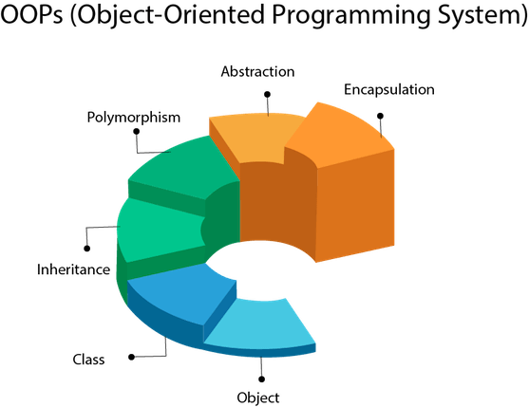

Image [1]

Assignment 1
Name: Zaeem
Student No.: 1902036
Course: Applied Computing (Web Development)
Module: Object Oriented Programming and Algorithms
Date: 31/03/2021

Table Of Contents
Content Page Number
1. Introduction 4
1.1. C# 4
1.2. Visual Studio Code 5
2. What is Object Oriented Programming? 6
2.1. Principles of OOP 6
3. Snakes & Ladders 7
3.1. Class Files 8
3.2. What Is A Class? 8
3.3. Program.cs 9
3.4. Game.cs 10
3.5. Board.cs 11
3.6. Player.cs 12
3.7. Dice.cs 13
3.8. Snake.cs 14
3.9. Ladder.cs 15
3.10. Implementation Of Game 16
4. RPG Game 18
4.1. What is Polymorphism? 18
4.2. What is an Interface? 19
4.3. Class Files 19
4.4. Program.cs 20
4.5. Game.cs 21
4.6. Hero.cs, Villian.cs 22
4.7. Fighter.cs 23
4.8. Arena.cs 24
4.9. IGuard.cs, IPower.cs 25
4.10. NoPower.cs, FireBallPower.cs, MetalHands.cs, GoldenStar.cs 26
4.11. Implementation Of Game 27
5. References 29

1.Introduction
In this documentation, the user will need to create two 2D Games as the first game will be a 4 Player Snakes and Ladders board game for the user to demonstrate the usage of classes and object within the Snakes and Ladders program. The other game will be RPG game as the user would be able to demonstrate the usage of Polymorphism and Interfaces. The language that would be used to create these 2 games will be C# and the program that will be used as well is called Microsoft Visual Studio Code.

1.1. C#
C# would be a Microsoft object-oriented programming language which seeks to blend C++'s computational ability with Visual Basic's programming usability. C# would be based on C++ and has features that are close to Java. [1]
C# is a programming language that works with Microsoft's.Net platform. Microsoft's goal is to make it easier for users to share information and resources over the Internet, as well as to make it easier for users to create highly portable programs. Extensible Markup Language (XML) and Simple Object Access Protocol (SOAP) within C# make programming easier by allowing access to a programming object or method without needing the user to produce additional code to every stage. C# is supposed to make it easier and less costly to bring new ideas to market as users can develop on existing code instead of repeating it. [1]
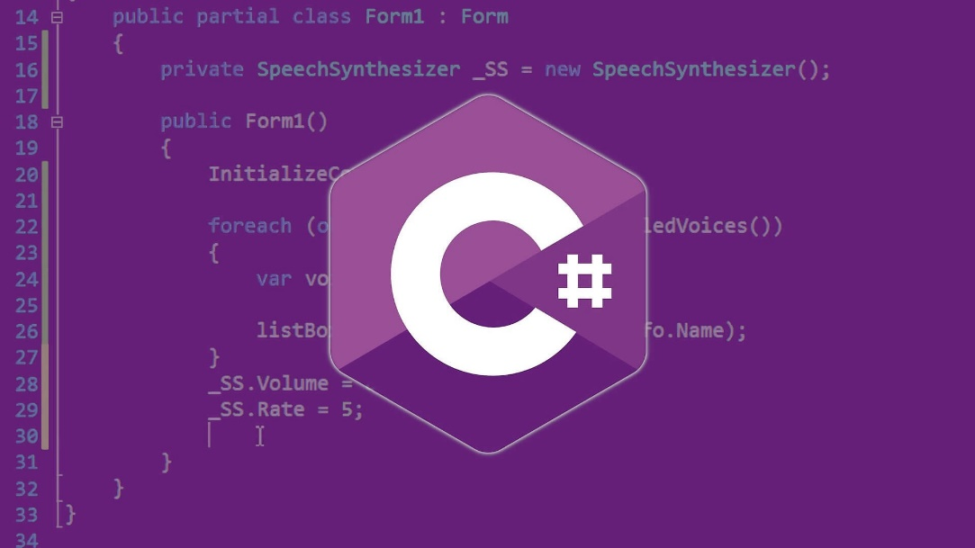

Image [3]

1.2. Visual Studio Code
Microsoft's Visual Studio Code would be a free and open source text editor. For Windows, Linux, and macOS, VS Code is usable. VS Code contains many advanced tools which have produced and one of the most common development framework resources in recent years, despite its lightweight materials. VS Code is associated with a wide variety of programming languages, including Java, C++, Python, CSS, Go, and Dockerfile. Additionally, VS Code enables users to build on and even create new features, such as code linters, debuggers, and support for cloud and web creation. [2]
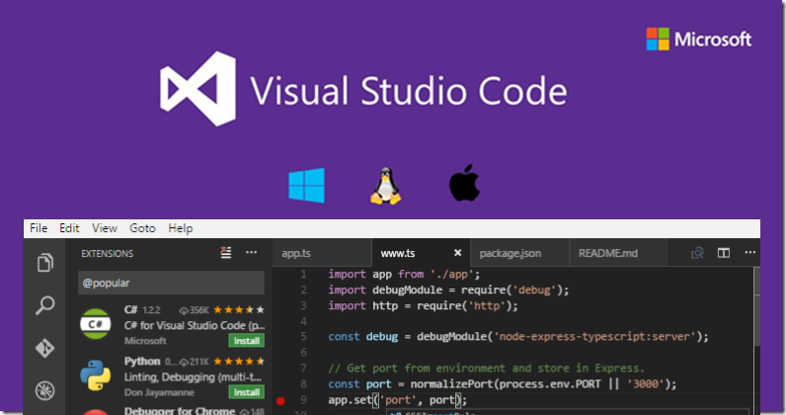

Image [5]

2. What is Object Oriented Programming?
Object Oriented Programming (OOP) would be a programming technique which arranges software development across data, instead of functions and logic. An object is a data field with its own set of attributes and actions. Object Oriented Programming (OOP) reflects on the objects which users would like to modify instead of the logic that is needed to manage them. This method of programming is well adapted to massive, complex, and frequently modified or maintained applications. [3]
The first stage in OOP will be to gather all of the objects a user needs to control and figure out how they interact, this would be referred to as data modelling. Physical objects, including a person can be identified with properties like name and address, and small software programs, such as widgets, are all examples of objects. If an object has been identified, it is assigned to a class of objects that determines the type of data it includes as well as any logic sequences which could be used to modify it. A method is the name given to each separate logic sequence. Messages are well-defined interfaces through which objects can interact. [3]

2.1. Principles of OOP
- Encapsulation - Each object's implementation and status are kept private within a given boundary, or class. Other objects have really no access towards this class and no power to force modifications, but they can call a list of public functions or methods. This information feature increases application protection and prevents unintentional data corruption. [3]

- Abstraction - Internal structures which are important for the use of other objects are only exposed by objects, and any unwanted software code is secret. This idea allows users to develop updates and improvements more effectively over time. [3]

- Inheritance - Users can allocate relationships and subclasses within objects, enabling them to reuse basic logic while retaining a distinct structure. This function of OOP requires a more detailed data analysis, shortens development time, and ensures greater accuracy. [3]

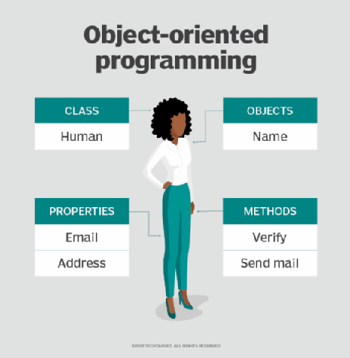
- Polymorphism - Based on the circumstance, objects could take on several forms. The software can find out the meaning or use is needed for each object execution, reducing any need for duplicate code. [3]

Image [3]
3. Snakes & Ladders
The first game that will be created in Visual Studio Code will be called Snakes & Ladders. Snakes and Ladders will be a 2 – 4 players board game which the player will have to roll the dice and use their specific counter shape or colour from the number 1 position to the number 100 position in the quickest amount of time to win the game. However, there will certain obstacles during the board game. The first obstacle will be called Snakes as if the player lands on the snake’s head, the player would progress backwards as they will move towards the snake’s tail. The other obstacle will be called Ladders as if the player lands on the bottom of the ladder, the player would progress forward as they will move towards the top of the ladder. Below will be an image to represent the board game, Snakes & Ladders.
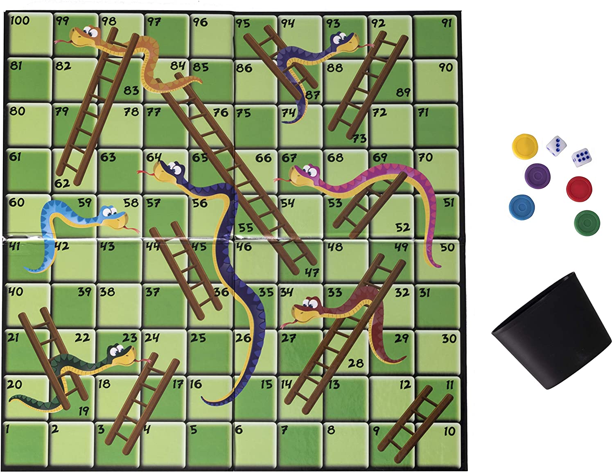

Image [7]
3.1. Class Files
Within the Snakes and Ladders project, a .Net Console Application project was created and there are multiple class files and they are called:
- Program.cs
- Game.cs
- Board.cs
- Player.cs
- Dice.cs
- Snake.cs
- Ladder.cs
The class files for this project are very important as they will be needed to compile / build the specific project. Without the class files, the project will not be suitable enough to be built as the class files are like the main element towards the project.
3.2. What Is A Class?
A class would be a template for building objects (a specific data structure), specifying initial values for configuration (member variables or attributes), and implementing functionality in object-oriented programming (member functions or methods). The class keyword would be used to produce user-defined objects. The class is a model for a potential object which determines its existence. A specific object generated from a specific class is referred to as an instance. Classes are used to build and handle new objects, as well as to enable inheritance, which is a core component of object-oriented programming and a method to reuse the code. Below will be an example of class method and what it can do in OOP. [4]
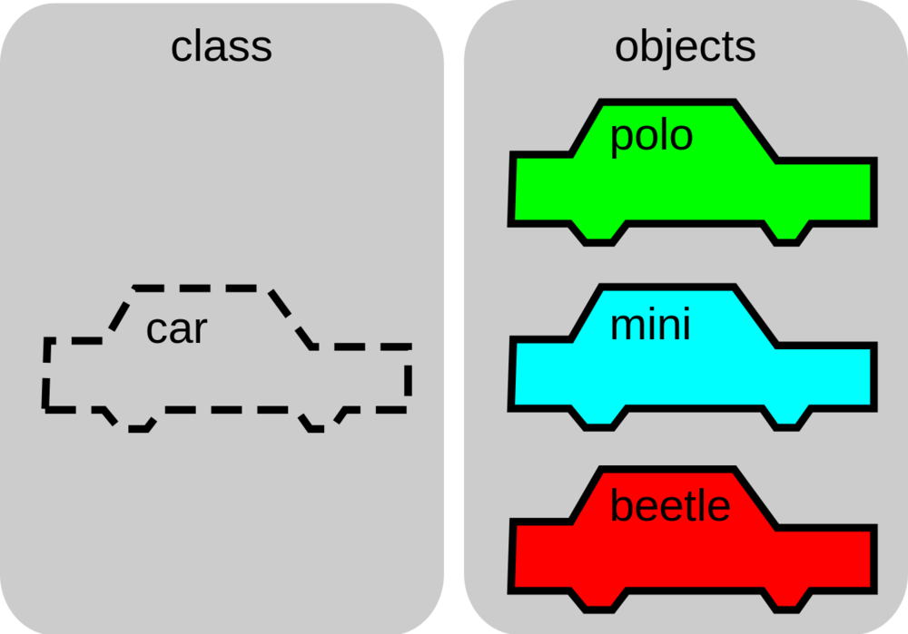
Image [4]
3.3. Program.cs
The first class file for this project will be called Program.cs. This class file will contain the C# code to start up and run the project as this specific class file is very essential to the project.
The image below will show the code for the Program.cs class file. On line 1 and 4, its shows that the project will be using the current computer system to run the program and the name / namespace of the project will be called Demo. If the namespace is different towards the name of the specific project, the project will not be able to run / operate as an error window will show up. This specific type of code / function will be used for all .cs class files but with different class names referring to their .cs file name and also, there will be no need to repeat this explanation throughout this documentation.
On line 6, it shows a class function for the Program class file as this will create the object for the Program file to reused again within the project (it can be used or connected on other .cs files) as the user will not have to retype the specific code again.
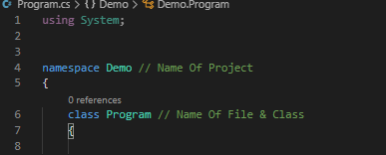

On line 9, it shows that a main method can be called without an object being used and the main method will not return anything since it has a void function.
On line 11 - 17, it shows that a Game is being called and its referring to the Game.cs class file. It will also show that it will load up and display any code and functions that have been typed on the Game.cs class file such as the introduction screen, the players configurations screen and the main game itself.
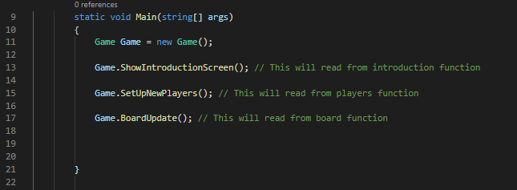

3.4. Game.cs
The second class file for this project will be called Game.cs. This class file will contain the C# code to start up and run the main game application as this specific class file is very essential to the project.
The image below will show some code for the Game.cs class file. The code shows a variable is being created and it shows that it is bool input. This will create the variable for the game to start and because it shows “= true”, it will not stop the user to run the game. It will also show how the board for the game will be created and displayed as the configuration for this will be 10 x 10 square / grid. The character for the board display will be the “_ “ symbol as this symbol will be the closest to square blocks that is shown on the original board game, it will show a variable for the players element to be created as a array of 4 players has been placed for this variable and it is linking to the Player.cs class file.
Most of the code will be a public void which can be seen and used throughout the whole project and it contains sound effects, specific text lines, an array of 4 players, the value of “i”, if statement, the x and y winning position, the position of the player, the name of player, adding 4 points to the winning player, bool validation, running the leaderboard loop and program interaction.
Please view the file “Game.cs” to look at the full code.
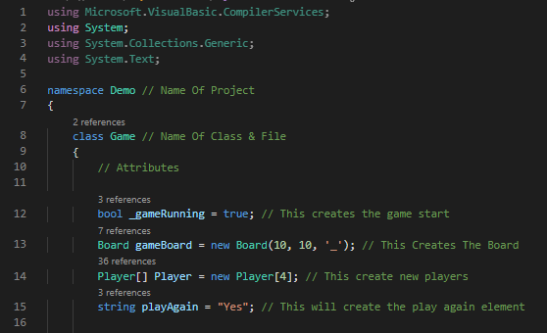

3.5. Board.cs
The third class file for this project will be called Board.cs. This class file will contain the C# code to configurate the board and its settings.
The image below will show some code for the Board.cs class file. The code shows a variable is being created and it shows that it is integer input which will config the width and the height of the board. It will also show a char variable which will show the empty cell on the board game. Most of the code will be under a public void which can be seen and used throughout the whole project.
Please view the file “Board.cs” to look at the full code.
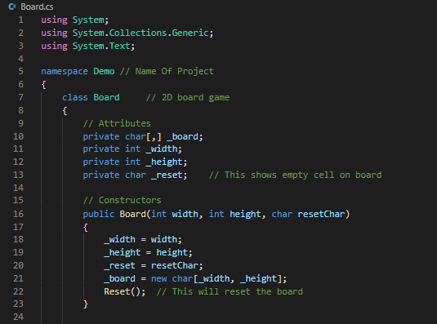

3.6. Player.cs
The fourth class file for this project will be called Player.cs. This class file will contain the C# code to configurate the player and its settings.
The image below will show some code for the Player.cs class file. The code shows a variable is being created and it shows that it is integer input which will config the player score and the player position. It will also show a char variable which will show the player counter colour and a string variable which will determine the player name. Most of the code will be under a public void, int and char which can be seen and used throughout the whole project.
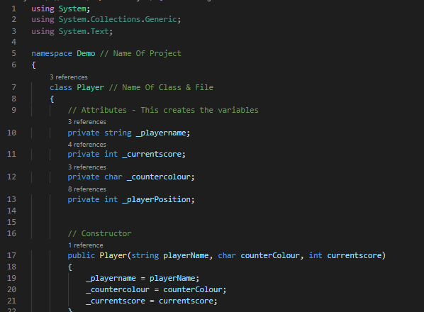
Please view the file “Player.cs” to look at the full code.

3.7. Dice.cs
The fifth class file for this project will be called Dice.cs. This class file will contain the C# code to configurate the dice (random number generator) and its settings.
The image below will show some code for the Dice.cs class file. The code shows a function is being created and it shows that it is private static which will be the random number generator as the numbers will randomise from 1 - 6. Most of the code will be under a public int which can be seen and used throughout the whole project.
Please view the file “Dice.cs” to look at the full code.
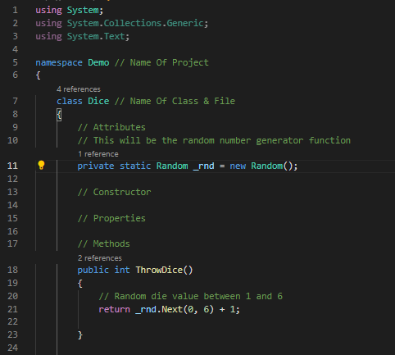

3.8. Snake.cs
The sixth class file for this project will be called Snake.cs. This class file will contain the C# code to configurate the snake element and its settings.
The image below will show some code for the Snake.cs class file. The code shows a variable is being created and it shows that it is integer input which will config the snake start and end. Most of the code will be under a public int which can be seen and used throughout the whole project.
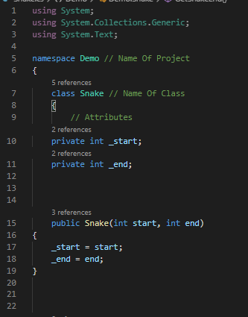
Please view the file “Snake.cs” to look at the full code.

3.9. Ladder.cs
The last class file for this project will be called Ladder.cs. This class file will contain the C# code to configurate the ladder element and its settings.
The image below will show some code for the Ladder.cs class file. The code shows a variable is being created and it shows that it is integer input which will config the ladder start and end. Most of the code will be under a public int which can be seen and used throughout the whole project.
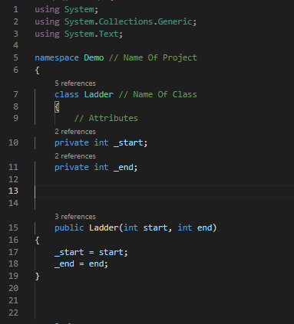
Please view the file “Ladder.cs” to look at the full code.

3.10. Implementation Of Game
After the code has been completed, the user will need to run the program to see if the code has worked successfully. Below will be images from the Snakes & Ladders project.
The first image will be the introduction screen. This will show the user the name of the project, the creator and its description. It will then lead to the player configuration screen.
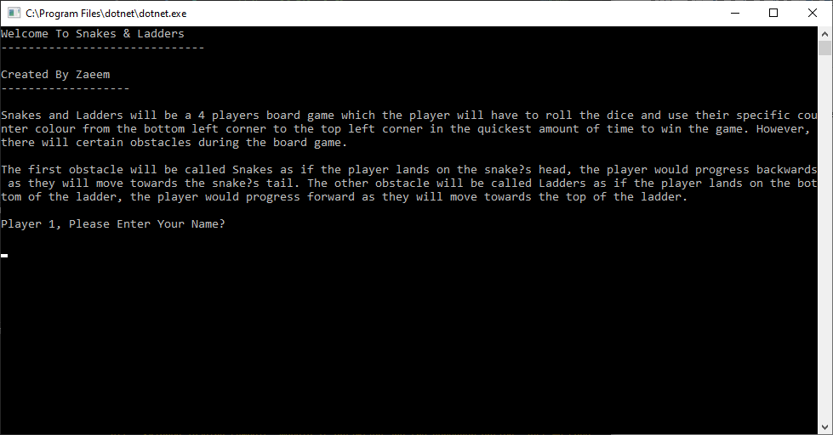

The second image will be the player configuration screen. This will show the user that each player will need to their name and their counter colour for the game. This will need to be done 4 times.
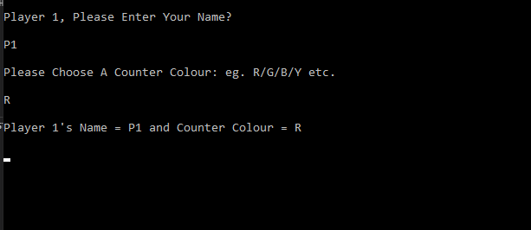

The third screen will be the main game. Once the user has set up all of the players, they will be able to play the game as the game will show which player turn is it, the dice being thrown and the number it shows, the player X and Y position and the game board with all of the players counters showing. This would use the other class files to allow the game to run successfully.
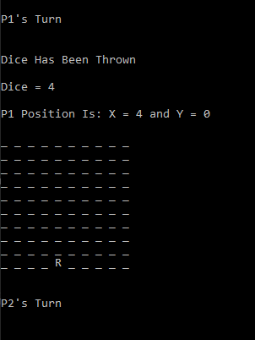

The last screen will be the leaderboard screen. This will show which player has won the game, all of the players scores and the opportunity to play the game again.
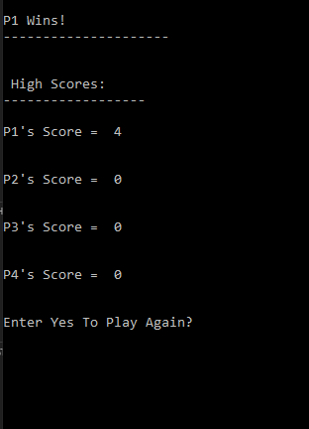

4. RPG Game

The second game that will be created in Visual Studio Code will be called Mario VS Bowser – RPG Version. This RPG game will let the user play through a story when Mario was fighting the evil Bowser inside a fighting arena. This RPG game will use a variation of Polymorphism and Interfaces as this was mostly used to create the game and the other elements.


Image [10]
Image [9]

4.1. What is Polymorphism?
Polymorphism in object-oriented programming refers to the allocation of a different definition to specific functions (of the same name) in various environments. Polymorphism would be the same element which reacts differently at different times. Think the user as a single entity with a speaking ability. The same activity can be carried out differently by the user's relatives or friends. To put it another way, polymorphism refers to the potential to operate several tasks. It helps users to have several roles in a project with the same name. Polymorphism is a key feature of the C++ programming language. [5]
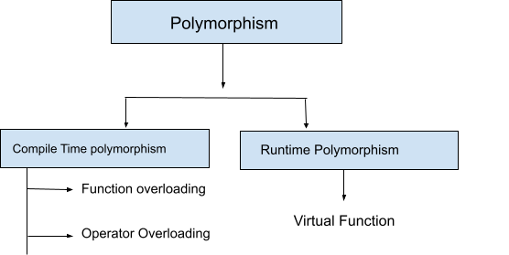

Image [5]
4.2. What is an Interface?
An interface defines a C++ class's actions or functionality without sticking to a specific implementation of that class. Abstract classes would be used to build C++ interfaces. These abstract classes really shouldn't be mistaken with data abstraction, which is a term that separates design specifics from related data. [6]

4.3. Class Files
Within the RPG Game project, a .Net Console Application project was created and there are multiple class files and they are called:
- Program.cs
- Game.cs
- Hero.cs
- Villian.cs
- Arena.cs
- Fighter.cs
- IGuard.cs
- IPower.cs
- NoPower.cs
- FireBallPower.cs
- MetalHands.cs
- GoldenStar.cs
The class files for this project are very important as they will be needed to compile / build the specific project. Without the class files, the project will not be suitable enough to be built as the class files are like the main element towards the project.

4.4. Program.cs
The first class file for this project will be called Program.cs. This class file will contain the C# code to start up and run the project as this specific class file is very essential to the project.
The image below will show the code for the Program.cs class file. The code shows that the project will be using the current computer system to run the program and the name / namespace of the project will be called Demo. If the namespace is different towards the name of the specific project. It will also show which functions to load that is created in another class file as well.
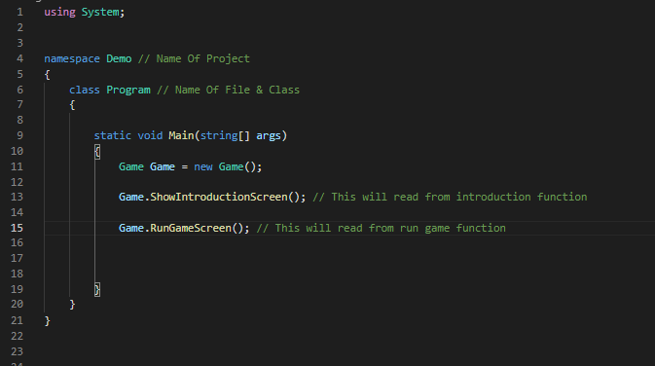

4.5. Game.cs
The second class file for this project will be called Game.cs. This class file will contain the C# code to start up and run the main game application as this specific class file is very essential to the project.
The image below will show some code for the Game.cs class file. The code shows a some variables being used which will create the characters and the location for the game from start to end as this is linking to the other .cs class file.
Most of the code will be a public void which can be seen and used throughout the whole project and it contains sound effects, specific text lines, the name of the character, running the polymorphism and interfaces elements and program interaction.
Please view the file “Game.cs” to look at the full code.
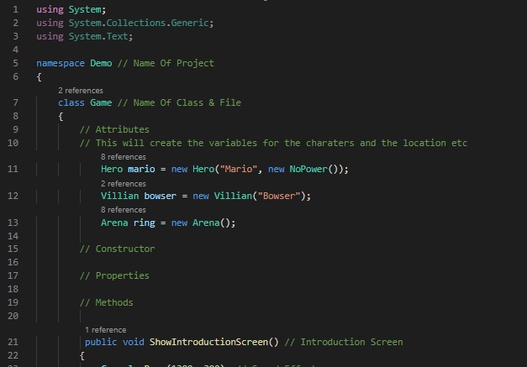

4.6. Hero.cs, Villian.cs
The third and fouth class files for this project will be called Hero.cs and Villian.cs. These class files will contain the C# code to configurate the hero and villian element and its settings.
The image below will show some code for the Hero.cs and Villian.cs class files. The both codes shows the base name and the attack perimeter function as this will show the quote when the player calls function in other class files.
But on the Hero.cs code, it will show a private variable being used when the player picks up the power and uses it element
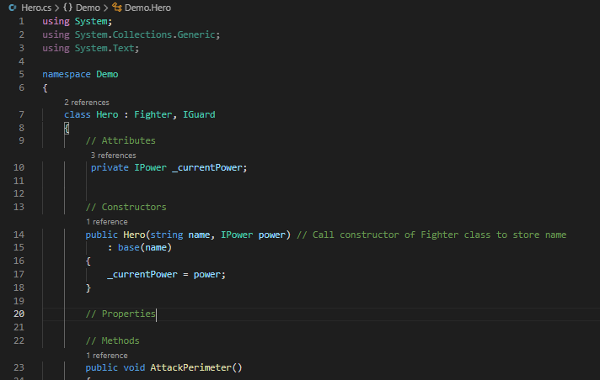
Please view the files “Hero.cs and Villian.cs” to look at the full code.

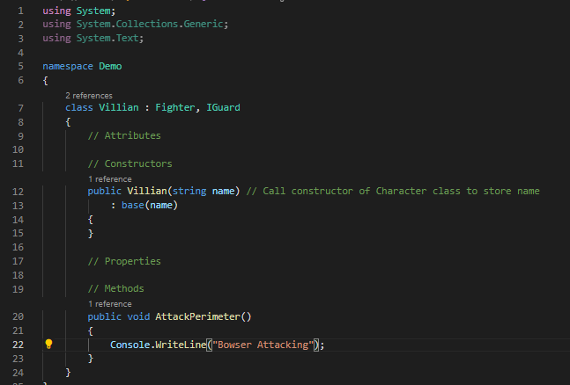
Villian.cs
Hero.cs

4.7. Fighter.cs
The fifth class file for this project will be called Fighter.cs. This class file will contain the C# code to configurate fighter element and its settings.
The image below will show some code for the Fighter.cs class file. The code shows the private string for the character name function and the receiving the character when the function gets called. This specific code will be under abstract class which is also part of the interface element.
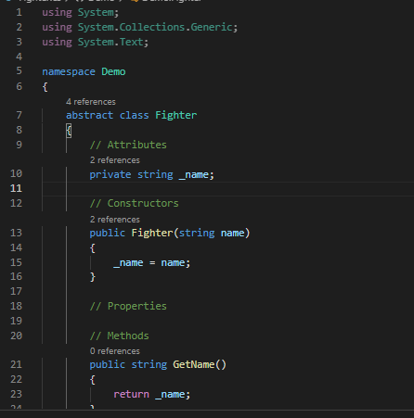
Please view the file “Fighter.cs” to look at the full code

4.8. Arena.cs
The sixth class file for this project will be called Arena.cs. This class file will contain the C# code to configurate arena element and its settings.
The image below will show some code for the Arena.cs class file. The code shows the private list and creation of that private list which is linking to IGuard.cs file. It will also use the function to assign the guard and let the character start the attack for the Game.cs file.
Please view the file “Arena.cs” to look at the full code
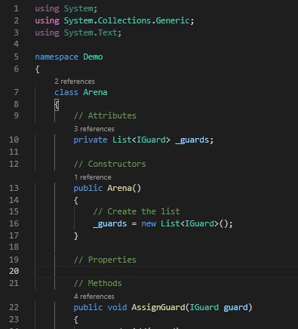

4.9. IGuard.cs, IPower.cs
The seventh and eight class files for this project will be called IGuard.cs and IPower.cs. These class files will contain the C# code to configurate attack and power use elements and its settings.
The image below will show code for the IGuard.cs and IPower.cs class files. The both codes shows the interfaces being using as one is for attacking function and the other one is for using the power up function.
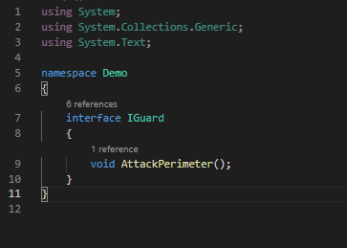

IGuard.cs

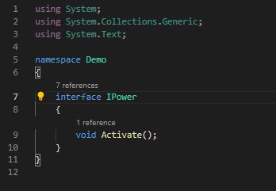

IPower.cs
4.10. NoPower.cs, FireBallPower.cs, MetalHands.cs, GoldenStar.cs
The last class files for this project will be called NoPower.cs, FireBallPower.cs, MetalHands.cs and GoldenStar.cs. These class files will contain the C# code to configurate the power up elements and its settings.
The image below will show some code for these class files. The codes show the specific class linking into another class and using the power up function as this will show the quote when the player calls function in other class files.
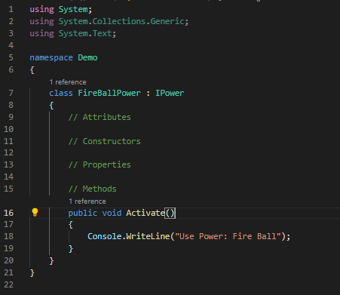
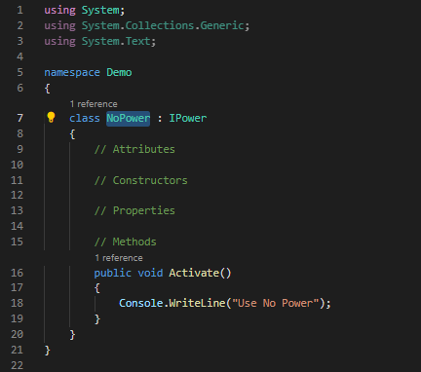

FireBallPower.cs
NoPower.cs

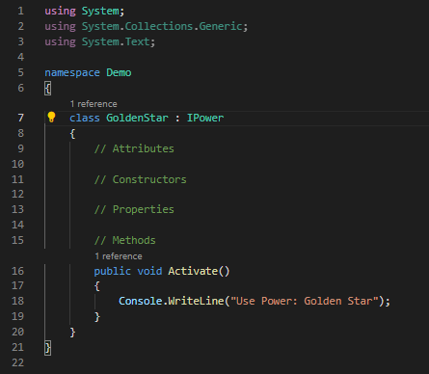
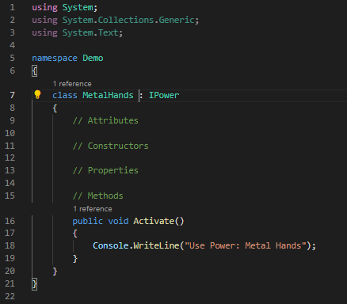
GoldenStar.cs
MetalHands.cs

4.11. Implementation Of Game
After the code has been completed, the user will need to run the program to see if the code has worked successfully. Below will be images from the RPG Game project.
The first image will be the introduction screen. This will show the user the name of the project, the creator and its description. It will then lead to the main game screen.
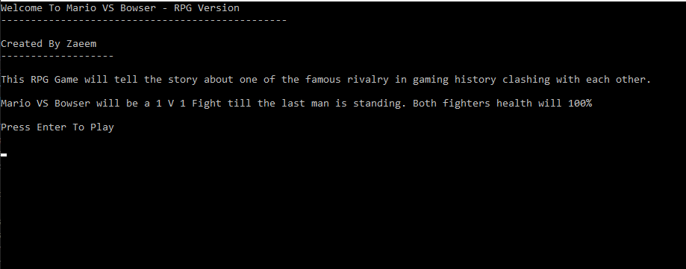

The second screen will be the main game. Once the user has pressed Enter on the keyboard, they will be able to play the game as the game will show which character is doing a specific action. This would use the other class files to allow the game to run successfully.
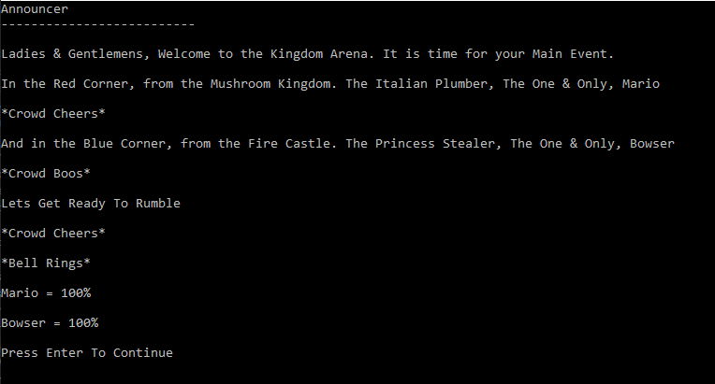

The last screen will be from the main game. This will show when a character is attacking and when a power up has been used as this would use the other class files to allow this function to run and show the output.
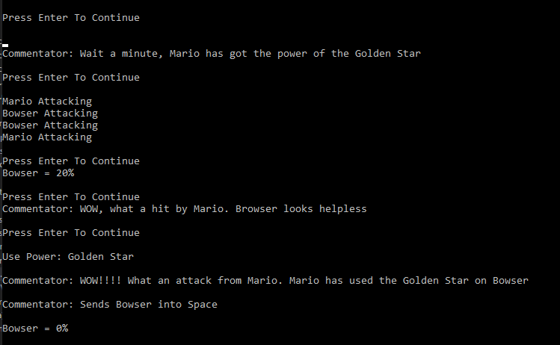

5. References

References

[1] | T. Contributor, "C#," 31 March 2021. [Online]. Available: https://searchwindevelopment.techtarget.com/definition/C. [Accessed N/A November 2007].
[2] | A. Z. Mustafeez, "What is Visual Studio Code?," N/A N/A N/A. [Online]. Available: https://www.educative.io/edpresso/what-is-visual-studio-code. [Accessed 31 March 2021].
[3] | S. Lewis, "object-oriented programming (OOP)," N/A April 2020. [Online]. Available: https://searchapparchitecture.techtarget.com/definition/object-oriented-programming-OOP. [Accessed 31 March 2021].
[4] | Karleigh Moore, Evans Njeru, Matas Pocevicius, "Classes (OOP)," 13 April 2021. [Online]. Available: https://brilliant.org/wiki/classes-oop/#:~:text=In%20object%2Doriented%20programming%2C%20a,(member%20functions%20or%20methods).&text=The%20class%20is%20a%20blueprint,nature%20of%20a%20future%20object.. [Accessed 13 April 2021].
[5] | G. L. Team, "Polymorphism In C++ and Types of it?," 1 February 2021. [Online]. Available: https://www.mygreatlearning.com/blog/polymorphism-in-cpp/. [Accessed 20 April 2021].
[6] | N/A, "Interfaces in C++ (Abstract Classes)," N/A N/A N/A. [Online]. Available: https://www.tutorialspoint.com/cplusplus/cpp_interfaces.htm#:~:text=An%20interface%20describes%20the%20behavior,particular%20implementation%20of%20that%20class.&text=The%20purpose%20of%20an%20abstract,which%20other%20classes%20can%20inherit.. [Accessed 20 April 2021].
[7] | J. D. Nguyen, "Joshua D. Nguyen," 26 June 2018. [Online]. Available: http://www.twinb0rnsoft.com/Object-Oriented-Programming/. [Accessed 31 March 2021].
[8] | A. Carvalho, "Avoiding the billion dollar mistake in C#," 12 November 2018. [Online]. Available: https://addcode.io/2020/02/07/avoiding-the-billion-dollar-mistake-in-c/. [Accessed 31 March 2021].
[9] | J. Cuesta, "TOP PLUGINS VISUAL STUDIO CODE FOR JS," 21 November N/A. [Online]. Available: https://openexpoeurope.com/top-plugins-visual-studio-code-for-js/. [Accessed 31 March 2021].
[10] | N/A, "HTI Toys Traditional Games Snakes & Ladders Family Board Game Set," N/A N/A N/A. [Online]. Available: https://www.amazon.co.uk/HTI-Traditional-Snakes-Ladders-Family/dp/B00ILADTEK. [Accessed 4 April 2021].
[11] | B. Graeber, "Mario," 6 February 2014. [Online]. Available: https://www.ign.com/wikis/super-mario-3d-world/Mario. [Accessed 20 April 2021].
[12] | E. Lenti, "“So Long, Gay Bowser”: A queer reading of Super Mario," 8 April 2017. [Online]. Available: https://blog.usejournal.com/so-long-gay-bowser-a-queer-reading-of-super-mario-7ab1ad0c904. [Accessed 20 April 2021].

