BSc Cloud Computing

ACCB6025 - Cloud Computing Administration

Student’s Name: Florin-Cristian Matic
Student’s ID:2029128
University Name: Wales Trinity Saint David

Table of Contents
Introduction 2
Cloud Support to Aspire Retailer 2
Cloud Providers Comparison 5
TCO Calculations 7
Azure Active Directory Usage 15
Cloud Governance Strategy 17
Disaster Recovery Plan for Aspire Retailers 36
Conclusion 38
References 40

Introduction
In association with the increasing aspect of digitalization, the majority of the business organization had been determined to have been seeking different prospect ways for enhancing their overall business operations, so as to further enhance their data handling efficiency. Based on the consideration, Aspire Retailers, which happens to be as one of the renowned home improvement retailers, which currently had been managing an on-premises datacenters, had been facing a significant challenge for delivering a proper and timely computing services to its customers, respectively [16]. For considerably overcoming these issues, the interacting IT administrator at the Aspire Retailers had been subjected to find a suitable solution that would be beneficial for allowing them to immediately access to a proper computing services for supporting their growing needs with more efficiency.
The following report here would be subjected to determine how a Cloud solution could provide appropriate support to the Aspire Retailers in delivering with a suitable solution for their needs to enhancing their computing services, respectively. In addition to that, the sophisticate feature of Load balancing for Aspire retailers would also be discussed here in details. Followed by these, a brief comparison among the top cloud service providers would be performed within the report, which would be based on selecting an appropriate one for being used by Aspire Retailers. Apart from that, a brief TCO calculation on the total cost the Aspire Retailers would require to manage their cloud services would be discussed here based on the cloud configuration being provided within the case study. In addition to that, the following report here would also be subjected to explain the proper usage of Azure Active Directory on behalf of Aspire Retailers, followed by discussing what cloud governance strategy is being used by Microsoft Azure and how it could assist Aspire Retailers in enhancing its operation. Last, but not the least, a proper Disaster Recovery Plan, suitable for Aspire Retailers to support their data and application on cloud would also be delivered within this report [10].

Cloud Support to Aspire Retailer
A major migration towards the Cloud Service could be considered extremely beneficial for Aspire Retailers, as it would be providing the organization with appropriate computing services so as to meet their existing needs of data handling and processing. In association with the complete analysis being conducted here, it should be the prime responsibility of the interacting IT administrator of Aspire Retailers to sufficiently understand each obstacle that had been involving with the management of On-Premises datacenter, which would also include proper surveillance to hardware procurement, installation of software, its deployment and network monitoring, respectively. The associated tasks being identified here could cause extreme delays in delaying an appropriate service to their users, thus hindering the overall ability of the company to respond to the changing market demands. During the process of migration towards the Cloud services, the Aspire Retailers would be subjected to experience the below mentioned benefits that they would be acquiring on behalf of a new Cloud services platform. The benefits had been summarized below:
- Reduced IT management: - After successfully being migrated to the cloud services, the Aspire Retailer could easily offload the overall responsibility of managing their hardware, software, as well as their entire network infrastructure over their cloud provider. This would be beneficial for allowing the IT department members to focus more on making strategic initiatives rather than acquainted with routine maintenance tasks [1].
- On-Demand Data Availability: - With a proper cloud solution, the Aspire Retailer could considerably access to computing resources within an instant. They would never be required to go through the time-consuming procedure for hardware procurement and all other related procedures. This immediate availability of data would enable a faster development and deployment of applications, thus helping Aspire Retailers to easily ensure a timely delivery for its users.
- Rapid Deployment: - In comparison to that of a traditional On-premises setup, that had been utilized by Aspire retailers previously, the migration towards the cloud services would be beneficial for the organization to easily start a new server, or add additional services within their existing solutions. This overall agility would be crucial for enabling a faster innovation and experimentation, as the organization would become capable of generating new ideas regarding their service generation without the need of any external setup and configurations [13].
- Global Expansion Opportunities: - Apart from gaining enormous scalability and cost effectiveness, the migration of Aspie Retailer towards the Cloud Services would also be beneficial for the company, as it would expand their overall business, while generating new opportunities to gain new markets. Due to the involvement of cloud services, Aspire Retailers would easily acquire the ability to outreach each customer in different geographical locations, thus delivering proper services.
A Load Balancing had been considered to be as a critical feature within the cloud computing that could considerably provide enormous benefit to the Aspire Retailers for sufficiently improve as well as expand their business, respectively. Since Aspire Retailers had been looking to migrate to a proper cloud service, so that they could easily overcome their challenges regarding inconvenient data management and services, due to their existing on-premises datacenter. The overall process of Load Balancing generally involves with distributing the entire incoming network traffic across different sets of servers and resources, so as to make sure that an optimal reliability, performance as well as data scalability would be delivered to Aspire Retailers. Based on the complete analytical inspections that had been conducted here, the associated key features of Load Balancing had been discussed below [2]:
- Scalability and Elasticity: - The implementation of the Load Balancing would sufficiently be considered beneficial for the Aspire Retailers to easily scale their entire infrastructure with more efficiency and would also increase their probability to handle enormous traffic demands. Now, with the exponential growth of the business of Aspire Retailers, the Load Balancing would dynamically be allocating different resources for handling their overall resource loads.
- Performance Optimization: - The Load Balancing would even be beneficial for Aspire Retailers to evenly distribute their entire network traffic among all their multiple servers, thus reducing their overall network load on any individual servers. While doing so, it also ensures that each of the servers would operate within their own capacity, thus preventing the enormous overloading and improving their overall performances [4].
- Fault Tolerance: - Load Balancers could even determine any server failure, as well as unresponsive resources, while redirects the entire network traffic towards a healthy server. The associated fault tolerance would even ensure that the entire system of the Aspire Retailers would continuously operate with minimal risk of network downtime and customer dissatisfaction.
- High Availability and Redundancy: - Load Balancing would also be considered to provide higher redundancy while distributing the entire network traffic across the multiple servers. In this case, if any of the network servers fails to operate, or experiences failure, the load balancers would automatically redirect the entire network traffic over the network servers which were available for operation.
- Session Persistence: - Certain of the application, which were utilized within an organization, requires a proper maintenance of user session throughout their interactions. The implementation of Load Balancers could be configured here to ensure that a proper and subsequent network request from the user is being directed to the same server, thus maintaining a proper session persistence [14].

Cloud Providers Comparison
Based on the extreme need of Aspire Retailers to successively migrate their entire services and business over Cloud services, there had been an extreme need for the company to determine as to which Cloud service provider they should be considering to. In association with the making a brief consideration of the basic requirements and properties Aspire Retailers had been seeking to achieve on behalf of implementing a Cloud Service, a total of three Cloud Service Providers had been summarized here, that includes Microsoft Azure, Google Cloud Platform or GCP, as well as Amazon Web Service or AWS. Thus, for determining as to which Cloud Service providers does Aspire Retailers should be considering, a brief comparison among the three cloud service providers had been made, as it had been summarized below:

Microsoft Azure
Microsoft Azure had always been the most popular Cloud Service provider that had been associated with offering a comprehensive range of cloud-based services to its users/clients. In association with the complete analysis being conducted at the need for Aspire Retailers to migrate to a cloud platform, they can considerably leverage Azure’s offering for enhancing their overall business operation and gain the following benefits [15]:
- Storage Solutions: - Azure offers a subsequential range of storage options, that had been including with Blob storage for all unstructured data, that would include videos, Table storage for structured data, as well as Azure Files for sharing files, respectively. The Aspire Retailers could easily store and retrieve their application data and streaming videos using Azure’s scalable storage solution.
- Computing services: - Microsoft Azure had been acquainted with providing with the services of Virtual Machines which could considerably be provisioned with more efficiency and scales based on the demands. This kind of service flexibility had been considered beneficial for allowing the Aspire Retailers to easily deploy and configure as many servers for hosting their retail website, alongside with streaming their videos.
- Load balancing and Autoscaling: - The Azure’s Load Balancers had been associated with distributing various kinds of incoming network traffics across all multiple VMs, which had been beneficial for ensuring a high availability and performances to the services and data being utilized by Aspire Retailers. In addition to that, the Azure had also been beneficial for autoscaling various resources that had been based on predefined rules, thus enabling the Aspire Retailers to easily handle the increasing demands of their users, during extreme peak hours of the network [7].

Google Cloud Platform (GCP)
A Google Cloud Provider, or the GCP had been recognized as another Cloud Service provider, apart from the Microsoft Azure, which had been determined to be associated with providing a suitable set of cloud services to Aspire Retailers, while helping the organization to easily manage their data and resources for fulfilling their business needs. Based on the migration of Aspire Retailers to the Cloud platform, their consideration to use Google Cloud Platform would avail the following benefits for the company [8]:
- Compute Engine: - The implementation of GCP would be beneficial for the Aspire Retailers, as it would be allowing them to provision as well as manage VMs over the cloud. This aspect would be beneficial for the organization to easily scale up/down for meeting the demands of their customers.
- Cloud SQL: - Cloud SQL is one of the features that had been provided on behalf of Google Cloud Platform, which had been beneficial for providing the company to use several of the managed database services like that of MySQL and PostgreSQL services. While using the GCP, Aspire Retailers could easily scale-up their database, while maintaining an automated backup.
- Load Balancing: - The services of GCP also includes Load balancing, that includes options like that of HTTP(S) load balancing as well as Network Load balancing. These aspects of Load balancing would be beneficial for Aspire Retailers to easily distribute their overall network traffics for ensuring a higher availability and performances for each of their applications.

Amazon Web Services (AWS)
Last, but not the least, the final Cloud Service platform that Aspire Retailer should be considering is the Amazon Web Service or the AWS. Apart from the Microsoft Azure and that of the Google Cloud Platform, the AWS or the Amazon Web Services had been considered to be as the prominent cloud providers which had been associated with delivering with a wide range of services. Being one of the leading cloud service providers, the Amazon Cloud Services had been associated with helping the Aspire Retailers to obtain the following services and benefits [3]:
- Elastic Compute Cloud (EC2): - The EC2 services of AWS had been accompanied with delivering with a flexible and resizable computing capacity within the cloud, which had been subjected to allow the Aspire Retailers to quickly launch as well as scale their virtual servers based on their growing needs.
- Simple Storage Services (S3): - The S3 Services of AWS had been accompanied with delivering with a scalable object storage for better storing as well a retrieving a huge amount of data being utilized by the Aspire Retailers, which genuinely would include Streaming videos. This service of AWS had been subjected to deliver with high durability, availability and security for data storage.
- Elastic Load Balancing (ELB): - Last, but not the least, the ELB services of AWS had been accompanied with distributing all kinds of incoming network traffics all across different EC2 instances, thus helping Aspire Retailers to easily ensure high availability and fault tolerance.

TCO Calculations
From the given case scenario, it has been identified that the Aspire Retailers company utilized 5 virtual machines with different specifications. Therefore, it is important to calculate the cost of the computing configurations so that Aspire retailers can effectively manage their cloud spending. In order to prefer cloud platform over the on-premise solution, it is important for the organizations to compare the cost of both solution and prefer the feasible solution (27). As the organization will use Azure platform, Azure TCO cost calculator will be utilized to calculate the cost of the virtualization. From the computing specification, it has been identified that the virtual machines of the Aspire Retailers company will be operating on Linux or Windows operating system. The cost calculation is shown below:
VM 1
The TCO cost calculation for the VM 1 is shown in the below figures:
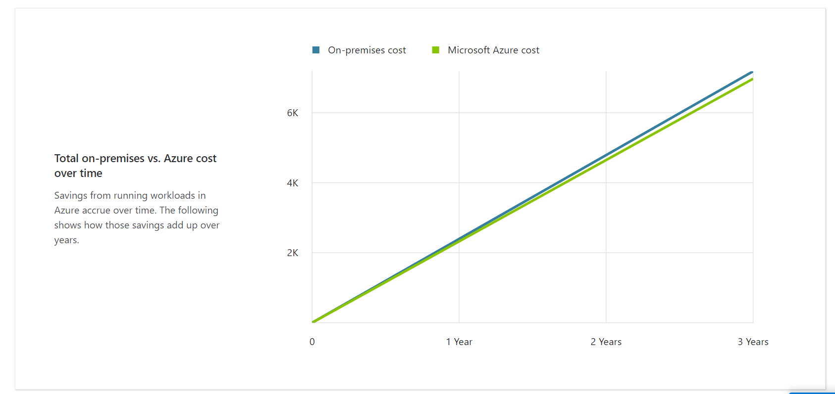
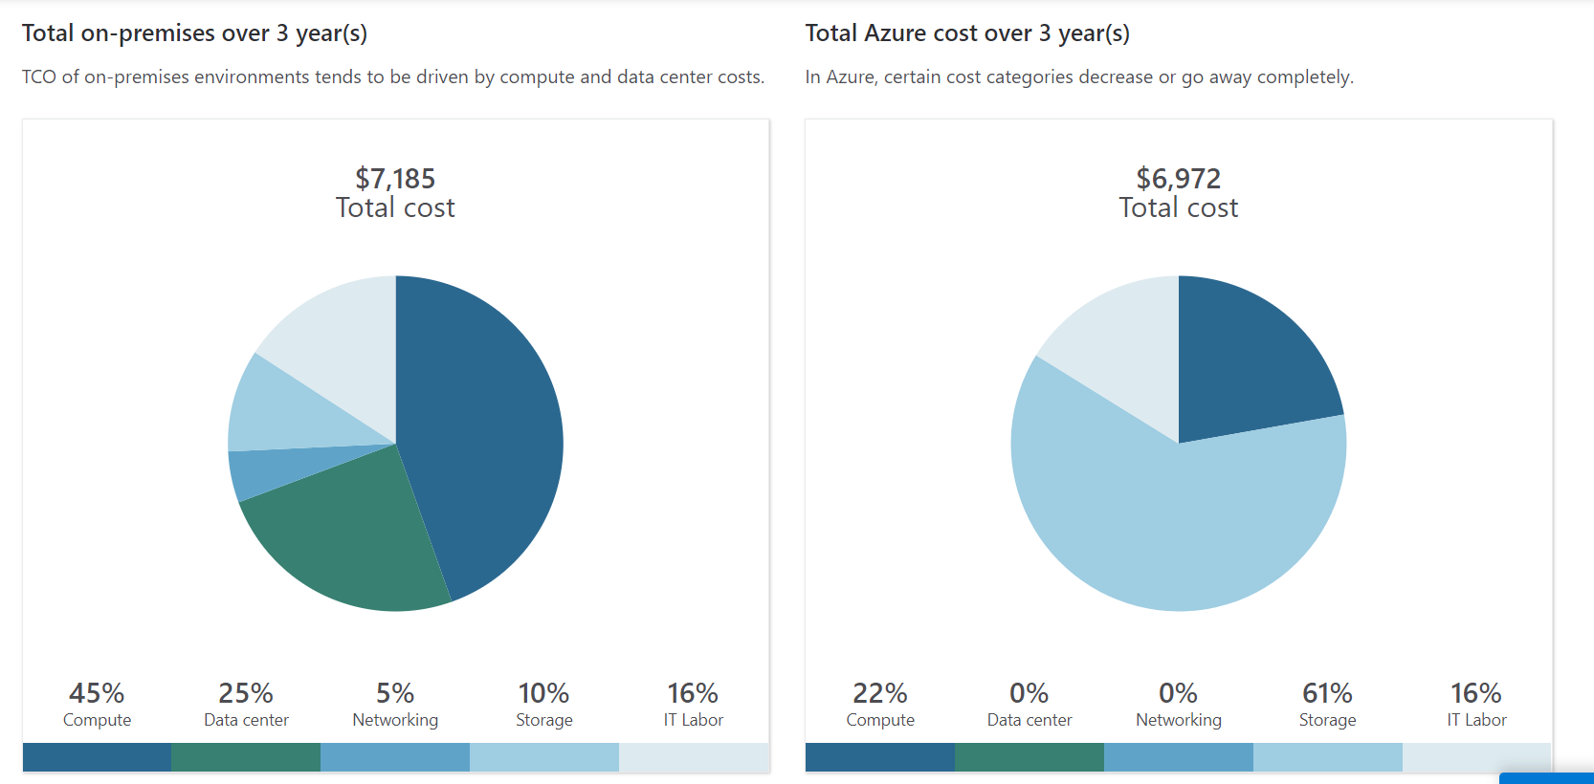
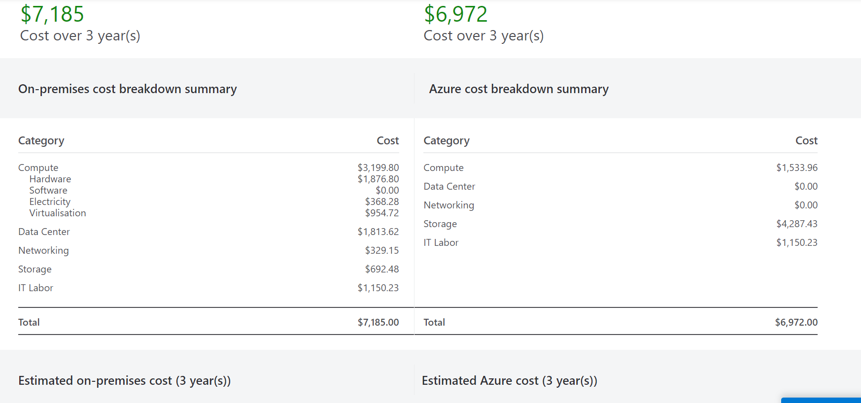
The TCO calculation for the next three years of VM 1 with 2 CPU cores and 14 GB of RAM is shown in the above figure. From this calculation, it can be seen that the estimated cost of VM 1 for the next three years is $6972 which is much lower than the On-Premise cost.
VM 2
The TCO cost calculation for the VM 2 is shown in the below figures:
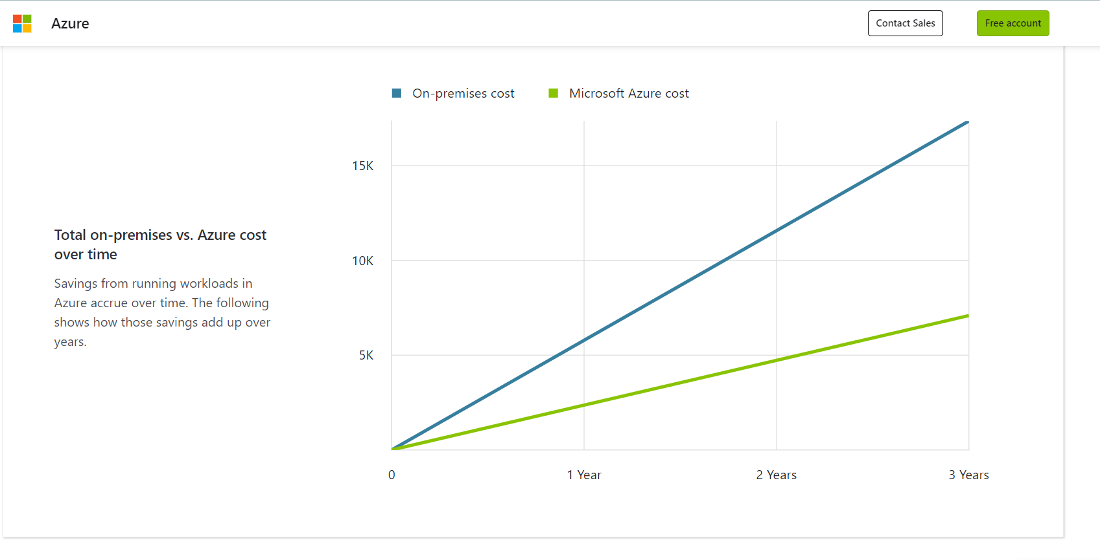
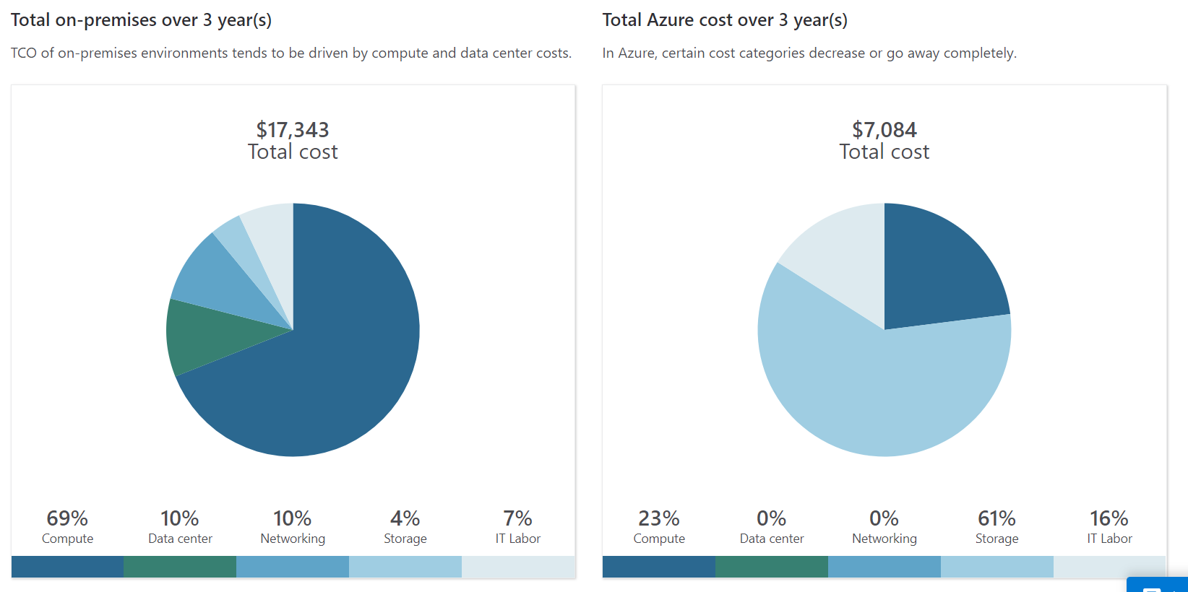
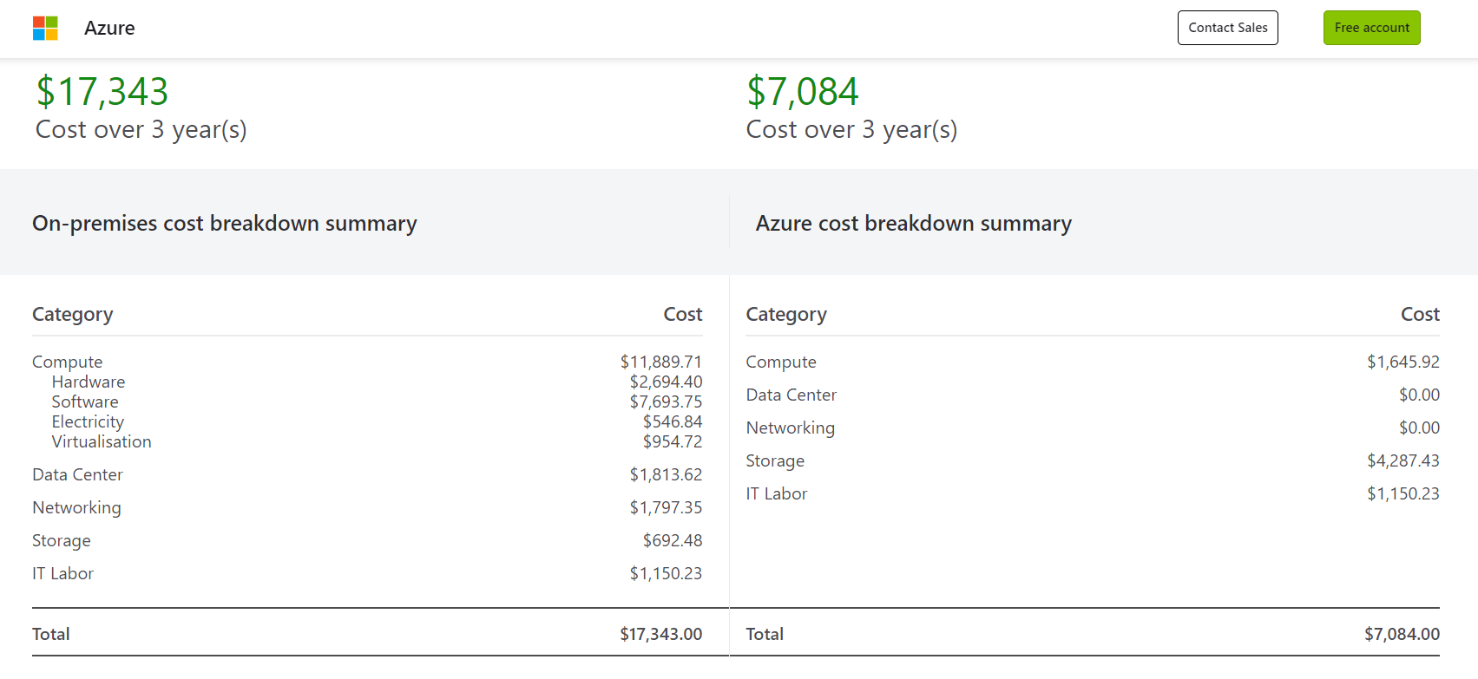
The TCO calculation for the next three years of VM 2 with 4 CPU cores and 16 GB of RAM is shown in the above figure. From this calculation, it can be seen that the estimated cost of VM 2 for the next three years is $7084 which is much lower than the On-Premise cost.
VM 3
The TCO cost calculation for the VM 3 is shown in the below figures:
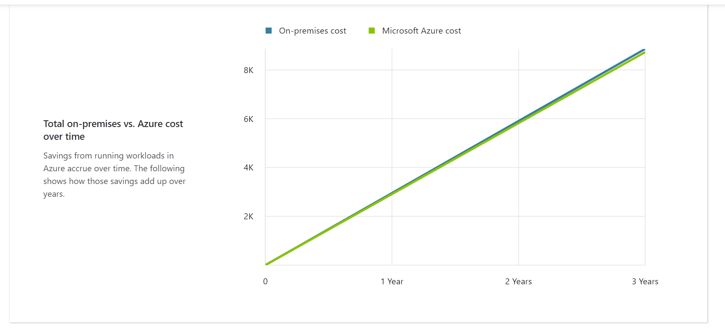
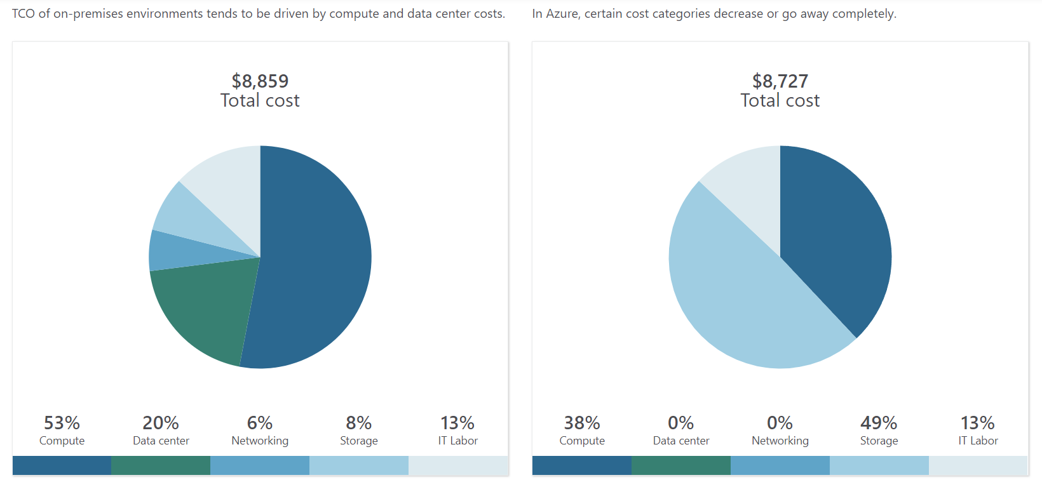
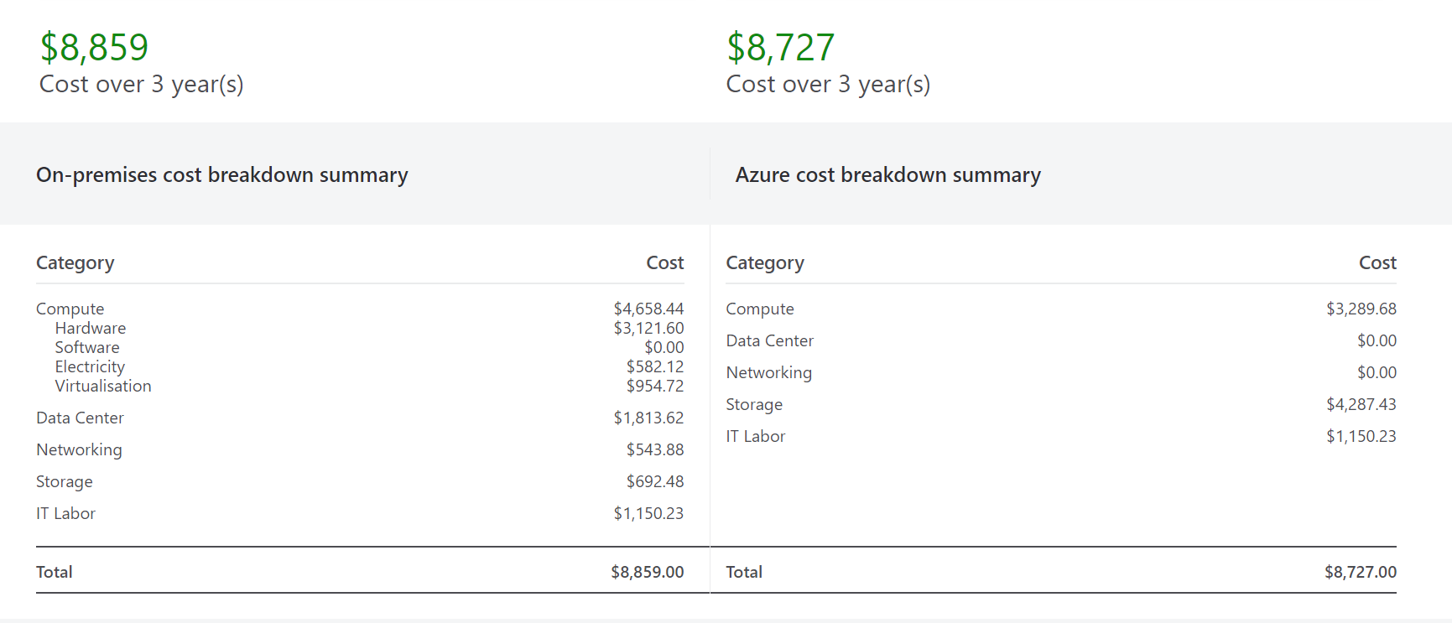
The TCO calculation for the next three years of VM 3 with 8 CPU cores and 32 GB of RAM is shown in the above figure. From this calculation, it can be seen that the estimated cost of VM 3 for the next three years is $8727 which is slightly lower than the On-Premise cost.
VM 4
The TCO cost calculation for the VM 4 is shown in the below figures:
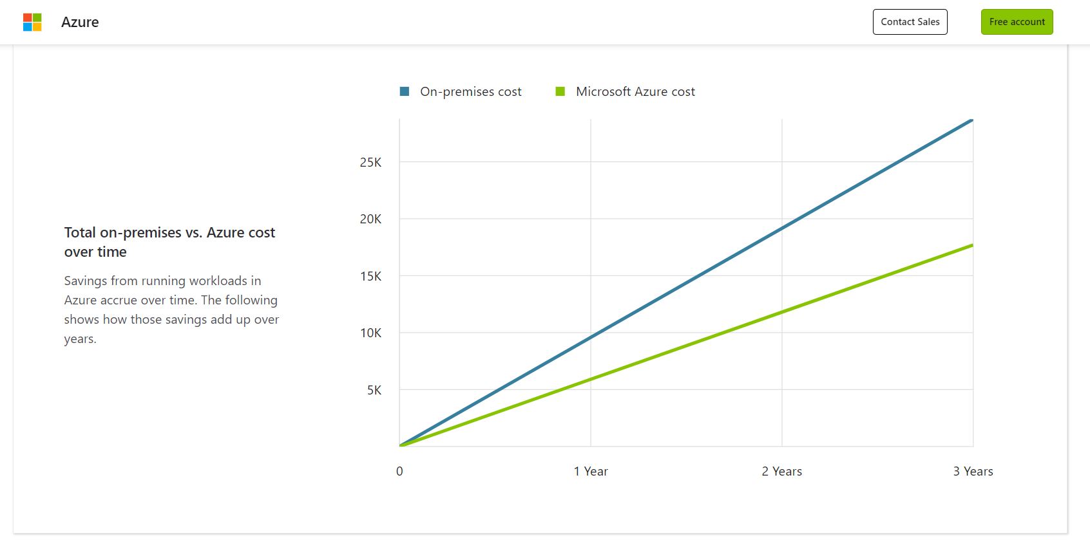
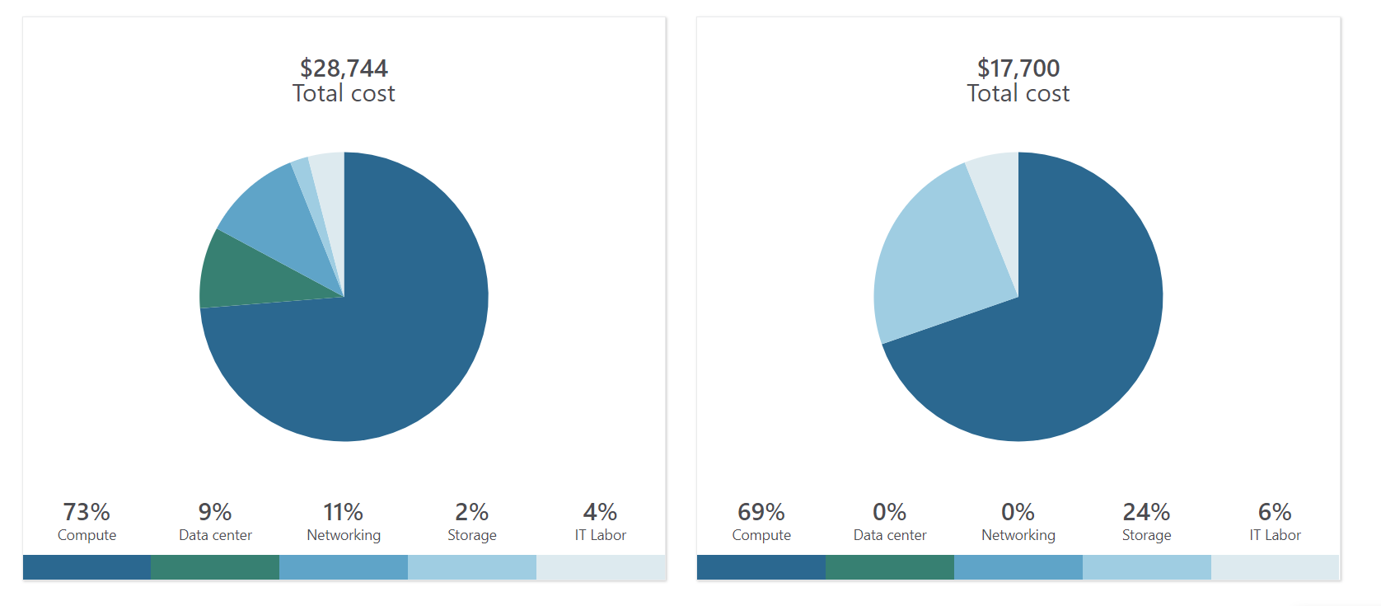
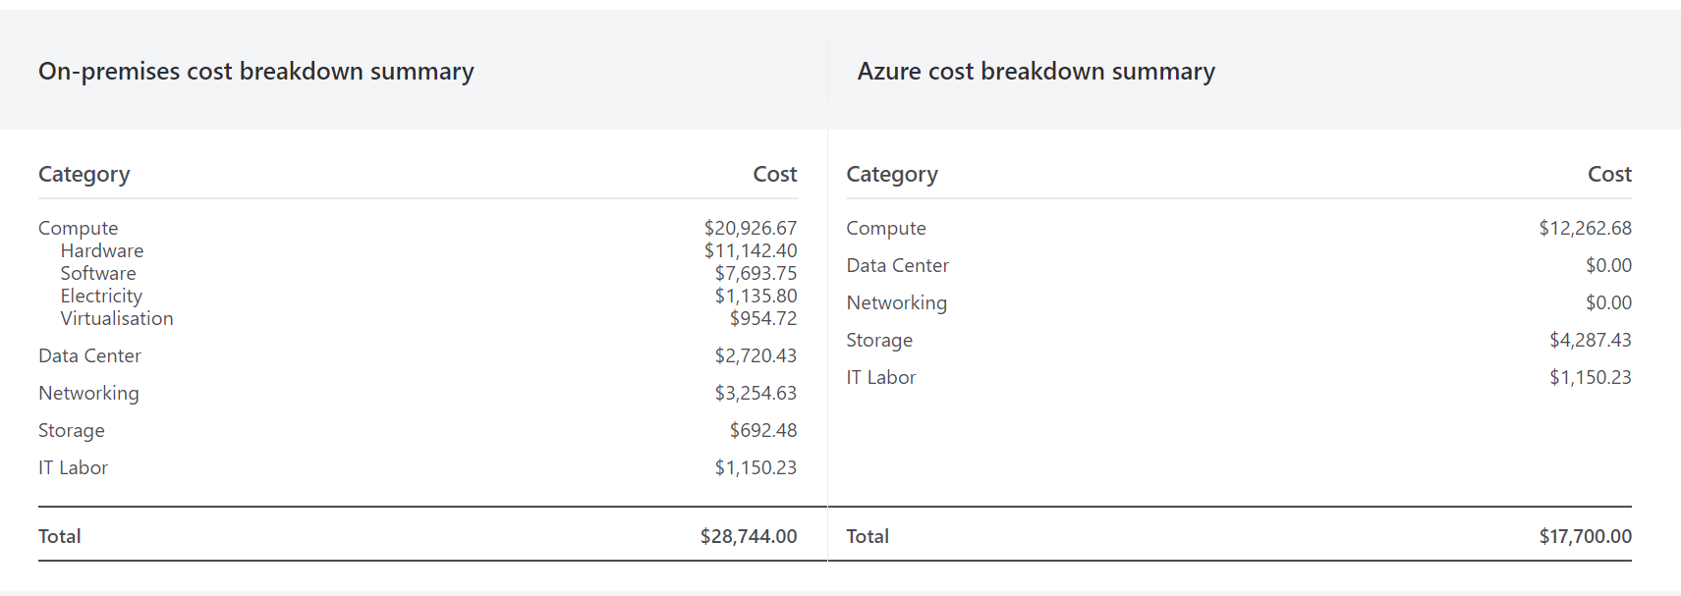
The TCO calculation for the next three years of VM 4 with 16 CPU cores and 112 GB of RAM is shown in the above figure. From this calculation, it can be seen that the estimated cost of VM 4 for the next three years is $17,700 which is much lower than the On-Premise cost.
VM 5
The TCO cost calculation for the VM 5 is shown in the below figures:
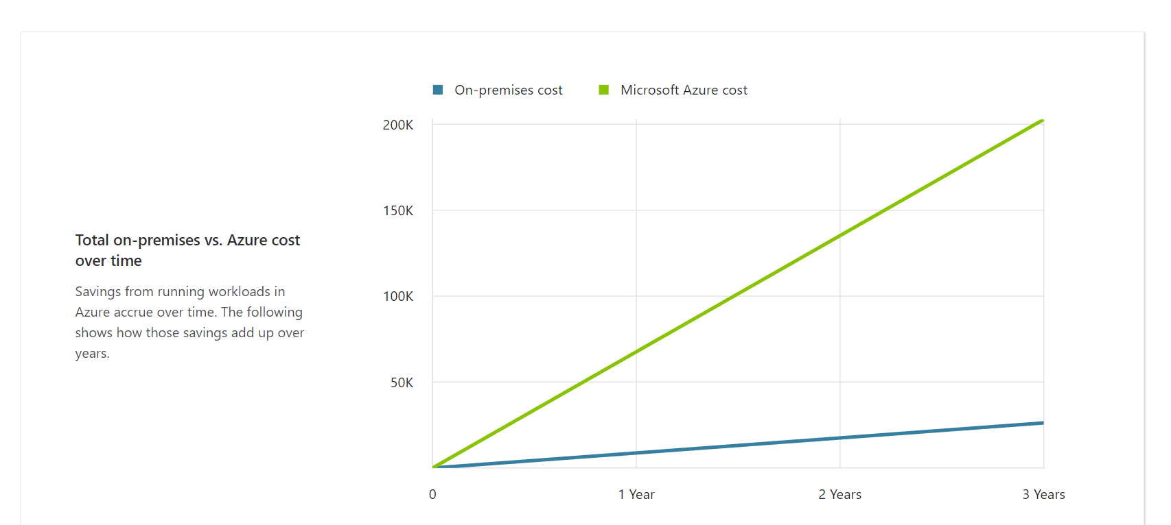
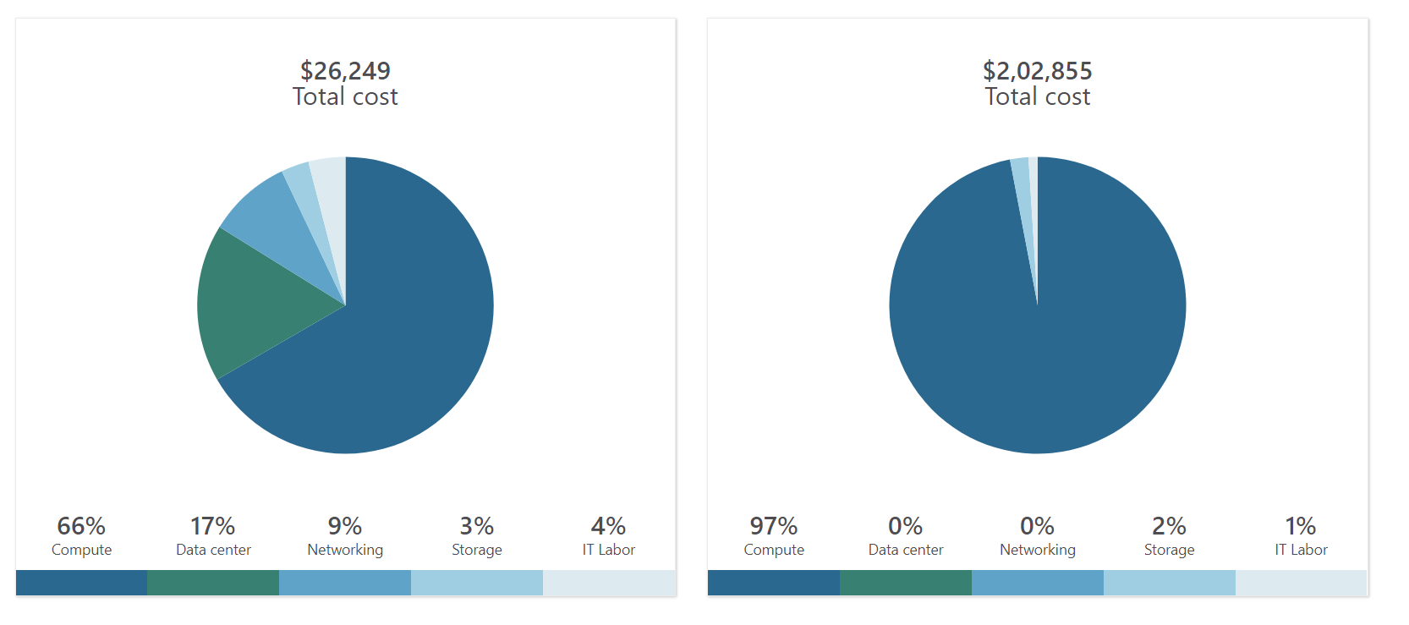
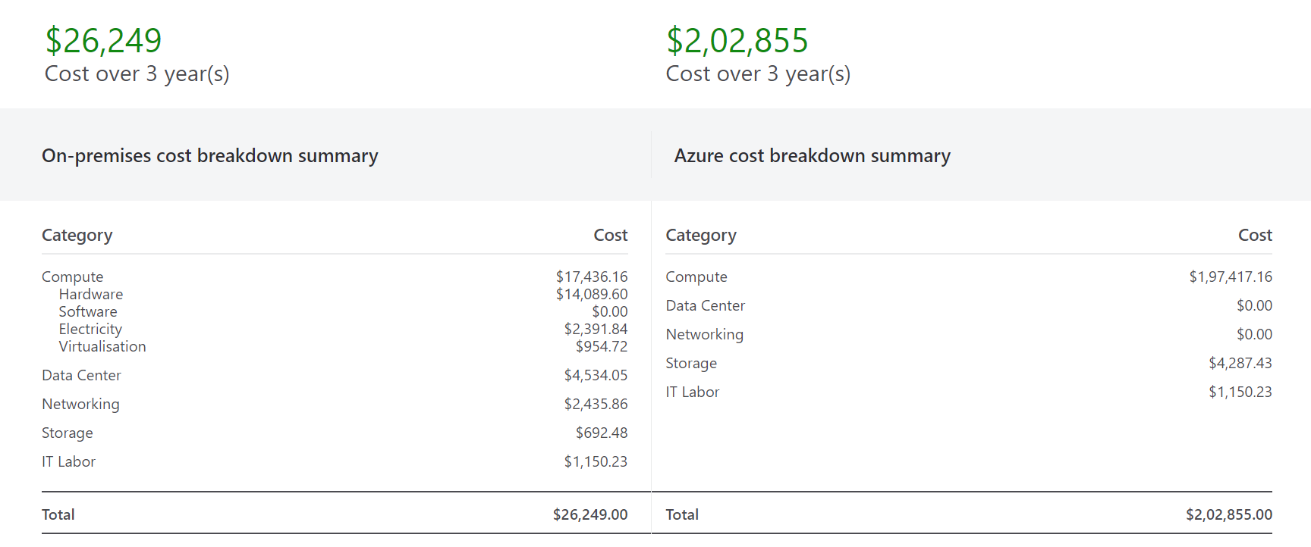
The TCO calculator of the Microsoft Azure is limited to 448 GB of RAM. So, exact cost breakdown summary of the VM 5 with 32 CPU cores and 512 GB of RAM has not been identified. So, it has been concluded that the that the estimated cost of VM 5 for the next three years is $2,30,000 which is much higher than the On-Premise cost.
The overall cost of all entire computing platform is shown provided below:
VM Name | Cost
VM 1 | $6972
VM 2 | $7084
VM 3 | $8727
VM 4 | $17,700
VM 5 | $2,30,000
Total | $270,483

Therefore, it can be said that Aspire Retailers needs to invest around $270,483 for the computing configurations of three years. The VM deployment on azure platform will significantly reduce the cost of the Aspire Retailers. By implementing the virtual machines, the organization can save the cost of hardware, software, and electricity as they need to pay only the computing cost (25). However, only limitation that the organization will is due to the VM5. In VM5, the organization require 32 cores of CPU as well as 512 GB of RAM. However, the Azure cloud platform is only limited to 448 GB of RAM.
Therefore, in terms of cost of 5 virtual machines, Azure is recommended to the Aspire Retailers as it provides better security with greather scalability, reliability, and speed as compared to on-premise solutions (30). The Azure cloud is much cheaper than the on-premise solutions and the organization does not need to invest in new infrastructure and machines.

Azure Active Directory Usage
Microsoft Azure provides a cloud-based identity and access management system which is commonly termed Azure Active Directory (Azure AD). Through its implementation organizations can handle and manage user accounts, along with groups and applications, and can provide secure access and authentication for cloud-based resources. Listed below are some of the uses of Azure Active Directory along with a segment reflecting a proper explanation and normal users:
- User Account Management: Azure AD implementation enables to create and manage accounts of an organization. Individually can be added on an individual basis or even in bulk, the next phase involves assigning them user names and passwords and defining properties such as display name and contact information. User profiles can even be synchronized with on-premises Active Directory or created even be created directly into Azure AD.
- Group Account Management: Groups can also be managed with the help of Azure AD and it can even be used to organizing users and assigning permissions. Can be also used for accessing control, by which organizations can assign permissions to multiple users at a time. Security groups can even be deployed for managing access to resources and another group can be assigned to operate over e-mail and send information to a set of groups.
- Single-Sign-On (SSO): By Supporting SSO, Azure provides individuals to sign in once and float from one application to another without entering the credential on a repeated basis [18]. Azure AD can be integrated with various applications with all its flexible and impressive facilities and features, whether it can be Microsoft or any other third party, with the help of protocols like SAML or OpenID Connect which also ensures seamless authentication and access management.
- Role-Based Access Control (RBAC): Azure AD facilitates RBAC capabilities, which enables an organization to assign roles to users and control their permissions within the organization’s resources [19]. Users who acquire full administrative access can be assigned as global administrators and the rest of the users can assign roles based on the functions and position of responsibility in the organization.
- Multi-Factor Authentication: An additional layer of security is presented inside the Azure AD for secure login and sigh-in practices. MFA enables an extra layer of security by asking for personal details from user such as date of birth and phone numbers, and this generally takes place after the first layer of security which is after providing correct passwords [17]. Making the whole process safe and secure from attempts of unauthorized access attempts.
To assign the roles to the users and to configure the Azure Activity Directory (Azure AD), it is recommended to Aspire Retailers to follow the below-given steps.
- Creation of an Azure AD tenant: It is the first step that Aspire Retailers have to take in the process of setting up an Azure AD tenant. For this, they have to make a login into the portal of Azure and then have to select the option to create a new directory [22].
- Add users and groups: After making the successful establishment of the Azure AD tenant, the company can now able to able to add accounts of the individual users or it also allows them to synchronize their accounts with an on-premises Activity Directory. This plays a major role for the group users, in after processes it helps to simplify the process of managing the access permissions.
- Configure applications: The company can also think to integrate its applications with Azure AD, this will contribute in enabling Single Sign-On (SSO). SSO will help Aspire retailers to smoothen their process of access management [21]. To achieve this the company, have to register their applications in the Azure AD and they will be able to make adjustments in their authorization and authentication settings.
- Define roles and assign permissions: Aspire Retailers can also take the help of RBAC to make a custom role in Azure AD tenant or to better utilize the roles that were earlier provided by Azure AD [23]. This allows the company to give role to the different members as per their responsibilities within the organization.
- Conditional access: Azure AD helps organizations in the process of establishing of conditional access policies, these policies force some particular rules on the organization in respect of some factors like the location of the users, understanding the devices that are being used, and creating an assessment on the threat levels. This feature can help the company to provide extra security for the management of its Azure AD tenant.

Cloud Governance Strategy
Cloud governance strategy for Aspire Retailer is provided below:
Cloud governance strategy is defined as the set of policies that basically includes the processes, which are needed to be controlled in such a way that it could be implemented in such a way so that it is able to ensure the proper functioning of the cloud resources and monitor them to ensure the efficient working of the resources [25]. The cloud resources are functioned in such a way that they could work in accordance with the organization's objective, what are the requirements needed to reach the end objective, and follow the best possible optimal way that is followed by the industry. It also offers a feature which enables it to define and enforce the rules and the guidelines that are mainly used for managing cloud infrastructure, applications, data, and user access.
Microsoft Azure cloud services is a CRM platform that is able to offer different services that can be very helpful and can have a huge impact on supporting the Aspire Retailer in building a secure user access platform by using these robust cloud features:
Azure Active Directory (Azure AD): Azure AD is basically a robust architecture that is used to identify and access the management solution that is provided by the Microsoft solution. Azure AD comprises of the features like single sign-on (SSO), multi-factor authentication (MFA), conditional access policies, and identity protection through this robust and lightweight features Azure AD is a powerful tool that can be used by the Aspire Retailer to build a secure and convenient access to their cloud resources, which will thus enforce a strong authentication and enhance the security feature of the overall application [23].
Azure Policy: Azure Policy is a service that is defined and developed in such a way that is able to allow the organization to build, define and enforce the policies for the resources that are associated with the Azure platform [29]. It is designed and developed in such a way that it allows the user to develop custom policies that are best suited for their cloud resources, so that their functioning can be configured according to the custom policies that are built keeping the requirements in mind. Thus helping the Aspire Retailer to build and define the policies in accordance with application' s architecture.
Policy to assist the Aspire Retailers:
One policy that has the maximum probability that could help the Aspire Retailers to achieve maximum security in terms of accessing the cloud resources is:
Policy: Multi-Factor Authentication (MFA) for Azure AD is the identified policy that can be used by the user so that there could be an addition of an extra layer of security in accessing the cloud resources. MFA offers an important feature that requires the users to provide for an extra verification step which is not the usual entering of the password when it's time to access the Azure resources. This policy adds an extra layer of protection that prevents the cloud services from getting attacked by various security threats, phishing attacks, and unauthorized attempts to access the resources.
Through the implementation of the policy, Aspire Retailers is able to certify that all the users accessing the Azure resources are under the MFA, which reduces the risk of unauthorized access.
The benefits of using this policy are listed below:-
- Enhanced Security: MFA makes the whole authentication process more secure and adds an extra layer of security measures to this process. It enhances the overall security of the architecture by enabling the use of two factor authentication which can be in the form of OTP sent to the registered mobile device or using different means of biometric authentication like fingerprint or face recognition through these ways it is able to eradicate the unauthorized access problem making the security feature more tight [24].
- Protection against Password Attacks: Password attacks, basically includes various techniques like brute force attacks and credential stuffing, these are the common methods that are used by the attackers to obtain the access of the cloud resources associated with the Azure platform unauthorized access. When we add MFA to our cloud platform, even if the attacker is able to obtain the user's password, they would require to pass the second step of authentication successfully to get the actual access of the resources [26]. So from this it is confirmed that MFA is able to reduce or even eradicate the risk of unauthorized access through password-based attacks.
Lab activity
In this task, Azure policy will be utilized to manage the cloud governance. The lab activity is shown below:
Task 1: Create and assign tags via the Azure portal
In this task, the creation and assigning of tags through Azure Portal is shown below:
Starting a powershell
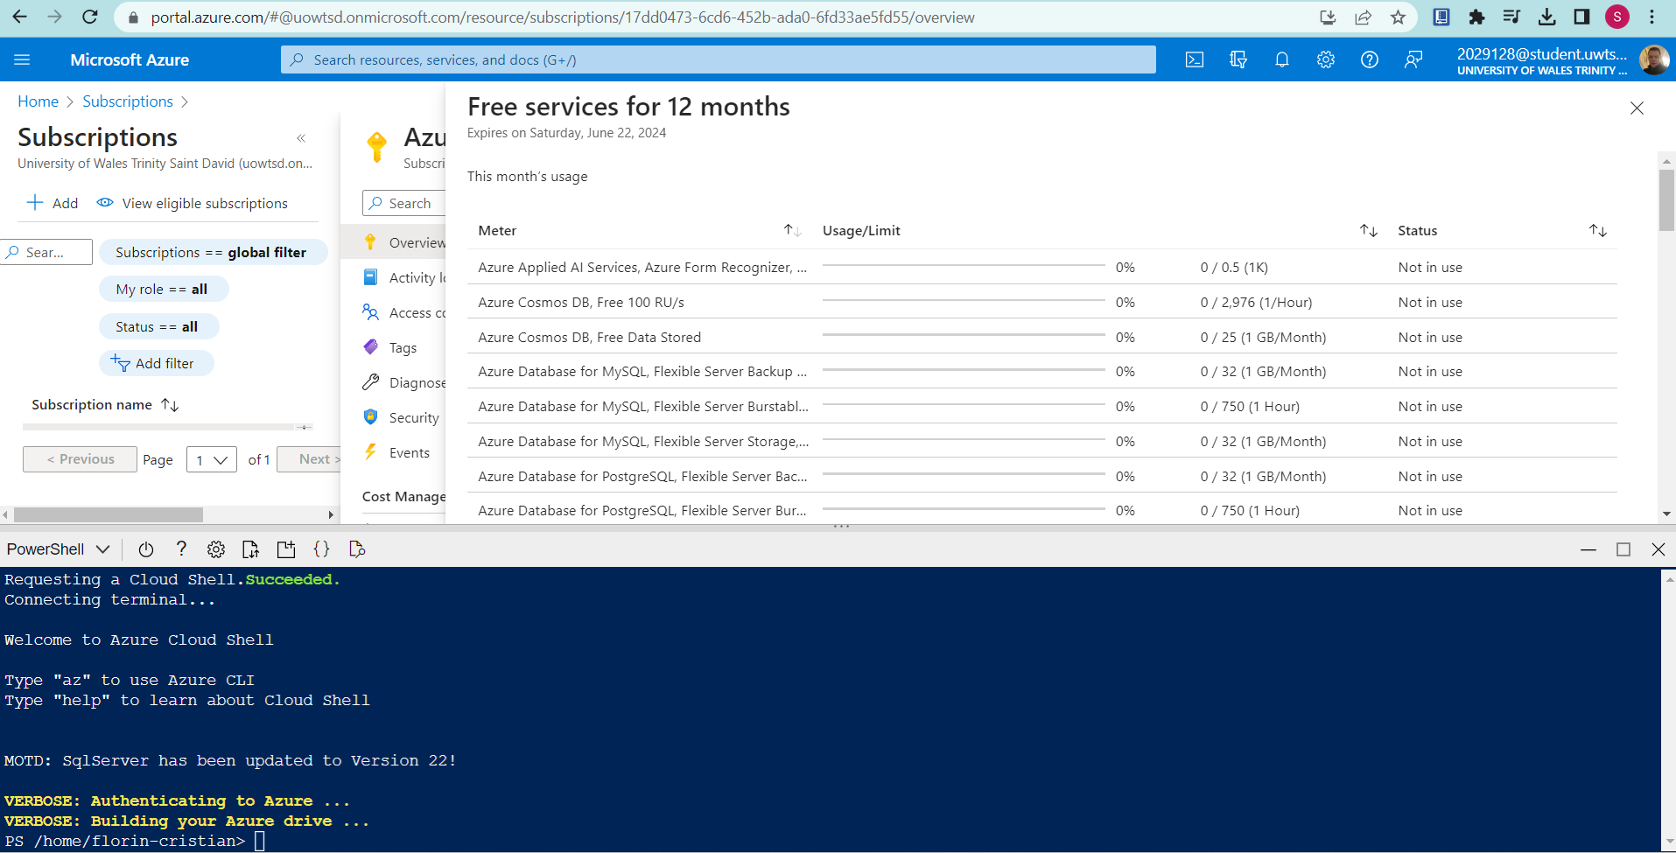
Identifying the name of storage account is shown below:
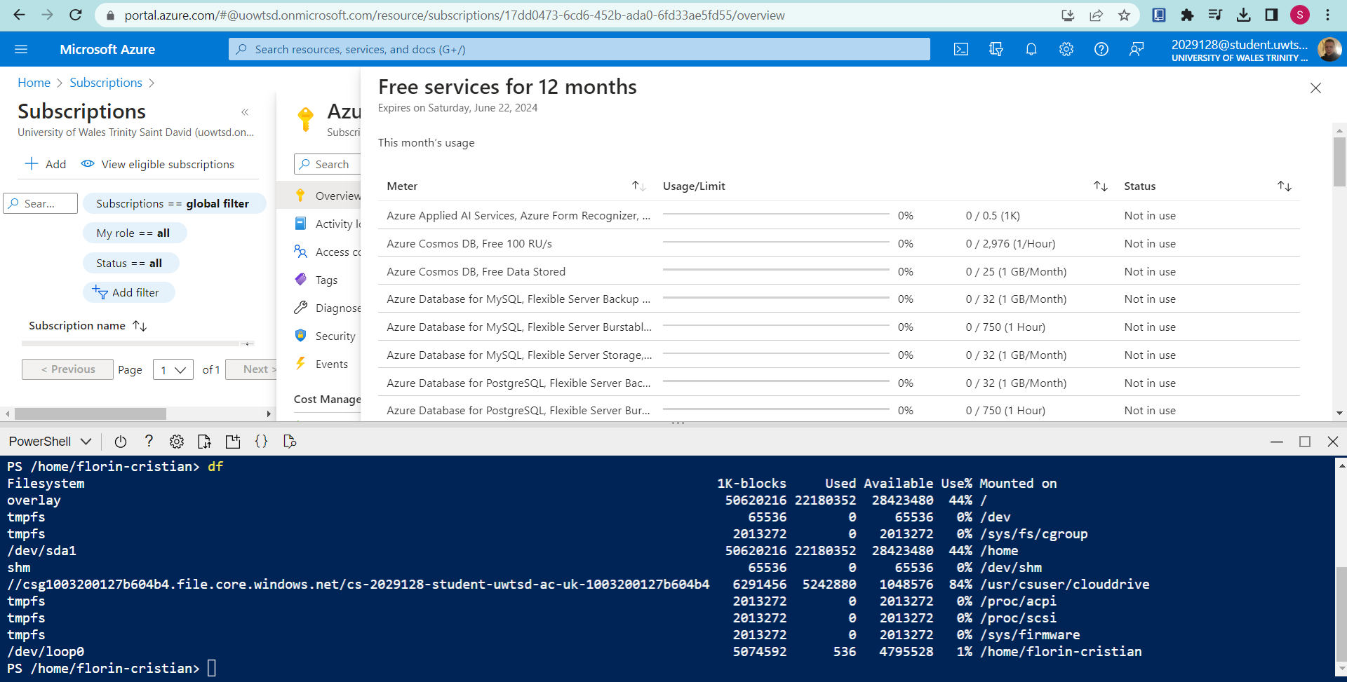
The following figure shows the opening storage account in Azure portal:
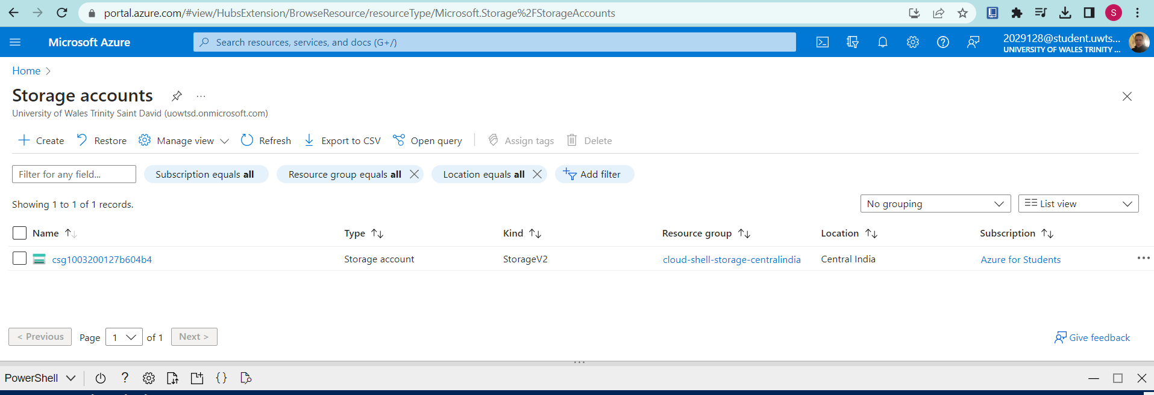
Opening resourcegroup is shown below:
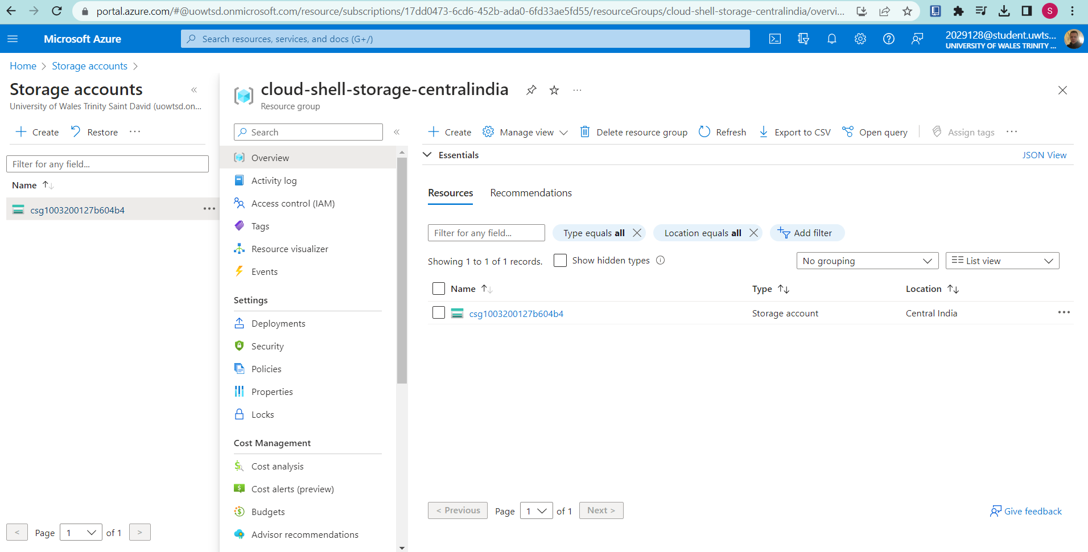
The creation of the tags in Azure portal is shown below:
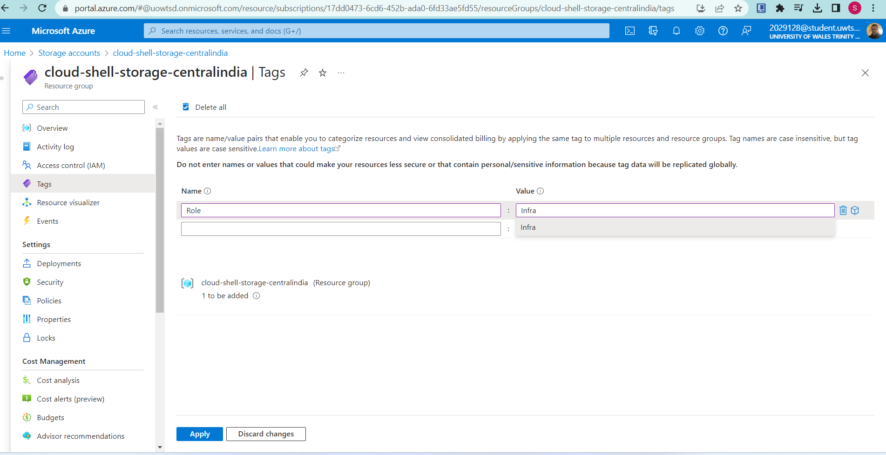
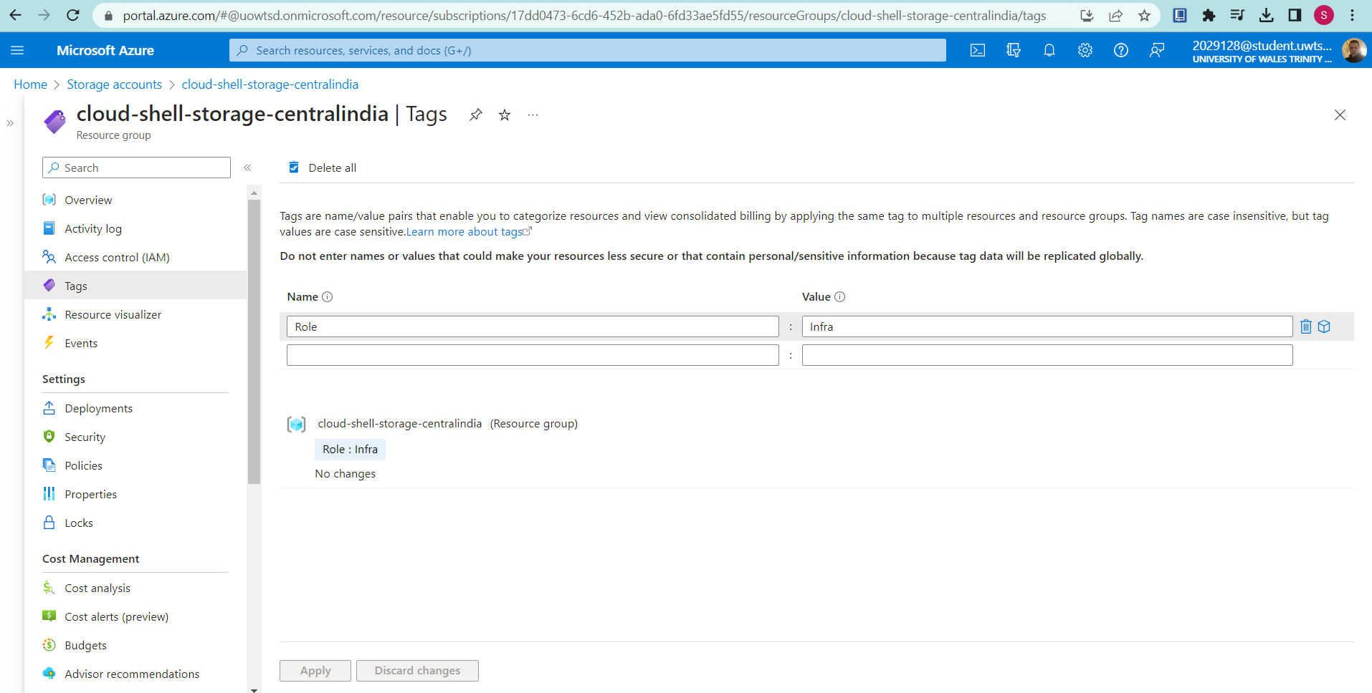
From the above figure, it can be seen that a tag has been created with the name: Role and Value: Infra.
Storage account tags is shown below:
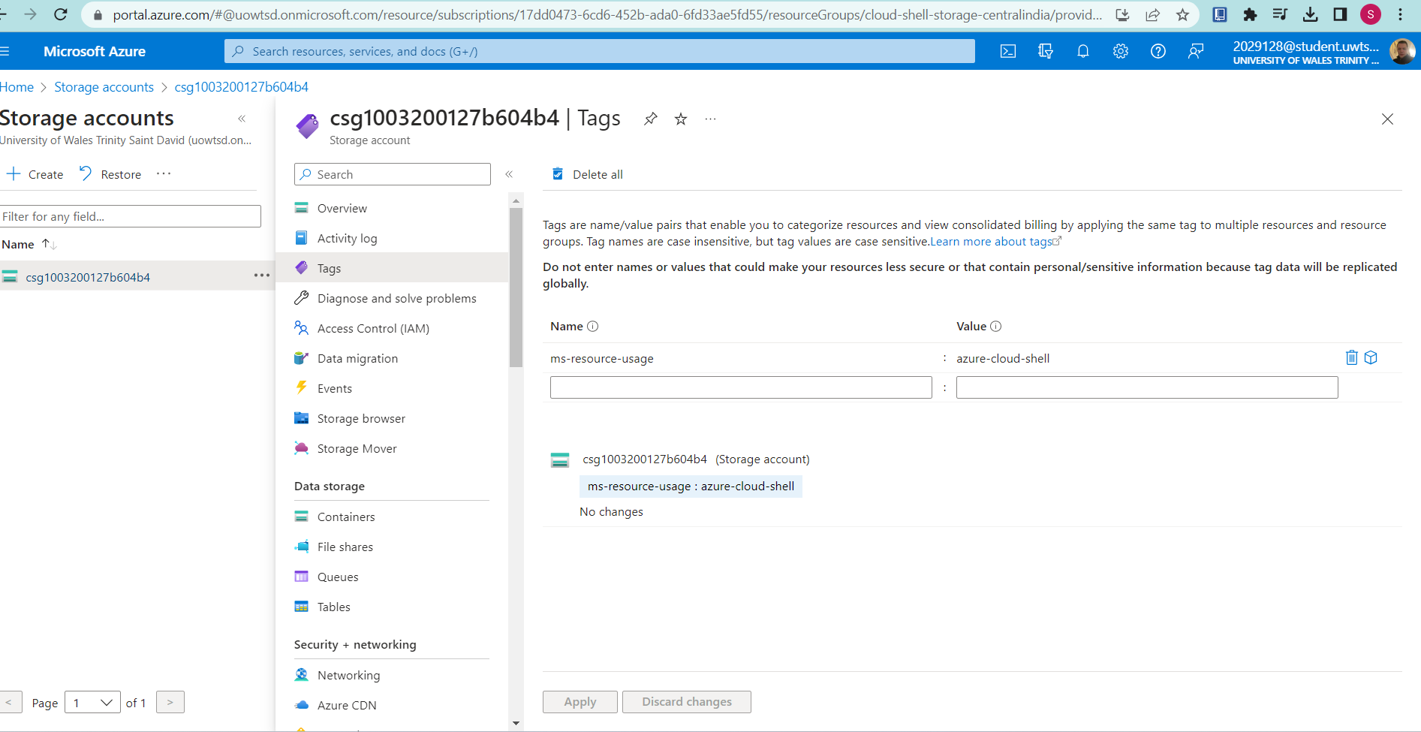
Task 2: Enforce tagging via an Azure policy
Opening policy in Azure portal:
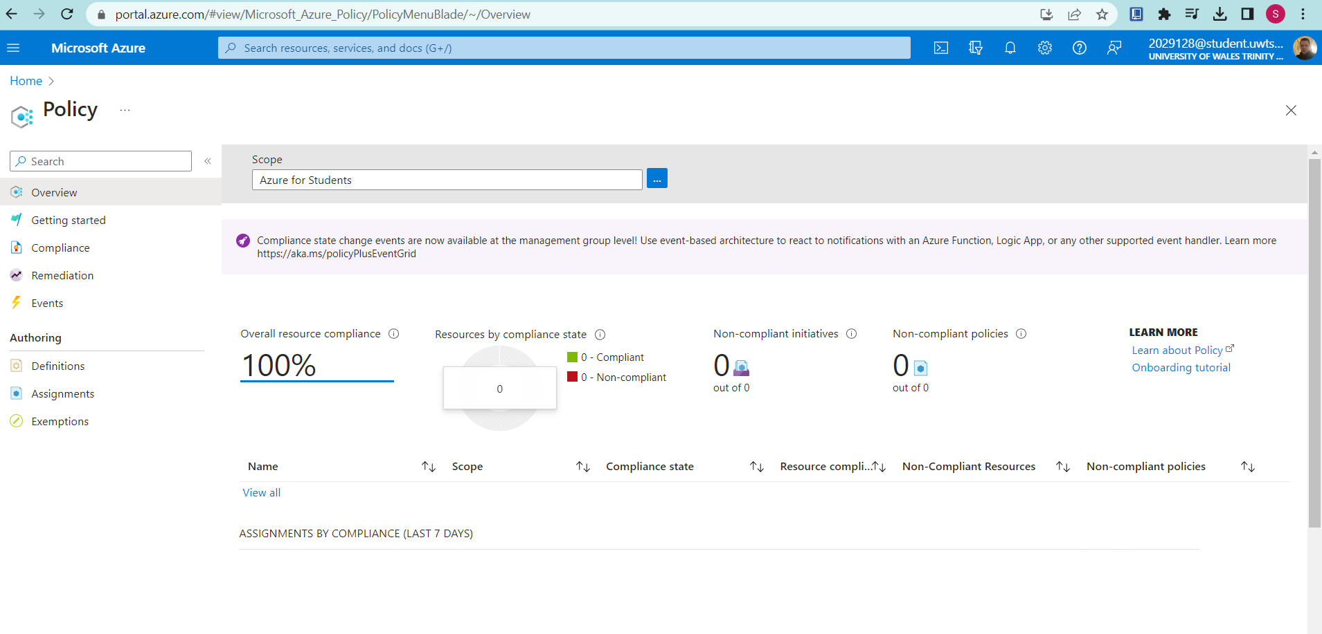
Opening tags policy:
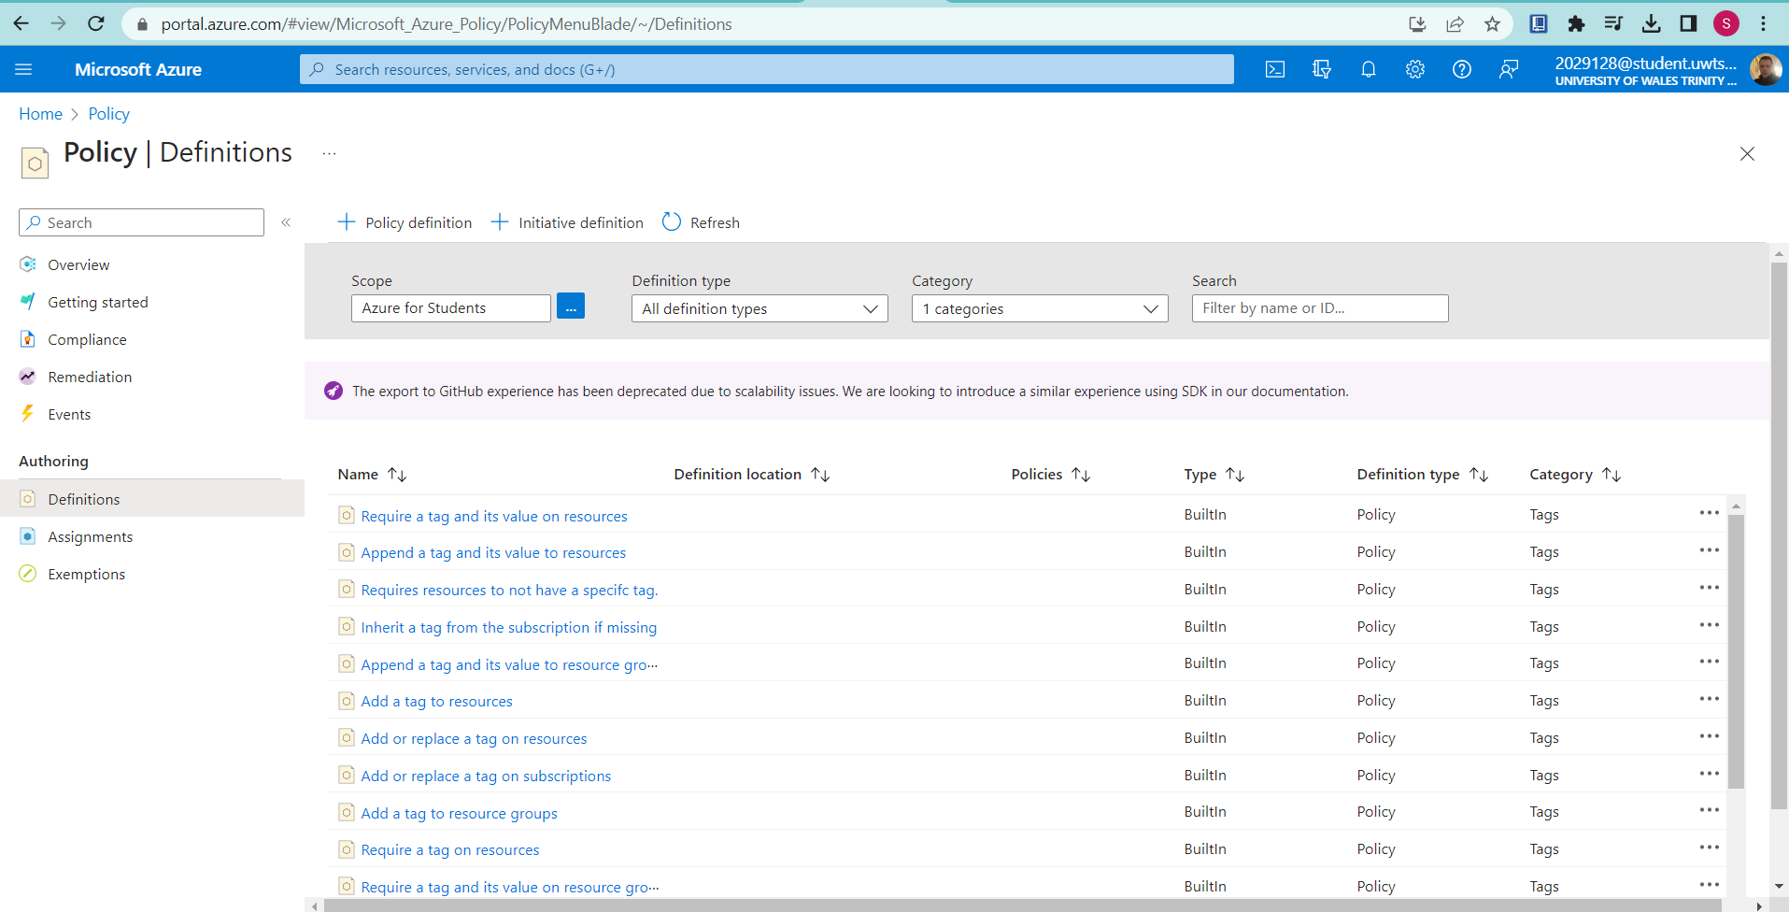
Opening a tag
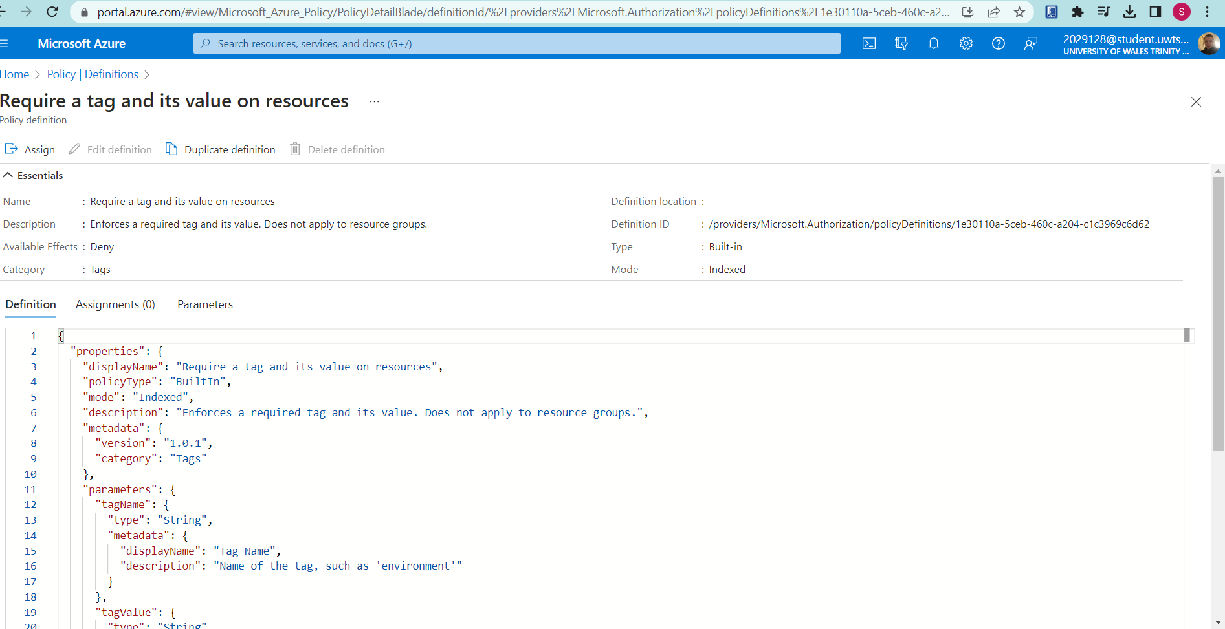
Assigning the policy is shown below:
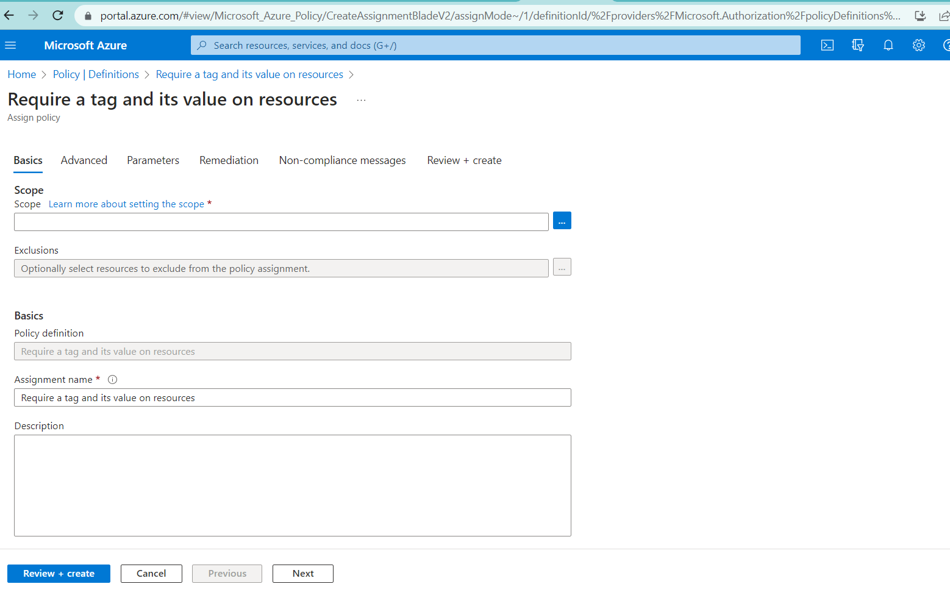
Specifying the scope is shown in the following figure:
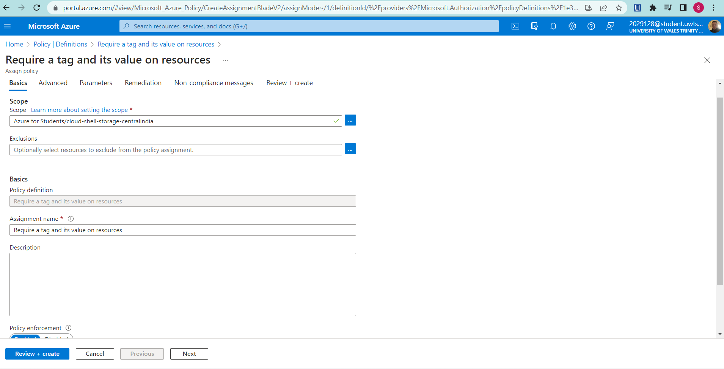
Basic properties configuration is shown in the following figure:
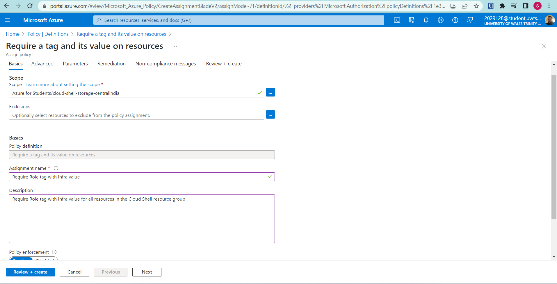
Setting parameter
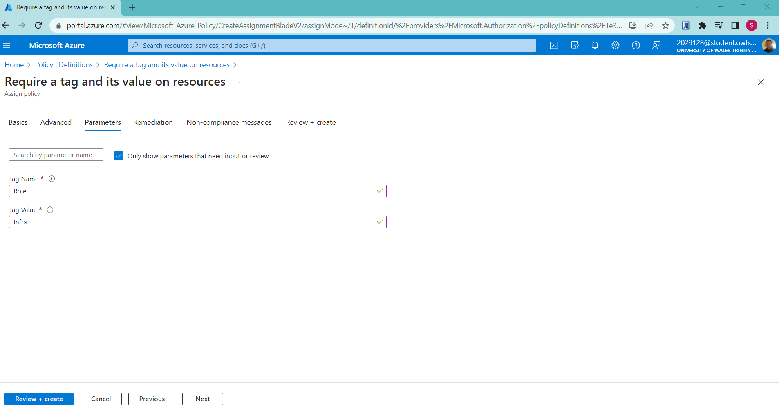
Creating the policy
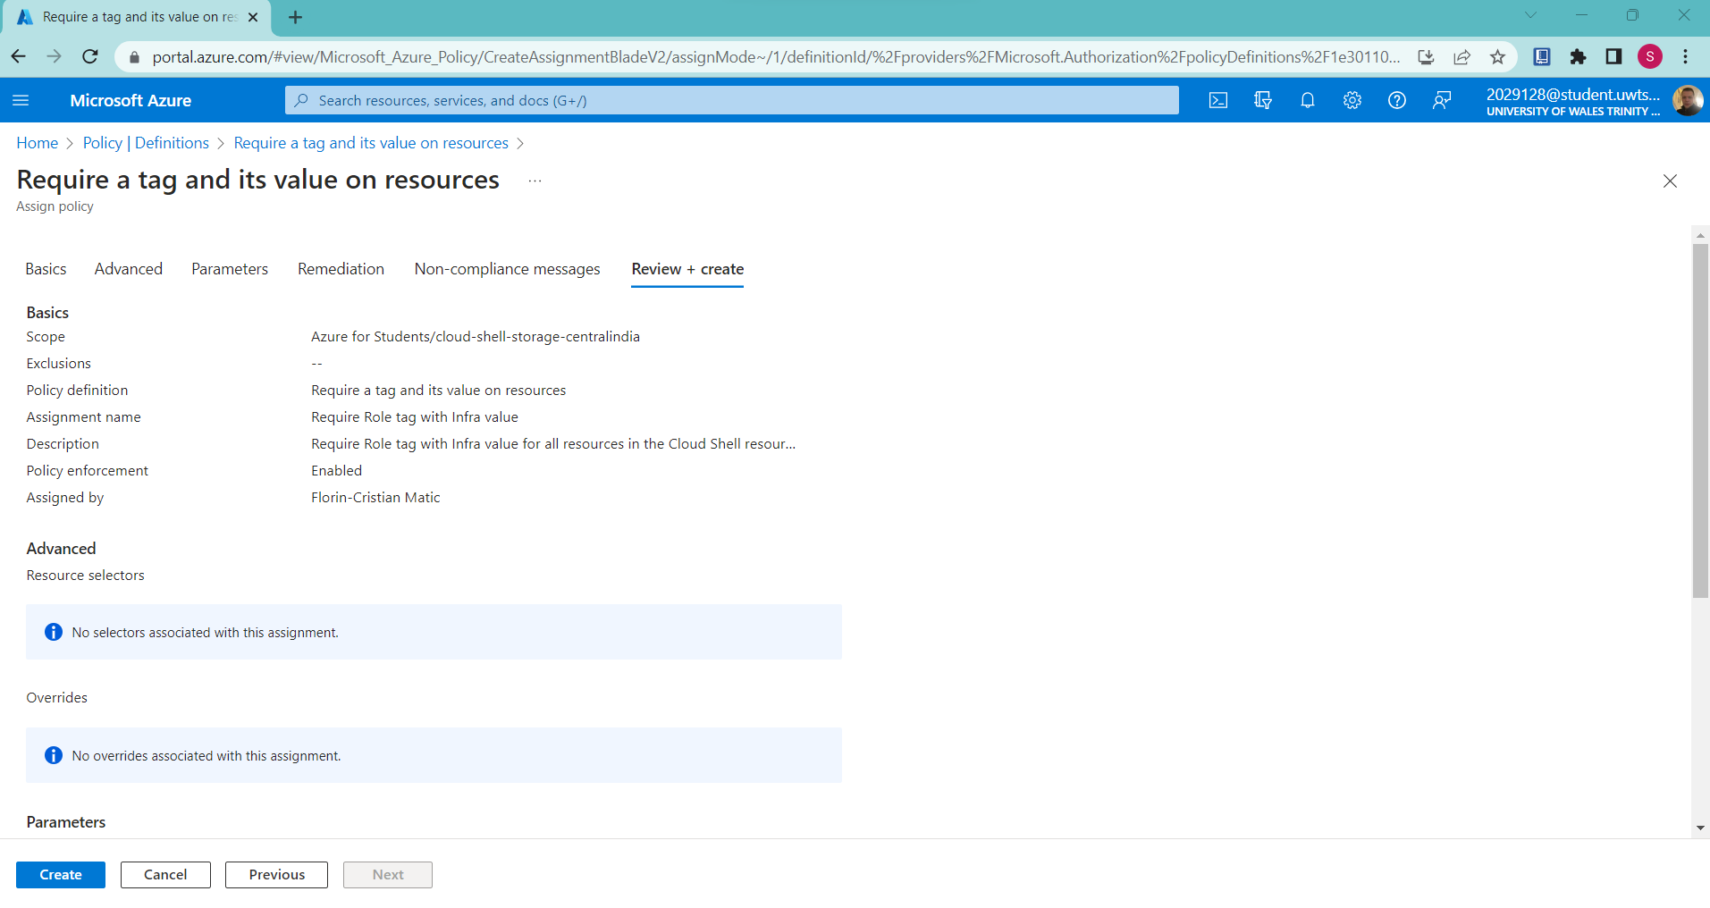
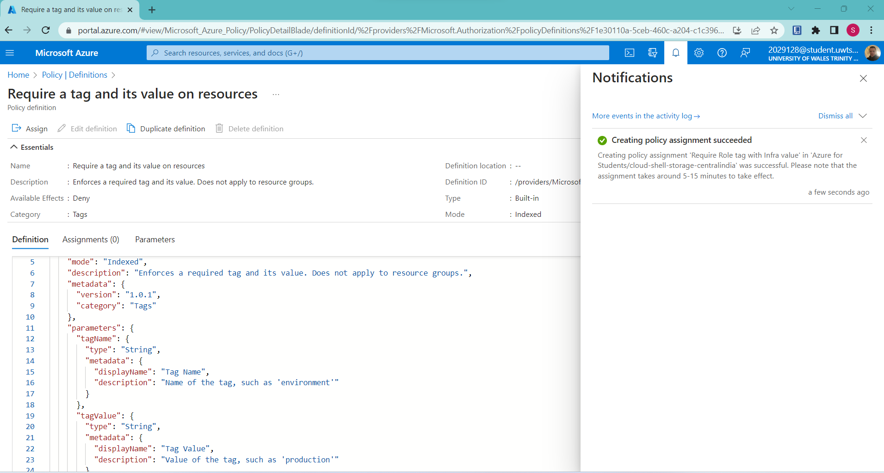
From the above figure, it can be seen that the policy has been created.
Navigating back to the resource group
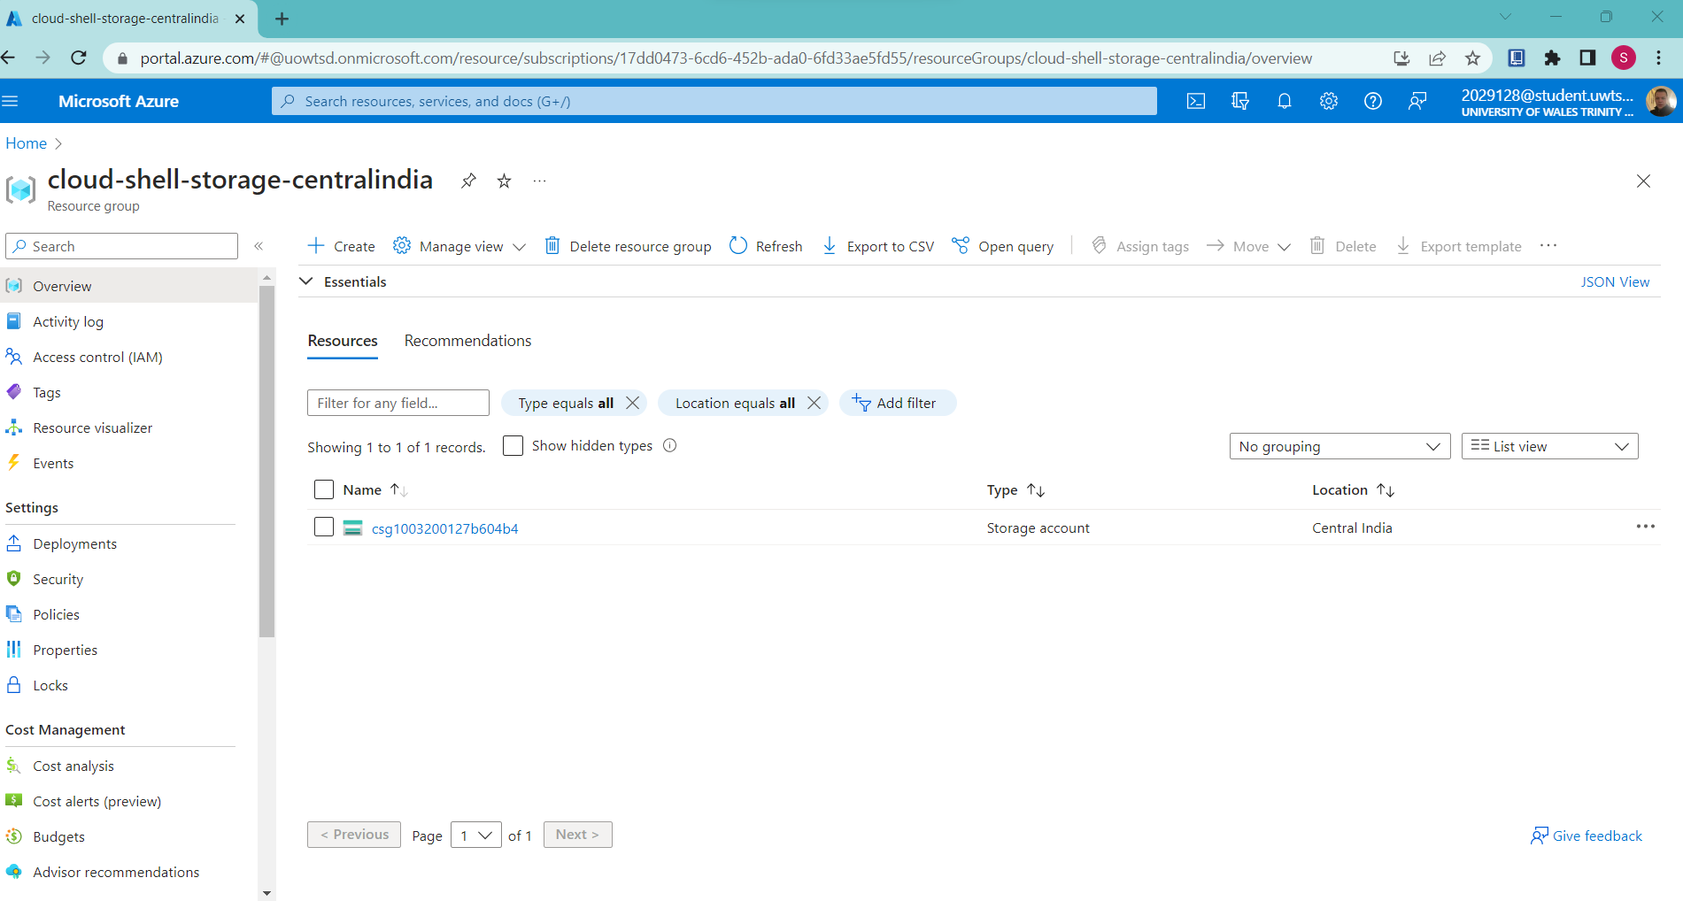
Creating a storage account
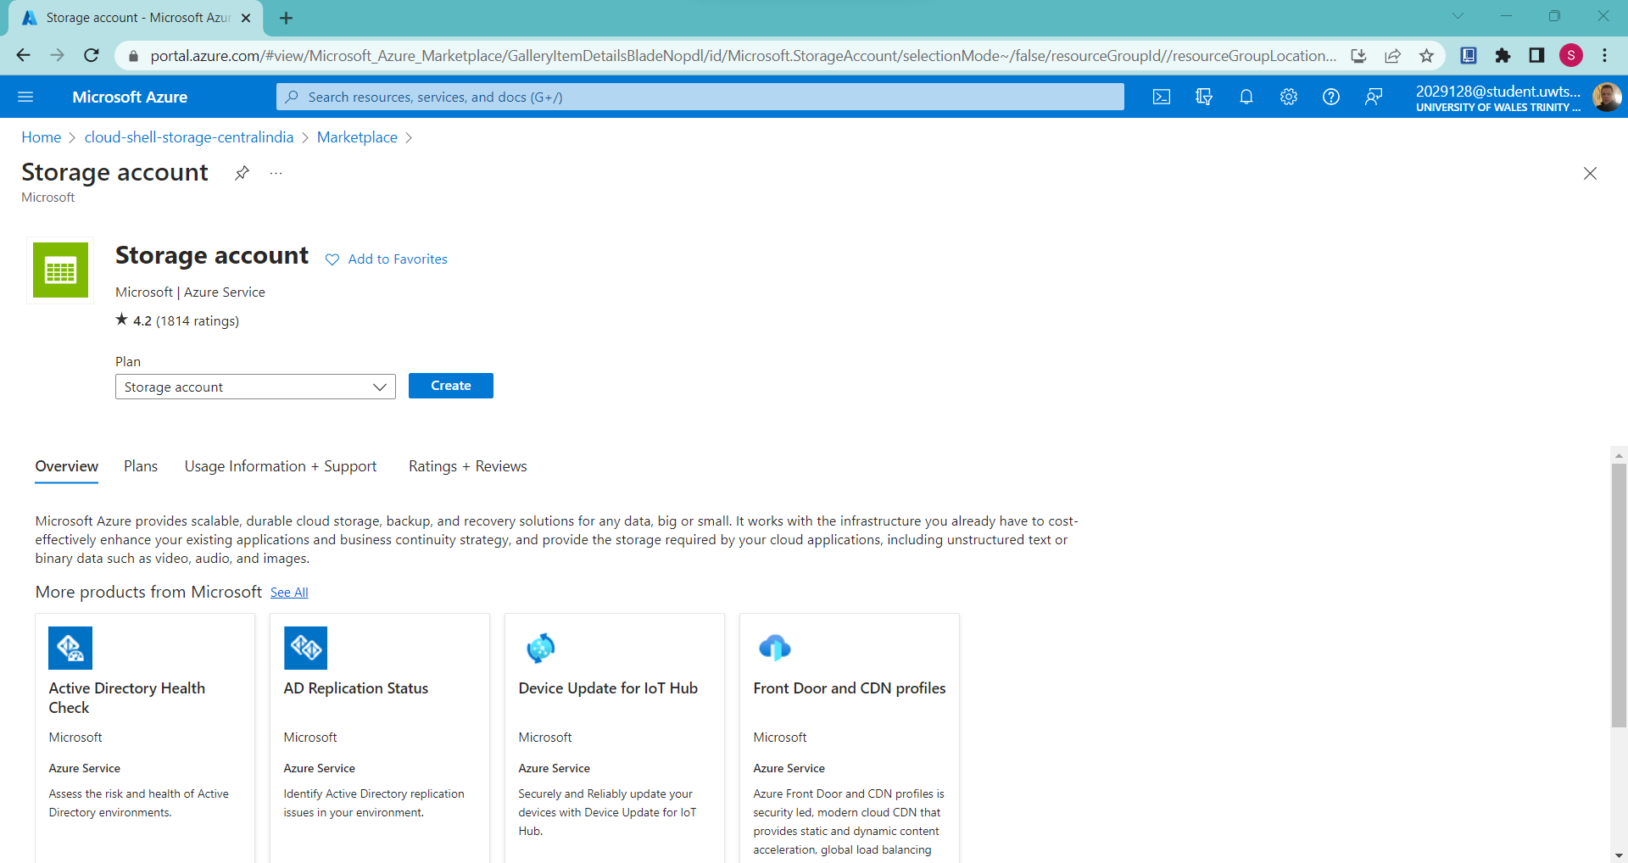
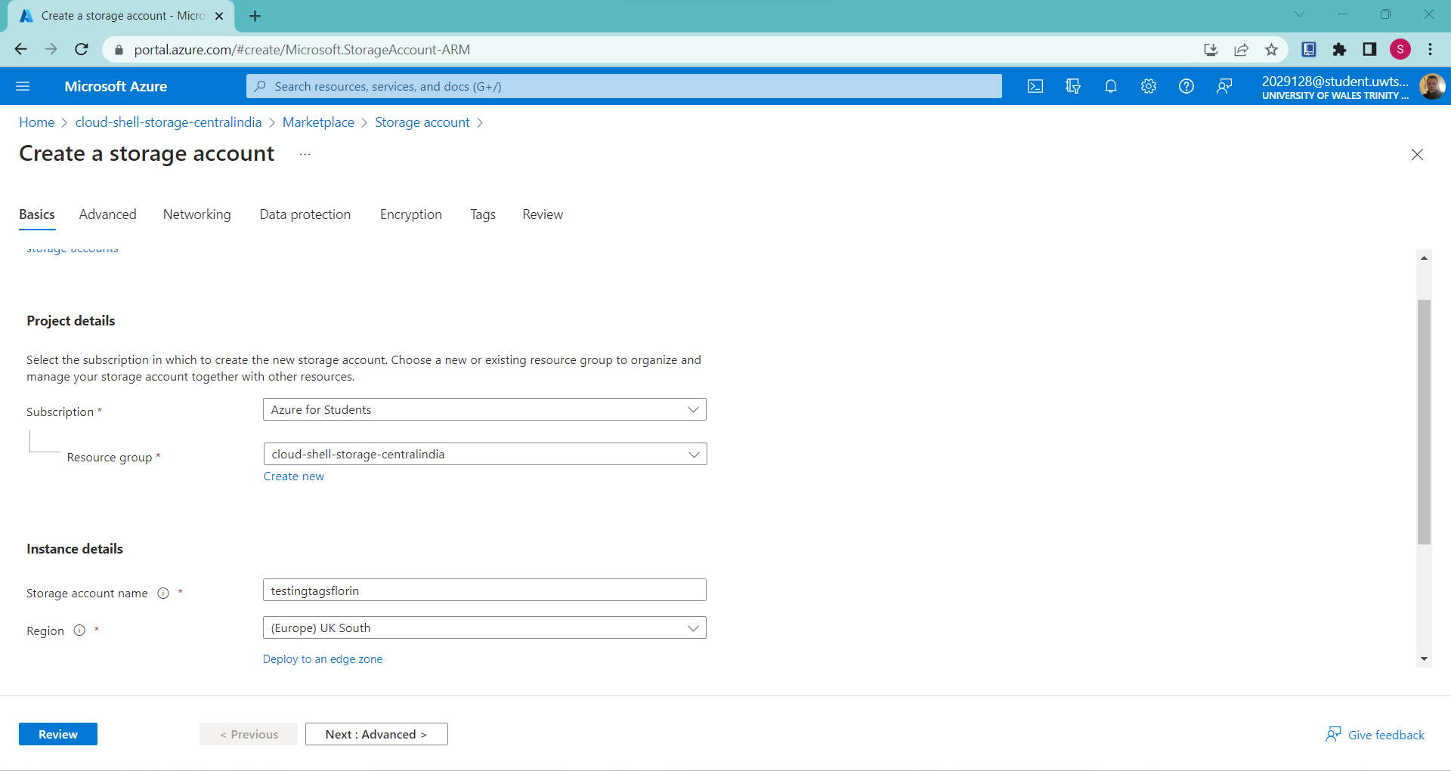
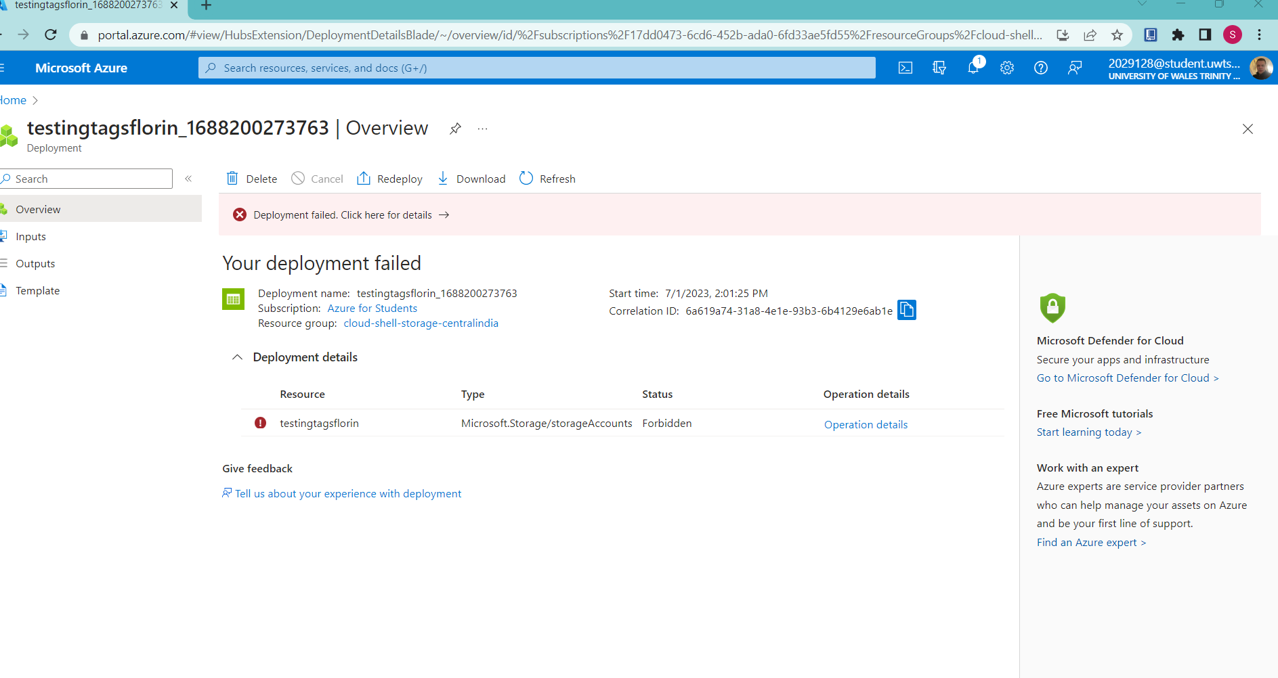
From the above figure, it can be seen that the storage account creation has been failed.
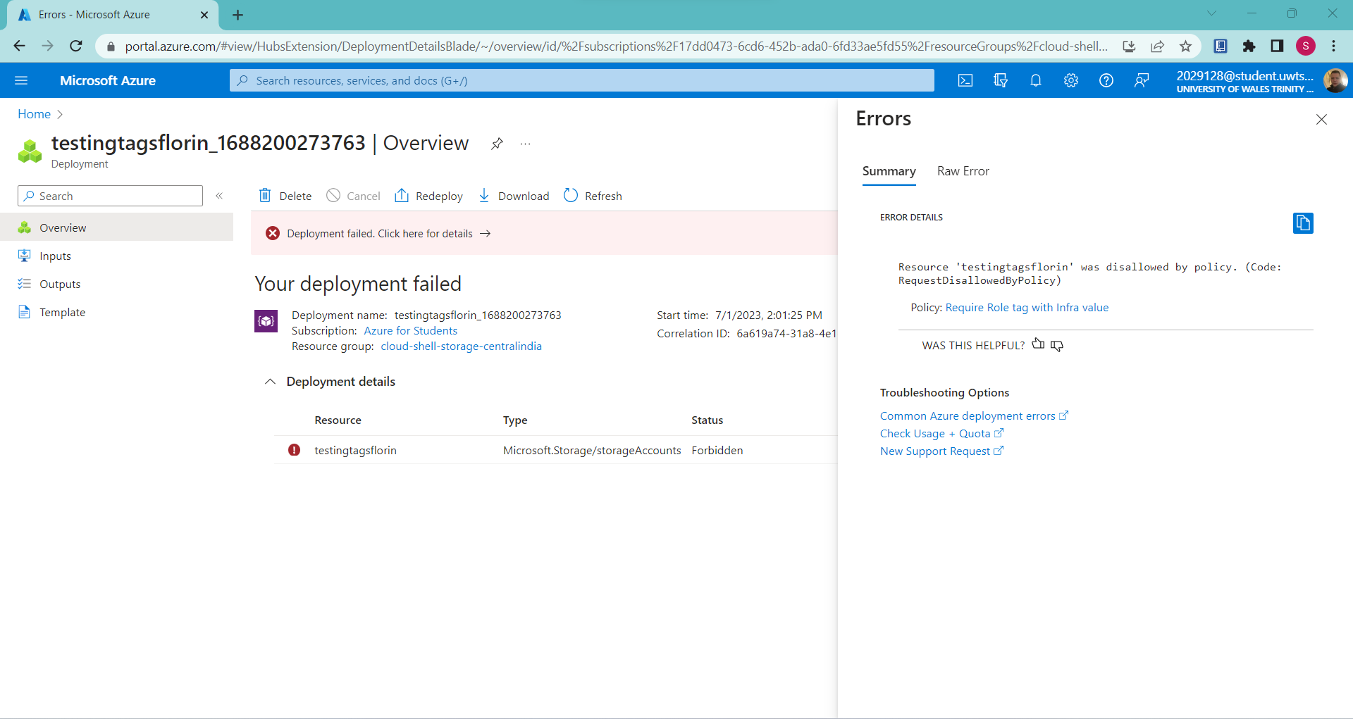
Here, the creation of the storage account has been failed because the storage account does not have a tag named Role with the value infra.
Task 3: Apply tagging via an Azure policy
In this task, an another policy definition will be utilized for remediating any kinds of non-compliant resource.
Opening policy is shown below:
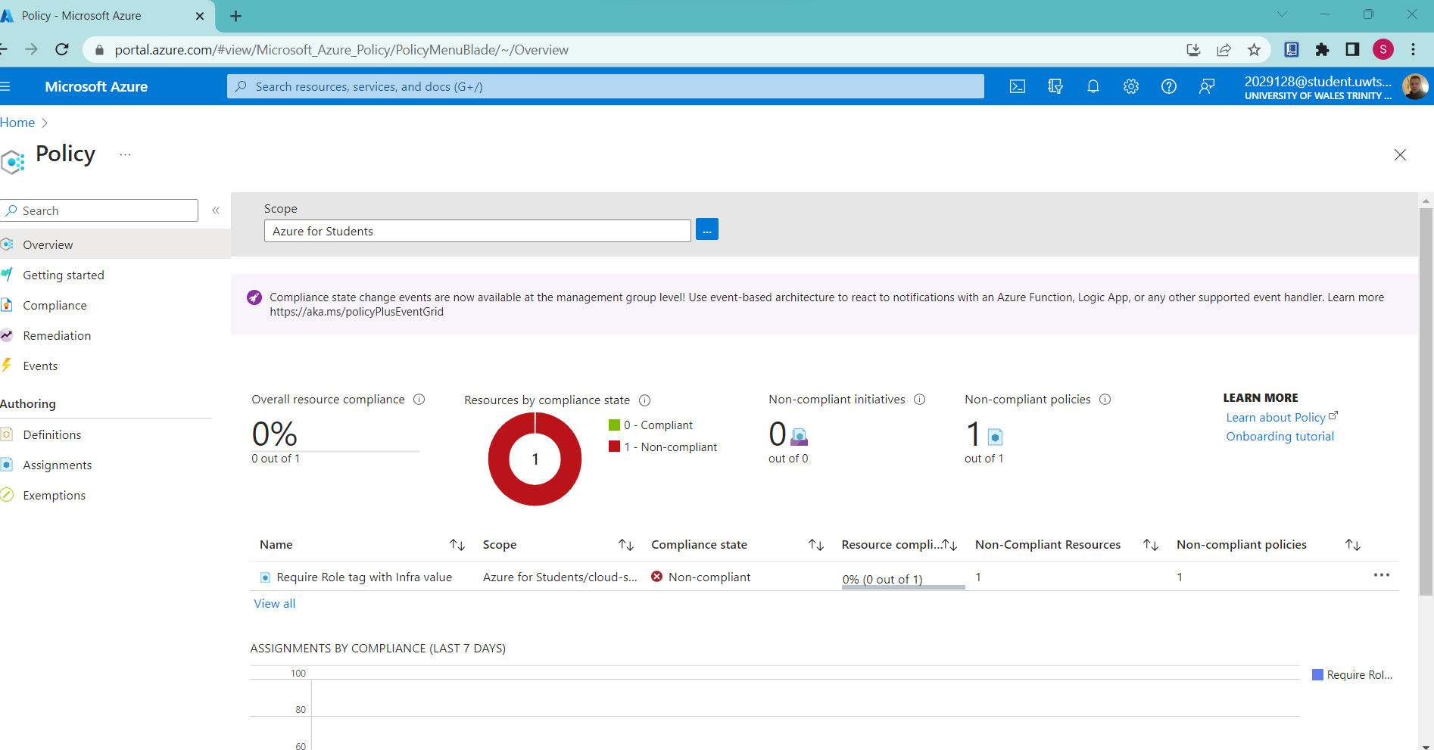
Opening assignment is shown below:
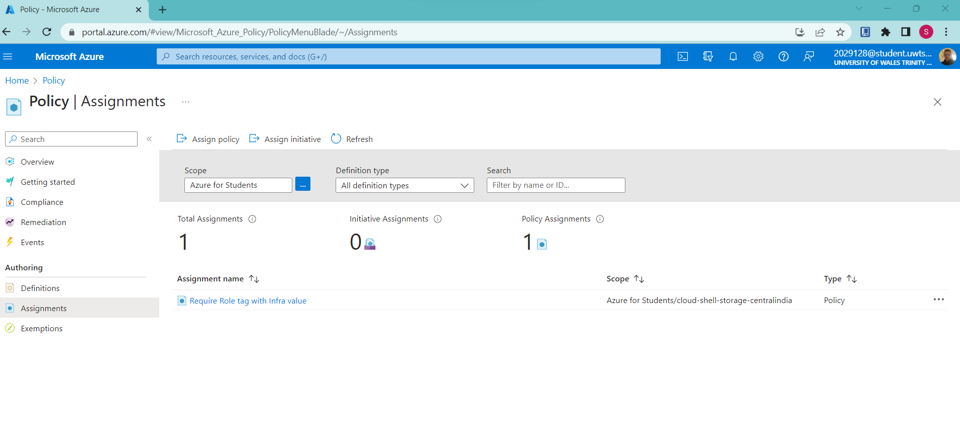
Deleting the assignment:
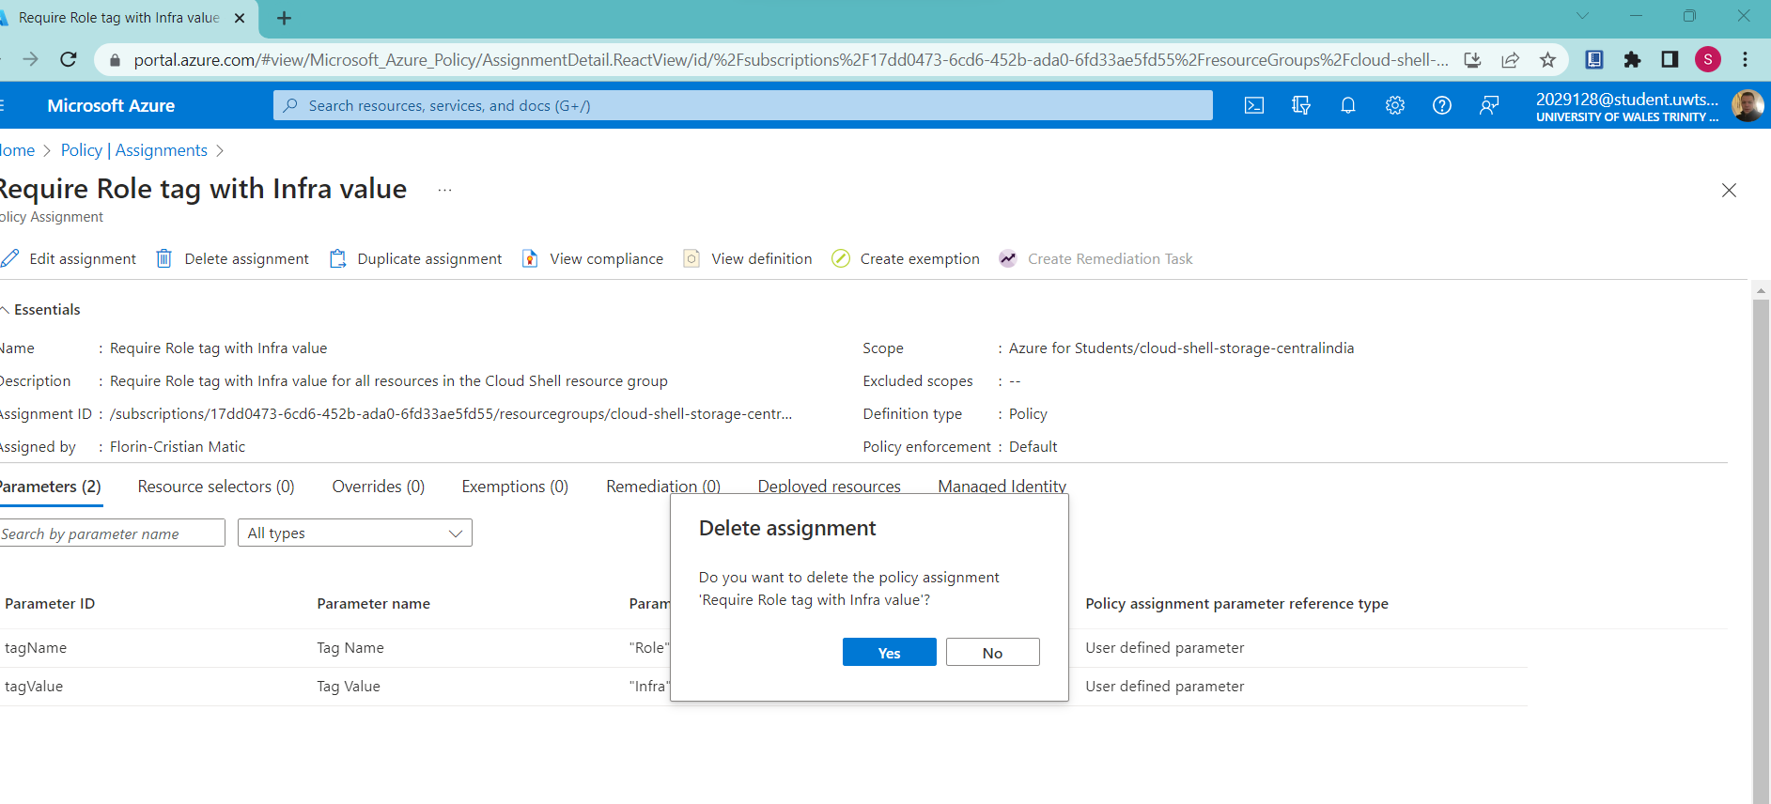
Assigning Policy
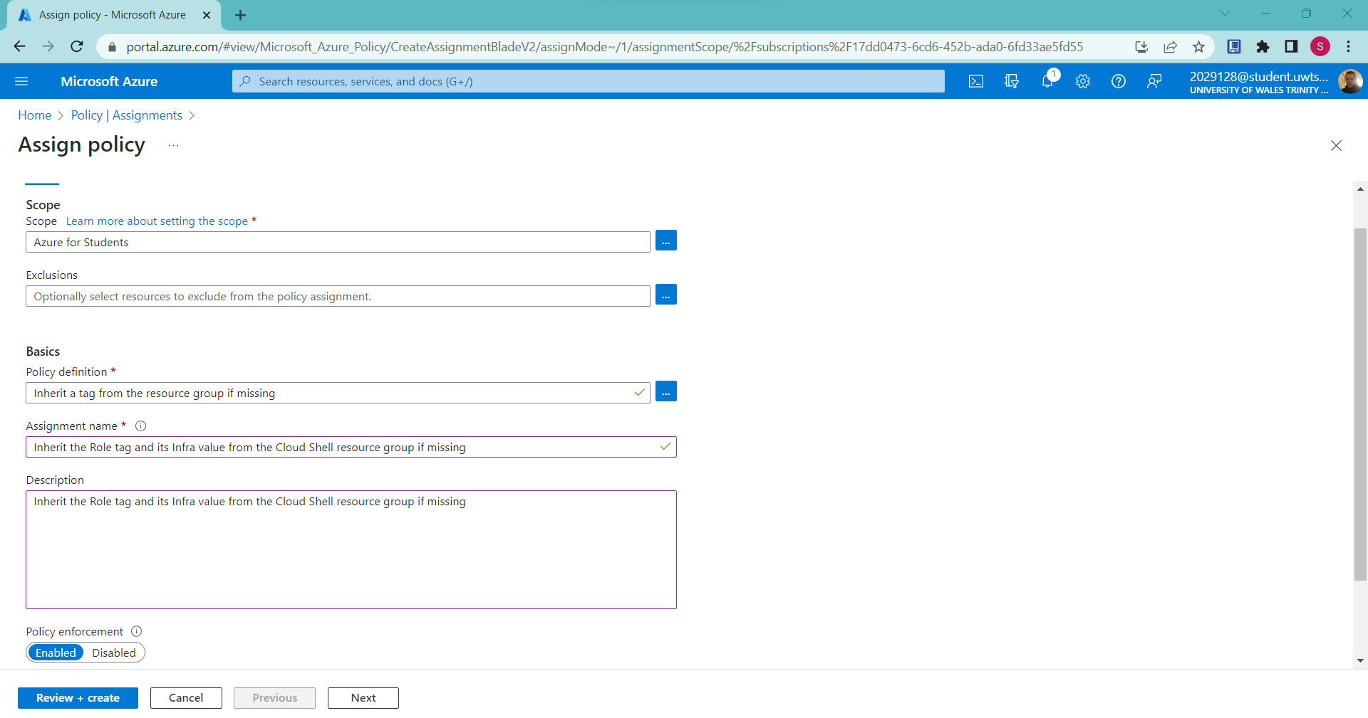
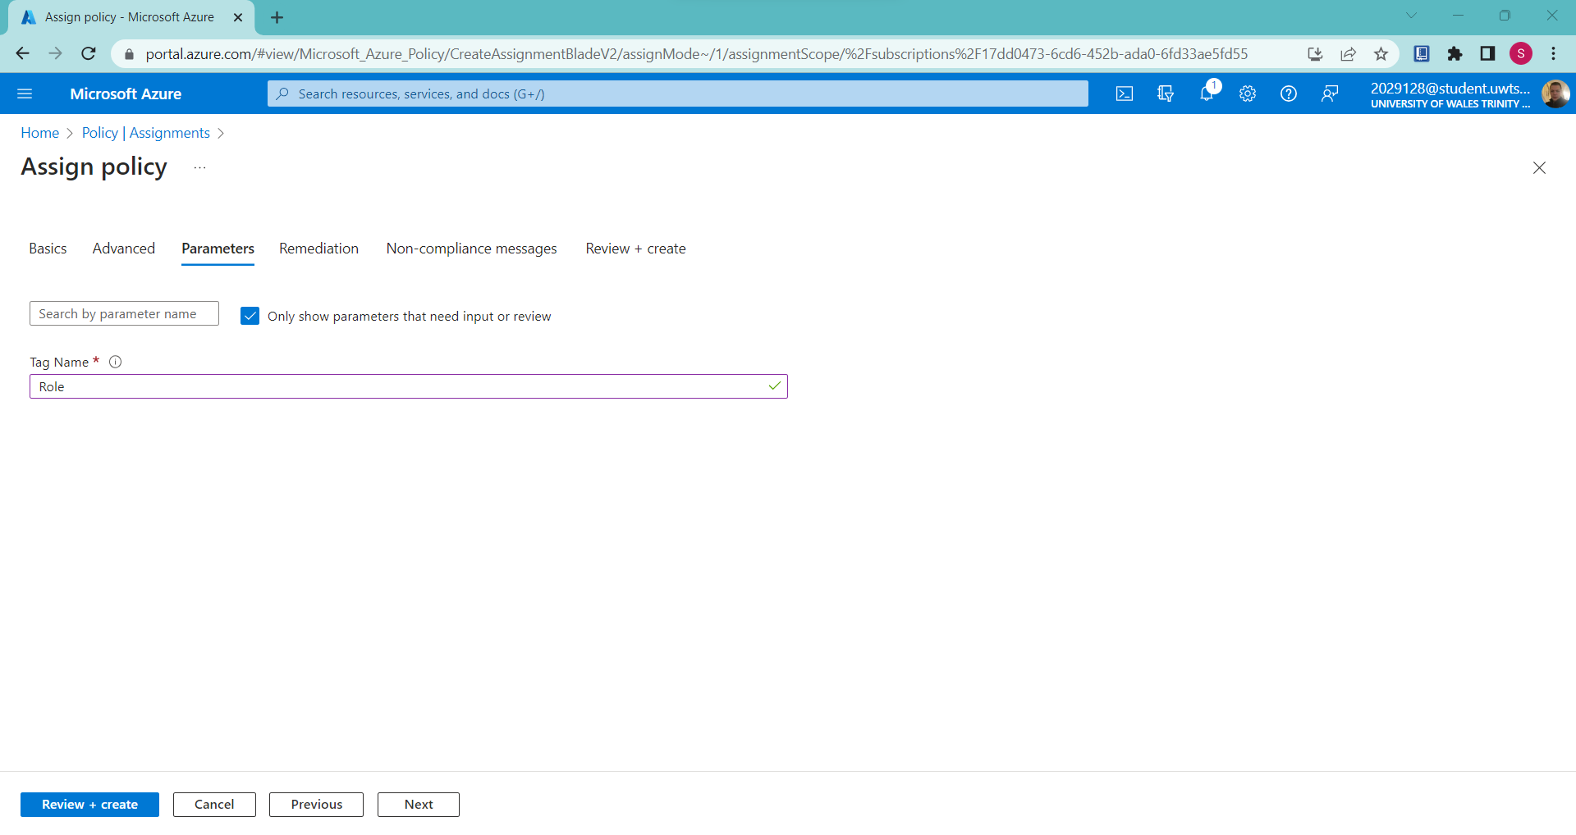
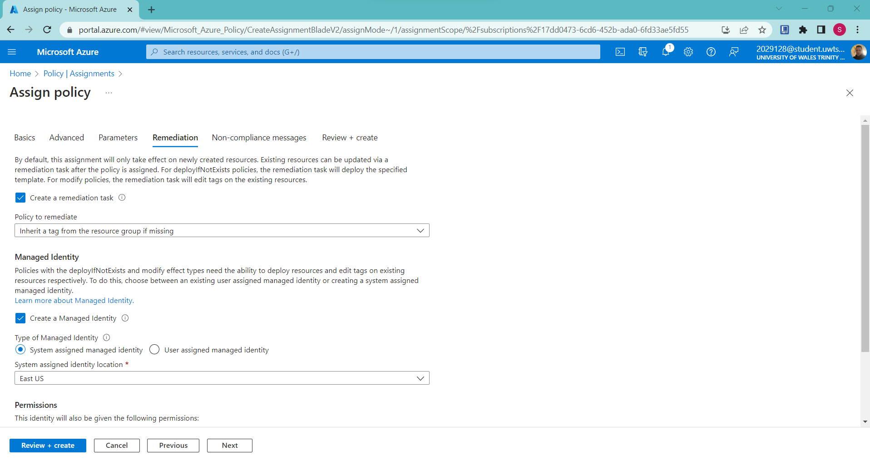
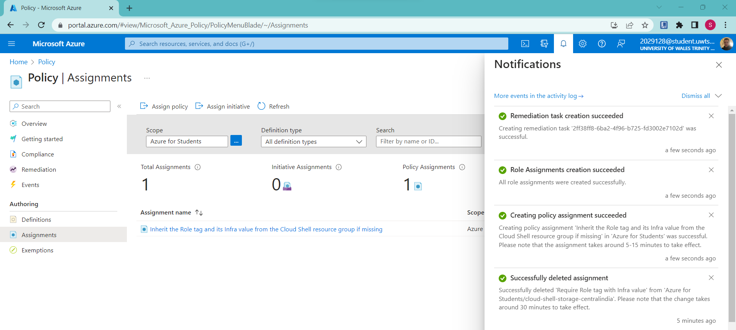
From the above figure, it can be seen that the policy has been assigned that inherit a tag from the resource if it is missing.
In order to verify the new policy, a new storage account will be created which is shown below:
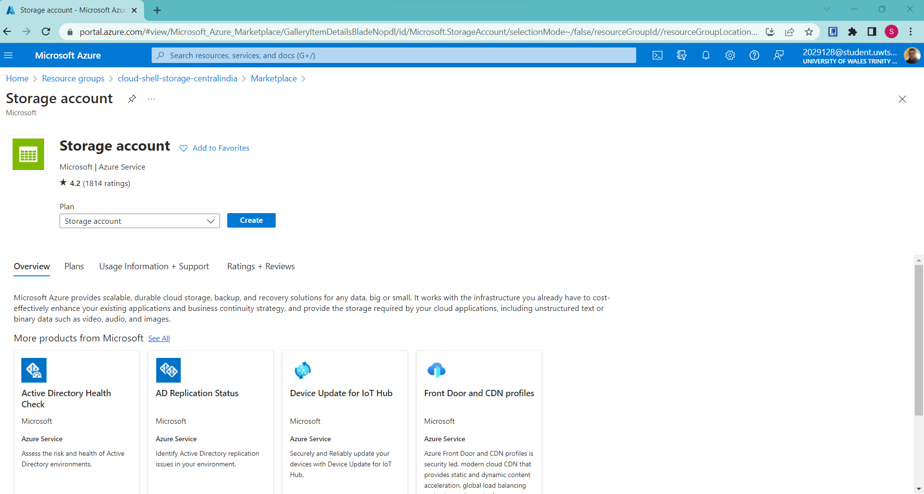
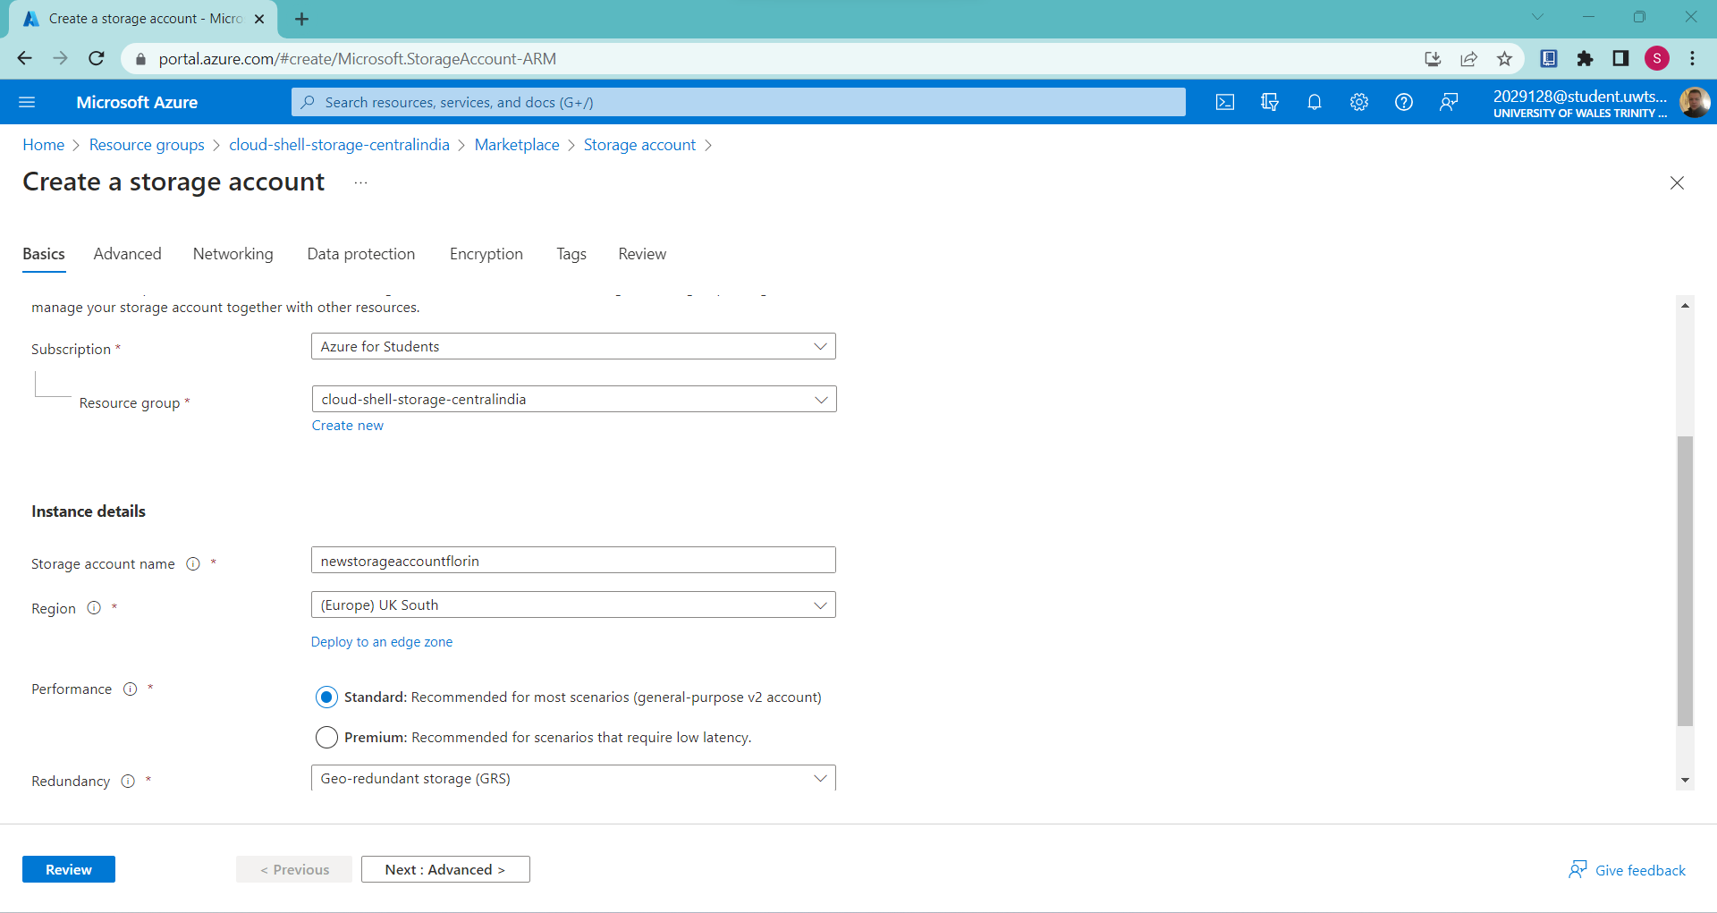
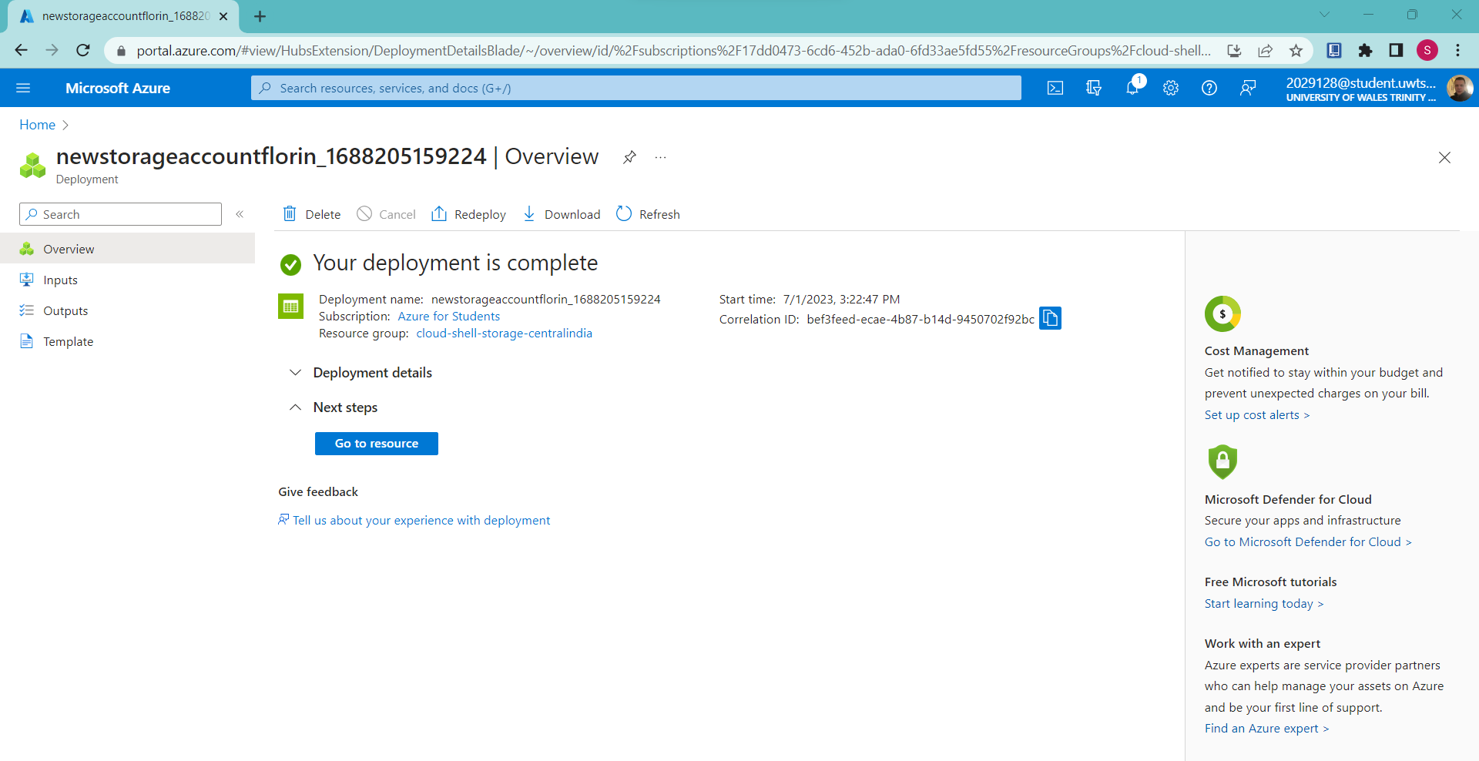
From the above figure, it can be seen that the deployment was completed successfully.
Tag verification
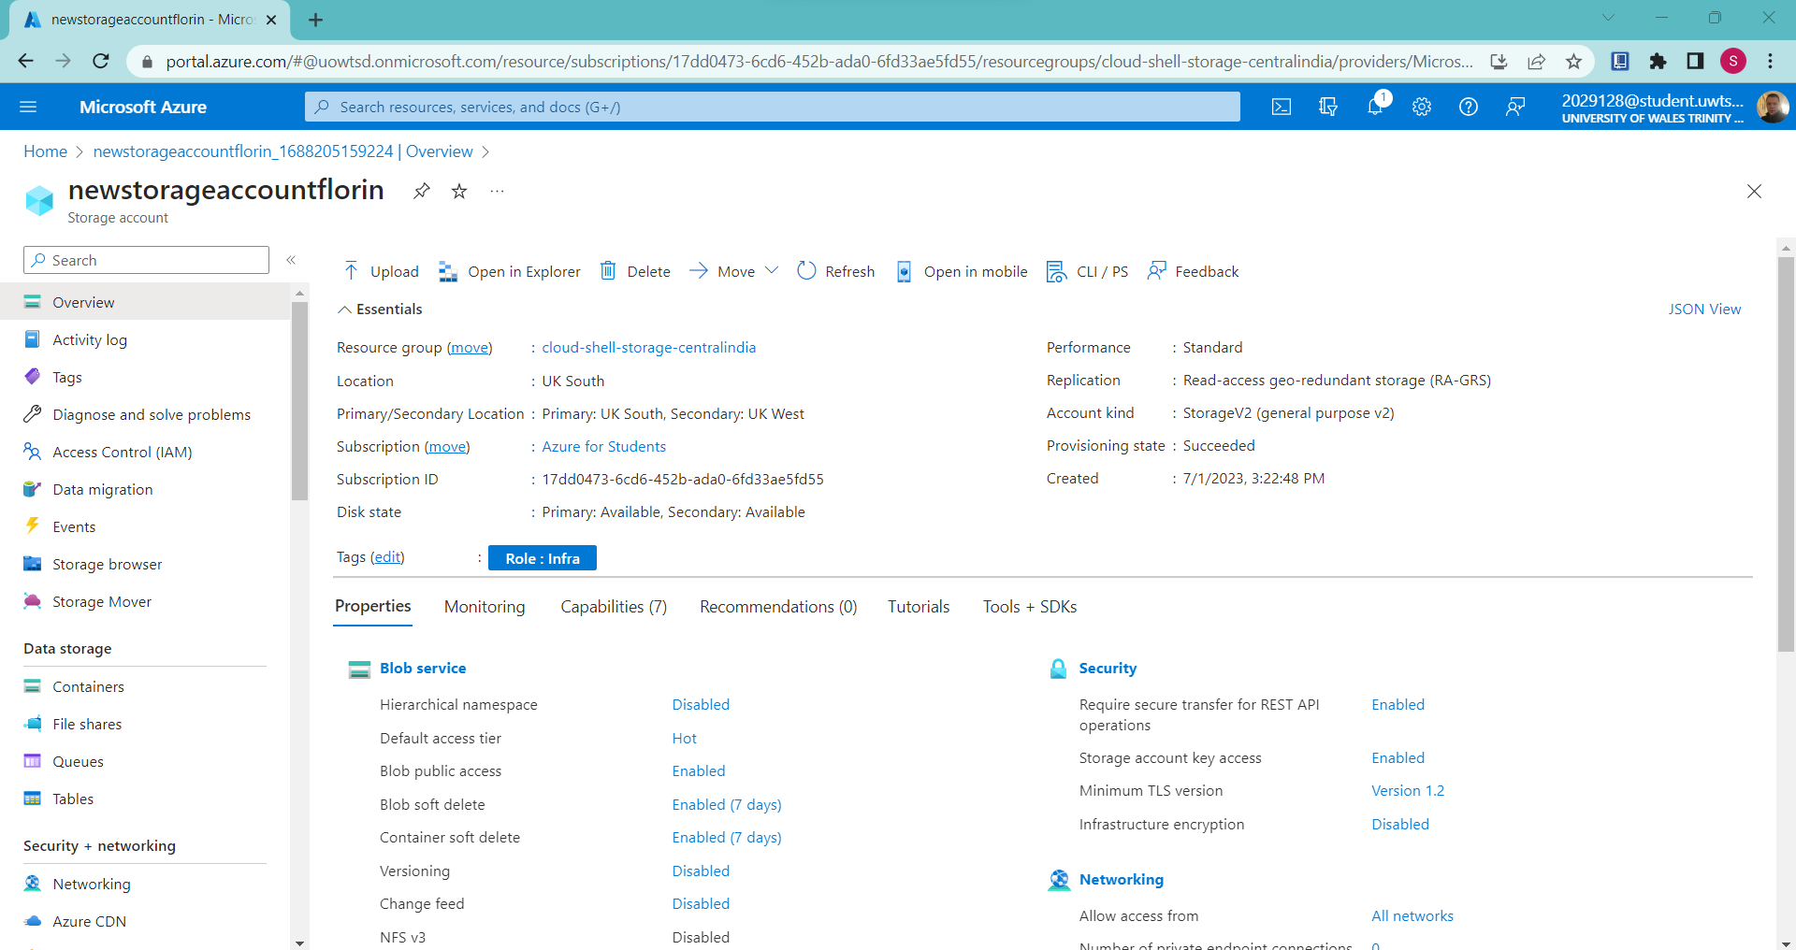
From the above figure, it can be seen that tag Role with the value Infra automatically assigned to the storage account.

Disaster Recovery Plan for Aspire Retailers
In association with the Aspire Retailers organization, for them to sufficiently keep a continuation with the usage of their confidential data and different cloud-based applications, a sophisticated and well-prepared Disaster Recovery Plan had been considered as the top most priority here. The so-called Disaster Recovery plan would be serving as a backup plan that the Aspire Retailers should be considering, if in future, they met with any kind of data breach. These plans generally had been composed of factors like that of a data backup, high data availability, geographic redundancy as well as failover mechanisms, respectively [6]. Based on the detailed analysis that had been conducted here on the migration of Aspire Retailers to the cloud platform, the associated Disaster Recovery Plan that should be implemented within the organization, based on their migration towards the Microsoft Azure had been composed of the following aspects:
- Azure Traffic Manager: - In association with the extreme need for implementing a Cloud Disaster Recovery plan here for Aspire Retailers, one of the aspects of Azure Cloud Disaster recovery plan, the Azure Traffic Manager would be extremely beneficial here for distributing the entire network traffic across different Azure regions, thus ensuring high availability and minimal downtime. With a proper configuration of Azure traffic manager, it would help Aspire Retailers to easily monitor the overall health of their retail website and would automatically directs their users to an alternative Azure server, if the currently operating server crashes. This aspect would further be beneficial for Aspire Retailers to route network traffics based on their performance, failover, so as to optimize their user’s overall performances [9].
- Identifying Critical Workload and Recovery Objectives: - Apart from managing the overall network traffic here, the Azure Cloud Disaster Recovery plan had also been sufficient for identifying the critical workloads and data that were needed to be protected and prioritized for recovery. This would even be beneficial for defining the objective of recovery, like that of Recovery Point Objective and Recovery Time Objective, which had been summarized for determining the acceptable loss of data and manage extreme network downtime.
- Azure Backups: - The associated feature of Azure Backup had been considered extremely beneficial for providing the Aspire Retailers with an additional layer of protection for the organization, while protecting and securing their data from any kinds of data breach. This very feature within the Azure Disaster Recovery plan had been composed of File-level, Folder-level, as well as System-level backups, which had been beneficial for allowing a flexible recovery option for Aspire Retailers. This feature would even be beneficial for the Aspire Retailers to sufficiently define a proper backup policy, retention periods, as well as frequencies of backup based on their requirement to protect their data [13].
- Azure Site Recovery: - Apart from this feature, the Azure Cloud Disaster Recovery plan had also been composed of a feature called Azure Site Recovery, which generally is a Disaster Recovery as a Services or (DRaaS) which had been beneficial for offering a sufficient number of replicated workloads to be executing on physical as well as VMs to Azure. Thus, the implementation of Azure Site Recovery to the existing On-premises VM of Aspire Retailers would be beneficial for providing the organization with a reliable recovery option, in case of any disaster. The Azure Site Recovery had also been considered beneficial for supporting for both homogenous as well as heterogenous environment, thus allowing the organization to easily replicate their existing infrastructure over Azure platform [7].
- Azure Virtual Machines Replication: - One of the aspects of a suitable Azure Disaster recovery plan here is that it would allow the Aspire Retailers to sufficiently utilize Azure Virtual Machine replication feature, which had been considered beneficial for ensuring their business continuity for critical workloads, which had been required to be hosted over the on-premises architecture of Aspire Retailers. With the utilization of this feature here, Aspire Retailers could easily replicate each change they determined to be making on their on-premises VMs over the Azure in real-time environment, which had been subjected to minimize any kind of data loss in the event of a system failure.
- Regular Testing and Monitoring: - As per this aspect, it had been extremely crucial here for conducting a frequent testing of the Azure Disaster recovery plan, that had been determined to be implemented over Aspire Retailers, so as to sufficiently ensure its effectiveness and further identify any kinds of potential issues, long before any actual disaster takes place, respectively. This also includes monitoring the status of each replication that had been made, while tracking the health of backup data and maintaining overall system performances, which could be performed while using the Azure Monitor and Azure Advisor [8].
- Documenting and Training: - Last, but not the least, it had also been required here to sufficiently document details of the disaster recovery plan, so as to ensure that each and every IT staff member at the Aspire Retailers could easily implement it whenever required without facing any issues regarding its execution. Apart from that, the Aspire Retailers should also be making sure that they had been taking notes for each job roles that their sufficient staff and related IT staff team should be playing, so as to overcome the disaster crisis in a coordinated way.

Conclusion
Based on the complete analysis being conducted at the report here, it had been determined that the adoption of Cloud solution could effectively benefits the Aspire Retailers for enhancing and improving their overall computing services while allowing them to overcome their subsequential issues regarding the proper data management on their existing on-premises datacenters. Thus, the report had determined the proper benefits that the Aspire Retailers could easily have gained while migrating their entire business architecture and on-premise datacenter over cloud platform, so as to easily manage the data availability, and manage rapid service deployment so as to meet their global expansion needs. While discussing the features that the cloud platform could deliver to Aspire Retailers, a detailed analysis on the Load balancing was also conducted at the report here. The report had sufficiently determined that through the usage of a load balancing, Aspire Retailer could easily achieve scalability, elasticity and optimize their overall performance and much more. Followed by that, the report had even proposed a detailed comparison among the top three cloud service providers which the Aspire Retailers should be consider to adopt to for providing a beneficial outrank for their existing business architecture, while migrating their business over the cloud platform.
For a detailed comparison, Microsoft Azure, Google Cloud Platform and Amazon Web Service had been selected, based on which it had been determined that the Microsoft Azure is the best choice for being used by Aspire Retailers organization, so as to fulfill their requirements. Followed by that, in terms of cost management, the Aspire Retailers had utilized Azure TCO or the Total Cost of Ownership here for successively estimating all ongoing monthly costs for all different aspects of computing configurations for the next 03 years. For furthermore analysis, it had also been found that Aspire Retailers had even adopted Azure Active Directory services for easily managing various users and group accounts over their platform. During the analysis, it had even been conveyed that with the proper usage of Azure AD, Aspire Retailers had been looking forward to gain benefits like that of security enhancement, identity management and user access control across their global operation. Apart from that, the report here had also discussed about what kind of cloud governance strategy that Aspire Retailers had been associated to utilize here for securing access of cloud resources. Last, but not the least, the report here had also provided a proper guidance of what kind of disaster recovery plan should be implemented here at Aspire Retailers for supporting their data and application on clouds.

References
[1] A. Alam, “Cloud-based e-learning: Scaffolding the environment for adaptive E-learning ecosystem based on cloud computing infrastructure,” Lecture Notes in Networks and Systems, pp. 1–9, 2022. doi:10.1007/978-981-19-1976-3_1
[2] A. S. Muhammed and D. Ucuz, “Comparison of the IOT platform vendors, Microsoft Azure, Amazon Web Services, and google cloud, from users’ perspectives,” 2020 8th International Symposium on Digital Forensics and Security (ISDFS), 2020. doi:10.1109/isdfs49300.2020.9116254
[3] B. Gupta, P. Mittal, and T. Mufti, “A review on Amazon Web Service (AWS), Microsoft Azure & Google Cloud Platform (GCP) services,” Proceedings of the 2nd International Conference on ICT for Digital, Smart, and Sustainable Development, ICIDSSD 2020, 27-28 February 2020, Jamia Hamdard, New Delhi, India, 2021. doi:10.4108/eai.27-2-2020.2303255
[4] C. Butpheng, K.-H. Yeh, and H. Xiong, “Security and privacy in IOT-cloud-based e-health systems—a comprehensive review,” Symmetry, vol. 12, no. 7, p. 1191, 2020. doi:10.3390/sym12071191
[5] H. R. Vanderhorst, S. Suresh, S. Renukappa, and D. Heesom, “Strategic framework of unmanned aerial systems integration in the disaster management public organisations of the Dominican Republic,” International Journal of Disaster Risk Reduction, vol. 56, p. 102088, 2021. doi:10.1016/j.ijdrr.2021.102088
[6] H. S. Munawar, S. Qayyum, F. Ullah, and S. Sepasgozar, “Big Data and its applications in smart real estate and the Disaster Management Life Cycle: A systematic analysis,” Big Data and Cognitive Computing, vol. 4, no. 2, p. 4, 2020. doi:10.3390/bdcc4020004
[7] M. A. Kamal*, H. W. Raza, M. M. Alam, and M. M. Su’ud*, “Highlight the features of AWS, GCP and Microsoft Azure that have an impact when choosing a cloud service provider,” International Journal of Recent Technology and Engineering (IJRTE), vol. 8, no. 5, pp. 4124–4132, 2020. doi:10.35940/ijrte.d8573.018520
[8] M. Giannakis, K. Spanaki, and R. Dubey, “A cloud-based supply chain management system: Effects on supply chain responsiveness,” Journal of Enterprise Information Management, vol. 32, no. 4, pp. 585–607, 2019. doi:10.1108/jeim-05-2018-0106
[9] M. Hasan and B. Starly, “Decentralized Cloud Manufacturing-as-a-service (CMaaS) platform architecture with Configurable Digital assets,” Journal of Manufacturing Systems, vol. 56, pp. 157–174, 2020. doi:10.1016/j.jmsy.2020.05.017
[10] P. Dutta and P. Dutta, “Comparative study of cloud services offered by Amazon, Microsoft and Google,” International Journal of Trend in Scientific Research and Development, vol. Volume-3, no. Issue-3, pp. 981–985, 2019. doi:10.31142/ijtsrd23170
[11] P. Wankhede, M. Talati, and R. Chinchamalatpure, “Comparative study of cloud platforms -microsoft azure, Google Cloud Platform and Amazon EC2,” Journal of Research in Engineering and Applied Sciences, vol. 05, no. 02, pp. 60–64, 2020. doi:10.46565/jreas.2020.v05i02.004
[12] R. M. Al-Sayyed et al., “An investigation of Microsoft Azure and Amazon Web Services from users’ perspectives,” International Journal of Emerging Technologies in Learning (iJET), vol. 14, no. 10, p. 217, 2019. doi:10.3991/ijet.v14i10.9902
[13] S. Hamadah and D. Aqel, “A proposed virtual private cloud-based Disaster Recovery Strategy,” 2019 IEEE Jordan International Joint Conference on Electrical Engineering and Information Technology (JEEIT), 2019. doi:10.1109/jeeit.2019.8717404
[14] S. S. Gill et al., “Transformative effects of IOT, blockchain and Artificial Intelligence on Cloud Computing: Evolution, vision, trends and open challenges,” Internet of Things, vol. 8, p. 100118, 2019. doi:10.1016/j.iot.2019.100118
[15] U. K.C., S. Garg, J. Hilton, J. Aryal, and N. Forbes-Smith, “Cloud computing in natural hazard modeling systems: Current research trends and future directions,” International Journal of Disaster Risk Reduction, vol. 38, p. 101188, 2019. doi:10.1016/j.ijdrr.2019.101188
[16] Z. R. Alashhab et al., “Distributed denial of service attacks against cloud computing environment: Survey, issues, challenges and coherent taxonomy,” Applied Sciences, vol. 12, no. 23, p. 12441, 2022. doi:10.3390/app122312441
[17] Q. Wang and D. Wang, “Understanding failures in security proofs of multi-factor authentication for mobile devices,” IEEE Transactions on Information Forensics and Security, vol. 18, pp. 597–612, 2023. doi:10.1109/tifs.2022.3227753.
[18] M. Ghasemisharif, C. Kanich, and J. Polakis, “Towards automated auditing for account and session management flaws in single sign-on deployments,” 2022 IEEE Symposium on Security and Privacy (SP), 2022. doi:10.1109/sp46214.2022.9833753
[19] G. Fragkos, J. Johnson, and E. E. Tsiropoulou, “Dynamic role-based access control policy for smart grid applications: An offline deep reinforcement learning approach,” IEEE Transactions on Human-Machine Systems, vol. 52, no. 4, pp. 761–773, 2022. doi:10.1109/thms.2022.3163185
[20] N. Syynimaa, “Exploring azure active directory attack surface: Enumerating authentication methods with open-source intelligence tools,” Proceedings of the 24th International Conference on Enterprise Information Systems, 2022. doi:10.5220/0011077100003179
[21] H. Qonitah, “Asset tagging and line number automation: A cloud-based application system used for identification and registering of tag and line numbers of equipment, components, device, and valves,” Proceedings of Indonesian Petroleum Association, 46th Annual Convention &amp; Exhibition, 2022, 2022. doi:10.29118/ipa22-f-13
[22] J. Chilberto, S. Zaal, G. Aroraa, and E. Price, “Identity security with azure active directory,” Cloud Debugging and Profiling in Microsoft Azure, pp. 215–234, 2020. doi:10.1007/978-1-4842-5437-0_7
[23] P. De Tender, “Deploying azure ad connect- Custom Setup,” Azure Active Directory Connect, 2020. doi:10.1007/978-1-4842-5593-3_4
[24] M. Copeland and M. Jacobs, “Azure security center and azure sentinel,” Cyber Security on Azure, pp. 153–196, 2020. doi:10.1007/978-1-4842-6531-4_5
[25] K. S. Trivedi, “Microsoft Azure Ai Fundamentals Certification Companion,” Certification Study Companion Series, 2023. doi:10.1007/978-1-4842-9221-1
[26] P. Smith, S. L. Harrell, A. Younts, and X. Zhu, “Community clusters or the cloud,” Proceedings of the Practice and Experience in Advanced Research Computing on Rise of the Machines (learning), 2019. doi:10.1145/3332186.3333155
[27] A. S. Muhammed and D. Ucuz, “Comparison of the IOT platform vendors, Microsoft Azure, Amazon Web Services, and google cloud, from users’ perspectives,” 2020 8th International Symposium on Digital Forensics and Security (ISDFS), 2020. doi:10.1109/isdfs49300.2020.9116254
[28] R. M. Al-Sayyed et al., “An investigation of Microsoft Azure and Amazon Web Services from users’ perspectives,” International Journal of Emerging Technologies in Learning (iJET), vol. 14, no. 10, p. 217, 2019. doi:10.3991/ijet.v14i10.9902
[29] J. Bush, “Auditing azure SQL databases,” Practical Database Auditing for Microsoft SQL Server and Azure SQL, pp. 213–244, 2022. doi:10.1007/978-1-4842-8634-0_13
[30] S. Das et al., “Automatically indexing millions of databases in Microsoft Azure SQL Database,” Proceedings of the 2019 International Conference on Management of Data, 2019. doi:10.1145/3299869.3314035

