
Programme: Master of Business Administration
Module: International Marketing: Principles and Practices
Module code: LCMB7026
Assignment Title: International Marketing: Principles and Practices
A Comparative Analysis of Coca-Cola’s International Marketing Strategies in the United States and China
Lecturer: Tushara Balendran (London)
Student Name: Rishith Reddy Jammidi
Student ID: 2429155
Word Count : 5309
Submission Date: 19-12-2025

Table of Contents
1.Introduction 2
2.Brand Overview 2
3.Macroenvironment Comparison: PESTLE 3
4.Socio-Cultural Comparison: USA vs China 5
5.Comparison of STP Strategies (USA vs China) 10
6.Comparison of Marketing Mix (7Ps) 14
7.Evaluation of Performance 17
8.Marketing Ethics Evaluation 17
9.Recommendations and Conclusion 18
10.Conclusion 20
11.References 21
12.Appendices 28
Appendix 1: USA GDP per Capita 28
Appendix 2: China GDP 29

1.Introduction
International marketing is the strategic management of marketing processes across borders to address the needs of heterogeneous consumers, regulatory and cultural contexts. It means the necessity to balance standardisation and adaptation, which have been emphasized in the globalisation, introduced by Levitt (1983) and criticized by (Vrontis et al., 2009) as the argument that competitive advantage becomes more reliant on selective localisation. Such discussions hold special importance to The Coca-Cola Company, which was founded in 1886 by Dr. John Stith Pemberton, in Atlanta. Coca-Cola is currently among the most globalised brands in the world, selling 2.2 billion drinks daily, and it operates in 200+ countries, with a network of 700,000+ employees, and net operating revenues of 47.1 billion in 2024 (The Coca-Cola Company, 2025).
The report compares the international marketing practices of Coca-Cola in the United States (home country) and China (host country) two of the largest beverage markets in the world and quite distinct in terms of cultural norms, regulatory frameworks, economic systems, and digital ecosystems, which is why they are best suited to a high-level comparative analysis. These two countries are especially appropriate to explore how a global strategy of international marketing should be adjusted to various contexts because of their large market size, high cultural distance, and strategic value to the overall revenue of Coca-Cola.
The report continues with brand overview; socio-cultural comparison with Hofstede, GLOBE and Consumer Culture theory; STP comparison; an evaluation of the 7Ps marketing mix; evidence-based evaluation of marketing performance; ethical and a conclusion of the report.

2.Brand Overview
The Coca-Cola Company has been transformed into a very diversified international beverage company with more than 200 brands and a daily consumption rate of 2.2 billion servings, since its creation at the end of the nineteenth century, (The Coca-Cola Company, 2025). It has a global network that touches 200+ countries and is backed by over 700,000 system employees, which create cash flow of 6.8 billion and organic revenue growth of 12 percent in 2023 (The Coca-Cola Company, 2025).
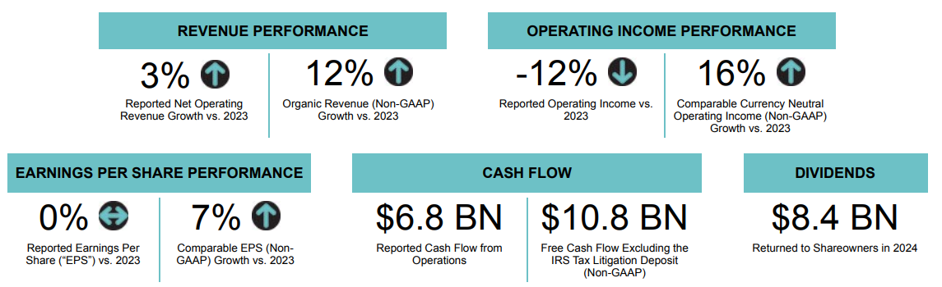
Figure 1: Financial Performance of Coca-Cola
(Source: The Coca-Cola Company, 2025)
United States Coca-Cola has its largest and most mature market, with strong brand heritage, deep retail penetration, and product mix more focused on Coca-Cola Classic and Coke Zero Sugar that experienced 9% growth globally in 2024 and flavoured extensions (The Coca-Cola Company, 2025). In China, where the company is highly strategic with emerging markets, such as peach, lychee and tea-based variations, Coca-Cola benefits by having established digital commerce platforms including WeChat, Tmall and JD.com. It depends on a capital-light franchising model and a global bottling system with about 200 bottling partners across the globe in its international expansion (The Coca-Cola Company, 2025).

3.Macroenvironment Comparison: PESTLE
Political
USA: Stable federal democracy; state-level sugar taxes; strong FDA regulation. China: One-party system; strict advertising controls; “Healthy China 2030” targets sugar reduction (Gao et al., 2021).
Economic
USA: GDP $29.18T (2024) (EconScope, 2025); GDP per capita $85,810 (O’Neill, 2025a); inflation ~2.9% (Bureau of Labor Statistics, 2025). China: GDP $18.74T (2024) (EconScope, 2025); GDP per capita over $13,300 (CEIC, 2025); inflation 0.2% (The Times of India, 2025).
Social
USA: Obesity 40.3% (CDC, 2024); urbanisation 82.66% (O’Neill, 2025b); strong demand for Zero Sugar products. China: Over 50% overweight (BBC, 2020); urban population 910M (Macrotrends, 2024); tea-based & low-sugar preferences.
Technological
USA: Amazon holds 40.4% of e-commerce (Lebow, 2024); mature digital advertising ecosystem. China: 1.12B internet users (Xinhua, 2025); 85%+ mobile payment adoption; strong WeChat/Douyin commerce (Liu, 2025).
Legal
USA: Strict FDA labelling; state PCR plastic targets (Sorensen et al., 2022). China: Tight food-safety rules; 2025 national rPET standards; censorship on online ads.
Environmental
USA: Plastic recycling rate 13.3% (packaging) (Heffernan, 2023); growing water-stress states. China: 9 northern provinces face extreme water scarcity; circular-economy push; ~20M tonnes plastic recycled (Lai, 2023).
Critical Comparison Analysis
The macroenvironmental differences between the United States and China place structurally different restrictions on Coca-Cola and reveal the confines of a homogenous global approach. The USA has a high GDP per capita ($85,810) permitting Coca-Cola to divide consumer markets into lifestyle and health-related segments, which supports the continued existence of high-end versions like Coke Zero Sugar (O'Neill, 2025) (Refer to Appendix 1). Nonetheless, this maturity stifles volume growth, driving Coca-Cola towards portfolio renewal, instead of market growth. China is the opposite of this: GDP is much less as the GDP $18.74T and GDP per capita ($13,300) is significantly lower, but the rapid urbanisation and digitally empowered middle class result in a large, price-sensitive segment (yet opportunity-rich, still) (EconScope, 2024; CEIC, 2025) (Refer to Appendix 2). Coca-Cola has to strike a balance between affordability and innovation and the tension between the two is inherent in the US market.
The interruptions in the sugar-tax landscape of the USA and the pressure of Healthy China 2030 practices and strong advertising bans impose political and legal necessities of defensive re-formulation and clear labelling on Coca-Cola, and Healthy China 2030 demands health-promoting and culturally appropriate communication and low-sugar localisation (Gao et al., 2021). The difference in regulatory pressures makes brand consistency across the globe difficult.
Technological gaps increase the strategic divide: 85%+ mobile payments in the urban area of China require QR-driven trips and platform-specific deals on WeChat and Douyin (Liu, 2025). In contrast to the USA, where Amazon (40.4% share) is a monopolist in e-commerce (Lebow, 2024). China is facing acute water scarcity, which raises the operational risk of Coca-Cola, and US plastic-recycling failures exacerbate the central question on packaging sustainability.
The combination of these forces places Coca-Cola in two different strategic logics: premiumisation and health-positioning in the USA, and localisation, affordability and digital-immersion in China.

4.Socio-Cultural Comparison: USA vs China
Overview of Cultural Analysis Approach
Consumer expectations, symbolic responses and meanings of marketing strategies are heavily dependent on culture. To critically analyze the way Coca-Cola changes across markets, this section uses Hofstede Cultural Dimensions, the GLOBE Framework, and Consumer Culture Theory (CCT). The combination of these models demonstrates the impact of cultural norms, social rituals and identity systems on the positioning of Coca-Cola, product selection, communication and consumption instances.
Application of Hofstede Cultural Dimensions
The Cultural Dimensions by Hofstede (1984) assists in interpreting the differences in countries using several dimensions. Quantitative cultural scores presented by Hofstede indicate that there are significant structural variations between the United States and China, which directly influence the Coca-Cola STP and 7Ps strategies.
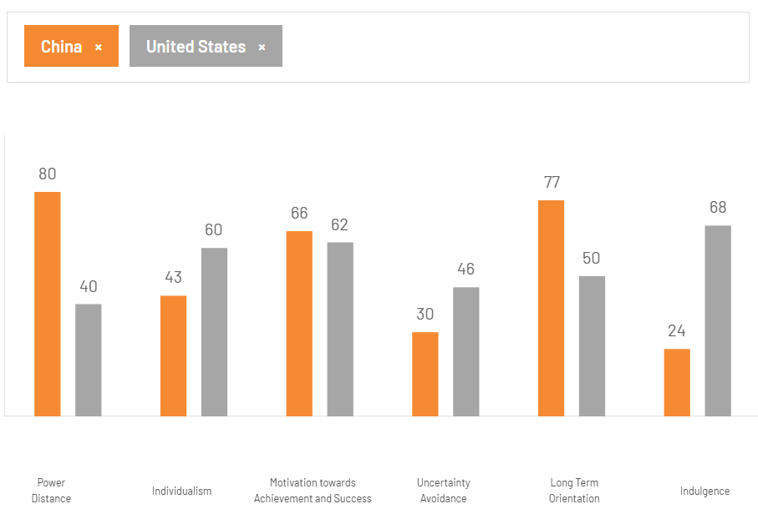
Figure 2: Country Comparison China Vs United States
(Source: The Culture Factor Group, 2025)
Individualism (USA 60 vs China 43)
The increased individualism score in the United States shows a self-expressive, autonomy and personal choice centred culture. This correlates with the study of consumption as a personal lifestyle marker: 72% of consumers in the US indicate that their brand choices are a representation of who they are (Retail Touch Points, 2025). Coca-Cola exploits this with individual-focused narrations, personalised packaging (e.g. Share a Coke with personal names) and large portions, which are better suited to the US average household of just 2.5 people, the lowest in the world (Korhonen, 2024).
The fact that China is less individualistic (43) corroborates that it is a collectivist society in which consumption is social, relational, and ritualistic. The mean household size is 2.8, and more than three-quarters of beverage purchases to attend a celebration are related to the purchase of drinks as a present or as part of a group meal (Textor, 2024). In response, Coca-Cola adapts by launching Chinese New Year collectible bottles, red-gold themed packaging, and group-oriented advertising which focuses on family, harmony and mutual celebration. Contrasting the US, Coke is consumed not on an individual basis but on a cycle of festivals, particularly Spring Festival, which has been a significant portion of beverage giving in the country.
Power Distance (China 80 vs USA 40)
The much higher score (80) of China indicates respect of hierarchy, cues of authority and status (The Culture Factor Group, 2025). This is evident with the high level of cultural power of Key Opinion Leaders (KOLs), more than 74 percent of young consumers declare buying goods because they are recommended by influencers (Kuzminov, 2024). Coca-Cola thus spends heavily on celebrity or KOL affiliations; whereby aspirational figures are employed to justify the quality of the brands. Conversely, the low score (40) of the US is indicative of egalitarian norms and relatability. In the advertisement of Coca-Cola in the US, common people, humour, nostalgia and less formal communication is employed instead of upper hand promotion. This contrast shows why promotion requires cultural adaptation despite the fact that the core brand is international.
Long-Term Orientation (China 77 vs USA 50)
The high long-term orientation of China (77) is in line with the nature of health preservation, tradition, and subtle flavour palates. This orientation is reflected in the success of Coca-Cola products in China such as Peach Coke, Lychee Coke and tea-flavored variants. China also has a lower-sugar drink market that is rapidly growing (CAGR of projections 10.2% to USD 8,152.6 million by 2030), which explains why Coca-Cola is expanding Zero Sugar and localised reduced-sugar recipes (Grand View Horizon, 2025).
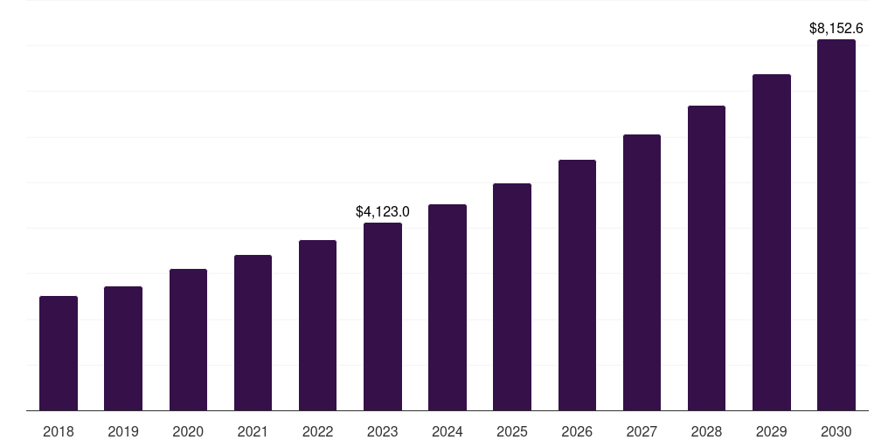
Figure 3: China reduced sugar food & beverages market
(Source: Grand View Horizon, 2025)
The US moderate orientation (50) endorses instant satisfaction and luxurious consumption. This is in line with high usage of soft drinks (41.9 gallons per year) and willingness of the US consumers to adopt brighter, sweeter tangs (IBISWorld, 2025). The American campaigns of Coke focus on joy, fun, and refreshment of impulse but not on health or tradition.
Indulgence (USA 68 vs China 24)
With a high score on indulgence, the US is characterized by a cultural permissiveness to pleasure and consumption (The Culture Factor Group, 2025). This is evidenced by the 40.3 national obesity rate (CDC) and the high demand of sweet drinks (CDC, 2024). Coca-Cola reacts to this by providing variety (Cherry, Vanilla, seasonal limited flavours) and multipacks that might be used to celebrate and enjoy the moment.
The low score in indulgence (24) of China indicates suppressed behaviour and emerging health awareness (The Culture Factor Group, 2025). This creates pressure on smaller pack sizes, low-sugar products, and tea-based products. The growth of functional drinks and development of local billion-dollar brands such as Maaza by Coca-Cola reflects the adjustment to subdued consumption patterns.
Application of the GLOBE Framework
The GLOBE model introduces a level of specificity through the recognition of more profound behavioural demands in relation to leadership, communication and social coordination (Yeganeh, 2025).
Future Orientation
The relatively high future orientation of China encourages long-term health planning and preventive consumption behaviours. That is why Zero Sugar, tea-based beverages, and functional beverages are of great interest. Local product innovations include herbal flavours and local teas and light versions, which are in line with this cultural orientation at Coca-Cola (Bolton, 2022). The low future orientation of the US market corresponds to the idea of short-term emotional satisfaction which allows Coca-Cola to market the idea of nostalgic and hedonistic consumption.
Humane Orientation
The greater humane orientation of China is associated with the values of warmth, kindness, and social bonding (Gobel and Miyamoto 2024). Coca-Cola leverages on this by conducting campaigns that show respect among generations and community solidarity, particularly during Spring Festival when the gift-giving of wines is more common in the country. The narratives of the brand emphasize harmony, collectivism and gratitude, which have a powerful presence in Chinese culture.
Assertiveness
The US is more assertive and prefers expressive, bold and straightforward advertising. These American campaigns by Coca-Cola thus focus on empowerment, quick experiences and high emotional stimuli. The less assertive nature of China implies that customers are more attracted to soft colors, communicative messages, and advertisement that is emotionally warm and less competitive (Yu et al., 2025).
Institutional Collectivism
The increased collectivism in China enhances the campaigns that promote group sharing, family gatherings and communal celebrations. This culture trend made Coca-Cola bottles with Share a Coke successful, albeit in a different manner than in the US (Kelly, 2025). In China, the success of the campaign was due to group identity other than individual identity as consumers gave gifts in the form of personalised bottles in the meetings.
Application of The Consumer Culture Theory
The Consumer Culture Theory articulates how the consumers exploit brands to create identity, engage in cultural rituals, and negotiate social meaning (Hungara and Nobre 2021).
United States
Individualism, lifestyle distinction and self-branding have a heavy influence on American consumer culture. More than two out of three Americans identify drinks as a personal lifestyle statement (American Beverage, 2025). The marketing of Coca-Cola is no exception as it sponsors sports (NFL), music festivals, and personal experiences. The subcultures within the US market are highly fragmented which enables Coca-Cola a campaign micro-targeting using its data-driven marketing model. Coke is applied as a symbol of individual mood, occasion and emotional condition and is supported by single-serve sizes and big multipacks to be convenient.
China
The consumer culture of China is based on rituals, gifting as well as community celebration. Beverage consumption is influenced by household parties, festivals (especially Chinese New Year) and social gifting. The number of drinks given during the Spring Festival is also higher and the New Year editions of coke are distributed during the festival as symbols of good fortune and prosperity. Digital consumption is also social, 74% of young Chinese consumers buy products that were suggested by social media, and group-buying in WeChat and JD result in communal consumption patterns (Kuzminov, 2024). These culturally ingrained practices are targeted by the festival-related QR-code campaigns and lantern-style packaging provided by Coca-Cola.

5.Comparison of STP Strategies (USA vs China)
Segmentation
Coca-Cola also uses a multi-dimensional approach to segmentation, yet the cultural, economic and behavioural distinctions between the USA and China require very different strategies to be used.
Demographic Segmentation
Coca-Cola in the United States is designed to be popular with a broad group, and especially among the teens and young adults as the people who consume the greatest amount of carbonated soft drinks (CSD). Health-conscious consumers are the second core demographic, although the prevalence of obesity in the US is also 40.3% among adults (CDC, 2024). This is in line with the revelation by Coca-Cola that Coke Zero sugar experienced a growth in the global volumes, a reaction to the increased demand of low and no-calorie drinks.
The demographics in China vary significantly. The growing consumption of young people in cities led to a 5% growth of the soft-drink market at a CAGR by 2030 (Mordor Intelligence, 2025) as disposable income in urban territories increased. Nonetheless, China has a lower level of GDP per capita ($13,300) (CEIC, 2025) and is more price-sensitive, which means that Coca-Cola will have to sell smaller packs and lower prices. The collectivist norms also have a more significant impact on the family-based demographic groups: the number of beverages gifted during the Spring Festival, and Coca-Cola creates red-gold packaging specially to market to this population group.
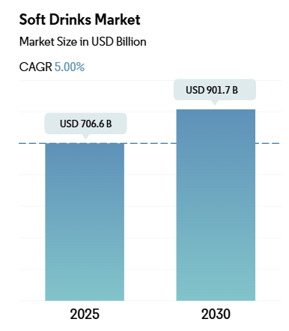
Figure 4: Soft Drink market growth in China
(Source: Mordor Intelligence, 2025)
Psychographic Segmentation
In the USA, where individualism is severe (Hofstede: 60), consumers correlate drinks with self-identification, freedom and lifestyle determination (The Culture Factor Group, 2025). Coca-Cola takes advantage of that, focusing on emotional freedom (Open Happiness), personal nostalgia, and on the go convenience. Major psychographic anchors include sports, music festivals and personal identity stories which attract consumers with brand selection as their personality expression.
China is less individualistic (43) and more collectivistic, which produces various psychographic trends (The Culture Factor Group, 2025). Family harmony, social approval and community rituals are associated with brand value. The marketing of Coca-Cola reflects this orientation, as it includes family get-together, shared meals, and culturally symbolic objects. Chinese consumers also exhibit greater experimentation of seasonal and culturally flavoured drinks, including Peach Coke and Lychee Coke, psychographically as it is associated with a tendency to seek novelty within the context of culturally significant parameters.
Behavioural Segmentation
The behavioural patterns become divergent. Soft drink consumption in the USA is one of the highest in the world (41.9 gallons per year), which supports the heavy-user segmentation (IBISWorld, 2025). Classic taste loyalty is high, and the strategic emphasis of Coca-Cola is to protect share in multipacks, convenience-store sales, and fountain sales partners.
The behavioural segmentation of China is determined by the cycles of festivals, online shopping, and taste experimentation. More than three-quarters of young shoppers buy beverages according to KOL/influencer suggestions, which indicates behavioural reliance on social commerce platforms such as Douyin and WeChat (Kuzminov, 2024). Another period of consumption spike is when national holidays take place, thus influencing behavioural targeting along cultural rhythms and not daily habit.
Geographic Segmentation
Segmentation in USA is not very difficult:
- City drinkers prefer one- Served bottles, vending machines and delivery apps.
- Suburban and rural consumers buy in bulk and multipacks.
China needs a much more subtle geographic partitioning:
- Tier-1 cities (Beijing, Shanghai, Shenzhen): pioneers, Zero Sugar demand, high-end innovations.
- Tier-2/3 cities: segments that are price-sensitive and demand low SKUs.
- Inland and western provinces: less penetration and increasing distribution opportunities via local bottlers.
Such complexity means that Coca-Cola will have to vertically differentiate prices, pack sizes and flavour availability in different regions of China.
Targeting
United States Targeting
- Youths and young adults, whose consumption of soft drinks is high; are reached via TikTok, music festivals, esports, and NFL and NBA partnerships.
- Families, particularly suburban families who buy in bulk multipack; they are being hit with value deals and holiday promotions.
- Educated adults, who are increasingly concerned about their health; focussed on Coke Zero Sugar, Diet Coke, mini cans, and clear nutritional messaging.
- Multicultural consumer populations, especially Hispanic and African American communities with disproportionately high levels of CSD consumption; whom culturally inclusive marketing will reach.
China Targeting
- Young urban consumers and gen z the fastest growing market segment of beverages; with trendy limited editions and online-first campaigns on Douyin (Xiaoxin et al., 2025).
- Cultural central market customers Festival and gifting shoppers; targeted using Chinese New Year, Mid-Autumn and festival theme packaging.
- Emerging regions (price-sensitive consumers) targeted by small-format bottle and value SKUs.
- The 1.12 billion internet users and the unmatched high rates of mobile-payment penetration (85) in China make digital-native consumers, who target the promotion with QR-codes, mini-programs on WeChat, and social-commerce-based incentives (Xinhua, 2025; Liu, 2025).
In both countries, Coca-Cola applies differentiated targeting, yet the strategy in China is much more connected to cultural traditions such as gifting and online ecosystems.
Positioning
In the USA, Coca-Cola also bills itself as a nostalgic, traditional American brand that has its dominant 46% U.S. CSD market share against (Alonso, 2024) PepsiCo 23.8% (Ridder, 2024). The advertising underlines the emotional memory, heritage and classic taste, but Coke Zero Sugar is promoted as something more modern, guilt-free, which fits the US health pressures, since the obesity rate among adults is 40.3 percent (CDC, 2024). Coca-Cola has used sports sponsorship as well as holiday nostalgia as a way of sustaining brand leadership.
Positioning will have to be more dynamic in China, where Coca-Cola has a smaller market share (GlobalData, 2022) in a fragmented market led by domestic tea brands such as Master Kong. Coca-Cola aligns itself with youth, fashionable and culturally applicable, with its seasonal flavours (e.g. Peach Coke), packaging design with festival themes, and robust digital activity on Douyin and WeChat. The increasing prevalence of overweight changes the positioning to Zero Sugar and health-conscious versions, distinguishing Coca-Cola among the local brands.

6.Comparison of Marketing Mix (7Ps)
Product
The two markets vary sharply on product strategy as Coca-Cola has different taste preferences and health trends. Coca-Cola Classic, Diet Coke, Coke Zero Sugar, Cherry Coke and Vanilla Coke are considered the core portfolio in the USA. The fructose corn syrup (HFCS) is a common ingredient in US formulations, as it reflects cost-saving and consumer recognition, whereas in China, the most common ingredient is sucrose or cane sugar, leading to variations in taste, which are pertinent to adapting a product to the local market. The US needs health-based reforms: as 40.3% of adults in the US are obese (CDC, 2024), Coca-Cola has heavily promoted mini cans (7.5oz) and no-sugar versions, with Coke Zero Sugar registering +9% of global volume growth (The Coca-Cola Company, 2025).
In China, the Coca-Cola localisation is more significant. The trendy innovations are that of Peach Coke, Lychee Coke, Jasmine Tea Coke, and lower-sugary formulas that account to the long-term health orientation of China and the increased prevalence of overweight (Munch Addict, 2025). Even the packaging is adjusted to a culture: zodiac editions, red-gold Chinese New Year editions, and festival cartons are symbolic gifts. In low-end cities, smaller sizes of PET bottles (250-300ml) are available out of cost-saving motivation.
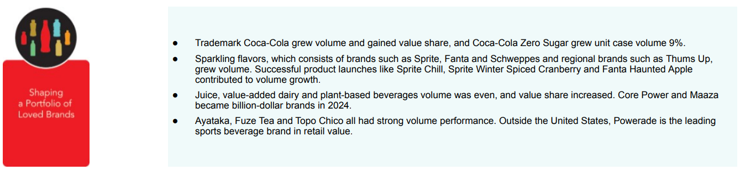
Figure 5: Volume Growth of Coca-Cola Zero Sugar
(Source: The Coca-Cola Company, 2025)
Price
Pricing indicates brand equity and income level and competition in the area. Coca-Cola uses a premium approach to psychological pricing in the USA, which is backed by its dominant 46% CSD position on the market (Alonso, 2024). An average 500ml bottle is priced at approximately 2.99 USD in the US with mini-can packages having a better relative margin (ETimes.in, 2025). The brand does not compete based on low price, but on value added convenience, which is high loyalty and category leadership.
Coca-Cola uses tiered pricing in China due to income differences (GDP per capita 13,300) (CEIC, 2025) and competitive forces of the local products, such as Master Kong and Wahaha. A 330ml can be priced at ¥3-¥6 and this indicates the pressure of affordability. Festival bundle promotions and group-buy discounts on TMall and JD are also applied to help Coca-Cola compete in the price-sensitive regions. This illustrates the point by Okonkwo et al., (2023) that global brands need to be able to standardise with a heavy emphasis on localisation to stay competitive.
Place (Distribution)
Distribution models reflect the maturity of the retail industry within each country. Coca-Cola distribution in the USA involves large retailers (Walmart, Target, Costco), convenience stores, QSRs, gas stations and an extensive network of deep vending machines. The 40.4 percent of US e-commerce sales attributed to Amazon (Lebow, 2024) makes it a prime medium to deploy multipacks, whereas the association of Coca-Cola with McDonald, Burger King, and Wendy as a fountain enhances the availability of premises.
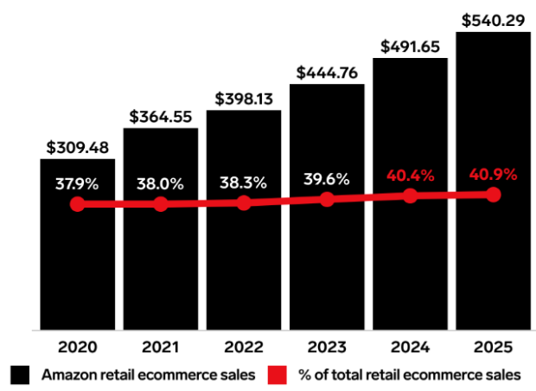
Figure 6: Amazon retail sales in USA
(Source: Lebow, 2024)
Distribution in China is digitally motivated as 1.12 billion internet users and 85%+ mobile payment users (Xinhua, 2025; Liu, 2025). Coca-Cola is depending on direct purchases via JD.com, TMall, Pinduoduo, and WeChat mini programs. Through offline, it focuses on Family Mart, Lawson, 7-Eleven, and vehicles vending machines around metro stations since these are consumed by high commuting populations. This is a hybrid model that is more advanced in terms of online-offline integration than the USA.
Promotion
Advertisement plans show variations in cultural communication. Coca-Cola employs fondness, emotional narrations, and images of national heritage in the USA in the campaign, Open Happiness (Behind Wellness, 2025). The iconic positioning of the brand is supported by high-profile activities, including Super Bowl advertising, the Olympics and sports sponsorships. The US promotions are promotional in nature, preferring humour, relatability and personal emotion, which fits low power distance and high individualism.
The promotions of Coca-Cola in China are based on the KOLs, livestreamer influencers and Douyin short-video campaigns that are part of the local digital consumption behavior. The importance of festival marketing is paramount: the Chinese sales of beverage products in Tmall had grown by 198% (Liang, 2020). QR-code campaigns are associated with packaging, promoting the use of WeChat loyalty programs, which combines promotion with digital payment systems. In contrast to the USA, the Chinese advertising focuses on family bonding, auspicious signs and group feast.
People
People strategy is the strategy of service expectations and collaborations with bottlers. The USA customer service focus is on efficiency and speed, and Coca-Cola uses its hired retail employees and its key bottlers (e.g., Coca-Cola Consolidated) to ensure uninterrupted supply of its product. In China, power distance is higher and it is reflected in the expectations of politeness and attentive service. Coca-Cola also collaborates with COFCO Coca-Cola Beverages to ensure that the behaviour of its staff is aligned to cultural expectations, particularly during festivals where branded staff members are on display in-store in their themed uniforms and sampling stations (COFCO Coca-Cola, 2025).
Process
Coca-Cola has significant automated supply chains and data access enabled by its massive bottlers like Coca-Cola Consolidated, which is beneficial to the USA (Shao, 2025). Processes focus on efficiency of distribution, reliability of cold-chain, and replenishment of retail. The processes in China integrate QR-codes, mobile payments, and online journeys of loyalty. QR scan on the bottle transports consumers into campaigns, games, or coupons on WeChat, and incorporates the purchase into a larger digital system. In China, the supply chain of Coca-Cola is built around a high rate of product rotation because of flavour variety and increased seasonality.
Physical Evidence
Coca-Cola in both nations has regular global red labelling, shape bottles and common typography. Yet, China is more seasonal, symbolic and festive, especially red-gold New Year issues and zodiac themes, and the USA builds its branding on multipacks, vending machines, and classic imagery (The Coca-Cola Company, 2025).

7.Evaluation of Performance
The international marketing strategies of Coca-Cola lead to good performance results in both markets and the world. In 2024, the company recorded net operating revenues of 47.1 billion, which shows that it is well stewarded in terms of brand (The Coca-Cola Company, 2025). Its health variant strategy has been effective, and Coke Zero Sugar has generated +9% increase in volume worldwide. Coca-Cola continues to dominate its categories in the USA, scoring about 46% market share, which is backed by a high brand awareness level and high emotional loyalty (Alonso, 2024). Nostalgia and lifestyle attachments are supported by digital performance on Instagram and YouTube. Coca-Cola lacks company-owned branches and instead gauges success by distribution penetration, which is made possible by widespread availability on Walmart, Target, Costco, and Amazon who control 40.4 percent of US e-commerce (Lebow, 2024).
Localisation and targeting with digital-first drives performance in China. Brand awareness is 85% and higher, and Douyin and Weibo perform better than the West (Liu, 2025). China is one of the fastest-developing emerging markets of Coca-Cola, which was facilitated by flavour localisation (Peach, Lychee, Jasmine Tea Coke). The expansion of the portfolio is accelerated, with drinks such as Maaza selling over one billion retail units worldwide (The Economic Times, 2025). Thus, standardisation enhances the stability of the USA, whereas deep localisation boosts higher growth velocity in China.

8.Marketing Ethics Evaluation
The marketing mix of Coca-Cola in both the countries attracts some ethical issues. The USA is facing a critical public health problem due to the formulations of high-sugar products, and 40.3% of adults experience obesity (CDC, 2024). Sponsorships and digital youth engagement as a promotional tool are likely to indirectly target minors and thus are ethically questionable in the approach of justice, which focuses on fair treatment and protection of vulnerable groups. Moreover, the high CEO-to-worker pay ratio of 1,980:1 by Coca-Cola is a distributive justice issue concerning equity in the organisation (The Coca-Cola Company, 2025). Such problems are inherent within the ethical dilemmas inherent in the brand (sugar content) and its advertisements (targeted at young people) and pricing (higher price of the healthier versions).
Ethical scrutiny in China is focused on the sustainability of the environment and use of resources. Even though Coca-Cola claims 22.5% rPET use in selected packaging portfolios and 89.1% watershed renewal, bottling in northern China is overlapping with the area where water shortage is severe (The Coca-Cola Company, 2025).
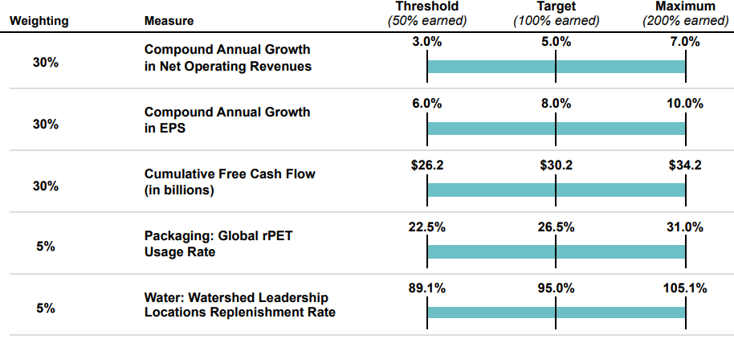
Figure 7: Packaging portfolio and watershed replenishment
(Source: The Coca-Cola Company, 2025)
This creates CSR and environmental stewardship issues. Although culturally congruent, festival-related promotional campaigns can also stimulate more consumption of sugary drinks, which puts ethical concerns under the cultural relativism perspective to the test, which is a dangerous practice of justifying harmful behavior by cultural symmetry. Plastic waste is still an issue, with PET packaging becoming a major contributor to urban wastes in China regardless of its enhanced recycling facilities. In sum, the marketing mix used by Coca-Cola, be it the formulation of the product, the marketing approach taken in promotional activities, the packaging choices and the distribution practices, poses constant ethical challenges that demand greater responsibility and responsible marketing practices.

9.Recommendations and Conclusion
Recommendation 1: Market-Specific Health Innovation Strategy
Coca-Cola ought to increase product innovation with health orientation all geared towards the cultural and nutritional environment of respective markets. Expanding no-sugar versions and functional drinks would be in line with the popularity of PepsiCo Gatorade Zero and Prime Hydration, both of which have taken over health-conscious consumers in the USA, where obesity rates reach 40.3% of the adult population (CDC, 2024). In China, where half of the adults are overweight (BBC, 2020); but favour delicate flavours, Coca-Cola ought to create tea-based, herb based and low-sugar soft beverages, in the wake of a good performance of Nestle in RTD tea. Such a dualised approach to health would improve regulatory congruency, brand reputation and competitive differentiation in both markets.
Recommendation 2: Deep Digital Integration Across Platforms
Coca-Cola needs to further integrate within the digital systems that are driving consumption behaviour in both nations. In China, 85 per cent of payments are mobile (Liu, 2025). Social commerce is driven by platforms such as Douyin, and Coca-Cola can follow in the footsteps of Starbucks China, which made 60% of sales through digital payments and 80% of sales were made using no cash (Sweeney, 2018). Improved QR-based communication, custom offers and key opinion leader-led campaigns would boost the frequency of purchase. Coca-Cola ought to increase omnichannel bundles with Amazon, which dominates 40.4% of e-commerce (Lebow, 2024), and duplicate the content-marketing ecosystems provided by Red Bull on TikTok and YouTube to strengthen youth relevance and connection with culture in the USA.
Recommendation 3: Strengthen Sustainability and Ethical Marketing Standards
To respond to the increased ethical pressure, Coca-Cola needs to commit to sustainability and conduct more responsible marketing. The environmental impact would be diminished by increasing the use of rPET and the trials on refillable/returnable packaging, such as electronic examples of such systems as SodaStream produced by PepsiCo and refillable and returnable packaging with Latin-American focus (Packaging World, 2023). Coca-Cola is encouraged to release province-level metrics of stewardship in its water stressed Chinese areas following the transparent environmental reporting of Unilever. Sugar-marketing laws, especially when it comes to youth exposure, would be stricter in the USA and this would put the company on a par with other dominant food companies like General Mills, thus setting the credibility of Coca-Cola as an ethical brand worldwide.

10.Conclusion
This report has established that the international marketing performance of Coca-Cola is anchored on its capability to strike a balance between the global brand consistency and local responsiveness. The comparative study of the US and China shows that the two markets are quite different in terms of cultural norms and regulatory pressure, economic conditions and digital ecosystems. In the USA, Coca-Cola is winning with their nostalgia positioning, high prices, and extensive distribution by Amazon. Conversely, the Chinese market is fueled by flavour localisation, festival cycles and extraordinarily developed digital commerce, which underscore the significance of culturally entrenched and mobile-first marketing.
The performance analysis reveals excellent financial performance, which is evidenced by a revenue of 47.1 billion and the significant successes of Coke Zero Sugar, which experienced a +9% volume growth, yet conveys the growing ethical and sustainability issues in both markets. The recommendations accentuate health-innovation, integration of digital ecosystem, and enhanced sustainability governance, each of which is backed by applicable industry standards.
In conclusion, the further competitive edge of Coca-Cola will be based on the development of a hybrid marketing model: the model that is globally consistent, locally smart, ethically accountable, and digitally adaptive. This combined strategy is vital in maintaining brand equity on the long-term basis in more intricate global markets.

11.References
- Alonso, T. (2024) Strategy Study: How Coca-Cola became one of the most successful brands in history, Cascade. Available at: https://www.cascade.app/studies/how-coca-cola-became-successful (Accessed: 26 November 2025).
- American Beverage (2025) American Beverage Association Works to Protect Consumer Choice, American Beverage Association. Available at: https://www.americanbeverage.org/initiatives-advocacy/protecting-consumer-choice/ (Accessed: 25 November 2025).
- BBC (2020) ‘Over half of Chinese adults overweight, study finds’, BBC News. Available at: https://www.bbc.com/news/world-asia-china-55428530 (Accessed: 25 November 2025).
- Behind Wellness (2025) Learn How Coke Mastered Emotional Branding | Behind Wellness, Behind Wellness. Available at: https://behindwellness.com/coca-cola-open-happiness-an-ode-to-emotional-marketing/ (Accessed: 26 November 2025).
- Bolton, D. (2022) Coca-Cola Launches First Bottled Herbal Infusion in China, STiR. Available at: https://stir-tea-coffee.com/tea-coffee-news/coca-cola-launches-first-bottled-herbal-infusion-in-china/ (Accessed: 25 November 2025).
- Bureau of Labor Statistics (2025) Consumer prices up 2.9 percent from August 2024 to August 2025, Bureau of Labor Statistics. Available at: https://www.bls.gov/opub/ted/2025/consumer-prices-up-2-9-percent-from-august-2024-to-august-2025.htm (Accessed: 25 November 2025).
- CDC (2024) Obesity and severe obesity prevalence in adults: United States, August 2021–August 2023, CDC.gov. CDC. Available at: https://www.cdc.gov/nchs/products/databriefs/db508.htm (Accessed: 25 November 2025).
- CEIC (2025) China GDP per Capita, Ceicdata.com. CEICdata.com. Available at: https://www.ceicdata.com/en/indicator/china/gdp-per-capita (Accessed: 25 November 2025).
- COFCO Coca-Cola (2025) COFCO Coca-Cola - COFCO Corporation, www.cofco.com. Available at: https://www.cofco.com/en/BrandProduct/COFCOCocaCola/ (Accessed: 26 November 2025).
- EconScope (2024) Nominal GDP (China) - Data & History, EconScope. Available at: https://econscope.com/economies/china/gdp-nominal (Accessed: 25 November 2025).
- EconScope (2025) Nominal GDP - Global Comparison, EconScope. Available at: https://econscope.com/economies/overview/gdp-nominal (Accessed: 25 November 2025).
- ETimes.in (2025) ​How much does Coca-Cola cost in different countries​, The Times of India. Times Of India. Available at: https://timesofindia.indiatimes.com/life-style/food-news/how-much-does-coca-cola-cost-in-different-countries/photostory/120019975.cms (Accessed: 26 November 2025).
- Gao, C., Xu, J., Liu, Y. and Yang, Y. (2021). Nutrition policy and healthy China 2030 building. European journal of clinical nutrition, 75(2), pp.238-246.doi: https://doi.org/10.1038/s41430-020-00765-6
- GlobalData (2022) China’s soft drinks category - The future - just-drinks magazine | Issue 41 | May 2022, IN DATA. Available at: https://just-drinks.nridigital.com/just-drinks_magazine_may22/china-soft-drinks (Accessed: 26 November 2025).
- Gobel, M.S. and Miyamoto, Y. (2024). Self-and other-orientation in high rank: A cultural psychological approach to social hierarchy. Personality and Social Psychology Review, 28(1), pp.54-80.doi: https://doi.org/10.1177/10888683231172252
- Grand View Horizon (2025) China Reduced Sugar Food & Beverages Market Size & Outlook, Grand View Horizon. Available at: https://www.grandviewresearch.com/horizon/outlook/reduced-sugar-food-beverages-market/china#:~:text=The%20China%20reduced%20sugar%20food,revenue%20generating%20product%20in%202023. (Accessed: 25 November 2025).
- Heffernan, M. (2023) US recycles 13.3% of packaging, Plastic Pact estimates, Plastics Recycling Update. Available at: https://resource-recycling.com/plastics/2023/02/28/us-recycles-13-3-of-packaging-plastic-pact-estimates/ (Accessed: 25 November 2025).
- Hofstede, G. (1984). Cultural Dimensions in Management and Planning. Asia Pacific Journal of Management, 1, 81-99.
- Hungara, A. and Nobre, H. (2021). A consumer culture theory perspective of the marketplace: An integrative review and agenda for research. International Journal of Consumer Studies, 45(4), pp.805-823.doi: https://doi.org/10.1111/ijcs.12670
- IBISWorld (2025) Per capita soft drink consumption, Ibisworld.com. Available at: https://www.ibisworld.com/united-states/bed/per-capita-soft-drink-consumption/1786/ (Accessed: 25 November 2025).
- Kelly, C. (2025) Coke refreshes ‘Share a Coke’ to reach Gen Z with digital experiences, Marketing Dive. Available at: https://www.marketingdive.com/news/coca-cola-share-a-coke-campaign-refresh-gen-z-digital-experiences/743648/ (Accessed: 25 November 2025).
- Korhonen, V. (2024) Average size of households in the U.S. 2023| Statista, Statista. Available at: https://www.statista.com/statistics/183648/average-size-of-households-in-the-us/?srsltid=AfmBOoqEPE2qoy6BN8AUpFSUO0UHtOK94FEx6sipkUcTZ-EdCI2MC4n9 (Accessed: 25 November 2025).
- Kuzminov, M. (2024) ‘How Influencers Can Drive Consumer Purchasing Behavior’, Forbes, 14 August. Available at: https://www.forbes.com/councils/forbesagencycouncil/2024/08/14/how-influencers-can-drive-consumer-purchasing-behavior/ (Accessed: 25 November 2025).
- Lai, O. (2023) What’s Behind China’s Plastic Pollution Crisis?, Earth.org. Available at: https://earth.org/china-plastic-pollution/ (Accessed: 25 November 2025).
- Lebow, S. (2024) Amazon will surpass 40% of US ecommerce sales this year, despite competition in grocery, home improvement, EMARKETER. Available at: https://www.emarketer.com/content/amazon-will-surpass-40-of-us-ecommerce-sales-this-year (Accessed: 25 November 2025).
- Levitt, T. (1983) ‘The globalization of markets’, Harvard Business Review, 61(3), pp. 92–102.
- Liang, A. (2020) Tmall unveils beverage sales report for 2020 CNY celebration, The Drinks Business. Available at: https://www.thedrinksbusiness.com/2020/01/tmall-unveils-beverage-sales-report-for-2020-cny-celebration/ (Accessed: 26 November 2025).
- Liu, J. (2025) Mobile Payment Methods in China: A Simple Guide, InfluChina. Available at: https://influchina.com/moblie-payment-methods-in-china/ (Accessed: 25 November 2025).
- Macrotrends (2024) China Urban Population, Macrotrends. Available at: https://www.macrotrends.net/global-metrics/countries/CHN/china/urban-population (Accessed: 25 November 2025).
- Mordor Intelligence (2025) Soft Drinks Market Size & Share Analysis - Industry Research Report - Growth Trends, www.mordorintelligence.com. Available at: https://www.mordorintelligence.com/industry-reports/global-soft-drinks-market (Accessed: 25 November 2025).
- Munch Addict (2025) Coca Cola Soft Drink - Peach (China), Munch Addict. Available at: https://munchaddict.com/products/coca-cola-soft-drink-peach-china?srsltid=AfmBOoogmiTHTEcrGBng0uN_ImN3ey_wYr2LTxMrrjQaFkfG_rwhQmQK (Accessed: 26 November 2025).
- O’Neill, A. (2025a) Gross domestic product (GDP) per capita in the United States 2030, Statista. Available at: https://www.statista.com/statistics/263601/gross-domestic-product-gdp-per-capita-in-the-united-states/?srsltid=AfmBOorf7LJs6PqV8iYvRUi4rKPerukQgWfmaYVZQg8Q80RWmeOQ2VLT (Accessed: 25 November 2025).
- O’Neill, A. (2025b) Urbanization in the United States 1790 to 2050, Statista. Available at: https://www.statista.com/statistics/269967/urbanization-in-the-united-states/ (Accessed: 25 November 2025).
- Okonkwo, I., Mujinga, J., Namkoisse, E. and Francisco, A. (2023). Localization and global marketing: Adapting digital strategies for diverse audiences. Journal of Digital Marketing and Communication, 3(2), pp.66-80.doi: https://doi.org/10.53623/jdmc.v3i2.311
- Packaging World (2023) PepsiCo to Expands SodaStream Business, Packaging World. Available at: https://www.packworld.com/sustainable-packaging/article/22657380/pepsico-to-expands-sodastream-business (Accessed: 26 November 2025).
- Retail Touch Points (2025) 72% Of U.S. Consumers Want Brands To Reflect Their Values, Retail TouchPoints. Available at: https://www.retailtouchpoints.com/resources/72-of-u-s-consumers-want-brands-to-reflect-their-values (Accessed: 25 November 2025).
- Ridder, M. (2024) PepsiCo CSD market share in the U.S. 2013-2024, Statista. Available at: https://www.statista.com/statistics/225419/us-market-share-of-the-pepsico-company-since-2004/?srsltid=AfmBOopyNUL1iWI8n_hiUthagvt4T6Xe-CeF9kTexI2Xm5G_cS3zJ8my (Accessed: 26 November 2025).
- Shao, Y. (2025), July. A Value Chain Analysis on Coca-Cola Company. In 2025 International Conference on Financial Risk and Investment Management (ICFRIM 2025) (pp. 879-886). Atlantis Press.doi: https://doi.org/10.2991/978-94-6463-748-9_96
- Sorensen, R. M., Kanwar, R. S. and Jovanović, B. (2022) ‘Past, Present, and Possible Future Policies on Plastic Use in the USA, Particularly Microplastics and Nanoplastics: A Review’, Integrated Environmental Assessment and Management, 19(2). doi: https://doi.org/10.1002/ieam.4678.
- Sweeney, E. (2018) Starbucks caffeinates China strategy with more social gifting, AR, Marketing Dive. Available at: https://www.marketingdive.com/news/starbucks-caffeinates-china-strategy-with-more-social-gifting-ar/523710/ (Accessed: 26 November 2025).
- Textor, C. (2024) Average number of people living in one household in China in 2023, by province or region, Statista. Available at: https://www.statista.com/statistics/1087871/china-average-household-size-by-region-province/?srsltid=AfmBOorYQlxAGaeUijHBe1fazxRM8HyEq8sQ7d4mo3BEKx0I83enUwsB (Accessed: 25 November 2025).
- The Coca-Cola Company (2025) The Coca-Cola Company 2025 Proxy Statement, The Coca-Cola Company. Available at: https://investors.coca-colacompany.com/_assets/_d751f19d2b308b0aaf2006424bb44fad/cocacolacompany/db/892/10861/proxy_statement/0001558370-25-003056.pdf (Accessed: 25 November 2025).
- The Culture Factor Group (2025) Country comparison tool, Theculturefactor.com. Available at: https://www.theculturefactor.com/country-comparison-tool?countries=china%2Cunited+states (Accessed: 25 November 2025).
- The Economic Times (2025) Building resilience, sustaining health: Abu Dhabi’s blueprint for future-ready care, The Economic Times. Economic Times. Available at: https://economictimes.indiatimes.com/news/international/uae/building-resilience-sustaining-health-abu-dhabis-blueprint-for-future-ready-care/articleshow/120388329.cms (Accessed: 26 November 2025).
- The Times of India (2025) China CPI: Inflation rises 0.2% after months of stagnation in October; property and spending pressures persist, The Times of India. The Times Of India. Available at: https://timesofindia.indiatimes.com/business/international-business/china-cpi-inflation-rises-0-2-after-months-of-stagnation-in-october-property-and-spending-pressures-persist/articleshow/125197208.cms (Accessed: 25 November 2025).
- Vrontis, D., Thrassou, A. and Lamprianou, I. (2009) ‘International marketing adaptation versus standardisation of multinational companies’, International Marketing Review, 26(4/5), pp. 477–500. doi: https://doi.org/10.1108/02651330910971995.
- Vrontis, D., Thrassou, A. and Lamprianou, I. (2009) International marketing adaptation versus standardisation of multinational companies. International Marketing Review, 26(4/5), pp.477-500.
- Xiaoxin, L., Chuah, S.H.W. and Lye, V.W.E. (2025). Harnessing the Power of Social Media Marketing to Transform the Food Industry in China. In Technological Innovations in the Food Service Industry (pp. 23-48). IGI Global Scientific Publishing.DOI: 10.4018/979-8-3693-7683-6.ch002
- Xinhua (2025) China has over 1.12B internet users, boosting prowess in culture, AI - China.org.cn, China.org.cn. Available at: http://www.china.org.cn/2025-07/21/content_117988165.shtml (Accessed: 25 November 2025).
- Yeganeh, H. (2025). Hofstede, GLOBE, Schwartz and Inglehart’s cultural dimensions: a critical examination and assessment. European Business Review, 37(6), pp.1073-1090.doi: http://dx.doi.org/10.1108/EBR-05-2025-0144
- Yu, M., Chan, K., Diehl, S., Koinig, I. and Terlutter, R. (2025). Chinese consumer perceptions of offensive advertising: assessing advertising matter, manner, and media and the role of cultural identity. International Journal of Advertising, pp.1-34.doi: https://doi.org/10.1080/02650487.2025.2514865

12.Appendices

Appendix 1: USA GDP per Capita
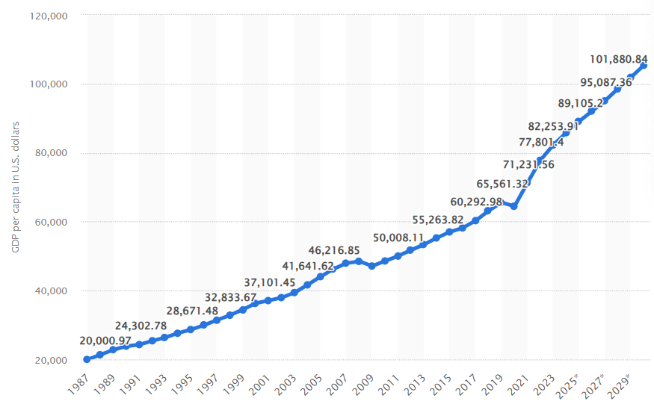
Figure 7: Gross domestic product (GDP) per capita in the United States 2030
(Source: O’Neill, 2025)

Appendix 2: China GDP
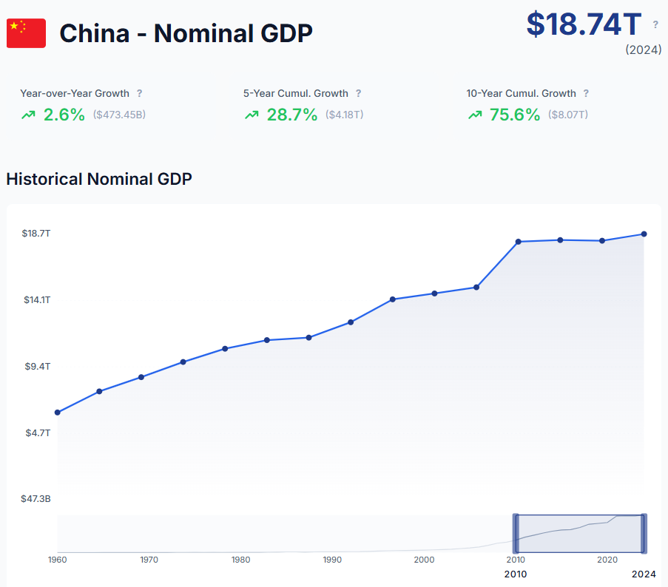
Figure 8: China - Nominal GDP
(Source: EconScope, 2024)

