Name: Paloma Nadine Morais Araujo 
Student number: 1907291
Module title: Psychology for health and social care
Lecture Name: Diya Ganguly
Module code: BMHP4003



CONTENTES

Introduction …………………………………………… 3
Development psychology ………………………. 4
Adolescence …………………………………………. 5
Lifespan ………………………………………………. 6 , 7
Complexes and challenges ……………………… 8
Emotions and behaviours …………………………. 9 , 10
Physical changes ………………………………. 11 , 12
Psychological problems ……………………… 13 , 14
Conclusion ………………………………………………… 15
References …………………………………………………….

INTRODUCTION

The purpose of this as essay is to research studies based on theoretical perspective related to developmental psychology. In this essay I will discuss about Adolescence and her path.
DEVELOPMENT PSYCHOLOGY

Development psychology is a very logical approach which means to explain constant development, change and consistency however the life expectancy of an individual. The constructive research also explores how thinking and feeling can provoke change all through an individual’s life and have a major impact in society.
Various critical theories inside this research focus on the improvement and rapid development during youth, as this is the stage in which a person's life expectancy changes the most.
Influential brain science is a logical methodology which clearly explains development, change and consistency however the life expectancy. It further informs how thinking, feeling and conduct can change and create impact throughout an individual’s life.
Furthermore, improvement during youth is defined as being a critical magnitude inside this order centre which is shown under an extent of theories, as this is the stage during an individual’s life expectancy when the most transformation happens.
According to research decisive analysts should conduct a thorough study to clarify and further explain the progressions they have witnessed to regularizing procedures and individual contrasts. Even though, it is often simpler to illustrate advancement than to clarify how it happens.
At last, formative clinicians would like to upgrade advancement, and apply their speculations to help individuals in down to earth circumstances ( M. Saul , 2017 ) .

Adolescence

Puberty is a process of various physical changes, which occurs when a child’s body matures into an adult body capable of sexual reproduction. This happens during adolescence into adulthood. It is quite a drastic change to the body, and the way that teenagers identify with the outside world and fit into society.
The numerous physical, sexual, intellectual, social, and enthusiastic changes that may happen during this time can bring many expectations, pressure and nervousness for any youngster and their families. Understanding what is in store at various stages can advance sound improvement all through youthfulness and into early adulthood. (Brittany Allen ,2019)

During youthfulness, many emotional changes occur creating detachment from parents and friends. This moment of separation is an important advance in the foundation of the development of individual qualities and ideas, the big transition of a youth from being dependent to independent powers a variety of changes upon many teenagers. Also, young people who experience puberty earlier may have higher rates of becoming depressed and oppressed in which it can unable emotional connection with others.
Emotional changes such as detachment from parents, or expressive conflicts can often be seen immaturity in Western societies, and the way it is portrayed settles the idea of an individual’s grown-up years. Likewise, during youthfulness, individuals may encounter an upsurge of sexual emotions and desires following the idle sexuality of adolescence. It is during immaturity that the individual figures out how to control and direct sexual desires. (Britanica , 2017 )

LIFESPAN

Erik Erikson's hypothesis of psychosocial is character versus job disarray, and it happens during immaturity, from 12-18 years. At this phase teenagers begin to feel sense of being independent and individual character, going through different situations searching for their own individual qualities, convictions, and objectives within society.
During youthfulness, the constant change and impact from adolescence to adulthood is commonly significant. Individuals are getting more self-sufficient and begin to look for the future in search of profession, different connections, families, lodging and so forth. Finding a place within society and trying to fit in with the public can become stressful for any youth.
This is an important stage of self-development and discovery where the youth seeks to become familiar with the jobs he will have as a grown-up. In this phase the adolescent will gain his own personality and make an effort to unveil his own desires to fit within society. Erikson proposes that two characters are comprise : the sexual and the word related.
As point out by bee (1992), what is necessary to happen in direction of the end of this phase is "a reintegrated feeling of self, of what one needs to do or be, and of one's suitable sex job". During this stage the self-perception of the juvenile becomes different (E. Erikson’s , 2018 ).
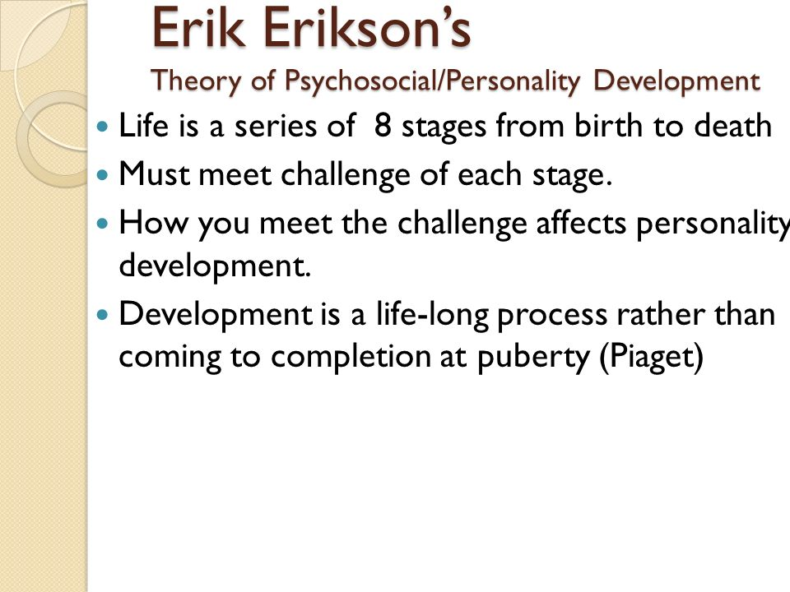

COMPLEXES AND CHALLENGES

Complexes during youthfulness are rigidly connected to youngsters' degree of confidence. Luckily, a solid, very much educated family can help defeat these issues. Immaturity is a convoluted time in an individual's life, ruled by physical and mental changes. A young person's public activity can turn into a wellspring of dramatization when edifices during youthfulness start to rise.
These edifices are additionally the consequence of enthusiastic components. Notwithstanding the abrupt changes in a youngster's body, the mental factor of frailty assumes a significant job. The entirety of this is exacerbated by the media, who sell youngsters a perfect picture of physical flawlessness.
At this age, young men and young ladies are extremely delicate to the requests forced by family, the media, and public activity. These factors, when joined with their own arrangement of desires, lead to sentiments of uncertainty, dread and stress (your are mom , 2018 )

EMOTIONS AND BEHAVIOUR

Pre-adulthood is a time of individual and social character development, where various jobs, practices, and belief systems are investigated. In the United States, puberty is viewed as a chance to create autonomy from guardians while staying associated with them. Some key focuses identified with social improvement during pre-adulthood incorporate the accompanying:
- Adolescence is the time that is known for positioning of single and communal personality .
- Teenagers should go into , test limits, become self-governing, and centre on a character, or feeling of self.
- Erik Erikson suggest to the agreement of the juvenile as one of personality versus job disarray. In this manner, in Erikson's view, a juvenile's primary inquiries are "Who am I?" and "Who would I like to be?"
- Right off the bat in youth, intellectual improvements bring about more noteworthy mindfulness, the capacity to consider dynamic, future prospects, and the capacity to consider various prospects and personalities on the double.
- Changes in the degrees of specific synapses, (for example, dopamine and serotonin) impact the manner by which young people experience feelings, regularly making them more passionate and more touchy to stretch.
- At the point when young people have progressed intellectual turn of events and development, they will in general purpose personality gives more effectively than peers who are less psychologically evolved.
- As a adolescent they make effort to shape their characters, they pull away from their folks, and the companion bunch turns out to be significant; notwithstanding this, associations with guardians despite everything assume a huge job in personality development.
Conduct issues in youth can make life hard for guardians. Be that as it may, recollect that it is a passing stage, and is completely ordinary.
Picking up youngster's trust is significant on the off chance that you need to assist him with social issues. Converse with them and tune in to what they need to state. Try not to pass judgment or censure them, as it could compound their conduct.
Tell them that you love them similarly as they seem to be. Urge them to be consistent with themselves and not take on a character just to satisfy others. Recollect that your young adult kid isn't totally autonomous in managing his feelings and requirements your help. Help him by mentioning to him what you do when you are feel pitiful, irate, desirous, and so on. He can give those answers for come his very own shot intense subject matters.
You should mediate in the event that you see them falling into awful organization. Recall that young people are touchy and may not take analysis well (G.Sangari , 2019 )

PHYSICAL CHANGES

Physical changes occur because of progress in the young person's hormone levels.

- Advancement of full bosoms in young ladies can be off kilter at the outset. Young ladies may begin to feel cognizant about their figure.

- Change of voice and presence of facial hair in young men is maybe the most conspicuous change that happens during puberty.

- Skin break out is one of the serious issues.

- Muscle gain occasionally prompts unreasonable body weight in teenagers.

- The development of pubic hair in young ladies and young men.

- Personal stench gets clear.

- Young ladies start their periods.

The most ideal method to enable your adolescent to obtain past the phase is to build them mindful of these changes. It is good to always clarify that it is typical for the body to change as each youngster experiences it! Assist them with adjusting to these changes – recognize the change and assist them with tolerating it. Empower them to remain solid and fit through a nutritious eating regimen and exercise (G.Sangari , 2019) .

Psychological problems

Exploration contain expose that on every side half of psychological well-being messes that grown-ups have, start at 14 years old. Truth be told, 33% of juvenile passings are suicides set off by sadness (1). In the event that your kid is excessively grouchy and isn't eating or dozing by any stretch of the imagination, it is basic you get proficient assistance for them.
Adolescents may posses trust or certain issues . The feelings of mediocrity or predominance regularly comes from the way of appearance , skin shading, magnificence, and figure.
Despondency is one of the regular mental issues related with pre-adulthood. The compulsion and heaviness of youthfulness can build uneasiness connected issues, while state of mind swings can prompt lead issue or oppositional rebellious confusion .
Dietary issues are additionally psychosomatic as they start with the juvenile having a helpless mental self view and the need to change the manner in which they look using any and all means.
While irritability and hissy fits are ordinary in high school young ladies and young men, they may not generally be what they appear. Distinguishing manifestations of mental issues in youthfulness isn't simple and requirements the eye of a specialist.
More often than not, discussing the issues and keeping up a sound way of life can forestall the beginning of discouragement.

On the off chance that kid’s are excessively grouchy and sceptical, the time has come to mediate and look for proficient assistance if essential. In some cases, your high school young lady or kid might be miserable just at home, and doing fine outside. Converse with the kid's instructors and companions to know whether they are ill humoured and perplexed at school too. On the off chance that they are, at that point it is a reason for concern.
Try not to brush away their sentiments, as that can exacerbate the situation. Urge them to speak with you. For this, you have to converse with them. In the event that you figure your kid would not relax, converse with him in the vehicle where the odds of encounter are less as you are not eye to eye (G.Sangari , 2019 ) .

CONCLUSION
In this report analysed the life stage of an adolescence . Explaining how are the stages of being a teenager , to the complexes and challenges they go through during this life stage . Teenager develop more emotions and behaviours in this life stage . This behaved that in this life stage in when psychological problems start to show up . So I can conclude my essay , with a brief explanation of this phase of the adolescence .
REFERENCES

Simply psychology (2017) Development psychology [online] available from : https://www.simplypsychology.org/developmental-psychology.html (Accessed : 16 Aug. 20 )

Healthy children (2019) Stages of adolescence [online]
Available from :
https://www.healthychildren.org/English/ages-stages/teen/Pages/Stages-of-Adolescence.aspx
(Accessed : 16 Aug. 20 )

Britanica (2017) Adolescence [online] available from;
https://www.britannica.com/science/adolescence
(Accessed : 16 Aug. 20 )

Simply psychology (2018) Erik Erikson’s stages of psychosocial development [online] Available from : https://www.simplypsychology.org/Erik-Erikson.html#:~:text=The%20fifth%20stage%20of%20Erik,values%2C%20beliefs%2C%20and%20goals. (Accessed : 19 August )
You are mum (2019) Complexes during adolescence [online] available from : https://youaremom.com/children/complexes-during-adolescence/ (Accessed : 19 August)

Lifespan development (2017) motional and social development in adolescence [online] Available from: https://courses.lumenlearning.com/wmopen-lifespandevelopment/chapter/emotional-and-social-development-in-adolescence/ (Accessed : 19 August )

Mom junction (2019) 11 common problems of adolescence , and their solutions [online] available from : https://www.momjunction.com/articles/problems-of-adolescence_00381378/ (Accessed : 23 Aug. 20 )

