Morgan 1501469
AHSK6002 Dissertation, Outline and Reflective Report

Introduction.
For my dissertation I have chosen to do a graveyard survey. This survey is to consist of collecting data from the graveyards in New Quay, Ceredigion and the immediate vicinity. New Quay is a small coastal village in the Cardigan Bay area of West Wales. Up until the early 19th century, New Quay was just a small village on the coast consisting of a few farms. The natural cove here gives good shelter for fishing vessels and from the later part of the 18th century this was utilised to great effect. Due to the shelter of this bay ship building transformed the village into a busy hub of activity. The ‘New Quay Harbour Act’ was set up in the early 19th century. This allowed for the construction of a new pier, trading increased and for a period of approximately 30-40 years the village thrived and the population rose rapidly. From a small farming community New Quay was transformed into a thriving hub with all the hustle and bustle of a ship building centre.
After the decline of the ship building trade in this area, the natural beauty of this coastal village allowed for tourism to become its major attraction. This has not changed until the present time and this is born out in the population of the village. With the majority of the homes being 2nd homes it can be argued that the population in this village is decreasing. This is one of the reasons I felt it important to include the surrounding graveyards. For many years with the introduction of tourism local people who had lived in the village of New Quay all their lives, have moved to the surrounding villages. This has been partly due to the rising house prices in New Quay whereas the surrounding villages have not benefited in this way so much. Another reason is because at the height of the ship building trade New Quay would have drawn people from the surrounding villages to work in New Quay itself.
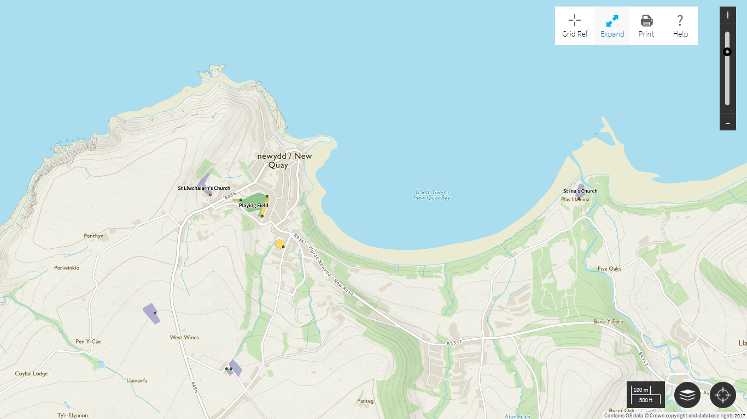
4
3
2
1
Image 1 1
The four graveyards which I am gathering my data from for this survey, are numbered on the map above. 1- St Llwchaiarn’s Church graveyard, 2- New Quay cemetery (council run), 3- Maen-Y-Groes Welsh Independent Chapel and 4- St Ina’s Church, Cei Bach. In the above map area there are no other cemeteries. There is a war memorial in New Quay memorial hall whose data has also been collected, some of those mentioned on that also appear in some of the graveyards.

St Llwchaiarn Church, New Quay, dates from 1865 after the previous church was demolished. In 1833 the previous church was described as ancient, at that time it was also noted that there was a medieval cross in the churchyard. There had been also been chapel or a church on this site during the ‘post-conquest period’ (Coflein 1). St Llwchaiarn’s is situated high above the village overlooking New Quay on the south side.
New Quay cemetery is situated high above the village just on the outskirts on the road to Maen-y-Groes. There is no church or chapel at this cemetery just a bandstand style wooden seating area. This seating area is flanked on either side by uniformed rows of graves, there is additional scope in this cemetery for many more plots. The first recorded burials at New Quay cemetery are recorded as being from 1925 (Ceredigion County Council) although there are memoriam dating to earlier years.
Just outside New Quay and not several hundred metres from the previous cemetery is Maen-y-Groes independent chapel. This chapel was first built in 1828 and then enlarged in 1873 before being rebuilt in 1902 (Coflein 2). There are 3 defined areas in this graveyard, one around the chapel itself with another two phases of burial over the road in an adjacent area. The initial burial phase in the grounds of the chapel itself seems like any other churchyard, in the overspill across the road they seemed to be crammed in like sardines, until the third phase was created where it seems a little more spacious.
St Ina’s Church is situated to the north of New Quay, right on the coast. In 1810 the current church was rebuilt on the site of an earlier church (Coflein 3), but it is said there has been a place of worship on or near this since the 8th century. The original burial phase of this churchyard seems very underpopulated with fewer headstones than burial plots. That is not to say that there aren’t graves there, due to the softness off the ground I would say the headstones had been removed. There were obvious grave indentations without headstones also. The current burial phase of the churchyard is concentrated right on the foreshore, coastal erosion and local folklore suggests this is not a good idea.

Aims and Objectives
The whole nature of this dissertation is because I wanted to look at the ages and periods of death in a rural coastal village community in comparison to statistics reported about the rest of Wales. These are to include looking at ages of death male/female in their relevant age groups, also months of deaths in the same respect. I will also look at the average age of deaths in each decade also the number of deaths per decade. Once all the data is collected and analysed It is quite difficult to list everything I will be looking at as some things may become more relevant further down the line.

Methodology
Because primarily I was looking at death rates I made up a recording form (see appendix A). This form recorded sex, age, date of birth, date of death, month born, month died, year born and year died. It also recorded occupations and house names. On the top of the form there was space for the name of the church, the parish, date and number recorded. In all thirty-two individual memorials could be recorded on each sheet.
The first cemetery I visited was New Quay Cemetery, there was no one else there so I decided to make use of the seating area and plan my assault. Fortunately, it was a nice sunny October day so it gave me a good chance to draw the cemetery out for future reference. This cemetery happens to be the youngest of the four not yet being a century old, the earliest burial being 1925. The uniformity of the cemetery made recording each individual burial plot quite a simple task, it also made it possible to note where plots were vacant which were also recorded in my sketch. Sketching the graveyard beforehand made it possible to record the memorials by photographing them. By crossing them off after recording the data I could be sure that I had recorded them all, there was also the bonus that if for some reason I could not read the data, I could identify the burial plot quickly to rectify this issue. As is the case with most cemeteries and churchyards not all headstones are decipherable this may be because they are missing or because they have fallen, this cemetery proved no exception. I made the decision to treat the place with as much respect as I could and not upright any headstones or interfere. The most I allowed myself to do was a visual inspection, maybe moving some flowers but always putting them back as best I could and apologising. After one visit back to check three headstones, one for checking it was dated the 29th of February all the data required was collected. In all there were 347 individual plots memorialising 600 individuals.
I used roughly the same approach for St Ina’s graveyard which I recorded next. The only difference with recording this one was that I found I had to draw the plan and take the photographs at the same time. In the first phase the lack of uniformity meant I had to draw the burial plot on a plan, number it then take and check the photo. The newer part of the churchyard was more uniform so again much simpler to plan. St Ina’s is only a small churchyard so was relatively simple to record. The earliest recordable burial there was from 1765. The age and condition of some of these headstones made them impossible to read, taking an etching was out of the question or anything else other that visual inspection for fear of damage. The most I was prepared to do in this graveyard was to flatten any grass in front the headstone to read any lower inscriptions. St Ina’s consisted of 174 burial plots recording 234 individuals.
The next graveyard, Maen-y-Groes chapel proved the hardest to record. The weather was grey and misty and it was Halloween. I decided to record the area across the road from the chapel first because time was limited for sketching the plan, this area allowed for a quick sketch due to the uniformity of the layout. Taking photos proved more difficult, the plots in this graveyard were taken up by far grander monuments than the other two, with each one taking up as much space as possible thus making it very difficult to get access. With limited access just to take a photograph some of these memorials were in dire need of maintenance. Managing to take photos of all these headstones was just about possible but that involved tripping over long brambles and watching out for leaning headstones. There are more than 800 individuals memorialised in Maen-y-Groes.
St Llwchaiarn’s graveyard is next, I feel I am prepared for whatever this may through at me through the experiences of the other three. I had planned on recording data from there last week but they were having an actual burial so there is another lesson learnt.

Conclusion
Having not completed the recording at all sites yet it would be unfair to come to any conclusions. Having collated the information from the first site which only covers the start of the 20th century onwards, nothing jumped out. Observations of the data at St Ina’s, albeit a small sample again was very routine. When collating the information from Maen-y-Groes chapel it was hard not to notice the difference between that and New Quay cemetery which is just over the road. There is not a large difference in the number of memorials but the average age of death would be significantly lower in Maen-y-Groes purely because of those extra hundred years. These results highlight the effects of cholera and other diseases on this rural village. Infant mortality was very high as is shown on many of the headstones, some with 6 or 7 infants one above the other year after year. These results are not unexpected in any way, infant mortality in Wales was at its highest at the turn of the twentieth century with infant mortality at nearly 180 per 1000 (Michael, 2008). I am sure the data from St Llwchaiarn’s graveyard in New Quay will support that of Maen-y-Groes if not more so as New Quay cemetery was designed as overspill for St Llwchaiarn.
The memorials in Maen-y-Groes also had another difference to the ones of New Quay cemetery, although a few memorials in New Quay cemetery had their house name on them nearly all the ones in Maen-y-Groes had them. If they did not have their house name they would normally belong to a captain and therefore his ships name would be on the memorial, sometimes they had both but very rarely neither. There are also many seamen who have been lost at sea and people who have died on ships in other countries memorialised here. This shows how important the ship trade was to New Quay, many professions are recorded as ‘Master Mariner’ far more than any other. This trend I would expect to see in St Llwchaiarn, maybe more so. Surprisingly the church closest to the sea has fewest Master Mariners to date, many here are remembered as farmers but as some of these are even earlier it is no surprise because New Quay before ship building and trading was mainly a farming community.

Bibliography
Michael P. Thompson P. 2008. Public Health in Wales (1800-2000): A Brief History. WAG Cardiff.
https://www.ceredigion.gov.uk/English/Resident/Births-Deaths-Marriages-Civil-Partnerships/Cemeteries/Cemetery-Locations/Pages/default.aspx
http://www.coflein.gov.uk/en/site/301818/details/st-llwchaearns-church-new-quay
http://map.coflein.gov.uk/index.php?action=do_details&cache_name=&numlink=7347#tabs-4
http://www.coflein.gov.uk/en/site/105619/details/st-inas-church-llanina

Image courtesy of Ordnance Survey Maps

Appendix A


