https://www.dailypost.co.uk/news/north-wales-news/morning-travel-guru-simon-calder-19097984

(Accessed 14-10-20)

This Morning travel guru Simon Calder 'naive' for 'travel to Wales' call but FM condemns abuse
Police issue statement about coronavirus hotspot travel ban to Wales
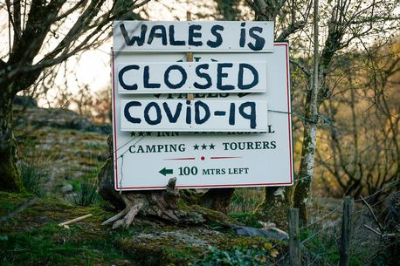
The English and Scottish cities and regions on Welsh travel ban list
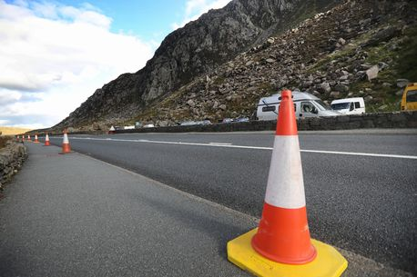Snowdonia visitor pass plan to combat parking issues and boost economy
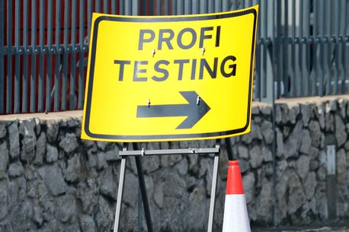Covid-19 infection rates almost double in week but Conwy leader calls for 'balanced' review
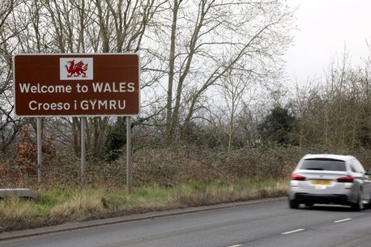
What UK Government say about Wales travel ban - which could be in place by the end of the week
Mark Drakeford was asked about Mr Calder's suggestion of North Wales as a good holiday getaway option
Owen HughesBusiness correspondent
- 17:02, 13 OCT 2020

Holly and Phil try the Back to the 90s viral takeaway box on This Morning
Play
Unmute
Loaded: 100.00%



Sign up to our free newsletter for the top North Wales stories sent straight to your e-mail
Sign up now!
When you subscribe we will use the information you provide to send you these newsletters. Sometimes they’ll include recommendations for other related newsletters or services we offer. OurPrivacy Noticeexplains more about how we use your data, and your rights. You can unsubscribe at any time.

First Minister Mark Drakeford says tourism pundit Simon Calder was "naive" to call for people to travel to Wales - but condemned the abuse he received for his comments.
Simon Calder last week appeared on ITV's This Morning to talk with presenters Holly Willoughby and Phillip Schofield about staycations for the upcoming half-term holiday.
He suggested some holiday destinations in North and Mid Wales for a quick getaway as other areas of the country remain under local lockdown.
But it sparked a furious backlash from people in parts of Wales with low Covid rates over concerns about visitors spreading the virus.
He said he had experienced some of the most intense abuse of his career.
Tourism bosses have been concerned of the impact this could have on efforts to promote Wales in other parts of the UK.
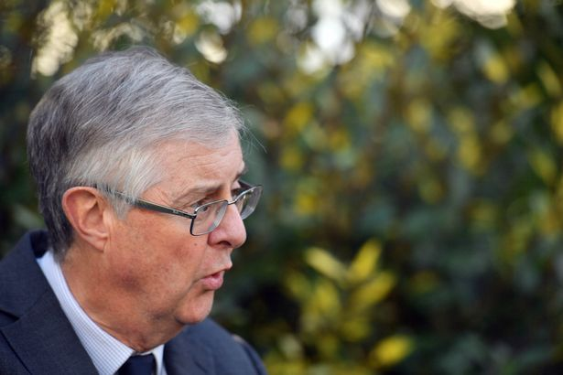
First Minister for Wales, Mark Drakeford, (Image: WalesOnline/Rob Browne)
Today First Minister Mark Drakeford was asked in the Senedd whether he would condemn the abuse he had received.
Mr Drakeford said: "I think his advice to people was naive but I absolutely do not believe that people who speak on any subject should be subject to abuse and I regret the fact that that was the result of what he had said.
"I may not agree with him but he has every right to say it and he has every right to be respected."
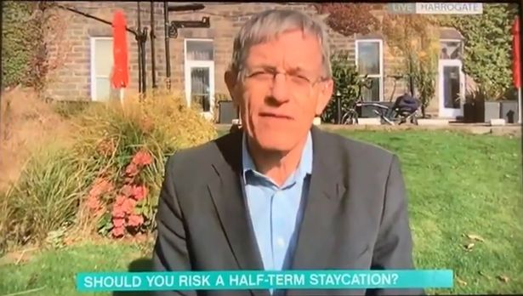
Simon Calder appeared on Monday's show (Image: ITV)
Writing in a column in The Independent, Mr Calder said he understood "the deep concern of any community that is fearful of outsiders spreading this vile virus" but also said there was a "tourism economy to support".

He also pointed out that Visit Wales was featuring mid Wales prominently on its homepage as a place to visit.
The website also features Cardiff below that, which is under lockdown.
https://www.dailypost.co.uk/news/north-wales-news/morning-travel-guru-simon-calder-19097984

