

Assessment 1 – Reading Task Template
PART 1: Upload your photo of your A3 in-class notes here:
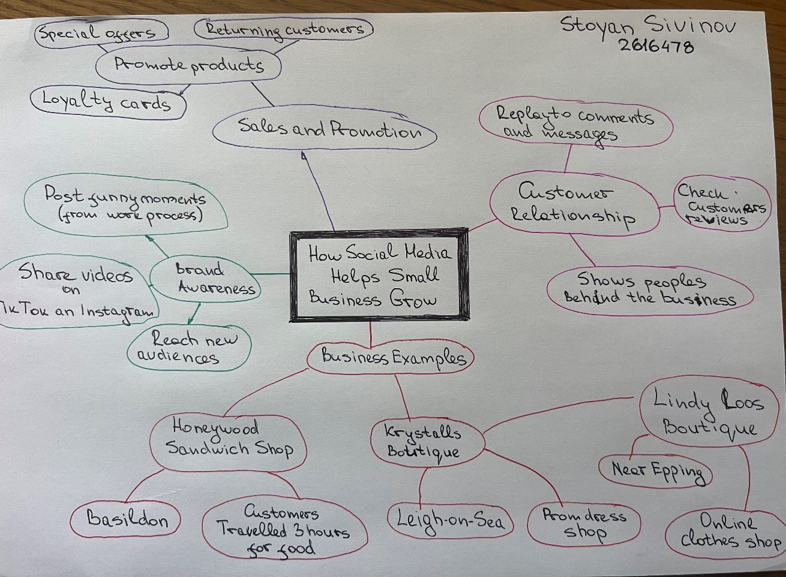

PART 2:
- Answer every question below in 1-3 full sentences.
- Use your own words. Do not use generative AI to answer these questions.
- Include a specific detail from the text when asked.
REMINDER
- The main idea is the overall message of the whole text.
- A key point helps to explain the main idea.
- A specific detail or example from the text shows that the key point is true.

- What is the main idea of the whole text?

Main idea in the text is to understand how Business works together with social media.
How social media helps small Business growth.

- What is one key point that supports the main idea, and which specific example from the text shows this?

Honeywood Sandwich Shop in Basildon becomes popular on Tik Tok because customer posted a video of its big chicken burger. After this video some peoples started traveling to try the burger.

- What is a different key point that supports the main idea, and which specific example from the text shows this?
The other key point is the example of Linda Hunter.
In the past she started her own business sealing clothes at the street markets.
Now she has around 320,000 followers on Instagram and Facebook because she turned her business to the online clothes shop.
After this changing she sells clothes across the UK and even in Australia.

- Which part of the text do you think is most important, and why?

The most important point in the text is that social media platforms such us
Tik Tok and Instagram have made it easier for business to get noticed around the world.
Because ever small business can reach more customers by posting a their product on social media.

Reflection:
- What did you find difficult in this task (including in-class components), and why was it difficult?

I did not have any major difficulties with the task.
The only problem is that English is not my first language, and when I try to organise my thoughts and answer the question, I sometimes struggle to find the right words and use the correct grammar.

- What helped you with this difficulty, and how did it help you?
I think I could improve my English vocabulary and practise my grammar, by reading more articles in English and must practice writing in my own words.

