DIGITAL SKILLS AND RESEARCH METHODS
TERM II
CLASS: BMSW4003_LON

RESEARCH RAPORT



STUDENT NAME: IOANA CADERE
STUDENT ID: 1909479
LECTURER NAME: ANUPAM MAZUMDAR

TABLE OF CONTENT:

1 INTRODUCTION page 2
2 RATIONALE OF THE RESEARCH page 2
3 LITERATURE REVIEW / ANALYSING EXISTING LITERATURES page 3
4 RESEARCH METHODS / METHODOLOGY page 3
5 ANALYSIS AND DISCUSSION page 3
6 LIMITATIONS OF THE RESEARCH page 10
7 RECOMMANDATION FOR FUTURE RESEARCH page 10
8 CONCLUSION page 10
9 REFERENCES page 11

1 INTRODUCTION

In this research report I will present to you my research and finding about our Moodle platform from University of Wales Trinity Saint David who was created to help them students who much they can. I will share with you the experience of me and several students of this university with the Moodle Platform. It was difficult to gather all the necessary data due to this global pandemic, but we tried to live up to expectations.
I found out many details about the strengths of the platform but also about the dissatisfaction of different students. I analysed and thought about each situation and came to certain individual conclusions

2 RATIONALE OF THE RESEARCH

This is a research report about the impact of Virtual Learning Environment (VLE) - Moodle on students’ learning experience in University of Wales Trinity Saint David London Campus. We need to collect and analyse primary and secondary data. We will develop a questionnaire on the above topic, which should be used as a primary data collection tool. The students learning experience should be analysed as a secondary data collection tool. The scope of the research is to analyse both primary and secondary data to see who useful it is for different students and what impediments they have with the platform.
In this report we will talk about the usefulness of the university's Moodle platform and what is missing and how it could be improved in the future for better functionality.
I kept in touch online with students and colleagues as much as I could

3 LITERATURE REVIEW/ANALYSING EXISTING LITERATURES

For this assessment I collected the data using an online questionnaire that helped me get in touch with several of my colleagues and helped me do my job.
I researched a lot on the Moodle Platform and I shared the experience I had in this university with other colleagues in order to reach a conclusion.
I spoke with most of my colleagues in particular in order to be able to reach a real conclusion and to realize exactly the weaknesses but also the strengths of this platform and to be able to try to figure out how we could be more useful for all age groups, but with some of them I did not have the opportunity to contact them in private due to this situation created by the global pandemic.

4 RESEARCH METHODS/METHODOLOGY

In this research report I will reflect on the experience I had with the Moodle platform as well as on the experience of my colleagues who shared their opinions with me and I will use primary data and the collection method it will be by online survey. I will use 5 Likert Scale with 20 sample for graphic representation.
I created a questionnaire based on this topic and talked about each other's experiences, analysing all the data collected and following the results of this survey, I managed to analyse and graphically represent these answers in percentages and to form an opinion but I got in touch and in particular most colleagues, sharing our personal opinions.

5 ANALYSIS AND DISCUSSION

Here I will present to you the online survey created by me about this research and the conclusions I reached after collecting and analysing all the necessary data.
My survey contains five questions and two clarifications regarding the impediments encountered using this platform and recommendations for better functioning and utility for all tips of students.

THE IMPACT OF VIRTUAL LEARNING ENVIRONMENT

This is a little research report about the impact of Moodle Platform from University of Wales Trinity Saint David, London Campus on students learning experience made by me with the help of my colleagues who shared with me their own experience from this university.

Q1 Do you find it difficult to use the Moodle platform from University of Wales Trinity Saint David?

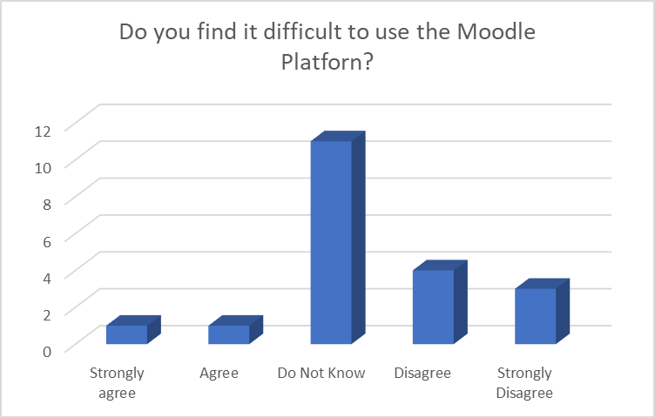
Discussion:
The vast majority of my correspondents do not find it difficult to use this platform, but we must keep in mind that not everyone is so used to the new modern technology and its use.
Personally, I didn't find it difficult at all and I got used to this platform very quickly.

Q2 ​Do you think Moodle has a lovely environment at University of Wales Trinity Saint David?

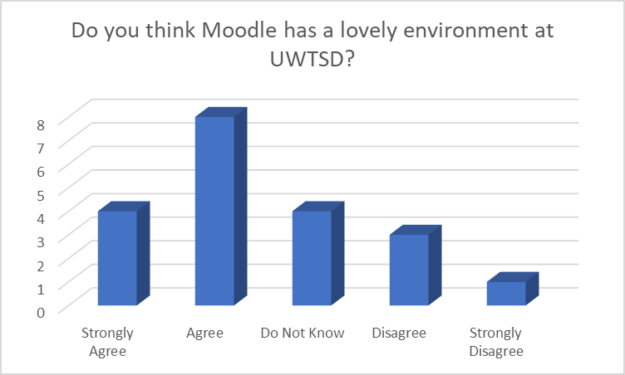
Discussion:
Almost all of my correspondents believe that the University of Wales Trinity Saint David has created a wonderful learning environment with the help of the Moodle platform for his students.
I found this platform enchanting and very useful, helping us in our learning process.

Q3 ​How hard was it for you to get used to this platform and it’s tools?​

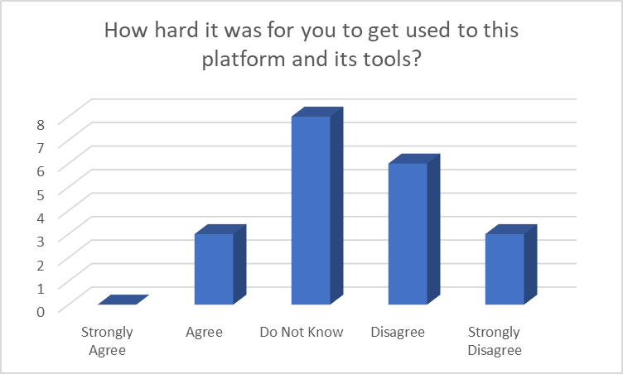
Discussion:
It is not at all difficult to get used to this platform for the first time because it is very carefully arranged.
Even for those who are not so used to using the new modern technology, getting used to this platform has not been difficult because it is an easy application.

Q4 Is it easy for you to find the right information on Moodle?​

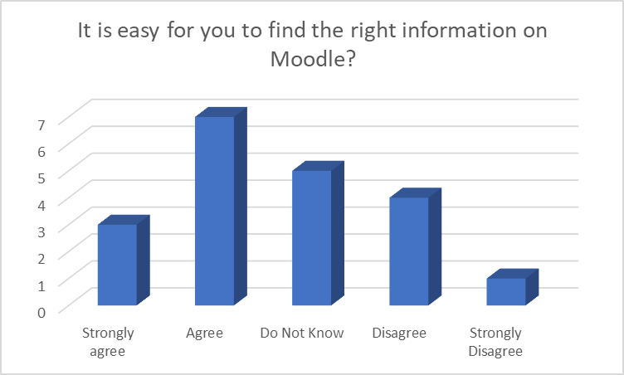
Discussion:
It is very easy and handy to find information on Moodle and it is always the correct information.
Once you get used to the platform, it is very simple to find everything you need to progress.
In other words, you can't find everything you need here. But I don't think it's good for students if they could find absolutely all the material in one place

Q5 How useful was it for your personal and educational development?​

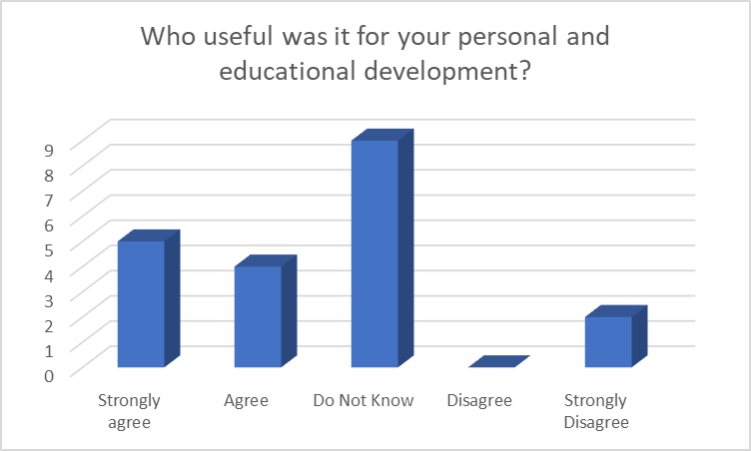
Discussion:
It is very useful for personal and educational development in this faculty.
Many do not know if this platform has contributed to their personal development, but I believe that only with the help of this platform have we all managed to advance in our knowledge.
I realized and understood that it is designed for that category of people who are accustomed from an early age to modern technology because it was not taken into account that some students are a little past the normal age of this stage and need slightly more precise and accurate explanations in order to be able to adapt quickly to the new modern technology at least as much as is necessary for the deepening of studies and knowledge. I also think that no one has thought of an ideal way to make the requirements understood by all students given that they come from different countries, with different cultures and ways of education, as a result it makes it difficult to convey the correct information in two or three words because everyone will understand something completely and completely different from the one required, not being English from birth, too short explanations can put you in difficulty until you get used to the English way of thinking and speaking.
It personally helped me a lot that I could go back over the hours and courses I did whenever I needed information or omitted something.
Especially now, lately, since we do the online courses, it is very useful for us because we find the lessons that we should have deepened in class and we also find extremely many sites that can complete our knowledge and that probably not we would be able to find them on our own in the vast online environment.
In my survey I asked the students what impediments they found on the Moodle platform and what recommendations they would have to improve this platform. Not everyone answered but based on the answers I received from them I will only come up with what is useful for improving the platform.
The biggest impediments encountered were: difficulty navigating, difficulties in finding the correct and detailed information, ambiguity, misunderstanding of the requirements for the assignment because the requirements are not specific enough and detailed.
In connection with finding the correct information, I think that a kind of table of contents should be introduced (or sent to the student at the beginning of each term) showing what lessons study each week contains so students will know exactly where they can find the correct information on Moodle and will be much more satisfied with this platform.
In my opinion, I think they expected it to be a platform like Google and with a simple click to find everything. On the one hand I understand them, but on the other hand I think it's good that we don't even get blackberries in our mouths. because we are at university now and we have to give some time for research and learning if we want to succeed in exams but also to keep something in our head even after completing the exams because this knowledge is useful for us in real life every day, not only in the university
If we learn mechanically then it will be in vain because there will be no knowledge left in our heads and after a while we do not remember anything.
Students would also like: to find the information easier and more detailed, to find a simpler method of using this platform, to make the topics clearer, to explain the work requirements for the deadlines in more depth and in more detail as a help from the teachers to guide us on the right path given that many have passed the years of youth and strive to keep up and, of course, we want to be able to access the materials in the Library much easier, here finding important materials that are useful to us in the final projects.
I think it would be a substantial improvement for all students at these universities if a common chat were created where students could get in touch online at any time and where they could support and help each other. It should be taken into account that the students of this university belong to different countries and cultures and here there is little difficulty in understanding the too detailed requirements of Moodle and in finding the right information because each language has its own particularities and you can not make a statement. to understand what you want to say only in 2 or 3 words because they will be perceived different and the translation will not be the desired one.
In order to improve the usefulness of the platform, I think that a change in the essential explanations would be welcome, considering the requirements and the tasks that the students have to do. And, in order not to become a kind of technological manual, I think that a kind of online chat should be introduced where we can constantly contact different lecturers available to answer our questions, guide us and give us feedback in a real time to be able to make the necessary changes where needed.

THANK YOU FOR YOU TIME AND ATTENTION!

You will find the original survey here if you like to see the design: https://freeonlinesurveys.com/s/McYc7skG#/0

6 LIMITATIONS OF THE RESEARCH

Because of what is happening around the world, because of this COVID-19 virus, our learning time has been shortened and we have had many obstacles in trying to create a very good research report. We try hard to make up for lost hours in class with online sessions, but it is not the same and for many of us it is much more difficult. We will appreciate if you consider the impediments caused by this mysterious disease that keeps us in our homes and limits our possibilities to be able to do more research on this topic.
All this makes our research difficult and it will be hard to get in touch with the right correspondents, because communication is very important for this project and we cannot go out for research.
I personally sent the survey to more than 40 students, but only almost 20 responded. Even so, it was extremely difficult to get in touch with them, all of them busy and caught up in the current problems.

7 RECOMMENDATION FOR FUTURE RESEARCH

For the future, I recommend you to do more research with students, online and face to face, in order to better establish and define their needs and help them in their personal and educational development better and better.

8 CONCLUSSION

In conclusion, this research helped me understand the extent to which the Trinity Saint David University of Wales Moodle platform is useful to students and the influence it has had on their personal and educational development. Based on the personal experiences of different types and categories of students from different age, I was able to understand both the strengths and weaknesses of this platform and his utility.

9 REFERENCES

Original survey, https://freeonlinesurveys.com/s/McYc7skG#/0

