Hannah Thomas

Business Inquiry and Research
Assignment 2
Quantitative Research
Hannah Thomas
1703882
Dr Alex Bell.

Introduction:-
During this study, the quantitative research method has been used as the approach. The purpose of this study is to determine if social media impacts people’s mental well-being. This topic was chosen, due to the fact that there is currently a high number of people whose mental well-being is effected due to social media. In recent news, a number of celebrities have found this pressure, and the purpose of this research is to determine if people who are not in the public eye have similar feelings and experiences. In order to conduct a result from this quantitative research, the data will be collected from a survey then inputted to SPSS.
There are number of pros and cons to consider when thinking about social media. It has brought a global community closer together, however on the other hand it has also resulted in individuals isolating themselves. Our reliance on social media has the detrimental effect on our mental health, with the average Brit checking their phone as much as 28 times a day. (Barr, 2019). During the survey that has been conducted for the purpose of this research, a variety of people from different age groups have taken their time to answer the questions to see if there is a comparison or not between the impact on their mental health.
Methodology:-
Quantitative Research method is used as a way of generating numeric data, or data that can be transformed into usable statistics. Through this method, we are able to quantify attitudes, opinions and behaviour’s including other defined variables. In comparison to Qualitative research, the quantitative method is much more structured as the data is collected through a form of surveys, whether they are conducted online or an alternative way. (DeFranzo, 2016)
The purpose of quantitative research is to gain a real understanding and knowledge of the social world. This research method is commonly used by scientists and communication researches in order to observe phenomena and/or occurrences that impact people. Therefore, quantitative research is a tool to discover more regarding a population (group of people). Quantitative research relies on data that is being measure to examine the questions being conducted within the research. (Allen, 2017).
For the purpose of this research, a quantitative method has been used. However, in order to collect the data, a survey was conducted via Google Forms. Survey research is regarded as an easy approach to collect data, however we must ensure that they are conducted with the highest quality. (Kelley, 2003).
By conducting 10 questions and providing structure to the survey, it was then made live on a social media platform. Before creating the survey, the 10 questions were specifically asked in order to gain a real understanding of what the report was trying to achieve, without gaining any unnecessary information. The survey design created needed to be attractive to participants in order to encourage them to participate. The questions asked were simple, therefore didn’t encourage them to withdraw their participance. By creating an unorganised and unstructured survey, it can discourage people from taking part. There was a variety of formats used in order to answer the questions within the survey, e.g. “Please chose from number 1-5”, Multiple choice answers and yes or no answers also.
The platform used was “Facebook”, where friends were asked kindly if they would voluntarily participate within the survey. A total of 50 people participated, and there was no need to ask consent via an agreement document, as they were agreeing to participate through completing the form voluntarily. (Please see appendix 1. for copy of the survey).
After a period of 5 days, the results were concluded from the surveys in order to be analysed. In order to do this, the software of SPSS was used. SPSS or IBM SPSS Statistics is known as software that is used to analyse statistical data. (Statistical Package for the Social Sciences = SPSS). Its commonly used within the field of social sciences, however it is also widely used within other fields such as healthcare, marketing and education research. (Rouse, 2020).
There are different types of data that can be analysed within SPSS.
- Nominal = the data that classifies or categorises some attribute, may be coded as numbers however they don’t have any real meaning. They are used as labels e.g. “1” = Male, “2” = Female.
- Ordinal = this is the data that can be put in order however doesn’t have any numerical meaning. (Garth, 2008)
It is very important to structure the workbook correctly whilst using SPSS, in order to gain true and accurate results from the survey. After creating structure, and putting in the numbers and their labels in the workbook, it’s important to input the numbers correctly also following the results from the surveys.
In order to gain a real understanding of SPSS, I had a tutorial during lectures, however to ensure I had a full understanding I also watched YouTube tutorials.

Data Analysis-
The results conducted from the survey can be presented in a variety of ways e.g. charts and tables. By presenting data in this form, it makes the data more visually appealing to people. The descriptive statistics are used to explain the data that’s entered into the SPSS system through graphical and table form.
Below, I will show a variety of forms to present the data along with an analysis of the results from the survey.
Frequency:
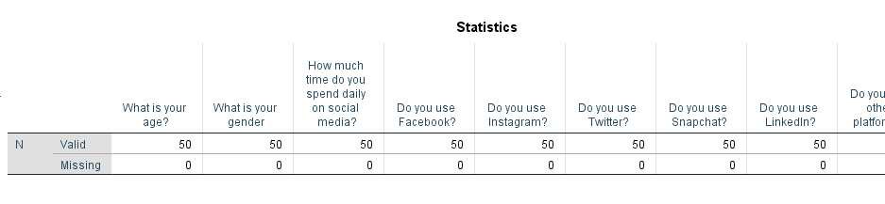
Statistics Table:
Above, the statistics table demonstrates that all 50 participants answered all the questions and that there is no missing data. This is shown as there are 50 valid responses on the first row of the table and on the second it states there the is 0 missing answers.

What is your age?
 |  | Frequency | Percent | Valid Percent | Cumulative Percent
Valid | 18-25 | 27 | 54.0 | 54.0 | 54.0
Valid | 26-35 | 3 | 6.0 | 6.0 | 60.0
Valid | 36-45 | 6 | 12.0 | 12.0 | 72.0
Valid | 46-55 | 10 | 20.0 | 20.0 | 92.0
Valid | 56-65 | 4 | 8.0 | 8.0 | 100.0
Valid | Total | 50 | 100.0 | 100.0

All data inputted has been transformed into frequency tables, above, is an example taken from the results of the inputted data. This frequency table, simply displays the age range of people who participated within the survey. By analysing the table, we can see that all 50 participants answered gaining a 100% valid response. A high number of participants were between the age of 18-24 (54%) and the lowest age group was 26-35 (6%). This suggests, that the audience was mainly ages between 18-25.

Bar Charts:

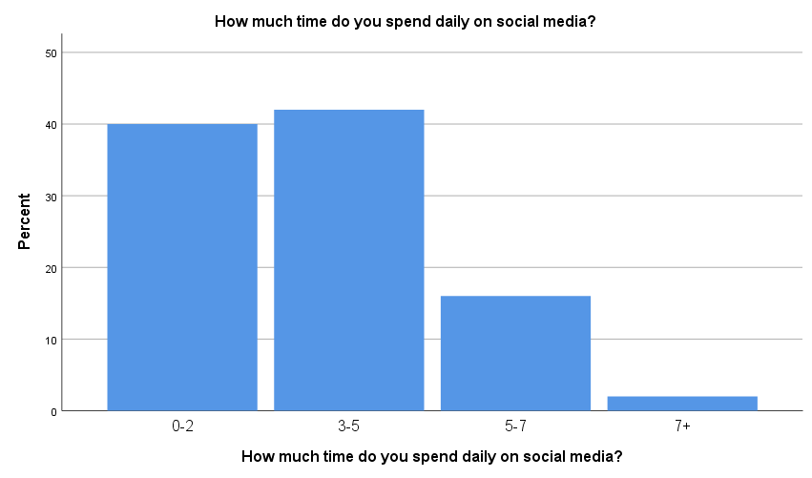

Bar charts are visual tools that are used in order to compare data among different categories, where the bar will display either vertically or horizontally. (Anon, 2020).
Above, is a bar chart that displays data regarding the amount of time that is spent on social media. Through analysis of this chart, we can visually see that the most time spent on social media is 3-5 hours per day. However, we can also see that many people try and limit their daily social media usage by using it for 0-2 hours daily. This could result in positive impact on individuals mental health by limiting their daily usage. A bar chart is easily interpreted and is visually appealing for individuals.

Pie Charts:
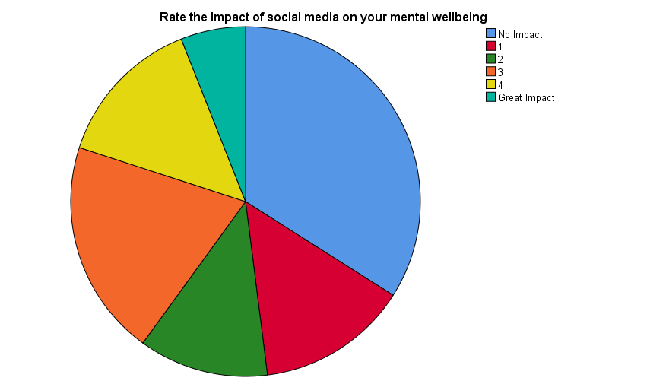

A typical pie chart is a type of graph that is displayed as a circle, being divided into sectors to represent data as whole. This type of graph is a useful tool to organize data in order to see the size of components relative to the whole. (Moore & Shahrlar, 2020).
During the survey, the audience was asked to rate the impact of social media on their well-being. As there is a mixture of ages within the audience, it was interesting the see how much social media impacts them. Similarly to bar charts, pie charts are also visually appealing as they are easy to understand and to interpret results. Through analysis of the pie chart, 1/3 of applicants found that there was no impact on their mental health. However, with closer analysis we can see that 2/3 of the audience found that they had some impact from social media on their mental health. All rating from 1-5, 5 being the highest. After asking the audience to rate the impact of social media on their mental health, I was interested to know If it resulted in them removing themselves from social media.

Have you ever taken yourself off social media?
 |  | Frequency | Percent | Valid Percent | Cumulative Percent
Valid | Yes | 23 | 46.0 | 46.0 | 46.0
Valid | No | 27 | 54.0 | 54.0 | 100.0
Valid | Total | 50 | 100.0 | 100.0
By asking the audience if they had taken themselves off social media, due to the impact on their mental health, we can see from the table above that 54% stated no. This correlates with the 1/3 who said that they felt that social media has no impact on their mental health. However, we also know that 2/3 of the audience stated that they were impacted slightly by the effects of social media. From the above table we can see that 46% said that they has removed themselves from social media. There isn’t a great difference between these figures, and this could correlate to the number of hours that people spend daily on social media.
Conclusion:
In conclusion, through analysis of the results, we can see that majority of the audience was of the age 18-25, this could suggest that the younger generation is most dependant on social media.
Just over half of the audience felt that there was no impact on their mental health from social media. However, 23 out of 50 people decided to remove themselves from media platforms due to the impact on their mental health. This is quite a large number, and shows the impact that social media can have on people, where they need to take a break. From analysing the data from the surveys, it is slightly difficult to state whether the audience is impacted by social media as the statistics are so close. However, through closer analysis majority of the audience stated that they were unaffected by social media. Through personal experience, I have not has any negative experiences with social media.

References
Allen, M. (2017). Retrieved from https://methods.sagepub.com/reference/the-sage-encyclopedia-of-communication-research-methods/i11671.xml.
Anon. (2020). Retrieved from https://www.smartdraw.com/bar-graph/.
Barr, S. (2019). Retrieved from https://www.independent.co.uk/life-style/health-and-families/social-media-mental-health-negative-effects-depression-anxiety-addiction-memory-a8307196.html.
DeFranzo, S. (2016). Retrieved from https://www.snapsurveys.com/blog/qualitative-vs-quantitative-research/.
Garth, A. (2008). Retrieved from https://students.shu.ac.uk/lits/it/documents/pdf/analysing_data_using_spss.pdf.
Kelley, K. (2003). Retrieved from https://academic.oup.com/intqhc/article/15/3/261/1856193.
Moore, K., & Shahrlar, M. (2020). Retrieved from https://brilliant.org/wiki/data-presentation-pie-charts/.
Rouse, M. (2020). Retrieved from https://whatis.techtarget.com/definition/SPSS-Statistical-Package-for-the-Social-Sciences.

Appendices:-
APPENDIX 1. GOOGLE FORMS – PLAIN COPY OF SURVEY
How Does Social Media Impact Your Mental Well-being?
This survey has been conducted in order to research whether your social media usage has any impact on your mental well-being.
What is your age ?
18 - 25
26 - 35
36 - 45
46 - 55
56 - 65
66 - 75
75+
What is your gender?
Male
Female
Prefer not to say
How much time do you spend on social media daily?
0 - 2 hours
3 - 5 hours
5 - 7 hours
7+ hours
Please chose what platforms you use from the following:
None
Facebook
Instagram
Twitter
Snapchat
LinkedIn
Including others.
What devices do you use to access social media platforms? If more than 1 applies to you, please tick them.
Mobile Phone
Tablet or iPad
Computer or Laptop
None of the above
Has Social Media ever had an impact on your mental well-being?
Yes
No
Prefer not to say

Please rate the impact that social media has had on your mental well-being.
0 - it hasn't had any effect
1
2
3
4
5 - It has had a great effect
Have you ever taken yourself off social media, as it has had an impact on your mental well-being?
Yes
No
Social Media restricts people from doing daily activities.
Strongly Disagree
Disagree
Agree
Strongly Agree
Social Media has improved your social life.
Strongly Agree
Agree
Disagree
Strongly Disagree

