Assessment 1
Module: LCBB5000 Data Handling & Business Intelligence
Lecturer: Amitave Banik
Student: Danica Kanchevska
Student ID: 2124692

Table of contents:
- Introduction………………………………………………………2
- Data Mining, CRISP-DM, and securing data………………2-3
- Artificial Intelligence………………………………………….3-4
- Natural Language Processing…………………………………4
- Mobile Business Intelligence………………………………......5
- Cloud Computing…………………………………………….5-6
- Data Literacy…………………………………………………....7
- Conclusion……………………………………………………....8
- References………………………………………………….9-10

1
Introduction
Business Intelligence (BI) is an umbrella term that refers to automated processes which are used to analyse an organization’s data and convey the information to users. Originally, BI was introduced in 1965 but has significantly evolved due to a ‘digital revolution’; the introduction of technology in the business realm resulted in businesses expanding domains and gaining a competitive edge in their industries. BI in itself is a means of collecting and interpreting data for a business and to do so, businesses use the Data Processing Chain (consisting of 5 steps: Data, Database, Data Warehouse, Data Mining, and Data Visualisation).
In this report, I will be analysing Data Mining, The CRISP-DM framework, and analysing 5 contemporary BI trends within the healthcare industry.
The healthcare industry has evolved to be more data-driven and consequently, the application of BI in this sector has grown in popularity. BI can be “used to analyse patient data, track outcomes, and identify trends in healthcare delivery. This can help healthcare providers improve patient care, reduce costs, and increase efficiency”- Khanna, V. (2023). The 5 trends I have chosen for the healthcare industry are Artificial Intelligence, Natural Language Processing, Mobile Business Intelligence, Cloud Computing, and Data Literacy.

Data Mining, CRISP-DM, and securing data
Data mining is a modern-day term that describes the process of “using automated tools to uncover meaning”- De Ville, B. (2001). This can come in the form of trends, patterns, and relationships between data. According to De Ville, data mining offers insight into business processes, customer behaviours, and market dynamics. It takes advantage of data and accumulates patterns reflected in the data.
Cross-Industry Standard Practice for Data Mining (CRISP-DM) is a widely known data mining methodology. The CRISP-DM framework is a standardized approach to describe, document, and continuously improve data mining. This process is not linear; there are many loops and turns. Its true value comes with time and with the refinement of its characteristics.

2
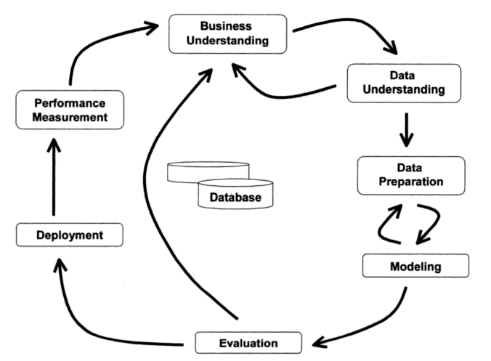
Fig. 1 CRISP-DM Framework
Source: Barry de Ville, B. (2001), Microsoft Data Mining: Integrated Business Intelligence for E-Commerce and Knowledge Management
Data should be protected in order to avoid financial/reputational damage, comply with standards and regulations, monitor sensitive data, and prevent breaches. The reason that data security concerns are rising is the fact current technologies are not suited for maintaining security/privacy, thus improving approaches to data breaches and algorithms is required.

Artificial Intelligence
Artificial intelligence (AI) refers to various tools and technologies that can be “combined in diverse ways to sense, cognize and perform with the ability to learn from experience and adapt over time” (Akerkar, R. 2018). AI has advanced over the years and has been applied to offer many benefits to various industries such as the healthcare sector. Thanks to AI, manual health systems have been digitally transformed into automated versions, leaving complicated procedures to AI components. In an environment where the amount of data (e.g., from monitoring devices, electronic health records, and medical imaging) is continually growing, AI technology has to ability to capture data, process it and produce an analysis, resulting in effective medical interventions. Through daily observation of medical data, AI can establish reliable predictions when it comes to patterns in patient behaviour.

3
Despite displaying a range of benefits for the healthcare industry, it is important to recognize the number of challenges and down-sides AI presents; a few of these issues include system errors resulting in patient injury, data is limited due to concerns around patient privacy, and the ethics surround the idea of AI making a decision about human life.
Regardless, the application of AI in this crucial field brings forth countless advantages that outweigh its disadvantages. Decision processes are accelerated leaving major impacts in lifesaving situations.

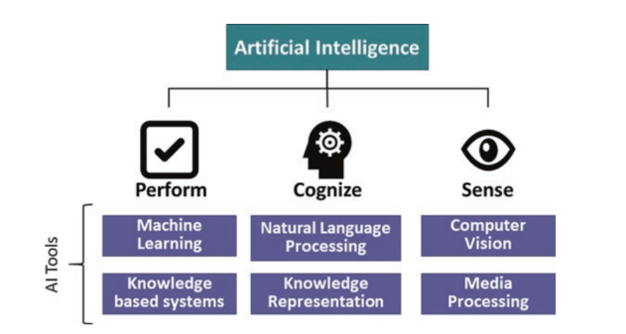
Fig. 2 “What is AI?”
Source: Akerkar, R. (2018), Artificial Intelligence for Business

Natural Language Processing
Natural Language Processing (NLP), a subset of AI, “is an interdisciplinary effort between linguistics and computer science”. It is a powerful and popular method that converts unstructured clinical text into a structured format for user convenience since most clinical text data is unstructured. In healthcare, NLP has replaced the traditional manual coding method which was both costly and time-consuming. NLP automatically extracts essential data for medical practitioners, allowing them to swiftly locate crucial data, eliminating the need for manual searching. NLP methodologies are useful for not only clinical text preprocessing but also more advanced processing such as the application of algorithms. However, the key to quality performing NLP is the training/testing of clinical text corpora. Consistency, accuracy, and linguistic realism are all evaluative metrics to measure the quality of NLP performance; it is vital to ensure optimum NLP performance.

4
Mobile Business Intelligence
According to Madsen, L. (2012), Mobile BI is a key trend that will impact the future of healthcare BI. Healthcare professionals are ‘flocking’ to iPad-driven mobility schemes to access vital patient information swiftly. A surge in accessing medical data via mobile devices is predicted to happen by an analyst firm, Ovum. In addition, Dr Steve Hodgkinson (Ovum research director) said “We are seeing a trend towards the use of devices like iPhones and iPads in healthcare”; with mobile devices, healthcare professionals are able to access critical information at their fingertips. The time to make decisions is shortened and the engagement of staff is boosted.

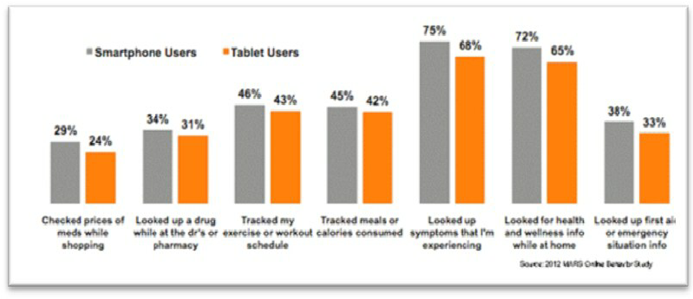
Fig. 3 Shows the use of Smart Phones in the Health Sector
Source: Sarwar, Muhammad & Soomro, Tariq. (2013), Impact of Smartphones on Society

Cloud Computing
Cloud Computing refers to implementing remote servers (accessed via the Internet) to store, manage, and process data. In the medical field, cloud computing improves the quality, safety, and efficiency of services; the majority of hospitals have turned to cloud storage and have abandoned their previous practices of paper record-keeping. Cloud computing solutions handle cloud data storage services (administration, construction, and maintenance), reducing healthcare providers’ upfront costs. In the past, physicians faced major risks of data theft/damage as they stored patient records in filing cabinets but with cloud computing, patient EMRs (Electronic Medical Records) are stored securely and comply with legal requirements, ensuring total security.
5
In the medical field, cloud computing is proven to be highly beneficial for both patients and physicians. It reduces costs, enhances security, and most importantly, fosters improved patient care.
Cloud computing services are varied with the most common service types being Software as a Service (SaaS), Platform as a Service (PaaS), and Infrastructure as a Service (IaaS). SaaS “provides, both the server hardware and software to an organization”- Srinivasan, S. (2014). For example, an organization’s email would qualify as a SaaS service. PaaS allows subscribers to have more flexibility when selecting the computing platform of their preference. IaaS, similar to PaaS in terms of providing the same features, provides the customer will full responsibility of the control of leased infrastructure.

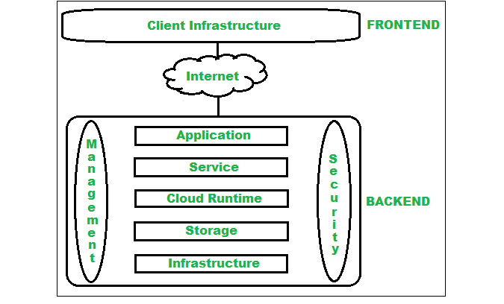
Fig.4 Architecture of Cloud Computing
Source: https://www.geeksforgeeks.org/architecture-of-cloud-computing/

6
Data Literacy
Data can help the healthcare industry make more informed/impactful decisions that will benefit their operations and to achieve this, healthcare organizations should prioritize having a data-literate workforce.
Based on an article by b-eye (2022), data literacy is being able to comprehend, analyse and communicate with data effectively. A few key concepts of data literacy are the ability to read data, comprehend it within its concept, and competence in working with data. Initially, companies often prioritized hiring data professionals to build the necessary infrastructure but often overlooked hiring staff with the capabilities to harness these skills (specifically in healthcare where clinical staff falls short in data analytics training). Data literacy is varied across different roles to effectively work using data-based tools.
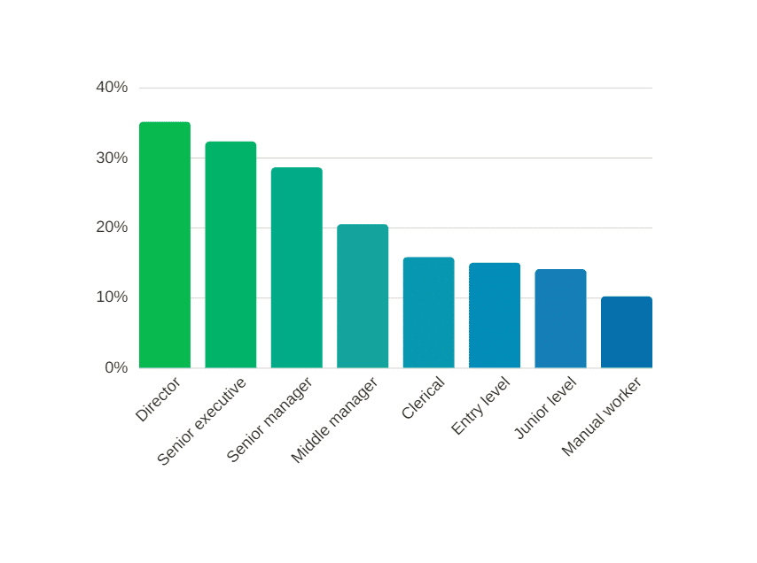
Fig. 5 Value of Data Literacy in today’s information economy
Source: https://b-eye.com/blog/the-value-of-data-literacy-in-todays-information-economy/

7
Conclusion

Based on my research, I have concluded that data security, data discovery, and the various data types are critical aspects of handling big data effectively. Integrating the BI trends listed above can bring significant advancements to the healthcare industry but the best BI solution is AI. In healthcare, AI automates systems, comprehends data, and predicts outcomes. Regardless of its challenges (ethical issues), the accelerated decision-making which saves lives outweighs its drawbacks. Ultimately, the healthcare sector should utilize data mining (specifically CRISP-DM) and secure its data whilst incorporating these five BI trends.

8
References
Academic Sources:

Akerkar, R. (2018), Artificial Intelligence for Business, Springer International Publishing
-Figure 2

Abdallah, M., Abdelbaki, W., Ali, O., Dwivedi, Y.K., Elbasi, E., Shrestha, A., A systematic literature review of artificial intelligence in the healthcare sector: Benefits, challenges, methodologies, and functionalities,
Balancing risks and benefits of artificial intelligence in the health sector. Bull World Health Organ. 2020 Apr
Khanna, V. (2023), Business Intelligence: From Data to Decisions A Beginners Guide

Cloud Computing Applications for Quality Health Care Delivery (2014). United States: IGI Global.
Srinivasan, S. (2014), Cloud Computing Basics, Germany: Springer New York.

Madsen, L. (2012), Healthcare Business Intelligence: A Guide to Empowering Successful Data Reporting and Analytics, Germany: Wiley.

Sarwar, Muhammad & Soomro, Tariq. (2013), Impact of Smartphones on Society. European Journal of Scientific Research, - Figure 3
Barry de Ville, B. (2001), Microsoft Data Mining: Integrated Business Intelligence for E-Commerce and Knowledge Management, United Kingdom: Elsevier Science. - Figure 1
Privacy and Security Issues in Big Data: An Analytical View on Business Intelligence. Germany: Springer Nature Singapore, 2021.

Goodman, K., Reis, A., Vayena, E., Zandi, D., Theory, and Practice of Business Intelligence in Healthcare (2019), United States, IGI Global.

9

Rest of sources:
https://b-eye.com/blog/the-value-of-data-literacy-in-todays-information-economy/
- Figure 5
https://business-of-data.com/articles/data-literacy-healthcare/
https://galendata.com/9-benefits-cloud-computing-healthcare/#:~:text=What%20Exactly%20is%20a%20Cloud,and%20process%20healthcare%2Drelated%20data.
https://www.geeksforgeeks.org/architecture-of-cloud-computing/
- Figure 4
https://medcitynews.com/2022/10/how-to-improve-data-literacy-within-healthcare-organizations/
https://securenvoy.com/blog/5-reasons-why-organisations-need-data-discovery-tools/

https://www.yellowfinbi.com/blog/health-insurance-and-retail-industries-turn-to-mobile-bi-many-struggle-with-dema

10

