Lydia Waters (2416674)

ACBA4016
Construction Materials
Steel framing vs Concrete framing

Contents
Introduction 1
Case study 1: Stahl House #22 (steel frame) 2
Original Design and Construction Method 2
Strength, Durability and Climate Resistance 2
Environmental and community impact 3
Ease of Assembly and Adaptation 3
Case Study 2: Habitat 67 (Concrete Frame) 4
Original Design and Construction Method 4
Strength, Durability and Climate Resistance 4
Environmental and Community Impact 5
Ease of Assembly and Adaptation 5
Table comparing concrete framing and steel framing for construction usage 6
Conclusion 8
References: 10
Bibliography: 12

Introduction
In construction, the selection of an appropriate type of framing material plays a critical role in determining the durability, structural integrity and environmental impact of a building. The report will focus on analysing two habitable buildings which each represent a different type of framing material: Stahl House In Los Angeles, USA, which utilises a steel frame, (Veranda, Atlanta, Ga, 2022) and Habitat 67 in Montreal, Canada, a modular concrete-framed structure. (Habitat 67, N/A) This report will explore their original design, methods of construction as well as evaluating their framing materials in terms of durability, strength, environmental impact, climate resistance, adaptability and ease of assembly. A comparative table is provided to help summarize the advantages and disadvantages of both framing systems.

Case study 1: Stahl House #22 (steel frame)
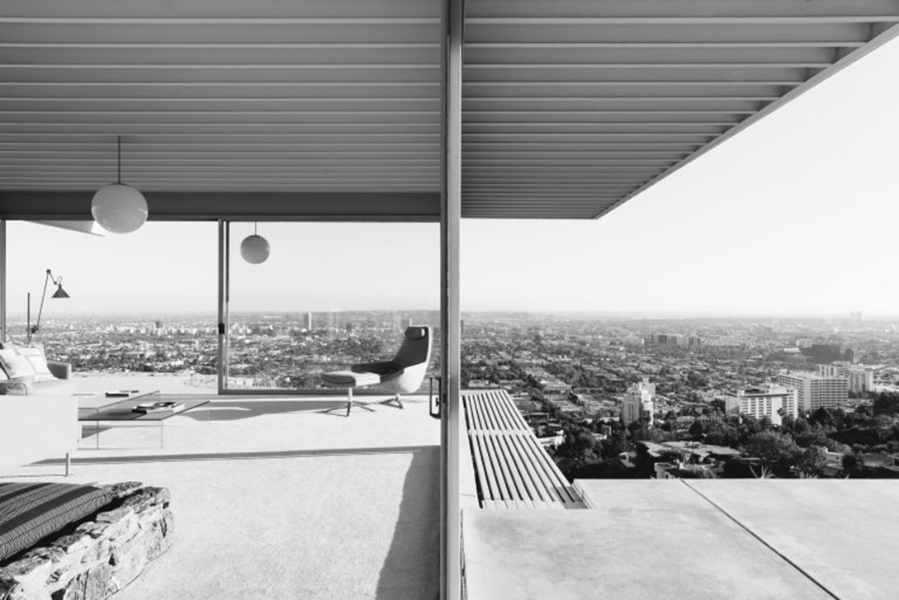
Original Design and Construction Method
Stahl House, an iconic example of mid-century modern architecture, designed by Pierre Koeing and completed in 1960. Located in the Hollywood Hills, it features an L-shaped floor plan and glass walls, this is to emphasize openness and simplicity. The structure primarily consists of a frame with steel columns and beams the support the roof and floor loads. The second most used material is glass, featuring 20-foot-wide floor-to-ceiling panes. (Andrew Kroll, 2010)
(Rick Poon, 2008)
The foundation comprises concrete piles and grade beams to help provide stability against the challenges posed by the steep hillside. The foundation ensures minimal settlement or movement. Industrial sized decking was used for roof assembly, with an overhang to provide shade. Solar panels integrated to heat the pool. The steel frame was erected in a single day by five workers, demonstrating the effectiveness of prefabrication within construction. (Andrew Kroll, 2010) (Hines, Thomas S. 2020)
Strength, Durability and Climate Resistance
Steel was chosen due to its high strength-to-weight ratio, this is essential for the cantilevered design on the hillside. It offers durability, which helps maintain structural integrity over decades when it is protected with appropriate coating. Given that Los Angeles’ (LA) has a mild climate, steel has demonstrated strong resistance against environmental degradation. Whilst LA’s proximity to the ocean exposes structures to salt-laden air, which can increase corrosion rates, galvanised steel and protective coating mitigate this issue. (Hines, Thomas S. 2020) (Claire Glynn, 2023)
In seismic zones like LA, steel offers significant advantages due to its ductility and flexibility. It can absorb seismic forces more effectively than concrete, reducing damage risks. Additionally, being lightweight helps reduce foundation loads, which is beneficial in earthquake-prone areas. (SteelConstruction.info, N/A) Fire resistance is crucial considering California is a wildfire-prone environment. Using fireproofing sprays, intumescent paints and use on non-combustible materials help mitigate risks. (Claire Glynn, 2023)

Environmental and community impact
The production of steel is an intensive energy process which produces substantial greenhouse gasses. However, its high recyclability offsets some of the environmental drawbacks. (American Institute of Steel Construction, N/A) The prefabrication of steel components minimises construction waste (SteelConstruction.info, N/A) and site disruption as well as contributing to skilled workforces in steel manufacturing plants. On the other hand, offsite manufacturing limits local labour participation. The rapid assembly on site reduced dust, noise and road disruption. (Becky Stiepe, 2024)
Although steel construction generates air pollution due to fossil fuel consumption, the Stahl House design worked with nature to minimise excavation and soil erosion. (Becky Stiepe, 2024)

Ease of Assembly and Adaptation
The prefabrication of steel components enables rapid construction, as demonstrated by single-day erecting of the frame. Steel allows for large open plan rooms without numerous supporting walls, which makes modifications and expansions feasible. The adaptability allows for functional and aesthetic changes. (SteelConstruction.info, N/A)

Case Study 2: Habitat 67 (Concrete Frame)
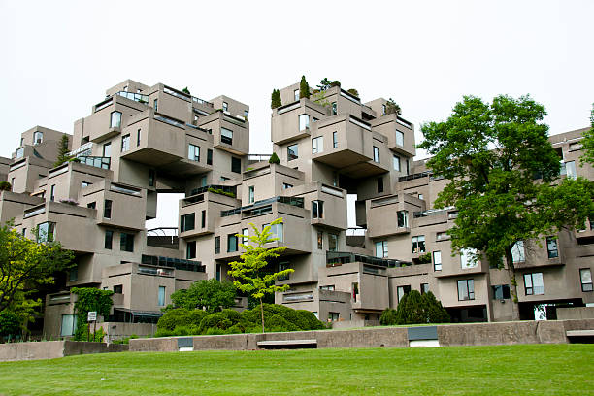
Original Design and Construction Method
Habitat 67, designed by Moshe Safdie and completed in 1967, is a residential complex in Montreal. Originally constructed as the Canadian pavilion for Expo 67, it aims to merge suburban home benefits with high-density urban living. (Habitat 67, N/A) The structure consists of 354 identical precast concrete modules stacked in various configurations to form 158 residences. Each unit measuring approximately 39 feet 6 inches in length, 17 feet and 6 inches in width and 10 feet in height. The structure as an entirety rises 12 storeys. (Andrew Mcintosh, Jennifer Carter, 2018) (Legault, R, 2021)
(Adrian Wojcik, 2016)
Each of the modules weigh approximately 90 tonnes and were prefabricated and then assembled on-site. (SafdieArchitects, 2025) This reduced construction time and ensured quality control. The stepped arrangement of each block provides a private garden terrace for each residence, promoting a sense of individual outdoor space in an urban setting
The entire complex is supported by a cast-in-place concrete structure, which rests on expanded base concrete piles driven approximately 20 feet into the ground to reach bedrock. The foundation system ensures stability against Montreal’s variable soil conditions and its harsh climate. (Jan Komocki, 1967)

Strength, Durability and Climate Resistance
Concrete was selected due to its exceptional durability and strength. (Patton, W.J, 1976) It is highly resistant to Montreal’s harsh winter conditions, which feature freezing temperatures and heavy snowfall. (Legault, R, 2021) Concrete’s thermal mass provides insulation, helping regulate indoor temperatures and reducing heating costs. Additionally, concrete resists moisture and rot, making it well-suited for the wet climate of Montreal. (Gili Merin, 2023)
Each module functions as a load-bearing entity, supporting its own weight and loads of modules above. The walls, typically 5 inches thick (which increase to 12 inches in specific areas) are reinforced with steel bars (rebar) (Illston, J.M., 1994) to balances compressive and tensile strength, ensuring structural stability, The reinforcement helps prevent cracking and enhances resilience against environmental stresses. Post-tension cables and steel rods are utilised to enhance structural integrity. (Jan Komocki, 1967)

Environmental and Community Impact
While concrete production has a significant environmental impact due to energy-intensity processes of mixing and curing, the use of precast units minimises the construction waste and disruption on site. Concrete production releases high carbon emissions, contributing to environmental concerns.
From a community perspective, Habitat 67’s design allows for social interaction and increased community living. As an architectural landmark, it attracts tourism, boosting the local economy. (Legault, R, 2021)

Ease of Assembly and Adaptation
The modular design of Habitat facilitated efficient construction, with precast units produced off-site and lifted into place. This approach reduced on-site labour requirements and accelerated assembly. The design allows for future adaptions, offering long-term flexibility. Concrete structures usually lack the ease of modifications found in steel framed buildings, Habitat 67’s design accommodates changes more effectively than conventional concrete structures. (Gili Merin, 2023)

Table comparing concrete framing and steel framing for construction usage
Factor | Concrete framing | Steel framing
Strength | High compressive strength but low tensile strength, requires reinforcements (e.g. steel rebar). (Patton, W.J, 1976) (Illston, J.M., 1994) | High tensile and compressive strength, making it structurally efficient and suitable for high-rise buildings. (Patton, W.J, 1976) (Claire Glynn, 2023)
Durability | Highly durable and resistant to fire, corrosion and weather. (Illston, J.M., 1994) | Durable but prone to corrosion without appropriate treatment, especially in humid and coastal environments. (Wald, František, Jandera, M, 2019)
Climate resistance | Performs well in in extreme weather conditions, including high heat and cold. | Can withstand harsh climates but requires protective coating against rust in humid or coastal areas. (Gonçalves, M. et al. 2024)
Ease of assembly | Requires formwork, curing time and skilled labour, leading to longer construction time. (Illston, J.M., 1994) | Prefabricated components for faster assembly and reduced labour costs. (Becky Stiepe, 2024)
Adaptability | Less flexible for modifications and future extensions. (Sayed Hemeda, 2019) | Highly adaptable and allows for easy modifications, extensions and reconfigurations. (Patton, W.J, 1976)
Fire resistance | Excellent fire resistance. Does not burn or weaken significantly under high temperatures. (Matt L, N/A) | Fire resistant but can be weakened at high temperatures unless protected. (SteelConstruction.info, N/A)
Cost | Generally lower material costs but higher labour costs due to on-site casting along with longer construction times. | Higher initial material costs but lower labour costs due to prefabrication and faster assembly. (Wald, František, Jandera, M, 2019)
Weight | Heavier, requires stronger foundations, increased material and transportation costs. | Lighter, reducing foundation requirements and transportation costs.
Sustainability and carbon footprint | High carbon emissions from cement production but can incorporate recycled aggregates. Can use alternative cement blends. (Koren, L, 2017) | Highly recyclable if sourced responsibly. Recycling and reusing can lower overall carbon footprint. (Becky Stiepe, 2024) (American Institute of Steel Construction, N/A)
Seismic resistance | Performs well in resisting lateral forces but can be brittle under extreme earthquakes. Requires reinforcement for improved seismic performance. (Byron Guaygua, 2023) | Excellent flexibility and ductility, making it highly resistant to seismic forces. (SteelConstruction.info, N/A)
Thermal performance | High thermal mass helps regulate indoor temperatures, reducing heating and cooling costs. | Low thermal mass; requires additional insulation to improve energy efficiency. (Gonçalves, M. et al. 2024) (SteelConstruction.info, N/A)
Acoustic performance | Excellent sound insulation due to its density, reducing noise transmission. | Poorer sound insulation; additional materials (such as insulation or drywall) are needed to minimise noise transfer. (SteelConstruction.info, N/A)
Construction waste | Generates significant waste from formwork and excess material but can be minimised with efficient planning. | Reduced on-site waste if prefabricated; scrap steel can be recycled. (SteelConstruction.info, N/A)
Transportation and logistics | Heavy materials can increase transportation costs and require careful planning for site access. | Lighter materials make transportation easier and reduce fuel consumption as well as logistical complexity.
Maintenance | Low maintenance due to durability and resistance to weathering. (Koren, L, 2017) | Requires periodic inspection and maintenance for corrosion and fireproofing integrity. (Becky Stiepe, 2024)
Aesthetic flexibility | Can be molded into a variety of shapes for architectural flexibility. (Koren, L, 2017) | Allows for open floor plans with fewer columns due to its high strength-to-weight ratio.
Moisture resistance | Highly resistant to water damage but cracks may allow water to seepage. (Sayed Hemeda, 2019) | Prone to rust if not properly coated or maintained in humid environments. (Becky Stiepe, 2024)
load-bearing efficiency | Effective for load-bearing walls but will require reinforcement for taller structures. (Sayed Hemeda, 2019) | High load-bearing efficiency allowing for taller and larger structures with ability for large open spaces. (Becky Stiepe, 2024)
Resistance to pests | Highly resistant to termites and other pests. | Susceptible to rust and deterioration if exposed to pests in humid environments.
Vibration resistance | Naturally dampens vibrations, making it ideal for residential and commercial buildings. | More prone to vibrations; additional measures such as damping systems may be required. (SteelConstruction.info, N/A)
Integration with other systems | Works well with embedded systems like electrical conduits and plumbing. (Koren, L, 2017) | Requires additional design considerations for integrating electrical, plumbing and ventilation and air conditioning systems. (Becky Stiepe, 2024)
Insurance costs | Lower insurance costs due to being more fire resistant and its durability. | Higher due to fire risks and maintenance requirements and corrosion concerns.
Legal and regulatory compliance | Stringent regulations for curing, reinforcement and structural integrity. | Requires compliance with fireproofing, corrosion protection and structural standards.

Conclusion
The analysis of the Stahl house and Habitat 67 highlights the distinct advantages and challenges of steel and concrete framing systems within construction. The Stahl House shows the efficiency, adaptability, and seismic resistance of steel framing, making it ideal for lightweight structures in earthquake- prone areas. Its fabrication components allow for rapid assembly which reduces on-site disruption and labour costs. However, steel’s susceptibility to corrosion and fire necessitates protective measures, increasing maintenance requirements and cost. (Claire Glynn, 2023)
In contrast, Habitat 67 showcases the durability, thermal performance, and climate resistance of concrete framing. Its module design enables efficient construction and offers exceptional fire resistance, making it well-suited for Montreal’s harsh climate. However, concrete’s weight leads to higher transportation costs and more substantial foundation requirements. Additionally, its lower adaptability compared to steel limits future modifications.
From an environmental perspective, both materials present sustainability challenges. Steel production generates high carbon emissions but benefits from recyclability, while concrete’s energy-intensity manufacturing process contributes to environmental concerns, potential reductions through alternative cement blends and recycling aggregates.
Overall, the choice between steel and concrete framing depends on the project- specific requirements, including location, climate conditions, structural demands, and sustainability goals. While steel is preferred for flexibility, rapid construction and seismic resilience, concrete is advantageous for its durability, fire resistance and thermal efficiency. The comparative analysis highlights the importance of selecting the appropriate material to optimise structural integrity, longevity and environmental impact in modern construction projects.

References:

Adrian Wojcik (2016) Public Apartment – Montreal – Canada Stock Photo, Available at: https://www.istockphoto.com/photo/public-apartments-montreal-canada-gm519739306-90691821 (Accessed: 11 February 2025)
American Institute of Steel Construction (N/A) Structural steel: The most sustainable choice. Available at: https://parallax.aisc.org/sustainability.aspx?utm_source=chatgpt.com (Accessed: 9 February 2025)
Andrew Kroll (2010) AD classics: Stahl/ Pierre Koeig Available at: https://www.archdaily.com/83038/ad-classics-stahl-house-pierre-koenig?utm_source=chatgpt.com (Accessed: 6 February 2025)
Andrew Mcintosh, Jennifer Carter (2018) ‘Article, Habitat 67’, Available at: https://www.thecanadianencyclopedia.ca/en/article/habitat-67?utm_source=chatgpt.com (Accessed: 3 February 2025).
Becky Stiepe (2024) Is steel still the best material for building? Available at: https://science.howstuffworks.com/engineering/structural/steel-best-material-for-building.htm?utm_source=chatgpt.com (Accessed: 8 February 2025)
Byron Guaygua, Antonio J. Sanchez-Garrido, Victor Yepes (2023) A systematic review of seismic resistant precast concrete buildings, Volume: 58. Available at https://www.sciencedirect.com/science/article/pii/S2352012423016867 (Accessed: 11 February 2025)
Claire Glynn (2023) The Strength of Steel Frame Homes in US Residential Construction. Available at: https://framecad.com/blog/the-strength-of-steel-framing-in-us-residential-construction?utm_source=chatgpt.com (Accessed: 8 February 2025)
Gili Merin (2023) ‘Architecture classics: Habitat 67 / Safdie Architects’. Availability at: https://www.archdaily.com/404803/ad-classics-habitat-67-moshe-safdie?utm_source=chatgpt.com (accessed: 3 February 2025).
Gonçalves, M. Figueiredo, A. Almeida, R. Vicente, R. Samagaio, A. Kosny, J. (2024) ‘Thermal performance evaluation of a light steel framing building with macroencapsulated phase change materials in a Mediterranean climate’, Energy and buildings, 323, pp. 114837-. Available at: https://doi.org/10.1016/j.enbuild.2024.114837 (Accessed: 7th February 2025)
Habitat 67 (N/A) ‘About Habitat 67’. Available at: https://www.habitat67.com/en/about/ (Accessed: 3 February 2025).
Habitat 67 (N/A) ‘Home to an icon’. Available at: https://www.habitat67.com/en/homage/ (Accessed: 3 February 2025).
Hines, Thomas S. (2020) Architecture of the sun: Los Angeles Modernism, 1900 – 1970. Rizzoli. Available at: https://www.rostarchitects.com/articles/2020/10/6/nine-things-you-should-know-about-the-stahl-house-case-study-house-22?utm_source=chatgpt.com (Accessed: 8 February 2025)
Illston, J.M. (1994) Construction materials: their nature and behaviour. 2nd edition. London: E & FN Spon. Pp. 179 -191. (Accessed: 6th February 2025)
Jan Komocki (1967) ‘Structural Design of Habitat ’67’ Pci Journal, volume: 12, pp. 67-70. (Accessed: 6th February 2025)
Koren, L. (2017) Concrete. Edited by W. Hall. London; Phaidon. (Accessed: 7th February 2025)
Legault, R. (2021) ‘The Making of Habitat 67: A Tense Pas de Deux between Moshe Safdie and August Komendant’, Journal of the Society for the Study of Architecture in Canada, 46(1), pp. 30–50. (Accessed: 7th February 2025)
Patton, W.J. (1976) Construction materials, Englewood Cliffs; Prentice-Hall. Pp. 80,102, 152,154 (Accessed: 6th February 2025)
Rick Poon (2008) Stahl House Case Study Home, Available at: https://www.readcereal.com/articles/stahl-house#1874 (Accessed: 11 February 2025)
SafdieArchitects (2025) ‘Habitat ’67’. Available at: https://www.safdiearchitects.com/projects/habitat-67 (Accessed: 4 February 2025)
Sayed Hemeda (2019) Sustainable Construction and Building Materials. Edited by S. Hemeda. London, United Kingdom: IntechOpen (Accessed: 6th February 2025)
SteelConstruction.info (N/A) Acoustics. Available at: https://steelconstruction.info/Acoustics (Accessed: 8 February 2025)
SteelConstruction.info (N/A) Fire and Steel Construction. Available at: https://steelconstruction.info/Fire_and_steel_construction (Accessed: 8 February 2025)
SteelConstruction.info (N/A) Floor Vibrations. Available at: https://steelconstruction.info/Floor_vibrations (Accessed: 8 February 2025)
SteelConstruction.info (N/A) Recycle and reuse. Available at: https://steelconstruction.info/Recycling_and_reuse (Accessed: 8 February 2025)
Veranda, Atlanta, Ga (2022) Designing the California Dream: With starring roles in countless photo, film, and video shoots, it is perhaps Hollywood’s most famous residence. But how did the Stahl House, Case Study #22, come to be? A new book reveals the surprisingly humble beginnings of this modernist icon, Hearst Magazines, a Division of the Hearst Corporation, Volume.36 (1) pp. 40-. (Accessed: 7th February 2025)
Wald, František, Jandera, M. (2019) ‘Stability and ductility of steel structures 2019’, in. S.l: CRC PRESS. 1st Edition. (Accessed: 7th February 2025)

Bibliography:
‘The Stahl House: Case Study House #22: The Making of a Modernist Icon’ (2021) Publishers Weekly. PWxyz, LLC, volume.268 (22) pp. 51-.
IMSM (N/A) ISO 14001: reduce waste, costs and risk. Environmental management system. Available at: https://www.imsm.com/gb/iso-14001/?utm_medium=cpc&utm_source=bing&utm_term=environmental%20accreditation%20iso%2014001&utm_campaign=LOL+-+Search+-+UK+14001&hsa_acc=4883803773&hsa_cam=11756592169&hsa_grp=1146791373279257&hsa_ad=&hsa_src=o&hsa_tgt=kwd-71675183412374:loc-4139&hsa_kw=environmental%20accreditation%20iso%2014001&hsa_mt=e&hsa_net=adwords&hsa_ver=3&msclkid=c83b3d86d1a315fb49925a2c5a721419&utm_content=UK%20-%2014001 (Accessed: 9 February 2025)
López-Almansa, F., Segués, E. and Cantalapiedra, I.R. (2015) ‘A new steel framing system for seismic protection of timber platform frame buildings. Implementation with hysteretic energy dissipators’, Earthquake engineering & structural dynamics, Volume.44(8), pp. 1181–1202. Available at: https://doi.org/10.1002/eqe.2507 (Accessed: 6 February 2025)
Lyons, A, Arthur, R (2019) Materials for architects and builders. Sixth edition. Abingdon, Oxon: Routledge. pp. 67-102. (Accessed: 6th February 2025)
Matt L (N/A) Is Concrete Fireproof? Understanding Fire Resistance of Concrete, Available at: https://craftingwithconcrete.com/is-concrete-fireproof-understanding-fire-resistance-of-concrete/ (Accessed: 11 February 2025)
Qiu, M, Shao, X, Wille, K, Zhu, Y, Wang, Y, Zhang, Y, Tao, Z. (2024) ‘Effect of rebar ratio, rebar diameter, cover thickness, and fiber shape on flexural and cracking behavior of rebar-reinforced UHPC beams’, Engineering structures, 321, pp. 119008-. Available at: https://doi.org/10.1016/j.engstruct.2024.119008 (Accessed: 4 February 2025)
Safdie, M. and Legault, R. (2022) ‘Exchange between Moshe Safdie and Réjean Legault about the article “The Making of Habitat 67. A Tense Pas de Deux between Moshe Safdie and August Komendant”’, Journal of the Society for the Study of Architecture in Canada, 47(1), pp. 2–6. Available at: https://doi.org/10.7202/1095162ar (Accessed: 6 February 2025)
SteelConstruction.info (N/A) Fabrication. Available at: https://steelconstruction.info/Fabrication (Accessed: 8 February 2025)

