

International Business Communication

LCBB6001

Assessment 1

Name: Vanya Nikolova
Student Number: 1920484
Module Lecturer: Husam Alharahshah

Table of Contents

Introduction 3
International Business and Communication 3
Store To Home Public Limited Company 3
India 4
Application of Hofstede Theory 4
Power Distance 4
Individualism Versus Collectivism 4
Masculinity Versus Femininity 5
Uncertainty Avoidance 5
Orientation 5
Critical Evaluation of Cultural Sensitivity in India 6
Social Learning 6
Sub Cultures 6
Education 7
Language and Political Philosophy 7
Importance of Networking 7
Importance of Language of buyer 7
Communication Barriers 8
Linguistic Barrier 8
Cultural Barrier 9
Psychological Factor 9
Communication Strategies and Recommendations 9
Conclusion 10
References 11

Introduction

The primary purpose of this report is to understand how international cultures play an important in the decision of a business to open a branch or production plant in some other country. this will also focus on the factors taken into consideration by Store to home Public Limited company while deciding to open a production plant in a developing country like India. It will analyze the different business situations and communication problems which will be faced by this UK-based company in India.

International Business and Communication

International business is a business carried out by an organization outside its domestic boundary. This is done to increase sales and earn profits from the new region by capturing a new consumer base. But before entering into an international market it becomes important that the organization conduct research and analyze the situation prevalent in the target market based on the language, culture, availability of raw material, labour, etc so that it can take an apt decision. Otherwise, it could be hard for the organization to survive in a new market (Gomez-Trujilio and Gonzalez-Pererez,2020).

For a business to be successful in a new market it is necessary that it first go through all the communication barriers which can be hurdles in working. The culture of every country is different so it becomes important to understand the culture of the target country. sometimes it becomes for the organization to understand the local language of the target country which creates a hurdle in its systematic work the new customer is not able to connect as a result it leads to failure. Thus, it is very much important to understand the communication factor of the target country before taking the final decision on plant set up in that country (Takino,2020).

Store To Home Public Limited Company

Store to home is a UK-based Public Limited that deals in grocery items, packed foods, snacks, clothes, and other daily essentials. Store to home public Limited company has already established its base in UK Market and is now trying to expand in the Indian market. This is because it wants to gain benefits from globalization and foreign direct investment. For this, it is going to start its own production plant in India.

India

India is a developing country and doing wonders in a different area. India has an abundance of labour workforce which can be useful in setting up a new plant. The main reason for selecting India is that it is developing a lot with technological advancements and different studies show that people over there now have started using their mobile phones to get their groceries delivered at home. This is all because of the Covid-19 situation that consumers over there have now left the traditional way of shopping. This can be a great advantage for the store to home. A store to home provides fresh and organic groceries at your door steps in just a few minutes. This could be a great advantage along with the factor of communication. The people in India now hold on to the English language thus store to home can easily convey its vision and mission to people over there also because of different trade going on between India and UK in past and present store to home is fully aware of the beliefs, ethics and moral of the people living over there. Further, the weather and the political situation over there can be of great benefit for the store to home (Kota, 2018).

Application of Hofstede Theory
Power Distance: India tops in this dimension because of in equality in the distribution of income. Which means most of the power and money is concentrated in the hands of top officials. But this is not something the store to home public limited company should be afraid of because this culture is already accepted by the people residing over there and in fact it could be plus point it has more population n middle or lower class which will prefer fresh grocery from online retail stores or local retail stores rather than going to the super marts. Another plus point related to this dimension is that the work force employed by the company will be obedient to them and will follow every instruction clearly.

Individualism Versus Collectivism: India has good score related to this dimension because people over here are very social and they believe in doing work together and effectively rather than individual goals. The people over here are friendly and open to new change. The employer and employee in India share a cordial relationship they believe in working that loyalty to their bosses is the most important thing and thus believe that if they will work according to them, they will get frequent promotions, incentives, bonus, recognition and many more. Thus, is could be plus factor which store to home can consider while taking business decision related to opening a production plant in India (Thampi,Jyotishi, Bishu,2020).

Masculinity Versus Femininity: India has a score of 56 in this domain. This is because India is considered a male oriented country but not to forget this concept is now changing with changing mentality of people over there. The concept of women staying at home and managing activities are changing with them going to workplace along with having status in society. This will help store to home because now no or less time left for shopping as people are busy with office work, they want all the grocery needed to them should be delivered to them at doorstep.
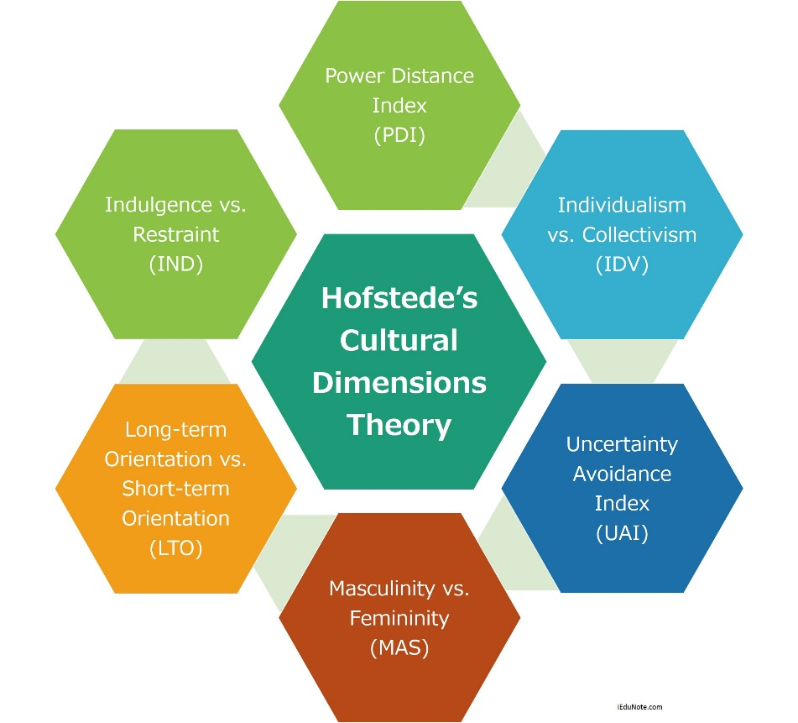
Figure 1:(Source: iEduNote,2022)

Uncertainty Avoidance: India has low to medium Uncertainty avoidance score. This means that consumers over there believe in new change and risk taking rather than being with stagnate thinking. They adopt themselves to new and frequent change rather than being aggressive to them. In thus case if store to home will step up its production branch in their people will take this as positive change and take it as a new opportunity for employment and development. Also, the customers here always like to try new apps available or services available so that they can take the best out of it.

Orientation: India has high score in orientation dimension, this is because people over here believe that what and how they will group will decide their future. There is high value of karma in different religions. They believe in religions and respect them as more of a philosophy rather than just a religion. So, store to home should precisely consider this feature. Store to home should make its strategy on the basis of religious thinking, communication, and beliefs and morale of the people living in India (Gupta and Sukamto,2020).

Critical Evaluation of Cultural Sensitivity in India

Cultural sensitivity is a concept where the organisation which is going to work in new international market is aware of the similarities and dis similarities which are preventing in the domestic and international market. It is important for the organisation to do critical evaluation of cultural sensitivity of the target country. here culture means a collective thinking which is common in the people living in a particular culture related to work culture, work ethics, morals, beliefs and many more thing. This culture factor plays an important role in deciding the perception of people towards a particular organisation. Thus, culture of a particular country has influence on the business in that country.
The culture of India is very diverse in respect to the people living in the India. There are several religions followed by people over there. But they believe in unity in diversity. Thus, before entering into India Store to home has to go through following factors (Carruthers, et al, 2018).

Figure 2:(Skilldom-WordPress.com,2022)

Social Learning: Social learning are the concept which an individual has learned from his family, religious groups, occupational groups etc. in India most of the people think that women are pride of their home and should stay at home and mange all the household activities.

Sub Cultures: apart from religious groups the people in India are also divided on the basis of caste and racial group. Every caste and racial group have their own definition related to work culture and they try never to compromise on that. This has categorised the people over in high- and low-class people.

Education: Another important while considering cultural sensitivity in India is Education. Individuals with good education believes in change and compatibility in work cultural along with change in the thinking of the society and the people with no education thinks that change will spoil their cultural value and ethics. So, it becomes important that store to home company make strategies which without hurting sentiments of people over there attract them to their brand.

Language and Political Philosophy: language is important while evaluating cultural diversity. Though there are thousands of languages spoken and written over India but their main language remains Hindi so it is important that store to home appoint officials who can speak and understand Hindi so that they are able to convey mission and vision of store to home clearly to audience out there. Apart from these political conditions define that organization will be successful over a particular country based on the rules and regulations prevalent in that country (Suzuki, Hogue and Law, 2019).

Importance of Networking

Networking Is a source of networks which are useful for an individual or an organisation while carrying out a particular project. In context to international business, networking in target country help the organisation to know about the culture, belief, values, work culture and etc which are necessary to be taken care of before taking the final decision. In the context to store to home public limited the organisation will first have to build networks in India or they can appoint someone who will do all the study related to different factors such as social, economic, political, technological and etc and will provide a detailed record analysis of these factors can be useful or create hurdles will setting up production plant in India.

Other benefits of having networks in India is that they already know the best location which can be useful in setting production plant along with that as they are already ware of rules and regulations and procure over there, they can help store to home get easy permissions from the government to setup plant over there (Anwar and Ali Shah, 2020).

Importance of Language of buyer

Language of buyer is important while setting up new business in the target country. this is because it is ultimately buyer who has to by the products so the the organisation should from starting use the language of the buyer so that they can attract them. Apart from this language of buyer is important in doing negotiations with the target audience. Also, that target language can use metaphors which can help store to home convey its idea to the target audience.

Other benefits that are associated with communicating in buyers’ language is that it will increase the sales of store to home. Further it will help store to home to get wider access to Indian market this is because may people in India have not started speaking in English but there is large population which only communicate in Hindi so suppose if English will attract 30% market with same advertisement in Hindi, they can attract 90% market keeping the margin for the regional language. It will also build trust and loyalty among the consumer along with avoiding miscommunication which sometimes attract bad goodwill. Not but not the least it will provide competitive advantage to the organisation (Drics and Koller, 2018).

Communication Barriers:

Communication barrier in respect to international business in respect India can be studied under different categories. This communication barriers arise because of different language, culture and mentality in India with respect to UK.
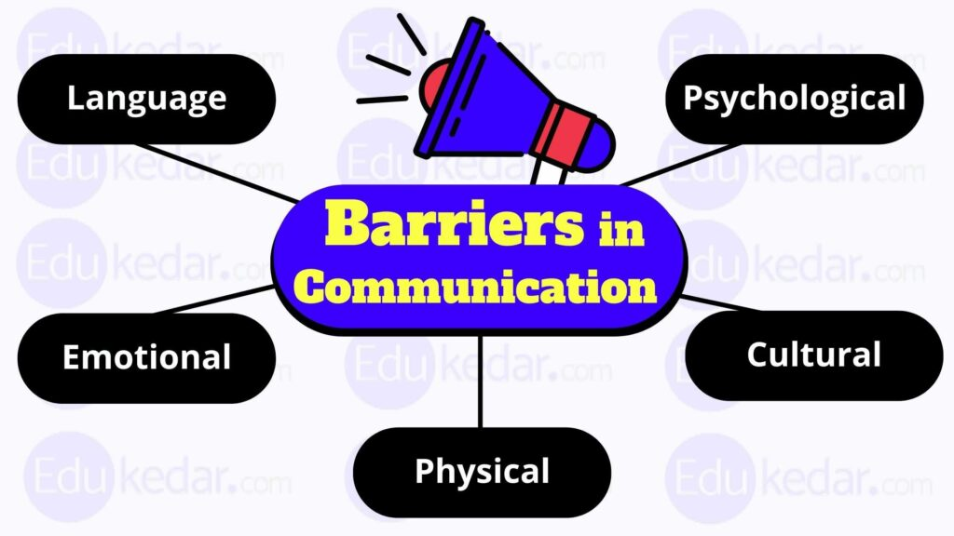
Figure 3:(Source:EduKedar,2022)

Linguistic Barrier: this barrier is concerned with the difference in language spoken and written in the domestic and target country. in this case where English is primary language of UK, Hindi is the primary language of India even though there are several other languages spoken and written there. This can create communication barrier because due to translation some ideas loose there authencity and some other meaning is concluded by the target audience which tarnish the brand image.

Cultural Barrier: the barrier related to culture which is different in both the country on the one hand where UK is already developed country and follows western culture, India is still developing and follows old and authentic culture which is fully different from western culture. Here the main job of women is to systematically manage the house.

Psychological Factor: psychological factor is mainly concerned with the thinking of the people. The people in India feel that they main job is to fulfil the responsibility given to them and on successful completion they will be awarded different rewards and promotions will be given. While in country ice UK individuals like to be their own boss (Hamilton).

Communication Strategies and Recommendations:

Store to home should try to advertise their brand through local celebrities in the target country as the people over there connect with them. This will help store to homes build brand image in their initial stage. Apart from that instead of appointing officials of UK to manage work In India. they should appoint skilled and experienced professionals in India itself as this will help employees easily understand the orders given to them. Also, they can do an awareness drive to attract consumers to their brand, and employing a local workforce will build its brand image. Store to home should manufacture those products in their production plant in India which is mostly needed by the people out there (Ali, et al,2021).

Conclusion:

This report has shown the factors which should be considered by the store to the home public limited company before setting up its plant in India. The report has also highlighted how language plays important role in deciding the future of products in the international market. Further the report focusses on communication barriers faced by the store to the home public limited company while setting up its production plant in India and how they can be overcome. Along with that, the report provides suggestions and recommendations which should be followed by the store to home public limited company before expanding its business in India.

References

Ali, B.J., Anwar, G., Gardi, B., Jabbar Othman, B., Mahmood Aziz, H., Ali Ahmed, S., Abdalla Hamza, P., Burhan Ismael, N., Sorguli, S. and Sabir, B.Y., 2021. Business communication strategies: analysis of internal communication processes. Ali, BJ, Anwar, G., Gardi, B., Othman, BJ, Aziz, HM, Ahmed, SA, Hamza, PA, Ismael, NB, Sorguli, S., Sabir, BY (2021). Business Communication Strategies: Analysis of Internal Communication Processes. Journal of Humanities and Education Development, 3(3), pp.16-38.

Anwar, M. and Ali Shah, S.Z., 2020. Managerial networking and business model innovation: Empirical study of new ventures in an emerging economy. Journal of Small Business & Entrepreneurship, 32(3), pp.265-286.

Carruthers, S., Kinnaird, E., Rudra, A., Smith, P., Allison, C., Auyeung, B., Chakrabarti, B., Wakabayashi, A., Baron-Cohen, S., Bakolis, I. and Hoekstra, R.A., 2018. A cross-cultural study of autistic traits across India, Japan and the UK. Molecular autism, 9(1), pp.1-10.

Darics, E. and Koller, V., 2018. Language in business, language at work. Bloomsbury Publishing.
Gomez-Trujillo, A.M. and Gonzalez-Perez, M.A., 2020. What do we know about organizational sustainability and international business?. Management of Environmental Quality: An International Journal.

Gupta, M. and Sukamto, K., 2020. Cultural communicative styles: The case of India and Indonesia. International Journal of Society, Culture & Language, 8(2), pp.105-120.

Hamilton, P.J., Process of Business Communication and barriers of Business Communication.

Kota, H.B., 2018. The impact of regulations and technology on the business environment in India. Australasian Accounting, Business and Finance Journal, 12(2), pp.1-4.

Suzuki, M.K., Hogue, M.D. and Law, M.G., 2019. Cultural sensitivity and global pharmacy engagement in Asia: India, Indonesia, Malaysia, Philippines, and Vietnam.

Takino, M., 2020. Power in international business communication and linguistic competence: Analyzing the experiences of nonnative business people who use English as a business lingua franca (BELF). International Journal of Business Communication, 57(4), pp.517-544.

Thampi, P.P., Jyotishi, A. and Bishu, R., 2020. Regional cultural diversities amongst small business entrepreneurs in India. International Journal of Globalisation and Small Business, 11(1), pp.1-17.

