This is a report of my study question ‘the effect of the pandemic has had on the participants mental health and local knowledge’ which is about seeing how people have been affected by the pandemic, the effect this has had on their mental health. “considerable increase in anxiety and depressive symptoms among people who do not have pre-existing mental health conditions” (Cullen, W., Gulati, G. and Kelly, B.D., 2020.) tis shows that there have been a lot of mental health factors that have gotten worse due to the pandemic. But also wanted to see if people have changed their opinion on the outdoors since being restricted on where they can go. To do this, the study will be using quantitative research to gain my data, to do so there will be a survey using survey monkey, I will be aiming to gain some responses form mainly people in 18-24 year olds age group. Once the quantitative data was collected, it was in turn put into a graph to show where the larger number of people thought, this would help show any patters within the work. This is because I felt that this would be the best area to explore, to be able to see what young people would have and see what affect the pandemic has had on them also.

the approach has taken is a quantitative approach “Methodology – Quantitative (Paradigm)– Methods will used structured approaches. Methods used ask questions that result in data that can be assessed in a quantitative way.” (Mullins 2021) this shows that this way of data collection is to gain results from question that can be counted, from this you’ll be able to see through the number of people have answered through the options provided and gain data-based results.

Survey Monkey was used to make the survey to collect the data, this is because it has a good system to be able to put the questions needed and then put the options that would be given to everyone that would participate to answer, the survey also has the ability to add up all the votes and give a percentage at the end, once these numbers are calculated, it became much easier to make graphs based of the results. Using the data that was collected quantitatively, there were some visible patterns that came across. The survey is a cross-sectional survey, “In a cross-sectional study, the investigator measures the outcome and the exposures in the study participants at the same time” (Setia, M.S., 2016)

this because the questions are only going to be answered once and are talking around this point of time. This survey is mentioning the pandemic throughout making this a question that can only be asked in this point time.

The first two questions of the survey where simple questions to show what kind of audience where in the survey for example, the age group and the gender of the participants, there was an attempted to try and keep the gender for male and female even so there where to be no gender biased in the survey as well as attempting to keep to the age range of the survey which was mostly 18-24.

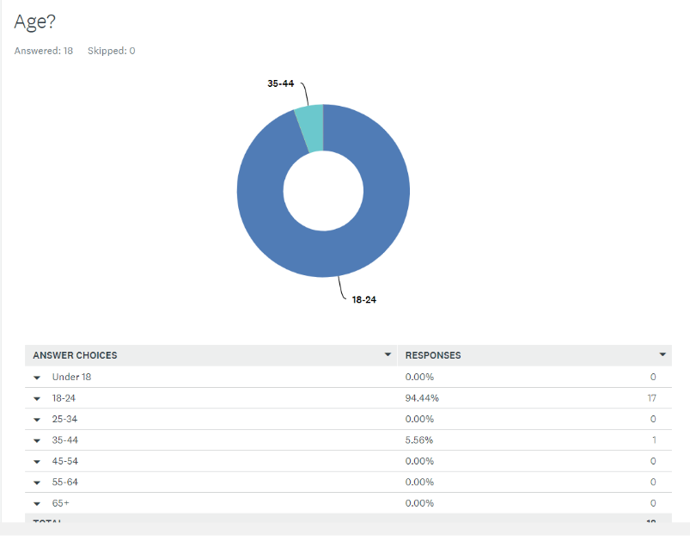

This is a graph to show the age group that was aimed for was almost hit with there just being one participant to be in a different age group. And this is an example of how the format of the survey has been taken.

The next question was asking ‘how often did you do outdoor activities’ this was to get an idea of how often people would be adventures, this will can show the affect the pandemic would had
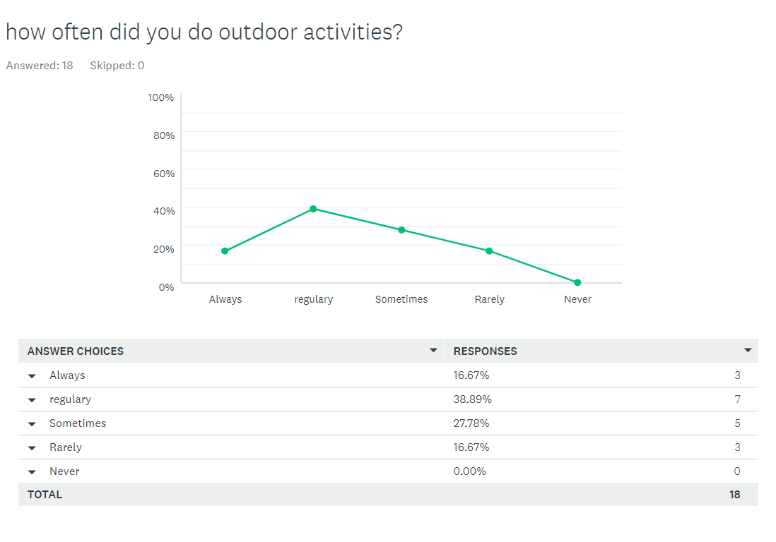

For this you are able to see that a huge majority of people (38.89%) saying that they would be doing outdoor activities regularly as well as further 16.67% saying they would always be doing outdoor activities, which adds up to 55.56% which shows majority of people that participated in the survey take apart in outdoor, this also shows that there was 0% of people said that they would never go to do outdoor activities. Meaning that everyone takes part in some activities one way or another, this opened the discussion around what affects the pandemic, this opened up a few possibilities to explore, the idea of a more connected local area and the affect the pandemic has had on the participation’s mental health. Because of this the next thing explored was the mental health aspect before moving on to the local area prospect. This was done to see both the negative and positives affects this could have had on the general public. Before this though, the next question was to do with travel, the idea of a possible transport issues being related.

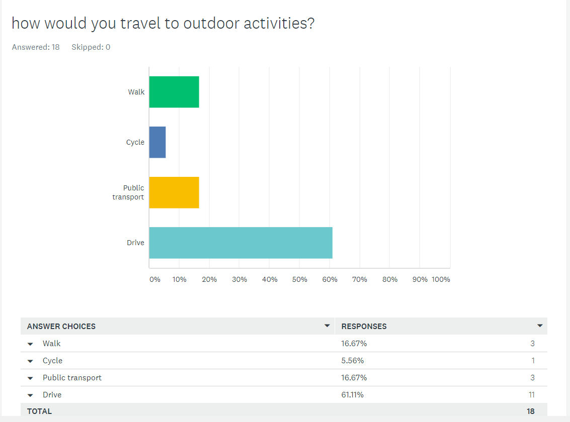
looking between the data of this showing that 61.11% of the participants would drive to the activities along side the fact that 55.56% of participants would go to activities either regularly or always shows a possible link between how often they would take part in outdoor activities, with the participants that put that they would have driven to do these activities would have much more access to go on adventure weather it was there own adventure or one through an activity centre, having the ability to do so anytime without the need of others or public transport meaning the participants are more likely to go on adventures. Which is reflected with the similarity in percentages. Which also the case in the other direction, for the ones that need public transport would have walk to the activities most likely to not go to do them as often.

The next two graphs are going to show how well the participants would know there local area both before the pandemic and know after a year of being in lockdown.
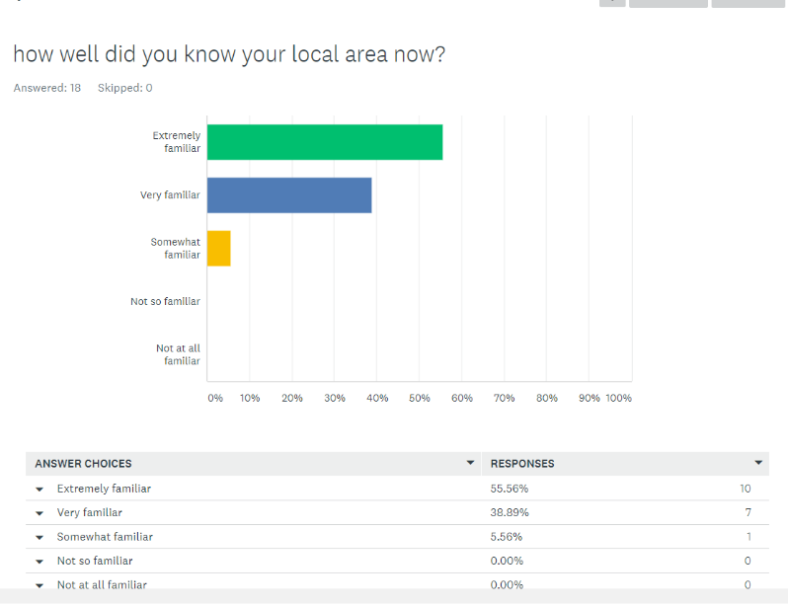
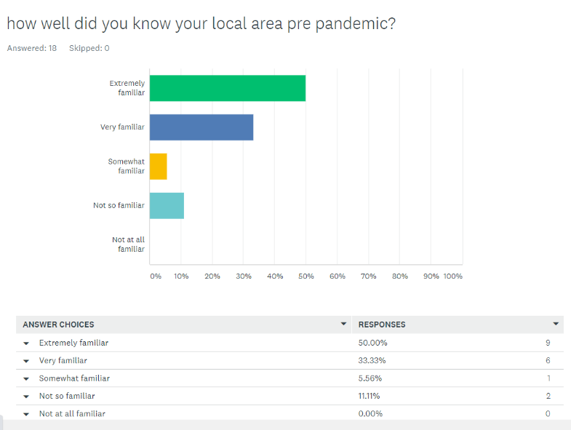

From the two graphs above and answer a questions to see how much the lockdowns would have changed peoples view on their own local areas, in the first graph it is visible that majority of the participants felt they knew the local are ‘extremely well’ or ‘very well’ with a few stating that they were ‘not so familiar’ but in the second graph, this clearly shows that people felt they knew the local area more, as both ‘extremely well’ and ‘fairly well’ increased and no participant stating anything less then ‘somewhat familiar’. This shows that there is a pattern with the fact that pandemic meant that everyone had to stay with in there local are, even having a five-mile restrictions at one stage. “The new stay local rule will mean people can leave their homes and travel within their local area – usually within 5 miles” (Stay local – Wales takes first steps out of lockdown | GOV.WALES, 2021) this would have meant more people would have explored the local community and possibly be more in touch with everyone in their local area which is one positive of the local down. As people will now have a better understanding of their local environment.
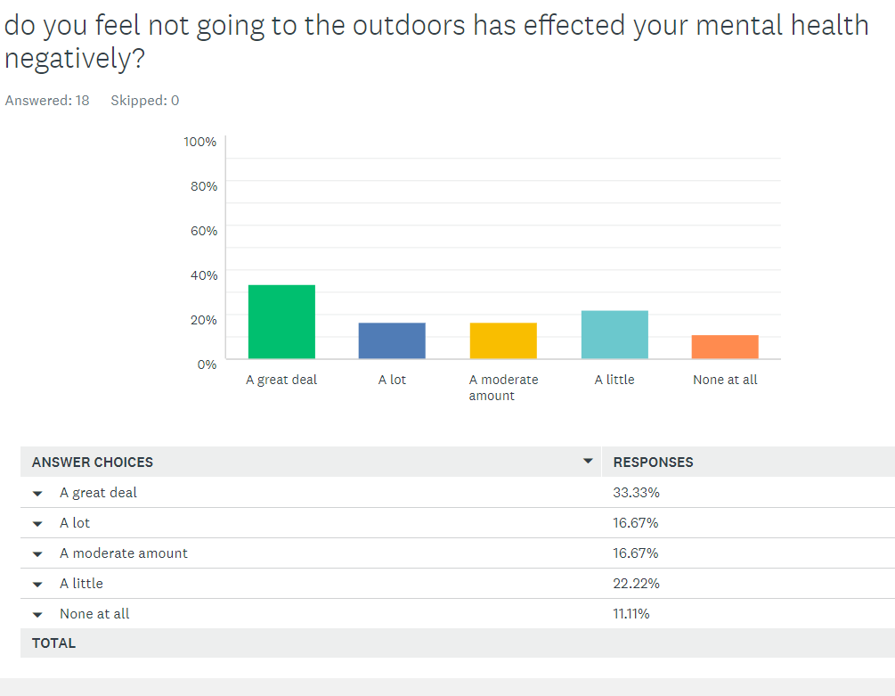

this graph above shows that there where a mixed answer with the number of people that felt there mental health was affected, but if this I compared to the amount of people the that use the outdoors and this suggest that there could be a relation between the two, as the number of people no longer being able to go outside and participate in there hobbies would be the most affected my the lock down and pandemic so this is a very probably pattern that seemed to accrue.

Conclusion

To conclude, from some of the research there were some visible links between some of the questions asked, such as the idea that people with the ability to drove would go to explore more in the outdoors as they had the anility to do so when they please, another link made between the local areas, people being more together with there local communities meaning they would have a better understanding of the local environment , which could assist more micro adventures. There was an obvious link to this as the lock down made it so that there was a five mile restrictions during the pandemic, which gave the excuse to people to explore their local and environmental which would be a link between the pandemic how people would know there community which answers my questions to some degree. The final link was with mental health the number of people going on the activities.
With the mental health link to the pandemic, there wasn’t to much of a link but compare it to the numbers of people going n activities regularly and you can see pattern, the numbers where similar suggesting that the ones that are restricted from out door activities which are more then likely to be there hobbies, where gain more mental health issue.

Word count 1474

References

Cullen, W., Gulati, G. and Kelly, B.D., 2020. Mental health in the Covid-19 pandemic. QJM: An International Journal of Medicine, 113(5), pp.311-312.

GOV.WALES. 2021. Stay local – Wales takes first steps out of lockdown | GOV.WALES. [online] Available at: <https://gov.wales/stay-local-wales-takes-first-steps-out-of-lockdown> [Accessed 23 April 2021].

Roisin Mullins 2021 reference week 6 quantitative foundations.
https://moodle.uwtsd.ac.uk/course/view.php?id=9543

Surveymonkey.com. 2021. Log in to your account. [online] Available at: <https://www.surveymonkey.com/analyze/Z_2BbBt3qegU2xfctGNkm6xqboZDRymEz6ne63KwS_2FjxM_3D?tab_clicked=1> [Accessed 23 April 2021].

Setia, M.S., 2016. Methodology series module 3: Cross-sectional studies. Indian journal of dermatology, 61(3), p.261.

