

Certificate of Higher Education in Skills for the Workplace

Task 2
Professional career development report

Student name: Gheorghe Trifoi
Student ID: 2030295

Module name: Professional Career Development
Module code: (BMSW4005_LON)
Lecturer name: Bianca Sanfilippo
Word count: 2166 excluding appendices
Submission date: 06/05/2022

Contents
Introduction 3
Personal reflection on the role play: Recruitment and Selection - Applying Kolb’s (1984) learning cycle 3
Skills and knowledge which contribute toward working effectively 5
Knowledge required to work effectively in my job role as a site manager 6
My personal strengths and areas for further development 7
SWOT ANALYSIS 7
My employment goals and develop a personal career action plan 7
SMART Targets plan 8
Appendix A: SWOT analysis 11
Appendix B: SMART targets 11
Appendix C: The questions asked as interviewer in the role play A1 12
Appendix D: Application Form completed as applicant for the role play A1 14

Introduction
The reason for writing this report is to present an action plan for my career development analysing own skills and strengths needed to progress on the job. To do this I will be reflecting on the role play interview that is part of my learning and use the help of different tools like SWOT analysis, choose a reflective learning cycle to help with my reflection and make a personal development plan to help with my future career planning.
First, I will start writing my reflection on the role play. Then the skills and knowledge needed to work effectively in the role of site manager I am intending to progress into. After my personal strengths and areas for further development will be shown in a SWOT analysis and end with the personal goals and an action plan.
I intend to self-evaluate myself by reflecting on my talents and learn how to strengthen them hoping to create a personal plan of action for my development to help me get where I want to be in the future

Personal reflection on the role play: Recruitment and Selection - Applying Kolb’s (1984) learning cycle
A person is doing reflective practice when is thinking about himself and the experiences, actions and effects this has on them. Being able to recognise own strengths and areas for improvement when reflecting is an advantage on a person’s profession (Tarrant, 2013). So In order to reflect on this experience, I am using Kolb’s (1984) theory that focuses on individual’s learning through experience. His reflective cycle will help me to reflect on the role play, learn from that experience and improve my practice. The reflection process, according to Kolb has four stages that can be used to reflect effectively.
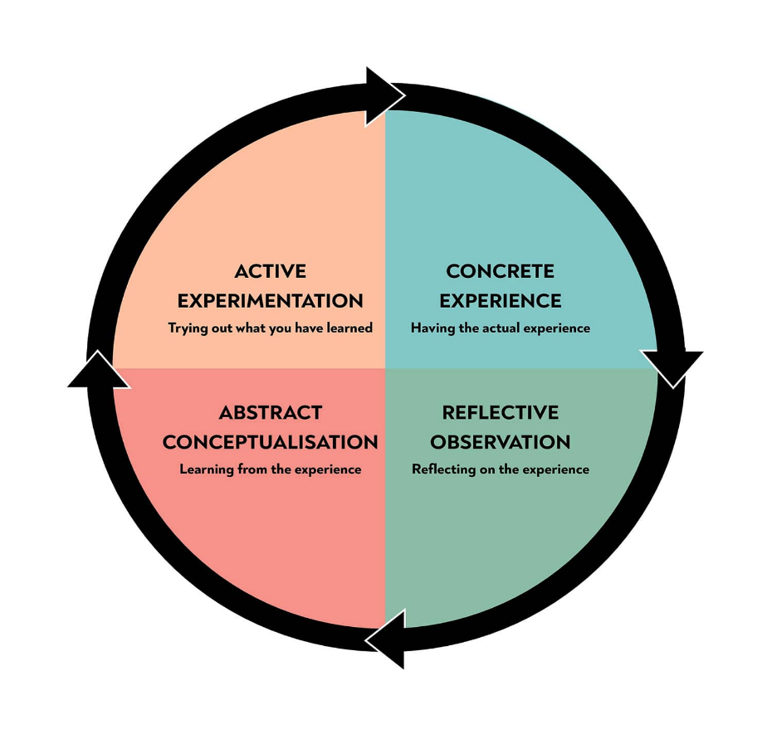
Image accesed at: https://www.simplypsychology.org/learning-cycle-kolb.jpg
The first stage must have an actual experience or a situation. If we don't have an event or an experience to reflect on, we won't be able to think about it. The second stage is called reflective observation because is the reflection on the experience or event and why this event is important as a learning experience. Abstract conceptualisation is the third stage and here a new idea is formed through reflection and the individual is learning from that experience. The last stage experimentation is formed from the new idea and the learner applies what he learnt from the event into future practice.
This model of reflection can be applied in my reflection on the role play acted in week 8 of the CPD assessment.
(The experience) During the role play, together with a colleague, we each had to play the role of the interviewer and applicant for a chosen job (10 minutes each). In my role as an interviewer, I pretended to be an HR manager for Tesco and I did well as I started the interview with greetings, I invited the candidate in to take a seat and asked how her journey was, just to make her feel relaxed. I also offered coffee, or something to drink. The candidate answered the questions well with simple answers and examples from experience.
In my role as an applicant, I pretended to be applying for the position of Site manager on the construction site I work because this is part of the plan I made for my career. I think I did well as an applicant when I answered the questions, but I was stressed during the interview and I moved a lot with my hands, I also had a shaky voice because I am not very confident with public speaking.
(Reflective observation) Playing the role of applicant was very important for me because it was an opportunity to experience what will happen in a real interview. I was able to reflect on my skills and strengths and areas that I need to improve. Reflecting on my performance during the roleplay made me more aware of my strengths, the knowledge that I have of the building site and positive attitude that helps me use my organisational skills properly. The areas of development that I found I need to work on are my communication skills and presentation skills.
(Abstract conceptualisation) What I have learnt is that I must focus on my communication skills, especially my non-verbal communication like my body language, facial expression, and confidence, are areas in which I need to improve.
(Active experimentation) Looking back at this roleplay interview and what I have learnt will help in my next interview. I will prepare more to improve my presentation skills. And practice my communication skills every day especially my body language making sure to fidget less when speaking and make eye contact to help me express myself.

Skills and knowledge which contribute toward working effectively
If I want to work as a site manager, I'll need to concentrate on the skills necessary for this position, skills that are related to the role and the responsibilities this position involves.
According to Indeed (2022) a site management needs to delegate a team of construction workers to finish a task on a building site, give instructions and follow safety protocols, also do HR duties like taking new people in and train them. He will work with architects, surveyors and builders to ensure a project is on track and there are enough staff, machinery and materials to get the job done.
As found on National Career Services (2022) other skills a Site manager will need are knowledge of building and construction, the ability to work well with others, business management skills, the ability to use your initiative. Maths knowledge are important as there are financial tasks like budgeting, monitoring expenses, tracking income, and preparing reports to deal with, buying materials. Being able to organise your time and workload to keep track of information project deadline, work schedule and expenses is essential.
Leadership skills as a manager are important because you delegate a big team of workers, supervisors, and subcontractors.
Presenting the construction project and plan requires excellent verbal and written communication skills, they are also needed for instructing workers, write documents, interact with executives, architects, surveyors, and other people where you ned to present yourself clearly in speaking and writing as well.
Another skill a site manager should hold is to be able to use a computer and the main software packages like computer aided design, HR software or project management software.
Problem solving skills are essential as a project can bring issues like accidents, delays, shortage of materials, deal with bad weather conditions, health and safety, budget issues and many others.

Knowledge required to work effectively in my job role as a site manager
Each job requires specific knowledge related to that position and services provided. As a site manager I must be aware of all the legislation-imposed, use and train others on following rules and regulations like: Health & Safety, GDPR, The Equality Act, rules, knowledge on rights and contract and human rights.
Health And Safety at Work
The Health and Safety at Work Act of 1974 (HSWA) requires all employers to "ensure, so far as is practically feasible, the health, safety, and welfare at work" of all their workers and anyone working on their premises. Everyone entering a construction site must comply with all the safety regulations this act states (HSE, 2022).
GDPR In Construction
General Data Protection Regulation deals with protecting the personal data of an individual, his identity, professional and personal data. In the construction industry a project’s sensitive data is being exchanged with contractors, surveyors, architects, engineers or project managers and there is a risk on the data being compromised. All information should be kept confidential. Sensible information cannot be shared or private information and personal details. This is related to all workers and customers, everyone involved in the project (Data protection Act, 2018).
It is important to know about Employment Legislation. For example, the Equality Act 2010. It is against the law to discriminate people based on 9 protected characteristics: Age, disability, gender reassignment, race, religion and belief, sex, sexual orientation, pregnancy and maternity, marriage, and civil partnership (Gov.uk, 2013).

My personal strengths and areas for further development

SWOT ANALYSIS
By looking at appendix A, using the Swot analysis helped me to find skills I have and am good in doing it and areas that I need to work on and improve. Because I have more than ten years working on the construction site and have done lots of jobs I was able achieve different qualifications needed to do a job, I worked under pressure and adapted to changes that was coming every now and then. With the help of regular trainings that I was offered at work I was able to improve my abilities and work. Skills for the workplace course was an opportunity to learn how to be successful in the workplace, work in a team, and also how to be a good leader. My weakness is fear of speaking in front of people and this I need to work on because I will have daily meetings with workers as a site manager.

My employment goals and develop a personal career action plan
Morgan (2016) defines a Professional Development Plan as a plan intended to improve the necessary qualities a person needs to have to work in a company.
My professional career pathway is to finish the course in skills for the workplace and maybe continuing with the leadership and management in skills for the workplace that will help me to improve my knowledge and skills I need to become a site manager.
My strengths are: I have the necessary certificates to work in construction; I manage my time efficiently and the work experience that helped me to adapt to new situations are areas that will help me in the future job.
Since the start of the programme I improved my communication skills with the help of the assignment presentations each term and worked well on speaking in front of others. I revised my literacy and computing skills. My team working improved a lot and I deal better with people at work. I also learnt how to solve problems and how to apply tools to help me find what is caused the isues.
I need to develop: my leadership skills and practicing will help me. I need to learn to communicate better to make myself clearly; my public speaking too because is easy to speak just with one person but in front of people is scary because everyone is looking at me. For example my body language, I move a lot and have a shaky voice; my communication skills need to improve. My English is not so good and I want to improve that so people understand me correctly.
I need to be a good leader to manage people to follow me and motivate them to do their work. Improving my communication will help me to make myself clearly when speaking to people and need to make sure I send the correct message to people so they can do their job. I also speak to a lot of people, managers and contractors and I need to know what I say to them.
To improve my public speaking I need to prepare and organise myself before I say something and how to do it so people understand me. I hope to learn to be a better leader with the help of the next course and practicing. Already this course is helping me to improve and learn new skills, it helped me to make this work and my communication skills with activities in class. I will also try and use reflection, that I learnt in this module to help.
A barrier to improve myself in the workplace is that I was always laid back but now that I have a family there is more costs and my current job is not helping. So for a long time I wanted to do a course to improve myself and change jobs for a better paid one.

SMART Targets plan
My short - medium – long term targets for the development of my own professional career plan are shown in appendix B using Cottrell (2021) practice tables.

Conclusion
To conclude on my reflection work I can say that experiencing the interview in a roleplay was a great experience considering that I haven’t been in an interview before and it helped me too see how is working and how well I did. This way I now know what mistakes to avoid and what to do different in my next interview.
Also working on my development plan opened my eyes to see what I can do and want to do in the future. Plus the fact that I started the CertHE certificate I learnt how to work on myself to get better and found skills that I didn’t know I have. This will help me to reflect on my life and skills and work on my plan of passing the interview and be a site manager.

References
Cottrell, S 2021, Skills for Success: Personal Development and Employability, Macmillan Education UK, London. Available from: ProQuest Ebook Central. [25 April 2022].
Data Protection Act, (2018) UK public General Acts, Data protection Act 2018. (Online) Accessed April 2022 at: Data Protection Act 2018 (legislation.gov.uk)
Gov.uk, (2013) Equality Act 2010: guidance. (Online) Accessed April 2022 at: Equality Act 2010: guidance - GOV.UK (www.gov.uk)
HSE (2022) Health and Safety in construction (online) accessed April 2022 at:
Construction - Health and safety for the construction industry (hse.gov.uk)
Indeed Editorial Team, (2022) Site Manager Skills: What They Are and How To Improve Them (Online) Accessed April 2022 at:
Site Manager Skills: What They Are and How To Improve Them | Indeed.com
Kolb, David A. (1984) Experiential Learning: Experience as the Source of Learning and Development. Englewood Cliffs, N.J.: Prentice-Hall, Inc.
Kolb learning cycle image copied from : https://www.simplypsychology.org/learning-cycle-kolb.jpg
Morgan, P. (2016), The Business Student′s Guide to Study and Employability, SAGE Publications, Ltd. (UK), [London].
National Careers Service (2022) Construction manager (online)Accessed April 2022 at:
Construction manager | Explore careers | National Careers Service
Peter Tarrant (2013) Reflective Practice and Professional Development. London: SAGE Publications Ltd. Available at: https://search-ebscohost-com.ezproxy.uwtsd.ac.uk/login.aspx?direct=true&db=nlebk&AN=1366847&site=ehost-live (Accessed: 25 April 2022).

Appendix A: SWOT analysis
SWOT ANALYSIS

STRENGHTS  Adapt to any change  Experience on the construction site  Time management  Hold certificates in Health&Safety, First aid, Working at heights, NVQ level 2 -Steel erector | WEAKNESSES  Speaking in public or presentations  Hard to say no  Not very creative
OPPORTUNITIES  Enrolling into Skills for the workplace course to improve skills and knowledge  Regular trainings in the workplace | THREATS  Long working hours  People that don’t listen

Appendix B: SMART targets
Short-term plan (3 -6 months)
Specific | I plan to complete the Cert HA skills for the workplace course and to apply for the site manager position in my workplace.
Measurable | I am going to do this by passing my exams and getting the diploma at the end of the course.
Agreed | With the help of the course I was able to learn new skills that will help me to become a site manager and my manager is aware that I am working on myself so I can progress at work.
Realistic | Yes, my plan is achievable because I am working hard to learn new skills and I am completing all my assignment to finish the corse too.
Time-Bound | By September I should be able to get my certificate.
Medium-term plan (1-2 years)
Specific | I plan to be the site manager. Also continue to study the BALM course to improve my skills as manager and leader.
Measurable | With more work and responsibility at work, practicing interview skills and the modules in my study.
Agreed | At work my boss knows I want to become a manger and he supports me.
Realistic | I can do this if I work really hard at work and in study.
Time-Bound | Next year on this time.
Long-term plan (2-5 years)
Specific | The idea of opening a business is in my mind and maybe in the next 5 years I will have some people working for me on the site.
Agreed | My family supports me.
Realistic | My ambition and hard work will get me there some day.
Time-Bound | After working as a manager for a bit to be more experienced and put some money away to help maybe around 2-4 years.

Appendix C: The questions asked as interviewer in the role play A1
Keti interviewer and Gheorghe candidate
Construction Site Manager Interview Questions
- Why you think you're a good fit for the job?
- How have you responded to challenges during construction projects in the past?
- Describe one situation where you solved an issue on a construction site.
- Do you enjoy teaching new concepts or helping others learn new construction skills?
- What safety practices do you follow in during construction work?
Do you have any questions?
when to expect an answer about the interview?

Question asked to interviewee (Gheorghe interviewer and Keti candidate)
1 Tell us something about yourself.
2 Why do you want this job?
3 What are your strengths?
4 what’s your biggest weakness?
5 What is your ideal work environment?
Do you have any questions?
What are the company benefits that Tesco is offering?

Appendix D: Application Form completed as applicant for the role play A1.
Job application form

Application for [job title] – Construction Site Manager

Your details
Name: Gheorghe Trifoi

Education and training
Please give details:

2OOO – Forestry High School, Sighet, Romania – Graduated with a Baccalaureate diploma

Qualifications
Please give details:

First aid Course
Working at heights
Manual handling
Health and Safety
NVQ level 2 - Steel Erector

Employment history
Your current or most recent employer
Name of employer: DNA Construct

Job title: Roofer

Length of time with employer: 8 months

Reason for leaving: working here

Duties:

Water proofing, installing slabs, isolations on terrace, balconies, or roofs.

Previous employers
Please tell us about other jobs you have done and about the skills you used or learned in those jobs.

Dane Architecturals for 7 years – Here I have worked as a steel erector, I was working at heights and learnt and applied the health and safety procedures. Also working in a team was a skill that I learned and worked under pressure.

Newnorth Ltd – 6 years – I worked as a fixer double glazing. Attention to detail was important here and dangerous when working at heights and during bad weather.

Supporting statement
Please tell us why you applied for this job and why you think you are the best person for the job.

I am applying for the position of site manager as I think I have come so far with my work and experience, and is time to grow in my career. I think I will do good at this job as I have over 5 years working in a construction site, and I know how things work. I was able to work as a supervisor where I learnt how to be a leader for a small team. I am able to carry on more responsibility and deal with any situation and deliver a good job with my team at the end of the day.

Right to work in the UK
Do you need a work permit to work in the UK? No
References
Please give the names and contact details of 2 people who we can ask to give you a reference. We may ask them before an employment offer is made. We will not ask your current employer until we get your permission.

Available if requested.
Declaration
I confirm that to the best of my knowledge the information I have provided on this form is correct and I accept that providing deliberately false information could result in my dismissal.

Name: Gheorghe Trifoi

Signature: GT

Date: 1/04/2022

