SUPPORTING YOUNG CHILDREN THROUGH TRANSITIONS

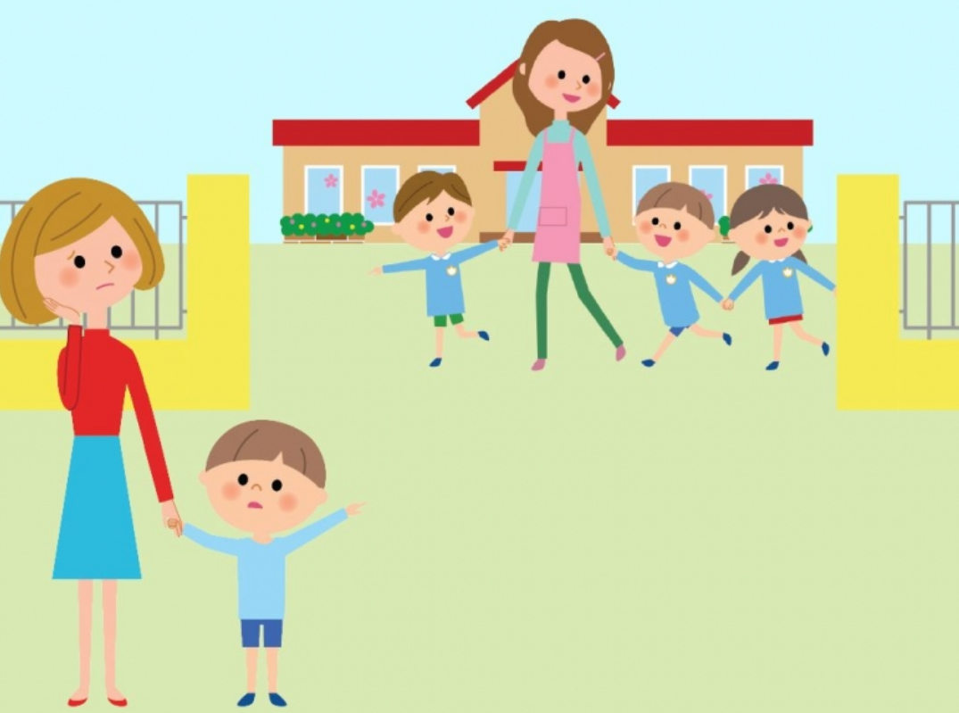
(Source: B R Parents, 2017)

A HANDBOOK FOR CHILDCARE PRACTITIONERS
THE IMPORTANCE OF EFFECTIVE COMMUNICATION AND BEST PRACTICE FOR THE BENEFIT OF YOUNG CHILDREN’S LEARNING AND DEVELOPMENT DURING TRANSITIONS.
CONTENTS

- An Introduction to the desired outcomes for under 3’s entering childcare either for the first time or from another setting.
- How to use this handbook
- Transitions
- The Role of the Adult
- The needs of the Child
- Partnerships
- Interventions
- Proposed Outcomes
- Reference list

An introduction to the desired outcomes for under 3’s entering childcare either for the first time or from another setting
This handbook has been produced with the aim of informing and enabling childcare professionals to be able to provide the best possible transition experiences and outcomes for babies and young children entering the childcare setting for the first time. The common thread throughout will be the emphasis on the value of effective communication between all parties involved during the transition. This will be linked with reference to children’s rights, human behaviour theorists, government policy and National Minimum Standards leading to best practice.
In the ‘General Comment 7’ of 2005, the UNCRC clarified the importance of recognising the rights of very young children and babies and their ability to express themselves and communicate their needs long before they have acquired the skills of speech and language. Having the attentive care of a keyperson will enable a relationship and bond to grow to ensure the child feels safe, secure, listened to and that their needs are completely met. (Brooker, 2008)
According to the theorist John Dewey, a child should be at the centre of their learning and a young child’s development is directly formed around their relationships with their carer’s and educators. Aubrey and Riley (2016) interpret Dewey’s theory as meaning that a child does not have a passive experience during any social interactions and will always be learning. It is therefore important that we have policies and procedures in place in to ensure positive experiences from the very start of the child’s transition into childcare.

How to use this handbook.
This handbook is a guide on the importance of effective and successful communication between all parties during a child’s transition into childcare.
By following the guidance in this handbook, practitioners will be able to understand the reasoning behind the guidance and put into place best practice to help the process go as smoothly as possible for the child, the parent and the keyperson.
This handbook is divided into comprehensive sections for reference on all the aspects that enable a positive transition process and outlines the roles of all those involved.
There are practical interventions for good practice in line with professional, government and local authority requirements. Lastly there is a section on how we can measure outcomes and monitor progress and development.

Transitions and Communication
What is transition?
“1. change or passage from one state or stage to another. 2. the period of time during which something changes.” (The New Collins Concise English Dictionary, 1986).
This dictionary definition ties in with how practitioners must view the transition of each child. It is generally considered today that transition is a gradual process, a journey, not just a singular event on the child’s first day in nursery and then done with. The transition starts long before the first day and continues until the child is fully settled. It is crucial that practitioners understand the significant impact the experience of transitions into childcare have on the child’s development and wellbeing. (Welsh Government, 2017a)
What is communication?
“the imparting or exchange of information, ideas or feelings.” (The New Collins Concise English Dictionary, 1986).
This clarifies that communication is a two-way exchange. It is just as important to listen as well as to speak for communication to be effective. Practitioners will have information to impart to their service users, but they must also gather as much information as possible about the child and their needs to have the capacity to carry out their work effectively.
Speaking. Informing. Hearing. Listening.
Communication is ~~~~~~~~~~ Understanding and being understood.
Reading. Signing. Watching. Seeing.

The Role of the Adult
“The little, or almost insensible impressions on our tender infancies, have very important and lasting consequences.” (Locke, 1692)
In this quote Locke recognises that even the smallest experiences can affect a child’s development and therefore it is important to be mindful how they are cared for.
Bronfenbrenner’s theory emphasises that within childcare settings it is important to create a culture of inclusion. Children develop to their best potential when they feel valued and have good relationships with the people around them. (Hayes, O’Toole and Halpenny 2017)
Childcare practitioners need to be fully aware of how important their role is in ensuring smooth transitions. Montessori recognised that It is essential that practitioners are properly qualified in child development and education to carry out their work effectively and successfully. Planning and facilitating are key to this approach. (Aubrey and Riley 2016).
It is the responsibility of the management of the setting to ensure proper procedures are in place and NMS are met. Staff must be kept up to date on regulations and be reflective on their practice. All settings are required by their registration to follow the National Minimum Standards. This is a comprehensive set of mandatory guidelines which must be followed and applied to the setting practice. (Care Inspectorate Wales, 2016)
Within the NMS there are key points for practitioners to follow to ensure smooth transitions for children and families. These include:
NMS 3: Assessment: This involves the collection of as much information on the child as possible to give the practitioner a sound picture of the child.
NMS 4: Meeting individual needs: this is in place to make sure that any specific requirements for the child’s care can be met, for example any SEND. Plans can be put in place ready for the child.
NMS 6: Working in partnership with parents: parents are made to feel valued as well, they are given information to enable them to make decisions and choices. They are also kept fully informed of their child’s activities and achievements. Parents are encouraged to partake in two-way communication. It is vital that significant information about the child is shared with practitioners to enable them to provide proper care and understanding.
NMS 8: Nurture and Wellbeing: This Standard ensures that practitioners are aware of their important role in helping children to feel happy and secure, comfortable with their carer and valued. Standard 8 places special emphasis on the practitioner’s responsibility to be aware of the importance of the UNCRC, the voice of the child and the importance of the parental role. (Care Inspectorate Wales, 2016)

The role of the keyperson: This role has been recognised as being crucial to the settling in period. Attachment and separation theories of Bowlby and Ainsworth (Brooker 2008) emphasise how a child’s bond with their parents and relationships with new adults in their lives are can be positively developed. During transitions a child will have to cope with being separated from their parent and simultaneously form a new attachment with another adult. This process can be made easier by having the family visit the setting together a few times before the child is left. (Pacey).
There is a complex relationship to be formed by the three parties, guided by the practitioner but with the full cooperation of the parent. This is known as the ‘Triangle of Care’ (Hohmann, 2007). The two adults develop mutual trust to create reassurance and for the child to have a positive experience and build a strong bond with their keyperson.
“sustaining a caring triangle demands regular close, open and trusting communication between parents and minders” (Brooker, 2014)


The child will have more confidence in himself if he trusts his parent’s confidence in the situation.
It is the role of the parent to give the keyperson as much knowledge as possible about the child so that informed and relevant care can be provided.
It is the role of the keyperson to reassure the parent that their child’s needs will be met and that they will be cared for as an individual, valued and listened to. (Brooker, 2014)
.

Source: stock image, word 2020

The Needs of the Child
The theory of Winnicott (1964) places great significance on the role of the mother, or primary carer. A baby would not survive without someone to care for it. He recognises how nurture and care provides a loving and supportive environment for the totally dependent infant. This mantel must be carefully shared with the childcare practitioner and received with confidence. The care should be no less caring.
Pikler’s approach draws on the theory of how a new bond can be formed between the child and practitioner through affectionate and tender daily caregiving. By meeting basic needs in a kind, focused and interactive way the child will grow to feel loved and secure and the child’s confidence in this new relationship will follow. (Weber, 2010).
Maslow’s Hierarchy of Need can be applied to the way care must be given to children. That basic needs are met, while essential, is not enough. Good practice in childcare means that great emphasis is placed on meeting the psychological needs of children too. Support of the child’s wellbeing and self-worth are written into policy. (Care Inspectorate Wales, 2016)
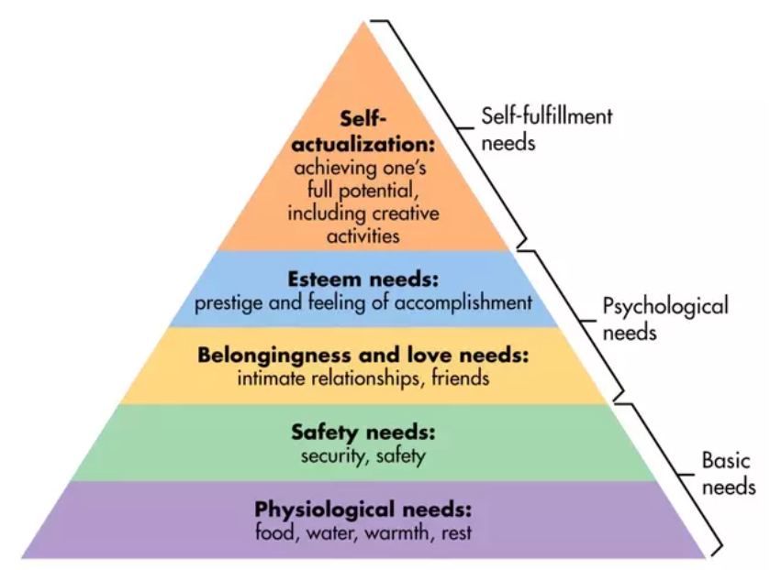
Source: simplypsychology.org/maslow(2020)

These theories are backed up by recent scientific research on the neurological development of babies and young children’s brains. An infant brain is like a sponge, waiting to be fed enriching and positive experiences so it may to grow to its full potential. These many experiences will create neurological connections enabling healthy mental and physical growth.

“Even the growth of the brain itself… may not progress adequately if the baby does not have the right conditions to develop” (Gerhart, 2015)
Notably both Piaget and Vygotsky’s theories place significance on providing the child with rich and supportive learning environments. (Tassoni, Bullman and Beith, 2008) A child that is surrounded by amusement and stimulus to all his senses will thrive.

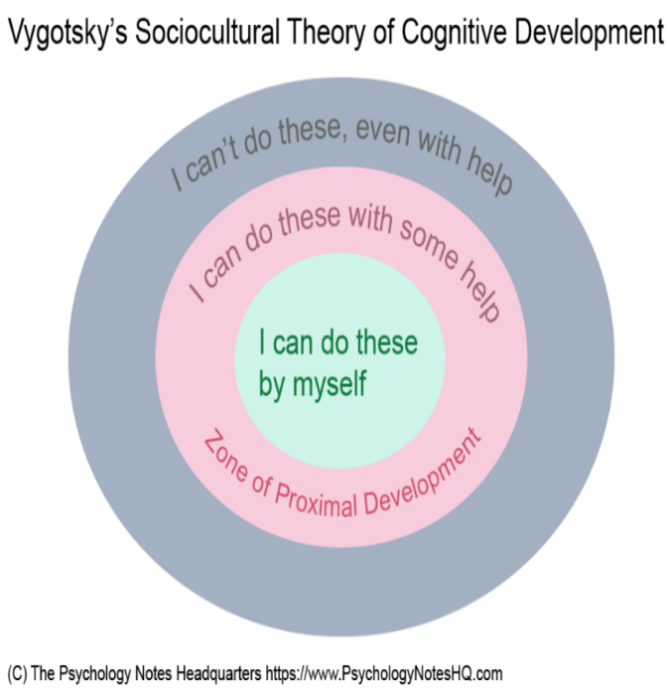
Vygotsky’s theory of cognitive development relies on direct interaction and communication between the child and the adult. To extend the child’s ability beyond what they can already achieve on their own they must engage in sustained shared thinking, guiding the child onto next steps. Listen to the child, observe their actions, see when and if they are ready to move on to the next stage. (PsychologyNotesHQ, 20**)

With people to care for him and meet all his needs and guide him in his development he will become a confident and happy child. (Dodds, 2016).
The theories and principles of Froebel are very much relevant in todays practice. He believed that children should have freedom of expression, a connection to their environment and community and the opportunity to play, be creative and connected with nature. (Tovey, 2017) These principles are recognisable in the UNCRC. Article 13 highlights the right to freedom of expression and article 31 states that children must have time and opportunity for leisure, play and culture. (UNICEF)
Studies show government and local authorities that provide supportive and positive services for families and young children, are investing in healthier more resilient and successful communities for the future. (Harvard University).
While we focus on the positive step’s we can take to enable smooth and happy transitions, it is important to recognise that not all children will react to our strategies in the same way. Some children will find the process upsetting and difficult more than others. The children whose emotional needs are greater must be listened to. The build up of toxic stress is very unhealthy for development and can be hugely detrimental to a child’s well-being, coping mechanisms and future health. It is important to communicate with these children, speak with their parents, understand how and why they are feeling distressed, and offer more support. (Harvard University)

Partnerships
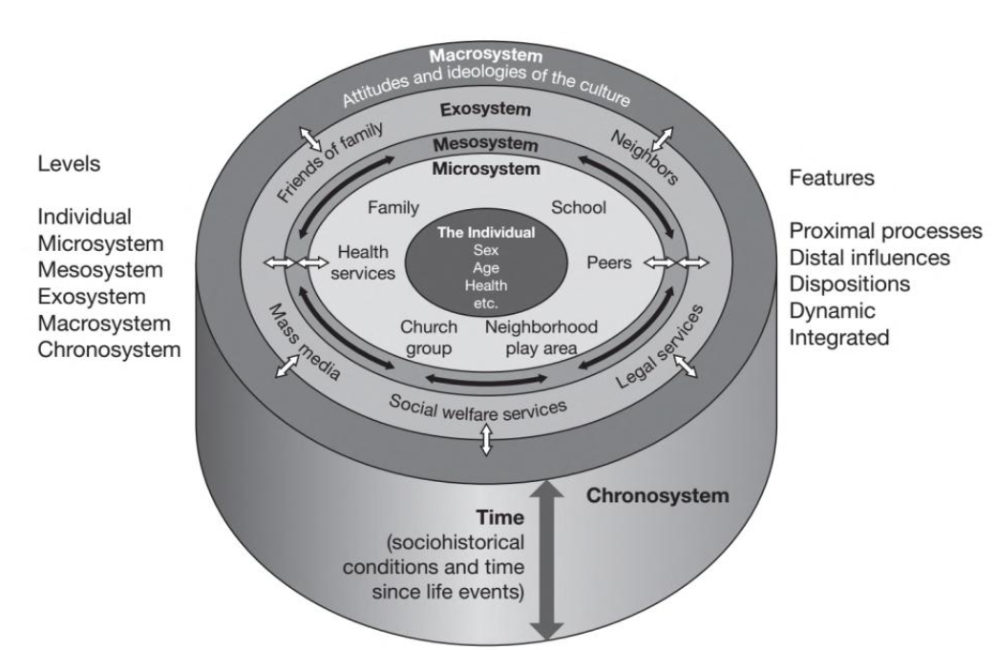
During the transition, the child is at the centre of the process. Their world and routines will be changing for good and they will probably be spending a lot of time in the setting. It is therefore important for practitioners to be aware of all the influences in the child’s life.

This is illustrated and explained in Bronfenbrenner’s Ecology Model, “The Ecological Theory of Child Development”, and focuses on how a child’s environment and relationships effect their sense of well-being and development.
Source: Haynes et al. (2017)

Practitioners can use this model to see where they fit into the child’s life and what else can directly affect, influence, or help the child. Normally the parents will be the primary connection, then family, siblings and grandparents. Childcare might be the child’s first introduction to the wider community, but they may attend other groups, such as places of worship or playgroups. The child may have already come into contact with health, social care or medical services.
The keyperson must respect and acknowledge the parent’s responsibility in their child’s care and development. Childcare services have a duty to consult with parents about any issues arising with development before consulting with support services. Parents must be made aware of extra support they can access. The Family Information Service is one of the best avenues to follow in terms of finding relevant help. They are set up in all local authorities and are there to guide parents and families to find the help they need. The Welsh Government is committed to helping parents access relevant support for their children to ensure best outcomes. This support is based on the principles of the UNCRC and working in the best interests of the child. (Welsh Government 2017b).
It is important to gain as much information from parents about the child’s wider community in order to have a comprehensive picture of the child and also to be able to communicate and talk with the child about these extra-curricular relationships and activities. Vygotsky recognised that a child’s world is shaped by their family and community so when a key adult in the child’s life acknowledges what is important to the child with direct communication, the child will feel valued, have a sense of importance and belonging. (Mella, 2017).

Interventions
This part of the handbook puts forward procedures and activities that will enable the transition process to go as successfully as possible. This will include the relaying of information between the setting and families and practical steps that can be taken.
It is vital that the setting is professional, consistent, organised, welcoming and inclusive. This view is upheld in the practices of Froebel, Montessori and McMillan. (Froebel, Montessori…… McMillan……).
Standard 1 of the National Minimum Standards is about information, the childcare service must have a written statement of purpose which outlines all the practical aspects of the setting. This comprehensive document allows parents to make informed decisions about the service they require. (Care Inspectorate Wales 2016).
The National Minimum Standards are there to guide settings in correct practice, but they are a minimum. Settings can develop their own methods from these standards and take inspiration from best practice nationally and internationally. The Te Whariki approach from New Zealand emphasises the child’s belonging in their environment, ownership of their situation and builds on empowering the child in developing relationships in order to thrive. (New Zealand Government, 1996). In Wales, the Foundation Phase and Flying Start are curriculums put in place to ensure babies and young children have an equal start in life, the same opportunities, quality of care and education. (Welsh Government, 2016).
- Ensure parents are aware they can ask questions and are comfortable to express their concerns about transitions.
- Provide plenty of opportunity for visits to the setting and meeting the staff to establish relationships and keyperson pairings.
- Allow the child to participate in activities or to play during these visits.
- Give at least 2 weeks for the settling in period before the child is left.
- Have simple routines in place to provide security and familiarity, for example designated coat pegs and a welcoming song.
- If staffing allows, let the child chose their keyperson.
“It is also important for settings to adapt their routine to the needs of the baby, rather than the other way around” (Tassoni, Bulman and Beith, 2008) ****
Proposed Outcomes
The desired outcome is child who is happy, confident, engaged and equipped with the emotional and social skills to cope with transitions in a positive way and to trust the system to support his needs.
But how is this measured? How is it known.
Shuttleworth (2010) refers to Darwin’s article in Mind (1877), “A Biological Sketch of an Infant.” This article triggered the concepts of recording the progress of children as a scientific notion. Previously considered a matter for mothers to worry about, Darwin opened a new avenue of research, observations and theories that are now scientifically proven and implemented today.
Loris Melaguzzi, founder of the Reggio Emilia approach, believed that recording a child’s achievements would create a snapshot of the child in the moment, building a record of their learning, interests, ideas and development through time. He did not believe in setting targets and tick boxes, instead he promoted nurturing a child’s development by observing and guiding their interests. (Yu, 2008)
Martland (2020) discusses how observations of the child in the moment will help build a picture of their unique journey and development. A record in the form of a Learning Journal, containing observations, assessment data, parent input and the child’s voice or work will provide a useful source of information to assess progress holistically.
Observations will allow the keyperson to respond to the child’s needs and provide opportunities to develop next steps. This ties in with the theory of sustained shared thinking which happens during adult and child interaction.
Holistic assessment is there to support the child in the moment, connecting the child in the setting with the child at home and facilitating planning for next steps. It will also enable the practitioner to equip them for the future, to acquire the skills and confidence for their subsequent transitions through life. (Brooker, 2008)

Reference List
Aubrey, K. and Riley, A. (2016) Understanding and Using Educational Theories. London:SAGE
Brooker, L. (2008). Supporting Transitions in the Early years. Maidenhead:Open University Press.
Brooker, L. (2014) ‘Childminders, parents and policy: Testing the triangle of care’, Journal of Early Childhood Research, 1st October. Available at: https://journals-sagepub-com.ezproxy.uwtsd.ac.uk/doi/full/10.1177/1476718X14548779 (Accessed: 20th November 2020)
Care Inspectorate Wales (2016) National Minimum Standards for Regulated Childcare for Children Up to the age of 12 years. Available at: https://careinspectorate.wales/sites/default/files/2018-01/160411regchildcareen.pdf (Accessed 13th November 2020).
Dodds, H. (2016) Let’s Play Learning. Great Britain:Oak Avenue Press
Gerhart, S. (2015) Why Love Matters: how affection shapes a baby’s brain. Hove:Routledge
Hayes, N., O’Toole, L. and Halpenny, A-M. (2017) Introducing Bronfenbrenner: A Guide For Practitioners and Students in Early years Education. London:Routledge
Hohmann, U. (2007) ‘Rights, Expertise and Negotiations in care and Education’, Early Years Journal, 16th March. Available at: https://www.tandfonline.com/doi/abs/10.1080/09575140601135114 (Accessed: 19th November 2020)
Locke, J. (1692) Some Thoughts Concerning Education Available at: https://sourcebooks.fordham.edu/mod/1692locke-education.asp#Some%20Thoughts%20Concerning%20Education (Accessed: 19 November 2020).
Harvard University https://developingchild.harvard.edu/resources/health-and-learning-are-deeply-interconnected-in-the-body-an-action-guide-for-policymakers/ (Accessed: 22nd November 2020)
Harvard University https://developingchild.harvard.edu/resources/stress-and-resilience-how-toxic-stress-affects-us-and-what-we-can-do-about-it/ (Accessed 20th November 2020)
Image https://www.brparents.com/article/the-stress-of-leaving-your-child-at-daycare.html (Accessed: 13th November 2020).
Pacey (2020) Separation and transitions https://www.pacey.org.uk/working-in-childcare/spotlight-on/2-year-olds/separation-and-transitions/ (Accessed 10th November 2020)
Martland, R., (2020) Kinderly Webinar In the Moment Planning Available at https://learn.kinderly.co.uk/courses/in-the-moment-planning-webinar/#/page/5e2f1966244030384232c6fb (Accessed: 17th November 2020).
Mella, E, et al., (2017) Emotion and Exclusion: Key Ideas from Vygotsky to Review our Role in a School with a Cultural Diversity Setting. Revista brasileira de educação especial, 23(2), pp.169–184. Available at: https://doaj.org/article/180438b293a1471aabc75c534d73c7b0 (Accessed: 20th November 2020)
Sally shuttleworth https://oxford.universitypressscholarship.com/view/10.1093/acprof:oso/9780199582563.001.0001/acprof-9780199582563-chapter-12
Schroeder-Yu, G. (2008) Documentation: Ideas and Applications from the Reggio Emilia Approach, TEACHING ARTIST JOURNAL, 6:2, 126-134, Available at: https://doi.org/10.1080/15411790801910735801910735 (Accessed 20th November 2020)
Tassoni, P., Bulman, K. and Beith, K. (2008) Children’s Care, Learning and Development Harlow:Heinemann
The New Collins Concise English Dictionary (1986)
Tovey, H. (2016) Froebel’s Principles and Practice Today. Available at: https://moodle.uwtsd.ac.uk/pluginfile.php/393991/mod_resource/content/1/FT%20Froebels%20principles%20and%20practice%20today.pdf (Accessed 14th November 2020)
UNICEF https://www.unicef.org.uk/wp-content/uploads/2019/10/UNCRC_summary-1_1.pdf
The Psychology Notes HQ Vygotsky’s Sociocultural Theory of Cognitive Development in Children [image] Available at: https://www.psychologynoteshq.com/vygotsky-theory/ (Accessed 14th November 2020)
Winnicott, D. (1964) The Child, The Family and The Outside world. Penguin:London
Weber, S. (2010) ‘The Work of Dr Emmi Pikler’. Research Bulletin, Autumn/Winter 2010. Available at: https://docplayer.net/84484676-Susan-weber-the-work-of-emmi-pikler-research-bulletin-autumn-winter-2010-volume-15-2.html (Accessed 13th November 2020).
Welsh Government (2017a) Flying Start- Annex Transition Guidance Available at: https://moodle.uwtsd.ac.uk/pluginfile.php/214826/mod_resource/content/1/141124-transition-guidance-en-v1.pdf (Accessed 7th November 2020).
Welsh Government (2017b) Parenting in Wales Guidance on Engagement and Support Available at: https://gov.wales/sites/default/files/publications/2019-10/parenting-engagement-and-support-guidance-for-providers.pdf (Accessed: 19th November 2020).

