

LCHS4003 Introduction to Health and Social Care
Name : Thahmida khanom
Student ID : 2531916
Lecture : Sam Parker
Component 2
Written Assignment

Table of Contents
Introduction 3
1. Effective Communication in Mrs Thompson's Care 4
2. Administrative Skills, Record Keeping and Data Protection 5
3. Collaborative Working with Other Professionals 7
Conclusion 8
References 9

Introduction
The needs of Mrs Thompson, an 84-year-old woman who is just returning home after visiting the treatment centre because of pneumonia, are under study in this report. She lives in sheltered accommodation and is living alone, with domiciliary care twice a day, and her dementia is mild. That she is not on medication and is growing more disoriented, not to mention the fact that she was discovered outdoors in improper clothes and in cold weather, means that her present support needs to be viewed more attentively (Glasby, 2026). These considerations in the report are how the professionals will respond safely, but still respect the dignity, rights and independence of Mrs Thompson. It initially talks about effective communication with Mrs Thompson and her family based on the Equality Act 2010 and the communication cycle at Argyle. It then talks about professional administration, accurate records and safe processing of information in the Data Protection Act 2018.

1. Effective Communication in Mrs Thompson's Care
The communication skill is the key to effective, safe, respectful and person-centred care of Mrs Thompson. It could be difficult to notice once the pneumonia occurs due to infection, dehydration, fatigue or medication absence, and it is the responsibility of the staff to be aware of the changes and relay their issues to the supervisor. A visit should start with a relaxing introductory part, identification and a brief description of the purpose of the visit. The workers should talk slowly, in brief sentences with a question at a time and give time to respond (Bate and Robert, 2023). They will always be good listeners and will listen to the tone of voice, facial expression and behaviour, observing nonverbal or verbal signs of distress and making sure they get it without being patronising. The supports that can be considered as the practical ones are as follows: a noisy room, good lighting, hearing aids or glasses, a written medication prompt, large print timetable and visual reminders.
The communication cycle of Argyle comes in handy, as it considers communication as a process, and not a one-time order (Hegyi et al., 2021). The employee comes up with a thought, puts it in the form of an understandable message, selects an effective channel, and the message is received and decoded by Mrs Thompson. The feedback will then give a hint as to whether the intended meaning was conveyed or not. To illustrate this, in the case of medicines, a care worker might state, 'Your morning tablets are due; open the dosage pack that is labelled and tell me what you are going to do next, Mrs Thompson. In case she is not able to do so, the worker ought to repeat or paraphrase the message and document this challenge in detail.
The services must not be discriminatory; they are supposed to make reasonable adaptations to the disabled as per the Equality Act 2010. Dementia can be an impairment, and age of Mrs Thompson should not be presumed by the staff to mean that she is not able to make decisions. Communication is thus available in the form of an equality duty and good practice. The staff will refer to her by her preferred name, preferred language, sensory needs and the availability of a relative or an advocate (Hussain, Rizvi and Sheikh, 2022). The discussions should be negotiated with Mrs Thompson face to face and in private and under control. Relevant updates can be given to the family members with her consent, and family members can assist in keeping the routines and detecting changes in her usual behaviour. Capacity should be considered in case it is not clear whether she has the capacity to decide on a particular issue at that point.
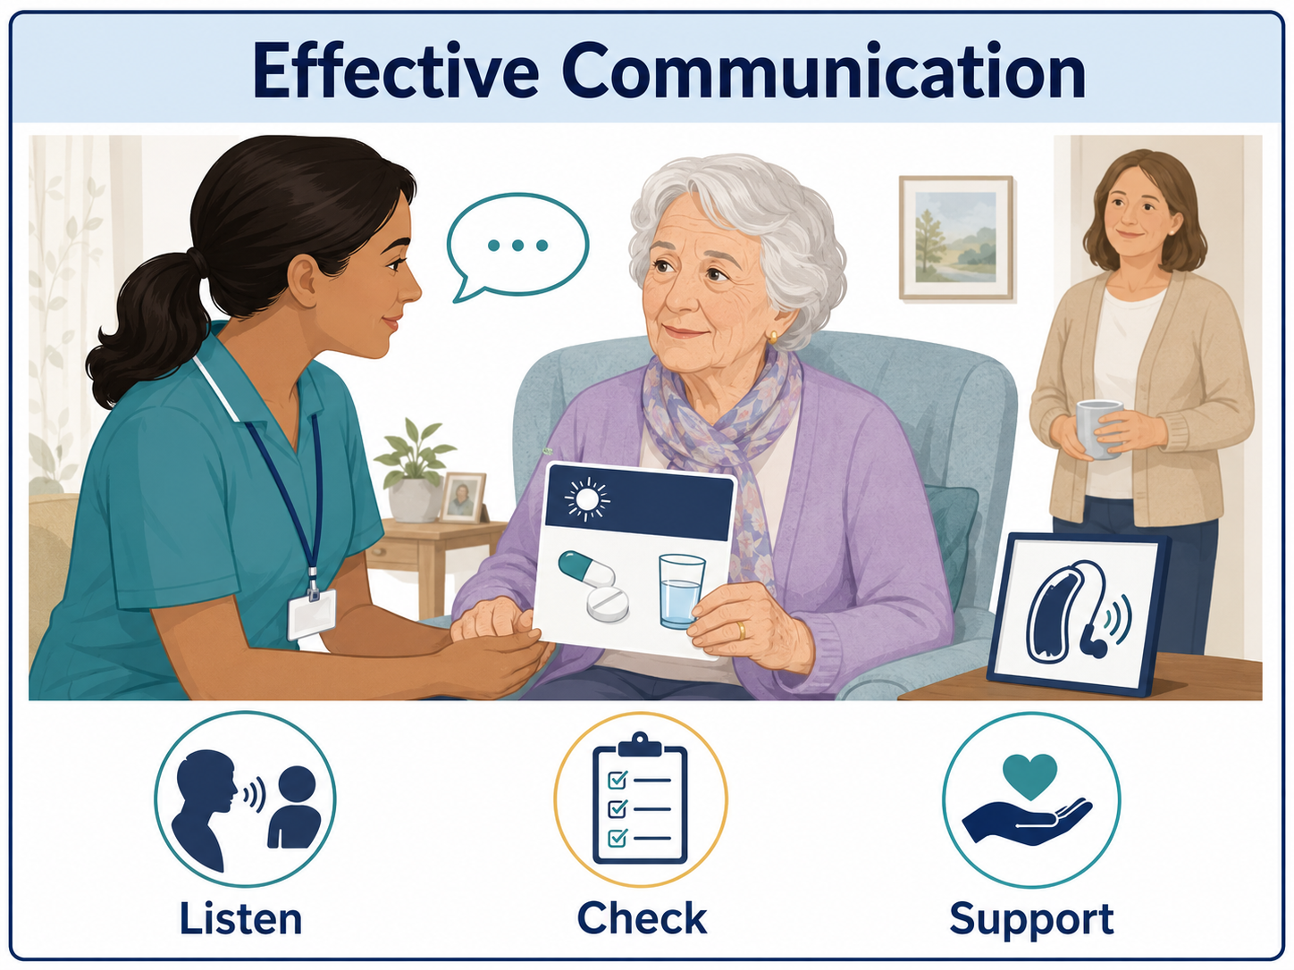
Figure-1: Effective Communication (Hussain, Rizvi and Sheikh, 2022)

2. Administrative Skills, Record Keeping and Data Protection
Professional safe action is achieved by observations that are turned into effective evidence through the use of effective administrative skills. The medication administration records in the case of Mrs Thompson will have to be filled in by the domiciliary care workers whenever they visit the patient; they will have to fill in the records with the details of the medicine, dose, time, whether it was taken, why it was not taken and what they did. The two days of absence, confusion escalation, meeting with the manager, medication review and cold weather should also be reported in the incident process of the service (Mduwile and Komariah, 2021). Records should be factual, time- and date-bound, signed or attributable electronically, legible and not containing any judgemental language. Instead of talking about Mrs Thompson as a challenging or irresponsible individual, a worker is to write what she said and what she saw. Any amendment should maintain the original record, demonstrate who did the correction and the reason why. Sound records might enable the GP and community nurse to identify trends, evaluate potential causes and whether an emergency treatment, increase or decrease in dosage or other support is required.
The use of the personal information of Mrs Thompson is regulated by the Data Protection Act 2018, as well as the UK GDPR (Hartzog and Richards, 2020). Her health, medication, capacity and incident records are special category data, which should be particularly addressed. The staff should apply the principles of lawfulness, fairness and transparency; purpose limitation; data minimisation; accuracy; storage limitation; integrity and confidentiality; and accountability. Practically, it involves clarifying the reasons for record keeping, gathering information that is pertinent to her care, verifying information before sharing, retaining records as per the schedule of the provider and the use of secure systems. The supplier ought to locate a legal basis, as well as a health or social care circumstance, which needs to be handled.
Sharing of information should be requisite, just and documented. Whenever possible, consent should be obtained to update family members, but emergency safeguarding or essential care issues might necessitate information on the same to be communicated immediately. The Care Act 2014 provides for the Mental Capacity Act 2005 (decision-specific capacity assessment and best interests decision-making) and adult safeguarding (Zhao et al., 2020). The Caldicott Principles require staff to articulate the purpose why they access confidential information, utilise the least possible information and have the obligation to disclose when it safeguards care. Regulation 17 of the Regulated Activities Regulations that forms a part of the Health and Social Care Act 2008 places the requirements on the providers to keep accurate, secure and contemporaneous records. Retention periods, reporting paths, audit plans and secure disposal procedures should be established in the Records Management Code of Practice and local policies.
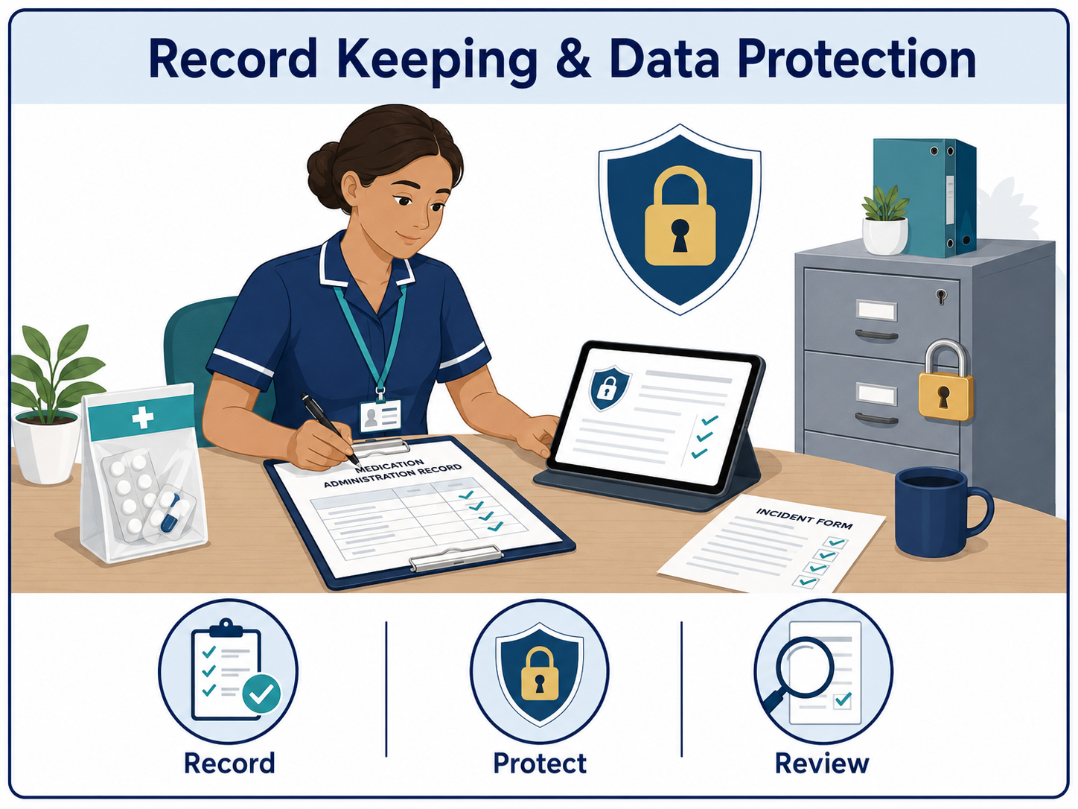
Figure-2: Record Keeping and Data Protection (Zhao et al., 2020)

3. Collaborative Working with Other Professionals
There should be collaborative working since one professional cannot handle all the aspects of the situation of Mrs Thompson in a safe manner. The GP can check medicines, investigate whether confusion is a result of infection or side effects, as well as changing. The community nurse is able to evaluate recovery following pneumonia, hydration, cognition, mobility and health deterioration. The domiciliary care workers play the most active role in the formation of the most frequent observations as they assist with medication times and detect behavioural or self-care alterations (Seaward, 2020). The local council will be capable of coordinating the external incident review, taking into account the safety problems and making the decision whether her care package or housing support should be varied.
An ordered, interdisciplinary meeting with the subsequent joint, conveniently accessible course of care is the suggested solution. The plan should entail the identification of a lead professional, roles of each person, medication reminders and escalation, and record the wishes of Mrs Thompson. Handovers, including SBAR, may be formalised to ensure that the interaction is concise and to the point: report on the situation, background, assessment and recommendation. Those regular reviews, the single channel of communication to provide any emergency issues and feedback agreed upon by both parties to the care workers, can help in making sure that the decisions will be implemented (Hargie, 2021).
These barriers are usually organisational systems, lack of speed in response, role ambiguity, employee turnover, hierarchy and fear of confidentiality and family feud. The role agreements known as deputies, case updates, and respectful challenge can help overcome these risks. Medication and protection training provides employees with a common tongue and assurance. In case the opinions are different, the team will be forced to revisit evidence, assessed capacity of Mrs Thompson, her preferences, and the least restrictive safe alternative.

Conclusion
The situation of Mrs Thompson illustrates the importance of communication, administration and collaboration in health and social care. Transparent and open communication allows her to comprehend support, communicate preferences and be involved in decision making regarding medication and safety. It helps the staff to involve the family in an appropriate manner without disregarding her rights, consent or capacity. Appropriate, secret documentation converts the observations that are made on a daily basis into medication review evidence to safeguard the response planning and future care planning. The information of Mrs Thompson and professional responsibility are safeguarded by the use of the Data Protection Act 2018 and the standards of care that should be used. Lastly, the collaboration of domiciliary care, the GP, community nurse, local council, Mrs Thompson and her family presents a more balanced view of risk than would be presented in each of the services individually.

References
Bate, P. and Robert, G., 2023. Bringing user experience to healthcare improvement: the concepts, methods and practices of experience-based design. CRC Press.
Glasby, J., 2026. Understanding health and social care. In Understanding Health and Social Care. Policy Press.
Hargie, O., 2021. Skilled interpersonal communication: Research, theory and practice. Routledge.
Hartzog, W. and Richards, N., 2020. Privacy's constitutional moment and the limits of data protection. BCL Rev., 61, p.1687.https://doi.org/10.2139/ssrn.3441502
Hegyi, P., Erőss, B., Izbéki, F., Párniczky, A. and Szentesi, A., 2021. Accelerating the translational medicine cycle: the Academia Europaea pilot. Nature Medicine, 27(8), pp.1317-1319.DOI: 10.1038/s41591-021-01458-8
Hussain, Z., Rizvi, L.J. and Sheikh, H., 2022. The Equality Act (2010)-pre-and post-pandemic historic development on equality and discrimination issues for employers: review of literature. International Journal of Law and Management, 64(2), pp.168-183.https://doi.org/10.1108/IJLMA-03-2021-0067
Mduwile, P.L. and Komariah, A., 2021, February. Leadership and Administrative Skills. In 4th International Conference on Research of Educational Administration and Management (ICREAM 2020) (pp. 11-16). Atlantis Press.10.2991/assehr.k.210212.003
Seaward, B.L., 2020. Managing stress: skills for self-care, personal resiliency and work-life balance in a rapidly changing world: skills for self-care, personal resiliency and work-life balance in a rapidly changing world. Jones & Bartlett Learning.
Zhao, J., Mao, Z., Fedewa, S.A., Nogueira, L., Yabroff, K.R., Jemal, A. and Han, X., 2020. The Affordable Care Act and access to care across the cancer control continuum: a review at 10 years. CA: a cancer journal for clinicians, 70(3), pp.165-181.DOI: 10.3322/caac.21604

