Student Name: Alexandra Staicu  Student ID: 2222626  Module Title: Foreign Languages & Cultural Awareness  Module Code:BMIH 5003 | 
ASSIGNMENT 1: PORTFOLIO
(4 Components)
Component 1: Professional Reflection (500 words +/- 10%)
Weighting: 25%
In this section, I have shared my reflection on the theme of cultural misunderstanding that I have observed physically. Very recently, I witnessed a large cultural blunder between a waiter in an hotel restaurant and Japanese client during breakfast service. The guest coming from Japan carried out the usual activity of slurping their soup, as this is considered a polite and almost complimentary act towards the chef in Japanese dining etiquette.
Nevertheless, the waiter was unaware of this norm that is why he could not understand it as rude and uncultured behaviour. This misunderstanding resulted in an uneasy encounter, suggesting how easy it is for cultural differences to lead to unintentional conflicts, especially because hospitality was surrounded by various guests and staff interactions. In retrospect, it becomes evident how important cultural sensitivity development is to mitigate and prevent such misconceptions in the future.
First, I realize the importance to improve my awareness on various customs practiced in different parts of world particularly dining habits through adequate cultural sensitivity training. These training sessions would give me very valuable information about different cultures and their specific codes of conduct that help to understand cultural diversity. With this information in hand, I can interact with guests from various cultural backgrounds appropriately and a climate of understanding is established.
Additionally, I know the importance of proper communication in regulating cultural confusion. Listening to guests carefully, anticipating their needs along with clearly communicating is one of the core human skills in hospitality. I get why it is important to clarify expectations and adjust my communication style in accordance with the cultural diversities, sensitive but respectful. In addition, I realize the significance of language proficiency for more straightforward interactions. Though multilingualism might not always be possible, memorizing at least some phrases in widely used languages of hotel visitors can dramatically improve communication and demonstrates respect for people with different cultural backgrounds.
All in all, the observation of cultural miscommunication between the waiter and Japanese guest signifies how crucial culturally aware and communication skills are. It is critical that professionals in this area continue to work towards increasing their cultural-sensitivity and communicative skills, which lead them to better guest experiences as well as avoiding miscommunication. As such, I am determined to undergo a cultural sensitivity training program and develop improved interpersonal skills that will allow me to relate better with the diverse needs of hotel guests in pursuit for an inclusive hospitality environment. This was my overall professional reflection in my own words that takes place in the aspect of the cultural misunderstanding.
Reference List
Danatzis, I., Möller-Herm, J. and Herm, S., 2024. Curbing customer-to-customer misbehavior contagion in the sharing economy. Journal of Business Research, 173, p.114460.
Magdy, A., Kamal, M. and Weheba, D., 2022. Impact of Guest Misbehavior on Frontline Employees' Emotional Traits: The Moderating Role of Distributive Justice. Pharos International Journal of Tourism and Hospitality, 1(1), pp.1-20.
Sun, W., Chien, P.M. and Pappu, R., 2023. Responses to Compatriot Tourist Misbehavior: The Importance of Social Identity, Emotions, and Misbehavior Type. Journal of Travel Research, p.00472875231206543.
Component 2: Training Plan (500 words +/- 10%)
Weighting: 25%
Identified cultural misunderstanding (in a few words):
1. Cultural Sensitivity Training
2. Effective Communication Skills
3. Conflict Resolution
4. Continuous Learning and Improvement
Training plan
Training Plan: Cultural sensitivity and communication skills
Introduction
Cultural sensitivity and communication are key in hospitality to maintain good guest relations and avoid misunderstandings (Tews et al., 2020). This training plan will prepare all employees from our placement Level 4 Hotel with the essential knowledge and abilities to navigate other cultures confidently, respectfully.
Objectives
- Illuminate diverse cultural practices especially those concerning to dining habits.
- Improve communication skills necessary for interacting with guests coming from different cultural backgrounds (Ushakov et al., 2020).
- Promote an open and accepting setting that appreciates cultural differences.
Training Content
1. Cultural Sensitivity Training
- Cultural diversity in the hospitality industry.
- Knowledge of the customs and etiquettes surrounding eating, greeting, gesturing as well as communication (Waqanimaravu and Arasanmi, 2020).
- These include the use of case studies and role-play scenarios for developing cultural sensitivity.
2. Effective Communication Skills
- Active listening skills to better understand guest requirements and preferences.
- Effective communication strategies that will aid in the transmission of information correctly and gently (Tews et al., 2020).
- Language awareness training: Most spoken languages in the halls and basic phrases that are essential for clear communication.
3. Conflict Resolution
- The process of identifying and correcting cultural misunderstandings in a preventive but diplomatic way (Waqanimaravu and Arasanmi, 2020).
- Methods of defusing tense situations and peacefully settling conflicts.
- Empathy and cultural empathy: Understanding guest’s viewpoints and responding to them appropriately.
4. Continuous Learning and Improvement
- The promotion of lifelong education as it pertains to cultural sensitivity and communication skills.
- Frequent feedback meetings and platforms where employees can share their views (Ushakov et al., 2020).
- Providing cultural awareness and communication skills as part of performance reviews and development plans.
Training Delivery
- Blend of interactive workshops, seminars, and online courses to cater for the different learning styles as well as suitable time.
- Invited guest speakers and culturists to share their knowledge as well as experience.
- Practicing a newly acquired skill in mock or simulated settings by role playing.
Evaluation
- Measuring the cultural sensitivity and communication skills to be assessed before training as well as after it.
- Observation and manager, peer, and guest feedback on employee interactions (Waqanimaravu and Arasanmi, 2020).
- Questionnaires to measure employee satisfaction with the training program and determine where additional developments may be necessary.
Concluding Statement
To achieve this implementation of such an elaborate training program will help our employees to be confident when interacting with the guests from different cultures. Practicing cultural sensitivity and encouraging inclusive interactions improves guest satisfaction but also our hotel’s reputation for being a warm, culturally aware environment. As partners, we can make our guests remember their stay and think about the diversity of culture they enjoyed in the hospitality sector.
Reference List
Tews, M.J., Hoefnagels, A., Jolly, P.M. and Stafford, K., 2020. Turnover among young adults in the hospitality industry: examining the impact of fun in the workplace and training climate. Employee Relations: The International Journal, 43(1), pp.245-261.
Ushakov, R.N., Kryukova, E.M., Khetagurova, V.S., Mukhomorova, I.V. and Zelenov, V.V., 2020. Efficiency of hotel management. Training of specialists in hotel industry field. Journal of Environmental Management & Tourism, 11(2 (42)), pp.388-395.
Waqanimaravu, M. and Arasanmi, C.N., 2020. Employee training and service quality in the hospitality industry. Journal of Foodservice Business Research, 23(3), pp.216-227.
Component 3: Student Self-Reflection (500 words +/- 10%)

Weighting: 25%
Self-Reflection: Consideration of the Essentialities of the Cultural Awareness in the Hospitality Industry
Description: In analysing the significance of cultural consciousness in the hospitality area, I have recognized Gibbs Reflective Cycle as a constructive tool for analysis (Adeani et al., 2020). My understanding of this topic has developed immensely over time, which makes me critically evaluate the effect of cultural diversity on guest satisfaction and organizational performance.
Feelings: At first, my view of cultural awareness was relatively narrow. Though I understood its implications in theory, my perception of it may have been misguided especially when focusing on the hospitality industry. On the other hand, as I met a range of guests and witnessed cases of cultural mishaps; then it dawned upon me that such awareness holds great capacity to enhance guest satisfaction level which in turn influences business performance.
Evaluation: I have encountered various factors that tend to make cultural awareness in the hospitality industry complex. It is more than tolerance of differences to encompass honour, appreciation recognition and celebration in diverse settings (Manoharan et al., 2024). It has made me more sensitive towards stereotypes and prejudices, so I have become open minded not only as a host but also amongst coworkers.
Analysis: Cultural awareness and effective communication are inseparable; this is one of the most significant realizations my reflection brought me. I have also learned that cultural sensitivity does not mean only the awareness of differences, but rather negotiation and bridge building between those. For instance, while visiting a Chinese visitor last week I realized that lacked information about the ambient personal space and eye contact culture of China which had made her slightly uncomfortable. The incident above brought out the importance of cultural conscience in forming communication standards and positive visits.
Conclusion: There are several advantages associated with my changing perception of cultural awareness in the hospitality industry that include its increasing presence and importance within this sector (Markkanen et al., 2020). The more I test myself in this area, the more prepared for relevant cultural differences and tend to understand them better. In the end, this not only improves guest engagement but also promotes cultural and harmonious organizational culture (Williams et al., 2020).
Action Plan: Hence, I will continue to pursue higher levels of cultural awareness through ongoing education and training as well as exposure to various international styles. I will be proactive in looking for opportunities to interact with guests from diverse cultural environments, hear their stories and act on such observations. Moreover, I will promote cultural diversity and inclusion programs within my institution acknowledging the need to embrace a culture of tolerance.
References
Adeani, I.S., Febriani, R.B. and Syafryadin, S., 2020. Using GIBBS’reflective cycle in making reflections of literary analysis. Indonesian EFL Journal, 6(2), pp.139-148.
Manoharan, A., Madera, J.M. and Singal, M. eds., 2024. The Routledge Handbook of Diversity, Equity, and Inclusion Management in the Hospitality Industry. Routledge.
Markkanen, P., Välimäki, M., Anttila, M. and Kuuskorpi, M., 2020. A reflective cycle: Understanding challenging situations in a school setting. Educational Research, 62(1), pp.46-62.
Williams, K., Woolliams, M. and Spiro, J., 2020. Reflective writing. Bloomsbury Publishing.
Component 4: Training Presentation (6 Slides)

Weighting: 25%
Title: Training Presentation Multilingualism and Language Awareness as Benefits for Hotel Staff.
Introduction

Such staff with multilingualism and language awareness skills are an invaluable asset to the hotel, which ensures more satisfied guests, better communication among them all by creating a much inclusive environment (Ushakov et al., 2020).
Notes: This outline will discuss advantages of multilingualism and language awareness such as Spanish in the UK-based hotel sector.
Increased Guest Satisfaction
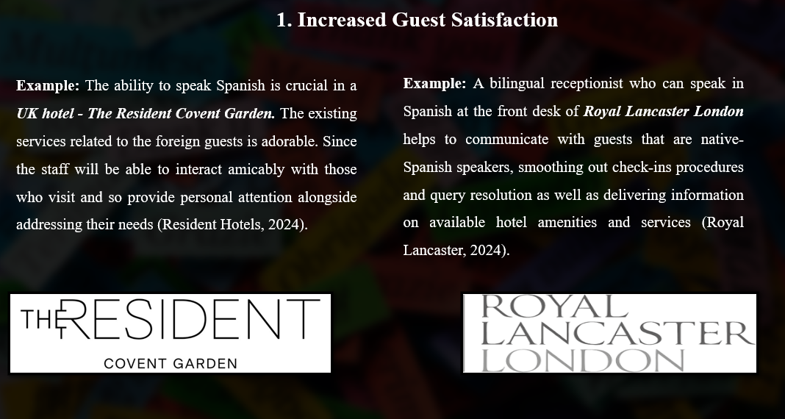
Example: The ability to speak Spanish is crucial in a UK hotel - The Resident Covent Garden. The existing services related to the foreign guests is adorable. Since the staff will be able to interact amicably with those who visit and so provide personal attention alongside addressing their needs (Resident Hotels, 2024).
Example: A bilingual receptionist who can speak in Spanish at the front desk of Royal Lancaster London helps to communicate with guests that are native-Spanish speakers, smoothing out check-ins procedures and query resolution as well as delivering information on available hotel amenities and services (Royal Lancaster, 2024).
Notes: Benefit: This practice makes the guests feel valued and respected, which generates their satisfaction at a higher level, resulting in possible commitment to providing them with services. Benefit: As clear and succinct communication removes the language barrier, guests are fully informed with accurate information hence precise assistance to them which improves their experience.
Enhanced Cultural Understanding
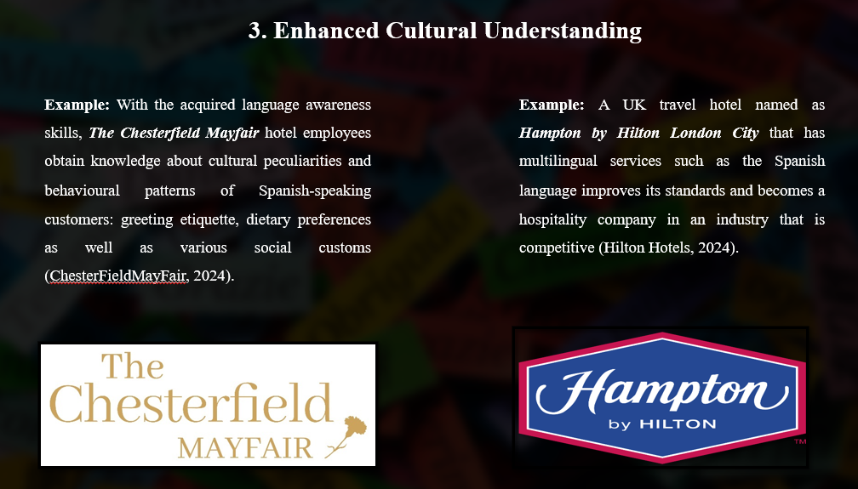
Example: With the acquired language awareness skills, The Chesterfield Mayfair hotel employees obtain knowledge about cultural peculiarities and behavioural patterns of Spanish-speaking customers: greeting etiquette, dietary preferences as well as various social customs (ChesterFieldMayFair, 2024).
Example: A UK travel hotel named as Hampton by Hilton London City that has multilingual services such as the Spanish language improves its standards and becomes a hospitality company in an industry that is competitive (Hilton Hotels, 2024).
Notes: Benefit: Through the knowledge and respect of cultural differences, staff members can adjust their conducts as well as services to be consistent with guest expectations which result in a friendly atmosphere where culture is still respected. Benefit: By portraying itself as a language-friendly establishment, the hotel appeals to an extensive range of clientele comprising Spanish speakers who want convenient lodging facilities.
Conclusion

Finally, multilingualism and language awareness have several benefits for hotel staff; this is demonstrated by Spanish competence within the UK-based hotel sector. Language skills are critical assets for hotel personnel that include improved guest satisfaction and communication, cultural understanding as well as competitive advantage to offer the best service while providing memorable experiences to guests from various linguistic backgrounds.
Notes: Using investment in language training and creation of an environment that is friendly to languages, hotels will be able position themselves as inclusive destinations for national tourists.
References
ChesterFieldMayFair, 2024. Home. Chester Field May Fai. Available at: https://chesterfieldmayfair.com/ Accessed on: 29 January 2024].
Hilton Hotels, 2024. Hiltons Hotels, Hampton London City. Available at: https://www.hilton.com/en/hotels/lonarhx-hampton-london-city/ Accessed on: 29 January 2024].
Resident Hotels, 2024. Home. Resident Hotels. Available at: https://www.residenthotels.com/covent-garden/ [Accessed on: 29 January 2024].
Royal Lancaster, 2024. About Us. Royal Lancaster. Available at: https://www.royallancaster.com/ Accessed on: 29 January 2024].
Ushakov, R.N., Kryukova, E.M., Khetagurova, V.S., Mukhomorova, I.V. and Zelenov, V.V., 2020. Efficiency of hotel management. Training of specialists in hotel industry field. Journal of Environmental Management & Tourism, 11(2 (42)), pp.388-395.

