Tristan Budenis (2428021)
Vigilant Trust & Asset Management | 2428021@student.uwtsd.ac.uk
Cybersecurity report

Table of Contents
Introduction 2
Modern Cyber Threats 2
Security Policies (Zero Trust Approach) 3
Zero Trust Architecture Model 4
Policy 1: Access Control 4
Policy 2: Patch Management 4
Policy 3: Data Protection 5
Policy 4: Device Management 5
Technical Mitigation Measures 5
SIEM Event Processing and Analysis Flow 6
Monitoring and Incident Response 7
Incident Response Lifecycle Flowchart 7
Security Training and Awareness 8
Phishing Attack Lifecycle and User Response Model 8
Conclusion 9

Introduction
Cyber threats targeting financial institutions have increased significantly, with a reported 238% rise in attacks [1]. Vigilant Trust & Asset Management has recently experienced security incidents, including a phishing campaign that bypassed email filters.
This report develops a Zero Trust-based [12] cybersecurity framework aligned with the NIST Cybersecurity Framework to strengthen organisational security and reduce the likelihood of future attacks.

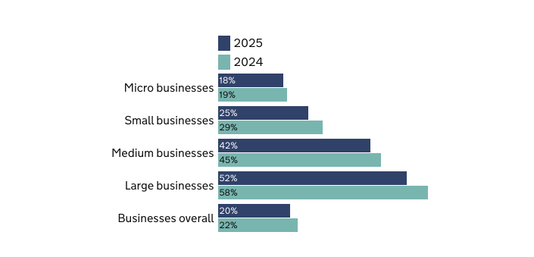
Figure 1 Percentage of businesses that have experienced any cybercrime in the last 12 months, over time [3]

Modern Cyber Threats
As of 2026, the cybersecurity landscape has shifted towards AI-enabled, multi-layered extortion techniques. Hybrid working has increased exposure to insecure home and public networks, while widespread cloud adoption creates attractive centralised targets for attackers [1]. This section outlines four key modern cyber threats.
Ransomware-as-a-Service (RaaS) involves ransomware developers licensing malicious tools to affiliates for a share of profits. These subscription-based platforms enable fewer technical attackers to deploy ransomware and extort organisations by encrypting data and demanding payment [2]. VTAM is a high-value target due to the sensitivity of its financial and client data. AI-driven phishing and vishing use email, phone calls, and synthetic media to impersonate trusted entities and obtain credentials or financial information.
Supply chain attacks target third-party providers to compromise downstream organisations. The 2023 MOVEit breach demonstrated how exploiting widely used software can lead to large-scale data exposure across multiple sectors [4]. Cloud misconfiguration occurs when storage or access controls are misconfigured, exposing sensitive data without direct exploitation. For VTAM, this poses a significant risk given its reliance on cloud-based systems for hybrid working and data storage.

Security Policies (Zero Trust Approach)
Zero Trust is an approach and a model in which ‘there is no inherent trust in the network’ [5]. For Vigilant Trust & Asset Management (VTAM), adopting a Zero Trust approach requires implementing strict security policies that enforce continuous verification, least-privilege access, and strong identity management. These policies align with the NIST Cybersecurity Framework, which is designed to reduce the likelihood of an organisation being attacked. This section will highlight 4 recommended policies that incorporate a Zero Trust approach and can be integrated with Vigilant Trust & Asset Management.

Zero Trust Architecture Model
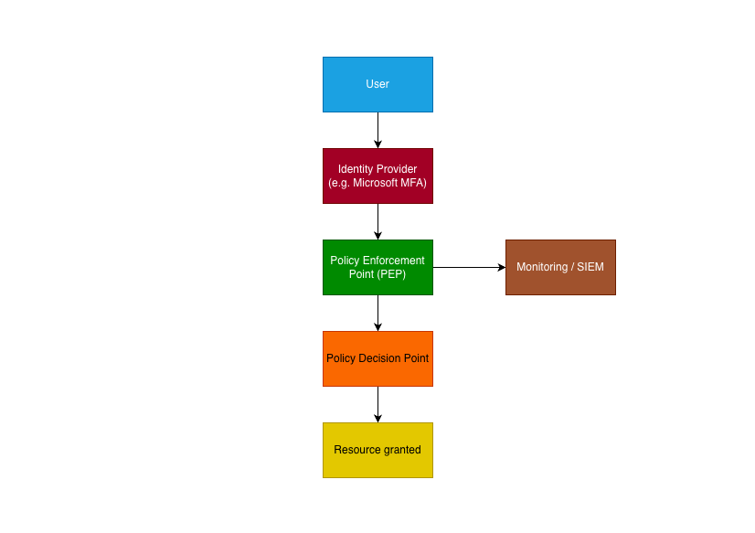
Figure 2 Demonstrates a Zero Trust Architecture where all access requests are continuously verified through identity validation, policy enforcement, and continuous real-time monitoring.

Policy 1: Access Control
Access control restricts user access to data, systems, and functions based on verified identity, preventing unauthorised access. To enforce this, Multi-Factor Authentication (MFA) will be required for all logins, significantly reducing the risk of account compromise [8].

Policy 2: Patch Management
Patch management ensures systems are regularly updated to remediate known vulnerabilities. Attackers often exploit unpatched systems across multiple organisations using repeatable methods. This policy implements automated patch deployment and prioritisation of critical vulnerabilities, reducing exposure to known threats.

Policy 3: Data Protection
Data protection ensures sensitive information remains secure during storage and transmission. This is critical for VTAM due to the financial sensitivity and high value of its data. The policy incorporates Advanced Encryption Standard (AES), a block cypher operating on 128-bit data blocks, standardised by NIST in 2001 [6]. This ensures consistent encryption across all organisational data.

Policy 4: Device Management
Device management ensures all organisational endpoints meet security standards. The rise of hybrid working increases exposure to insecure networks. Endpoint Detection and Response (EDR) tools continuously monitor devices to detect and prevent threats such as ransomware in real time [7]. Combined with regular compliance checks, this reduces endpoint vulnerability.
These policies collectively align with the NIST Cybersecurity Framework and support VTAM’s overall security posture.

Technical Mitigation Measures
Key technical controls are implemented to mitigate identified threats, aligned with the NIST Cybersecurity Framework (Identify, Protect, Detect, Respond, Recover) and Zero Trust principles, which assume no trust within or outside the network boundary.
Multi-Factor Authentication (MFA) limits credential-based attacks, particularly phishing and brute-force attempts, by requiring a secondary verification factor such as an authenticator application. At VTAM, MFA should be enforced across all remote access, cloud platforms, and privileged accounts, ensuring that compromised credentials alone are insufficient for access. This significantly reduces the likelihood of ransomware deployment through stolen authentication data.
To strengthen identity security further, Role-Based Access Control (RBAC) and the principle of least privilege should be enforced. This ensures users only have access to the systems and data required for their role, limiting lateral movement in the event of account compromise.
A Security Information and Event Management (SIEM) system supports real-time threat detection by compiling and analysing logs from end devices. At VTAM, the SIEM should correlate indicators such as unusual login patterns, escalation attempts, and repeated authentication failures. This enables early detection of compromise attempts and reduces the attacker's time within the network.

To complement detection capabilities, integration with a Security Orchestration, Automation and Response (SOAR) platform would enable automated containment actions, such as isolating affected endpoints or disabling compromised accounts, reducing response time and operational impact.
Additionally, EDR provides continuous endpoint monitoring and automated isolation of compromised devices to contain threats and prevent lateral movement. This is particularly effective against ransomware payload execution following phishing attacks.

SIEM Event Processing and Analysis Flow
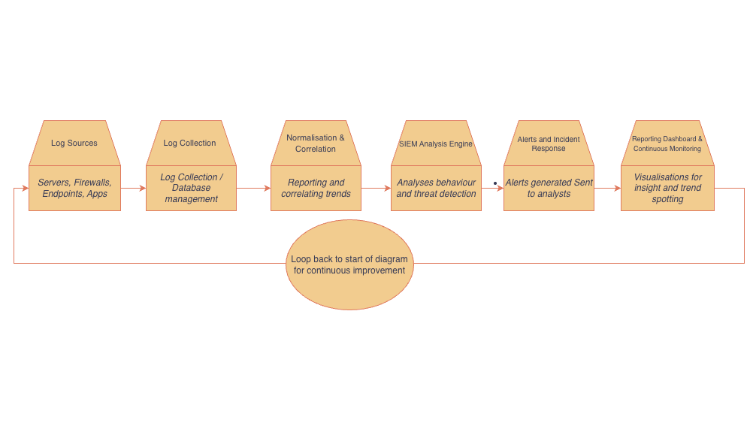
Figure 3 Visualises the SIEM process flow, where security event data is collected, normalised, and analysed to detect threats in real time, enabling rapid incident response and continuous security improvement.
Endpoint Detection and Response (EDR) provide continuous monitoring of endpoint devices to detect malware and ransomware activity. VTAM should implement behaviour-based detection, automated device isolation, and centralised monitoring to enable early containment and prevent lateral movement across the network.
Patch management is essential to reduce exposure to known vulnerabilities. VTAM should prioritise critical updates based on exploitability, particularly those listed in the CISA Known Exploited Vulnerabilities catalogue, while using automated patching and regular vulnerability scanning to maintain system security.
Finally, Cloud Security Posture Management (CSPM) ensures secure cloud configurations by identifying misconfigurations, excessive permissions, and exposed resources. For VTAM, CSPM should enforce secure baselines, monitor access controls, and provide continuous visibility across cloud environments, supporting the Zero Trust principle of continuous verification.

Monitoring and Incident Response
Constant monitoring and a structured incident response process are essential for detecting and mitigating cyber threats in real time [10]. This aligns with Zero Trust principles, which assume that compromise may already exist within the environment and therefore require continuous verification rather than implicit trust. Security monitoring is typically implemented through a Security Information and Event Management (SIEM) system. This enables real-time identification of anomalous or suspicious activity using rule-based and behavioural analysis.
When an incident is detected, a defined lifecycle is followed. This begins with detection, followed by triage to validate and assess severity. If confirmed, the incident moves to containment, isolating affected systems to prevent further impact. Eradication then removes the root cause, such as malware or compromised credentials, followed by recovery, where systems are restored securely. A final lessons learned stage reviews the incident to improve future controls and detection capability.
To enhance efficiency, organisations may deploy Security Orchestration, Automation and Response (SOAR) tools, which automate repetitive tasks, coordinate workflows, and accelerate incident response across integrated security systems.

Incident Response Lifecycle Flowchart
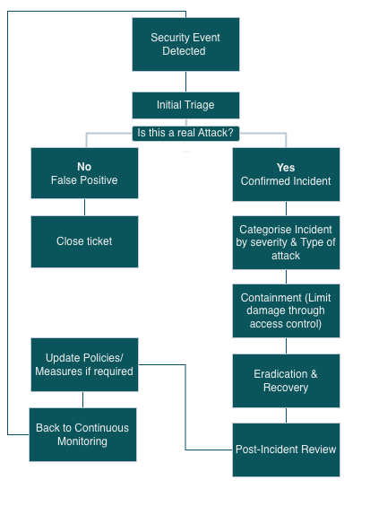
The figure 4 presents an incident response flowchart, illustrating how security events are assessed, classified, and handled through containment, eradication, and recovery, followed by continuous improvement of security controls.

Security Training and Awareness
Employees are frequently targeted through social engineering attacks such as phishing and vishing, making security awareness a key defence for VTAM. As noted, “Additional training and awareness emerged as the most common preventative measure adopted following a breach (32% of businesses and 38% of charities)” [3], highlighting its importance in reducing risk. The aim is to establish a security-conscious culture that limits human vulnerability to attack.
Training should include simulated scenarios such as phishing emails and fraudulent calls to improve detection and response. This is increasingly critical due to AI-generated content, which enables highly convincing emails and deepfake impersonation. Micro-training can reinforce secure behaviours, including handling sensitive data, recognising suspicious activity, and staying current with threats.
Role-based training ensures relevance, particularly for high-risk teams such as finance. A strong reporting culture should also be encouraged so employees can quickly escalate suspected incidents and reduce organisational impact.

Phishing Attack Lifecycle and User Response Model
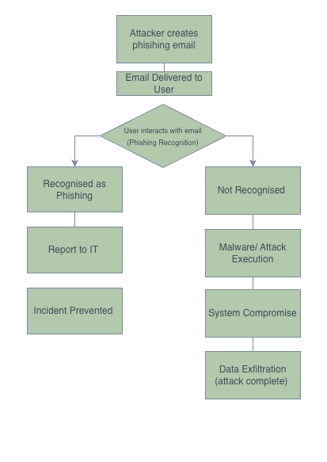
The figure 5 highlights the lifecycle of a phishing attack, highlighting how user awareness and training can interrupt the attack chain and prevent compromise.

To conclude, security training and awareness initiatives align with the recognised standards in ISO/IEC 27001. The standards emphasised in ISO/IEC 27001 promote continuous education and user-responsibility in human-based cyber-attacks. Auditors such as Certified Information Systems Auditor (CISA) offer ‘no cost online cybersecurity training on topics such as cloud security, ethical hacking and surveillance, risk management, malware analysis, and more.’ [11]

Conclusion
In conclusion, a Zero Trust security framework gives VTAM a robust, modern defence against cyber threats. Key policies include access control, patch management, and device security. Technical measures such as MFA, SIEM, and CSPM reduce the attack surface.
Consistent monitoring and a structured incident response process to help detect and manage threats. Regular security training further strengthens the human element to mitigate damage.
This strategy improves VTAM's capacity to recognise, detect, defend against, respond to, and recover from cyber threats in accordance with the NIST Cybersecurity Framework. Finally, these measures safeguard the organisation's brand, financial stability, and regulatory compliance while strengthening security resilience.

References
[1] E. Kost, “The 6 Biggest Cyber Threats for Financial Services in 2021 | UpGuard,” www.upguard.com, Jan. 30, 2022. Available: https://www.upguard.com/blog/biggest-cyber-threats-for-financial-services. [Accessed: Apr. 07, 2026]
[2] J. Holdsworth and M. Kosinski, “Ransomware as a service,” Ibm.com, Sep. 05, 2024. Available: https://www.ibm.com/think/topics/ransomware-as-a-service. [Accessed: Apr. 07, 2026]
[3] S. Rizvi, E. Fordham, Home Office, and Department for Science, Innovation & Technology, “Cyber security breaches survey 2025,” GOV.UK, 2025. Available: https://www.gov.uk/government/statistics/cyber-security-breaches-survey-2025/cyber-security-breaches-survey-2025#chapter-6-cyber-crime. [Accessed: Apr. 07, 2026]
[4] I. Arghire, “MOVEit Customers Urged to Patch Third Critical Vulnerability,” SecurityWeek, Jun. 19, 2023. Available: https://www.securityweek.com/moveit-customers-urged-to-patch-third-critical-vulnerability/. [Accessed: Apr. 07, 2026]
[5] National Cyber Security Centre, “Zero trust architecture design principles,” Ncsc.gov.uk, Jan. 28, 2026. Available: https://www.ncsc.gov.uk/collection/zero-trust/architecture-design-principles. [Accessed: Apr. 08, 2026]
[6] National Institute of Standards and Technology, K. Brown, P. Bond, and D. Evans, “Advanced Encryption Standard (AES),” Advanced Encryption Standard (AES), May 2023, doi: https://doi.org/10.6028/nist.fips.197-upd1
[7] IBM, “EDR,” Ibm.com, Jan. 10, 2022. Available: https://www.ibm.com/think/topics/edr. [Accessed: Apr. 14, 2026]
[8] Microsoft Security, “Multifactor Authentication (MFA) | Microsoft Security,” www.microsoft.com. Available: https://www.microsoft.com/en-gb/security/business/identity-access/microsoft-entra-mfa-multi-factor-authentication. [Accessed: Apr. 14, 2026]
[9] S. Sekharan and K. Kandasamy, “This full-text paper was peer-reviewed and accepted to be presented at the IEEE WiSPNET 2017 conference. Profiling SIEM Tools and Correlation Engines for Security Analytics,” Feb. 2018. Available: https://ieeexplore.ieee.org/document/8299855/references#references. [Accessed: Apr. 14, 2026]
[10] Corps Security, “Why CCTV Monitoring Services Are Essential for 24/7 Site Security,” Corps Monitoring, Sep. 14, 2025. Available: https://www.corpsmonitoring.co.uk/security-monitoring-blog/why-cctv-monitoring-services-are-essential-for-24-7-site-security/. [Accessed: Apr. 14, 2026]
[11] Certified Information Systems Auditor, “CISA Learning,” National Initiative for Cybersecurity Careers and Studies, Sep. 04, 2025. Available: https://niccs.cisa.gov/training/cisa-learning. [Accessed: Apr. 14, 2026]
[12] José Miguel Sánchez, “What is Zero Trust? Understanding the Security Architecture • Veridas,” Veridas, May 27, 2024. Available: https://veridas.com/en/what-is-zero-trust/. [Accessed: Apr. 21, 2026]

