A COMMUNITY PROFILE
ON LLANELLI
BY
SAMANTHA PLANT

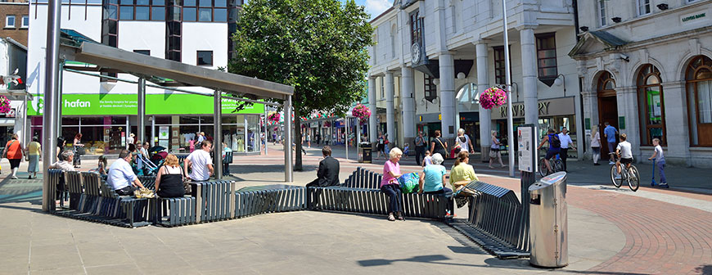
Griffiths (2019).

Llanelli town is located in the county of Carmarthenshire, with a population of 35,000 people (Llanelli Town Council, 2019). Llanelli is a large, rural, coastal town with past links to the tinplate, steel, and coal-mining industries and known for their dairy, sheep and beef farming. It is known for their famous Scarlet's rugby team. Llanelli has a local shopping area in the town centre; however, it also has a large shopping centre called Parc Trostre just outside the town centre. The retail park is based in the Trostre area of Llanelli, they have thirty-two shops and restaurants which include River Island, Primark, JD sports, Mc Donald's and Pizza Hut all great for the younger generation to meet up with friends and spend a day of shopping. Parc Trostre has a car park that holds two thousand vehicle spaces. The Parc brings over ninety thousand shoppers per week. This has a positive outcome for the town and more employment opportunity for the people of Llanelli (CompletelyRetail, No date). Trostre Parc is outside the centre of the town, this may be an issue for young people without transport however, in 2012 Llanelli expanded their town centre by five acres with a new leisure and tourist attraction called East Gate Llanelli with a hotel, restaurants and a cinema (East Gate Llanelli, 2014).
Population
Llanelli is the largest town within Carmarthenshire, it is situated on the coast in the south east of the region. It sits within the electoral region and National Assembly for Wales constituency area of Llanelli. This region has a population of 78,300 people. 19.2% of this population is aged 0-15 years old, 58.3% are working age, and 22.5% are retirement age (Members’ Research Service, 2010, p.3).
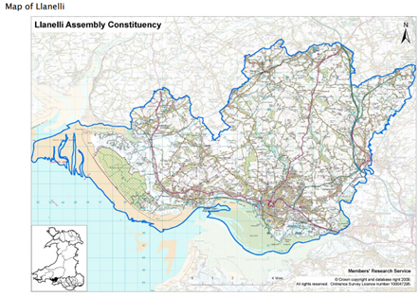
(National Assembly for Wales 2010).

Population Statistics
Mid-2007 | Llanelli District | Wales
Population | 78,300 | 2,980 000
Area | 235 km² | 20,742 km²
Population density | 333 per km² | 144 per km²
Male | 48.2% | 48.8%
Female | 51.8% | 51.2%
Aged 0-15 | 19.2% | 18.7%
Working age | 58.3% | 60.3%
Retirement age | 22.5% | 21.0%

2001 | Llanelli District | Wales
Single age 16+ (never married) | 24.7% | 28%
Living in communal establishment | 1% | 1.5%
Non-White Ethnic Group | 1% | 2.1%
Migrant | 10% | 11.2%

Education
2008/9 | Llanelli District | Wales
Highest qualification attained, (2007) % of working age
Level 4 and above | 21% | 27%
Level 3 | 21% | 20%
Level 2 | 23% | 21%
Below level 2 | 14% | 17%
No qualifications | 21% | 15%
Achievements in teacher assessments in each of the core subjects:
Level 2 at Key Stage 1 | 79% | 81.1%
Level 4 at Key Stage 2 | 75.7% | 77%
Level 5 at Key Stage 3 | 58.6% | 61.3%
GCSE Examination / equivalent achievements (% of 15 year olds)
5+ GCSE Grades A*-C | 58.9% | 60.6%
A*-C in each of the core subjects | 47.5% | 46%
Average wider points score | 377.1 | 378.8
Leaving full time education without a recognised qualification, 2008 (% of 15 year olds) | 1.5% | 1.5%
A Level Examination / equivalent achievements (% of entrants)
2+ A Level Grades A-E | 100% | 96%
Average wider points score | 793.5 | 687.7
Absence from maintained secondary schools (% of half-day sessions)
Unauthorised absence | 1% | 1.7%
All absence | 9.5% | 9%
Pupil teacher ratios
Primary schools | 18.9 | 20
Secondary schools | 17.5 | 16.4
Average class sizes (Number of pupils)
Key Stage 1 | 22.6 | 24.5
Key Stage 2 | 24 | 25
Mixed Key Stages 1 & 2 | 23.1 | 23
Key Stage 3 | 22.6 | 23.6
Secondary: Years 7-11 | 21.6 | 22.1
Secondary: Years 12-13 | 8.1 | 10.9
Pupils entitled to free school meals (% of compulsory school age pupils) | 20.1% | 17.8%

In 2007 a greater percentage of working age adults within the Llanelli area, at 21 %, were estimated to have no qualifications compared with Wales as whole at 15% (Members’ Research Service, 2010, p.5). Llanelli have a high percentage of working aged adults with no qualifications. A greater percentage of compulsory school age pupils were entitled to free school meals in the Llanelli area (20.1% compared with Wales as a whole at 17.8%) (Members’ Research Service, 2010, p.5). According British Youth Council, (no date) pupils are entitled to free school meals if they come from low income families such as claiming benefits and living in poverty. Unauthorised absences of half day sessions at maintained secondary schools were at 1 % within the Llanelli area, this is slightly less than Wales as a whole, which had 1.7% in 2007. However, Llanelli had a higher percentage of all absences at 9.5% with Wales at 9% (Members’ Research Service, 2010, p.5).

Due to the Covid 19 pandemic outbreak in March 2020, this had a massive impact on society including young people. Young people’s lives changed overnight all schools, colleges and universities closed. Pupils were provided with work online and expected to work from home, however, this would not work for everyone, some people need more support than others meaning one to one support and need things explained to them face to face. This was a very difficult time for young people. The pupils GCSE’s results will be predicted and according in 2020. Young people were allowed back to school in June 2020 however, a normal school day would hold a class of up to 20 pupils however to avoid transmission in school now have to reduce class sizes and have to stay 2 metres apart with no physical contact with any staff or other pupils. According to GOV UK (2020) it is important for pupils to go back into education for their well-being and academic development. Young people being out of school for months, being isolated from friends and family the feeling of loneliness may influence their mental health.

Employment
National Statistics Socio-economic Classification 2001 (age 16-74) | Llanelli District | Wales
Managerial and professional | 18.7% | 22%
Intermediate | 13.3% | 15.1%
Routine and Manual | 31.9% | 30%
Never worked and long-term unemployed | 4.4% | 3.8%
Not classifiable | 31.7% | 29.1%
Economic activity 2008
In employment | 68.6% | 70.7%
Economically inactive, excluding students | 23.1% | 20.5%
Average weekly earnings 2006- 08 | £468 | £470

Jobseeker's Allowance claimants, February 2010 | Llanelli District | Wales
Persons (of working age) | 4.7%
Males (of working age) | 7.1%
Females (of working age) | 2.1%
% of claimants
Aged 24 and under | 37%
Aged 25-49 | 49%
Aged 50+ | 14%
Duration of claim
Up to 6 months duration | 66%
6 to 12 months duration | 20%
Over 12 months duration | 14%
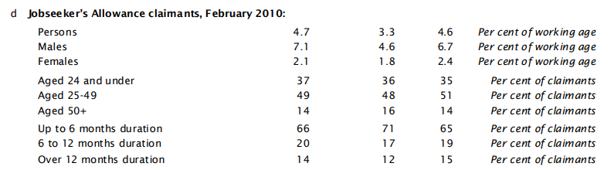
According to National Assembly for Wales Statistics (2010), 4.7% of the working age population of Llanelli are claiming Jobseekers Allowance, out of this 37% of young people are claiming Job seekers allowance, this is a large amount of the population unemployed and claiming benefits such as Jobseeker's Allowance. This percentage is likely to increase with the economic downturn and expected recession due to Covid-19 and according to TUC (2020) ‘Wales may be on the brink of a surge in youth unemployment’. This is due to young people (aged 25 and under) being three times more likely to work in the high-risk sectors of ‘accommodation and food’ and ‘arts, entertainment and recreation’. Areas in Llanelli such as Parc Trostre, Parc Pemberton and East Gate town centre developments are all dependent on these high-risk sectors, with food, retail, cinema and Ffwrnes theatre being the main employers.

Crime
Drug use is very much happening in Llanelli town, when I was on placement at Ysgol Rhydogos school in Carmarthen many of the young people would talk openly about drugs and how easy it is to get hold of drugs in Llanelli, this for me was concerning, they said how they have tried all sorts of different drugs. I asked the young people why they take drugs and they said there is nothing else to do. Hearing the young people speak like this about the place they live in was very sad. I felt there is a need for more facilities for the young people of Llanelli. These young people were at a young age of fifteen years old. I wanted to research this further, so I took it upon myself to read through many articles about the drug use in Llanelli and articles on county lines.
According to The Guardian (2019) Llanelli town is being targeted by gangs in the bigger cities such as Birmingham and Liverpool. The gang members are targeting vulnerable young people bringing them to Llanelli to sell class A drugs on their behalf. In 2019 Llanelli had the youngest drug trafficking incident in Wales as young as 14 years old (The Llanelli Herald, 2019). The gang members pay vulnerable young people and even provide a house for them to sell the drugs from, this may make the young people feel they need the gang members if they do not have housing accommodation. Reading all the different articles about County Lines it is clear to see there is need for more support for young people in Llanelli now more than ever, so they will not be drawn into this lifestyle and think it is acceptable.

Facilities
There are ten community halls within Llanelli, researching the halls further these halls provide classes and activities for the older generation such as knitting classes and dog behaviour classes however one hall provides a youth club during school term time every Friday. Llanelli have a leisure centre in the town centre. There is a public tennis court in the centre of Llanelli providing young people with outdoor activities. Llanelli has a rugby stadium in Trostre area and a skate park for young people.

Community action and initiatives
According to Fyfe (2019) providing more youth clubs in Llanelli will help build young people's resilience and reduce the influence of being drawn into drug gangs. The community have come together to provide funding for more youth clubs in the areas most affected by drug gangs.
Llanelli Community Partnership supports community led action looking at ‘The Llanelli We Want’. They are inclusive of young people in their aims and highlight the need to:
- ‘Find out the community’s needs. Talk to young people’
- ‘Ensure that the young people of Llanelli have a voice – and it is heard’
- ‘Develop young ambassadors for the future of Llanelli’
- ‘Social media is best way to promote to young people and families’
(Llanelli Community Partnership, 2014)
Llanelli Town Council have created a Community Activity and Development Work Programme 2020-21. It sets out goals based on the Well-being of Future Generations (Wales) Act 2015, looking at ‘ a prosperous Wales, a resilient Wales, a more equal Wales, a healthier Wales, a Wales of cohesive communities, a Wales of vibrant culture and thriving Welsh language and a globally responsible Wales (Future Generations Commissioner for Wales, 2020). The Community Activity and Development Work Programme focuses on young people in Llanelli by:
- ‘Providing opportunities to local young people to attend the Tall Ships Youth Trust Voyages’
- ‘Support the Unloved Youth Heritage programme funded by Cadw’
- ‘Support a number of community based projects e.g. Coedcae / Penrhos Summer school programme, People Speak Up, Llanelli Young Voices’
- ‘Facilitate the Meet the Mayor and Young Citizenship Project’
- ‘Officers to support Welsh Language Youth Club where appropriate’

(Llanelli Town Council, 2020)
According to Jones (2020) the Welsh Government have designed a Covid 19 Resilience Plan for young people, the plan includes organisations to work alongside young people supporting them and building their resilience after the impact of Covid 19 on their well-being and mental health.

Reference list
British Youth Council. (No date) Going hungry. Available at: https://cpag.org.uk/sites/default/files/Going%20Hungry%20young%20peoples%20experiences%20of%20Free%20School%20Meals.pdf (Accessed: 6 July 2020).
CompletelyRetail (No date) Parc Trostre Shopping Parc. Available at: https://completelyretail.co.uk/scheme/Parc-Trostre-Shopping-Park-Llanelli (Accessed: 2 July 2020).
East Gate Llanelli, (2014) Welcome to East Gate Llanelli/Croeso I East Gate Llanelli. Available at: https://eastgatellanelli.co.uk/about/ (Accessed: 2 July 2020).
Future Generations Commissioner for Wales (2020) Well-being of Future Generations (Wales) Act 2015. Available at: https://futuregenerations.wales/about-us/future-generations-act/ (Accessed: 7 July 2020)
Fyfe. E (2019) County lines drugs: Youth clubs 'key to tackling gang rise' Available at: https://www.bbc.co.uk/news/uk-wales-49635078 (Accessed: 2 July 2020).
Gov UK. (2020) Guidance for full opening: schools. Available at: https://www.gov.uk/government/publications/actions-for-schools-during-the-coronavirus-outbreak/guidance-for-full-opening-schools (Accessed: 4 July 2020).
Jones. G (2020) Welsh Government Publishes Covid 19 Resilience Plan for Post-16 Sector. Available at: http://www.llanellionline.news/welsh-government-publishes-its-covid-19-resilience-plan-for-the-post-16-sector/ (Accessed: 4 July 2020).
Llanelli Community Partnership (2014) The Llanelli We Want Report. Available at: http://www.llanellitowncouncil.gov.uk/assets/images/community%20support/Llanelli-We-Want-Report-Sept-2014.pdf (Accessed: 7 July 2020).
Llanelli Town Council (2020) Community Activity and Development Work Programme 2020-21. Available at: http://www.llanellitowncouncil.gov.uk/assets/documents/2020-21%20Work%20Programme.pdf (Accessed: 7 July 2020).
Llanelli Town Council (2019) About Llanelli. Available at: http://www.llanellitowncouncil.gov.uk/about-llanelli/ (Accessed: 6 July 2020).
Members’ Research Service (2010) Key Statistics for Llanelli. Available at: https://senedd.wales/NAfW%20Documents/10-034.pdf%20-%2014052010/10-034-English.pdf (Accessed 6 July 2020).
National Assembly for Wales, (2010) Key Statistics for Llanelli May 2010 https://senedd.wales/NAfW%20Documents/10-034.pdf%20-%2014052010/10-034-English.pdf (Accessed: 2 July 2020).
The guardian (2019) Llanelli hit by wave of 'county lines' drug gangs. Available at: https://www.theguardian.com/uk-news/2019/feb/15/llanelli-hit-by-wave-of-county-lines-drug-gangs (Accessed: 2 July 2020).
The Llanelli Herald (2019) Child victim of Drugs Trafficking Youngest in Wales. Available at: https://www.llanelliherald.com/42767/child-victim-drugs-trafficking-youngest-wales/ (Accessed: 2 July 2020).
TUC (2020) Wales is on brink of surge in Youth unemployment, warns Wales TUC. Available at: https://www.tuc.org.uk/news/wales-brink-surge-youth-unemployment-warns-wales-tuc (Accessed: 4 July 2020).

Picture Reference list
Griffiths C (2019) Welcome to Llanelli. Available at: http://www.llanellitowncouncil.gov.uk/ (Accessed: 24 June 2020).
National Assembly for Wales, (2010) Key Statistics for Llanelli May 2010 https://senedd.wales/NAfW%20Documents/10-034.pdf%20-%2014052010/10-034-English.pdf (Accessed: 2 July 2020).

