Word count: 1,864
Negligence in Construction

Prepared for:
Lara Hopkinson

Created by:
Lloyd wilson
2211509

Date completed:
27th November 2022

Contents
1. Contents 1
2. Introduction 1
3. Terms of reference 1
3.1 My principal focus will be 1
3.2 Procedure 2
4. Findings 2
5. References 7

Introduction

In this report I will be investigating negligence in construction, I’ll be describing tort of negligence and its essential elements that make up the law act. Choose a case law I will outline its importance to the construction industry and how it can impact progression of a project. I’ll be investigating a case study and outline the adjudication upon deciding such a dispute, I will also summarise my findings and how I can relate it to my personal experiences.

Terms of reference

3.1 My principal focus will be

- What is Tort of negligence

- Reporting on law in construction

- Describing my experiences relating to negligence and Law

- The report is due 2nd December 2022

3.2 Procedure

This section identifies the research sources used

- Refences will be from books and online sources

- Notes I’ve taken in class also provide background to my report

- Examples from my own experiences

Findings

  - To understand fully what tort of negligence is I must firstly touch upon what a tort in law means. It’s a civil wrong that causes damages or loss to the claimant, which results in the claimant seeking legal liability against the person who committed the tortious act. There are then different types of laws of tort, but looking at tort of negligence, in this definition: It’s in place to promote the concept of justice towards those who have been wronged by someone causing or admitting liability for there actions or lack of causing damage to the claimant. Its main purpose is to ensure that a person is compensated for a wrong between both parties involved, through a just and fair system. It’s aimed at being a remedy for civil wrongs committed and restore the victim to the same position they were before the act was committed. This process is done through the United Kingdom court system that covers cases within Wales, England and Northern Ireland, this example is shown in (Appendix 1). The tort of negligence is a civil wrong so will be dealt along the civil side of the system, most of the cases will be dealt at the county courts or tribunals depending on if it’s an appeal about land or tax. County courts are governed by a judge or district judge, the case doesn’t have to get to this stage as issues/disputes are settled outside of the courts by negotiation between the parties. Most companies and businesses would prefer to have the case to get to this stage as it can be detrimental to reputation of their businesses as the court room is open to the public to attend. In my personal experience I’ve had an accusation against my company but luckily it was sorted out between solicitors which didn’t end up in court. I work for a housing association called Ateb (landlord) where my previous role was a foreman in property maintenance, the tenant applied for a no win no fee type of case against us for negligence. This related to a condensation/damp issue at the property which Ateb were accused of not rectifying the issue. Ateb were in discussion with the claimant’s solicitor and provided evidential data of Ateb’s records of site visits and actions from the said visits. It was clearly proofed that backed that Ateb attended the property four times, on two occasions they visited there was no access and also had photo graphic evidence of no access cards being posted into the property. The other two times was because they were refused access as the tenant denied access as it was inconvenient at the time, this data was all recorded-on the company’s system and was used to defend the accusation against the Ateb as the landlord. The solicitor had no choice but to drop the accusation case, then suitable steps were made via the solicitor and tenant to resolve the issues in the property. So, looking at the elements that make up tort negligence did Ateb provide duty of care to my tenant? Yes Ateb do, as they must provide a home which is habitable to the standard set by Welsh housing quality standards (WHQS). Did Ateb breach that duty of care? No, operatives tried to gain access which was planned with the customer on set times/dates, even though they were denied access. Was there damage caused by the breach? Yes, but without reasonable allowance for Ateb to prevent possible accused damages and rectify said issues. The case was never taken to court as the there was insufficient evidence from the defendants to prove Ateb was being negligent in their landlord contract binding duty of care and no tortious breach in that agreement by the landlord occurred. You could argue that Ateb should of forced entry as they own the property, but this was reported by the tenant with no evidence of any said issues.

  - In construction it is vital to have legislation in place to prevent chaos in the workplace of the construction industry. Imagine not having rules in place to protect employers, public and employees to follow, they can act as protection against loss, damages, and work behaviours. It would be bedlam regarding safety and progression of all projects would be in doubt, as accidents and loss would be constant. Case law has helped to shape the construction industry with many cases being settled by judges in civil courts and sets a president for future similar cases. These judge ruling decisions of previous cases will affect civil disputes that arise in the construction industry, the case of Donoghue v Stevenson (1932) Set a precedent and legislation was changed by the “rule that you must love your neighbour became in law that you must not injure your neighbour”. This is important as it adds persons who are not directly involved but by association, cases like this helped shape the construction industry into a more conscientious industry in relation to behaviour and practises. Most projects in construction will be under contract agreements between the different parties for example the client and principal contractor. Contracts don’t have to be written they can also be verbal, but three requirements are needed to make it law abiding, these are: an agreement, contractual intention, and consideration. This is vitally important in progression of any project as deadline/timetables and finances are agreed within the contract. These obligations are made so if failure to keep the promises in the agreement they will become liable as they will breach the contract. I find by having these contracts its beneficial to performance manage contractors, so if there is trends where they are underperforming I can set new mini targets to get the overall project back on track. However, the law of tort is not about the said agreements/contracts between the parties, it is about a general obligation to abide the set laws. In the case of SSE Generation Ltd v Hochtief Solutions AG, (2018) this arose as a partial collapse of a tunnel occurred at the hydroelectric power station. It was accused that Hochtief where liable for the collapse of the tunnel as they were the ones contracted to build it. It was catastrophic for the power station as it had to be closed for a protracted period, it was extremely costly to fix. Under the contract they were obliged to do any remedial works within the defects period, it was disputed whether it was due to the construction or the design of the tunnel. The judges looked at several different previous cases to help decide who is liable for the damages (£107,617,830.94). In the end it was determined that, at handover it did not meet the 75 years life design as what was intended. Hochtief did not design and build it considering the erosion of rock and insufficient preventive measures were done in the construction of the tunnel. This case is important to find the right compensation for the cost of not just the repair works in this settlement, as the new contractors employed to rectify the tunnel to its proper state of function could also be paid for their rectifying works. Then also the money lost to the company through not being able to operate fully could be compensated to the state of what they would have earned without the incident occurring. This is fundamental in restoring the company books because if it was just the repair compensated for it could of potentially crippled SSE financially in lost income.

  - The case of Vinci Construction Ltd v Beumer Group Ltd (2018) was a case relating to the contractual duties of Vinci to design, manufacture, and supply of Gatwick airports baggage handling system. Vinci were subcontracted under an NEC3 engineering and construction subcontract in 2012, the works were in delayed in 2014. The parties’ disputes went through adjudication seven times concerning the issue of the extension of time breach of the contract and in the end Beumer was to pay just over 9.5 million pounds in compensation to Vinci. However, Beumer did not pay fine to Vinci, so Vinci proceeded with enforcement proceeding to gain the compensation money owed to them. Beumer then challenged the enforcement stating that the adjudicator did not have in mind natural justice when deciding upon the case. Beumer argued that firstly that the adjudicator adequate reasons, secondly the findings weren’t consistent with previous adjudications and lastly, they did not take in account that the adjudicator failed to order Vinci to disclose materials from a previous adjudication. The TCC which means the technology and construction court, is a subdivision of the kings (was queen at the time) bench division. It is part of the High court of justice, which is associated with the Crown court and court of appeal. They concluded with being in favour of Vinci stating that the adjudicator decision was not inconsistent with previous cases, because previous adjudications only dealt with monetary value of compensation events. The counter second point was squashed as the they stated that “no difficulty in discerning the adjudicator’s reasoning” and finally they felt that there was no reason for the adjudicator to look at the previous adjudication if not ordered to do so. The court found that there was no breach of natural justice, they did not view this lightly and scrutinised the argument that was made by Beumer. They were strict on the fact, backing the summary judgment system as they want to maintain its ongoing commitment of upholding adjudication decisions. This fair system doesn’t always mean the adjudicator has a typical standard of judgment or response but needs to be clear on the reasoning for why the decisions have been made. I do this in contract tender procurement for works tenders within my company Ateb, we are governed by law under the (Public Contracts Regulations 2015), scoring/scrutinising the company tendering for work. In this process I must be fair and consistent with each tender application by marking on only what I see in the documents provided, not considering other outside factors. This is vitally important when the decision can be challenged by one of the loosing applicants, so it shows clearly how scores were made. By making these decisions in court they can be up for scrutiny or challenged at times but having previous adjudications to reference and acts/laws as guidance overall there is a well-established forever evolving fair Judicial system in the United Kingdom.

References

Donoghue v Stevenson (26 May 1932) A.C. 562, [1932] UKHL 100, 1932 S.C. (H.L.) 31, 1932 S.L.T. 317, [1932] W.N. 139
Available at: https://uk.westlaw.com/Document/I99FC57C0E42711DA8FC2A0F0355337E9/View/FullText.html?navigationPath=Search%2Fv1%2Fresults%2Fnavigation%2Fi0ad62aef00000184b954b1b3a6af65e4%3Fppcid%3Da6a7371d9ca846db9ee0651175487094%26Nav%3DRESEARCH_COMBINED_WLUK%26fragmentIdentifier%3DI99FC57C0E42711DA8FC2A0F0355337E9%26parentRank%3D0%26startIndex%3D1%26contextData%3D%2528sc.Search%2529%26transitionType%3DSearchItem&listSource=Search&listPageSource=c836e743ecbff4824ce440dce1b3a319&list=RESEARCH_COMBINED_WLUK&rank=2&sessionScopeId=74ebf7bb0aaba58861ab75ddb0883c1ade4f80212d708b08b2da218fc5eb7de0&ppcid=a6a7371d9ca846db9ee0651175487094&originationContext=Search%20Result&transitionType=SearchItem&contextData=(sc.Search)&comp=wluk
Accessed: 27/11/2022

Law Reform (Contributory Negligence) Act 1945
available at: https://www.legislation.gov.uk/ukpga/Geo6/8-9/28
Accessed: 5/11/2022

The public Contracts Regulations 2015
Available at: https://www.legislation.gov.uk/uksi/2015/102/contents/made
Accessed: 27/11/2022

“SSE Generation Ltd v Hochtief Solutions AG (10 April 2018)” court of session (inner House, First Division) CSIH 26 2018 S.L.T. 579
Available at: https://uk.westlaw.com/Document/ID78477503CB511E8A241B7836D893FAB/View/FullText.html?transitionType=CaseAnalyticsItem&contextData=(sc.CaseAnalytics)&navId=E032C57262360441A3BBD92C02C14430&comp=wluk (source date 20/11/2022)

Appendix

1. Image of the UK court structure

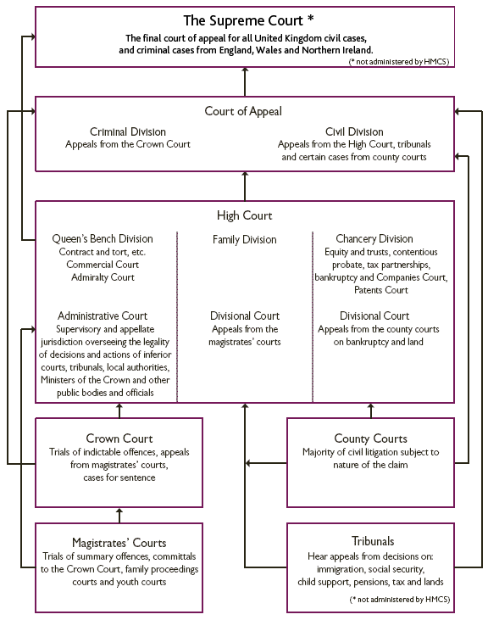
https://www.bing.com/images/search?view=detailV2&ccid=JR9sLx4k&id=491E44DDE116C43D7505C0696AC569BB35019639&thid=OIP.JR9sLx4kPn7FNSmYE73AZAHaJZ&mediaurl=https%3a%2f%2fth.bing.com%2fth%2fid%2fR.251f6c2f1e243e7ec535299813bdc064%3frik%3dOZYBNbtpxWppwA%26riu%3dhttp%253a%252f%252fwww.justcite.com%252fkb%252fwp-content%252fuploads%252f2014%252f02%252fUKcourt-structure.png%26ehk%3d6fGTUcaxoLCHecnt44XT%252f%252f%252fqDrR%252b4KORPqBlJVAycRI%253d%26risl%3d%26pid%3dImgRaw%26r%3d0&exph=731&expw=576&q=picture+of+judicial+court+structure+uk&simid=608019141735112564&FORM=IRPRST&ck=02E3B51366BE861390D7869D3D3B916D&selectedIndex=1&ajaxhist=0&ajaxserp=0
Accessed: 27/11/2022

