Research Article / Review Article / Communication / Editorial / Erratum
Analysis of Vulnerabilities in an Operational Technology
Hughes J.¹, Campbell C. E-A^{1*}, Thomas S.¹
¹Wales Institute of Science and Art, University of Wales Trinity Saint David, Swansea, UK
*carlene.campbell@uwtsd.ac.uk

Abstract
In recent years, threats and attacks on Industry involved operation technology systems, making manufacturing industry one of the most attacked industries. This paper investigates the cybersecurity issues that emerges from an increased modernization of industrial process through industry 4.0. In particular, this work focuses on the IT industry tools and techniques to improve the cyber security profile of an operational technology (OT) organization through a vulnerability assessment of its network.
The vulnerability assessment uses automated scanning tools within a grey box testing approach from Kali Linux distribution for the network mapping and finding vulnerabilities. Prior to the vulnerability assessment being performed, the appropriate testing methodology was selected in accordance with the amount of information available regarding the target system. The assessment was carried out in a grey box environment, which involves partial disclosure of the target infrastructure by the network administrator. This method is a compromise between the attributes of black box testing and white box testing which specific areas of the network are singled out for analysis but still gives an accurate reflection of an internal security assessment. The results of the assessment uncovered vulnerabilities and provided an indication of how an attacker might take advantage of this, as well as enumeration of the steps that must be taken to improve the security of a manufacturing organisation through the use of automated information gathering, vulnerability identification and assessment tools.
While there exists a large body of knowledge on the use of individual vulnerability assessment tools such as Nmap, Nikto and Wifite, there is limited evidence of their integrated use in a current brownfield Operational Technology environment comprising legacy industrial capability and Industry 4.0 technologies. The tools have also been featured on the Kali Linux distribution, which was used in the experiment Detailed, this work makes a practical contribution by adapting a known vulnerability assessment method in a real-world industrial production scenario, evaluating the practical security context of IT/OT integration and illustrating how the identified vulnerabilities can be quantified to enable remediation prioritisation in practice. In contrast to presenting additional scanning approaches, this work offers a transparent approach to quantifying cyber risk in a modern OT environment combining existing legacy assets with modern connected devices.

Keywords: Operational Technology (OT), Cybersecurity, Industry 4.0, Industrial Control Systems (ICS), Vulnerability Assessment (VA), Penetration Testing (PT)

INTRODUCTION

Cybersecurity relates to the technologies, processes and organisational practices used to defend systems, networks and data from cyber attacks. In the context of OT environments, it also covers physical process and industrial control systems including safety critical operations.

The prevalence of cyber security threats has grown significantly with the convergence of IT and OT systems, the innovation brought about through Industry 4.0 technologies and the increased exposure of operational environments outside the factory to external networks. Cyberattacks on OT systems can cause operational down time, safety incidents, financial loss and damage to reputation. As a result effective cyber security is a critical enabler of operational resilience and business continuity rather than just an IT technical issue.

The manufacturing sector has many barriers to industrial modernisation. One of these relates to the support of old infrastructure and the expense of replacing legacy systems with new ones. Digital technologies are much more sophisticated now and increased connection via the IoT, Industry 4.0 and other smart technologies, and machine to machine communication has meant significantly increased industrial efficiency is made possible through a greater interconnectedness of operations. This development has resulted in the emergence of the Industry 4.0 model, integrating digital and automated techniques to further improve manufacturing efficiency, quality and working conditions [1].

A vast increase in connectivity underpins the Industry 4.0 revolution, converging IT and OT systems which were once simple isolated programmable control systems such as PLCs, and Distributed Control Systems (DCS) now technological networks accessed remotely and powered by data. Increased digital connectivity has abolished the air gap previously prevalent within control systems, exposing OT to the same cybersecurity threats faced by any other IT system [2].

CYBERSECURITY & ITS SIGNIFICANCE TO MODERN SOCIETY
With the growing reliance on technology, security in cyberspace has been a growing concern. The extensive deployment of devices and systems in cyberspace has resulted in an ever-expanding flow of data. According to the statistic provided by the International Telecommunication Union (ITU) the United Nation's agency for information and Communication Technology [3], in 2022 there are a total of 5.3 billion (66%) active users (out of the world's population) on the internet, representing an increase of 24% increase from 2019.

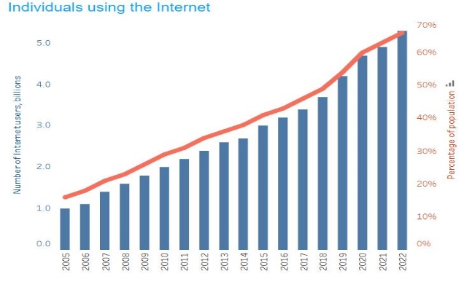
Figure 1 Internet usage statistics, adapted from [3]
Though the data does not include the special situation caused by Covid related lockdowns in the period, the data shows that the number is increasing over time consistently since 2005, when there were only one billion users and only 15% of the world population. The burgeoning of global connectivity emphasizes the prominent necessity of global cybersecurity. Figure 1 illustrates the growth of global internet users over time from 2005 to 2022.

Cybersecurity in Operational Technology Environments
In the journal 'The Importance of Cyber Security' written by the author Rajesh Goutam, demonstrates that the ever increasing reliance on technology is directly proportional to the increased levels of vulnerability to cyber-crimes and as a result this has made cybercrime an issue for every individual, and business or government. The journal lists some types of cybercrime including DoS attacks that aim to overwhelm a computer target by sending it more traffic than it can handle, or a number of different types of malware, trojans, worms, or viruses that infect a computer target [4].
Goutam describes cybersecurity as the way and tools to protect system infrastructure, software and data from hackers, terrorist groups, cybercriminals and other unauthorised users accessing and tampering them through internet to consume the weaknesses in security [4].
While it can be accepted that the first part of Goutam’s definition is more or less correct about the attack vectors, the second part about digital attacks through internet exposure ignores physical cyber-threats that can attack the system without going through a network, e.g. social engineering attacks.
The paper by authors Salahdine and Kabouch, entitled Social Engineering Attacks: A Survey, shows several examples of social engineering as weakening of the cybersecurity chain. Attacks resulting from human based social engineering such as pretexting, impersonation or tailgating allowing physical breach of a system, this pose a separate threat from exposure through the internet. Components of cybersecurity security such as firewalls, cryptography and anti-virus software are all susceptible to attack by this human element. In terms of social engineering, this human element is regarded as the weakest link in the cybersecurity chain [5].
According to the authors, even though social engineering can exist in many ways, they all have a common scheme for implementation which is carried out in four stages. The first stage is the reconnaissance of the target. Once sufficient information is collected, the second phase catches the target by creating a human liaison. The third phase runs the play/exploitation and the last phase exits the attack before getting detected [5].

Attack Vectors in Operational Technology

The 2023 Threat Intelligence report by IBM identified that 3 of the top 10 most attacked industries in the last year utilized OT based systems, with manufacturing emerging as the most attacked sector. Vulnerability exploitation was the most prevalent attack vector, representing 47% of all attacks. Phishing attacks ranked second (40%), with removable media (7%), stolen credentials (3%) and brute force (3%) following [6].

Other organizations that used OT were also frequently targeted and energy organizations was ranked fourth in the top 10 attacked industries. Once again vulnerability exploits and Phishing were the leading attack vectors and DDoS, remote access Trojan (RAT) and business email compromise (BEC) were being heavily used. Moving onto the seventh industry in the top 10 attacked industries, the transport industry, server access attacks, 'credentials harvesting', and RATs were most frequently attacks [6].

THE CONVERGENCE OF OT & IT SYSTEMS
In order to understand the effect of cyber threats to industry 4.0, the following research covers the emerging technologies that enabled the evolution of OT systems and its convergence with IT.

Traditional OT Systems
Industrial Control Systems are part of the OT environment. As it relates to security, the network architecture of ICS is characterized by the Purdue reference model, known as the Purdue Enterprise Reference Architecture (PERA). As shown in fig 2, the model splits the network into 6 levels, level 0,5, with a hierarchical flow of data between them following the structure depicted in Microsoft documentation [7].

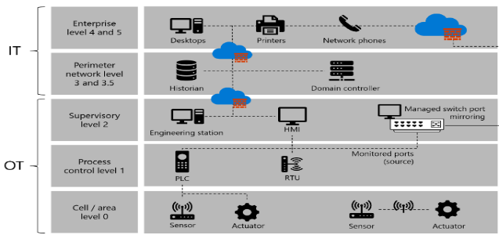
Figure 2 Purdue reference model, adapted from [7]

Figure 2 refers to the Purdue reference model, illustrating how operational technology environments are often mapped onto a hierarchical framework. By illustrating the differences between the enterprise systems (top) and the industrial control levels (bottom), this model underpins the significance of network segmentation (curbing lateral movement) in minimising cyber risk. However, in reality, operational obstacles and older legacy systems frequently lead to compromise of this segmented architecture, therefore giving advantages to cyberattacks.
The following is used to describe the PERA taken from [8]:
- Level 0 represents the physical nature of the system, the actuators, sensors, valves and motors involved in controlling mechanical systems.
- Level 1 assimilates the physical and cyber nature of the plant through the industrial computers, for example Programmable Logic Controllers (PLC), Remote Terminal Units (RTU), specialized industrial computers used for optimizing the cyber network to process data from robotic devices.
- Level 2 SCADA Supervisory Control and Data Acquisition (SCADA) overviews the industrial computers higher-level management and provides human interface over the processes of the plant in real time.
- Level 3/3.5 is structured into two sub levels, the 3,level itself is comprised of domain and software controllers used for production control, the 3.5 is the manufacturing operations management which incorporates data historians for storing data to enable enterprise level analysis.
- Level 4/5 is where the system integrates with the business with the enterprise itself, otherwise known as Business Planning and Logistics Domain
The Purdue model is an example of how to apply air-gap security controls to prevent cyber-attack on valuable OT equipment. This can be applied at any level of the hierarchy along with segmentation of the network and access controls [8]

Industrial Internet of Things
The Industrial Internet of Things (IIoT) is often used to describe the use of IoT technology in industrial settings. The publication by Zhen Ying et al. titled “An Overview of Computational Models for Industrial Internet of Things to Enhance Usability” discusses a number of upgrades to OT enabled by IIoT. For instance, enhanced effectiveness and decision-making can be achieved using instantaneous performance evaluation of tools and machines.
An example of which could be, detecting performance problems and correcting faults as soon as possible, thus pre-empting failure and minimising down time. Ying et al explain how the most ethical of business models could be created by optimizing resources by using data to reduce energy or material waste [9].
Zhi Li et al mention that additional computers can be placed near the data sources, to send the information to remote systems in the cloud in order to stabilize the IIoT scenario in the journal “Edge-to-Cloud IIoT for Condition Monitoring in Manufacturing Systems with Ubiquitous Smart Sensors” [10].
The industrial edge technology generated by the coming solution has forced the Purdue Reference Model to be questioned, whether data for a given hierarchical level mentioned in the PERA either can be sent to the cloud directly resulting in drastically threat to cyber security.

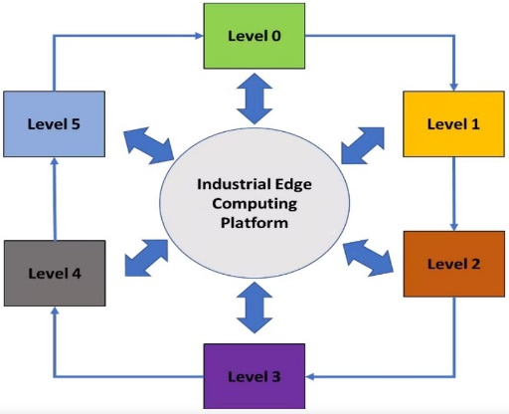
Figure 3 Industrial edge technology data flow, adapted from [11]

X. Jiang et al. identified the various security weaknesses of IoT nodes such as edge devices, sensors and actuators and SCADA systems that oversee their operation, are susceptible to multiple forms of cyber,attack. Here is a sample of these problems from the authors paper: "An Experimental Analysis of Security Vulnerabilities in Industrial IoT Devices" [12]:
- Wireless device encryption issues, can compromise data communications which can be intercepted and thus put the integrity of data at risk.
- Older devices that have been upgraded with sensors may find themselves obsolete in regards to security. This can lead to the inability for port security to be properly applied due to the use of the devices.
- Unpatched, known vulnerabilities can be present if the firmware isn't updated.
- Insecure default settings, possibly leading to easy-to-guess passwords and default users that might be vulnerable to brute force or other password related attacks.
- Services that are easy to compromise such as HTTP, TELNET and SSH.
- Human error that results in networks being exposed to malicious links & downloads and social engineering attacks that undermine the security of the network.

VULNERABILITY ASSESSMENT PROCESS
In contrast to existing literature that offers established procedures and tools for undertaking vulnerability assessment, these are more described as universal processes, suitable for use on both Information Technology (IT) as well as Operational Technology (OT), with less focus on real OT environments that have legacy IT systems as well as new Industry 4.0 capabilities. This study fills that gap by using existing vulnerability assessment procedures in a real OT environment and testing the findings on those vulnerabilities according to the context of industrial cybersecurity.
The work of authors Shah and Mehtre propose a four-step process to vulnerability assessments [13].
- Target Discovery - the initial stage of the vulnerability assessment process creates an image of the target infrastructure by estimating a topology based on the assets discovered, resulting in improved decision making.
- Scanning - With an estimated image of the network infrastructure, system scanning can be refined to a target area.
- Result Analysis - This step analyses the results based on their impact & severity.
- Reporting – This documents the entire process, including an executive summary, results & findings, risk assessment & recommendations.

VULNERABILITY ASSESSMENT TOOLS
The tools displayed below are those present on the version of Kali Linux distribution used for the experiment.

Wifite
Wifite is a python script that simplifies and automates the process of auditing Wi,Fi security. The attack on Wi,Fi networks encrypted with WEP, WPA, and WPA2,PSK encryption keys. It is compatible with most wireless network adapters, Wifite automates WEP cracking, WPA handshake capturing, password brute-force guessing, and attacks on WPS networks.

Nmap/Zenmap
In asset discovery, there are a number of completely automated utilities which can determine network topology. In Penetration Tester’s Open-Source Toolkit, author Jeremy Faircloth described Nmap as being used in Asset Discovery with many different methods. The author notes that a ping sweep will find any asset that is listening for ICMP messages by sending out echo requests over a group of IP’s within a subnet. Nmap then produces a list of hosts that are currently active to the user [2].

Nikto
Nikto is an open-source application that enables the user to perform various tests to identify vulnerabilities. It is claimed by the developers that it has a database which can detect in excess of 1250 server versions and specific issues relating to 250 types of servers in addition to checking for outdated software/ plug-ins, application misconfigurations and default files and directories [14].

Wifite was chosen to discover wireless networks and automate the capture of the 802.11 wireless encryption standards WEP, WPA and WPA2. Zenmap was then chosen to map the network by locating hosts, services and operating systems and showing the network topology graphically. Nikto was then used to scan the services that had been discovered for insecure software versions and known vulnerabilities. This sequence of tools enabled each phase of the vulnerability assessment to integrate further information gathered in the previous phase.

VULNERABILITY ASSESSMENT STAGES AND RESULTS

Approval
Preparation is the essential stage in the design of the vulnerability assessment; it involves gaining the official endorsement of the target organization in order to access the correct tools that will be used during the vulnerability assessment and to determine the parameters with which the vulnerability assessment will be conducted within. Once approval has been gained the process can proceed to the first stage.

Due to the sensitive nature of the network, access was limited to only the 172.21.0.0 network and only for non-destructive identification of vulnerabilities. No Security information was kept back from the networks administration, and all vulnerabilities were fed back to the customer in confidential business data.

Approach
The physical network infrastructure that was used during grey-box conditions remained in the university robotics laboratory, and target information was supplied by the network administrator as:
- Target SSID: CP-S-UniversityofWales-5GHz
- Subnet mask: 255.255.192.0.
- Gateway address: 172.21.0.200

According to the literature review, there is a degree of variation in the steps taken in a vulnerability assessment, with differing variations on the process being implemented by various information security organisations. In converting what had been learned from the literature into the needs of a target Operating Technology environment, a structured assessment was performed based upon target identification, scanning, analysis of results and reporting, with each stage relying on the successful completion of the previous stage, providing a repeatable process for performing the assessment.

Process
The procedure in figure 6 has been identified and implemented as follows to comply with the network condition:

Figure 6 Vulnerability assessment process

Target discovery - The following steps were performed:
- Physically investigate the infrastructure.
- Create an image of the network topology.
- Investigate the system information.

Scanning - Investigated the SSID and Wireless security. Wifite used to identify several WLANs. Using an automated process of copying packets and cracking the 802.11 wireless encryptions standards such as WEP, WPA and WPA2. As shown in Figure 7 the wireless adapter will discover a large number of WLANs in the UWTSD campus building and outputs the list numerically, which includes the target SSID CP-S-UniversityofWales-5GHz.

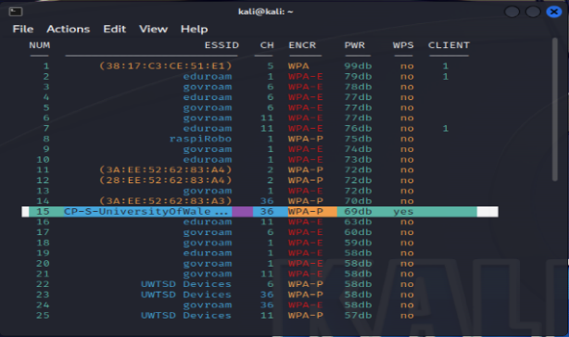
Figure 7, Wifite target selection

The Zenmap network scanner was chosen in order to locate open ports, services & operating systems using an intuitive, visual interface. This tool was used primarily due to the visual depiction of data, and because scanning options could be selected from drop down menus that would provide the appropriate Nmap command line. The information acquired using Zenmap was then fed into the Nikto scanner to probe the open ports for outdated versions of programs and incorrectly configured options, thus adding another layer of detail to the vulnerability scan

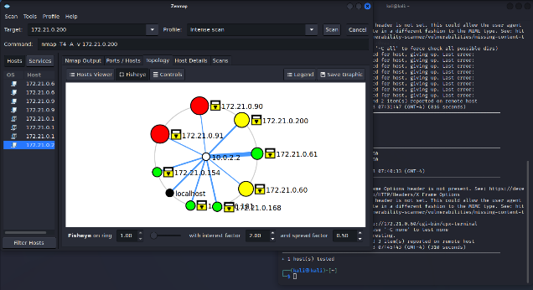
Figure 8, Zenmap router topology
Sequentially, the data gathered from the Zenmap scan, illustrated in figure 8 was used in conjunction with the Nikto http probe, to look for open ports with known vulnerabilities such as misconfiguration or insecure versions. This was done to provide a higher level of sophistication to the vulnerability identification process.

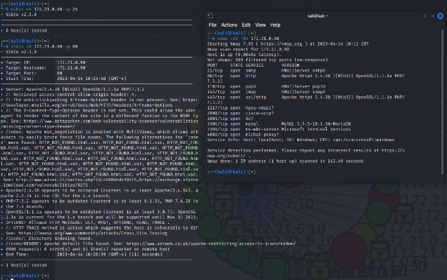
Figure 9, Nikto port scanning results

Result Analysis – Severity of the vulnerabilities discovered was assessed using the NVD (National Vulnerability Database) along with the CVE (Common Vulnerability Exposure) database.
The consolidated vulnerabilities were evaluated by means of the Common Vulnerability Scoring System (CVSS). Three of the found vulnerabilities had a CVSS value in the High Severity range, these were weak password security, wireless WPA2 encryption and the MyHelpDesk cross-site scripting vulnerability. Four vulnerabilities fell into the Common Vulnerability Scoring System Medium Severity range with a single High Severity finding. Despite the individual vulnerabilities being of generally moderate severity the total effect added multiple factors to an already vulnerable operational technology platform.
The most common vulnerabilities were identified from the result established from the scan, as shown in figure 9. The result identifies the percentage occurrences of the vulnerabilities, where Cross Site Scripting was the highest. Password encryption and mis configuration were also one of the most common vulnerabilities.
The analysis showed that the highest percentage of identified issues were web application vulnerabilities, with Cross Site Scripting (XSS) being the most prevalent type. The two following highest percentages of detected issues were related to exploitable passwords and weak encryption algorithms; this suggests that the issue of authentication & access control is a significant security consideration for converged OT environments. The final three category of security issues (such as legacy software, exposed services and default configurations) were however primarily with respect to legacy equipment being used in combination with Industry 4.0 technologies.
Severity analysis was conducted using the Common Vulnerability Scoring System (CVSS) where published scores could be retrieved from the National Vulnerability Database. Three vulnerabilities; Weak wireless authentication, WPA2 encryption and the MyHelpDesk Cross Site Scripting vulnerability were therefore shown to be of High severity on the CVSS scale (≥7.5). Of the other discovered vulnerabilities, the majority were of a Medium severity while there was only one Low severity issue. This suggests that the combined effect of the multiple Medium to Low vulnerabilities would considerably increase the attack surface of the network, even if one individual device wasn't a critical weakness.
The evidence gathered during this assessment aligns well with the literature study conducted earlier in this report, finding exploitation of known vulnerabilities as the most popular attack method used on manufacturing organisations. The discovered presence of outdated software and unsecure configuration and web application deficiencies reinforces earlier research demonstrating that legacy systems and poor patching practices remain prominent Cyber security concerns for Operational Technology systems.

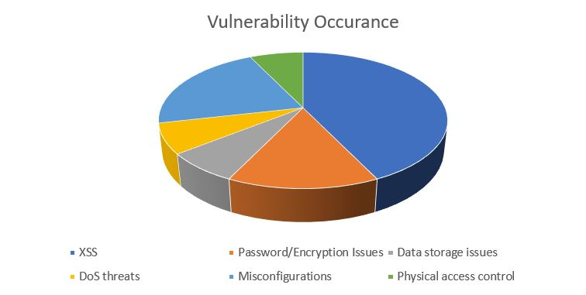
Figure 10 Most common vulnerabilities

Reporting – The final report of vulnerability assessment. It involved details of software used, steps taken & results of the scans. It also provides an executive summary which offers an overview of the assessment's objective, results & recommendations.
The findings suggest a high incidence of vulnerabilities within legacy platforms, systems running outdated versions and with known exposure. Several of those classified as compromising the system was noted, with these vulnerabilities appearing on a large number of hosts, indicating the increased risk to security that these threats pose through the incremented risk of compromised systems in IT/OT convergence. The recurrence of configuration related deficiencies, unsupported software and web application flaws increases the likelihood of initial compromise and lateral Movement through connected Industrial Network architectures.
This seems to be in line with the typical challenges faced by OT security items, with availability and longevity generally being far more important than green security updates.
These issues are, therefore, evidence of some of the systemic vulnerabilities present in industrial environments, especially when coupled with the excessive connectivity now inherent in many of these systems. The compromise of such security flaws could allow an attacker to access, interfere with or even bring down the system services. This underpins the importance of a risk-based approach to vulnerability management within an OT context rather than a straight implementation of an IT-centric model.
The research shows that vulnerabilities of OT environments are typically not just a technical matter but are generally embedded in architectural design, legacy dependency, and operational focus. The integration of digital is to enhance operational efficiency but at the same time the pathways for cyber-attack are created and need to be addressed by coordinated technical, organisational and people controls. This reaffirms the need for cybersecurity strategy that are specifically designed for OT environments as opposed to traditional IT oriented security technology.

CONCLUSION
This paper explored the weaknesses of an operational technology domain and the cyber security issues resulting from transportation of processes toward automation and the reliance on legacy systems. It is evident that digitalization result in improved operational performance, an expanded attack surface and, consequently, more entry points for cyber-attackers.
The results highlight some important lessons that one can draw from an academic viewpoint, namely the importance of a comprehensive holistic OT approach (encompassing technical controls, network segmentation, ongoing monitoring, and human capability development). From a practical perspective, the results reaffirm the need to adopt a practical approach to OT cybersecurity.
Future work should also focus on predictive detection methods, better vulnerability handling specific to the limitations of OT, and the importance of skills development in enhancing OT cyber resiliency.

ACKNOWLEDGMENT
This research was supported by the University of Wales Trinity St David, The School of Applied Computing and the department of Innovation and Engagement.

CONFLICT OF INTERESTS
The authors confirm that there is no conflict of interest associated with this publication.

REFERENCES
- M. Nardo, D. Forino, and T. Murino, ‘The evolution of man–machine interaction: the role of human in Industry 4.0 paradigm’, Prod. Manuf. Res., vol. 8, no. 1, pp. 20–34, Dec. 2020, doi: 10.1080/21693277.2020.1737592.
- G. Murray, M. N. Johnstone, and C. Valli, ‘The convergence of IT and OT in critical infrastructure’, Aust. Inf. Secur. Manag. Conf., 2017, doi: 10.4225/75/5A84F7B595B4E.
- ‘Statistics’, ITU. https://www.itu.int:443/en/ITU-D/Statistics/Pages/stat/default.aspx (accessed Jan 04, 2026).
- R. K. Goutam, ‘Importance of Cyber Security’, Int. J. Comput. Appl., vol. 111, no. 7.
- F. Salahdine and N. Kaabouch, ‘Social Engineering Attacks: A Survey’, Future Internet, vol. 11, no. 4, Art. no. 4, Apr. 2019, doi: 10.3390/fi11040089.
- IBM, ‘IBM Security X-Force Threat Intelligence Index’, 2023. https://www.ibm.com/reports/threat-intelligence (accessed Jan. 04, 2026).
- batamig, ‘Understand your OT network architecture - Microsoft Defender for IoT’. https://learn.microsoft.com/en-us/azure/defender-for-iot/organizations/best-practices/understand-network-architecture (accessed Jan. 04, 2026).
- H. Boyes, B. Hallaq, J. Cunningham, and T. Watson, ‘The industrial internet of things (IIoT): An analysis framework’, Comput. Ind., vol. 101, pp. 1–12, Oct. 2018, doi: 10.1016/j.compind.2018.04.015.
- Z. Ying et al., ‘An Overview of Computational Models for Industrial Internet of Things to Enhance Usability’, Complexity, vol. 2021, p. e5554685, Aug. 2021, doi: 10.1155/2021/5554685.
- Z. Li, F. Fei, and G. Zhang, ‘Edge-to-Cloud IIoT for Condition Monitoring in Manufacturing Systems with Ubiquitous Smart Sensors’, Sensors, vol. 22, no. 15, Art. no. 15, Jan. 2022, doi: 10.3390/s22155901.
- D. Greenfield, ‘Is the Purdue Model Still Relevant?’, Automation World, May 12, 2020. https://www.automationworld.com/factory/iiot/article/21132891/is-the-purdue-model-still-relevant (accessed Jan. 04, 2026).
- X. Jiang, M. Lora, and S. Chattopadhyay, ‘An Experimental Analysis of Security Vulnerabilities in Industrial IoT Devices’, ACM Trans. Internet Technol., vol. 20, no. 2, pp. 1–24, May 2020, doi: 10.1145/3379542.
- S. Shah and B. M. Mehtre, ‘An overview of vulnerability assessment and penetration testing techniques’, J. Comput. Virol. Hacking Tech., vol. 11, no. 1, pp. 27–49, Feb. 2015, doi: 10.1007/s11416-014-0231-x.
- ‘Nikto2 | CIRT.net’. https://cirt.net/Nikto2 (accessed Jan. 04, 2026).

