 APPENDIX GA36d

LEVEL 7 ASSESSMENT SPECIFICATION
Student name: | Lee, Tak Man Anna Lisa | Student ID number: | 2124401
Programme: | DBA
Module: | Qualitative Research Methods
Module code: | HKBM7003 | Contribution to Overall Module Assessment (%): | 100%
Lecturer: | Dr. Tamara Savelyeva | Internal Verifier:
Assignment Title: | Research Article | Word count (or equivalent): | 8,178 words
Submission deadline: | 31st October, 2022 | Return date of provisional marks & written feedback:

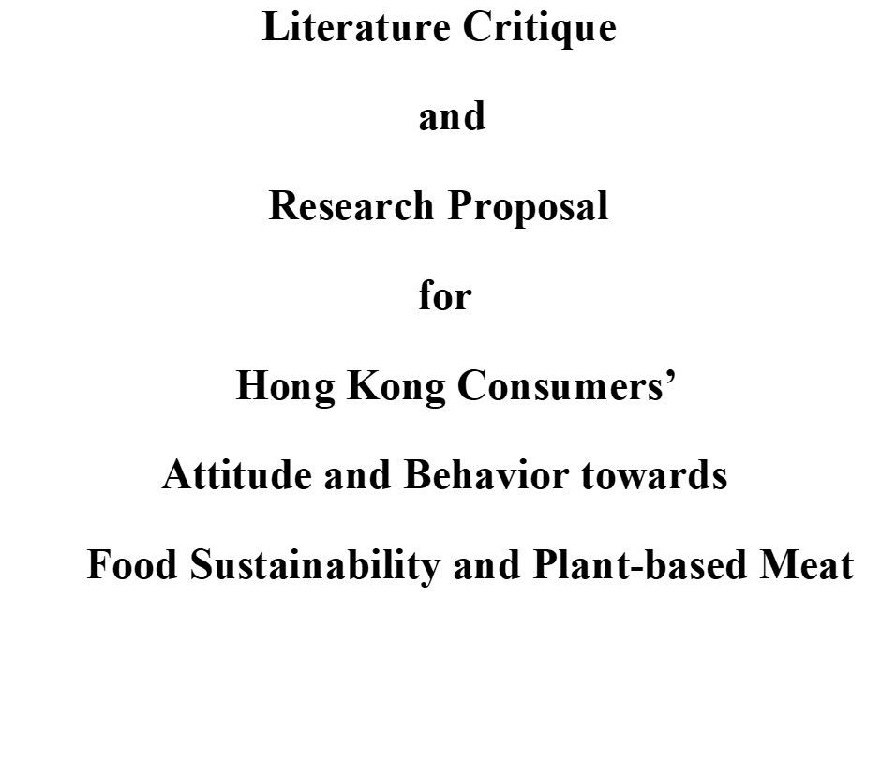

Table of Contents

List of Tables and Figures

1. Overall Abstract

Food sustainability is a challenging issue facing many world leaders of today and they have to look for solutions to feed the world with a healthy and sustainable food system (Berry et al., 2015). The major threats come from climate change that brings impacts to crop yields and livestock agriculture, political instability causing breakage of food supply chain, and the outbreak of epidemic diseases also brings devastating effect on food security. Humans have long been indicted to be the primary culprits for destroying environment by releasing excessive greenhouse gas that gave rise to disasters such as droughts and floods, followed by species extinction and biodiversity loss (Garnett, 2013). The rise of meat-alternatives becomes the “life-saving straw” to reduce utilization of resources and farm land for planting crops to feed livestock for meat (Gastaldello et al., 2022; Lusk et al., 2022), and also easing the stress of demand for irrigating water (Zhai, Y. et al., 2022). Consuming meat-alternative diets becomes a sensible and humane solution to eliminate the degree of impactss induced by food insecurity and unsustainability.

Hong Kong is a prosperous city and Hongkongers are not in the state to feel anxious about inadequate supply of food; however, the food unsustainability problems had already triggered the world alarm. The food sustainability issue is significantly prominent to Hongkongers, since Hong Kong’s food supply is over 90% imported, mainly from China. China’s food self-sufficiency rate had a direct impact on Hong Kong’s food security. The world population climbs drastically, and by 2050, it will reach nine billion people and there will be insufficient food to feed all (Chan, 2016). Awareness should be activated to start considering how the world can produce enough food to feed everyone. Scientists have been working in full strength to innovate meat substitutes by simulating the texture, flavour and aroma of conventional meat. The invention of meat-alternatives can be traced back in history, especially for plant-based meat; whereas cultured meat is a novel technological product growing in bioreactors. Besides these two common alternatives, there are also algae-based and insect-based meat (van der Weele, C. et al., 2019), from which proteins can be transited.

Eating greens in Hong Kong is not a contemporary issue as the city has a religious culture and culinary heritage of Buddhism and vegetarianism, but Hong Kong’s meat-alternative industry is not functioning in full swing, as Chinese people believes that the main source of nutrition come from meat. Despite the warnings from United Nation, Hong Kong people’s meat consumption rate is on rise, proportionately eating more meat than the rest of the world. There is an imperative need to raise their awareness and alert of the insecure food system, and they have the responsibilities to maintain a sustainable system by making efficient use of natural resources to protect the environment. Due to the urgency to address the problems with remedial solutions, the current researcher intended to conduct a qualitative study by using a grounded theory approach to establish a theory and look for the knowledge gap which was not discovered in previous researches.

Grounded theory is a research approach driven by data obtained directly from the field. Basing on inductive reasoning, patterns of paradigm appear and a new theory can be constructed from the grounded data. The theory can be used to explain about the attitude and behaviour of Hong Kong consumers towards meat-alternatives, especially plant-based meat in this study, so marketers can use these findings and apply the theory to form their promotion messages. The researcher will adopt theoretical sampling method as the main strategy to recruit participants for collecting data in focus group interviews, but will use the purposive and probability sampling technique to recruit participants for the first interview before theoretical categories occur. The reason for combining purposive and probability sampling is due to the necessity to recruit participants who are 18 years of age and older, who can make independent decisions for purchasing plant-based meat. During the first round of analysis, the researcher has to frequently step back and ask questions about the data collected, to see if they fit with the researcher’s own idea. When more information is needed for clarifying the puzzles, theoretical sampling will come into place by inviting more participants to join in extra rounds of focus groups for the clarification and refinement of questions emerging from the theoretical categories. Comparing data across groups will place disparities and complexities into analyses, any secondary data retrieved from reviewed literatures or from researcher’s personal experiences can be examined and checked against the data collected. The process will help to examine the correctness or biases of the researcher’s early assumptions to decide if more information is needed, or the researcher has to alter her original idea. The theoretical sampling process will continue until data saturates and a factual conclusion is approached. If necessary, the researcher will further conduct one-on-one interviews with experts to acquire more in-depth insights. The researcher will construct a new theory – a theory that will be emerged in the process and was grounded in the data.
A pilot test will be executed for evaluating the data collection and analyses processes before a full-scale study will take place, for testing the research’s feasibility and the appropriateness of sample size. Pre-defined and open-ended questions will be asked during the semi-structured focus group interviews at the pilot run and major study, interviewees can freely express their opinions but guided by the questions when formulating their thoughts and ideas. Analyses of data will be done immediately after each session by open coding, memo-writing, themes-generating, thematic coding and categorizing.
By basing on the researcher’s assumptions and experiential knowledge, a new theory will be constructed and will be called the “Theory of Purposive and Motivational Consumption Behaviour”, which is adapted from the Theory of Reasoned Action by Ajzen and Fishbein. Complemented by Edward Tolman’s Purposive Behaviourism Theory, and Dean Pruitt and Peter Carnevale’s Dual Concern Theory, the researcher is able to explain in a more comprehensive manner about Hong Kong consumers’ attitude and behaviour towards plant-based meat. This anticipated new motivational behaviour will be further interpreted by borrowing the concept of Maslow’s Hierarchy of Need and reconstruct a new three-level model by the name “Hierarchy of Needs for Food Sustainability”.

Key words:
Plant-based meat, grounded theory, theoretical sampling, focus group interviews, Theory of Purposive and Motivational Consumption Behaviour, Hierarchy of Needs for Food Sustainability

2. Evaluation of a Research Article

For the purpose to enhance critical thinking skills and exceling to a level of higher cognitive mindset, the current researcher will critique on a qualitative research article to gain more understanding about the social conditions of meat-alternatives in the context of Brazil. The chosen paper has to meet certain criteria and standards proposed by Forchuk and Roberts (2016). The selected topic should be suitable for qualitative inquiry, the methodology adopted fit with the topic, and the research method stayed consistent throughout the paper. The paradigm of research must be clear and participants involved in the in-depth interview should be well-introduced. Data collection and analyses of findings should be conducted by adopting appropriate methods. Conclusion must be sound and the research should show significance. An article was chosen from the Food Policy journal for the critique. It was published by Elsevier BV, with an overall ranking of 1332 and a SCImago Journal Rank (SJR) of 1.926. The full citation of the research article is as follow:

“Morais-da-Silva, R. L. et al. (2022) ‘The social impacts of a transition from conventional to cultivated and plant-based meats: Evidence from Brazil’. Food Policy 111 (2022) 102337. Online. Available: The social impacts of a transition from conventional to cultivated and plant-based meats: Evidence from Brazil | Elsevier Enhanced Reader “

The reason for choosing this specific literature is due to its empirical research nature that the conclusions will be derived from concrete and valid evidences revealed by the participants of research. Among the four philosophical assumptions of ontology, epistemology, axiology and methodology, the authors undertook the epistemological assumption to collect subjective evidence from participants, basing on their individual views in the conventional meat and meat-alternatives fields. The authors tended to shorten the distances between researchers and the participants being studied, they held one-on-one in-depth interviews with field experts, and relied on their quotes for evidence assembling. Among various interpretive frameworks, Morais-da-Silva et al.’s study was linked to social constructivism. Research participants provided complex viewpoints about the meat industries, and reality is discovered by answering the open-ended questions. Reality is shaped according to interviewees’ individual experiences and personal background, then interpretation of findings can be co-structured through various ways of knowledge understanding (Creswell and Poth, 2012).
The article is interested to be conducted in Brazil, its adaptation and acceptance level of meat-alternatives would be distinctly different to that of Hong Kong. Hong Kong is the city where the current researcher will propose to do a study on. These two places vary greatly in their self-sufficiency rate of food – Hong Kong imports over 90% of its food (AFCD, 2022), whereas Brazil is one of the world leaders in meat productions with highest food security rate among the BRICS , accounting for over 50% of the global food supplies (Ren et al., 2020). Brazil is having a high self-sufficiency rate, not only able to feed its own population adequately, but capable to earn foreign exchange by exporting overseas, mainly to China and Hong Kong (Silva, 2019; Nogueira, 2021). With these diversities, it is interesting to study about their differences from contrary angles. The current researcher will also adopt a qualitative research method to conduct a study as Morais-da-Silva et al. This methodology can help the researcher getting hold of the thoughts, experiences and feelings of interviewed participants, for understanding how and why certain behaviors would occur (Austin, 2015). Qualitative research is a mindset, and researchers made it grow (Savelyeva, 2022).

2.1 Summary of the Critique Article
The research of Morais-da-Silva et al. (2022) aimed to explore the social impacts that would be accentuated in Brazil during the country’s transitional process from conventional meat to meat-alternatives. The authors conducted an empirical study by collecting data via semi-structured in-depth interview with 35 experts related to the field of food production; consequently, nine opportunities and five challenges were identified. The study of social impacts is significant since social implications was scarcely studied and had never been explored under current contexts. The authors explained the meaning of “transition” for their specific study – “by reducing the proportion of conventional meat consumption and increasing the share of alternative-protein’s intake, there will be potential changes in worldwide meat productions and variations in consumption chains”. In view of the research gap, Morais-da-Silva et al. (2022) established the research question of “What would the social impacts be if there is a transition from conventional meat to cultivated and plant-based meat?” By considering the suggestions from Gerhardt et al. (2020), the authors assumed that by 2040, the world meat market will be proportionated by 40% of real meat, 35% of cultured meat and 25% of plant-based meat. The authors introduced various kinds of conventional meat and meat-alternatives, but more focus was put on cultured meat and plant-based meat. Relative problems such as environmental disruption, animal welfare and human health issues were discussed in the study.
Morais-da-Silva et al. adopted the qualitative research strategy of in-depth interviews for their exploratory study. The study was grounded on the Theory of Social Impact, and the research is dominated by social constructivism to reveal multiple evidences of opportunities and challenges during the process of transition from conventional meat to meat-alternatives. The authors clearly explained the reason of why expert participants were invited for the research, it was due to the reason little information was available publicly in Brazil, so they intended to obtain primary insight about this innovative market of alternative-meat. Most participants were invited at a field conference meeting and further recruitment was done by snowball sampling. The authors set up interviews by following the semi-structured interview guide to ask open-ended questions regarding participants’ perception about Brazil’s future conventional meat and meat-alternative industries, in order to find out how Brazil would react to the transition of meat diets, for the purpose to identify social opportunities and challenges.
The authors adopted the Content Analysis approach by first transcribing the interview data, familiarities were identified in the transcript, and then these data were coded by ATLAS.ti for generating first-order concepts and second-order themes to aggregate two categories of nine social opportunities and five social challenges. The authors discussed about the generated results and uncovered the new opportunities for agricultural producers, including new jobs would be created for workers at different educational levels, meat-alternative technologies would raise workers’ educational qualifications, average salaries would be increased as the gap between rural and urban workers would be narrowed, working conditions would be improved by comparing factories with slaughter houses, increasing entrepreneurial opportunities for meat-alternative ingredients, poor people may gain easier access to proteins, healthiness would be improved, and animal welfare would be benefited. Regarding social challenges, the reduction of conventional meat demand would bring assault to real meat producers, unemployment rate would increase in the real meat sector, livestock workers’ low educational qualification needed long to be advanced, price of meat-alternatives was high and not affordable by general public, and Brazilians might find hard to accept meat alternatives as Brazil is a cultural “barbecue country”.
The research findings emphasized the importance of joint effort by all stakeholders, especially by the Brazilian government. The authors proposed the concept of “stakeholder engagement” for addressing the challenges of social impacts, the more Brazilians engage with meat-alternatives, the higher the chances for achieving the opportunities. The authors concluded that cultured meat and plant-based meat showed differences in perceived opportunities and challenges, but they are both playing a role in changing the world’s conventional meat supply chain. Changes in food system might bring both positive and negative social impacts, but will be different at dissimilar locations; therefore, the authors suggested that future studies should be conducted at other geographical contexts and a quantitative research approach can be adopted for obtaining closed-system perspectives. Moreover, animal benefits might seem to be enhanced when meat-alternatives came into focus, but more studies have to be conducted since animals are still involved in the cultivated-meat production.

2.2 Literature Critique
The title of research was clear to show the purpose and intention of the study. In the abstract, purpose, significance of study, research design, methodology adopted, findings, conclusion and recommendations for future studies were all briefly described. The research problems regarding social impacts were stated explicitly, and the research question was clearly defined with the research problem building in. The study adopted a Content Analysis approach for analyses of findings, therefore the use of ATLAS.ti for analyzing the complex and unstructured textual data was appropriate. The overall research design fulfilled the basic requirement of data collection, data measurement and analyses of findings. Critically speaking, the evidences obtained in the research were not generalized enough to address the research problem, since the selection of samples were choice-based and were chosen purposively. Their provided answers exhibited only the attributes and choice behavior favorable to their predetermined positions in the meat-alternative industry.

Choice of Sampling
The critique falls on the choice of samples for in-depth interviews. The authors adopted a choice-based sampling technique with intention to recruit field experts for the study and interview them on one-on-one basis. The authors and 50 experts attended a conference meeting organized by the Brazilian Federal Government’s Ministry of Agriculture, Livestock and Supply. The experts became targets for recruitment, and invitation letters were sent right after the meeting. With help of snowball sampling, 35 experts were recruited. The authors listed out all participants with titles and organizations they were in, but the current researcher discovered that among all 35 participants, 17 of them were from the meat-alternatives industry or related. The current researcher relisted their job titles, types of organization and sectors they were from in Table 2, whereas the other participants were listed in Table 3. By looking at the combination of participants, there is a possibility that the interviewees from the related meat-alternative industries tended to provide opinions which were advantageous and in favor of their belonged industry or government sector. For instance, the participants claimed that “there are health problems in conventional meat, so meat-alternatives may be healthier”, but the current researcher does not totally agree with this opinion, since there are numerous analytical reports and studies indicating that meat-alternatives are in lack of certain nutrients which are not equivalent to real meat, and intensive processing will lead to nutrient loss (Fraeye et al., 2020; van Vliet et al., 2021; Kolodziejczak et al., 2022). As a result, these contradictive views required further studies to examine the nutritional facts about conventional meat and meat-alternatives. On the other hand, the current researcher agreed with Morais-da-Silva et al. that “engagement of stakeholders seemed crucial” in section 5.3.1 of their paper. Recruitment of interviewees should be in a wider scope to cover more stakeholders from broader dimensions with diversified perspectives, especially farmers and rangers of both crop and animal agriculture, conventional meat marketers, meat-alternatives marketers; and most importantly, should include consumers. Social opportunities should belong to all stakeholders and they should all be embrace the social challenges.

Table 1 List of Interviewers related to the meat-alternative business. Information was retrieved from the study of Morais-da-Silva et al. (2022) and the table was reconstructed by the current researcher.

Table 2 List of other experts participated in the in-depth interviews. Information was retrieved from the study of Morais-da-Silva et al. (2022), and the table was reconstructed by the current researcher.

Sample Size
A sample with 35 experts in size is enough to collect insights from the meat and related industries, but too large a size might induce saturation of data. Normally, the common themes will be identified after 10 to 15 interviews, information will start to repeat after that. Sample size is partially determined by the scientific paradigm under which the study is taken place and the size is contextual (Boddy, 2016)

Social Impact, social opportunities and social challenges
For the key domain of “social impact”, Morais-da-Silva et al. did try to give an explicit explanation of the terminology by citing the quotations of seven past researchers. For instance, the quotation of Dietz (1987) stated that “social impact is recognized as improvement or deteriorations in the welfare of people”. Tello (2020) indicated that “social impact can be sensed by individual person, family units, social groups, or the whole society, direct or indirect impacts of changes may be felt”. Morais-da-Silva et al. further cited that “social impact can be assessed on a continuum ranging from positive to negative, passing through neutrality in the center” (Barrow, 2010) but “social impacts are difficult to be assessed since there are no direct causal relationships” (Vanclay, 2002). Actually, the authors did not instrumentally assess social impacts in their study and even the term “social impacts” was seldomly mentioned throughout their research. The current researcher had gone through literatures to search for more comprehensible explanation of “social impact” and some definitions brought greater inspirations: “social impacts are positive changes that people intentionally make to create a better world for all living beings” (The Impactful, 2022), and “social impact is how the community is affected by actions of organizations” (Woodson, 2013). Furthermore, the authors did not explain the meanings of “social opportunities” and “social challenges” within the realm of their research, and these terminologies were even not included in the list of keywords, but they occupied almost the whole Chapter 5 for interpretation. The current researcher started to search for better descriptions of social opportunities and social challenges, in order to find out more about how they would create social impacts. Zahra et al. (2008) explained that social opportunity is a vague concept, as it involves economic and non-economic aims, and if conceptualizations become global, definitions are more complex. Nevertheless, in order to make the term more explicit, Zahra et al. tried to break the barriers of understanding, the authors suggested to “look at opportunities through the lens of behavioral theory within the social realm”. For social challenges, Morais-da-Silva et al.’s study did not make clear of the standpoints of what their challenges meant to be and why they use the term “social challenges” instead of just “challenges”. The current researcher reviewed numerous past literatures and not be able to obtain a precise explanation of the terminology, but discovered that they came in different types when related to meat-alternatives, such as “sustainability challenges of animal agricultural” (Newton and Blaustein-Rejto, 2021), “social challenges change meat-alternatives into practical business products” (Post et al., 2020) and the like. On the web, there were different definitions about “social challenges”, but most of them related to psychological challenges that people experienced in society, such as people having problems to interact socially or to behave in common social behaviors, and very often the term was linked with emotional and behavioral challenges; therefore, if more precise and concise terminologies were used or explained in Morais-da-Silva et al.’s study, it would make the research paper more comprehensible.

Topic Title and Sub-titles for Discussions
The title of the paper did provide the basic idea and purpose of the research, but it gives readers a misconception at first glance that “meat” has been transited successfully from conventional to cultured or plant-based meat. In the Chapter of Introduction, Morais-da-Silva et al. defined the meaning of “transition” as “a potential change in worldwide meat-manufacturing and consumption chains, while the proportion of conventional meat reduces, there is a significant increase in the share of alternative meat”. As readers understand, the term “transition” simply means “the process of change from one state to another”. The authors highlighted the forecast studies of Gerhardt et al. (2020), Morach et al. (2021) and Tubb and Seba (2021) to determine the meat consumption dispersion at 2040 to be 35% of cultured meat, 25% of plant-based meat, and 45% of conventional meat. Obviously, the transition passage was not completed to change from one state to another by 2040; therefore, the term “transition” in the title brought misconception. Consumers’ acceptance and adaptation of meat-alternatives is not yet ascertained. Lee et al. (2020) expected that “meat-alternatives will maintain a complementary relationship with real meat”.

The subtitles of paragraphs were also not clearly written so they brought contrasting meanings when social opportunities and social challenges were discussed in different sections. The subtitles were listed in Table 1. The subtitles for sections 5.1.1 and 5.2.1 were well-set, as they reflected the cause-and-effect relationship between opportunities bringing growth to agricultural producers and challenges bringing decrease in demand to real meat producers. For sections 5.1.2 and 5.2.2, if the titles were made more explicit by stating what subjects were new job opportunities for, and which social class would be affected by unemployment, the titles would become more logical. In this case, the authors meant new job opportunities for people with higher technological qualifications for the invention of man-made meat and lower qualification jobs such as packaging, distributing and marketing will emerge for the novel products. But in reality, manpower for packaging and distributing was already existed in conventional meat industry and they are not new posts created for man-made meat. There was a confusing phrase in section 5.1.2: “bringing job opportunities to people with low and high qualifications are expected, mainly in the fields of agronomy, biotechnology, food engineering and chemical engineering”. It’s a known fact that schools of agronomy, engineering and biotechnology required people with higher educational qualification to be enrolled in, so the word “lower” should not be phrased in the same sentence ended with a full-stop. The authors explained later that “lower” applied to jobs such as packaging and distributing, but the phrase had already confused readers.

Table 1 Subtitles about social opportunities and social challenges. Titles are directly retrieved from the study of Morais-da-Silva et al., and the table is constructed by current researcher.

For section 5.1.7 “Access to proteins”, the authors mainly interpret the phenomena of poverty in Brazil that gave rise to starvation, and Brazilians were not capable to purchase meat-alternatives since price parity between man-made meat and real-meat was high. The authors use the title of “Access to proteins” was not to the point. Accessing to proteins is long-existed as “protein sources from plant and animals are abundant and they were available in different forms (Berkheiser and Brown, 2022). If the authors rename the title as “Access to alternative proteins”, the whole section would become more meaningful. Disparate meanings and usage of terminologies will bring misinterpretations.

At the end of discussion about opportunities and challenges, the authors did not summarize the findings, and jumped directly to implications and contributions. If a summary is entailed, the interpretation of results will be more structured and systematic.

Contribution to Previous Literature
The authors emphasized that they had made “contribution to previous literature” since social impacts were not studied by previous researchers, and only one paper was found discussing social and economic issues. If the sub-title is to be rewritten as “contribution to literature”, that will be more meaningful.

Conclusion of the Critique
Morais-da-Silva et al. followed the ethical issues in social study research and the University’s ethics committee had granted them approval to conduct their study in a quality way, without showing misrepresentation on data collected. The authors had made detailed description of new knowledge obtained from research and had also made numerous suggestions for future studies in multiple aspects. Their study can be concluded as: knowledge acquired was confirmable, since recurrent patterning was found with consistency, so knowledge could be transferred over dissimilar settings with credibility for validity, and dependability for acceptance by external auditors.

3. Research Proposal

A research proposal is going to be conducted according to the topic introduced in the long abstract, for the purpose to convince the relevance of the research’s originality and significance, and to show the strong academic base of the research. Approaches and methodologies will be carefully planned and structured, and the adoption of tools and instruments are rigorously considered, to confirm that the research is feasible and worth working on.

3.1. Introduction and Background Overview

Insecurity and unsustainability of the food system are bringing alarm to world leaders for being aware of the instability of global food supply chain. Agriculture of conventional meat is accused of being the major culprit to bringing environmental disruptions by emitting greenhouse gas, thus causing climate change and increasing droughts and floods, leading to extinction of animal species and biodiversity loss. Furthermore, 77% of total agriculture land were occupied for livestock farming but only producing 17% of total food. Eighty percent of water is wasted and polluted for farm-animal rearing, and large amount of antibiotics was also used for curing farm animal disease thus bringing health concerns to humans as antibiotic resistance rate is driven up. Green food lovers have been actively promoting the belief to eat less meat for loving our planet, and taking up plant-based diets were perceived as a responsible and humane solution to eliminate the menace of food unsustainability. Hong Kong is a small city of having only seven million in population, but Hongkongers consume most meat in the world. Although 90% of food is imported, Hongkongers are living in heck and manger, the affluent supply of food does not make them aware and realize of the threats approaching. Food insecurity and unsustainability may also be caused by social, economic and political unrest, and impacts can be enormous.

3.2 Research Objective

The research’s major objective is to investigate whether Hong Kong consumers will be willing to undertake a dietary change from conventional meat to plant-based meat if they were aware that the current world food system is insecure and unsustainable. Researched studies had confirmed that Hongkongers eat most meat in the world but live longest life, this sarcasm might reflect that Hong Kong people will not feel the necessity to switch from pro-meat diets to vegetarian or vegan diets. For the sake to protect the environment from destruction of climate change, what will be the motivators for encouraging Hongkongers to give up their established attitudes and eating habits?

3.2.1 Problem Statement

For a prosperous city like Hong Kong, Hongkongers are not at all be aware of the food sustainability problems uprising in the rest of the world. Hong Kong consumers’ attitude towards plant-based meat is the greatest challenge for marketers to launch the new products in Hong Kong and tactics are needed for enhancing consumer acceptance. Arousing consumers’ awareness is the initial step, and moving them to love the planet and mankind is the second step marketing plant-based meat. Previous researches focused mainly on the practicality of meat alternatives’ marketing techniques, aimed to find out where the target group is, how old they are, how much they made, and finalized that some consumers will be willing to pay an extra premium for meat-alternatives, but the underlying reasons leading to consumers’ willingness to pay a price that is two to three times more are not discussed thoroughly. Moreover, researches conducted at different countries had identified different demographic groups of customers who were willing to transform to plant-based diets, but what made the differences and what were their innate motivations, reasons were not disclosed. Cultural, social, psychological and economic factors play major roles in formulating consumers’ decision-making process, but they were not thoroughly studied around the world, especially not by Hong Kong researchers. Basing on these reasons, the current researcher intended to do an exploratory study to discover the problematic unknowns in the context of Hong Kong. A preliminary literature review had been conducted and the summary is exhibited in Appendix 1. The review showed that most studies were conducted deductively by adopting the quantitative research method, so the current researcher believed that by using an inductive qualitative approach is suitable for the current study to gain more experiential insights from participants. Three research questions were established for guiding the research process in focus.

3.2.2 Research Questions

Question 1:
How do Hong Kong people perceive food sustainability problems?

Question 2:
What are the determinants affecting Hong Kong people’s consuming intention and purchasing behavior of plant-based meat and why?
Question 3:
Will Hong Kong people’s awareness of food sustainability affect their humanistic love for environment thus motivating them to purchase plant-based meat?

3.3 Qualitative Insight and Significance of Study

Gathering qualitative insights from interviews can serve as a powerful tool to collect non-numerical in-depth data for understanding problems or generating novel ideas for research. For the current research, by asking the “why and how” questions about consumers’ decision-making process, qualitative insights can be gathered for revealing Hong Kong consumers’ purchasing motivation behind their perceptions, opinions, and expectations towards plant-based meat. Further supplemented by reviewing and reflecting on the preliminary literatures and anecdotal evidences studied, a knowledge gap would be discovered in the domain of Hong Kong people’s awareness about the food sustainability problem and what remedies can be undertaken for reducing the degree of impacts. There might be many reasons leading to their awakening or their attitudes would remain unchanged, these factors are what the researcher is interested in exploring for understanding the nuances of Hong Kong people’s thoughts. By adopting focus group interviews and grounded theory approach, a new theory is expected to be emerged during the process, assuming that Hong Kong people might be awakened by their psychological anticipation to maintain a sustainable food system for the well-being of environment, human health and animal welfare.

3.4 Research Epistemology and Philosophical Assumptions

Among the well-defined inquiry fields of epistemology, ontology, philosophy and methodology, epistemology allows researchers to inquire the questions of “what” they want to know about the originality, extent and certainty of propositional knowledge that they are interested in, complemented with personal beliefs and knowledge of researchers, the strategic approach of “how” would fit into the investigation of new knowledge (Locke, 2010). The process starts by asking reflexive questions, and reflexivity helps to establish research questions for provoking awareness and creating paradigms to explain and answer the inquiries. For the present research, the qualitative paradigm set assumptions by using concepts, theories and models to assist in shaping the investigative framework, and then incorporated with research methodologies to listen and observe closely at participants’ words, actions and body languages to discover the recurring patterns of their experiences. This process forms the philosophic underpinning of the qualitative research approach.

With the epistemological assumption, the current research paradigm showed characteristics of social constructivism and interpretivism. The researcher tended to gain a better understanding of Hong Kong on how it is going to address food unsustainability, aim to develop subjective meanings about consumers’ behavior if they realize the essentiality of reducing meat consumption, especially in the context of Hong Kong that food shortage is not the city’s concern. Participants’ backgrounds and historical experiences formulated their beliefs and opinions, thus shaping their own interpretations about their perceptions towards plant-based meat dieting. The inductive process of data collection in the field by visiting participants in their context helps researchers to generate meanings for developing a theory (Creswell & Creswell, 2018; Crotty, 1998), a theory that is able to explain about the missing parts of the phenomena that were not identified by past researchers.

3.5 Review of Literatures

For conducting qualitative research on the chosen topic, the researcher as the inquirer, will review existing literature for identifying gaps in the fields of food sustainability and plant-based meat, and will rework the study on different geographical setting and different people; however, with an approach grounded to learn and obtain knowledge from participants of focus groups, literatures would not be used to set the platform for the research (Creswell and Creswell, 2018). There were arguments regarding the appropriate timing for doing literature review in qualitative research, most researchers claimed that literature review should be done before data collection, so the fundamental grounds of research problems could be identified. This rationale was commonly found in quantitative studies. Conversely, researchers such as Frankel and Devers (2000), they claimed that “literature review at initial stage would block the inquirer’s true listening, observant and receptiveness to new concepts, knowledge and ideas”. The researcher agreed with the standpoints of Frankel and Devers, so the thorough literature review will be done after the findings are analyzed, for the objective to look for alternatives or reassuring views from past researchers for refinement of conclusion. At the early stage, the researcher will collect anecdotal evidences about the topic from online texts, digital evidences from videos, books, newspapers and magazines. A preliminary literature review will only be done on the key aspects of plant-based meat to gain better understanding of the product.

3.6 Theory Application in Qualitative Research

Adoption of theory in qualitative study is both complex and controversial (Bradbury-Jones, Taylor and Herber, 2014). Dissimilar with quantitative research, theories proposed the causal relationship among variables; but in qualitative study, theories can serve two purposes – they serve as the lens for inquiries or a new theory may be generated during the research by use of the grounded theory approach (Creswell and Creswell, 2018). The current research broadly explains the goal-directed behavior of Hong Kong people towards consumption of plant-based meat by use of theories and models. By applying a theoretical orienting lens, the scope of inquiry will be broadened by not only shaping the questions asked, but also informing the data collection and analyzing methods. These perspectives provide guidelines on what issues are essential to be examined and why they have to be studied. The current research will adapt the Theory of Reasoned Action (Ajzen, 2015) for grounding the research base. The belief of Purposive Behaviorism Theory of Edward Tolman (MacCorquodale and Meehl, 1954) will be used to explain consumers’ intended change in consumption behavior resulted from their cognitive perceptions towards protecting the environment. A purposive and goal-directed behavior will be formed by consuming more green food for the purpose to loving the Earth; however, consumers’ mentalistic transformation in consumption behavior had the possibility be conflicted by the consciousness of their double concerns. In the case of diet intake, consumers might eat according to their own interest, or they enact to eat by concerning others as there is a social norm of protecting the environment. Consequently, the Dual Concern Theory by Dena Pruitt and Peter Carnevale will also be applied to explain the conflicted consideration processes of consumers when they consider buying plant-based meat (Jang and Cho, 2022).

3.7 Research Design
The current research will adopt an exploratory approach to reveal hidden insights about the unknown knowledge of Hong Kong people’s awareness of food sustainability problems, to investigate how they will react with solving solutions, or they will just have the problems ignored. A qualitative research strategy of semi-structured focus group interviews will be adopted together with a methodological approach of grounded theory. Interested areas of exploration will be centered around environmental impact, nutritional health concern, animal welfare concern, effect of subjective norm and price of plant-based meat.

3.7.1 Research Methodology: Grounded Theory Approach

The grounded theory approach is a kind of inductive reasoning research strategy focuses on generating a new theory to explain a process, course of actions, or interactive phenomena shaped by the perceptions of participants, instead of focusing on existing theories. The approach begins with data collection via adoption of qualitative methods, then after data transcription, qualitative coding, similarities and concepts identifying, categorizing, theming, and analytical memo-writing, patterns and trends will be identified. Refinement might be needed, so more information is required to be obtained from additional focus group interviews, this is called theoretical sampling and sorting. Consequently, the researcher will construct a substantive theory emerging from data collected, which is related to the categories developed in early stages. Creswell (2007) introduced two most popular genres of grounded theory qualitative design:
- Barney Glaser and Anselm Strauss proposed in 1967 that when existing theories were improper and was ill-fitted for participants under study, theories should be “developed and grounded in field data, specifically through social interactive processes of people”. Researchers adopting grounded theory has no pre-existing knowledge about the data and they performed as neutral observers, they established theories by “inductive data collection and systematic analysis”.
- Kathy Charmaz proposed the “constructivist grounded theory” in 2006, the theory has a high degree of similarity with the traditional ones except for the relationship between researcher and participants. Charmaz argued that researchers are not in the neutral observer positions, but they are co-participants involved in the study, so research topic investigation is recommended before data gathering. When new ideas came out, the researcher could always return to the field to collect more information, thus multiple rounds of interviews will be taken place. Figure 1 illustrates the research process of Charmaz’s grounded theory approach.

Figure 1 The grounded theory approach research process. The figure was constructed by the researcher and was adapted from researcher’s previous work

The current researcher will employ Charmaz’s constructivist approach and adopt the theoretical sampling technique for the study.
3.7.2 Sampling Method and Sample Size

At the stage when research participants are to be selected, the researcher will adopt theoretical sampling method to recruit participants. This is a common method used in grounded theory studies. This approach is similar to purposive sampling in a way that criteria of participants are set to fit with the research objectives, but purposive sampling is done before research starts, whereas theoretical sampling is done after the data collection process starts and collection of information will be done continuously in progress as long as more data are required. A small handful of participants will be first selected as theoretical samples, they are interviewed and data will be analyzed. Based on the analytical result of the initial interview, the researcher will realize what additional information is needed and what extra kinds of interviewees are required for providing information in need. This supplementary information may give confirmation to previous findings or the researcher will purposively look for participants who will disconfirm the previous findings. The researcher will go back and forth between rounds and rounds of interviews with newly recruited participants, collecting data and doing analyses until saturation of data reached and the researcher is not able to collect anymore new information. Theoretical sampling is a non-probability sampling technique, but the current researcher will purposefully recruit Hong Kong residents of 18 years old and older to participate in focus group interviews. The sample size for each focus group will be of six persons.

3.7.3 Pilot Study

Before actual data collection, it is necessary to conduct a pilot study for finalizing and confirming the methodological approaches of major study, in order to trial test the research’s “applicability, viability and practicality” (Mortell, Ahmad and Abdullah, 2018). The current pilot study will follow the same strategies as planned for the actual research, but will use purposive sampling instead of theoretical sampling of grander scope. A semi-structured interview will be held for testing the data collection and analyzing methods, any unexpected issues can be identified before the actual primary study takes place. Ethical approval will also be sought and the informed consent form will also be signed by participants. After transcription and theme identification, if the initial round of pilot study has identified problems and clarifications are in need, then the purposive sampling approach can be interchanged with theoretical sampling for pilot testing a second group of participants. The purpose is to validate the qualitative rigor of the study that is has credibility of trust-worthiness, transferability of application, dependability of consistency, and confirmation of neutrality. The test is to verify that the constructivist grounded-theory approach and theoretical sampling method are the right choices for the study. Furthermore, problems can be averted at an early stage, and underlying assumptions can be made explicit. Pilot testing thus plays an important part in the preparation of research.

3.7.4 Data Collection and Analysis Method

In order to obtain interpretivist subjective views from participants regarding their own perceived realities about food sustainability and plant-based meat, semi-structured focus group interviews will be held by asking pre-defined and open-ended questions for revealing information for building up theoretical categories. Participants of the first focus group were chosen purposively and brief inquires will be made for gathering core information to define theoretical categories after coding and memo-writing. Theoretical sampling occurs when the researcher has identified theoretical categories which is relevant to the theory which is going to be evolved, then more participants will be recruited for additional data for developing, refining and checking on causes and consequence of the emerged categories (Charmaz, 2001; Khan, 2014). The data collection method and procedures will be more or less the same as those of pilot test. In case of necessity, in-depth one-on-one interviews may also be held. Interviews and reflections will generate concepts. The transcribed data will be carefully examined and common themes will be identified in the constant comparison process. Themes include theoretical or descriptive ideas, and patterns of meanings that recur constantly. These repeated passages will then be linked together by different “codes”. Coding is a categorization of thoughts found in the transcript. The current researcher will use the concept-driven coding method to build up in advance a list of prime thematic ideas, since the researcher is part of the social world, she will have fundamental sensitivity and awareness of theoretical ideas and potential codes. The color-coding method will be used by categorizing same codes into one color, and then the categories will be put into the codebook for constructing a framework of thematic schema, on which the new theory will emerge. The new theory come to light from the factual data provided by participants, it is supported and can be explained, so this theory said to be grounded.

The researcher will adopt a thematic analysis approach for analyzing data inductively. The method allows the researcher to approach data with preconceived themes, basing on the Theory of Reasoned Action, Purposive Behaviorism Theory, Dual Concern Theory and the researcher’s existing knowledge. The researcher is anticipated to discover reflections in the data as she is having strong idea on the themes that will be revealed.

3.7.5 Construction of New Theory

By basing on current researcher’s assumptions, personal experiences, literature reviewed, evidences studied and results expected, a novel theory will be evolved from the themes and categories grounded in the information of interview participants. The new theory will be named the “Theory of Purposive and Motivational Consumption Behavior”, shortly abbreviated as PMCB. The theory implies to explain behaviors that is driven by purposive intentions to perform courses of actions which are motivated by individuals’ personal views, beliefs and perceptual values to bring betterment to the environment. Applying to current study, the theory will provide an explanation to the actions that Hong Kong people will undertake if they were made aware of the global food unsustainability problems, and further interpret why they will be motivated to make dietary change by replacing their conventional meat diets with plant-based meals. The motivation is supported by Hongkongers’ basic physiological need for food and safety need for food sustainability, but with higher ideality to establish the need for protecting the world with humanistic love. This novel theoretical concept reproduced the bottom three levels of Maslow’s Hierarchy of Need, and the new conceptual model was renamed as “Hierarchy of Needs for Food Sustainability”. On top of the new hierarchy is the Need of Humanistic Love for safe-guarding the environment and mankind, which serves as the major propellent for achieving food sustainability when the food system is no more secure. PMCB develops a new future lens of theoretical orientation for food sustainability and food security. Figure 2 showed the newly developed model.

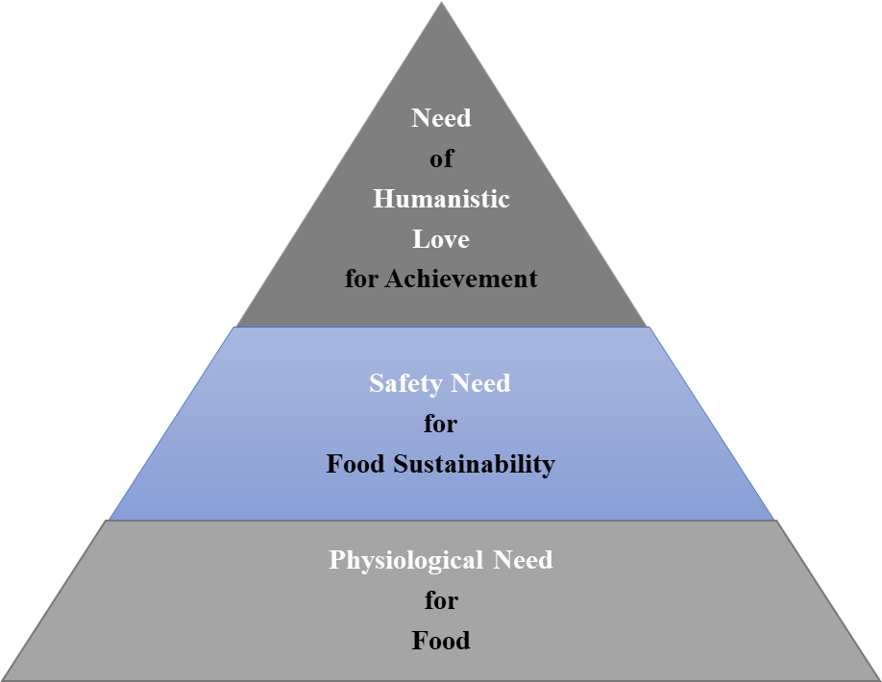

Figure 2 Hierarchy of Needs for Food Sustainability. The hierarchy was adapted from the researcher’s previous work.

3.8 Expected Findings and Recommendations for Further Studies

Analyses of findings, interpretation of results, and conclusions drawn from studies may have been shaped by experience of the researcher (Savelyeva, 2022). The researcher expected that the result of current findings will be similar to the forecasted findings of Gerhardt et al. (2020), Tubb and Seba, (2021) and Morach et al. (2021) mentioned in the Literature Critique, with a dispersion of consumption at 2040 to be 35% for cultured meat, 25% for plant-based meat, and 40% for conventional meat; but the researcher estimated that the proportion of favorability will be slightly different, as plant-based meat is currently perceived as more acceptable by consumers than cultured meat (Gomez-Luciano et al., 2019). Moreover, most people are not willing to change completely from a pro-meat diet to plant-based diet (He et al., 2020), and only 10% of consumers will buy cultured meat as it is laboratory-made (Stollar et al., 2022). The findings of these previous researchers were all supported by statistics, so their trustworthiness can be assured. Unfortunately, meat-alternatives are not totally acceptable by people around the world. The study of Carfora, Morandi and Catellani (2022) conducted in Italy indicated that Italian consumers had already been educated by promotional messages about meat-alternatives’ benefits, and they were also aware of climate change, but despite of their positive attitude shown, their purchasing intention of man-made meat is low. In view of this, it is interesting for the current researcher to conduct research on this topic in an Asian context to investigate the cultural, social, economic and psychological differentiations in purchasing behavior between Hong Kong and the rest of the world. For further studies, the researcher would like to employ a mixed research methodology to look for answers from a larger population to explain the evidences emerged surprisingly from the current research. A mixed integration of inductive and deductive reasonings will bring more comprehensive views to the matter and can be generalized to the general public.

3.9 Research Time Frame
A research time frame is developed with scheduled activities to serve as a guideline for the study, a complete Gantt Chart of the time frame is displayed in Appendix 2. The time frame was adapted from the previous work of the researcher.


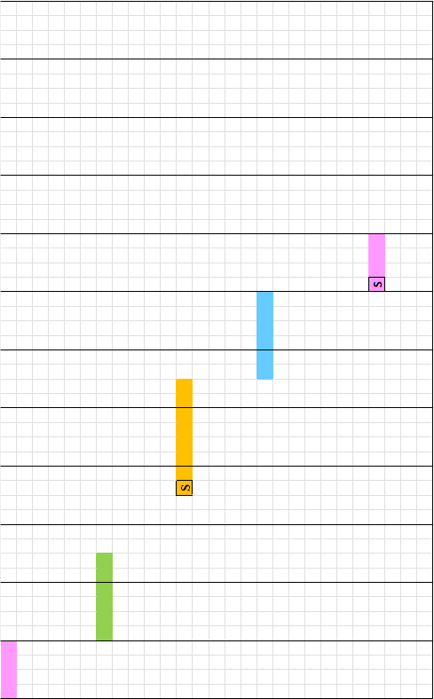


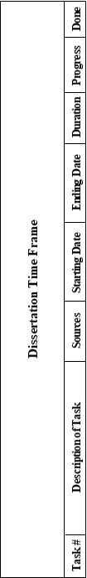
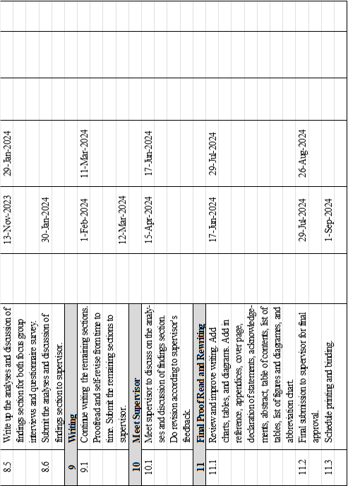

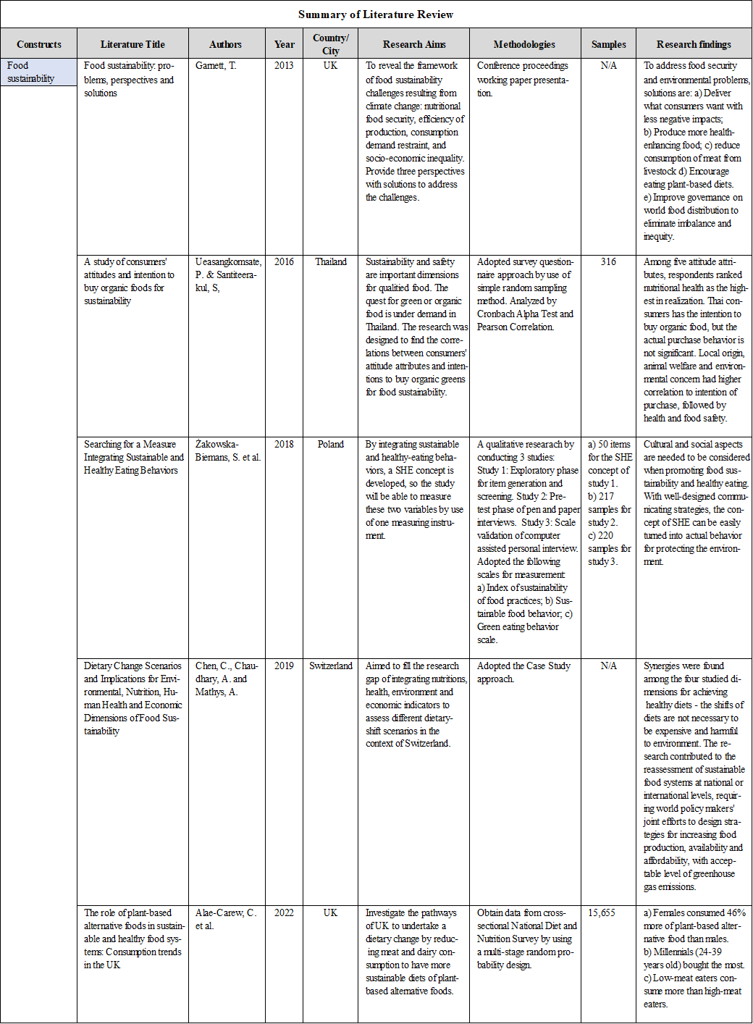
Appendix 1 Summary of Preliminary Literature Review

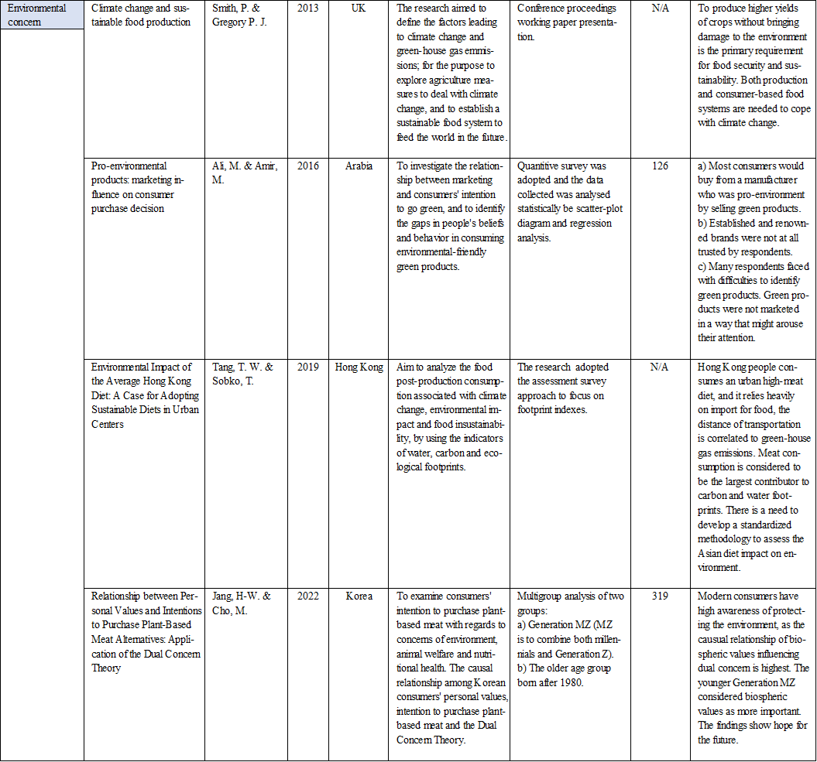

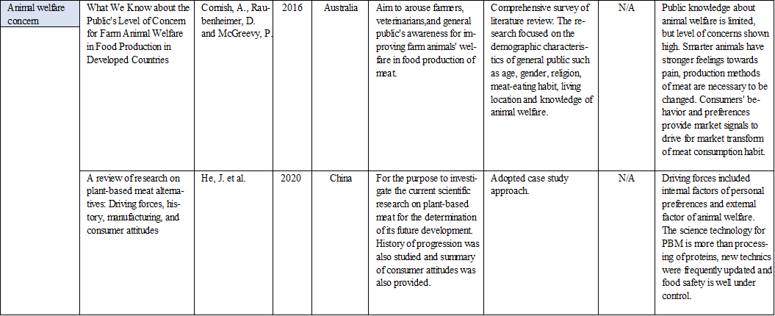

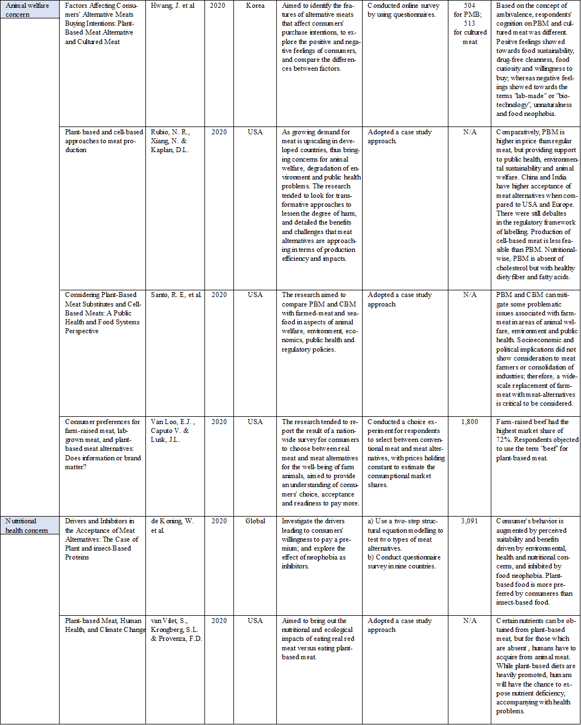

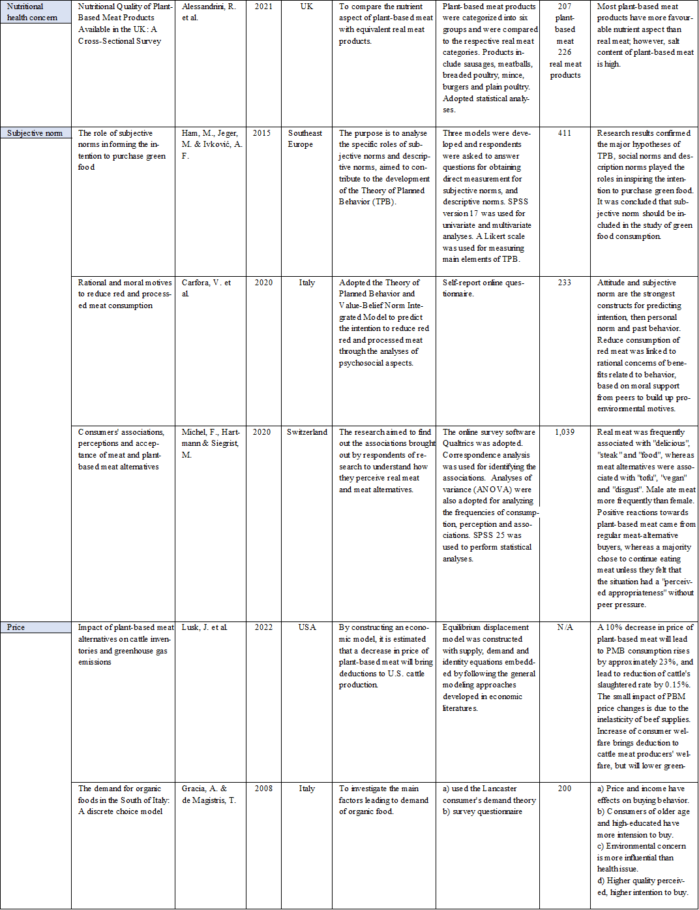

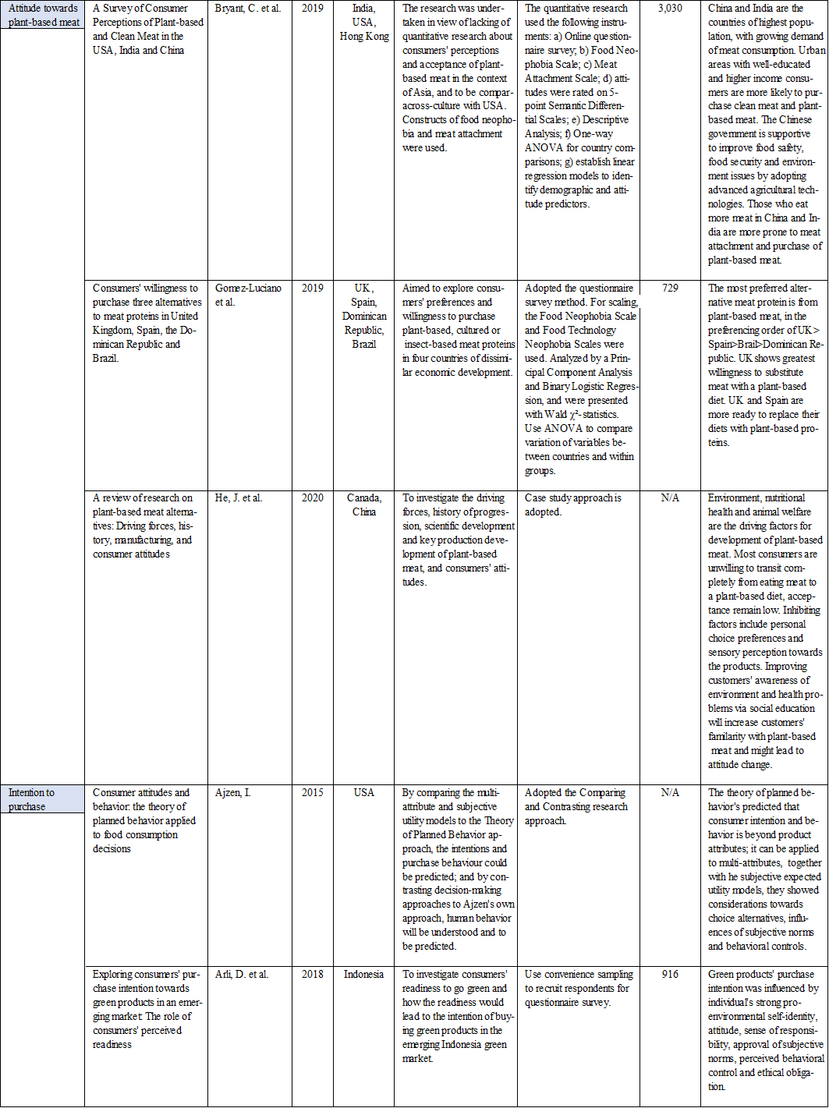

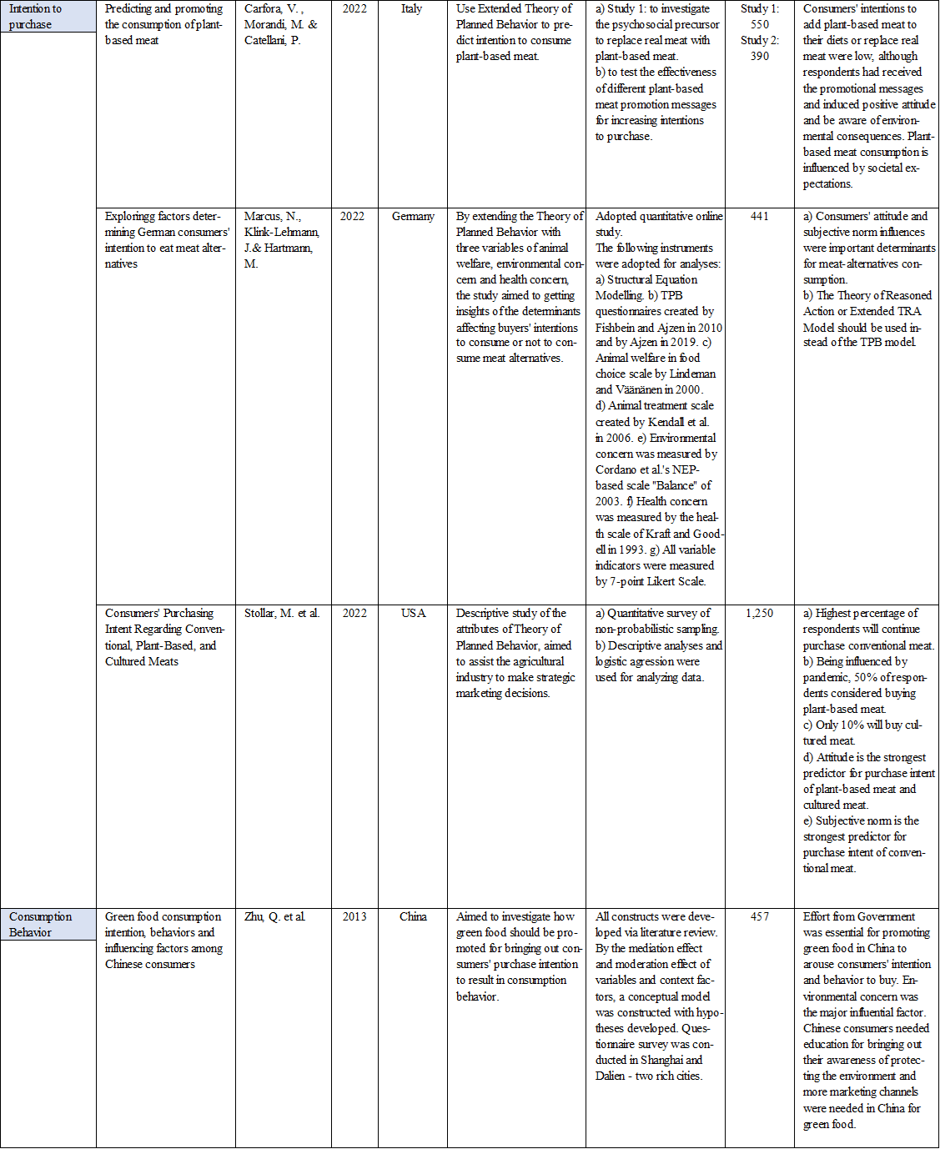

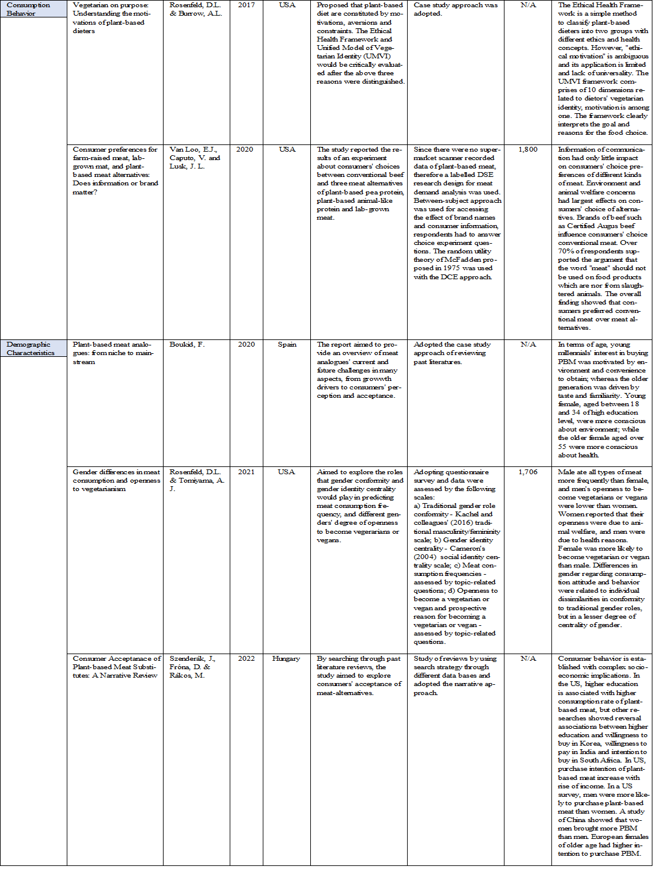

Appendix 2 Complete Gantt Chart of the Research Time Frame

AFCD stands for Agriculture, Fisheries and Conservation Department.
BRICS countries include Brazil, Russia, India, China and South Africa.
Retrieved from The Impactful (2022) at What is Social Impact? Definition, Types, & Examples — The Impactful
Retrieved from Woodson, E. (2013) at What is Social Impact? | The Stanford Daily
The meaning was retrieved from Microsoft Bing Dictionary @ definition of transition - Search (bing.com)
The Summary of Literature Review was adapted from the researcher’s past work of similar topic.

