NAME: Prasanna Dhakal
STUDENT NUMBER:2131567
MODULE: LCMB7001
LECTURER: Tushara Balendran
COURSE: Master’s in business administration
SUBMISSION DATE:07/09/2022
TITLE: Marketing Assessment 1

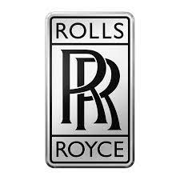

ROLLS ROYCE

Table of contents:
1. Introduction
2. Company’s Background
Communication:
- Definition of communication
- Communication Model
3. Integrated Marketing Communication
4. New Promotion Strategies
- Sources of promotion
5. Brand and Brand Equity
- Definition of Brand Equity
- Model and diagram
- Advantages and disadvantages of Equity (KELLER’s brand Equity Model)
6. Customer Journey Stages
7. Customer Touchpoints
- Pre-purchase
- Purchase
- Post-Purchase
8. Customer Journey MAP
9. Total Engagement model
10. Conclusion
11. References

- Introduction
“The Rolls-Royce Group plc is a notable global organization with tasks in 135 nations and creation offices in 14 distinct countries. Around 40,000 individuals work in different organizations going from common, guard, and aviation to marine and energy. Rolls-Royce keeps 56,000 airplanes motors for 300 carriers, 2,400 business companies, and in excess of 100 military powers around the world. Its motors can be found in each sort of business airplane made by aeronautics industry behemoths Airbus and Boing, whether they are the biggest contemporary carriers or business jets. Rolls-Royce is an incredibly famous and regarded brand known for giving posh quality, trustworthiness, and state of the art innovation to its clients.”
“Rolls-Royce Group plc revealed all out profit of £10,414 million, which is equivalent to $16,307.6 million, for the monetary year 2009, which finished up in December, a 14.7% increment over the earlier year. For the monetary year 2009, the organization's functional benefit was £1,174 million, or $1,838.4 million, an increment of 32.7% over the earlier year. In monetary year 2009, the general benefit was £2,217 million, or $3,471.7 million, contrasted with a complete deficiency of £1,342 million, or $2,101.5 million, in financial year 2008.”
- Company’s Background
“Rolls Royce is a premium auto and flying motor business that was laid out in 1904 by Charles Stuart Rolls and Henry Royce. Henry was the main thrust behind the car business, while Charles, whose side interests included flying, chose to take a stab at building flight motors.”
“During the First World War, extravagance vehicles were only that: an extravagance that a couple of individuals, generally the honorability, could purchase. This, alongside the bank's choice to eliminate Rolls Royce's overdraft line, implied that they needed to zero in on the flying motor side of the organization. Rolls Royce had an effective flight motor organization when WWII came, and they gave the world the Merlin, which controlled the unbelievable Spitfire. After the conflict, "the worth of our eminent name and brand was stretched out as the Rolls-Royce association developed and extended by means of its various business sectors." Any activity done for the sake of Rolls-Royce stuck to a bunch of values and rules that we love, esteems that empower us to keep on laying out new degrees of greatness." Rolls Royce Group PLC (Rolls Royce Group PLC, 2010). Rolls Royce has not created premium vehicles beginning around 1998, when it offered that division to BMW. Rolls Royce is as of now a market chief in flying motor production, specialized progress, and natural administration (UKEssay, 2017).”
Communication
The Latin word for "communication" is communicare, which signifies "to share or to make common" (Weekley, 1967). Communication is portrayed as a procedure of understanding and trading importance (Pearson and Nelson, 2000).
The affiliation that incorporates part connection is at the core of our communication study. This word is helpful since it underlines the exhibit of appropriately understanding and sharing another's perspective, which we will analyze completely all through this work.
Model of Communication
As indicated by the Shannon-Weaver model, communication comprises of five significant parts: source, encoder, channel, decoder, and recipient. It underlines the meaning of encoding and translating communications prior to sending them (for example transforming them into composed words, morse code, and so forth.). 'Commotion' occurs all through the encoding, transmission, and deciphering processes, which might hinder or darken a message. In the most strict sense, this might be static on a radio transmission, yet it could likewise allude to mishearing a discussion or misreading an email. This approach was quick to incorporate commotion into the communication cycle (Mereu, 2016).
Rolls-Royce is going through a time of change. The brand is most likely the zenith of extravagance autos, yet what we would call extravagance is moving. We've been jabbering about contemporary extravagance at Spinach recently since it impacts how we help organizations, our clients, speak with their shoppers. Extravagance is turning out to be less and less about the anticipated angles, and more about dynamic standards like insight, extraordinariness, forever... also, conceivably even importance.
As the House of Rolls-Royce plans to communicate the first of its short movies, The Spirit of Ecstasy, to celebrate the appearance of the marque's apex model, the Phantom, in 2018, Nargess Banks talked with Rolls-Royce CEO Torsten Müller-tvös to find out more.
Fig 1
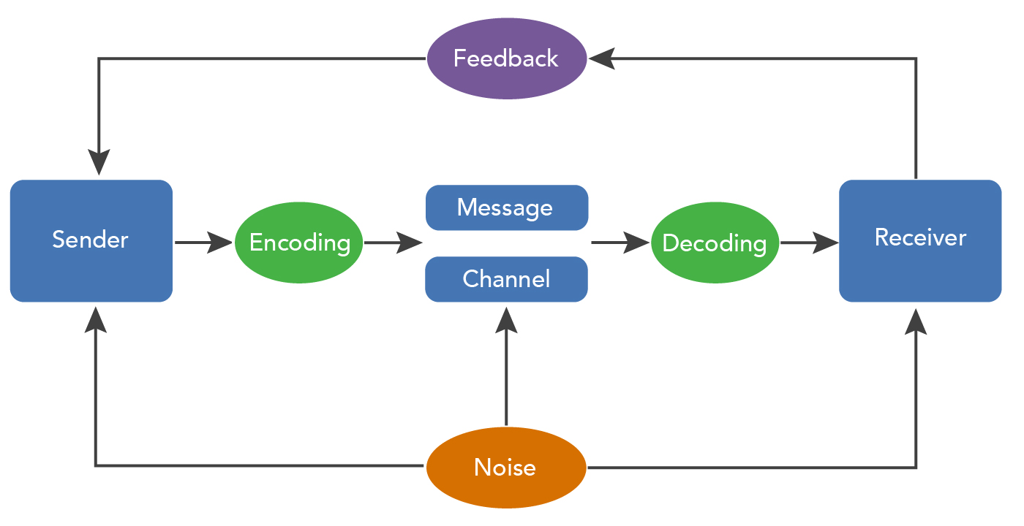
“Source: LumenLearning.com”
- Integration Communication Model
IMC is the most common way of binding together promoting communication viewpoints, for example, advertising, virtual entertainment, crowd investigation, business improvement ideas, and publicizing into a brand character that stays reliable across different media channels. It empowers public and confidential associations and partnerships to give a connecting with and smooth client experience for an item or potentially administration, as well as expand an association's picture and partner connections. Experts having experience with coordinated showcasing communications might work in areas, for example, web-based entertainment advertising, advanced media, reporting, statistical surveying and consultancy, advertising, non-benefit and government, diversion, TV and radio, and other related disciplines (Demmeler and Giusto, 2001).
“Rolls-inside Royce's interchanges technique comprised of three parts:”
Draw in - Ensure that individuals are roused to work and that they have an objective and close to home association with the work environment. This is achieved through their initiative messages.
Invigorate - ensure that specialists' physical, relational, and close to home prosperity is positive. They do this by means of the association's way of life, which is helped through its coordinated effort channels.
Empower - ensure that staff can perform what must be finished in a basic and useful manner. They do this by means of the use of innovation like their intranet.
- New promotion strategies
To advance items, promoting efforts utilize a scope of media, including TV, radio, print, and Internet stages. Organizations and establishments in exceptionally serious business sectors might participate in ordinary showcasing efforts and spend critical assets to help memorability and deals (iide, 2019).
“Havas London's Rolls-Royce "One of one"
It's a film where Siamese battling fish are contrasted with Rolls-Royce Phantoms to exhibit how each is a "perfectly remarkable creation" with no rivalry. The promotion, Havas London's introduction for the organization, endeavors to pressure that Rolls-Royce Phantoms are dispatched on a unique premise. It's one of a progression of short movies by Sam Pilling, well eminent for his work on F1 race vehicles and BMW (iide, 2019).
“Rolls-Royce Hingston Studio's "The Spirit of Ecstasy"
The House of Rolls-Royce is another drive made by Rolls-Royce Motor Cars to bring the popular brand's accounts, encounters, and legends to life. The film was imagined and created by Hingston Studio, and it utilizes a blend of movement catch, 3D checking, true to life, and liveliness to tell a thrilling 2.5-minute story (iide, 2019).
Online Presence
• While the sum spent on computerized has expanded to turn into a significant part of its promoting spend, Rolls-Royce stays a client-driven organization that flourishes with the interesting individual associations it has with its clients all over the planet.
• Client connection powered by advanced keeps on ascending as how they stay in contact with their clients and how they share their image's accounts. That organization additionally oversees Rolls Royce Motor Cars' web-based entertainment.
• In contrast with the business normal of 7-12%, the Rolls-Royce Motor Cars interpersonal organization brags a fabulous commitment rate more than 17%. (iide, 2019).
- Brand and Brand Equity
Brand
"A brand is a name, word, plan, image, or whatever other quality that recognizes one vender's thing or administration from another" (American Marketing Association).
"By and large, an item is whatever might be provided to a market to fulfill a need or need, like actual wares, administrations, encounters, occasions, individuals, areas, resources, associations, data, and thoughts" (Kotler and Keller, 2015).
Brand Equity
Brand equity is how much power a brand name has in the personalities of clients, as well as the advantage of having a perceived and very much considered brand. Associations expand brand value by giving incredible encounters that draw in clients to keep purchasing from them as opposed to rivals that give indistinguishable things (Aaker, 1992).
Brand value demonstrates the brand's whole worth. The brand not set in stone by the encounters and view of buyers. Negative perspectives address unfortunate brand worth and negative brand value, while positive discernments show high brand worth and positive brand value. Rolls-Royce Holdings Plc ought to look at its image value consistently to ensure long haul endurance in an undeniably confounded and serious buyer market.
Keller model
Kevin Keller made the Customer-Based Brand Equity (CBBE) idea, which is remembered for his smash hit course reading 'Key Brand Management.'
This worldview is client driven, as the name suggests. Keller imagines that offering the appropriate insight to your clients might assist you with expanding brand value. The brand should impact how purchasers think and feel about the item.
• Brand notability - how promptly and frequently do purchasers review a specific brand?
• Brand performance - how well do purchasers suppose a specific brand performs?
• Brand symbolism - characterizes a brand's extraneous highlights (variety, bundling, item consistency, undertones) and the degree to which they meet customers' mental or social requests.
• Brand judgement are a client's own perspectives and evaluations about a brand.
• Brand feelings are buyers' personal reactions and responses to a brand when energized by interchanges or companions.
• Brand resonance - the idea of the client's association with the brand and how much they feel faithful to the brand.

Fig 2
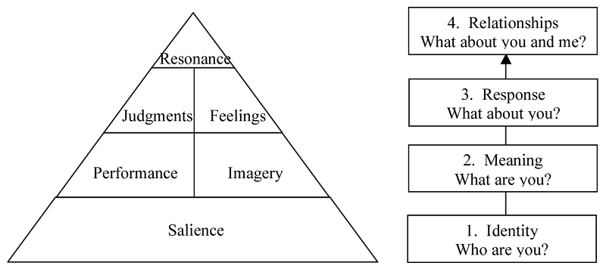
“Source: www.batheories.com”
Advantages and drawback
Advantage
- Businesses might use this system to get influence while sending off new things.
- Distinguish yourself from contenders
Drawback
- Umbrella brands or co-brands get benefits from their binds with the venture (Aaker, 1996a). The test this is deciding the way a significant part of the benefits are inferable from the item's image name and the amount to the umbrella or corporate brand.
- Customer Journey stages
“Stage 1: The principal stage is the latent/dormant stage.”
At this stage, the buyer isn't yet a client of the brand and may not be a client of any brand - as such, they might be a non-customer of that item class (Norton and Pine, 2013).
“Stage 2: Active Decision Making”
The dynamic/inactive client is roused to delay for various reasons including different promoting upgrades. They have basically been "enacted" as clients and will currently join the regular customer decision process model (Norton and Pine, 2013).
“Stage 3 - Purchasing and Consumption”
During this stage, the purchaser turns into a client of the organization/brand. This may be their most memorable exchange, or they could be making an intermittent purchase (Norton and Pine, 2013).
Fig 3
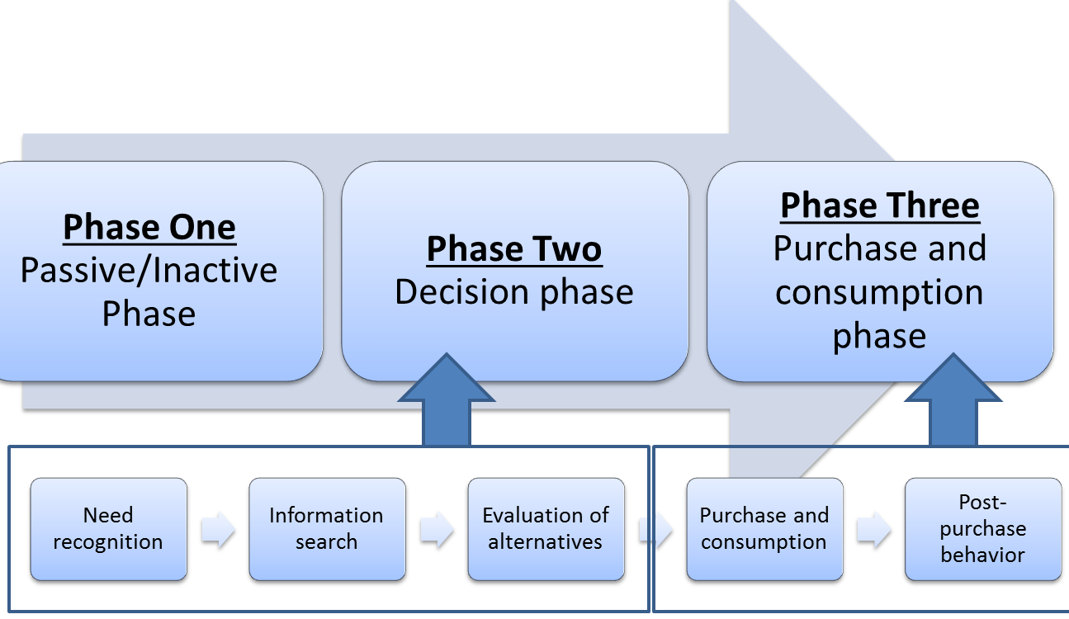
“Source: www.themarketingstudyguide.com”

- Customer Touchpoint
Any time a shopper interfaces with your image, whether by means of a worker, a site, a publicizing, or an application, that is a client touchpoint. Also, the cooperation that clients have with those touchpoints could impact how they see your association (Dhebar, 2013).
Fig 4
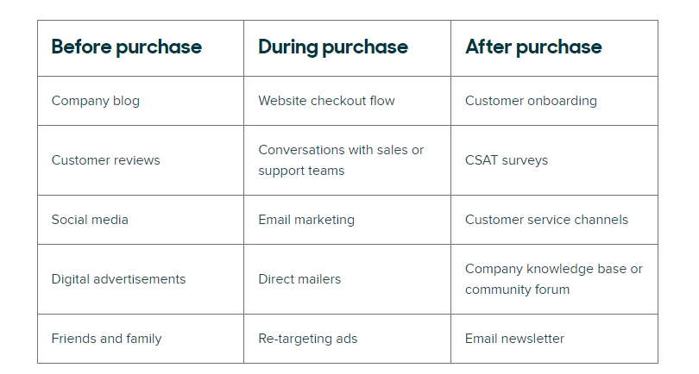
“Source: Zendesk.com”
With 2,500 individuals overall and many memorable relics, including a few hundred motors, the Rolls-Royce Heritage Trust has become stronger to strength.
The Trust helps the firm by going to occasions, giving preparation, and imparting its set of experiences to devotees. Rolls-Royce contributes essentially to the Trust in return.

- Customer Journey Map
Fig 5
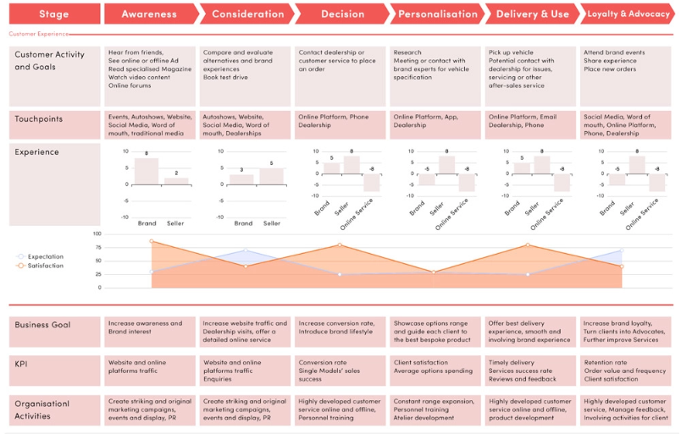
“Source:rccdbcars.com”
Touchpoints are resources between an organization and its clients. Commercials, item leaflets, the organization's site, eye-to-eye gatherings and individual connections with purchasers, merchandise, item packages, and upkeep/fix administrations are normal touchpoints in the B2B business. In the B2B business, conveying trust at these touchpoints is basic (Roto et al., 2013).
- Total Engagement model
A drew-in shopper is one who is faithful to an engaged brand and effectively advances the brand, as well as its labor and products, to other people. Our proposal for making drew in purchasers is to utilize the Total Engagement Model, which is communicated as
Figure 6
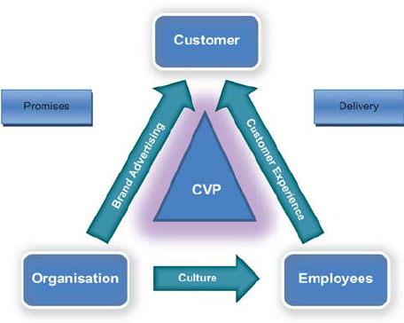
“Source: ResearchGate.com”
The methodology starts with the possibility that significant key pieces of an organization should be laid out and facilitated to create drew in shoppers. These viewpoints are available in most of the associations, and their singular benefits are generally demonstrated (Robert and Alphart, 2015). They are as per the following:
• Your Customer Value Proposition (CVP) is the worth you give to your purchasers. At the end of the day, for this reason, purchasers ought to pick you over your opposition. (Robert and Alphart,2015)
Your logo or name, yet your image is the entire measure of what your identity is and a big motivator for you. Your incentive should be a significant part of your endless image advancement, which is the way you pass the brand on to clients.
• Culture alludes to 'the manner in which we get things done around here,' and it represents the association's interior highlights, like its points, values, and inner ways of behaving. This ought to be expected to encourage an air wherein workers can reliably convey the brand's incentive and arranged client experience.
• Client Experience is a combination of physical and profound elements that buyers experience while interfacing with the brand and the organization (Robert and Alphart, 2015).
- Conclusion
From the first, we might deduce that Rolls Royce cars are a mix of sci-fi and history: it's challenging to remember how astoundingly modern developments in earlier many years were, yet the capability of future leap forwards actually interests.
In actuality, the following quite a while will be trying for Rolls Royce. With the economy falling apart and the request book contracting, the significant accentuation is on how the firm can hold its exceptionally qualified work force. Rather of cutting back or rebuilding, redeploying professionals to different region of the business might be reasonable. As recently demonstrated, these experts are among the most profoundly prepared and prestigious in the globe, and they are overwhelmingly popular, so the organization should, in all seriousness keep them.
With the new breakdown of worldwide financial exchanges, more modest firms are helpless before greater associations; this could prompt more noteworthy variety, however likewise with any consolidations, it could prompt redundancies.
The enterprise should plan for the long run by forcefully putting resources into R&D and youngsters through its apprenticeship program.
Rolls-Royce has altered its direction or technique from center designing to a more client centered business organization to manage steady changes inside its business region. As far as client mindfulness and administration accentuation, the association is currently adopting a more proactive strategy. Be that as it may, previously, this kind of exchanging action was intriguing since this organization likewise followed principally market developments. The all out framework will be revamped to address the issues of new and growing functional offices.
The functioning construction of this organization is adjusted to lay out great connections inside the business as well as a very much planned framework to satisfy expressed business objectives simultaneously.
- Reference
- Aaker, D.A., 1992. The value of brand equity. Journal of business strategy, 13(4), pp.27-32.
American Marketing Association (AMA)
- Demmeler, T. and Giusto, P., 2001, March. A universal communication model for an automotive system integration platform. In Proceedings Design, Automation and Test in Europe. Conference and Exhibition 2001 (pp. 47-54). IEEE.
- Dhebar, A., 2013. Toward a compelling customer touchpoint architecture. Business Horizons, 56(2), pp.199-205.
- https://iide.co/case-studies/marketing-strategy-of-rolls-royce/
- https://spinachbranding.com/rolls-royce-embraces-new-forms-brand-communication/
- https://www.rccdbcars.com/automotive-blog/luxury-automotive-customer-journey-toward-2030-whats-next
- https://www.ukessays.com/essays/management/rolls-royce-a-brief-history-management-essay.php
- https://www.zendesk.com/blog/customer-touchpoints/
Kotler & Keller: Marketing Management (2015)
- Mereu, S., 2016. The communication model of a Facebook live-video broadcast based on the Shannon-Weaver model: A practical example for football clubs.
- Norton, D.W. and Pine, B.J., 2013. Using the customer journey to road test and refine the business model. Strategy & Leadership.
- Pearson, J., & Nelson, P. (2000). An introduction to human communication: Understanding and sharing (p. 6). Boston, MA: McGraw-Hill.
- Roberts, C. and Alpert, F., 2015. Strategic drivers of customer and employee engagement: practical applications. In Customer Engagement (pp. 189-210). Routledge.
- Roto, V., Kim, T.Y., Markgren, H., Rebelo, C., Sundeson, K. and Lindborg, I., 2013, July. Trusted to Deliver Excellence–Trust Design in All Touchpoints. In Proceedings of workshop A Turn for the Worse: Trustbusters for User Interfaces, in conjunction with SOUPS'13 conference.
- UKEssays. November 2018. Introduction Of The Rolls Royce Company Management Essay. [online]. Available from: https://www.ukessays.com/essays/management/introduction-of-the-rolls-royce-company-management-essay.php?vref=1 [Accessed 24 August 2022].

