
BMSW4001 Assessment 1
Critical Analyses of Employability Skills

December 13, 2019
Shajna bagom Student number 1709594
University of Wales Trinity Saint David

Contents
Terms of Reference 2
Procedure 3
What are Employability skills? 4
Who are Employability Skills important to? 4
Why are Employability Skills Important? 5
Have Employability skills changed in the last decade? 5
Five of the top employability Skills 5
Does this mean that Employability Skills aren’t as important as they were? 8
What Employability Skills do Employers expect to see? 8
Time management skills 8
Problem solving Skills 9
Digital skills 9
Job seeking skills 9
Interview skills 10
Emotional Intelligence and Resilience skills 10
Conclusion 11
Bibliography 12

Terms of Reference

Report for Melanie Squire

Deadline : December 13TH 2019

Procedure

Books, websites articles and lecture notes have been studied and referenced to support finding.

What are Employability skills?
Employability Skills can be defined as flexible skills required by an individual to make them employable in all workplaces. Employability skills are a set of beneficial and flexible skills that an employee is expected to have to stand out from others. Employability depends on employability skills and how they are utilized.

Who are Employability Skills important to?
It is usually very important to employers who are looking to recruit that are very particular of employability skills. Employers are looking for the best people for their organisation/company, therefore they expect to their employees to have employability skills that would equip them to carry out their roles and responsibilities to their best capability. Employers are always looking for candidates with a variety of quality skills.
Employability skills are also very important to people/applicant who are looking for employment opportunities. It is important for applicant to be aware of the important to succeed in their career path. It is important for them to be recognise and understand their skills to develop and progress. They also need to have flexibility and adaptability skills as career paths are becoming unpredictable. Over the past decade some essential Employability skills have changed. There are many reasons for these changes some of which are Economy, the rapid emerging of technology, socially, emotionally, culturally, number of graduates and others. Many skills have remained the same as they are still very important even today at current times.

Why are Employability Skills Important?
Employability skills are important to be able to progress and achieve the goals aimed for in employment and for the workplace. Employability skills are necessary to sustain and carry out the responsibility of the employment role.
Employability skills are important for jobs in all field of employment. Important skills such as communication and listening skills, organised, decision making, and leadership skills are known as soft skills which are not always measurable. ‘Soft skills relate to your attitudes and your intuitions. As soft skills are less referable to your qualifications and more personality-driven, it is important to consider what your soft skills are and how you might show evidence of them before you apply for a job.’ (Anon., 2019). Hard skills such as writing, reading, physical skills, etc are measurable and are learned from learning. These soft and hard skills are important for employers when looking for the right employee to join and progress their company to success.

Have Employability skills changed in the last decade?

Five of the top employability Skills

Teamwork Skills -Communication skills, Support skills, Problem solving skills, Listening and feedback skills, Management skills related to teamwork.
Good teamwork skills are required in every job. Teamwork is a significant skill that every employee must have, lacking in teamwork skills can have an effect on the organisation, ‘without good teamwork in the workplace, it’s difficult to progress as a business – which can result in stagnation and loss of market share. In fact, 86% of employees and executives state that workplace failures are a direct result of a lack of collaboration or ineffective communication.’ (Pope, n.d.)
Good teamwork skills could progress organisations to a very high rated position, if an organisation has a team who work together effectively. Good teamwork consists on people understanding their target as a team/organisation, sharing ideas, discussing and solving problems to reach their goals. ‘Teamwork involves helping other members of your team to achieve a common goal quickly and effectively.’ (Anon., 2019). Activities such as group presentations, group projects and group tasks are good practice to enhance teamwork skill.
How has teamwork skills changed and why in the last decade? Teamwork is a very important skill that is require, saying that it is skill that is even more important now. Organisations are able to grow and succeed without a team that works together effectively. Organisations are more advanced in their specialities and need to team who can work together to progress the growth of the business. To be able to advertise, contact the correct effective people, fast communication with suppliers, etc. This is due to the change in advanced technology, they can get tasks done a lot quicker, with each team member having an input in carrying out tasks to achieve the same end goal.

Communication Skills - ‘Interpersonal skills are the abilities we use each day when we communicate and collaborate with others, both separately and in gatherings. Interpersonal skills are a soft skill, especially communication skills like verbal, non-verbal skills and active listening skills’ (Anon., n.d.).
Facial expressions, body language, sign language are all different methods on communication. Facial Expressions is a very effective method of communication. ‘Professor of psychology Albert Mehrabian studied the importance of non-verbal communication in the 1970s. The influence of non-verbal communication is stronger than was first assumed.’ ( (Mulder, 2012). His model shows:
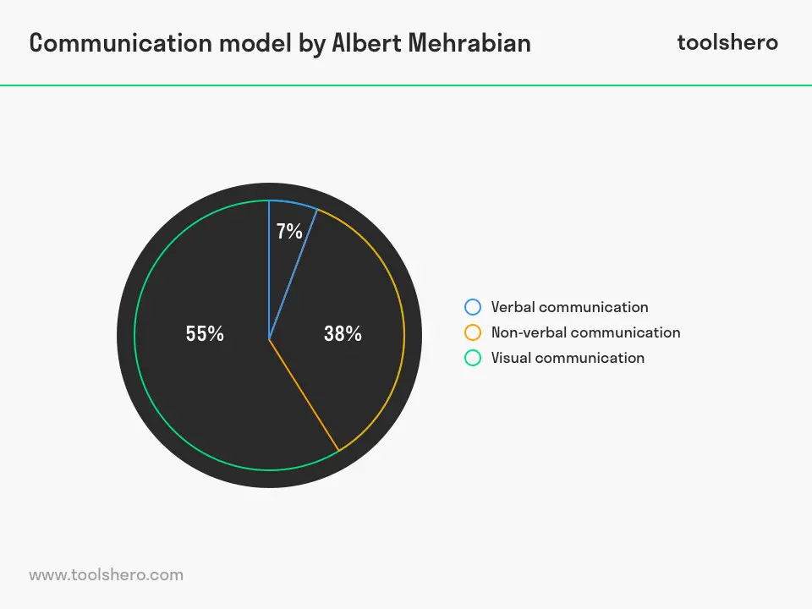
(Mulder, 2012)

Different situations in life differ the method of communication we chose. Many things such as psychological, cultural, situational, relational and environmental. Depending on these people adjust their ways on communicating with others. In employment individuals are required to have a good sense on communications to be able to work effectively in a workplace. good communication is needed to work effectively in a team.

How has Communication skills changed and why in the last decade? Communication skills are even more important now then it was a decade ago. As things are moving, faster now, technology is more advanced, many new software’s are available. Faster communication can be done through social media, emails, phone calls, video calls (skype, WhatsApp calls), text messaging. These methods were not as accessible a decade ago as internet connections was not as accessible as it is now. Internet access was a lot more expensive and a large number of data was not available for people to use on the go. Nowadays it is a lot cheaper for people to purchase a large amount of data from their smart phone network. Wi-fi has become cheaper as there are a lot of providers competing which allow people to purchase inexpensive deals. Free Wi-Fi has become available in many environments such as, coffee shops, bused, colleges, universities, workplaces, restaurants, libraries, etc. By have this change in place, people can communicate a lot faster when needed, whether in a workplace or in personal life.

Negotiation Skills - is a skill that is required in many workplaces. Good negotiation skills are important to support building good relationships with others with the interest of the organisation despite differences. This skill is important so companies can improve the quality of solutions (long term solutions).
To have good negotiation skills the individual should have good communication skills, to make them selves clear to others on what they want as well as being a good listener. They should be aware of all the necessary information of the company on what they want to attain and what they are willing to compromise on. The individual should be a willing to take on the role of decision making and leading negotiations. The individual should have the ability to deal with disagreements by utilising their problem-solving skills.
How has Negotiation skills changed and why in the last decade? Negotiation skills have changed a little in the last ten years. It is a skill that is that all individuals need for all working places. Negotiating skill are need for different roles and almost all roles in a job. This is due to the expenditure of organisations and employees are given opportunities to use their ideas on how too meet the organisations growth plan. Employees given more tasks to carry out in teams. To meet the goal the team members, need to be able to negotiate with each other and decide who is suitable for each input to complete the task successfully.

Leadership Skills - ‘leadership is usually about developing a vision for yourself or others, and then setting up and monitoring processes related to the achievement of this vision’. (Morgan, 2017). A leader is often recognised as a highly successful individual with a variety of qualities.
To have good leadership skills the individual must be able to have a very good knowledge of the organisation, manage to decide which member of the team’s expertise to utilise for certain tasks, support their team in a fair manner.
How has Leadership skills changed and why in the last decade? Leadership skills have not changed of the last ten years. It is still important now as it was. Leadership skills are need and required in individuals for the growth of organisations.

Problem solving Skills – ‘Problem solving is all about using logic, as well as imagination, to make sense of a situation and come up with an intelligent solution. In fact, the best problem solvers actively anticipate potential future problems and act to prevent them or to mitigate their effects’ (Anon., 2019). A variety of skills effect the outcome of an individual, skills such as initiative, teamwork, analytical, adaptability, resilience and creative thinking skills.
To maintain and develop a business it is essential for employees to have problem solving skills. problem are bound to occur in and workplace whether it’s an issue concerning the business, other staff or personal. Whatever the problem all individual should a good level of problem-solving skills
How has Problem Solving skills changed and why in the last decade? Problem solving skills have not changed in the last decade. It was important then and still important now in all working places.

Does this mean that Employability Skills aren’t as important as they were?
Employability skills are extremely important now than ever. With a fast-moving working society, with all new technology, changes in the economy and expectations of employers it is important for individuals to maintain a variety of quality employability skills.

What Employability Skills do Employers expect to see?

The five skills discussed above are very important in current times also a decade ago, the importance of these skills has not reduced, instead they are more highly required. Saying that there are also other skills that are exceedingly important now and are expected by employers. Skills such as:
- Job seeking skills
- Digital/IT skills
- Time management
- Interview skills
- Emotional Intelligence and Resilience skills
- Critical thinking
- Adaptability Skills
These skills are highly expected in employment by recruiters.

Time management skills
‘Employees who manage their time well are more productive, more efficient, and more likely to meet deadlines. They focus on the most important and time-sensitive tasks and limit the amount of time wasted on non-essential duties.’ (DOYLE, 2019). Completing tasks on time is essential for businesses to succeed, lacking can result in loss for the business.
The following skills can help maintain good time management.
- Organisation
- Prioritisation
- Goal setting
- Communication
- Planning
- Delegation
- Stress management
Being able to maintain these skills can result in having good time management skills. Planning helps in prioritising goals, get organised, help identify which areas need addressing to, who to communicate with, if all these skills are in place this leads to good stress management. Time management allows individuals to be more proactive and creative in the way they meet their goals.

Problem solving Skills
As discussed above this a required skill important to be implemented in all workplaces. it is a skill highly expected by employers.

Digital skills
‘Over the past decade, companies across industries have digitized their operations and processes. Even now, businesses are employing artificial intelligence to streamline workflows and supply chains. As a result, today’s jobseekers require specialized skills to help them stand out from the crowd’ (Anon., 2019). Digital skill is a highly expected skill of employers in current time as the advance in technology is changing and developing day by day. Some of the key digital skills involved are:
- Using devices and handling information
- Searching the web
- Creating and editing
- Utilizing Word Processor, PowerPoint, Data Excel, Publisher
- Emailing (sending messages, attachment, downloading attachment, etc)
- Using social media
- Being safe ad responsible online
- communication
- all devices, computer, smartphones, tablets
these skills are needed to have a good digital skill. It is important in all workplaces now as all information related to organisations are recorded on to computers. Communication is done digitally and sharing information with relevant people. Every aspect of an workplace is related to using technology.

Job seeking skills
Job seeking is one of the first steps to take toward employment. This also requires for the individuals to have skills, searching for job is not a minor task. It requires critical thinking and reading, to understand job roles. Self-awareness is very important for individuals to decide whether they are suitable for certain roles. This is where CVs are important. CVs have all the qualification details of the candidate and their previous employment and experience details listed. CVs also include their soft and hard skills, and references. CVs have all the qualification details of the candidate and their previous employment and experience details listed.
CVs require a cover letter to briefly indicate why the candidate considers themselves suitable for the job applying for and what outstanding qualification and skills they have to benefit and fit the job role, which stands out among other possible candidates.
Individuals should have the ability to use different methods of job seeking, such as websites (LinkedIn, etc), agencies, newspapers, recommendations, social media, etc.

Interview skills
Interview systems have changed, employers know exactly what they want from their employees. Every organisation has an interview policy and procedure in place to follow. This makes the interview process easier and fair for the organisation and the possible candidates. Therefore individuals must have the skills to prepare themselves for the interview, by understanding what the role of the job is, what skills the employers expect and want from them, how they are speaking, their attitude, body language, etc.

Emotional Intelligence and Resilience skills
‘The term 'Emotional Intelligence' was coined by psychologists John Mayer and Peter Salovey in 1990. It can be defined as your ability to use your emotions intelligently and appropriately in different situations, combined with your ability to use emotions to make yourself more intelligent overall’ (Anon., 2015). This a expected skill that is important for the employer and more for the individual. To develop emotional intelligence, the following skills need to be developed:
- Emotional Management
- Self-awareness
- Empathy towards others
- Self-motivation
- Relationship Management

All these skills are highly desired skills from organisations, ten years ago these skills were recognised but not as much demanded as today.

Conclusion
To conclude from the findings in my report it is fair to say that employability skills are very important not only for employers but also employees and individuals. Developing employability skills is vital step towards employment, in all fields of workplaces. Some skills importance has changed in the last decade due to the economy, technology, social, emotional, cultural and environmental expectations. I have found the top five skills a decade ago are still important now but even more. There are also other skill that employers expect employees to have in current times now, that were not as expected or require at a high level a decade ago.

Bibliography
Anon., 2015. Resilience: Emotional Intelligence. [Online]
Available at: https://www.mentalhelp.net/emotional-resilience/emotional-intelligence/
[Accessed 12 December 2019].
Anon., 2019. 10 DIGITAL SKILLS THAT CAN MAKE STUDENTS INSTANTLY EMPLOYABLE. [Online]
Available at: https://digitalmarketinginstitute.com/en-us/blog/10-digital-skills-that-can-make-students-instantly-employable
[Accessed 12 December 2019].
Anon., 2019. PROBLEM SOLVING: THE MARK OF AN INDEPENDENT EMPLOYEE. [Online]
Available at: https://targetjobs.co.uk/careers-advice/skills-and-competencies/300766-problem-solving-the-mark-of-an-independent-employee
[Accessed 12 December 2019].
Anon., 2019. Soft Skills. [Online]
Available at: https://www.wikijob.co.uk/content/interview-advice/competencies/soft-skills
[Accessed 1 December 2019].
Anon., 2019. Teamwork. [Online]
Available at: https://www.wikijob.co.uk/content/interview-advice/competencies/teamwork
[Accessed 1 December 2019].
DOYLE, A., 2019. Important Time Management Skills For Workplace Success. [Online]
Available at: https://www.thebalancecareers.com/time-management-skills-2063776
[Accessed 1 December 2019].
Morgan, P., 2017. The Business Student's Guide to Study and Employability. 1 ed. London: SAGE.
Mulder, P., 2012. Communication Model by Albert Mehrabian. [Online]
Available at: https://www.toolshero.com/communication-skills/communication-model-mehrabian/
[Accessed 22 November 2019].
Pope, A., n.d. 10 Surefire Tips to Improve Teamwork in the Workplace. [Online]
Available at: https://biz30.timedoctor.com/teamwork-in-the-workplace/
[Accessed 30 November 2019].

