Resonance

Keefe Mark Ricafort Montebon 1702762

Electrical and Electronic Principles

Wales Institute for Science and Art
University of Wales Trinity Saint David



Abstract
The aim of the assignment is to provide practical skills to candidates during the course, targeting areas such as practical measurement skills and data analysis. Candidates will be required to perform laboratory exercises that will be based on software simulation and a practical experiment using real equipment. Topics mentioned will be resonance effect, Q factor, bandwidth and inductance over frequency.

Introduction
This section should contain the background research related to your report. All third party work used should be cited correctly and listed in the references section.
The Quality Factor of an Inductor
The quality factor, characterized as Q of a circuit can be defined as the equation below.
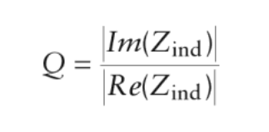
Zind is the impedance of the inductor. This is not necessarily the most common or basic definition of Q, but it is a good way to characterize the structure. A good way to think about this is that Q is a ratio of the desired quantity (inductive reactance) to the undesired quantity (resistance). In this case, a higher Q device is more ideal.
The Q of an on-chip inductor is affected by many things. At low frequencies, the Q tends to increase with frequency because the losses are relatively constant (mostly due to metal resistance Rs) while the imaginary part of the impedance is increasing linearly with frequency. However, as the frequency increases, currents start to flow in the through the capacitive reactance, and to a lesser degree, magnetic coupling. This loss of energy in the substrate causes an effective increase in the resistance. In addition, the sin effect starts to raise the resistance of the metal traces at higher frequencies. Therefore, most integrated inductors have Qs that rise at low frequencies and then have some peak beyond which the losses make the resistance rise faster than the impedance, and the Q starts to fall off again. It is easy to see the need for the proper optimization to ensure that that inductor has peak performance at the frequency of interest. [1]
There were two sets of data. One was for collating data to find the resultant resonant frequency in an inductor. Increasing frequency and noting the change in the resistance. In that set of data, Frequency and VLC have been highlighted. In that table there are two different readings for VLC where one is written in Volts, and the other is written in 2 decimal placed numbers, represented with (mV) and is just an extra set for note taking during the lab experiment. Note: See Appendix A
Another set of data was collated to pin point the Q factor or also referred to as Vc/ Vs or V_{L} / V_{S}. This was to find the peak or otherwise referred to as the ‘Quality’ Factor of the graph that was previously made. Note: See Appendix B
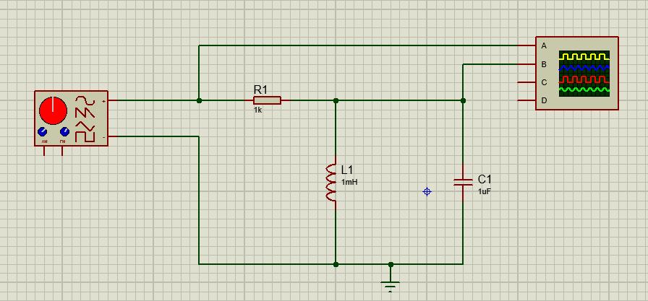
Circuit Diagram 1
Above, is the circuit diagram made in Proteus [2]; this allowed candidates to test the theory of the experiment before moving onto real world applications. In the case of this experiment, that was through the use of Bread boarding. In the circuit above, it has uses a virtual Oscilloscope, a function generator, a resistor, a capacitor and an inductor with the circuit being led to ground.

Equipment
This section should contain a list of the equipment used in the investigation.
Proteus – software
EdExcel – software
Oscilloscope
Function Generator
Breadboard

Method
To garner test readings, the use of Proteus [2] was essential in the process. Proteus allowed the users to simulate the circuit to prove the theory of our Q factors and the change in amplitude as the frequency was increased, to find the resonant factor. It was to test the peak frequency of the circuit above. See Circuit Diagram 1 in Introduction
During the lab, candidates had to use Proteus. [2] Proteus is a computer aided design software capable of creating simulated circuits; such as with this experiment, and also able to write code and had simple program commands.
In the circuit, the use of a digital oscilloscope was used, and a function generator. It was to monitor the change in peak to peak frequency.
The data collected was then inputted to find the correlation in the attenuation over frequency.
Below is a few cells used in EdExcel to locate Q Factor in our table of results. It shows the Band width of the Q factor frequency.
Q Factor (Simulated) 1
In the table above, please refer to the Q Factor Graph 2 (Simulated) in the Results section
Q Factor (Real World) 1
In the table above, please refer to the Q Factor Graph 2 (Real World) in the Results section

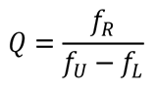
The equation above helped in locating Q factor. In the experiment, we input our data, which was aided by the VLC equation. See below.

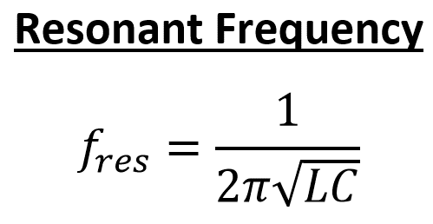
The equation above was to help in finding the resonant frequency in an inductor. This is otherwise known as Resonance Effect and occurs when an LC circuit is driven by an external source by a chosen frequency, fres at which the inductive and capacitive become equal in magnitude, thus outputting our equivalent answer in hertz.
X 10⁻³
10⁻³=ANS; ANS × 2
Squares counted × Ch2 (Voltage)
These were noted equations used personally as a small guide during the converting process when plugging in the data and changing said values from Volts to (mV).

Results
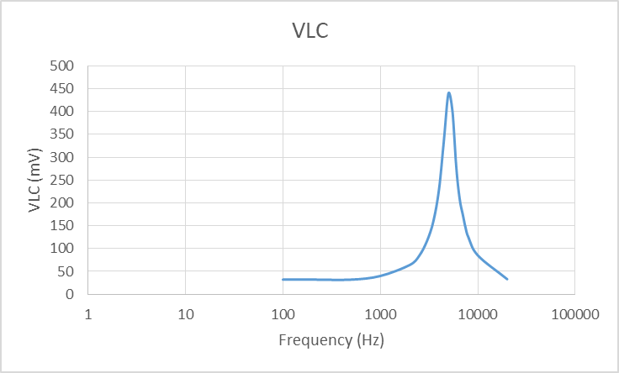
VLC Graph (Simulated) 1
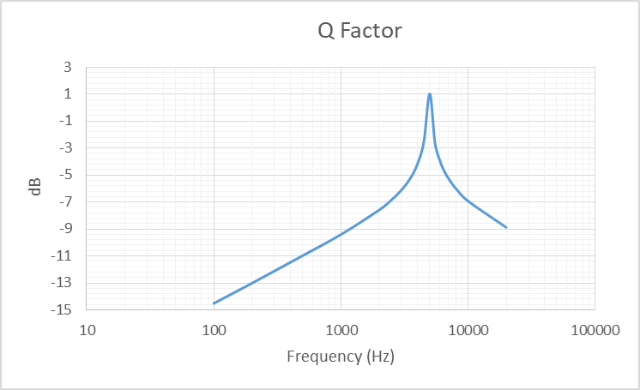
Q Factor Graph (Simulated) 1

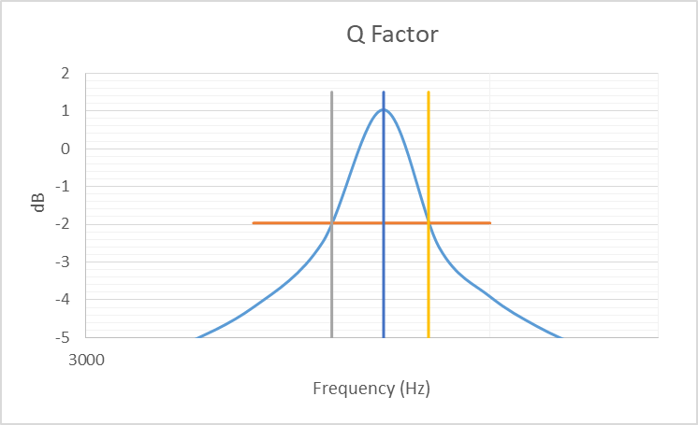
Q Factor Graph (Simulated) 2
VLC Graph (Real World) 1
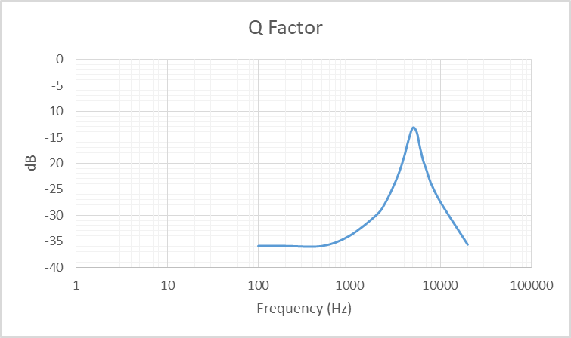
Q Factor Graph (Real World) 1
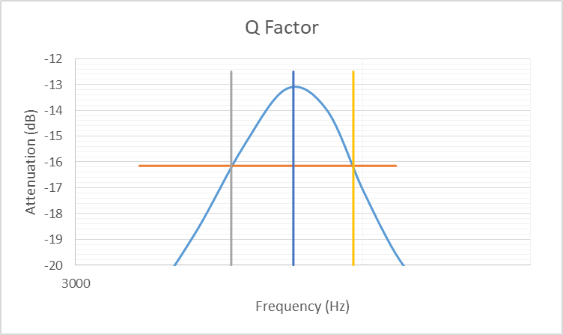
Q Factor Graph (Real World) 2

To see the table of results please refer to the appendix, through sections A, B, C. Please note: Appendix C shows the results table of the second set of results. The

Discussion
During the testing, you can see a clearer set of results in the simulated test results, and a consistent graph from both the VLC graphs and the Q factor graphs. In the simulated set of results, the bandwidth is narrower, suggesting a cleaner set of frequencies. However, this can be offset due to the second set of readings, when compared with the Bread board versions of the circuit.
As stated above; the first sets of results were taken from a simulated circuit. In the second set of results, one could argue the bandwidth is larger in comparison to the first set of results and the frequency which the Q factor was lower than the first set.
A number of factors could have occurred to have a few minor deviations when testing. One factor could through component resistance. Components such as wires, resistors and the inducer that was used in the experiment could have outputted its separate set of frequencies which could be the reason for eh discrepancy between the first and second set of results.
Another factor is the simulation itself. The software deals with a number of complicated mathematics and can dismiss the fact of a few a minor deviations to the overall circuit, which could also be a reason for the change in results.
Other factors could also include the reading of the oscilloscope in both digital and real world application. During the experiment, the skill in being able to read and use the oscilloscope could be the cause for the difference in both results. In real world use, there may not be an exact reading that can give the voltage or in some cases the (mV) to the correct decimal. Most candidates had to inspect the results by eye. In some places it was an educated guess as to where the frequency was being pointed. Although mentioned, it’s doubted that in cases such as making an appropriate estimation of the frequency is a major cause for concern, and should be noted that if it was major problem during the experiment, the difference would be small and mostly inconsequential to the overall lab.
Other minor problems could constitute towards human error. Human error when plugging the correct values for the equations presented above, but like the previous statement above, the final test results were collated together with other sets of results and the correlation seems to be the correct conclusions to the experiment.

Conclusions
The RLC circuit showed a gradual increase in the lower ranges of the frequency tested, however as the frequency was set higher the line indicated that it was a steep and exponential increase in attenuation. And as the circuit reached higher frequencies, the drop in attenuation was steep and was immediately noticeable.
Though the results were clear in showing the curve and correlation of both tests, the minor difference between simulated and real world application is quite interesting to note. Though the simulated circuit was correct in its correlation to the graph made, the observation made is that the climb of the frequency for the simulated circuit was quite clear and showed a consistent gradient.
However, the second set of readings showed a decrease in the consistency of the gradient; though for arguments sake, is quite small. The observation made here is interesting because before the experiment it was not noted that the difference in the manufacturing of said components, could be a factor in the change of its frequency and subsequently, on the gradient of the second set of results.
In conclusion, the difference between both sets of results outlined the disparity between real world testing and simulated testing, and although small, could be the difference to using proper shielding solutions, the difference in component quality, and the cost efficiency when working with the added knowledge of manufacturing inefficiencies.

References

[1] | C. P. John W. M. Rogers, “The Use and Design of Passive Circuit Elements in IC Technologies,” in Radio Frequency integrated Circuit Design , Artech House, 2010, p. 144.
[2] | “PCB Design and Circuit Simulator Software for modern EDA development,” [Online]. Available: https://www.labcenter.com/.

Appendices
Appendix A
Appendix B
Appendix C

