Analysing the impact of a coping intervention on psychological distress.

This study explored the impact that a self-help leaflet had on reducing individual’s distress waiting to learn whether they are at increased risk of developing an inherited cancer. The intervention was based upon psychological coping theory. This intervention involved participants receiving a self-help leaflet developed to reduce distress. This also involved participants to restrict consideration of the issues related to their potential risk for a set period of time (e.g., 10-20 minutes a day), and to actively distract from intrusive thoughts at all other times. 260 participants were included in the study. Participants were approached from the waiting area of the Cancer Genetics Service for Wales (CGSW).
The research aim of the study was to compare levels of distress in participants who received the intervention (intervention group) and those who received standardised information (control group). The specific objective of the study was to evaluate both short- and long-term effects of the intervention at three time points. The three time points were key stages in the assessment process, baseline (time 1), waiting for genetic risk information (time 2), and a month after diagnosis). The fully-powered MRC Phase III randomised controlled trail was targeted to determine the effectiveness of the intervention in reducing distress in individuals undergoing cancer genetic risk assessment across Wales.
The Impact of Events Scale (IES; Horowitz, Wilner, & Alvarez; 1979) adapted for familial cancer consists of 15 items capturing the frequency of participants’ intrusive thoughts regarding their risk of developing cancer and, their attempts to evade those thoughts. The IES has been utilised as a measure of cancer-specific distress in a number of studies and has demonstrated good internal consistency and test re-test reliability. The scale consists of 15 items (7 intrusion items and 8 avoidance items). The IES allows the calculation of a total score (with a possible range of 0-75) and separate intrusion and avoidance subscale scores (with a possible range of 0-35 and 0-40 respectively).
The participants were aged between 18 and 81 (M = 50.70, SD = 11.95). 86.7% of the participants were female and 12.2% were male. 14.3% were single and 68.9% were either married or living with a partner (M= 2.07, SD = .66). 29% of the population were educated to university level or higher.
After initial analysis five outliers were identified at the time 3 point. These were ID numbers, 241 (time 3 score of 79), 231 (time 3 score of 63), 180 (time 3 score of 59), 231 (time 3 score of 63), and 241 (time 3 score of 79). These participants were identified as outliers by SPSS in Q-Q plots and histogram graphs. The scores were unusually high and were therefore discounted for the research. The outliers were removed from the data in order to proceed with the analysis. Further outliers were identified by SPSS after the first groups removal. These were ID numbers 68, 22, and 244. They all reported a time 3 IES score of 48. These were not removed as participants may have received potentially distressing news at the diagnosis timepoint and therefore their levels of psychological distress would have naturally been higher.
An initial t-test was conducted between the two groups (control N =130, intervention N = 125) to ensure that there were no prior differences in distress levels between the intervention group (M =17.13, SD = 17.53) and the control group (M= 16.34, SD = 15.11). There was no significant difference in the levels of psychological distress between the two groups at baseline, t (253) = .38, p= .70, two-tailed.
A two-way mixed model Analysis of Variance (ANOVA) was conducted with the within subjects of time (time 1, time 2, and time 3) and the between-subjects factor of group (control or intervention). None of the assumptions were violated. There was no significant main effect of the between-subjects factor of group F(1, 253) = 0.41; p = .084, partial ƞ 2= .000, indicating that there was no difference in overall psychological distress between those in the control group and those who received the intervention. There was a significant main effect within the subjects of time, F(2, 506) = 1.00 p = partial ƞ2 = .09. This indicates a significant difference in psychological distress over time amongst the participants regardless of whether they belonged to the intervention group or the control group.
Table 1 reports the mean scores and standard deviations for the control and intervention group across all three time points.

Table 1
Means and standard deviations for distress scores by group and across the three time points.
Time 1 Time 2 Time 3
M SD M SD M SD
Control 16.34 15.11 17.67 17.20 12.53 13.64
N=130

Intervention 17.13 17.53 19.05 18.78 11.39 13.12
N= 125

Total 16.73 16.31 18.35 17.97 11.97 13.37 N= 255

Post-hoc pairwise comparisons with Bonferroni corrections applied revealed that for both groups, their levels of psychological distress were significantly higher during the waiting period (time 2) than at the referral period (time 3) (p = .000) and significantly higher between baseline (time 1) and diagnosis (time 3) (p = .000). There was no significance in levels of psychological distress between baseline (time 1) and referral (time 2) (p = 0.82).
The results appear to show increased psychological distress at time 2 (referral) for both of the groups, Control (M = 17.67) (SD =17.20) and intervention (M= 19.05) (SD= 18.78). This could be due to psychological distress caused by waiting for the diagnosis. Also, the IES scores at time 3 for the control (M = 12.53, SD= 13.64) and intervention (M = 11.39 SD = 13.12) groups could have been caused by a sense of relief of receiving positive or negative results and the waiting process ending.

References

Horowitz, M., Wilner, N., & Alvarez, W. (1979). Impact of Event Scale: a measure of subjective stress. Psychosomatic Medicine 1979: 41: 209-218.

Descriptive Statistics
 | N | Minimum | Maximum | Mean | Std. Deviation
Group | 260 | 1 | 2 | 1.50 | .501
Gender | 260 | 1 | 99 | 3.00 | 10.397
Age | 258 | 18 | 81 | 50.70 | 11.951
Marital status | 256 | 1 | 4 | 2.07 | .659
Education | 258 | 1 | 6 | 3.45 | 1.697
Number of children | 258 | 0 | 5 | 1.69 | 1.176
Toties1 | 260 | 0 | 67 | 17.12 | 16.631
Toties2 | 260 | 0 | 70 | 18.87 | 18.266
Toties3 | 260 | 0 | 73 | 12.90 | 14.852
Valid N (listwise) | 250

Case Processing Summary
 | Cases
 | Valid |  | Missing |  | Total
 | N | Percent | N | Percent | N | Percent
Toties1 | 260 | 100.0% | 0 | 0.0% | 260 | 100.0%
Toties2 | 260 | 100.0% | 0 | 0.0% | 260 | 100.0%
Toties3 | 260 | 100.0% | 0 | 0.0% | 260 | 100.0%

Descriptives
 |  |  | Statistic | Std. Error
Toties1 | Mean |  | 17.12 | 1.031
Toties1 | 95% Confidence Interval for Mean | Lower Bound | 15.08
Toties1 | 95% Confidence Interval for Mean | Upper Bound | 19.15
Toties1 | 5% Trimmed Mean |  | 15.97
Toties1 | Median |  | 13.00
Toties1 | Variance |  | 276.577
Toties1 | Std. Deviation |  | 16.631
Toties1 | Minimum |  | 0
Toties1 | Maximum |  | 67
Toties1 | Range |  | 67
Toties1 | Interquartile Range |  | 26
Toties1 | Skewness |  | .822 | .151
Toties1 | Kurtosis |  | -.356 | .301
Toties2 | Mean |  | 18.87 | 1.133
Toties2 | 95% Confidence Interval for Mean | Lower Bound | 16.64
Toties2 | 95% Confidence Interval for Mean | Upper Bound | 21.10
Toties2 | 5% Trimmed Mean |  | 17.66
Toties2 | Median |  | 14.00
Toties2 | Variance |  | 333.657
Toties2 | Std. Deviation |  | 18.266
Toties2 | Minimum |  | 0
Toties2 | Maximum |  | 70
Toties2 | Range |  | 70
Toties2 | Interquartile Range |  | 31
Toties2 | Skewness |  | .763 | .151
Toties2 | Kurtosis |  | -.477 | .301
Toties3 | Mean |  | 12.90 | .921
Toties3 | 95% Confidence Interval for Mean | Lower Bound | 11.08
Toties3 | 95% Confidence Interval for Mean | Upper Bound | 14.71
Toties3 | 5% Trimmed Mean |  | 11.46
Toties3 | Median |  | 7.00
Toties3 | Variance |  | 220.592
Toties3 | Std. Deviation |  | 14.852
Toties3 | Minimum |  | 0
Toties3 | Maximum |  | 73
Toties3 | Range |  | 73
Toties3 | Interquartile Range |  | 20
Toties3 | Skewness |  | 1.344 | .151
Toties3 | Kurtosis |  | 1.273 | .301

Extreme Values
 |  |  | Case Number | Value
Toties1 | Highest | 1 | 241 | 67
Toties1 | Highest | 2 | 129 | 66
Toties1 | Highest | 3 | 75 | 59
Toties1 | Highest | 4 | 165 | 59
Toties1 | Highest | 5 | 10 | 54
Toties1 | Lowest | 1 | 260 | 0
Toties1 | Lowest | 2 | 254 | 0
Toties1 | Lowest | 3 | 247 | 0
Toties1 | Lowest | 4 | 245 | 0
Toties1 | Lowest | 5 | 233 | 0ª
Toties2 | Highest | 1 | 75 | 70
Toties2 | Highest | 2 | 241 | 69
Toties2 | Highest | 3 | 10 | 60
Toties2 | Highest | 4 | 18 | 60
Toties2 | Highest | 5 | 7 | 58^{b}
Toties2 | Lowest | 1 | 256 | 0
Toties2 | Lowest | 2 | 255 | 0
Toties2 | Lowest | 3 | 247 | 0
Toties2 | Lowest | 4 | 245 | 0
Toties2 | Lowest | 5 | 244 | 0ª
Toties3 | Highest | 1 | 241 | 73
Toties3 | Highest | 2 | 231 | 63
Toties3 | Highest | 3 | 180 | 59
Toties3 | Highest | 4 | 135 | 54
Toties3 | Highest | 5 | 108 | 52
Toties3 | Lowest | 1 | 260 | 0
Toties3 | Lowest | 2 | 255 | 0
Toties3 | Lowest | 3 | 254 | 0
Toties3 | Lowest | 4 | 247 | 0
Toties3 | Lowest | 5 | 245 | 0ª
a. Only a partial list of cases with the value 0 are shown in the table of lower extremes.
b. Only a partial list of cases with the value 58 are shown in the table of upper extremes.

Tests of Normality
 | Kolmogorov-Smirnovª |  |  | Shapiro-Wilk
 | Statistic | df | Sig. | Statistic | df | Sig.
Toties1 | .152 | 260 | .000 | .885 | 260 | .000
Toties2 | .151 | 260 | .000 | .887 | 260 | .000
Toties3 | .193 | 260 | .000 | .825 | 260 | .000
a. Lilliefors Significance Correction

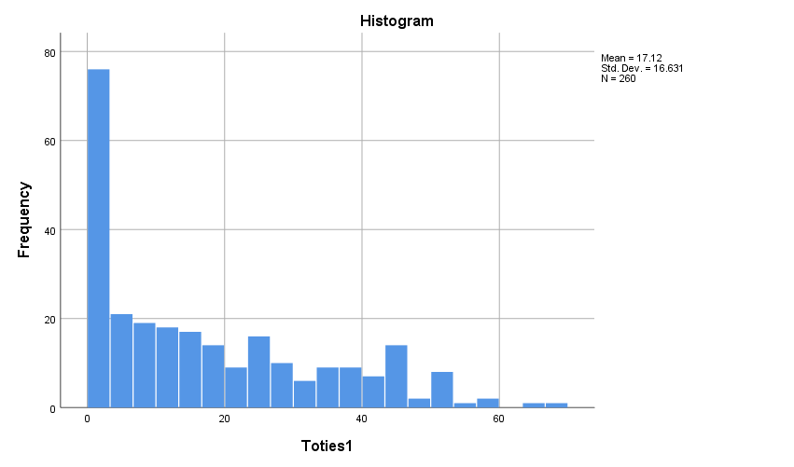

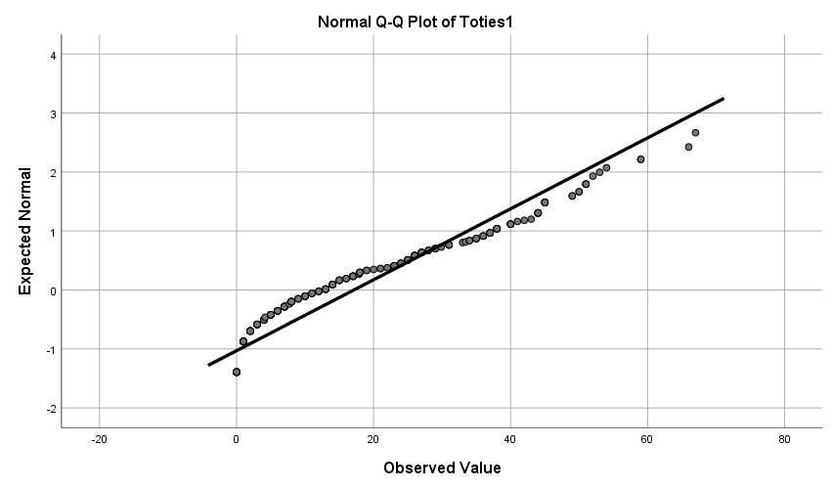

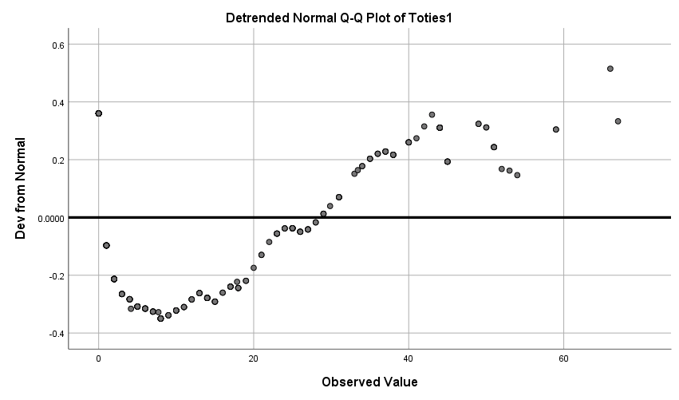

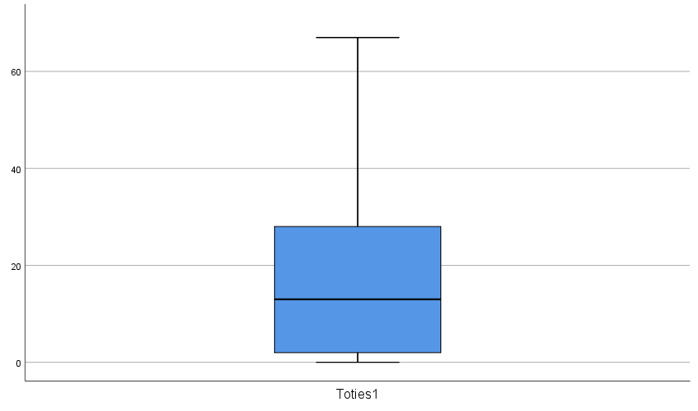

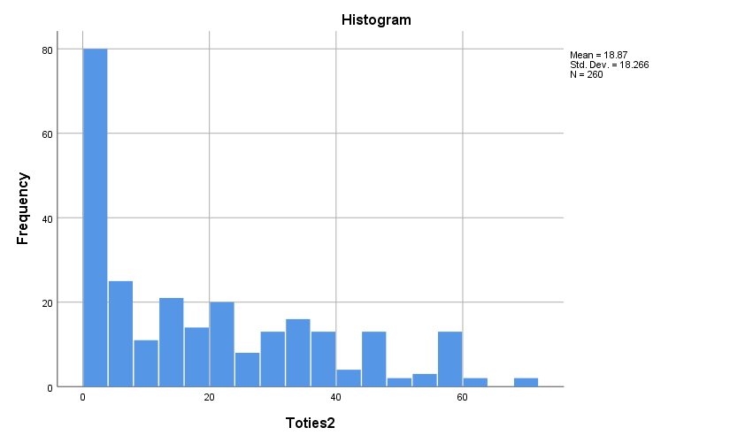

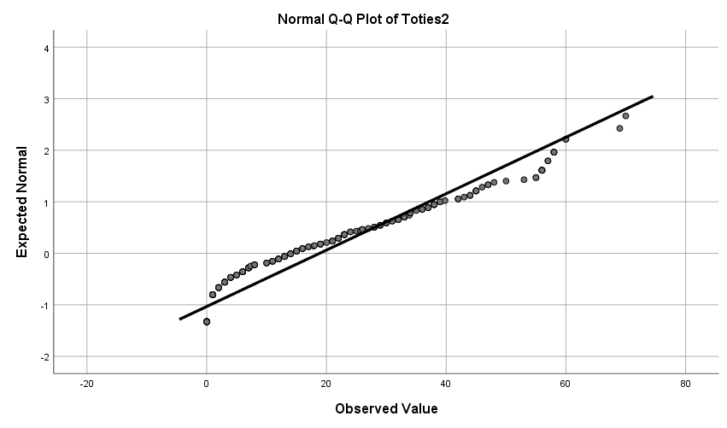

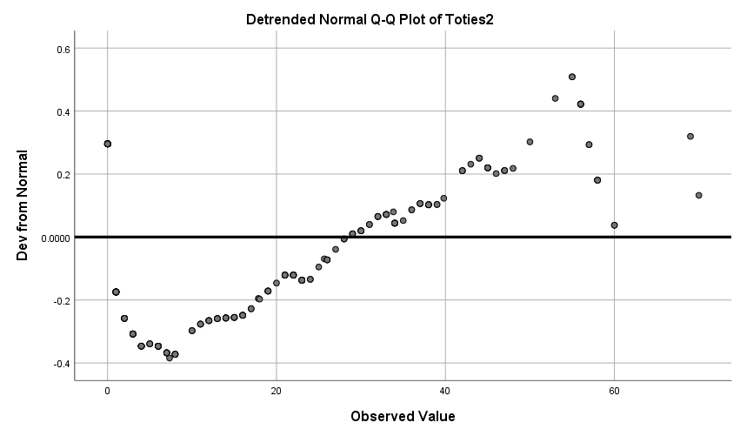

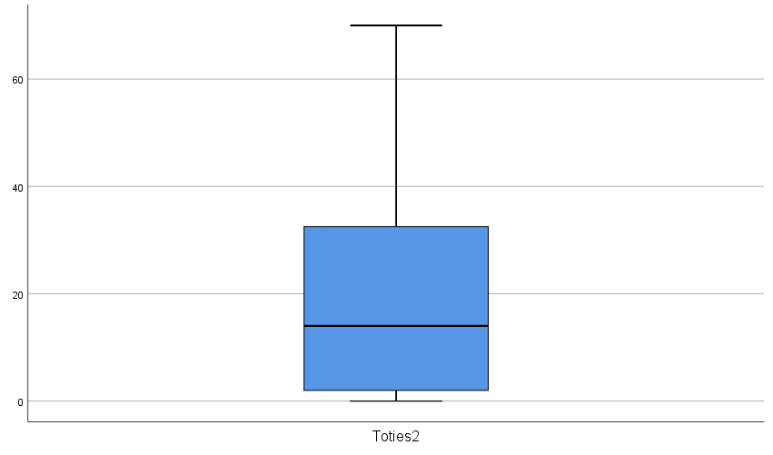

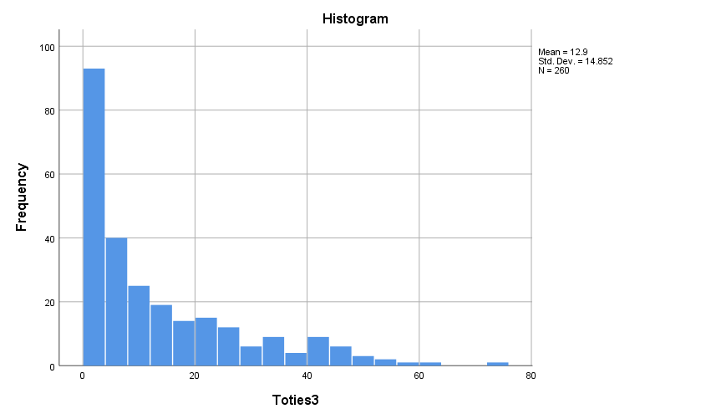

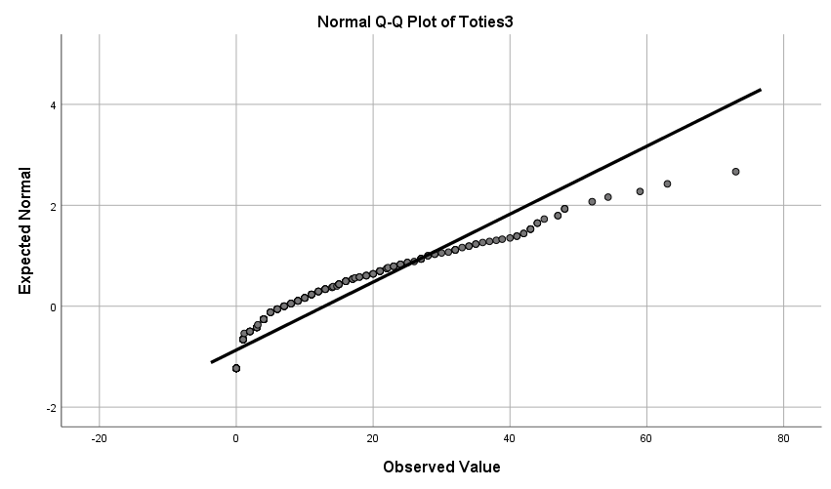

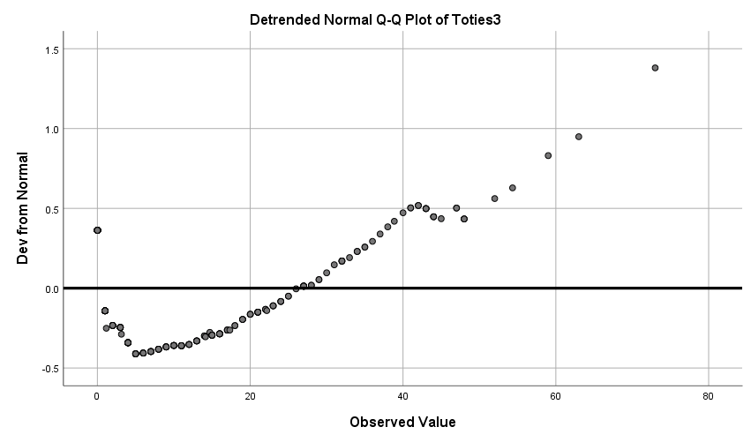
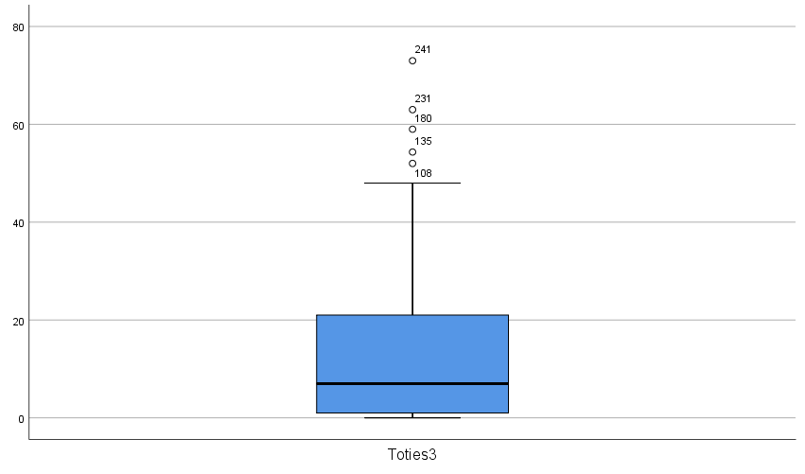

Descriptive Statistics
 | N | Minimum | Maximum | Mean | Std. Deviation
Group | 255 | 1 | 2 | 1.51 | .501
Gender | 255 | 1 | 99 | 3.02 | 10.498
Age | 253 | 18 | 81 | 50.70 | 12.032
Marital status | 251 | 1 | 4 | 2.07 | .663
Education | 253 | 1 | 6 | 3.47 | 1.696
Number of children | 253 | 0 | 5 | 1.68 | 1.171
Toties1 | 255 | 0 | 66 | 16.73 | 16.313
Toties2 | 255 | 0 | 70 | 18.35 | 17.968
Toties3 | 255 | 0 | 48 | 11.97 | 13.372
Valid N (listwise) | 245

Case Processing Summary
 | Cases
 | Valid |  | Missing |  | Total
 | N | Percent | N | Percent | N | Percent
Toties1 | 255 | 100.0% | 0 | 0.0% | 255 | 100.0%
Toties2 | 255 | 100.0% | 0 | 0.0% | 255 | 100.0%
Toties3 | 255 | 100.0% | 0 | 0.0% | 255 | 100.0%

Descriptives
 |  |  | Statistic | Std. Error
Toties1 | Mean |  | 16.73 | 1.022
Toties1 | 95% Confidence Interval for Mean | Lower Bound | 14.72
Toties1 | 95% Confidence Interval for Mean | Upper Bound | 18.74
Toties1 | 5% Trimmed Mean |  | 15.61
Toties1 | Median |  | 12.00
Toties1 | Variance |  | 266.115
Toties1 | Std. Deviation |  | 16.313
Toties1 | Minimum |  | 0
Toties1 | Maximum |  | 66
Toties1 | Range |  | 66
Toties1 | Interquartile Range |  | 25
Toties1 | Skewness |  | .823 | .153
Toties1 | Kurtosis |  | -.396 | .304
Toties2 | Mean |  | 18.35 | 1.125
Toties2 | 95% Confidence Interval for Mean | Lower Bound | 16.13
Toties2 | 95% Confidence Interval for Mean | Upper Bound | 20.56
Toties2 | 5% Trimmed Mean |  | 17.14
Toties2 | Median |  | 14.00
Toties2 | Variance |  | 322.857
Toties2 | Std. Deviation |  | 17.968
Toties2 | Minimum |  | 0
Toties2 | Maximum |  | 70
Toties2 | Range |  | 70
Toties2 | Interquartile Range |  | 29
Toties2 | Skewness |  | .791 | .153
Toties2 | Kurtosis |  | -.442 | .304
Toties3 | Mean |  | 11.97 | .837
Toties3 | 95% Confidence Interval for Mean | Lower Bound | 10.32
Toties3 | 95% Confidence Interval for Mean | Upper Bound | 13.62
Toties3 | 5% Trimmed Mean |  | 10.79
Toties3 | Median |  | 7.00
Toties3 | Variance |  | 178.813
Toties3 | Std. Deviation |  | 13.372
Toties3 | Minimum |  | 0
Toties3 | Maximum |  | 48
Toties3 | Range |  | 48
Toties3 | Interquartile Range |  | 19
Toties3 | Skewness |  | 1.140 | .153
Toties3 | Kurtosis |  | .269 | .304

Extreme Values
 |  |  | Case Number | Value
Toties1 | Highest | 1 | 128 | 66
Toties1 | Highest | 2 | 75 | 59
Toties1 | Highest | 3 | 163 | 59
Toties1 | Highest | 4 | 10 | 54
Toties1 | Highest | 5 | 245 | 53
Toties1 | Lowest | 1 | 255 | 0
Toties1 | Lowest | 2 | 249 | 0
Toties1 | Lowest | 3 | 242 | 0
Toties1 | Lowest | 4 | 240 | 0
Toties1 | Lowest | 5 | 229 | 0ª
Toties2 | Highest | 1 | 75 | 70
Toties2 | Highest | 2 | 10 | 60
Toties2 | Highest | 3 | 18 | 60
Toties2 | Highest | 4 | 7 | 58
Toties2 | Highest | 5 | 15 | 58^{b}
Toties2 | Lowest | 1 | 251 | 0
Toties2 | Lowest | 2 | 250 | 0
Toties2 | Lowest | 3 | 242 | 0
Toties2 | Lowest | 4 | 240 | 0
Toties2 | Lowest | 5 | 239 | 0ª
Toties3 | Highest | 1 | 22 | 48
Toties3 | Highest | 2 | 68 | 48
Toties3 | Highest | 3 | 244 | 48
Toties3 | Highest | 4 | 67 | 47
Toties3 | Highest | 5 | 117 | 47
Toties3 | Lowest | 1 | 255 | 0
Toties3 | Lowest | 2 | 250 | 0
Toties3 | Lowest | 3 | 249 | 0
Toties3 | Lowest | 4 | 242 | 0
Toties3 | Lowest | 5 | 240 | 0ª
a. Only a partial list of cases with the value 0 are shown in the table of lower extremes.
b. Only a partial list of cases with the value 58 are shown in the table of upper extremes.

Tests of Normality
 | Kolmogorov-Smirnovª |  |  | Shapiro-Wilk
 | Statistic | df | Sig. | Statistic | df | Sig.
Toties1 | .153 | 255 | .000 | .883 | 255 | .000
Toties2 | .154 | 255 | .000 | .882 | 255 | .000
Toties3 | .185 | 255 | .000 | .832 | 255 | .000
a. Lilliefors Significance Correction

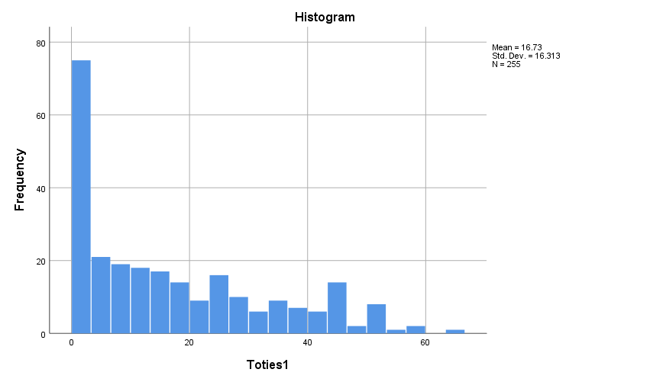

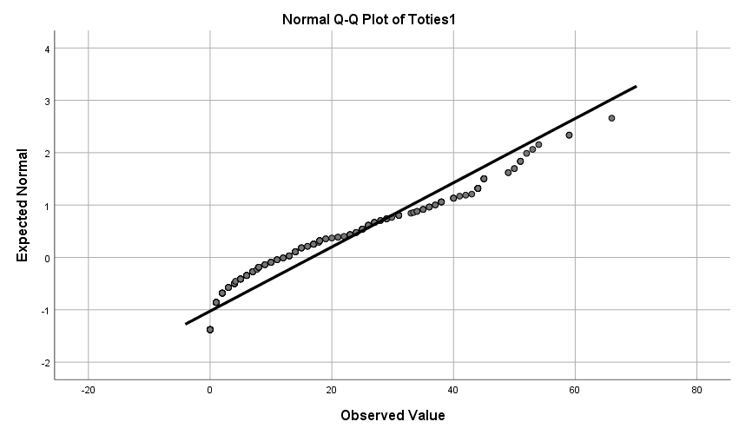

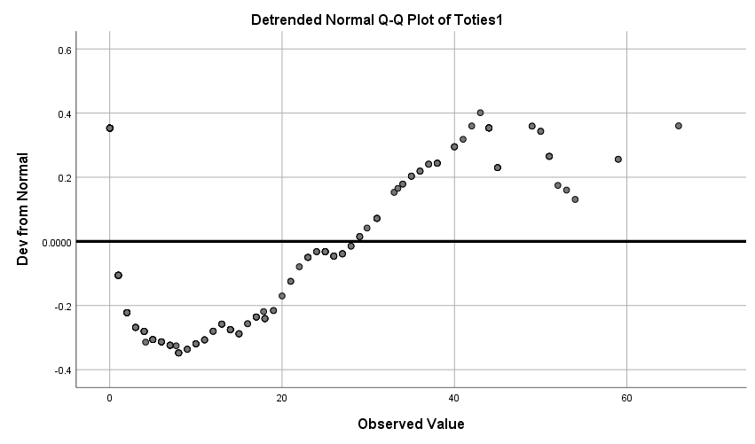

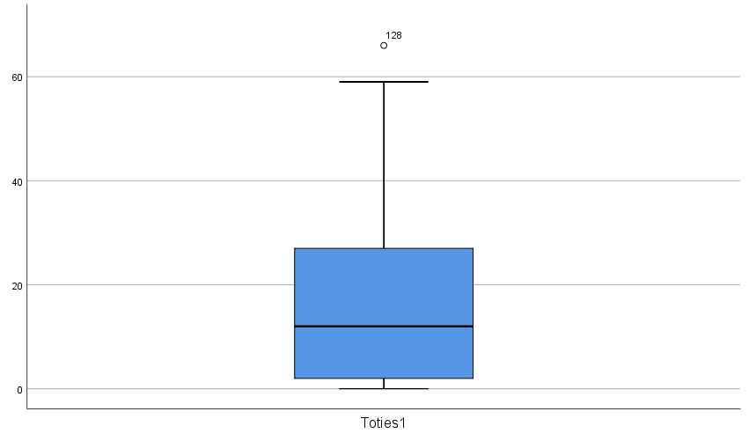

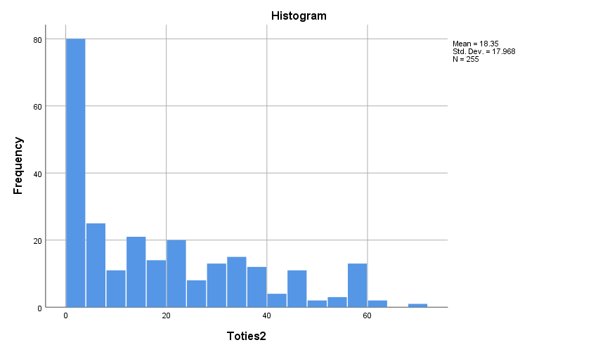

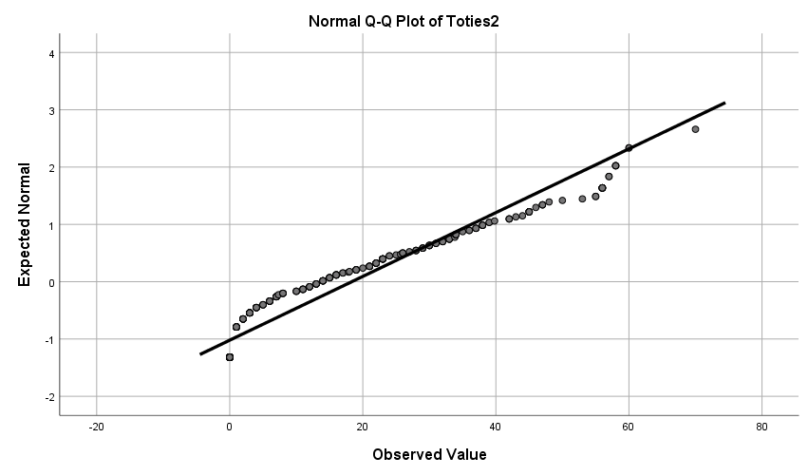

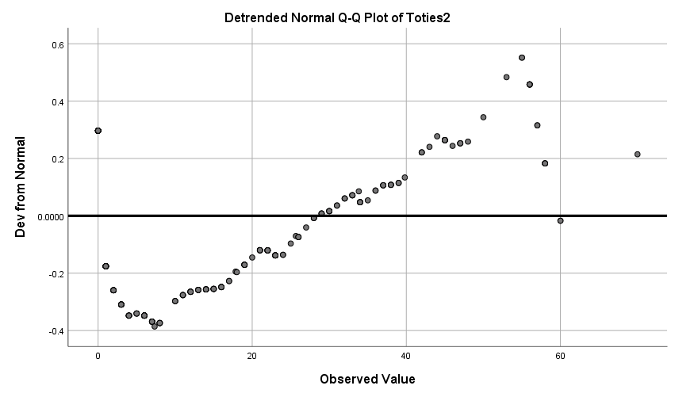

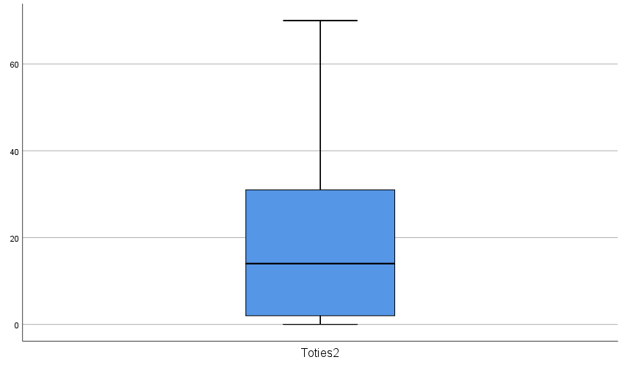

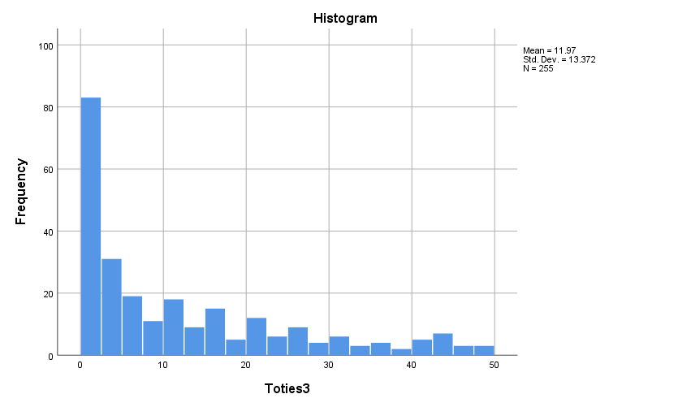

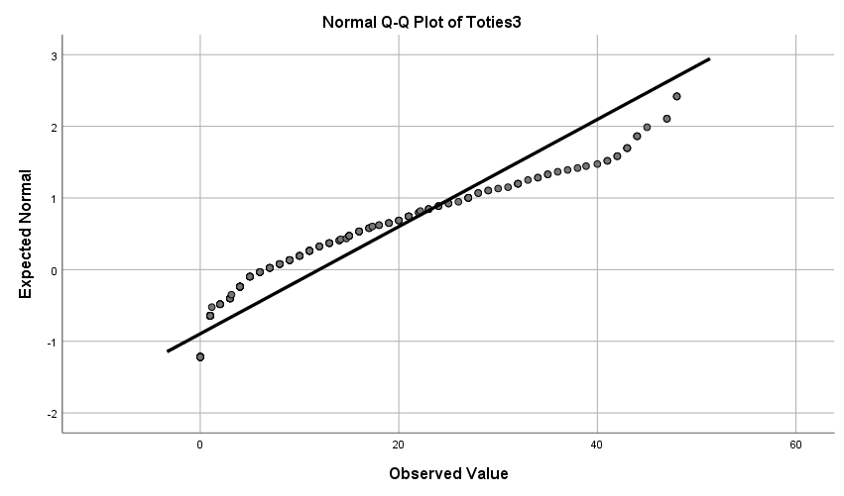

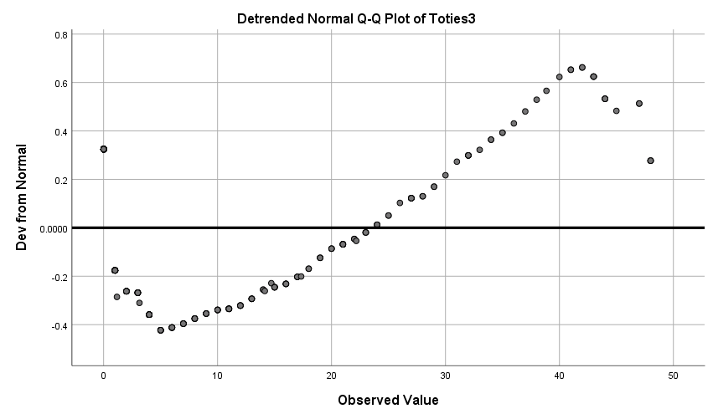

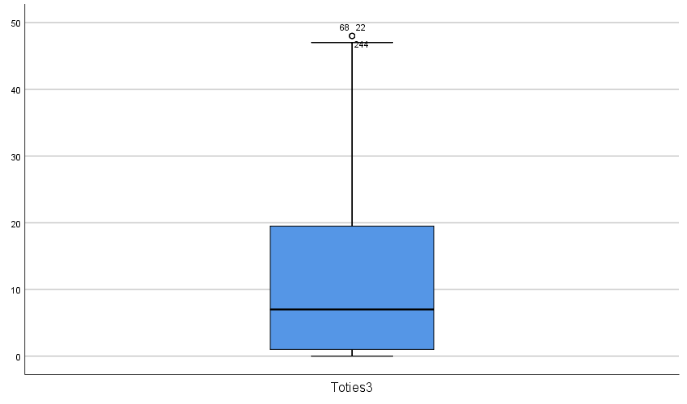

Group Statistics
 | Group | N | Mean | Std. Deviation | Std. Error Mean
Toties1 | Intervention | 125 | 17.13 | 17.529 | 1.568
Toties1 | Control | 130 | 16.34 | 15.110 | 1.325

Independent Samples Test
 |  | Levene's Test for Equality of Variances |  | t-test for Equality of Means
 |  | F | Sig. | t | df | Sig. (2-tailed) | Mean Difference | Std. Error Difference | 95% Confidence Interval of the Difference
 |  |  |  |  |  |  |  |  | Lower | Upper
Toties1 | Equal variances assumed | 1.625 | .204 | .388 | 253 | .699 | .793 | 2.047 | -3.238 | 4.824
Toties1 | Equal variances not assumed |  |  | .386 | 244.513 | .700 | .793 | 2.053 | -3.250 | 4.837

Within-Subjects Factors
Measure: MEASURE_1
time | Dependent Variable
1 | Toties1
2 | Toties2
3 | Toties3

Between-Subjects Factors
 |  | Value Label | N
Group | 1 | Intervention | 125
Group | 2 | Control | 130

Descriptive Statistics
 | Group | Mean | Std. Deviation | N
Toties1 | Intervention | 17.13 | 17.529 | 125
Toties1 | Control | 16.34 | 15.110 | 130
Toties1 | Total | 16.73 | 16.313 | 255
Toties2 | Intervention | 19.05 | 18.776 | 125
Toties2 | Control | 17.67 | 17.202 | 130
Toties2 | Total | 18.35 | 17.968 | 255
Toties3 | Intervention | 11.39 | 13.116 | 125
Toties3 | Control | 12.53 | 13.641 | 130
Toties3 | Total | 11.97 | 13.372 | 255

Box's Test of Equality of Covariance Matricesª
Box's M | 19.725
F | 3.245
df1 | 6
df2 | 461828.969
Sig. | .003
Tests the null hypothesis that the observed covariance matrices of the dependent variables are equal across groups.
a. Design: Intercept + Group
Within Subjects Design: time

Multivariate Testsª
Effect |  | Value | F | Hypothesis df | Error df | Sig. | Partial Eta Squared
time | Pillai's Trace | .134 | 19.447^{b} | 2.000 | 252.000 | .000 | .134
time | Wilks' Lambda | .866 | 19.447^{b} | 2.000 | 252.000 | .000 | .134
time | Hotelling's Trace | .154 | 19.447^{b} | 2.000 | 252.000 | .000 | .134
time | Roy's Largest Root | .154 | 19.447^{b} | 2.000 | 252.000 | .000 | .134
time * Group | Pillai's Trace | .006 | .753^{b} | 2.000 | 252.000 | .472 | .006
time * Group | Wilks' Lambda | .994 | .753^{b} | 2.000 | 252.000 | .472 | .006
time * Group | Hotelling's Trace | .006 | .753^{b} | 2.000 | 252.000 | .472 | .006
time * Group | Roy's Largest Root | .006 | .753^{b} | 2.000 | 252.000 | .472 | .006
a. Design: Intercept + Group
Within Subjects Design: time
b. Exact statistic

Mauchly's Test of Sphericityª
Measure: MEASURE_1
Within Subjects Effect | Mauchly's W | Approx. Chi-Square | df | Sig. | Epsilon^{b}
 |  |  |  |  | Greenhouse-Geisser | Huynh-Feldt | Lower-bound
time | .851 | 40.726 | 2 | .000 | .870 | .879 | .500
Tests the null hypothesis that the error covariance matrix of the orthonormalized transformed dependent variables is proportional to an identity matrix.
a. Design: Intercept + Group
Within Subjects Design: time
b. May be used to adjust the degrees of freedom for the averaged tests of significance. Corrected tests are displayed in the Tests of Within-Subjects Effects table.

Tests of Within-Subjects Effects
Measure: MEASURE_1
Source |  | Type III Sum of Squares | df | Mean Square | F | Sig. | Partial Eta Squared
time | Sphericity Assumed | 5652.284 | 2 | 2826.142 | 25.447 | .000 | .091
time | Greenhouse-Geisser | 5652.284 | 1.740 | 3247.882 | 25.447 | .000 | .091
time | Huynh-Feldt | 5652.284 | 1.758 | 3214.731 | 25.447 | .000 | .091
time | Lower-bound | 5652.284 | 1.000 | 5652.284 | 25.447 | .000 | .091
time * Group | Sphericity Assumed | 221.424 | 2 | 110.712 | .997 | .370 | .004
time * Group | Greenhouse-Geisser | 221.424 | 1.740 | 127.234 | .997 | .361 | .004
time * Group | Huynh-Feldt | 221.424 | 1.758 | 125.935 | .997 | .361 | .004
time * Group | Lower-bound | 221.424 | 1.000 | 221.424 | .997 | .319 | .004
Error(time) | Sphericity Assumed | 56196.082 | 506 | 111.059
Error(time) | Greenhouse-Geisser | 56196.082 | 440.296 | 127.633
Error(time) | Huynh-Feldt | 56196.082 | 444.836 | 126.330
Error(time) | Lower-bound | 56196.082 | 253.000 | 222.119

Tests of Within-Subjects Contrasts
Measure: MEASURE_1
Source | time | Type III Sum of Squares | df | Mean Square | F | Sig. | Partial Eta Squared
time | Linear | 2914.127 | 1 | 2914.127 | 22.237 | .000 | .081
time | Quadratic | 2738.158 | 1 | 2738.158 | 30.066 | .000 | .106
time * Group | Linear | 119.146 | 1 | 119.146 | .909 | .341 | .004
time * Group | Quadratic | 102.279 | 1 | 102.279 | 1.123 | .290 | .004
Error(time) | Linear | 33155.047 | 253 | 131.048
Error(time) | Quadratic | 23041.035 | 253 | 91.071

Levene's Test of Equality of Error Variancesª
 |  | Levene Statistic | df1 | df2 | Sig.
Toties1 | Based on Mean | 1.625 | 1 | 253 | .204
Toties1 | Based on Median | .671 | 1 | 253 | .413
Toties1 | Based on Median and with adjusted df | .671 | 1 | 243.358 | .413
Toties1 | Based on trimmed mean | 1.233 | 1 | 253 | .268
Toties2 | Based on Mean | .354 | 1 | 253 | .552
Toties2 | Based on Median | .149 | 1 | 253 | .699
Toties2 | Based on Median and with adjusted df | .149 | 1 | 243.834 | .700
Toties2 | Based on trimmed mean | .288 | 1 | 253 | .592
Toties3 | Based on Mean | 1.166 | 1 | 253 | .281
Toties3 | Based on Median | .421 | 1 | 253 | .517
Toties3 | Based on Median and with adjusted df | .421 | 1 | 252.988 | .517
Toties3 | Based on trimmed mean | 1.053 | 1 | 253 | .306
Tests the null hypothesis that the error variance of the dependent variable is equal across groups.
a. Design: Intercept + Group
Within Subjects Design: time

Tests of Between-Subjects Effects
Measure: MEASURE_1
Transformed Variable: Average
Source | Type III Sum of Squares | df | Mean Square | F | Sig. | Partial Eta Squared
Intercept | 188119.490 | 1 | 188119.490 | 343.448 | .000 | .576
Group | 22.568 | 1 | 22.568 | .041 | .839 | .000
Error | 138577.527 | 253 | 547.737



