Models of Reflection in University of Wales Trinity Saint David

Module: Academic and Employability Skills
BMSW 4001
Student name: Daniela Ciornea
Student ID: 1907166
Group: 11
Term: 2
Tutor`s Name: Lloyd Beharry

Terms of reference
A report submitted in attainment of the demands for the course Academic and Employability Skills, University of Wales Trinity Saint David London Campus.

Table of Contents:

Introduction…………………………………………………………….….3
Personal and professional development……………………………….4
Time management………………………………………………………..5
Writing a cover letter……………………………………………………...6
Reflective writing…………………………………………………………..7
Conclusion………………………………………………………………….9
Bibliography……………………………………………………………….10
Appendix A
Appendix B

Introduction
I will introduce myself as Daniela Ciornea, currently a student of the UWTSD, London Campus. My task for this module is to write an academic report in which I should reflect on my learning and how the topics I`ve studied have improved my outlook.
Being an international student comes with a slight advantage of having the tutors ready to go above and beyond, breaking any language barrier just to offer me a better understanding of the subjects or theories I came to study.
Coming from a conservative family, my parents always put an accent on my education. Despite of their efforts I wasn`t able financially to attend one. I start working in the hospitality environment back home in Romania, then I had the chance to move here, in the UK, where I continued working in the same field. Through my jobs I have developed naturally my ability to work in a team, time management-living in London I had to take into consideration the traffic or the rush hour, in order to complete my journey to work on time-as well as my capacity to communicate. But all this wasn`t enough, I dreamt of working in an office of those big shinny buildings in Central London and only graduating from a University will make that happen.
After a short time that I spent as an undergraduate I gained self-confidence, clarity and concise in my speech, I can accommodate my speech to different mass, or I can apply critical thinking where is needed.
As you will discover further in my work, I had depicted my understanding of different academic and employability skills and how they came in handy for me.

Personal and professional development
In my understanding, personal and professional development is a phenomenon which took place once I realized that I want more from this life, I wanted to live not just to exist. Having the foundation naturally in my conscience I had embraced the lessons aims and I tried to apply them by changing my daily routine, my way of interacting with people and as well I have learned to listen carefully to the tasks I was given to complete it with a can do attitude.
From book writers to bloggers and influencers, I got the push to better myself and from my teachers I learned how to approach each situation with a positive attitude. Personal and professional development is recommended to people like me, who want to expand their potential, to improve the communication skills in order to be more sociable and effective or simply to become the best version of them that they can be.
Since the beginning of the time, mankind understood that in order to have power or influence one must get knowledge which comes with self-discipline flexibility and a strong will to achieve goals that have been set. Biblical figures such as Jesus or Mohammed have shaped the spiritual way of personal development. In the current times, psychologists like Joseph Luft and Harry Ingham have developed the Johari Window, an approach meant to help us comprehend the affair with self or others. Another important outlining technique is SWOT analysis which had an unknown author, although most writers attribute it to Albert Humphrey, he took no credit for it, but he developed it in 1960 and 1970 at Stanford Research Institute, America.
As I learned from my teachers, the Strengths, Weaknesses, Opportunities and Threats if they are well defined one can prevent anything that can influence the success of a plan. In the appendix A I have attached a copy of my in-class exercise from term 1, a personal development plan.
Time management
In my opinion, time management is a set of principles, practices, skills and systems used to control the time spent for doing specific activities in order to increase efficiency and productivity.
By investing little time and effort I acquired a better understanding of self- discipline and how the lack of it is the main cause of failure. A better use of time was reflected by my personal efficiency in the work environment as my speech has improved, I can adapt better to changes as well as my creativity being well developed.
Eisenhower`s most famous strategy called `The Eisenhower box`, I`ve found it as a simple method of sorting activities according to four main outcomes:
- Urgent and important
- Important but not urgent
- Urgent but unimportant
- Neither urgent nor important
The advantage of this strategy is that it can be repeated in decision making, I found perseverance as being crucial. (M. Krogerus-2001)
On the other hand, `being perpetually busy is a kind of laziness` (T. Ferriss-2009), so I had to try and eliminate all the unnecessary time-consuming things on a daily basis in order to achieve a better productivity.
This course has made it clearer to me on how I see the culmination of my journey, what really matters to me and has defined the values according to which I live my life.

Writing a cover letter
`A covering letter is a professional business letter which provides an employer with an introduction to an accompanying CV`. (Morgan, 2017 339)
After years of work experience, tens or probably hundreds of interviews, this term I understood that what cause all my failures in getting the job I wanted was the complete lack of a cover letter as a selling point for my CV. Most of the ordinary jobs don`t require a cover letter and positions such as assistant manager or general manager are obtained by people who`ve been in the company from the beginning and worked their way up on better positions the company had available.
As I wanted a better lifestyle a change of carrier was imminent, but as no one taught me that I should`ve support my CV with a cover letter to highlight my strengths, ambitions or personality, I failed to get the job I wanted. After I discussed the subject at school, my teacher made me understand the importance of a cover letter, how recruiters are impressed by my extra effort into looking for information about their company and how I can differentiate myself from other applicants.
I have attached in the Appendix B, a copy of my in-class exercise, a cover letter which should suit the requirements of this study.

Reflective writing
Gibb`s reflective cycle is probably one illustrious figure of reflection which induce us through peculiar phases giving the taste of an experience.

I will enunciate systematically using the six steps of Gibb`s reflective cycle an individual issue which took place at work, time ago, while I was working as a duty manager for an arcade venue. I consider the incident as being relevant as a reflection model.
Description: I was on a closing shift with one of my trainee colleagues, Roy. Normally, the keys of the shop would stay with me until next day when I would bring them in. As I had off the next day, my manager asked me to handle the keys to Roy due to him being on the rota. The succeeding day has come and I found out that by mistake Roy`s parents took the keys with them on a holiday to France. It was a breach in the regulation of the company which my manager decided to keep it secretly from area manager, so my colleague won`t loose his job. Days have past, we struggled with one set of keys until Roy`s parents sent the keys via post. Everyone, including me, decided to support our manager and not tell a word to are manager.
Feelings: When my manager asked me to handle the keys to an unexperienced colleague, I was aware that it meant breaking the rules of the company. During the time we`ve waited for the keys to return, I felt bad fir not respecting my job description, but since I was loyal to the manager, I choose not to inform the area manager. After this episode, I felt relieved as nothing major affected our daily routine.
Evaluation: Considering that Roy was still in training, and not really a reliable colleague, he didn`t understood the importance of the task that he was given. All the team comforted him when we should`ve taken drastic measures.
Analysis: In this precise case, I consider that my manager didn`t had a good understanding of the time management notion, she should`ve manage better the priorities and made sure important work gets done. “What is important is seldom urgent- and what is urgent is seldom important” (Dwight Eisenhower)
Conclusion: If I were in my manager`s shoes, I would`ve not given the task in the first place to a trainee. Even if I would`ve committed the mistake to do it, I would`ve taken full responsibility for it and inform area manager, as things could`ve perverted into a worst situation.
Action plan: I am aware that this unique moment won`t happen again, but in case it would, I will offer myself to bring in the keys next day regardless if I have a day off. I consider that in order to be successful in any career you will go above and beyond to satisfy the company needs.

Conclusion
With the guidance of the previous arguments, I could understand that the world is in a permanent change and I needed to get out of my comfort zone, not to deceive myself that is enough as much as I knew. Using a personal development plan, I have changed habits and opened up to new perspectives as well with the help of The Eisenhower Box I became more fruitful and I could make a better use of my time constructively. I matured an attitude with which I read or listen to the arguments of others, advised, sceptical, sometimes sharp or other times praising. I was fortunate to have teachers with a “socratic attitude” that encouraged me to express different questions, preferably intelligently argued.
The above study shed light on the fact that the technological progress has also changed the situation of workers in production, retail and logistics. The process of modernization and automation will probably change the labour market as well, where processes are becoming more efficient and manual labour is largely replaced by robots. In the long run, graduates will represent a higher value in the labour market. Awareness of this leads to an increase in the education of the next generation and, therefore, to an improvement in living standards, such as health, productivity and well-being.

Bibliography

Brookes.ac.uk. 2020. Reflective Writing: About Gibbs Reflective Cycle - Oxford Brookes University. [online] Available at: <https://www.brookes.ac.uk/students/upgrade/study-skills/reflective-writing-gibbs/> [Accessed 29 April 2020].
Ferris, T., 2009. The 4-Hour Week: Escape 9-5, Live Anywhere and Join the New Rich. 2nd ed. New York: Crown Publishing Group.
Morgan, P.,2017. The Business Student`s Guide To Study And Employability. London: SAGE Publications Ltd.
Maund, A., Schriek, M., Tinkler, P. K., 2017. Certificate in Higher Education: Skills for the Workplace Student Yearbook. London: 1st ed. SAGE Publications Ltd.
Krogerus, M., Tschappeler, R., 2017. The Decision Book: Fifty Models For Strategic Thinking. new ed. London: PROFILE BOOKS LTD
Masters, M. and Albright, R., 2002. The Complete Guide To Conflict Resolution In The Workplace. New York: AMACOM.​

Appendix A

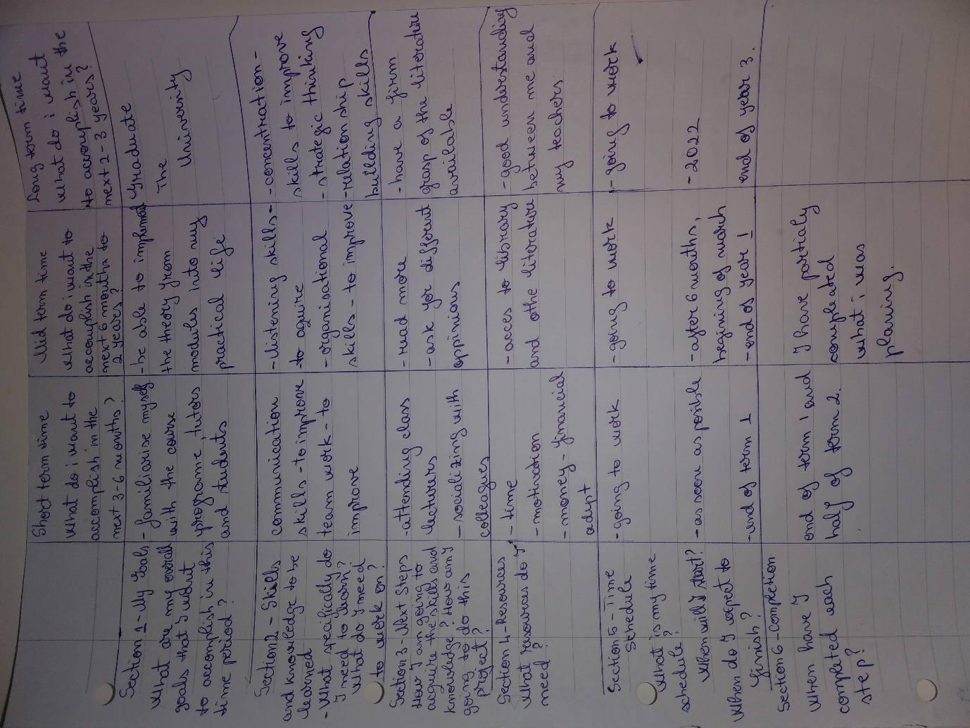

Appendix B


