Topic: How Can differentiation improve student engagement in school

Table of Contents
Topic: How Can differentiation improve student engagement in school 1
Aim, focus and purpose of the research / Research Context 3
Aims of Research 3
Objectives of Research 3
Purpose of the Research 3
Research Context 3
Overview of relevant literature 3
Explore the usage of differentiation strategies in academic settings 3
Assess the correlation between differentiation and student engagement 5
Identify challenges and excellent practices for implementing differentiation strategies 7
Explanation of Case Study 8
Research Methods for Enhancing Student Engagement through Differentiation Strategies 10
Data Presentation Methods: 12
Data Analysis Methods: 13
Ethical issues 14
Ethical Considerations: 15
Results Analysis: 16
Discussion: 18
Conclusions 19
References 20
Appendices 26
Appendix A 26

Aim, focus and purpose of the research / Research Context

Aims of Research
The aim of this research is to find out what different methodologies that could be used in the classroom which will increase the engagement of students. Another aim is to study what previous researchers have found out regarding the engagement of students and what solutions they have concluded. It seeks to explore how tailoring preparation to the wishes of individual students can boost their motivation, engagement, and normal instructional overall performance.

Objectives of Research
- Can differentiation improve student engagement in school.
- Look at the connection between differentiation and student engagement.
- Identify challenges and high-quality practices for enforcing differentiation strategies.

Purpose of the Research
The purpose of this research is to provide educators and participants with insight into the effectiveness of differentiation in improving student engagement. By analysing the connection between differentiated instruction and student motivation, engagement, and academic achievement, also this essay will look at goals to improve academic practices and offer evidence-based guidelines to develop learning and student engagement (Schnitzler et al. 2021). During my observations it has been notices that in lesson there was a lack of engagement from student’s which leads to negative impacts on students’ exams as they are not focused and not learning enough within the lesson time.

Research Context
Meeting school students’ demands and studying patterns has grown to be an increasing number of important factors in classrooms. However, traditional gaining knowledge of strategies never meets the need of each pupil. Differentiation gives solutions by using guidance to meet student’s needs (Wong, and Liem, 2022).

Overview of relevant literature

Explore the usage of differentiation strategies in academic settings
Differentiation strategies are vital to satisfy the diverse needs of school students in educational settings. According to Reeve et al. (2020), the most common method is handy grouping, where students are organised into small groups primarily based on readiness and learning needs. For instance, students in a technological understanding classroom can be grouped primarily based on previous understanding of the subject, the students who need extra support, and those geared up for suitable participatory activities. This allows teachers to tailor instructions to the specific needs of every organisation, providing suitable support or assignments. The research of Reeve et al. (2020), provides supports the research of differentiation can improve students’ engagement, this is by differentiation strategies like flexible grouping have the potential to improve student attention and increase student motivation.
Differentiation strategies such as handy grouping can be beneficial, however according to Ansalone (2010) it has been contradicted that using handy groupings can reinforce stereotypes and lower self-esteem and create a stigma for students in lower ability groups. As a result of this it can lead to unequal educational opportunities for different students.
The view of Reeve et al (2020) identifies the benefits of grouping student whilst Ansalone(2010) contradicts this view by explain how grouping students can create a stigma and lower self-esteem of student as they are being grouped. From both theories it can be understood that differentiation strategies like handy grouping have both benefits and drawbacks, requiring careful implementation to maximise effectiveness and minimize negative impacts.

According to Tomlinson, and Jarvis (2023) hierarchy of activities is an effective method of differentiation. Through standardised tests teachers carry out tasks of various levels of complexity within the classroom to prepare students to tackle different questions and exam techniques. For instance, students in a mathematics lesson doing algebra might be given an advanced level or challenging question. Some classwork requires a basic experience, whilst others require higher level experiences. This ensures that all students participate and make contributions at their suitable level and learn what is necessary for them.
In supporting the above authors’ perspective Cents-Boonstra et al. (2021) states educational organisations provide a dynamic approach of differentiating preparation. School students engage in diverse mastering-related activities. Each lesson is designed to deal with a particular aspect of the curriculum or getting to know targets and caters to several getting to know styles and choices, an example can be regulation’s role and peer advice. The theory of Tomlinson and Jarvis (2023) links to the research of differentiation and student engagement as differentiation strategies such as hierarchy of activities and learning stations have the potential to improve student engagement in school.

Tomlinson and Jarvis (2023), and Cents-Boonstra et al. (2021) provide evidence that schools can improve student engagement by diversifying learning styles and preferences. However, Oakes (1985) and Ansalone (2003) inform concerns about negative impacts on self-esteem, stereotypes, and inequalities.
Adopting a well-rounded strategy which capitalises benefits of differentiation while addressing potential risks could be the most suitable way forward. Implementation, continuous monitoring, and efforts to guarantee equal educational opportunities are crucial. Additionally, promoting a supportive learning environment can help moderate negative consequences. The effectiveness of differentiation strategies may depend on the specific context, implementation, and measures taken to address potential drawbacks.

Assess the correlation between differentiation and student engagement
The relationship between differences and student engagement with complex recommends through a variety of factors. On one hand, According to Wang, and Hoskens (2020) the difference of satisfying strong desires and learning the kind of students, possibly the most important to maintain socialisation while newcomers are more interested in what are encouraged to participate in. When training is adapted to individual’s readiness and choices, students are likely to feel accomplished in their academic skills, leading in the ideal steps of engagement. For example, a teacher might add a fun activity for students who choose handmade acquaintances rather than individuals who excel in creative discussions. Differentiation can shape their engagement in the curriculum by providing students with options that align with their interests and strengths. The view of Wang and Hoskens (2020) supports the researcher question of student engagement as he informs us options for students can increase the engagement.
The Curriculum for Wales (Welsh government, 2022) highlights the importance of developing a wide range of skills and knowledge across various Areas of Learning and Experience (Aoles). Differentiation can play a necessary role in increasing student engagement within these Aoles by creating options for student’s interests and strengths. This also links to the aspect of Ambitious, capable learners as differentiation allows teachers to adapt to individual student’s strengths, interests, and readiness levels within the Aoles.

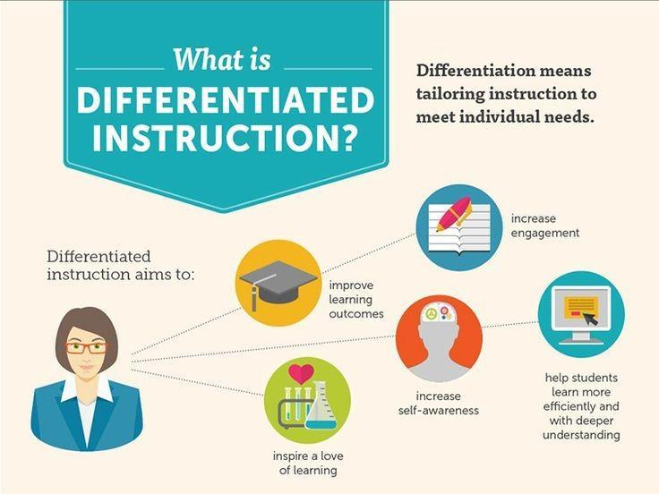
Figure 1: Differentiated Instruction
(Source: Cents-Boonstra et al. 2021)
In supporting the above author’s perspective Doman et al. (2020) said the options often incorporate interactive and collaborative game activities to develop understanding with the methods, which will further engage the students. For example, the possibility of institute work or peer coaching can encourage an interest in networking and collaboration between students, making learning more enjoyable and relevant. When students can collaboratively design and contribute their specific ideas to a cause, they may be more likely to engage in the activity.

However, Paulsen and McCormick (2020), the relationship between disparity and student engagement is not always reliable and can vary depending on many contextual factors. For example, the effectiveness of the differentiation depends on how well the classroom is managed through the teacher. If differentiation methods are not well designed or successful, they will not meet the needs of students or may aggravate feelings of frustration. Additionally, scheduling circumstances including restricted resources, time constraints, and class sizes may prevent them from taking advantage of powerful differentiation practices that affect student’s engagement.

Wang, and Hoskens (2020) suggest the differentiation strategies which cater students’ interest, readiness and learning preferences can increase engagement, whilst Paulsen and McCormick (2020) contradicts and states that effectiveness of differentiation in promoting engagement is not guaranteed which is influenced by contextual factors. Therefore, it can be agreed to Paulsen and McCormick (2020), that differentiation promise for increasing student engagement, the impact is conditional upon varies factors such as a lack of resources and cannot be guaranteed.

Identify challenges and excellent practices for implementing differentiation strategies
Some classrooms have difficult conditions and opportunities for teachers to use different teaching strategies. According to Zhao et al. (2021), careful planning requires good plans and education to tailor the guidance to the teachers' aims. Teachers must look at the different levels of students' coaching, interests, and learning choices to effectively use different teaching methods. Another challenge is to deal with the organisation and materials for separate education. Teachers may struggle to find enough time and resources, especially in small spaces, groups, teaching services, or lecture halls in large places, it can be hard to recognise each teacher personally, which can affect fairness and equity in the classroom. There is a need for professional flexibility for teachers to develop their skills and recognise the importance of differentiation. Without enough support and resources, teachers may feel overwhelmed or unprepared to use differentiation effectively, hindering its impact on student’s learning.

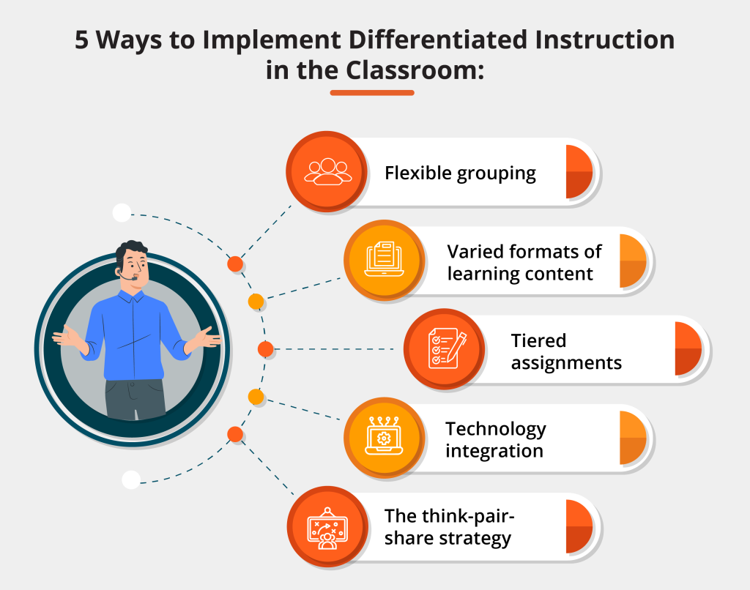
Figure 2: Best Practices for Differentiated Learning
(Source: Zhao et al. 2021)
Supporting the author’s views above, Tomlinson, and Imbeau (2023), states unexpected methods can help teachers overcome barriers and make the most of different teaching strategies.
Firstly, it is important to set clear goals and realistic expectations for teaching in a different way. Teachers need to talk to students to understand them and to give them the support and skills they can develop on their own. This clarity helps student’s see the goals and benefits of different activities and encourages them to take an active part in the learning process.
According to Bray et al. (2021), using technology and multimedia materials can provide practical ways to help students have the right access and interact with the material. Digital tools such as online simulations, interactive tutorials, and multimedia tips can fit with many different subjects and options, making it engaging and available to all students to learn more. Also, technology can help teachers plan student’s developments and change their different teaching methods because of different situations.

However, Valindes (2015) contradicted that differentiation can be challenging when there is large classrooms and limited resources, this leads to increasing work load for teacher therefore often the best quality of work may not be provided.
Both perspectives highlight valid points of implementation and effectiveness of differentiation strategies. While Zhao et al. (2021), Tomlinson and Imbeau (2023), and Bray et al. (2021) provide insights into overcoming barriers and using technology to support differentiation, Valiandes (2015) raise legitimate concerns about the potential challenges and unintended consequences of differentiation practices.
Effectiveness of differentiation can depend on different factors, including class size, resource availability and teacher training. While differentiation can be beneficial in meeting different student’s needs, it is vital to consider obstacles and address them using planning, and development.

Explanation of Case Study
Differentiation refers to adjusting the curriculum to meet the pupil's requirements. This teaching method works because it uses adaptability and continual evaluation, regardless of whether teachers change materials, processes, products, or the educational spaces. Pupils that are brilliant or very talented may also become disengaged. Consequently, irrespective of a student's beginning place or level of ability, personalised instruction gives techniques to motivate every pupil so that they take responsibility for their own investment in their education. Differentiation in school teaching has found the strategy to be a promising way to get students more engaged in classrooms (Pillai, 2022).
Principles of differentiation:
Teachers understand that each student learns differently. By teaching based on what students like and are good at, teachers can communicate more effectively. This approach agrees with modern educational theories that focus on what students learn and what they're interested in. However, putting this philosophy into practice can be difficult and challenging.
Practical Applications:
In practical education, changes are evident in more papers, combined with more teaching strategies, flexible group structures, customised assessment materials for example, teachers can take structured instructions the sequence has also offered a specific part of the work, or mastery facilities can be used to provide choice and autonomy for students. While such strategies promise to attract students, their implementation requires sophisticated strategies, and teacher profiles. Furthermore, effective differentiation depends on its alignment with curriculum standards and learning objectives.
The impact of student involvement can:
Differentiation is promoted by advocates as providing a more inclusive and welcome learning environment to meet the aspirations of behavioural students. Differentiation aims to reduce interference and increase academic performance by allowing for widespread study and scaffolding supervision. According to research, students who see their academic qualifications as meaningful and achievable are more likely to be motivated and engaged. However, empirical evidence on the direct effects of differentiation on teacher involvement is mixed and context-driven(Wong and Liem, 2022).
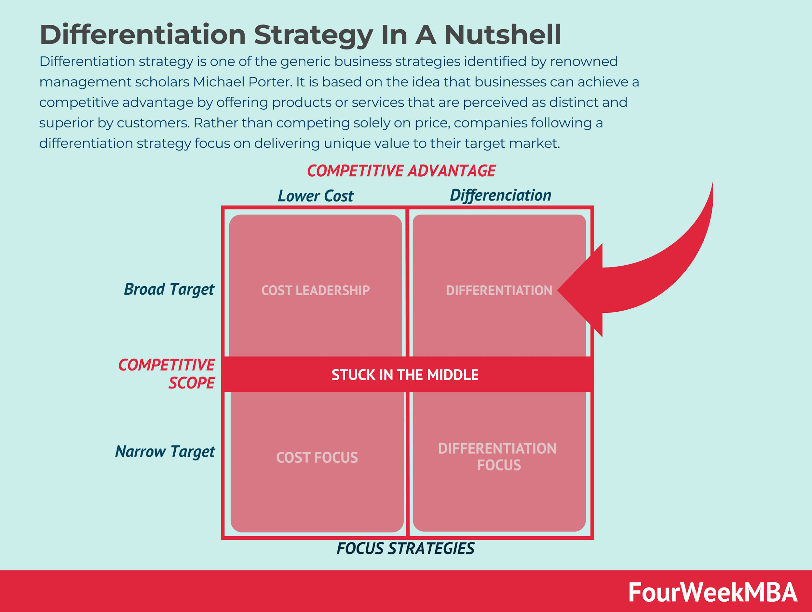
Figure 3: Differentiation Strategy
(Source: Wong and Liem, 2022)
Challenges and Limitations:
Differentiating instruction can be very challenging for teachers. They often have limited time and resources, especially in large, crowded classrooms (Tomlinson, 2014; Smit and Humpert, 2012). Effective differentiation requires a lot of planning, ongoing assessment, and personalised feedback, which can be overwhelming for teachers who are busy with other duties. Without training and support, teachers may struggle to implement differentiation successfully, resulting in inconsistent execution and little impact on student engagement.(Suprayogi et al., 2017)
Moreover, differentiation raises concerns about fairness and access, as marginalised children may not have the same learning opportunities. Differentiation methods may unintentionally widen existing gaps by favouring children who are more academically prepared or have more social support(Stavroula et al., 2011) Therefore, while differentiation aims to promote inclusivity, its implementation must address systemic inequalities and ensure all students have access to high-quality learning experiences (UNESCO, 2020).

Research Methods for Enhancing Student Engagement through Differentiation Strategies
Improving student engagement in classrooms requires a multifaceted approach that integrates numerous techniques to build up complete insights (Jin et al., 2021). This theory elaborates on the research strategies determined for analysing the impact of differentiation techniques on student engagement, highlighting their strengths and obstacles.

The research methodologies carried out are interview open questions, these questions will be selected for the appropriate age group and in simple English to make it easily understandable. Focus groups of fifteen students and other adults, students from the age of 11-15 will be participating. questionnaires of open questions, computer-generated log-files, and observations of different of the same lesson with different teachers and. This research should be carried out over a week. This research will be appropriate because it is not time consuming and each day there will be something different for the students to engage with.

Observation Method:
Observing classrooms helps researchers to quickly check how teachers teach, students behave, and interaction. Studies show it is good for getting real-time information about what is happening in classrooms. Teaching in different ways can make students more interested, especially when teaching is adjusted for boys and girls (Tomlinson & Allan, 2000). But there are challenges, like the observer's preference and the effects it has. People might change how they act if they know they are being watched. To make sure there is no favouritism, it's important to have a set observation schedule. This schedule lists specific behaviours related to how engaged students are, like taking part, staying focused, working together, and responding to different tasks (Insorio et al., 2021).

Whilst classroom observation can provide valuable insights into teaching and student engagement, Mujis (2006) contradicts this view and states observations can be subjective by personal beliefs and expectations therefore observations are not the best method to gather accurate information.

It can be agreeable to both theories that observations can be beneficial to an extent as it has positives and negatives.

Interview Method:
Interviews offer a qualitative intensity to enable researchers to explore into student’s views and emotions regarding engagement techniques. The literature highlights interviews as a tool for uncovering detailed insights (Creswell, 2013). Interviews can screen student’s options for certain education strategies, their perceptions of engagement, and the factors that enhance or forestall their engagement stages (Antonios et al., 2021). Structuring interviews with open-ended questions encourages contributors to percentage special memories and viewpoints. Semi-set up interviews strike a stability among flexibility and interest, making sure that key topics related to engagement, differentiation, and school room research are explored. Sample interview questions may additionally inquire about student’s reviews with differentiated guidance, their desired studying styles, demanding situations they face in staying engaged, and their tips for boosting school classroom engagement.

However Alshenqeeti(2014) argues interviews which are conducted in educational settings maybe bias as participants can be encouraged to give a favourable response to the institute. Therefore, the accuracy of the interviews may not be 100% accurate and the useful to an extent.

Limitations
However, there are some limitations to interviews such as it can be time consuming especially when dealing with large number of participants (Opdenakker, 2006; Younas and Muan Yew, 2021). Also interviews rely on self-reported data from participants, which can be influenced by various preferences and subjective interpretations (Baumbusch, 2010; Yin, 2018). Moreover, during interview the body language can introduce influence the responses provided by participants (Chenail, 2011; Patton, 2015).

Questionnaire Method:
Questionnaires are efficient tools for collecting quantitative information on engagement stages and satisfaction with schooling strategies. They offer steadiness, allowing researchers to build records from a larger sample length and conduct statistical assessment (Babbie, 2016). However, questionnaires furthermore have obstacles, which includes response preferences and reliance on self-cautioned facts (Gupta et al., 2021). Designing questionnaires allows researchers to diploma engagement stages quantitatively. Closed-ended questions with response alternatives starting from strongly observed to strongly disagree offers very limited information, whilst open-ended questions provide qualitative insights into student's perceptions and studies related to engagement techniques. Questionnaires can provide efficient data, however some researchers have raised concerns about questionnaires being biased or having leading questions According to Choi and Pak (2005). To avoids these factors, questionnaire will not contain biased or leading questions.

Focus Groups, Theoretical Research, and Previous Assessments:
Focus groups are valuable for exploring school’s dynamics, uncovering shared opinions, and producing discussions on engagement strategies. They provide a collaborative environment wherein people can share views and insights (Krueger & Casey, 2014). Theoretical studies give a theoretical framework for information engagement theories, which include Vygotsky's Zone of Proximal Development, which emphasizes the importance of scaffolding and tailor-made instructions (Nakhchivan et al., 2021). Looking at past exams and academic performance records helps understand trends in engagement levels, evaluates the effectiveness of previous strategies, and guide the creation of new approaches.
However, there are some limitations of focus groups such as certain individuals may dominate the discussion, while others may remain quiet or struggle to contribute. (Krueger and Casey, 2014; Onwuegbuzie et al., 2009). The focus group representative's skills, attitudes, and personal characteristics can influence the group dynamics and the nature of the responses found (Holloway and Galvin, 2016; Sim and Waterfield, 2019).

Impact of Information on Research Method:
The research methods chosen are influenced by various factors, such as the student’s ages, academic backgrounds, cultural diversity, and the specific context of the study. For example, research strategies need to be culturally appropriate to ensure that questions, activities, and tasks are relatable for different groups of students. Using age-appropriate language and engagement techniques is also essential (Marks et al., 2021). Additionally, considering the student’s current learning levels allows researchers to tailor their strategies to gather insights relevant to important skills and perspectives.

Data Presentation Methods:
Descriptive Statistics:
Descriptive information is essential for summarising and supplying quantitative information. Measures like mean, median, mode and frequency distributions provide a concise evaluation of crucial inclinations and variability in scholar engagement tiers. Using that information, you can efficiently talk about the distribution and tendencies in your statistics to your purpose market.
Charts and Graphs:
Visual representations which include bar graphs, pie charts, and graphs are powerful tool for showcasing patterns and comparisons. Bar graphs can display the variations in student engagement before and after enforcing differentiation strategies (Micanovicet al., 2021). These visible aids enhance facts interpretation and make complicated records extra on hand for your readers.

Qualitative Coding and Themes:
Qualitative data from interviews or open-ended survey responses can analyse the usage of coding techniques. By identifying topics and styles, you could use extract qualitative insights into student perceptions of engagement techniques. This technique offers depth on your evaluation with the resource of taking views and studies.
However, Researchers have highlighted issues with the potential subjectivity of coding qualitative data. St. Pierre and Jackson (2014) argue that identifying themes and patterns being subjective, precise to researcher’s personal preferences and experiences.
To avoid these issues all aspects triangulations will be used by using multiple data sources and methods.

Data Analysis Methods:
Statistical Analysis:
Statistical checks such as exams can verify the significance of variations in student engagement stages based totally on different factors, such as differentiation strategies. These exams provide quantitative proof to resource findings and decide the effectiveness of differentiating practices in improving engagement.
Content Analysis:
Content evaluation is required for studying qualitative records. By systematically reading interview transcripts or open-ended survey responses, it will discover underlying topics and commands related to student engagement factors and differentiation strategies(Smith et al., 2021). This approach presents depth in the evaluation through exploring the depth of the participants reminiscences.
Trustworthiness Processes:
Credibility:
To ensure the information is accurate, the use of more than one source of data such as interviews, surveys, and observations will be used. Checking data from multiple sources makes interpretations and findings more valid and reliable.
Transferability:
To make the findings more widely applicable detailed and honest descriptions of the research setting, participants, and how the data was collected will be provided. Using clear and transparent reporting allows readers to evaluate if the findings could be relevant to similar educational environments.
Dependability and Confirmability:
To Keep the research approach consistent, documents and any other documents will be maintain confidentiality and make detailed records of the collected data. This clarity ensures the findings are reliable and trustworthy (Kramer et al., 2021). By presenting the data clearly, analysing it thoroughly, and maintaining high standards of trustworthiness, the research can provide strong insights into how differentiation impacts student engagement. This can significantly contribute to discussions around education.

Ethical issues
There are several potential ethical issues that can arise when interviewing young students in a school setting such as privacy and confidentiality measures must be taken to protect the privacy and confidentiality of the student's and other participants. This includes using anonymous identifiers instead of real names, securing the data, and ensuring that sensitive or identifying information is not disclosed. Potential discomfort or distress can happen, some interview questions or topics may cause discomfort, distress, or bring up traumatic experiences for the students. To avoid this all participants can step put out any time to take breaks (Smith, 2023).
The interview questions and language used is age-appropriate and adapted to the developmental level of the students. Researchers are mindful of the potential for misunderstandings or limited comprehension due to the student’s cognitive and emotional maturity.
Students should be made aware that their participation is entirely voluntary, and they can choose not to answer any questions or withdraw from the interview at any time without consequences.
If the interview reveals any potential safeguarding issues or concerns about the well-being of a student, the researcher must follow appropriate protocols and reporting procedures to ensure the student's safety.
To mitigate these ethical concerns, researchers should follow established ethical guidelines, obtain necessary approvals from relevant bodies (e.g., institutional review boards, school administrators), and prioritize the well-being and rights of the student participants throughout the research process (Smith, 2023).

Anonymity and Confidentiality:
Anonymity:
Maintaining participant anonymity is critical to shield their identification and privacy. All information collected, which consists of responses from surveys, interviews, and observations, may be anonymised (Jin et al., 2021). Participant names, school information, and any figuring out statistics will get replaced with codes to ensure anonymity for the duration of the research.
Confidentiality:
Confidentiality safeguards the privateness of individuals and their information. All records obtained at some stage in the observation will be stored strictly. Data will be stored securely on university servers with restricted access, making sure that no unauthorized person can get right of access to or misuse the facts.
Process for Gaining Pupil Asset:
Informed Consent Process:
consent will be received from student’s parent’s guardians, as students are below the age of 18 and brought into interested minors (Doronio et al., 2021). Information sheets outlining the purpose, techniques, dangers, and confidentiality measures will be sent to parents/guardians. They will be handed with enough time to test the facts and decide whether they consent to their child’s participation.
Assent from Students:
Alongside parental consent, assent can be requested immediately from students. Assent tailor-made to the student’s statistics may be provided, explaining the check in age-appropriate language. Students can be informed that their participation is voluntary, and they could withdraw at any time without effects. Importance is placed on making sure students understand the cause of the observation, their function, and the confidentiality measures in place to protect their records.

Assuring Understanding:
To make certain students understand they will take part in researcher, interaction with them will be made making everything clear, addressing any questions or worries they may have (Panda et al., 2021). This interactive technique aims to guarantee that students understand their rights, the voluntary nature of participation, and the confidentiality assurances furnished.

Ethical Considerations:
Informed Consent and Assent:
Observing to ethical requirements, knowledgeable consent and assent techniques are important to understand people's autonomy and make certain they are willingly taking part in research. Clear communique of rights, dangers, and benefits fosters bear in mind and transparency.
Protection of Minors:
Given that students are minors, unique care may be taken to shield their well-being, privacy, and dignity within the direction of the test (Ogilvie, et al., 2021). Parental consent and pupil assent procedures are designed to prioritise the notable interests of the students.

Confidentiality Measures:
Confidentiality measures, as noted in advance, collectively with anonymisation of records, strong facts storage, and restricted, are critical to shield participants confidentiality and prevent unauthorised disclosure.
Ethics Form Compliance:
They will strictly follow to the suggestions noted inside the Ethics Form submitted for approval. Any deviations or amendments to the test protocol could be documented.

licensed via the applicable ethics committee.
By upholding the ethical issues, your test ensures that people's rights and well-being will be prioritised, fostering an honest and ethically sound study environment which will be inside of the school.

Results Analysis:
Observation Data Insights:
Classroom observations provides insights into the impact of differentiated schooling on student engagement. It was discovered that when teachers implemented differentiation techniques together with tiered assignments, bendy grouping, and varied educational materials, students exhibited higher tiers of participation, enthusiasm, and sustained interests in contrast to traditional educational techniques(Jin et al., 2021). This shows that adapting teaching techniques to in-form student’s numerous knowledge has an excellent effect on their engagement levels.
Differentiation was used in the classroom when students were provided with tiered assignments/ practices questions. The teacher provided different tasks for different ability levels to increase engagement. Also, another way differentiation was used was using grouping students based on different needs and interest, this improves students as they are given the ability to choose what they want to do and who to engage with. Furthermore, to this teacher differentiates the learning by using various materials such as texts, fun games, and different resources to increase student engagement. The use of differentiation to increase engagement is in this classroom used is mentioned by Jin, Yakar, and Somani (2021) in which it states an approach that tailors teaching methods, materials, and activities to meet the diverse needs and learning styles of students within a classroom will increase the level of engagement.

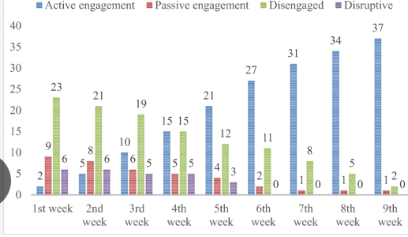

Figure : Student negement levels
(Source: researchgate 2021)
Interview Findings:
Interviews with teachers provided more detailed information for the analysis. Teachers said differentiation is important to meet each student's individual needs. However, they also discussed several challenges in using differentiation. Not having enough time, limited resources, and students being at different learning levels were major difficulties. Despite the challenges, teachers had positive views about using differentiation. They noticed improvements in student interest, skills, and academic performance when differentiated teaching methods were implemented properly (Biémar et al., 2021).

Survey Results Overview:
Surveys completed through students presented valuable feedback on their evaluations with differentiated gaining knowledge of. Students indicated a preference for personalised getting to know views that aligned with their specific analysing patterns and strengths. They preferred the possibilities to explore subjects at their personal pace, collaborate with friends of similar abilities, and acquire focused remarks from teachers. Overall, students stated feeling more brought about and assured in their getting to know while teaching techniques have been tailor-made to their individual desires.

Analysis of Results:
Interpreting the Data Significance:
The collective facts from observations, interviews, and surveys highlights the importance of differentiated teaching to improving student engagement, motivation, and educational overall performance(Muslimin et al., 2021). The correlation amongst differentiated educating strategies and persistent pupil engagement indicates that customised reading views sincerely impact student’s attitudes and behaviours inside the classroom.

Implications for Participants:
For teachers, the findings highlight the significance of ongoing professional development and manual in efficiently implementing differentiation strategies. Addressing worrying situations which include time constraints and useful resource boundaries is crucial to maximising the blessings of differentiated education. Schools can allocate educational workshops, collaborative planning periods among educators, and get admission to several educational materials to facilitate the successful adoption of differentiated practices.
Linking Results to Existing Literature:
The effects align with modern-day literature that highlights the benefits of differentiated guidance in offering student environments and enhancing instructional results(Jin et al., 2021). Studies have commonly shown that once school students obtain teaching tailored to their readiness, interests, and getting to know profiles, they screen higher ranges of engagement, achievement, and satisfaction with their learning studies. This test contributes to the continued discourse on powerful pedagogical methods that cater to numerous pupil needs and options.

Discussion:
From this researcher it can be identified that differentiation can improve student engagement in schools. The results show that using different teaching methods for different students has a positive effect on student engagement, motivation, and academic performance (Jin et al., 2021). Even though its challenging, teachers see the value in meeting each student's individual learning needs. Based on these findings, it is recommended that schools make professional development programs and resources a priority to help teachers implement different teaching methods effectively. Having collaborative planning time, access to a variety of teaching materials, and ongoing guidance can improve teachers' ability to tailor their teaching to meet the diverse needs of their students.

Future Research Directions:
Future studies could investigate deeper into specific techniques for overcoming boundaries to differentiation, assess the lengthy time period results of differentiated instruction on students gaining knowledge of consequences, and explore the effect of differentiated methods on student attitudes and self-efficacy(Jin et al., 2021). Comparative research among differentiated classrooms and conventional educational settings should provide in addition insights into the efficacy of differentiation in enhancing pupil engagement and academic fulfilment.

Conclusions
This research concludes that differentiation does improve student engagement in school classrooms. One of the key aspects from the research is the observational data has suggested that when teacher use differentiation techniques such as assignments, groupings, and other resource materials it will increase the engagement of students.
Further to this having carried out interviews with relevant staff members at school it has been found out that there will be challenges which will faced from differentiation such as having less resources and time consuming. On the other hand, improving the teaching skills it will improve motivation and engagement within students.
Moreover, the student surveys indicated a having lesson which are more aimed at the individuals needs during every lesson does increase the engagement in student as this is something they want to do. Willingly.
The information which has been collected from observing, questionnaires, and interviews informs that improving differentiation in teaching is a good for student engagement in classrooms.
In conclusion, this research strongly indicates that changing to new teaching methods to meet the need of students will increase student engagement. Meeting the need of students will and designing a lesson according to the student’s choices improve academic results in exams as the students will be more engaged in lessons.

References
- Schnitzler, K., Holzberger, D. and Seidel, T., 2021. All better than being disengaged: Student engagement patterns and their relations to academic self-concept and achievement. European Journal of Psychology of Education, 36(3), pp.627-652.
- Wong, Z.Y. and Liem, G.A.D., 2022. Student engagement: Current state of the construct, conceptual refinement, and future research directions. Educational Psychology Review, 34(1), pp.107-138.
- Tomlinson, C.A. and Jarvis, J.M., 2023. Differentiation: Making curriculum work for all students through responsive planning & instruction. In Systems and models for developing programs for the gifted and talented (pp. 599-628). Routledge.
- Cents-Boonstra, M., Lightwork-Aschoff, A., Denessen, E., Alterman, N. and Hearnes, L., 2021. Fostering student engagement with motivating teaching: An observation study of teacher and student behaviours. Research Papers in Education, 36(6), pp.754-779.
- Reeve, J., Cheon, S.H. and Jang, H., 2020. How and why students make academic progress: Reconceptualizing the student engagement construct to increase its explanatory power. Contemporary Educational Psychology, 62, p.101899.
- Wang, M.T. and Hoskens, T.L., 2020. Beyond classroom academics: A school-wide and multi-contextual perspective on student engagement in school. Adolescent Research Review, 5(4), pp.419-433.
- Domen, J., Hornstra, L., Weiders, D., van der Veen, I. and Petsamo, T., 2020. Differentiated need support by teachers: Student‐specific provision of autonomy and structure and relations with student motivation. British Journal of Educational Psychology, 90(2), pp.403-423.
- Paulsen, J. and McCormick, A.C., 2020. Reassessing disparities in online learner student engagement in higher education. Educational researcher, 49(1), pp.20-29.
- Zhao, L., Liu, X. and Su, Y.S., 2021. The differentiate effect of self-efficacy, motivation, and satisfaction on pre-service teacher students’ learning achievement in a flipped classroom: A case of a modern educational technology course. Sustainability, 13(5), p.2888.
- Tomlinson, C.A. and Imbeau, M.B., 2023. Leading and managing a differentiated classroom. Asad.
- Bray, A., Banks, J., Devitt, A. and In Chorkor, E., 2021. Connection before content: using multiple perspectives to examine student engagement during Covid-19 school closures in Ireland. Irish Educational Studies, 40(2), pp.431-441.
- Pillai, A.S., 2022. Student Engagement Detection in Classrooms through Computer Vision and Deep Learning: A Novel Approach Using YOLOv4. Sage Science Review of Educational Technology, 5(1), pp.87-97.
- Jin, R., Wang, X. and Chen, Y., 2022. A Comparative Literature Analysis of Differentiated Instruction on Improving Learner Engagement in the Context of Online Education. International Journal of Social Science and Education Research, 5(12), pp.75-82.
- Ins Orio, A.O. and Librada, A.R.P., 2024. Differentiated Instruction in Mathematics Classes: Increasing Student’s Mathematics Performance and Engagement in Statistics and Probability. Puissant, 5, pp.2047-2073.
- Antonios, P., Georgios, S., Konstantinos, K. and Apostolos, X., 2023. Differentiated Teaching Approach for Secondary Education in Applied Sciences.
- Student, A. and Student, B., 2020. Pretests: The Starting Blocks for Academic Differentiation. The New Teacher's Guide to Overcoming Common Challenges: Curated Advice from Award-Winning Teachers, p.71.
- Gupta, M., Georgiadis, P., Balazs, A., Devaraj, S., Scheurer, M.E., Gunn, S., Lin, Y. and Karaite, L., 2022. Provider Education as the First Step in Changing the Culture Regarding Care of Neonates with Differences in Sexual Differentiation (DSD). Paediatrics, 149(1 Meeting Abstracts February 2022), pp.713-713.
- Date, L.A. and Date, B.A., 2021. School Plan 2021-2022-Rosecrest School. LEA, 2021, pp.06-30.
- Nakhichevan, E.M., 2023. Phonetics and Phonology at NSU: Integrating the Eclectic Method in Transformative Student Research. Web of Semantics: Journal of Interdisciplinary Science, 1(2), pp.25-29.
- Marks, A., Woolcott, G., Markopoulos, C. and Jacka, L., 2021. Investigating the disconnect of theory and practice: Differentiating instruction in secondary mathematics. In Proceedings of the 43rd Annual Conference of the Mathematics Education Research Group of Australasia (p. 435). The Mathematics Education Research Group of Australasia.
- Milanovic, V., Vuckovic, D., Maslov Aric, B., Ascetic, N. and Nedovic, T., 2023. Effects and Challenges to Implement Differentiated Mathematics Teaching among Fourth Graders in Montenegro. South African Journal of Education, 43(3), p.2100.
- Smith, L., 2021. Taking a Closer Look at Student Participation in the Accelerated Reader Program.
- Yunusova, N., 2023. Modern trends in teaching foreign languages. Educational Research in Universal Sciences, 2(18), pp.416-425.
- Kramer Negin, H. and Bucker, J., 2022. Roundtable 3: Using Khan Academy to Effectively Enhance High School Math Instruction through Best Practices and Research Based Principles.
- Doronio III, F. and Renegado, J., 2023. Differentiated Instruction Amidst New Normal: A Phenomenological Study. Psychology and Education: A Multidisciplinary Journal, 14(8), pp.1-1.
- Schaub, S., 2020. Motivation and Achievement: Measuring the Effect of Student Choice Boards in the Flipped Classroom.
- Graham, T., 2022. The Importance of Art Integration: Promoting Educators and Students at the Junior High and High School Level.
- Panda, S.S., A STUDY TO IDENTIFY THE GOAL ORIENTATION AND ACADEMIC SELF EFFICACY FACTORS ON STUDENT ENGAGEMENT IN MANAGEMENT EDUCATION-A LITERATURE REVIEW. MTC Global®, p.75.
- REYES, E.M., DARAN, D.N. and DARAN, A.M., 2023. JUNIOR HIGH SCHOOL MAPEH TEACHERS LIVED EXPERIENCES, DIFFICULTIES AND COPING MECHANISM IN TEACHING PHYSICAL EDUCATION IN DISTANCE LEARNING. JUNIOR HIGH SCHOOL MAPEH TEACHERS LIVED EXPERIENCES, DIFFICULTIES AND COPING MECHANISM IN TEACHING PHYSICAL EDUCATION IN DISTANCE LEARNING, 126(1), pp.17-17.
- Ogilvie, A., 2020. Differentiated Homework Menus and Student Achievement in Math Fluency.
- Beitar, S., De Grove, K. and Fischer, L., 2020. Combining Flexibility, Structure and Variety to Maintain Student Engagement: Transforming an Educational Activity for Preservice Teachers. International Journal of Technologies in Higher Education, 17(3), pp.32-41.
- Bahia, S., Veiga, F. and Galvão, D., negatively to the engagement of students in the school. Some suggestions for the promotion of a creative climate are presented in order to encourage the engagement of students in the school. Involvement dos Alonso an Escola: Perspectives Internationalis da Psychologies e Edu cacao/Students’ Engagement in School: International, p.492
- Muslimin, A.I. and Khan, A., 2024. Indonesian EFL teachers’ attitudes toward the differentiated curriculum in junior high schools and factors contributing to their attitudes. Journal on English as a Foreign Language, 14(1), pp.97-123.
- Gorshkova, O., Kuznetsov, A. and Fedorchuk, Y., 2022. DIFFERENTIATION OF HARD SKILLS OF SCHOOL PRINCIPALS FOR EVALUATION OF MANAGERIAL COMPETENCES. In INTED2022 Proceedings (pp. 3924-3932). IATED.
- Hernandez-Cruz, N., Moore, S. and McCullagh, P., DISTINGUISHED EDUCATION EXCELLENCE AWARDS.
- Nimadi, S. and Vidsu, M., 2020. Exploring the impact of blending differentiated instruction with linguistically appropriate practice towards a culturally and linguistically responsive pedagogy: Action research in a reception class. Διάλογοι! Θεωρία και πράξη στις επιστήμες αγωγής και εκπαίδευσης, 6, pp.159-208.
- Chu, E.M. and Arrington, M.A., 2020. STRATEGIC TEAMING: WORKING TOGETHER BETTER. The Learning Professional, 41(5), pp.54-58.
- Tan, S.H. and Seet, I., 2020. Infrastructure and Pedagogy Innovation—A Differentiating Factor in TVET. Anticipating and Preparing for Emerging Skills and Jobs: Key Issues, Concerns, and Prospects, pp.109-115
- Bakhsh Azadi, V. and Soltani, A., 2021. The Relationship between Investigative Courses and Learning Outcomes: Exploring the Mediating Effects of Students’ Engagement Levels. The Journal of New Thoughts on Education, 17(3), pp.125-151
- Sari, D.E., Purnomo, M.E. and Indrawati, S2023. ENHANCING DESCRIPTIVE MATERIAL LEARNING AT PUBLIC JUNIOR HIGH SCHOOL THROUGH DIFFERENTIATED LEARNING AND WIZER. ME E-WORKSHEET. English Review: Journal of English Education, 11(3), pp.865-872…
- Panda, S., 2023. Learners as Focus in ‘Learning for Development’(L4D). Journal of Learning for Development, 10(3), pp.i-iv.
- Statti, A.L., 2021. Learner-active technology-infused classroom: A review of a LATIC case study and discussion of opportunities with virtual schooling. International Journal of Smart Education and Urban Society (IJSEAS), 12(1), pp.30-44.
- Hofverberg, A., 2020. Motivation, students, and the classroom environment: Exploring the role of Swedish students’ achievement goals in chemistry (Doctoral dissertation, Umeå universitet).
- Wills, T., 2020, July. WORKSHOP: Synchronous Online Strategies for Engagement, Access, and Community (90 mins). In Innovations in Teaching & Learning Conference Proceedings (Vol. 12).
- Jingbo, H. and Ying, L., 2023. Holistic Language Learning: Implementing Authentic Assessment to Cultivate 4C Skills in Chinese University English Course. Advances in Educational Technology and Psychology, 7(17), pp.126-130.
- Willis, K., Holmes, B. and Burwell, N., 2022. Improving graduate student recruitment, retention, and professional development during COVID-19. Kent L. Willis, Barbara Holmes, and Noah Burwell,“Improving Graduate Student Recruitment, Retention, and Professional Development During COVID-19.” American Journal of Educational Research, 10(2), pp.81-84.
- Tomlinson, C.A. (2014) The Differentiated Classroom: Responding to the Needs of All Learners. 2nd edn. Alexandria, VA: ASCD.
- UNESCO (2020) Inclusion and Education: All Means All. Global Education Monitoring Report. Paris: UNESCO.
- Stavroula, V.A., Leonidas, K. and Mary, K. (2011) 'Investigating the impact of differentiated instruction in mixed ability classrooms: It's impact on the quality and equity dimensions of education effectiveness', International Congress for School Effectiveness and Improvement.

- Chenail, R.J. (2011) 'Interviewing the Investigator: Strategies for Addressing Instrumentation and Researcher Bias Concerns in Qualitative Research', The Qualitative Report, 16(1), pp. 255-262.
- Opdenakker, R. (2006) 'Advantages and Disadvantages of Four Interview Techniques in Qualitative Research', Forum Qualitative Sozialforschung/Forum: Qualitative Social Research, 7(4), Art. 11.
- Baumbusch, J. (2010) 'Semi-Structured Interviewing in Practice-Close Research', Journal for Specialists in Pediatric Nursing, 15(3), pp. 255-258.
- Jin, X., Yakar, A., & Somani, R. (2021). Differentiated instruction: A literature review and implications for practice. International Journal of Instruction, 14(4), 1021-1038.
- Valiandes, S. (2015). Evaluating the impact of differentiated instruction on literacy and reading in mixed ability classrooms: Quality and equity dimensions of education effectiveness. Studies in Educational Evaluation, 45, 17-26.
- Oakes, J. (1985). Keeping track: How schools structure inequality. Yale University Press. Ansalone, G. (2003). Poverty, tracking, and the social construction of failure: International perspectives on tracking. Journal of Children and Poverty, 9(1), 3-20.
- Ansalone, G. (2010). Tracking: Educational apartheid. Educational Policy, 24(1), 131-148. Oakes, J. (2005). Keeping track: How schools structure inequality (2nd ed.). Yale University Press.

