
Module Code: LCBB4002
Community Engagement
Module Tutor: Mohammed Kalam
Student Name: Jolanta Wiecaszek
Student Number: 1909652

January , 2020

TABLE OF CONTENTS

1.) INTRODUCTION
2.) DISCUSSION
- REFLECTION
- EVALUATION OF GIBBS REFLECTIVE CYCLE
3.) ANALYSYS
4.) CONCLUSSION
5.) CPD (CONTINUING PROFESSIONAL
DEVELOPMENT)
6.) ACTION PLAN
7.) REFERENCES

- INTRODUCTION

The main role of this assignment is to reflect on the assignment one . This assignment will cover six sections. Main Body of that report is divided into two points: reflection and evaluation of Gibbs reflective cycle. After that analysis of the theory and my own experience. Conclusion and CPD , continuing professional development . The last section is an Action Plan , which is a summary of the report, and provide all the relevant information how to improve myself for the next time. My goal is to provide and explain to the reader my experience with the reflection, and to provide all necessary information about successful writing of the reflection report , based on the theory. What is reflection? It is ,, Something that shows, expresses , or is a sign of something ‘’- (URL http:// dictionary/english/reflection, Cambridge University Press, 2020). In my assignment I will share my experience , working for a giant coffee company Starbucks in the UK. And I will detailed my reflection about my personal experience in the next section.

- DISCUSION

- REFLECTION
I would be reflecting on my own personal experience working as a shift supervisor for a coffee chain Starbucks from my first assignment. I needed a lot of determination to write my report , about my chosen company. It was not easy to find the necessary information. I needed a lot of time to find the right source about the company. And the most difficult task was to start writing my report, and paraphrase the theory in to my own worlds. Also the best part of my writing was to describe goals, missions and values of my chosen company. Identifying customers was really easy , because I just shared my experience about customer service , about customers age etc. What I’ve learned from writing my first assignment? First of all I’ve learned how important is research , to help me gain all the data relevant to my chosen topic. Second part which I’ve learned is assignment structure, and how it supposed to looks like. Also very important thing is referencing, which was not easy to write , following the Harvard Referencing Style. I was watching several times Harvard Referencing Style video, to provide correct referencing to my own work. Also I find it difficult to write about my own experience within the company. I have chosen Starbucks coffee Company because I used work for that company for 4 years. My experience with the company was very positive . I have meet really nice people from all around the world, and during my time in there I have learned a lot about customer service and dealing with the customers. Also company provide huge range of different courses from baristas courses up to management courses. And I have learned how to manage people and operate a business.

- EVALUATION OF GIBBS REFLECTIVE CYCLE
,, Is a popular model for reflection. The model includes six stages of reflection’’ (Dye, V, 2011, p. 230)
First stage is Description, after that feelings, evaluation, analysis, conclusion and action plan.
- DESCRIPTION
I will reflect my work as a shift supervisor using Gibbs reflective cycle. I have been working for a Starbucks coffee company in London for four years. During my work in there I was going true a lot of courses. I was mainly managing a team of twenty people, and I was responsible overall for my shift, opening and closing the store , dealing with cash and customers etc. During my work in there I was afraid that one day I will forgot to follow my daily supervisor plan, and someone will be unsatisfied at the end about my work. One day I received a very bad complain from one of my customer , about one of my baristas. Complain regarding serving customer in a proper manners. My Barista become very rude to the customer, he refused to serve him, because he didn’t like his attitude. My task in there was to resolve that problem between client and member of staff. I had to follow management procedures and have a chat with the customer first, to make sure that he will leave our store happy and satisfied. After that I had to deal with my barista to make sure that this kind of problem is not going to occurred next time during his shift. It was very stressful for me to deal with an angry customer and upset Barista. However some how I mange to make customer happy , and to make sure that he will return to our store.
-FEELINGS
I felt extremely stressful and upset, but I was trying not to show it to the both sides , customer and barista. I was feeling that I didn’t get proper training on how to deal with angry customer. I also realised that company’s should provide support and special courses for the management teams, about how to handle stressful situations at work. ,,Twenty years ago , Harvey Gittler (1991) wrote an opinion piece for the Wall Street Journal tittled ,,Bless Job Stress.’’ (Richard S. DeFrank, November 16, 2011, Sage Journals) in his article he explained that if you are feeling stressed at work you should leave your job immediately, and find a job which is stress free.
-EVALUATION
At the time, I feel that I resolve the situation. However I could do it in a more professional way. The bad thing was that I was repeating every day to the baristas not to be rude to the customers , and it looks like they didn’t listen properly. However after having a chat with my line manager after all happened , he told me not to worry to much and he give me more tips how to deal in a situations like this. I felt much more supported. I realised that ,, most people believe that their capacity and capabilities are so little to encounter high level of stress’’( Ramezan Jahanian, Seyyed Mohammed Tabatabaei, Behnaz Behdad, 1, 2012) This is clear in the International Journal of Academic Research in Economics and Management Sciences 1 (6) , 1, 2012.

3.)ANALYSIS
Bad customer behaviour is occurring everywhere around the world. To prevent that we can try to communicate better with the customers to find their needs. I felt like I was confused when I approach upset customer, and I didn’t handle that situation very professional. Maybe because I was the only one person on my shift who is responsible for the customers complains. In my opinion Starbucks need more effective way to deal with upset customers . For example ,,Identify specific organization procedures or practices that may be annoying to your customers. Than you can work to change this. (Rebecca L. Morgan, CSP,CMS, Crisp Publications, 1989).
Starbucks need to improve their training , especially to the management team to improve their customer service. If the proper training will be provided , this kind of the situations could be handle in the more professional way.

4.)CONCLUSION
In retrospect , I would do some things differently. I should talk more to the Baristas , regarding customer service , and dealing with the customers in a professional manners. This situation show me how important is to build a relationship with your team workers. Also I find out after that situation that customer service is not an easy task , and not every one can deal with the customers. That’s why it is very important to choose right candidate for the specific position within the company, and provide proper training to the right person. I could do much more to deal with rude customer, for example fill customer complain form, take their details , and provide that form to my manager with all details about that situation. Also I should listen to my customer calmly , instead of stressing out inside.

- CPD (COUNTINUED PROFESSIONAL DEVELOPMENT)
I’ve received three reviews from my role play. My experience gained at role played are positive and negative. Positive one is that I managed to provide good example, and managed to resolve the problem quickly. Negative one is my conclusion, I felt like my conclusion was poor, and I could do much more to make it better.

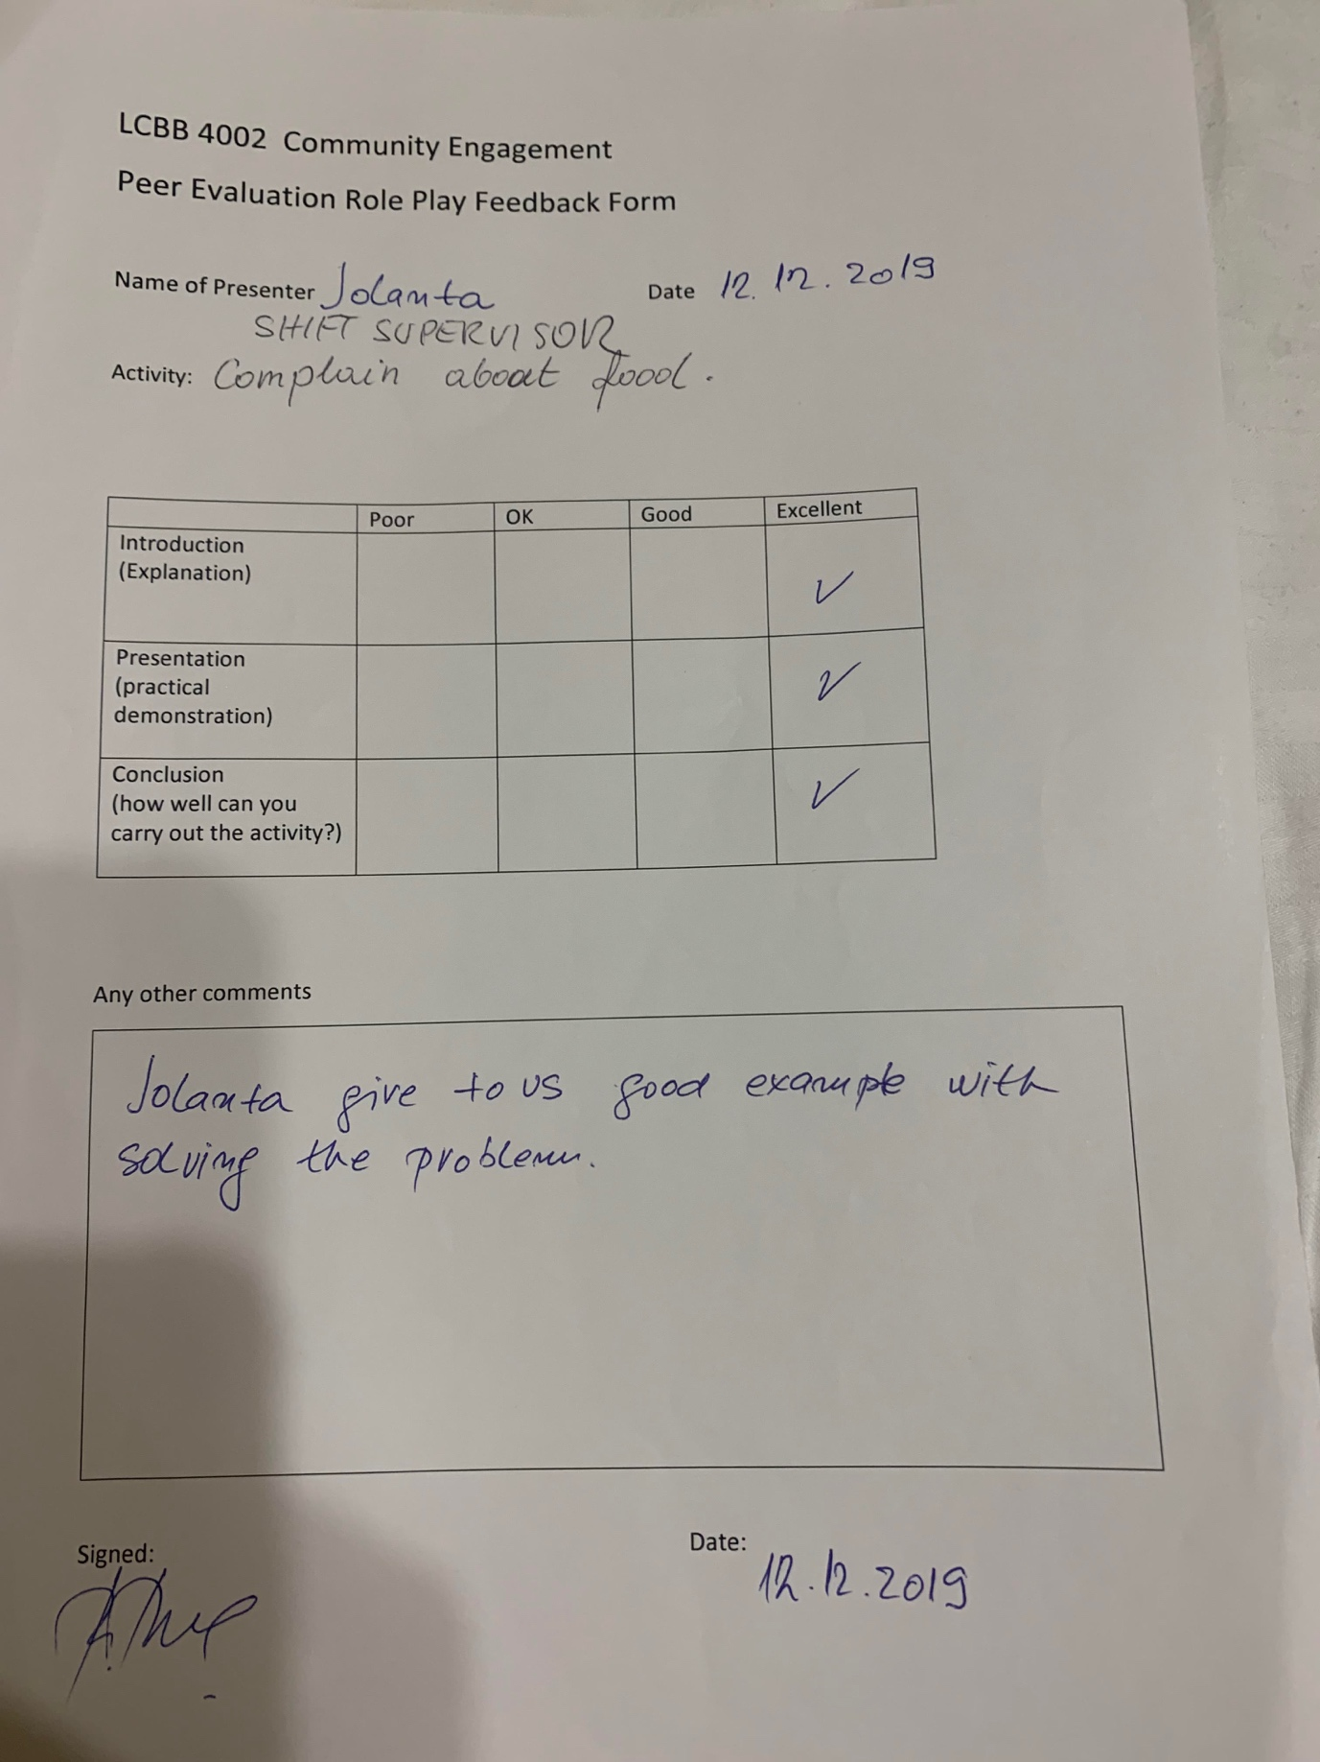
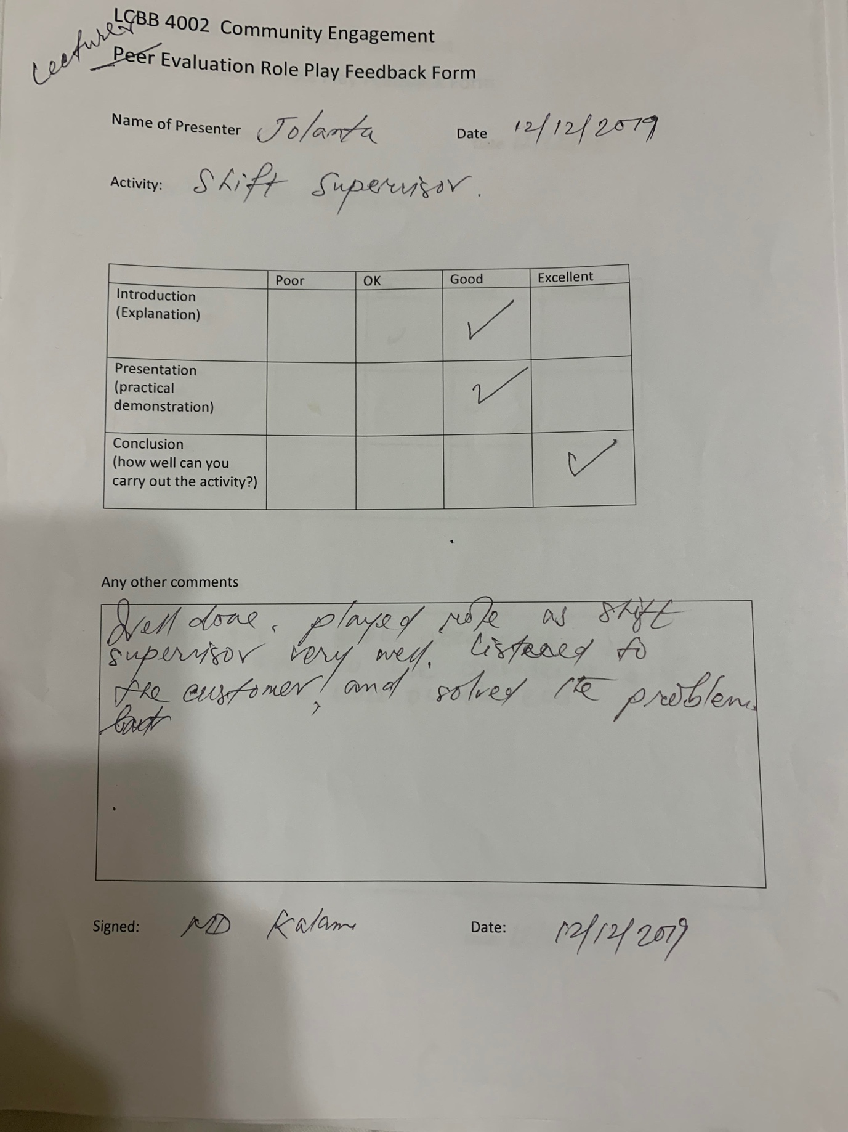

‘

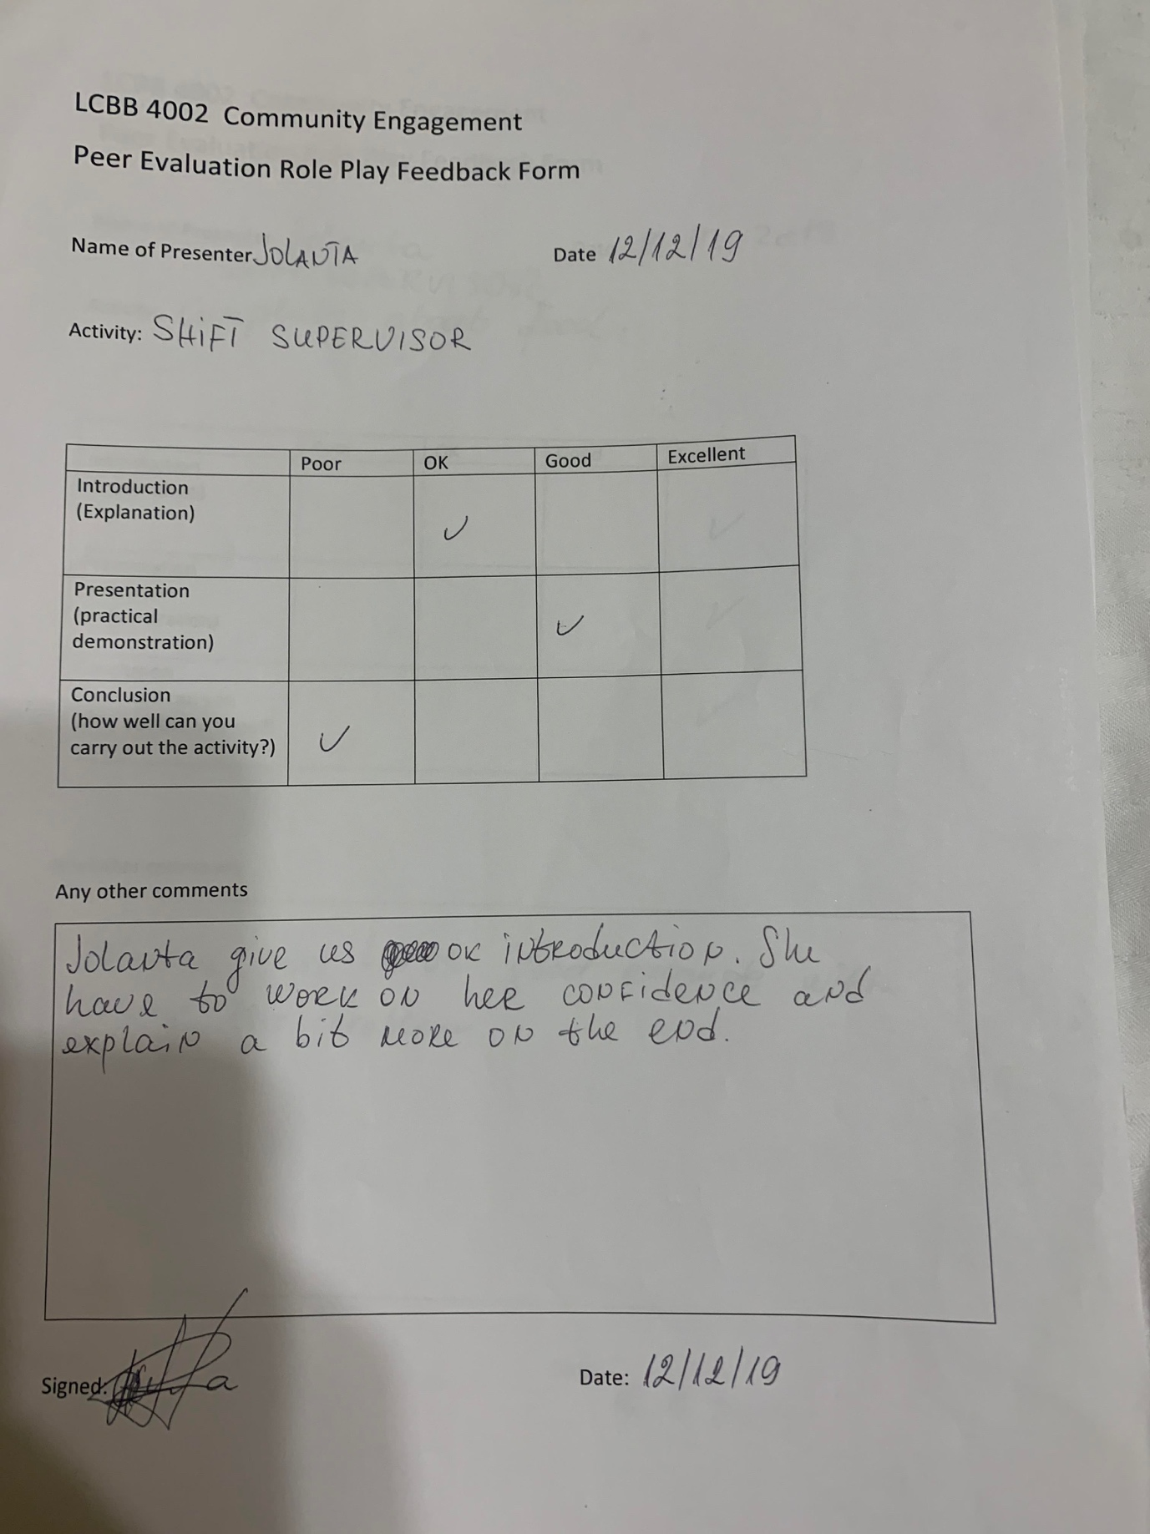

7.) ACTION PLAN
In future , I will ensure that I have a good relationship with my baristas , managers, and customers. I will speak to all my colleagues about all problems occurring at work, and make sure everything is resolve in a proper way. I will follow company standards and procedures more specific . I will try to build better relationship with my customers as well to provide excellent customer service. Also I will develop myself as much as I can to meet company standards. And ensure that I can deal with the difficult situations without stress.

8.) REFERENCES

URL http://dictionary/english/reflection ,CAMBRIDGE UNIVERSITY, Press, 2020
DYE, (2011, p230) Academic Services & Retention Team, SD March 2016
Harrey Gittler, 1991, Journal Bless Job Stress
Richard S. De Frank , November 16, 2011, Sage Journals
Ramezan Jahanian, Seyyed Mohammed Tabatabaei, Behnaz Behdad, 1, 2012, International Journal of Academic Research in Economics and Management Sciences 1(6), 1 , 2012
Rebecca L. Margau, CSP, CMS, CRISP Publications, 1989

