
Title: Assessment 1
Name: Saif Raza
Student ID: 2431762
Module Name: International Marketing: Principles and Practices
Module Code: LCMB7026_LON
Lecturer’s Name: Tushara Balendran
Word Count: 6088

Term 2

Table of Contents
Section 1: International Marketing Mix Report 4
1. Introduction 4
2. Comparative Market Analysis (PESTEL Framework) 5
2.1 Political Factors 6
2.2 Economic Factors 6
2.3 Social Factors (Consumer Behaviour & Culture) 7
2.4 Technological Factors 8
2.5 Environmental Factors 8
2.6 Legal Factors 9
3. Hofstede cultural dimensions: Market Selection Overview (India vs UK) 9
4. Comparative Analysis of STP Strategy 10
4.1 Segmentation 10
4.2 Targeting 11
4.3 Positioning 11
5. Comparative Analysis of International Marketing Mix (7Ps) 12
5.1 Product Strategy 12
5.2 Pricing Strategy 14
5.3 Place (Distribution) Strategy 15
5.4 Promotion Strategy 17
5.5 People 18
5.6 Process 19
5.7 Physical Evidence 20
5.8 Similarities and Differences Between India and the UK 21
6. Directional Development Strategy (Focus: India as Fav) 21
7. Ethical Issues in Marketing Mix 22
8. Recommendations for Future International Marketing Strategy 23
9. Conclusion 24
Section 2: Reflective Account 25
1. Introduction to Reflection (Gibbs) 25
2. Description of Experience 25
3. Feelings 26
4. Evaluation 26
5. Analysis 26
6. Conclusion 27
7. Action Plan 28
References 31

Section 1: International Marketing Mix Report

1. Introduction
Mercedes is one of the best-known luxury car manufacturers in the world. It is known for its innovative designs, high-quality engineering, and strong presence across the globe. As competition in the global luxury vehicle market heats up, firms need to be cautious about how they change their foreign marketing tactics to fit different economic, cultural, and legal situations (Pillai, 2024).

This report looks at how Mercedes-Benz markets itself throughout the world by comparing how it does business in India and the UK. These two markets are quite different from each other. India is a quickly rising emerging market with a growing demand for luxury cars. The UK, on the other hand, is a mature and highly competitive market with well-defined customer expectations and a strong emphasis on sustainability.

Hofstede cultural dimensions give a more detailed understanding of the consumer behaviour difference between India and the UK upon the analysis of macro environmental factors based on PESTEL. Whereas PESTEL represents the external factors of the business, Hofstede identifies the cultural values that commonly determine the purchasing decisions whereby by marketing its products according to the societal norms and expectations of the customers, Mercedes-Benz is likely to succeed in this market by adapting its marketing strategies to the prevailing cultural values.

The research uses analytical tools like PESTEL and STP to examine how macro-environmental conditions and consumer behavior vary (Kessens, 2022). It goes into further detail on how Mercedes-Benz changes their 7Ps marketing mix in both countries. The research also looks at the company's strategic orientation and ethical issues, and it gives suggestions for how to improve foreign marketing methods in the future. The Reflective Cycle developed by Gibbs will be used to reflect on the learning experience, strengths and weaknesses and use this to improve future academic performance.

Company Overview: Mercedes
The headquarters of Mercedes, a part of Mercedes-Benz Group AG, are in Stuttgart, Germany. Since its start in 1926, the brand has been known in the automobile market for being safe, luxurious, and cutting-edge in terms of technology. Founded by Karl Benz and Gottlieb Daimler, pioneers of early automobile engineering in Germany.

Mercedes-Benz makes a lot of different types of cars, including sedans, SUVs, electric cars (the EQ line), and high-performance cars (the Mercedes-AMG range) (Singh et al., 2025). The brand works all around the world and focuses on giving customers a great experience and employing cutting-edge technology.

Its strategy focuses on sustainability, digital transformation, and innovation, especially by putting money into electric mobility and self-driving car technology. Mercedes-Benz has a strong brand image across the world, but it changes its goods and marketing techniques to fit the demands of various regions, including India and the UK.

The vision of the company is to become the world leader in luxury mobility by innovation, sustainable, state-of-the-art technology, and providing the customer with outstanding experiences.

2. Comparative Market Analysis (PESTEL Framework)
PESTEL refers to a strategic framework to aid in the analysis of external macro-environmental forces in the form of Political, Economic, Social, Technological, Environmental and Legal factors that are capable of affecting business decisions, market situations, opportunities and risks, as well as organisational performance in various countries.
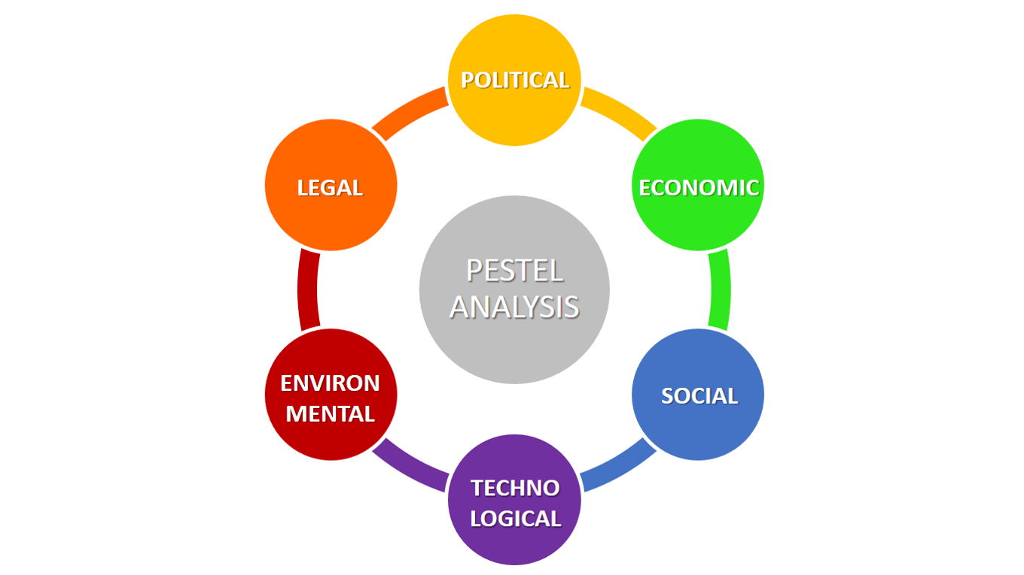
Figure: PESTEL Analysis
(Source: Research Gate, 2024)

2.1 Political Factors
Both India and the UK have stable political climates, but India's high import levies and complicated rules make luxury cars more expensive. The UK has clearer rules and government incentives for electric cars (Siddiqui and Ahmad, 2022). This helps Mercedes-Benz grow its business in sustainable transportation and strategies based on innovation.

In India, favourable factors include a stable government and growing market, while unfavourable factors are high import duties and complex regulations. In the UK, favourable factors include clear policies and EV incentives, whereas unfavourable factors involve strict compliance requirements and high regulatory costs.

2.2 Economic Factors
India is an emerging country that is expanding quickly. Its GDP grows by around 6–7% each year, and people are making more money and wanting more luxury automobiles, but prices are still quite sensitive. The UK has a consistent GDP growth of roughly 1–2%, which gives people more buying power and a mature luxury market. Inflation, taxes, and changes in the currency rate affect how Mercedes-Benz sets prices in both nations. The following graphic illustrates that India's GDP rises consistently from 2015 to 2025, finally overtaking the UK's. This demonstrates that the economy is growing quickly and the market is becoming more promising. The UK, on the other hand, has slower, more consistent growth, which means its economy is more mature. This shows that India has more chances for development, whereas the UK is more stable and has more buying power for luxury markets.

In India, favourable factors include rapid GDP growth and rising incomes, while unfavourable factors are high price sensitivity and inflation. In the UK, favourable factors include strong purchasing power and stability, whereas unfavourable factors involve slow economic growth.
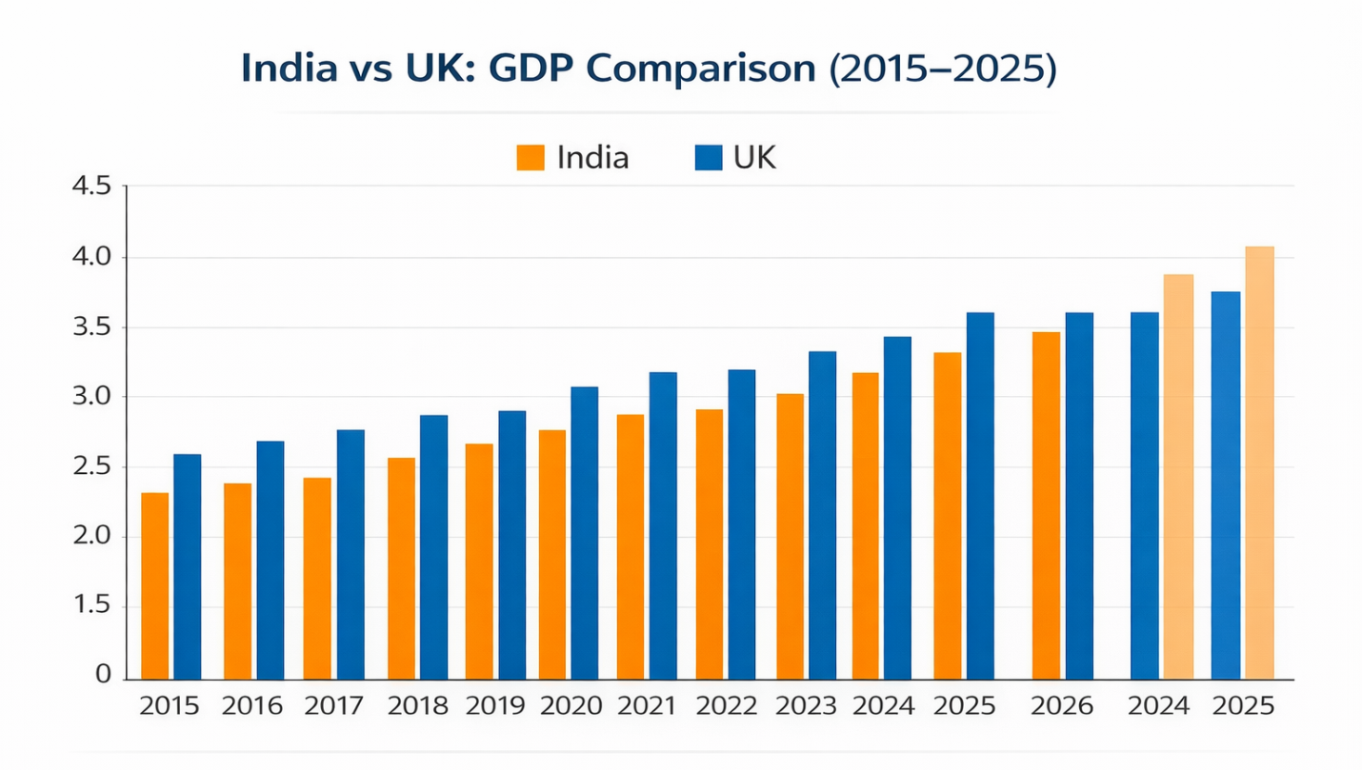
Figure: GDP Comparison
(Source: Mdpi, 2026)

2.3 Social Factors (Consumer Behaviour & Culture)
In India, luxury automobiles are a show of prestige, achievement, and social recognition. They have a big impact on people's choices about what to buy. When it comes to buying things in the UK, people care most about their own preferences, performance, and sustainability. In India, cultural norms favor collectivism, whereas in the UK, individualism fosters self-expression. This means that Mercedes-Benz has to change its branding and marketing strategy to fit both markets.

In India, favourable elements are good status-based demand; whereas the unfavourable elements are collective influence restricting individuality. Individual choice and sustainability have been identified as favourable influences in the UK, whilst views on brand prestige are diminished by unfavourable influences.

2.4 Technological Factors
The UK has a lot of digital adoption, a lot of EV charging stations, and a lot of modern automotive infrastructure, all of which foster innovation. India is quickly becoming more technologically advanced, but it still has problems with its infrastructure, notably for electric cars (Singh et al., 2025). Mercedes-Benz puts money on digital commerce and linked technologies in both markets, but the way people use and access them is quite different in each one.

In India, the factors are favourable (i.e. high rates of digital development), and unfavourable (i.e. poor EV infrastructure) ones. The favourable factors in the UK are high technology and charging networks though the unfavourable factors are the high implementation costs.

2.5 Environmental Factors
There are greater environmental worries in the UK, where there are rigorous emissions standards and a lot of people want electric cars. India is putting more emphasis on sustainability, but it is still slow to embrace it because of problems with infrastructure and costs. In the UK, Mercedes-Benz pushes its electrified EQ line more than it does in India.

The growing sustainability awareness is a favourable factor in India, whereas the slow EV adoption and the gaps in infrastructure are unfavourable factors. In the UK, some of the favourable factors are good environmental policies whereas the unfavourable factors are the ones that add to the cost of compliance.

2.6 Legal Factors
India has complicated tax structures, hefty import taxes, and rules that change all the time that impact prices and how businesses work (Prajapati, 2025). The UK has clearer laws, but it also has rigorous rules on emissions and safety. Following environmental regulations and consumer protection rules has a big effect on the products Mercedes-Benz sells and how it markets them in both nations
The favourable factors in India are the high consumer protection growth, and unfavourable factors involve complicated taxes and shifting regulations. In the UK, the positive aspects are evident in well-developed legal systems, and the negative aspects consist in the rigid system of compliance.

India and the UK have similar political systems and legal systems. But, India has a faster growth and the regulatory complexity, whereas the UK has market maturity, better infrastructure, and tougher environmental regulations.

3. Hofstede cultural dimensions: Market Selection Overview (India vs UK)
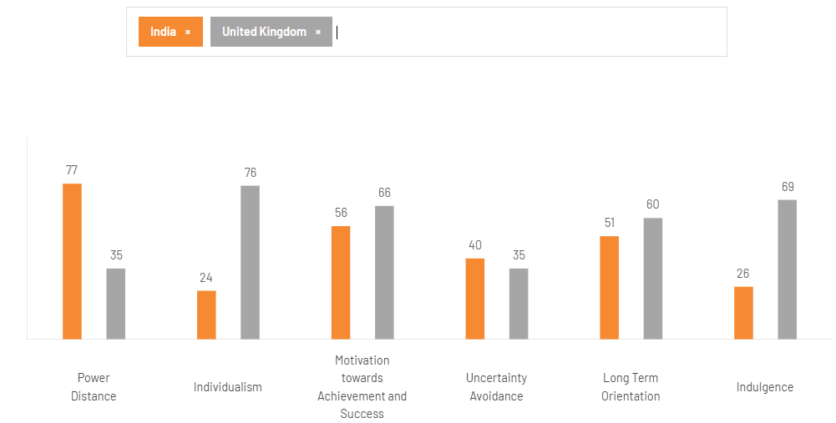
Figure: Hofstede Country Comparison
(Source: theculturefactor.com)
Using Hofstede's cultural dimensions to compare India with the UK shows important distinctions that affect Mercedes-Benz's marketing approach. India has a far greater power distance score (77) than the UK (35). This means that prestige and luxury items, such expensive vehicles, are very important in Indian culture. Because of this, Mercedes-Benz is a brand that people in India want to own (Von et al., 2023). On the other hand, the UK has a lesser power gap, which means that the society is more equal and people buy luxury items based on their own tastes rather than their social status.

The UK has a high score of 76 for individuality, while India has a low score of 24. This means that UK shoppers care more about their own identity and how they express themselves, whereas Indian shoppers are more affected by their families and social groups when they buy things.

Both nations have reasonable ratings for avoiding ambiguity, but India's is a little higher. This means that people in India choose brands they trust, like Mercedes-Benz (Prajapati, 2025). The UK has a higher indulgence score (69) than India (26), which shows that people in the UK are more likely to spend money on luxury items.

In general, these cultural variations mean that Mercedes-Benz has to take a more status-driven, relationship-focused approach in India and a more personalized, lifestyle-oriented approach in the UK. The strengths of Hofstede model are good comparison of cultures and strategic perspective to international marketing. Nonetheless, it has drawbacks, such as oversimplification, use of outdated data and not considering individual differences within cultures, which reduces specificity in the dynamic markets.

4. Comparative Analysis of STP Strategy

4.1 Segmentation
In India and the UK, Mercedes-Benz utilizes demographic, regional, psychographic, and behavioral segmentation. In India, the luxury car segment represents only about 1–2% of total passenger vehicle sales, but it is growing rapidly at around 20–25% per year, showing strong future potential. The corporation mostly goes after those with high incomes, such as the top 5–10% of earners, business leaders, and entrepreneurs. More than 70% of the demand for luxury cars originates from Tier-1 cities like Delhi, Mumbai, and Bangalore. Indian buyers think of luxury cars as a sign of prestige, prosperity, and social recognition. The UK market, on the other hand, is more mature, with luxury cars making up around 15–20% of all automobile sales. Segmentation is more about lifestyle, age, and environmental consciousness. More than 60% of customers think about sustainability and electric transportation. This makes the UK segmentation more focused on value and behavior. In India, innovators and achievers are identified as part of a segmentation, and the UK consumers are thinkers, and one concerned with sustainability, lifestyle, and how they appear.

4.2 Targeting
Mercedes-Benz uses distinct targeting tactics in India and the UK since the markets are at various stages of development and the customers are different. The firm uses a targeted targeting technique in India, concentrating on wealthy people in big cities where demand for luxury goods is strongest. About 80% of Mercedes-Benz sales in India originate from big cities, which shows that they are very focused on wealthy people who live in cities. The corporation also tries to attract younger professionals by making entry-level luxury models, which have brought in around 25–30% of new customers. The UK market, on the other hand, has a specialized targeting approach that targets many groups, such as corporate fleet buyers, environmentally aware customers, and performance fanatics. Electric cars are becoming a bigger part of the market. In the UK, more than 20% of Mercedes sales are for EV and hybrid models. This illustrates that targeting in India is restricted and centered on status, whereas in the UK it is wider and based on usefulness and long-term value.

4.3 Positioning
Mercedes-Benz uses different positioning tactics in India and the UK to fit with what customers want and the values of the cultures. In India, the brand is seen as a sign of prosperity, luxury, and distinction. This appeals to those who see owning a vehicle as a sign of social standing. Almost 70% of Indian luxury automobile purchasers say that brand image and prestige are important considerations in their decision to buy, which supports Mercedes-Benz's aspirational posture. Messages in marketing focus on being unique, having a rich history, and living a high-end lifestyle. In the UK, on the other hand, Mercedes-Benz is known for its innovation, performance, and sustainability. About 60–65% of people in the UK who buy luxury cars care most about technology, safety, and how well the automobile works with the environment. This affects the brand's advertising approach. The fact that more and more people are buying electric cars makes it seem even more environmentally good. So, even if the core brand is still premium across the world, in India it's based on status, while in the UK it's based on value and new ideas. This shows that consumers have different priorities and the market is more mature.
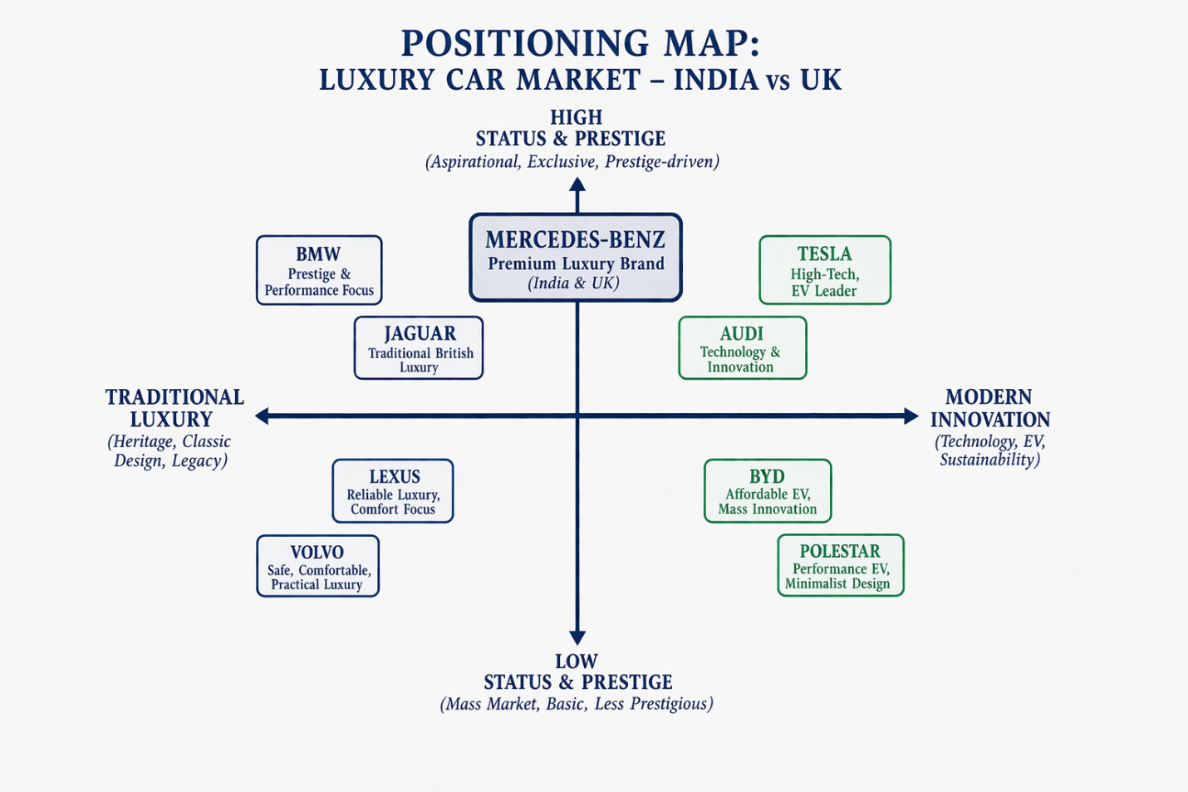
Figure: Positioning Map
(Source: Self-Created)
India and UK share segmentation, targeting and positioning strategies. But India is more niche targeting status based whereas the UK applies general and value oriented targeting and is keen on innovation and sustainability.

5. Comparative Analysis of International Marketing Mix (7Ps)

5.1 Product Strategy
In India and the UK, Mercedes-Benz modified their strategy with regard to their product to adhere to the prevailing market conditions. The Indian company produces comfortable, long lasting and stylish sedans and SUVs. Such cars possess features such as enhanced suspension system and an increased back space to be used by a chauffeur. To attract younger professionals and first-time luxury consumers, entry-level luxury models like the A-Class and GLA have been released. This has assisted the market to expand in urban areas (Chauhan, 2023). Moreover, the most widespread car is the internal combustion engine because there is not enough infrastructure to support electric cars.
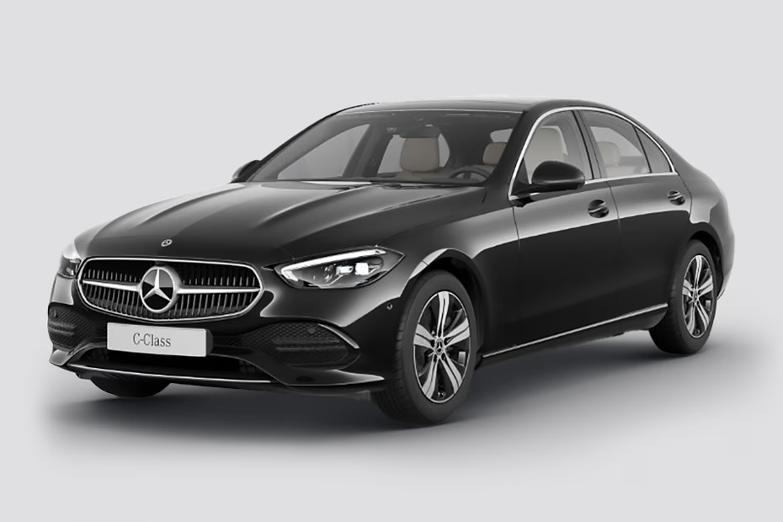
Figure: Mercedes Benz C class
(Source: mercedes-benz.co.uk)
The UK market, on the other hand, puts a lot of value on innovation and sustainability. This is especially true for electric cars like the EQ line, which are backed by sophisticated charging infrastructure and environmental rules. To be competitive, Mercedes includes high degrees of customisation, digital integration, and safety features in its products (Cui and Zhao, 2024). So, in the UK, product distinction is primarily about technology, but in India, it is still about comfort and status. Mercedes-Benz can keep its worldwide brand consistent while also meeting the demands of local customers and dealing with infrastructural problems thanks to this two-pronged approach (Cataltepe et al., 2023)

Product depth includes diverse models like sedans, SUVs, and EVs, while width covers luxury segments. India focuses on ICE variants, whereas the UK expands EV range and customization options.

5.2 Pricing Strategy
Mercedes-Benz has different pricing tactics in India and the UK since the two countries have different tax systems, customer buying power, and market maturity. High import charges, GST, and luxury taxes have a big effect on prices in India, making cars much more expensive. Mercedes-Benz uses a premium price plan to keep its luxury image and keep its brand exclusive among wealthy customers (Moraga-González et al., 2023). The firm also makes things in different places to save money and make it easier for those who want to purchase luxury goods for the first time to get them.

On the other hand, the UK market has greater competition when it comes to prices, less limitations on imports, and higher average income levels. Mercedes-Benz uses flexible and competitive price tactics, such as leasing alternatives, financing programs, and discounts for business fleets, to make its cars more affordable for a wider range of customers (Grieco et al., 2024). Price transparency and internet comparison tools also have an effect on prices in the UK. So, whereas price in India emphasizes exclusivity and prestige, pricing in the UK emphasizes value, affordability, and competition in the market. This allows Mercedes-Benz to meet a wide range of customer needs (Ather et al., 2023).

Aspect | India | UK
Pricing Approach | Premium pricing to maintain exclusivity and luxury positioning | Competitive and value-based pricing due to market maturity
Market Influence | Emerging market with high price sensitivity | Mature market with higher purchasing power
Tax Impact | High import duties, GST, and luxury taxes increase final price | Lower import barriers and more stable taxation
Affordability Strategy | Local assembly (CKD units) to reduce costs | Leasing, financing, and fleet pricing options
Customer Segment Focus | Wealthy individuals and status-driven buyers | Broader segments including corporate and eco-conscious buyers
Flexibility | Limited price flexibility due to costs and exclusivity | High flexibility with discounts, offers, and financing schemes
Price Transparency | Less transparent, negotiation-based in dealerships | Highly transparent with online comparison tools
EV Pricing Strategy | Higher prices due to infrastructure and low adoption | Competitive EV pricing supported by incentives and demand

5.3 Place (Distribution) Strategy
Mercedes-Benz has a selective distribution strategy that is based on the infrastructure and buying habits of each country. Most of the demand for luxury cars in India comes from Tier-1 cities like Delhi, Mumbai, and Bangalore, where most of the distribution happens. Dealerships are meant to provide high-end experiences that reinforce the brand's exclusivity. At the same time, the company is slowly expanding into Tier-2 cities to reach more wealthy customers (Chauhan, 2023). However, the use of digital retail is still not very common compared to established countries.
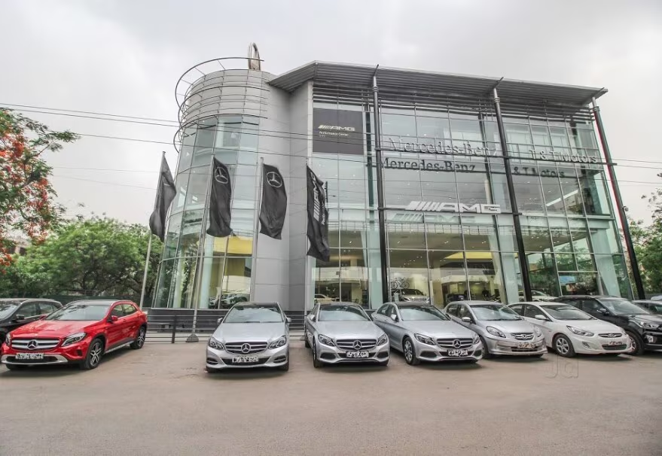
Figure: Mercedes Dealership Showroom in India
(Source: IoP, 2025)
The UK, on the other hand, has a very modern and connected distribution network that includes both physical dealerships and smart internet sales platforms. Customers may look at, customize, and buy cars online, which shows that a lot of people use the internet and digital technology (Suprayitno, 2024). Also, good logistics and after-sales service make customers happier and keep them coming back. Mercedes-Benz also uses direct-to-consumer strategies and works with fleet operators in the UK. So, distribution in India is all about exclusivity and slow growth, whereas in the UK it's all about making things easy to get, integrating digital technology, and being efficient to satisfy changing customer needs (Cataltepe et al., 2023).
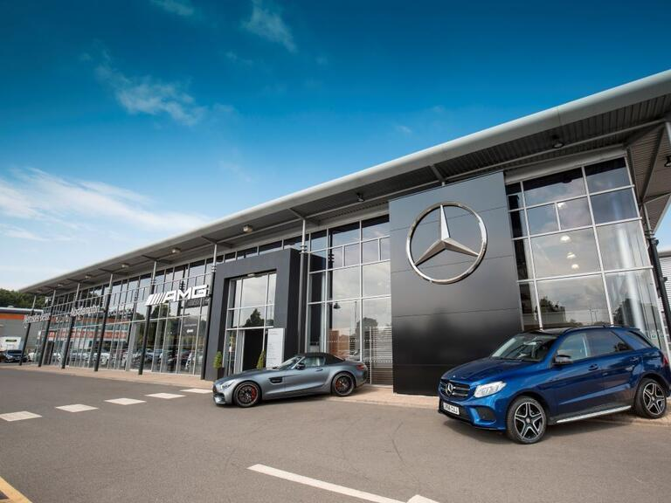
Figure: Mercedes Dealership Showroom in the UK
(Source: Mdpi, 2025)

5.4 Promotion Strategy
Integrated Marketing Communications (IMC) is a marketing strategy that organizes all the marketing communication instruments; advertising, digital media, sales promotion and public relations to convey consistent, clear and unified brand messages along various communication mediums.

Mercedes-Benz changes its marketing methods to fit the cultural and consumer variances between India and the UK. In India, marketing efforts center on aspirational marketing, which uses celebrity endorsements, high-end events, and experiential advertising to show off status, prestige, and achievement. Emotional appeal is very important because people link luxury cars to social status and personal success (Salelatu et al., 2023). Rich people often employ traditional media and big brand events to improve their brand image.

In the UK, on the other hand, advertising focuses on product characteristics, new ideas, and long-term use. Marketing efforts focus on electric mobility, safety, and new technologies, which is in line with what eco-friendly consumers want (Gong et al., 2023). Digital marketing, social media interaction, and partnerships with influencers are increasingly common now, which shows that people are using digital media a lot. Also, data-driven ads and targeted campaigns are utilized to efficiently reach certain groups of customers. In India, marketing tactics are based on emotions and status, whereas in the UK, they are based on knowledge and value. This allows Mercedes-Benz to stay relevant in different cultural settings (Postolache and Saharnean, 2025).

5.5 People
People play a very different part in Mercedes-Benz's marketing mix in India and the UK because of cultural differences and different expectations for service. In India, customer interactions are based on relationships, and salespeople are very important for creating trust and long-term relationships with customers. Personalized service, hospitality, and ongoing involvement are crucial, as customers prioritize human contact and brand relationships in their purchasing choices (Chauhan, 2023). Salespeople typically function as brand evangelists, making the premium experience even better.

Country | Total Employees | Explanation
India | ~3,500–3,700 (Mercedes-Benz India) + ~5,800 (R&D Bengaluru) | Mercedes-Benz Group AG has a significant workforce in India including manufacturing and R&D operations.
UK | ~10,000 – 11,000 (estimated across production, sales & corporate roles) | The UK hosts manufacturing plants, dealerships, and corporate functions, contributing to a larger workforce in a mature market (varies by division).

On the other hand, the UK market puts more value on professionalism, efficiency, and product knowledge when dealing with customers. Customers like workers that are competent and can provide them precise technical information and help them make decisions quickly. It's not so much about creating relationships as it is about providing great, quick service (Suprayitno, 2024). Digital tools, product knowledge, and giving customers more freedom are the main focuses of training programs in the UK. So, in India, the "people" part is more about managing relationships and providing individualized service. In the UK, on the other hand, it is more about efficiency, competence, and customer independence. This shows that individuals in different cultures behave differently when it comes to shopping (Cataltepe et al., 2023).

5.6 Process
Customers place the complaints through dealerships, helplines, or online platforms; Mercedes-Benz Group AG investigates and solves the problems and provides service improvements in response to the feedback. Mercedes-Benz transforms its car-selling and service selling models to meet the needs and technology of every region. The purchase decision making process in India is often more complex and relationship-oriented. It generally consists of visiting numerous showrooms, bargaining and receiving personal guidance. They desire very personal customer service that includes test drives, financing assistance, and post-sale follow-up that increases customer loyalty to the company (Ather et al., 2023). Still, when compared to the developed nations, the incorporation of digitization in the buying process continues to expand.

On the other hand, the UK market offers a simple, tech-driven way to buy things. Customers may look at, configure, and purchase cars online. There are also several choices for digital finance and home delivery. This shows that people are using digital technology a lot and that they want things that are easy and quick (Suprayitno, 2024). Also, modern systems for scheduling, diagnostics, and client feedback help with after-sales services. The method is meant to be as clear as possible while taking up as little time and effort as possible. So, whereas procedures in India concentrate on personalizing and creating relationships, in the UK they focus on efficiency, automation, and digital integration. This lets Mercedes-Benz meet the needs of different customers (Li et al., 2022).

5.7 Physical Evidence
Physical proof is very important for Mercedes-Benz's high-end brand image in both India and the UK. In India, showrooms are meant to seem classy, exclusive, and high-end. They generally include fancy interiors, private lounges, and spaces for high-end client care. These things make the brand seem more valuable and fit with what customers want in terms of status and distinction (Bull, 2025). Branded items, service quality, and the whole experience at the dealership are all examples of physical evidence that have a big impact on how happy customers are.
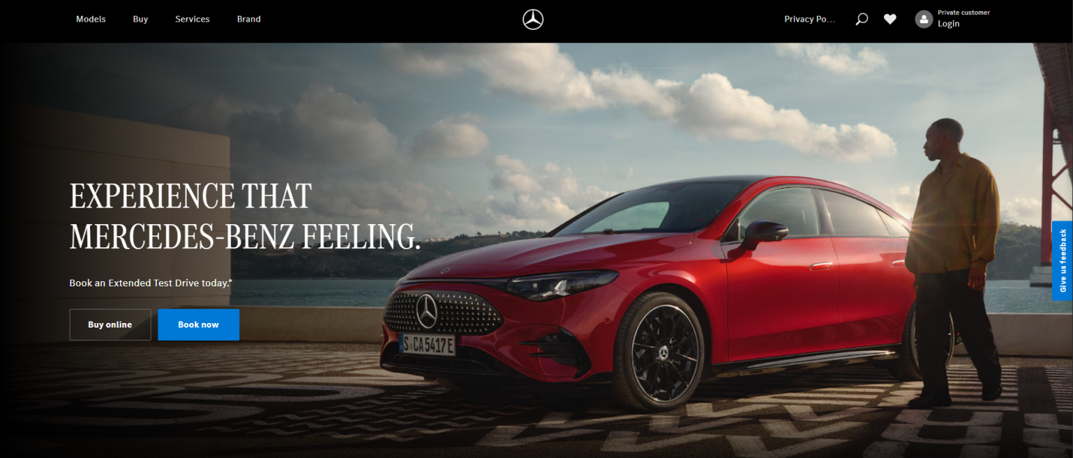
Figure: UK Website
(Source: mercedes-benz.co.uk)
In the UK, on the other hand, physical evidence mixes luxury with modernism and sustainability. Showrooms use digital displays, interactive configurators, and eco-friendly designs to show how committed the company is to being innovative and caring for the environment (De-La-Cruz-Diaz et al., 2023). Customers also look at tangible evidence via online interfaces like websites and smartphone apps, which are like virtual versions of the showroom experience. So, whereas physical evidence in India focuses on luxury and exclusivity, in the UK it focuses on technology, sustainability, and digital integration. This makes sure that the brand experience is constant yet tailored to each region (Bu et al., 2022).
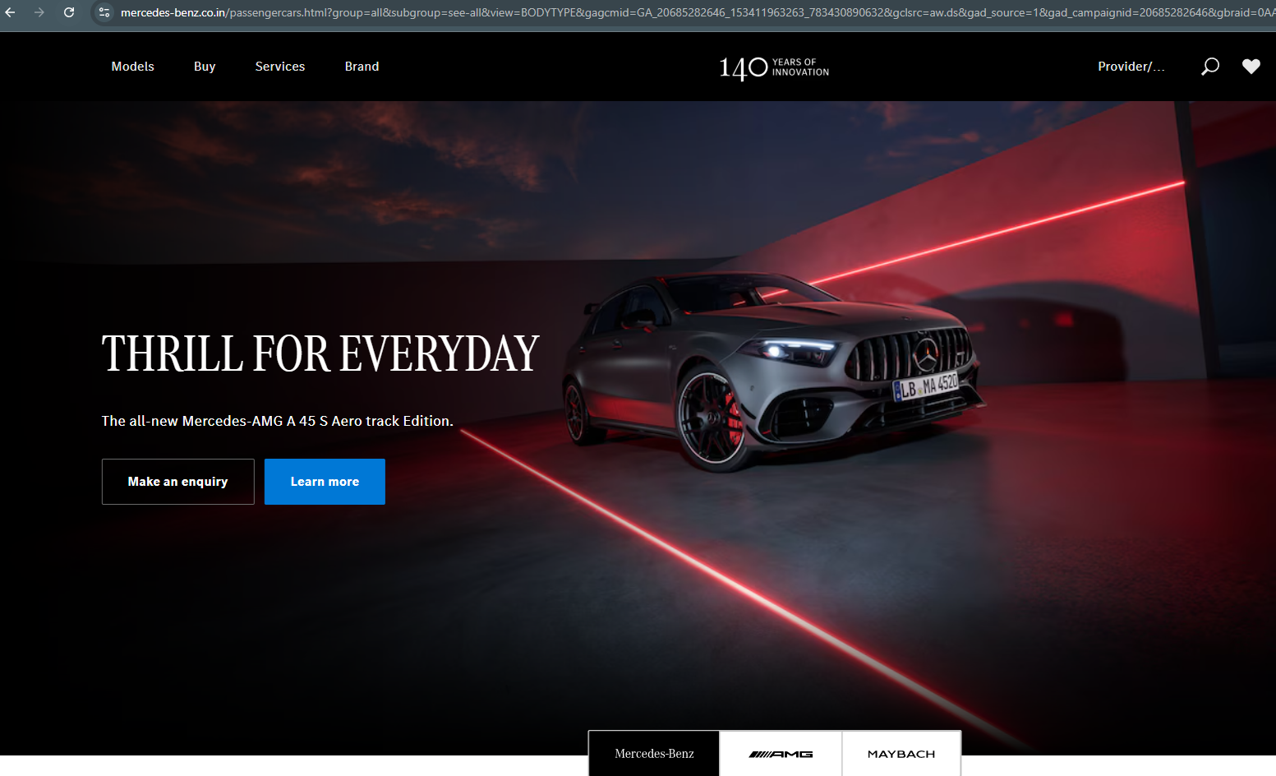
Figure: India Website
(Source: mercedes-benz.co.in)

5.8 Similarities and Differences Between India and the UK
Both India and the UK share similarities such as stable political systems, established legal frameworks, and growing demand for luxury automobiles, supporting Mercedes-Benz global expansion. However, significant differences exist between the two markets. India is an emerging economy with rapid growth, high price sensitivity, and status-driven consumer behaviour, while the UK is a mature market with strong purchasing power and value-driven preferences. Additionally, the UK has advanced infrastructure and stricter environmental regulations, whereas India faces infrastructural challenges but offers higher long-term growth potential.

6. Directional Development Strategy (Focus: India as Fav)

The gradual deployment of electric cars, with help from government programs that promote sustainable transportation, is a crucial strategic aim. But because of problems with infrastructure, Mercedes-Benz needs to take a staged approach, mixing classic internal combustion engine cars with electric ones. To lower costs and lessen the effects of high import levies, local manufacturing and assembly activities are also being increased, which makes prices more competitive (Chauhan, 2023).

Ansoff Matrix Application (Market India)
Market Penetration: The main ways through which Mercedes-Benz can boost sales in India are through enhancing brand awareness as well as providing finance opportunities and extending dealerships in Tier-1 cities to target more high-income consumers (Bull, 2025).

Product Development: The company is in a position to launch affordable luxury and electric cars according to the Indian conditions, including better suspension and indigenization, to satisfy the changing demands of the consumer.

Market Development: Tier-2 and Tier-3 expansion will offer a growth strategy as it focuses on the emerging luxury consumer and brand can be more varied in less metropolitan regions (Cataltepe et al., 2023).

Diversification: To accelerate growth in the changing Indian automotive industry, Mercedes-Benz can consider various opportunities, such as mobility, digital, and EV infrastructure partnerships to diversify products and boost growth in the long term.

7. Ethical Issues in Marketing Mix
The marketing mix is largely influenced by ethical concerns in India, which is especially clear in marketing strategies being used in regards to products, pricing and marketing. Luxury cars are commonly promoted as the representation of the success, status, and social presence, which may bring about the psychological pressure on consumers to relate ownership with their personal success (Gong et al., 2023). This can promote materialistic behaviour and dictate the choice to purchase more that is not well within the financial reach. At the level of pricing, expensive prices because of the import duties and taxes, and premium positioning make these vehicles be affordable to only a small group of wealthy, which gives rise to equity and inclusivity issues in an extremely unequal society.

An example of a scenario that would be ethical would occur when businesses toot environmental friendly cars e.g. electric cars or fuel-efficient cars and present the information on benefits to the environment in a clear and transparent manner. This upholds sustainable consumption and good decision-making (Salelatu et al., 2023). A negative aspect, however, lies in the unethical approach that promotion efforts highly overestimate the benefits of the lifestyle or associate the ownership of luxuries with the advantage in the society directly, which can push the consumer into spending where such spending is unnecessary. As such, corporations should have proper marketing practices that are honest, transparent and socially responsible within the Indian marketplace that balances the brand image and ethical matters.

8. Recommendations for Future International Marketing Strategy
Mercedes-Benz should develop a more integrated and forward-looking approach that is in line with changing customer expectations and worldwide trends in order to improve its international marketing. The first thing the corporation should do is speed up its move to electric mobility, especially in new areas like India. It can do this by investing in partnerships for charging infrastructure and adding more cheap electric vehicles to its lineup. This will help reach sustainability targets and make it easier for people to enter the market (Cui and Zhao, 2024).

Second, Mercedes-Benz should use data analytics, artificial intelligence, and tailored communication techniques to improve its digital marketing and sales skills. Better digital platforms may make it easier for customers to connect with businesses and make purchases, particularly in more developed economies like the UK (Suprayitno, 2024). Also, adding more online configurators and virtual showrooms may make the consumer experience better throughout the world.

Third, the corporation could use more socially responsible marketing by concentrating on messages that promote inclusion and sustainability instead of just status-driven ones. This strategy may help people trust the brand throughout time and keep up with evolving consumer values (De-La-Cruz-Diaz et al., 2023).

Lastly, Mercedes-Benz should keep localizing its strategy by changing its goods, prices, and marketing to fit the needs of each location while keeping the brand consistent across the world. Strategic partnerships and new ideas in mobility services may help it become even more competitive. These suggestions will help Mercedes-Benz keep growing and be competitive in a global automotive sector that is changing quickly (Cataltepe et al., 2023).

9. Conclusion
This paper has given a full look at Mercedes-Benz's worldwide marketing strategy by looking at how the company works in India and the UK. The results show that there are big variances in macro-environmental conditions, how consumers respond, and how mature the market is, all of which affect the company's strategic choices. India is a quickly rising emerging market where people want to buy things and are sensitive to prices. The UK, on the other hand, is a mature market where sustainability, innovation, and consumer autonomy are very important.

The study of STP strategies shows that Mercedes-Benz uses a status-driven strategy in India and a value-driven one in the UK. This shows how different cultures and economies are. The 7Ps marketing mix shows that the corporation changes its product, price, distribution, and promotion techniques to fit the needs of each local market while keeping a consistent worldwide brand image (Chauhan, 2023).

Also, India's directional development plan shows how important it is to find a balance between growth potential and problems with infrastructure and regulations. Ethics, especially when it comes to marketing and sustainability, are still very important for maintaining brand reputation in both sectors.

In general, Mercedes-Benz's success is due in large part to its ability to balance global uniformity with local flexibility. But in the future, its ability to be competitive will rely on how well it can come up with new ideas, be environmentally friendly, and meet evolving customer needs. The firm may increase its position in both developing and mature markets by making strategic changes. This will ensure long-term development and worldwide leadership (Gong et al., 2023).

Section 2: Reflective Account

1. Introduction to Reflection (Gibbs)
This reflective account utilizes Gibbs’ Reflective Cycle to assess the completion of the worldwide marketing report on Mercedes-Benz, using academic frameworks to underpin the study (Chauhan, 2023). It focuses on learning goals, problems, and skill building to make research and critical thinking better in the future.
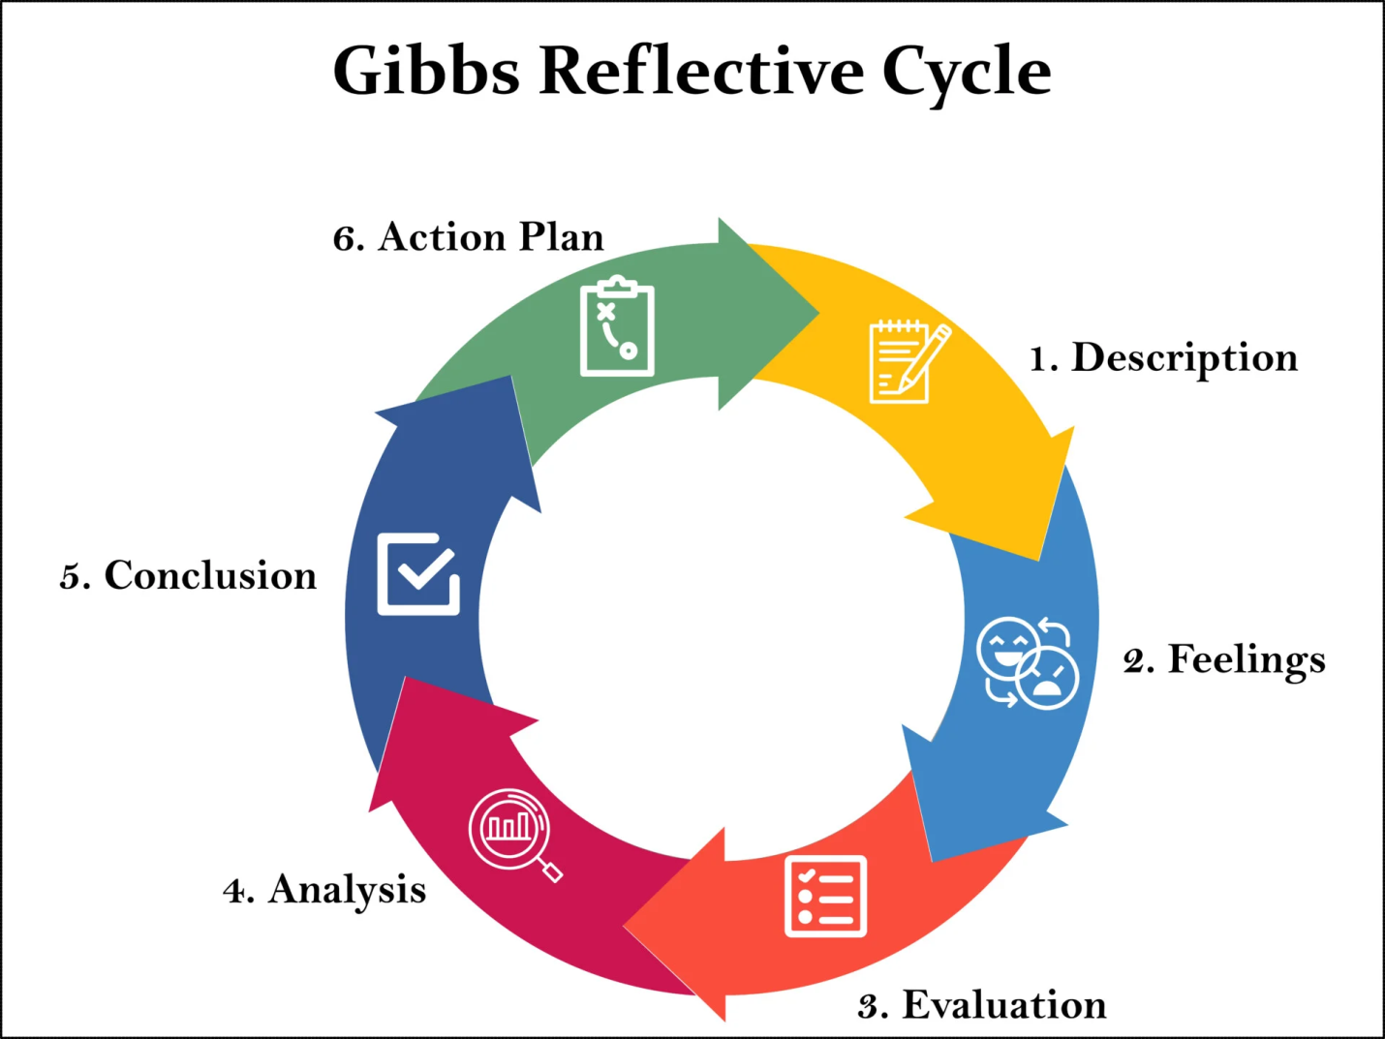
Figure: Gibbs Reflective Cycle
(Source: IoP, 2024)

2. Description of Experience
The task was to look at how Mercedes-Benz markets itself in India and the UK using tools like PESTEL, STP, and the 7Ps marketing mix. I started by gathering secondary data from scholarly publications and studies, which helped me learn about the state of the industry and how people act (Cataltepe et al., 2023). I then organized the report into distinct parts to keep it logical and consistent. A big part of the experience was connecting ideas from theory to actual life, especially when looking at how cultural variations affect different markets. I also worked on adding data to my analysis to make it better for school. It was important to pay close attention to word restrictions and consistent reference throughout the procedure. In general, the job needed good research, organization, and analytical abilities to put together a lot of material in a useful way.

3. Feelings
I was overwhelmed at first since it was hard to look at two separate worldwide marketplaces and use several frameworks at the same time. But as I learned more and had a better grasp of the ideas, my confidence grew (Suprayitno, 2024). I thought the subject was interesting, particularly when I looked into how multinational corporations change their strategy to fit diverse cultures. There were times when I was frustrated, especially when I was attempting to do a lot of research while still keeping the word count low and the references correct. Even though these things were hard, I stayed motivated and focused on doing the project well. I felt more sure of my skills and accomplished as I connected theory with practice as I worked on each area. In general, my sentiments went from being unsure at first to being sure and happy.

4. Evaluation
Overall, it was a good experience since it helped me learn more about international marketing and made me a better student. One of my main talents was using structured frameworks like PESTEL and STP to assist me organize the analysis well (Moraga-González et al., 2023). Adding facts and real-world examples also made the study more credible. One problem, however, was keeping word limitations while yet going deep, which often meant breaking down complicated concepts. Another problem was using secondary data, which could not necessarily show how the market is doing right now. Even though there were some problems, the experience helped me become better at writing and researching. It also helped me think more analytically, which let me look at company plans in other countries and see how they worked.

5. Analysis
This event showed me how important it is to use theoretical frameworks in real-world commercial situations. Using Gibbs' Reflective Cycle, I was able to look at each step of my learning process in a critical way and find ways to make it better. I learned that while marketing internationally, you have to take into account the variations in culture, economy, and technology in each region (Li et al., 2022). The contrast between India and the UK showed how businesses change their plans to fit the demands of each country. I also learnt how important it is to organize and manage your time when you have a lot of stuff to do. It was easier to understand and get things done when the assignment was broken down into smaller parts. Additionally, the process improved my capacity to critically assess sources and use them in academic writing, which is necessary for generating work of high quality.

Hofstede assisted in the study of the differences in cultures and the 7Ps framework provided a better insight into marketing strategies, making me more effective in the implementation of theory in reality in international business settings.

6. Conclusion
In conclusion, this practice of thinking about myself has helped me learn more about my talents and weaknesses in schoolwork. This project helped me improve my research, analytical, and writing abilities, which are all important for future studies. There were some problems, including managing my time and keeping my writing short, but they helped me learn overall (Gong et al., 2023). I feel more sure of myself when it comes to doing difficult tasks and using theoretical frameworks correctly. In the future, I want to become better at combining facts and improving my critical thinking skills. This thought emphasizes the significance of ongoing education and self-assessment in attaining academic and professional success.

7. Action Plan

Area for Improvement | Action to be Taken | How It Will Be Achieved | Timeframe | Expected Outcome
Time Management | Improve planning and task scheduling | Break assignments into smaller tasks and use a study timetable or planner | Ongoing (weekly review) | Better ability to meet deadlines without stress
Academic Writing | Enhance clarity and conciseness | Practice structured writing and seek feedback from tutors/peers | Next 2–3 months | Improved academic writing quality and coherence
Referencing Skills | Improve citation accuracy and consistency | Use referencing tools (e.g., Zotero, Mendeley) and review guidelines regularly | Immediate and ongoing | Accurate and properly formatted references
Critical Analysis | Develop deeper analytical thinking | Read more academic journals and practice evaluating arguments critically | Ongoing | Stronger ability to analyse and interpret data
Use of Data | Improve integration of data and evidence | Include more statistics and real-world examples in assignments | Next assignment cycle | More evidence-based and credible work
Understanding Frameworks | Strengthen application of models (PESTEL, STP, etc.) | Practice applying frameworks to different case studies | Ongoing | Better application of theory to practice
Digital Research Skills | Improve efficiency in finding quality sources | Use academic databases like Google Scholar, Scopus | Immediate and ongoing | Faster and more effective research process
Confidence in Complex Tasks | Build confidence in handling large assignments | Start early and review work progressively | Next 1–2 assignments | Reduced anxiety and improved performance

References
- Ather, D., Chaudhary, N., Singh, G., Beig, T. and Kler, R., 2023, December. Enhancing used automobile valuations: A data-cleaning and linear regression approach for predicting prices in competitive market. In 2023 4th International Conference on Computation, Automation and Knowledge Management (ICCAKM) (pp. 1-5). IEEE.
- Bu, J., Zhao, E.Y., Li, K.J. and Li, J.M., 2022. Multilevel optimal distinctiveness: Examining the impact of within‐and between‐organization distinctiveness of product design on market performance. Strategic Management Journal, 43(9), pp.1793-1822.
- Bull, T., 2025. Top 5 Upcoming Luxury Cars in India 2025–Mercedes, BMW, Audi, Jaguar, and Lexus.
- Cataltepe, V., Kamasak, R., Bulutlar, F. and Palalar Alkan, D., 2023. Dynamic and marketing capabilities as determinants of firm performance: evidence from automotive industry. Journal of Asia Business Studies, 17(3), pp.617-638.
- Chauhan, S., 2023. Impact of Marketing Strategies on Automobile Industry. International Journal for Multidisciplinary Research. doi, 10.
- Cui, S. and Zhao, N., 2024. A study on the current status and future prospects of EV automotive market. Journal of Social Science and Cultural Development, 1(2).
- De-La-Cruz-Diaz, M., Alvarez-Risco, A., Jaramillo-Arévalo, M., de las Mercedes Anderson-Seminario, M. and Del-Aguila-Arcentales, S., 2023. Green marketing and entrepreneurship. In Footprint and Entrepreneurship: Global Green Initiatives (pp. 211-224). Singapore: Springer Nature Singapore.
- Gong, Y., Xiao, J., Tang, X. and Li, J., 2023. How sustainable marketing influences the customer engagement and sustainable purchase intention? The moderating role of corporate social responsibility. Frontiers in Psychology, 14, p.1128686.
- Grieco, P.L., Murry, C. and Yurukoglu, A., 2024. The evolution of market power in the us automobile industry. The Quarterly Journal of Economics, 139(2), pp.1201-1253.
- He, J., 2025. Positioning and Footing in Chinese Social Media News Comments: The Case of the Mercedes Car Quality Dispute. WORD, 71(1), pp.20-36.
- Kessens, J., 2022. Scientific analysis on the opportunities and challenges of the electronic transformation in the automobile industry for Mercedes-Benz.
- Li, L., Wang, Z. and Xie, X., 2022. From government to market? A discrete choice analysis of policy instruments for electric vehicle adoption. Transportation Research Part A: Policy and Practice, 160, pp.143-159.
- Moraga-González, J.L., Sándor, Z. and Wildenbeest, M.R., 2023. Consumer search and prices in the automobile market. The Review of Economic Studies, 90(3), pp.1394-1440.
- Pillai, K., 2024. A Comparative Analysis of R&D Strategies and Their Impact on BMW and Mercedes-Benz's Market Dominance. Available at SSRN 4850759.
- Postolache, A. and Saharnean, L., 2025. Marketing and promotion in the online environment. In Simpozion Ştiinţific al Tinerilor Cercetători (pp. 168-171).
- Prajapati, S., 2025. Analyzing the role of Indian Auto Component Exports on the Supply Chain Resilience of European Car Manufactures.
- Qiu, Y., Zhang, K. and Zong, Y., 2022, December. The Market Analysis for BYD. In 2022 2nd International Conference on Financial Management and Economic Transition (FMET 2022) (pp. 246-256). Atlantis Press.
- Salelatu, M.K., Isnaini, S. and Wibawa, I.S., 2023. Female Empowerment on International Women's Day 2023 Ads: Critical Discourse Analysis of Mercedes-Benz “Be One of Many”. Lingua Susastra, 4(2), pp.139-151.
- Siddiqui, K.A. and Ahmad, S., 2022. Brand equity trend analysis for top auto brands on Interbrand’s 20-year longitudinal data. Journal of Brand Strategy, 10(4), pp.311-329.
- Singh, A., Bajpai, A. and Singh, S., 2025. Electric Vehicle Evolution in the United Kingdom and India: A Comparative Case Analysis for Stakeholders. Cureus Journals, 2(1).
- Suprayitno, D., 2024. Analysis of customer purchase interest in digital marketing content. Journal of Management, 3(1), pp.281-287.
- Von Der Heyden, T.K., 2023. Industry Note: The Automotive Sector and its Importance to the Economy Case Study: A New Era for Mercedes-Benz and Daimler Truck Begins (Master's thesis, Universidade NOVA de Lisboa (Portugal)).
- Wang, K.H., Su, C.W., Xiao, Y. and Liu, L., 2022. Is the oil price a barometer of China's automobile market? From a wavelet-based quantile-on-quantile regression perspective. Energy, 240, p.122501.
- Yang, A., Liu, C., Yang, D. and Lu, C., 2023. Electric vehicle adoption in a mature market: A case study of Norway. Journal of Transport Geography, 106, p.103489.

