What is a project?
A task is more ‘project-like’ if it is:
- Non-routine
- Planned
- Aiming at a specific target
- Work carried out for a customer
- Involving several specialisms
- Made up of several different phases
- Constrained by time and resources
- Large and/or complex
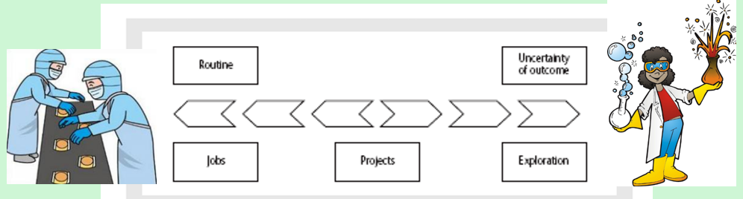
Put the following list of tasks in order of which most closely matches your idea of a project.
- Producing an edition of a newspaper
- Building the Channel Tunnel
- Getting married
- Amending a financial computer system to deal with Wales adopting the Welsh Punt
- A research project into what makes a good computer interface design
- An investigation into why a user has a problem with their home computer system
- A second year programming assignment for a computing student
- Writing an operating system for a new computer
- Organising the move of SOAC to the new SA1 campus

