HTML & CSS Web Development
Specification Report
Matthew Lewington - 1703645
BSc Software Engineering
Introduction to Web Development (ACCA4003)
UWTSD School of Applied Computing
Lecturer’s Name: Kemi Ademoye

Contents
1. Introduction 3
2. Website Requirements 4
2.1 Site Map 4
2.2 Wireframe Diagram 5
3. Implementation 6
4. Validation Overview 8
4.1 HTML Errors 8
4.2 HTML Re-validation 9
4.3 CSS Errors 9
5. Website Evaluation 10
5.1 Design 10
5.2 Usability 10
5.3 Content 11
5.4 Web Accessibility 11
5.4.1 WCAG (Web Content Accessibility Guidelines) 12
5.4.2 WCAG 2.0 12
5.5 Accessibility Evaluation 12
5.5.1 Headings 12
5.5.2 Information Structure and Relationships 13
5.5.3 Images and Media Content 14
5.5.4 Scalable Text Content 14
5.5.5 Website Colours and Contrast 15
5.5.6 Forms 16
5.5.7 Navigation 16
5.6 Future Improvements 16
6.0 References 17
6.1 Background Reading 18

1. Introduction
This report has been produced to provide an informational overview of the website that was produced for the ‘Introduction to Web Development’ module showing planning and implementation of skills learned over the past few months including validation of the work and any improvements.
Along with this, an evaluation and accessibility evaluation of the given website measured against the guidelines of the WCAG will be provided.

2. Website Requirements
‘For instance, it means that as far as is humanly possible, when I look at a Web page it should be self-evident. Obvious. Self-explanatory. I should be able to “get it” – what it is and how to use it – without expending any effort thinking about it’ [1, p. 11]
“Matts Motors” has been produced for the website owner to provide information and reviews to an audience of motorcycle enthusiasts, or people interested in learning how to ride a motorcycle. The reviews are on motorcycles and equipment. There is training information available for those who may be interested in learning to ride, sourced directly from the gov.uk website.
The website should be self-explanatory to any user visiting the website as it contains a large amount of information stating what it is about.

2.1 Site Map
Figure 2-1 shows a 'Site Map' illustrating the structure of the Website and how individual pages link to each other.
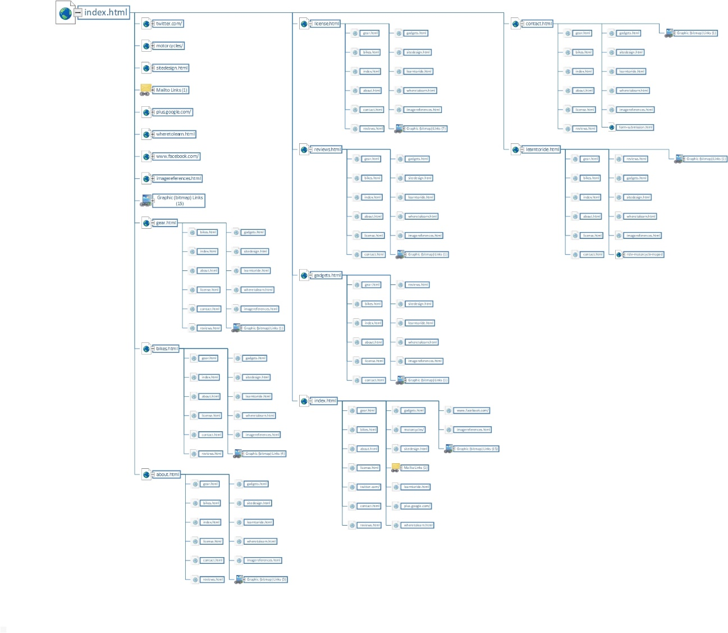
Figure 2-1 - Sitemap of Matts Motors

2.2 Wireframe Diagram
As seen in figure 2-2, the wireframe design for the index.html file shows the bootstrap framework being used highlighting the grid layout and each column respectively.
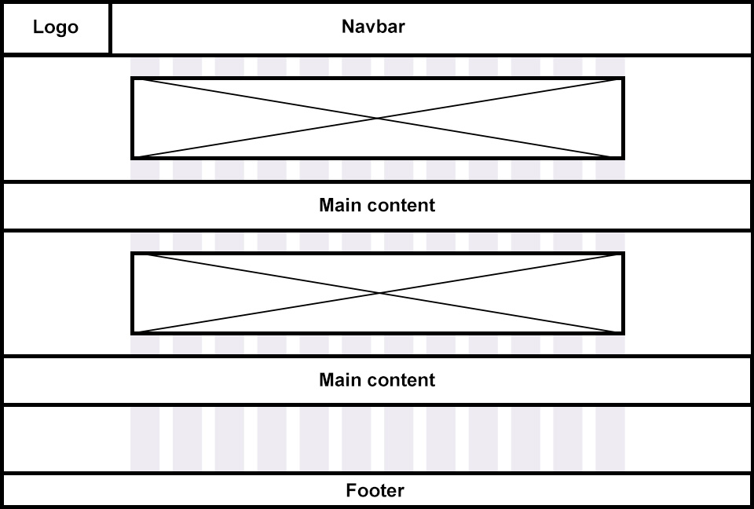
Figure 2-2 – Wireframe diagram of index.html

This is also implemented in figure 2-3 where the layout of the bikes.html page is showing the content section has been split and is spanning either 9 or 3 columns respectively.
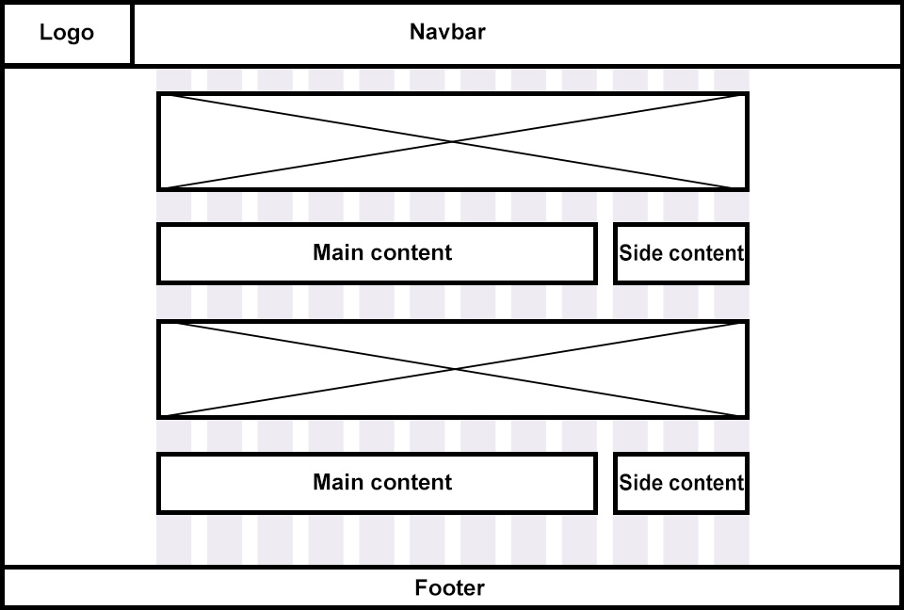
Figure 2-3 – Wireframe of bikes.html

3. Implementation
Below are some screenshots of various pages from the website that has been created with the knowledge gained from the module, personal research and tutorials.
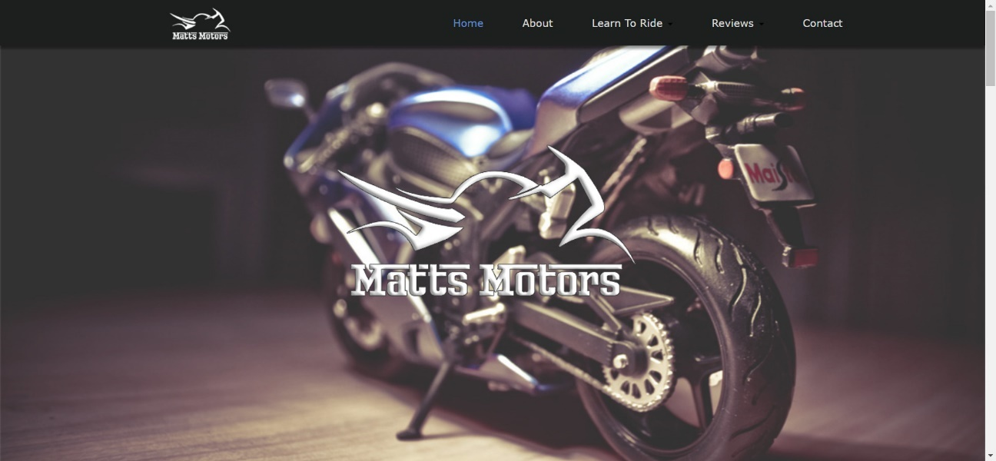
Figure 3-1 – index.html
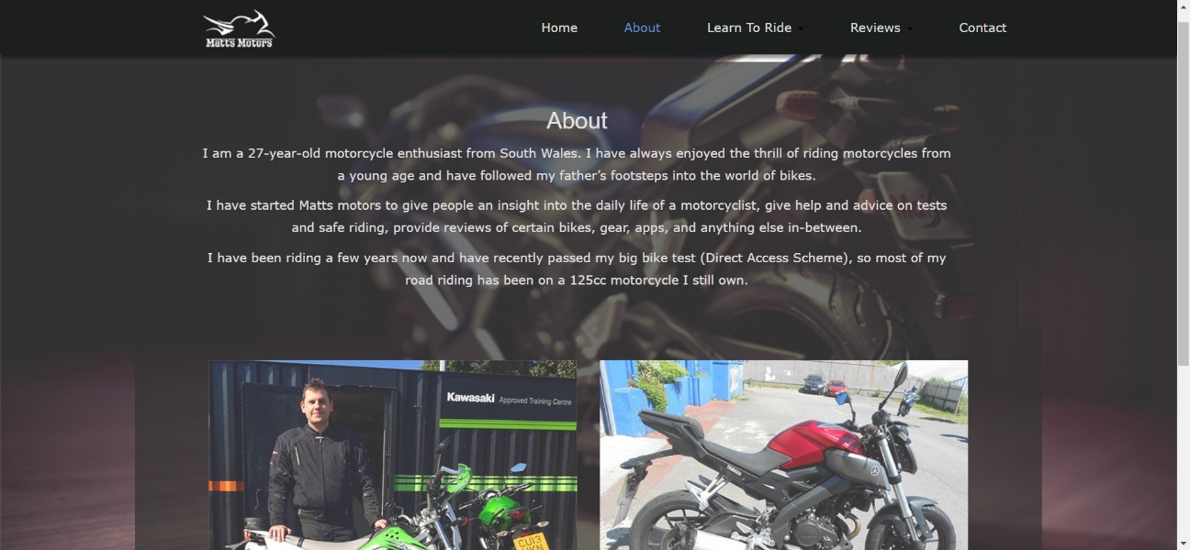
Figure 3-2 – about.html
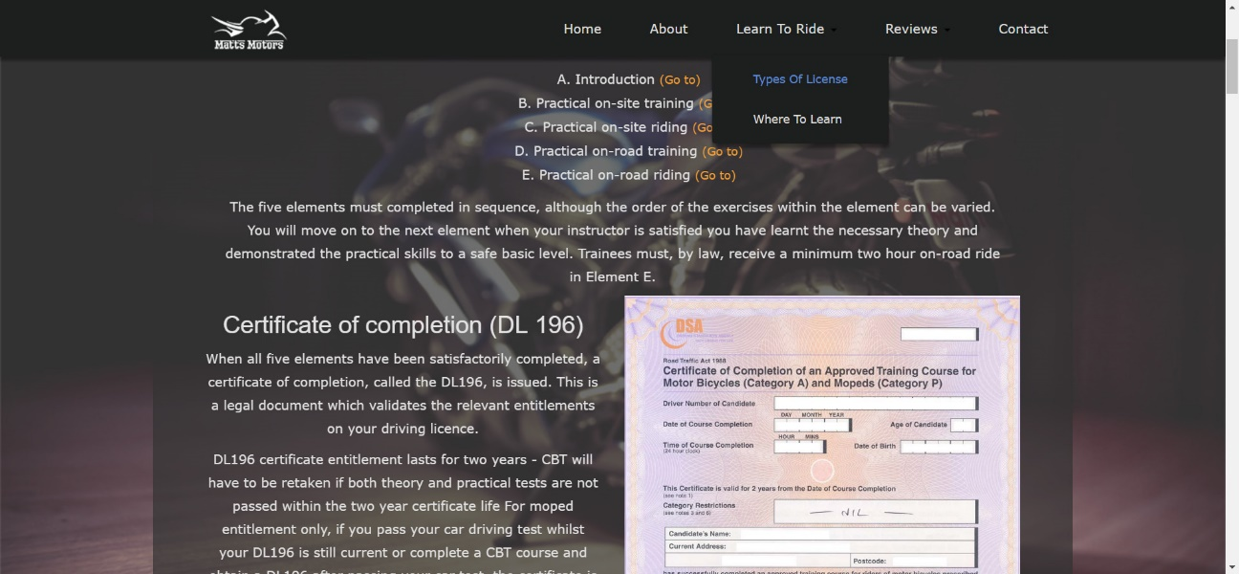
Figure 3-3 – license.html
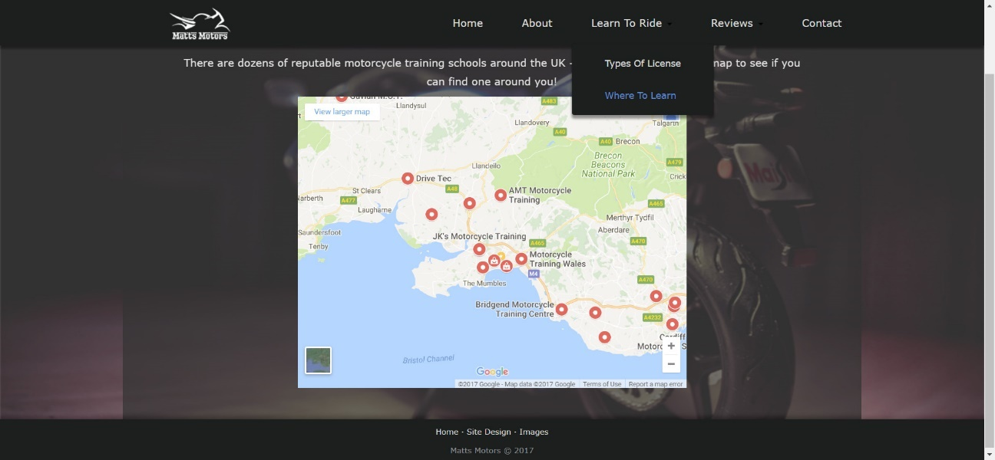
Figure 3-4 – wheretolearn.html
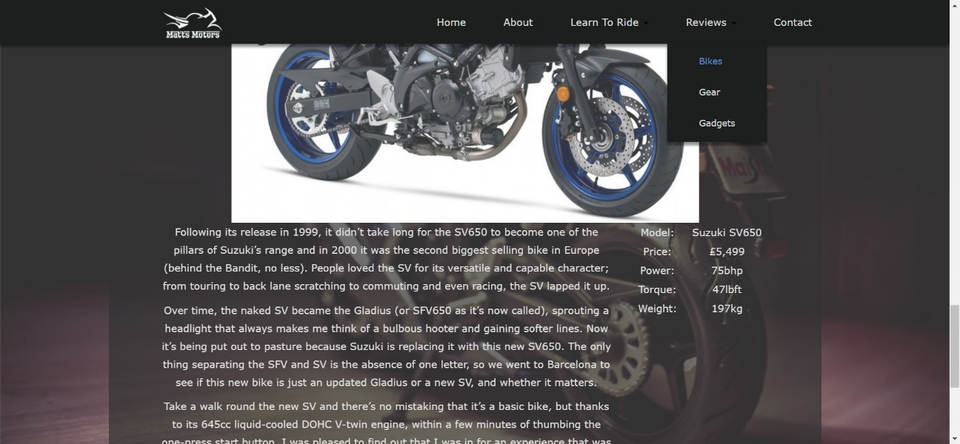
Figure 3-5 – bikes.html
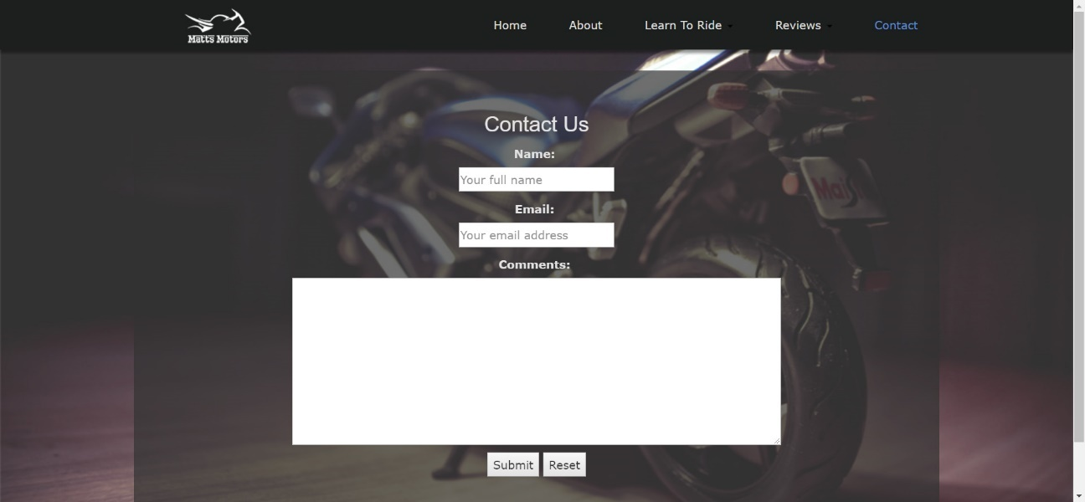
Figure 3-6 – contact.html

4. Validation Overview
Validation of web documents is an important step in making sure the quality of the code written is not poor [2]. It helps with saving time and money with unnecessary problems or changes in the future.

4.1 HTML Errors
Upon validating the main index.html page with the W3C Markup Validation Service [3], the results given showed 1 error and 2 warnings:
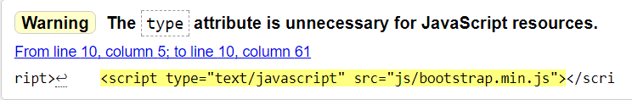
Figure 4-1 – HTML validation warning 1
From Figure 4-1, a warning is stating that there is unnecessary code, which is resolved by removing the ‘type=”text/javascript”’ attribute.

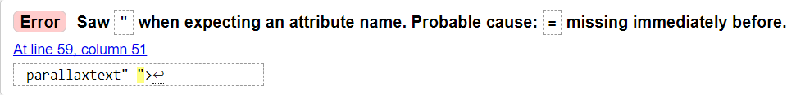
Figure 4-2 – HTML validation error 1
Figure 4-2 shows that there is an unnecessary character (“) which is resolved by removing it.

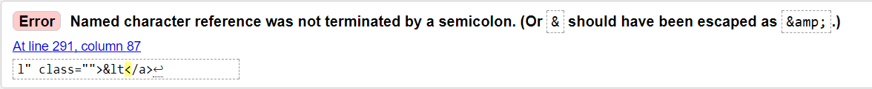
Figure 4-3 – HTML validation error 2
Figure 4-3 shows that a termination character was missed from the entity (an entity replaces a reserved character in HTML [4]). This needs a terminator.

4.2 HTML Re-validation
Once these 3 issues were corrected, the validation was successful with no warnings as shown in figure 4-4.
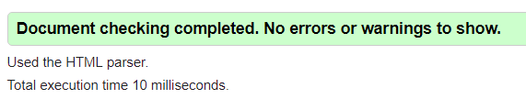
Figure 4-4 – HTML Validation clean

4.3 CSS Errors
Figure 4-5 – CSS validation error 1
Figure 4-5 states that ‘none’ doesn’t exist within the property for pointer-events, although the website behaves correctly when this is in the CSS and it stops the links being selectable again on the navbar. With this removed, it doesn’t perform correctly.
It can only be assumed that this error is stemming from the property seemingly to only be used to affect a graphic (SVG) file [5] and is merely experimental for non-SVG elements [6].
When checking browser support for the given property [7], it is shown that the majority of browsers do actually support this CSS property as displayed in figure 4-6.
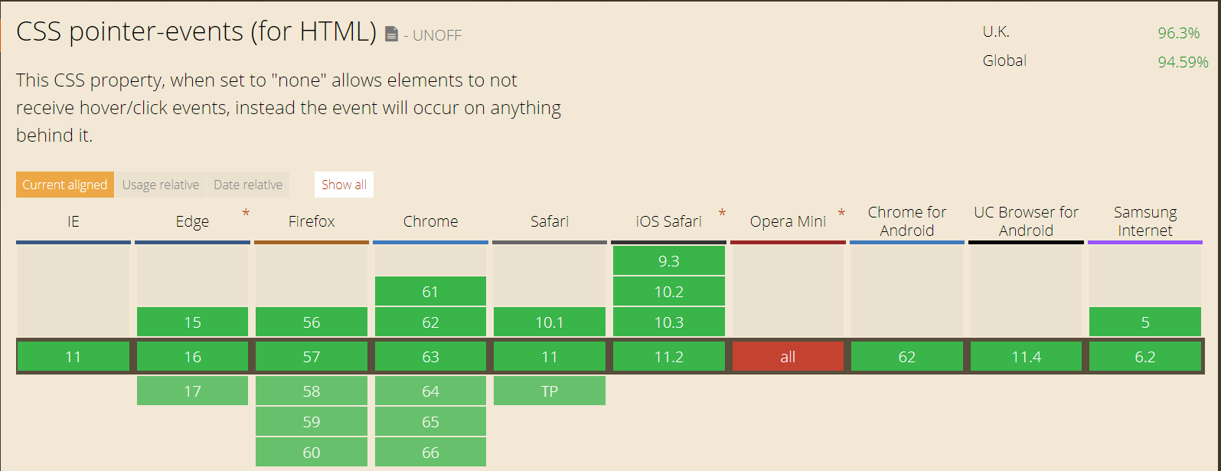
Figure 4-6 – Showing browser support for the property

Figure 4-7 – CSS validation error 2
Figure 4-7 highlights that the value 10 hasn’t been given a unit, which has been caused by the space between the two. Removing this space resolves the error.

5. Website Evaluation
The website evaluation will comprise mainly of 3 sections; design, usability and content. The screenshots provided of the website within the Implementation part of this report (figure 3-1, figure 3-2, figure 3-3, figure 3-4, figure 3-5 and figure 3-6), along with results from a survey of a small number of website users [8] will be used to explore these areas.

5.1 Design
It is easy to distinguish between separate sections of the website and along with navigation, the design seems to be well laid out. Along with results in figure 5-1, the website seems to be very engaging for end users.
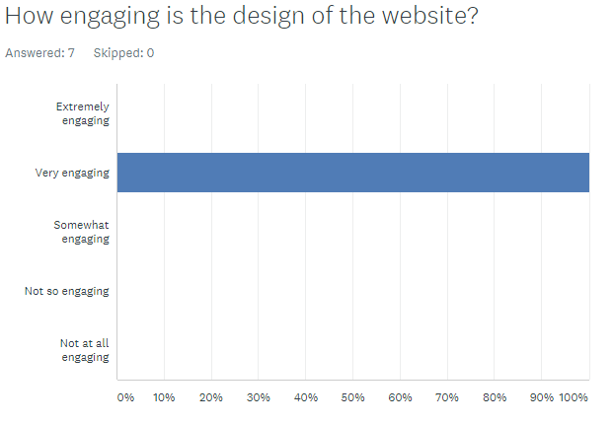
Figure 5-1 – Survey results of design

5.2 Usability
It would be said that the navigation is easy from the screenshots as it shows:
- The navigation bar does not change size from page to page.
- No elements move in the navigation bar from page to page.
- The selected element changes colour to show which page the user is on.

This is further backed up by the results in figure 5-2.
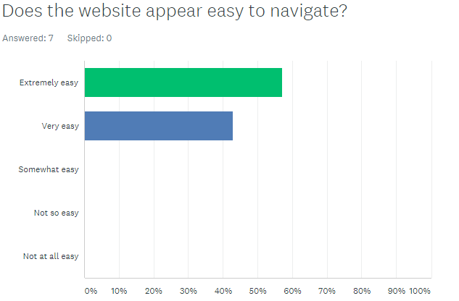
Figure 5-2 – Survey results of navigation

5.3 Content
The content is useful as it is what was outlined in the “About” section - there are reviews and training information available for the users. This again is backed up with the results from figure 5-3.
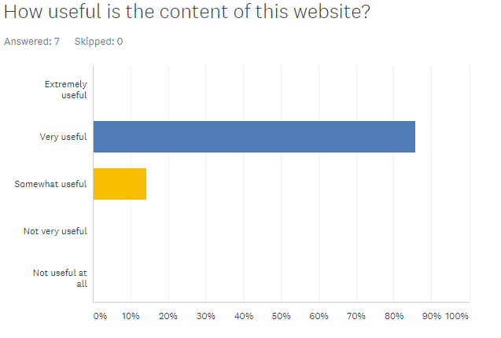
Figure 5-3 – Survey results of content

5.4 Web Accessibility
Web accessibility means that people with a disability can use the web [9, p. 2], [10], or website in question. This would mean maximizing the ability of the user so that they can access information and resources [11] but also understand, navigate and interact with the website. One set of guidelines for web developers is the WCAG.

5.4.1 WCAG (Web Content Accessibility Guidelines)
‘Web Content Accessibility Guidelines (WCAG) is developed through the W3C process in cooperation with individuals and organizations around the world, with a goal of providing a single shared standard for web content accessibility that meets the needs of individuals, organizations, and governments internationally.’[12]
WCAG originally developed in May 1999 [13] was a list of 14 guidelines to assist with making web content accessible for users with disabilities. This was then updated to WCAG 2.0

5.4.2 WCAG 2.0
WCAG was updated to WCAG 2.0 in December 2008 [14], which is an attempt to make the WCAG guidelines more robust and measurable [9, p. 460].
There are 4 main principles of web accessibility within WCAG 2.0 [9, pp. 462–464], [15], [16]:
- Perceivable – Content must be perceivable by the user in some way otherwise it is not useful.
- Operable – Any element on the website must be accessible by all users, whether it be through keyboard-only navigation or avoiding content that may cause seizures.
- Understandable – Content must be clear and readable by all users.
- Robust – Content must be designed in a way it will not have problems with future tools or third-party technologies.

5.5 Accessibility Evaluation
Following the WCAG 2.0 guidelines, it is believed for the website to be mainly accessible. This section will discuss how the use of headings, images, forms and various other elements prove this.

5.5.1 Headings
Each individual page has a <h1> element, which allows users with screen readers to easily skip over repetitive navigation links so they can get to the main content [9, p. 185].
Each section of content has been split up and utilises these heading elements to break up the structure as shown in figure 5-4, allowing screen readers to skim the page and navigate correctly [17], [18].
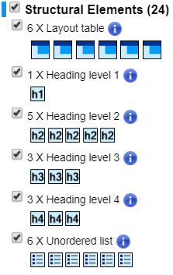
Figure 5-4 – WAVE Evaluation Tool for index.html
From section ‘2.4.6 – Headings and Labels’ of the WCAG 2.0 quick reference [19], both headings and labels within the website are descriptive as per figure 5-5 and figure 5-6.
Figure 5-5 – Descriptive <h2> element
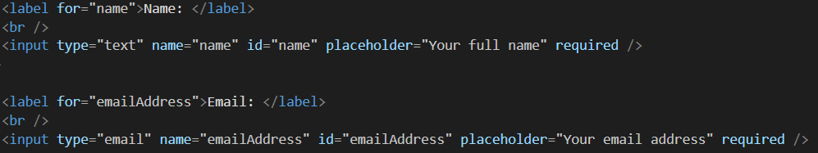
Figure 5-6 – Label element, name attribute and required attribute

5.5.2 Information Structure and Relationships
From section ‘1.3.1 – Info and Relationships’[19], landmarks, regions and headings have been implemented as shown in figure 5-7.
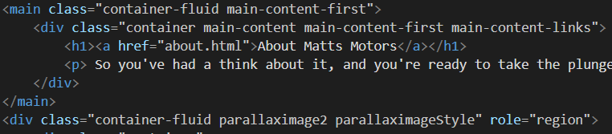
Figure 5-7 – Roles and headings
Table markup has also been implemented to present tabular information as seen in figure 5-8.
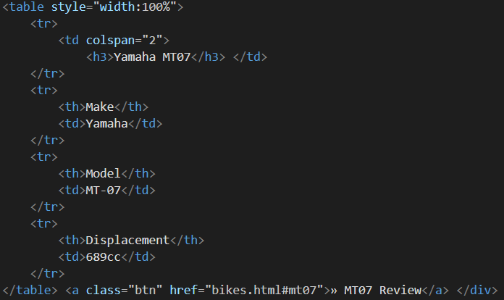
Figure 5-8 – Table markup

5.5.3 Images and Media Content
‘The one accessibility issue that is probably more important than all others is providing text information for web content that is nontextual. Nontext items include images, image maps, image buttons, audio files and multimedia files that provide both audio and video.’ [9, p. 131]
As per ‘1.1.1 – Non-text Content’ [19] each image throughout the website has an ‘alt’ tag to provide alternate text for description of the non-text content that is being displayed as shown in figure 5-9 and figure 5-10.
Figure 5-9 – alternative text
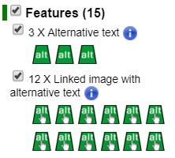
Figure 5-10 – WAVE Evaluation Tool showing alernative texts on index.html

5.5.4 Scalable Text Content
With section ‘1.4.4 – Resize text’ in mind, the website content was scaled up to 200% and worked as normal as per figure 5-11.
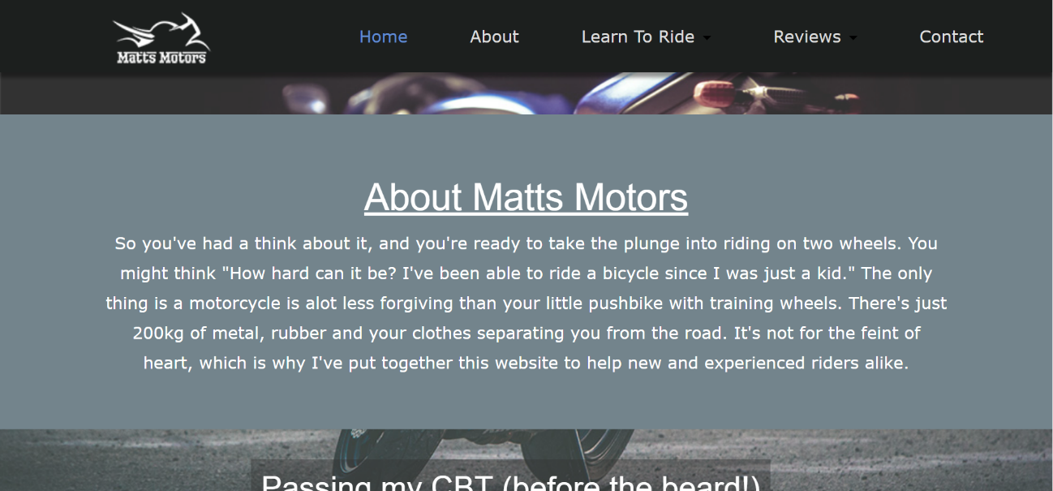
Figure 5-11 – Scaled up
It was also found that the optimal unit to use for font size is ‘em’, as this is a font property, it scales as the font size changes [20].

5.5.5 Website Colours and Contrast
The main problem encountered with accessibility for this website is colour contrast. For a rating of AA or AAA, this will need to be addressed as it is not 4.5:1 as per ‘1.4.3 Contrast (Minimum)’ [19].
From both figure 5-12 and figure 5-13 you can see that the current contrast ratio is 3.88:1. If more was known about accessibility and the WCAG before starting the project, it may have been easier to select a colour scheme that would be better suited towards this ratio.
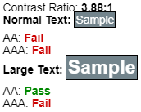
Figure 5-12 – WAVE Evaluation Tool contrast ratio
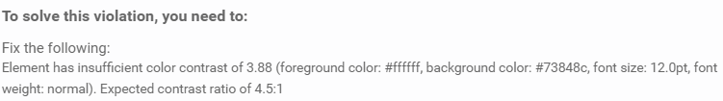
Figure 5-13 – aXe Evaluation Tool contrast ratio
Another method used that is related to the use of colours is by utilising CSS to change the colour of an element once the mouse hovers over it [21] which has been implemented on this website, figure 5-14.
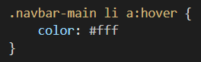
Figure 5-14 – CSS colour change on hover

5.5.6 Forms
Both sections ‘1.3.1 – Info and Relationships’ and ‘3.3.2 – Labels or Instructions’ [19] ask for the ‘label’ element to be used to associate control with a label [22], and the label can be hidden via CSS. This is again to assist screen readers [23], but if the label is hidden this does not matter as the screen reader can still read it.
The implementation of this can be seen back in figure 5-6 where the contact.html page has a form with labels that request the users name, e-mail address and comments.

5.5.7 Navigation
‘3.2.3 – Consistent Navigation’ [19] states that the navigation layout should remain the same from page to page and should occur in the same order each time they are repeated [24]. By keeping the navigation the same through the site means that the user only needs to figure out how this works the once rather than re-learning if there are any changes [1, p. 66].
As shown in figure 5-15 and figure 5-16, the only thing that would change from page to page would be the ‘current’ page is selected (shown by the colour change) and the user cannot select it again. There is no layout change with the navigation bar for ease of use.
Figure 5-15 – Navigation bar
Figure 5-16 – Navigation bar 2

5.6 Future Improvements
From research throughout studying this module and the WCAG it should be noted that going forwards following improvements could be made:
- More research into colour contrast for accessibility users with visual impairments.
- Links to different pages should be more distinguishable.
- Site to be made with responsive design in mind to cater for other personal devices.

6.0 References
[1] S. Krug, Don’t Make Me Think, Revisited: A Common Sense Approach to Web Usability (Voices That Matter), 3rd ed. Pearson, 2013.
[2] “About the W3C Markup Validation Service.” [Online]. Available: https://validator.w3.org/about.html. [Accessed: 28-Dec-2017].
[3] “The W3C Markup Validation Service.” [Online]. Available: https://validator.w3.org/#validate_by_input. [Accessed: 28-Dec-2017].
[4] “HTML Entities.” [Online]. Available: https://www.w3schools.com/html/html_entities.asp. [Accessed: 28-Dec-2017].
[5] “pointer-events - CSS | MDN.” [Online]. Available: https://developer.mozilla.org/en-US/docs/Web/CSS/pointer-events. [Accessed: 28-Dec-2017].
[6] J. Korpela, “Re: pointer-events from Jukka K. Korpela on 2012-11-21 (www-validator-css@w3.org from November 2012).” [Online]. Available: http://lists.w3.org/Archives/Public/www-validator-css/2012Nov/0033.html. [Accessed: 28-Dec-2017].
[7] “Can I use... Support tables for HTML5, CSS3, etc.” [Online]. Available: https://caniuse.com/#search=pointer-events. [Accessed: 28-Dec-2017].
[8] “Website Evaluation - Responses | SurveyMonkey.” [Online]. Available: https://www.surveymonkey.com/results/SM-MMXN9F9M8/?manage=true. [Accessed: 30-Dec-2017].
[9] J. Thatcher et al., Web Accessibility Web Standards and Regulatory Compliance. Friendsof, 2006.
[10] S. L. Henry, “Introduction to Web Accessibility | Web Accessibility Initiative (WAI) | W3C.” [Online]. Available: https://www.w3.org/WAI/intro/accessibility.php. [Accessed: 29-Dec-2017].
[11] D. Holstius, “Web Accessibility Explained,” Web Access. Break. Down Barriers, 2001.
[12] S. L. Henry, “WCAG Overview | Web Accessibility Initiative (WAI) | W3C.” [Online]. Available: https://www.w3.org/WAI/intro/wcag. [Accessed: 29-Dec-2017].
[13] W. Chisholm, G. Vanderheiden, and I. Jacobs, “Web Content Accessibility Guidelines 1.0.” [Online]. Available: https://www.w3.org/TR/WAI-WEBCONTENT/. [Accessed: 29-Dec-2017].
[14] S. L. Henry, “Web Content Accessibility Guidelines (WCAG) 2 FAQ | Web Accessibility Initiative (WAI) | W3C,” 2017. [Online]. Available: https://www.w3.org/WAI/WCAG20/wcag2faq#different. [Accessed: 29-Dec-2017].
[15] L. McGrath, “What are the Web Content Accessibility Guidelines?” [Online]. Available: https://wuhcag.com/web-content-accessibility-guidelines/. [Accessed: 29-Dec-2017].
[16] S. L. Henry, “WCAG 2.0 at a Glance | Web Accessibility Initiative (WAI) | W3C.” [Online]. Available: https://www.w3.org/WAI/WCAG20/glance/. [Accessed: 29-Dec-2017].
[17] “Using headings to improve accessibility | Drupal.org.” [Online]. Available: https://www.drupal.org/docs/7/creating-accessible-themes/using-headings-to-improve-accessibility. [Accessed: 29-Dec-2017].
[18] “Accessibility at Penn State | Heading Tags (H1, H2, H3, P) in HTML.” [Online]. Available: http://accessibility.psu.edu/headingshtml/. [Accessed: 29-Dec-2017].
[19] E. Eggert et al., “How to Meet WCAG 2.0.” [Online]. Available: https://www.w3.org/WAI/WCAG20/quickref/. [Accessed: 29-Dec-2017].
[20] “C14: Using em units for font sizes | Techniques for WCAG 2.0.” [Online]. Available: https://www.w3.org/TR/WCAG20-TECHS/C14.html#C14-description. [Accessed: 29-Dec-2017].
[21] “C15: Using CSS to change the presentation of a user interface component when it receives focus | Techniques for WCAG 2.0.” [Online]. Available: https://www.w3.org/TR/WCAG20-TECHS/C15.html#C15-description. [Accessed: 30-Dec-2017].
[22] “H44: Using label elements to associate text labels with form controls | Techniques for WCAG 2.0.” [Online]. Available: https://www.w3.org/TR/WCAG20-TECHS/H44.html. [Accessed: 30-Dec-2017].
[23] E. Eggert et al., “Form Instructions • Forms • WAI Web Accessibility Tutorials.” [Online]. Available: https://www.w3.org/WAI/tutorials/forms/instructions/. [Accessed: 30-Dec-2017].
[24] “G61: Presenting repeated components in the same relative order each time they appear | Techniques for WCAG 2.0.” [Online]. Available: https://www.w3.org/TR/WCAG20-TECHS/G61.html. [Accessed: 30-Dec-2017].

6.1 Background Reading
[1] V. L. Hanson and J. T. Richards, “Progress on Website Accessibility?,” ACM Trans. Web, vol. 7, no. 1, p. 2:1--2:30, Mar. 2013.
[2] M. Waight and W. Oldreive, “Accessible websites - what is out there?,” Br. J. Learn. Disabil., vol. 44, no. 2, pp. 122–129, Jun. 2016.
[3] “Home of free code snippets for Bootstrap | Bootsnipp.com.” [Online]. Available: https://bootsnipp.com/. [Accessed: 30-Dec-2017].
[4] “W3Schools Online Web Tutorials.” [Online]. Available: https://www.w3schools.com/. [Accessed: 30-Dec-2017].
[5] “Web Design and Applications - W3C.” [Online]. Available: https://www.w3.org/standards/webdesign/. [Accessed: 30-Dec-2017].
[6] H. Nyh, “Github - twbs/bootstrap.” [Online]. Available: https://github.com/twbs/bootstrap/issues/1768. [Accessed: 30-Dec-2017].
[7] K. Ademoye, “Course: L4 - Introduction to Web Development (ACCA4003).” [Online]. Available: https://moodle.uwtsd.ac.uk/course/view.php?id=2051. [Accessed: 30-Dec-2017].
[8] “Traversy Media | Web Development &amp; Programming Tutorials.” [Online]. Available: https://www.traversymedia.com/. [Accessed: 30-Dec-2017].

