

Programme:
BA (Hons) Leadership and Management Skills for the Workplace
Module:
Managing Business Information
Module Code:
LCLM5004
Assessment Component:
Component 2 – Individual Report
Assignment:
Information Systems Improvements

Student Name:
Toshko Trifonov
Student ID:
2407602
Lecturer:
Chinomso Nwagboso

Enhancing Operational Performance Through Integrated Enterprise Systems: A Strategic Proposal for Kalori Ltd.

Table of Contents
Introduction 4
Evaluation of Existing Systems 5
Recommended Solution 7
Implementation Plan 9
Conclusion 10
Reference 11

List of Figures
Figure 1: Evaluation of Existing Systems 5
Figure 2: Identification of Inefficiencies and Gaps 6

Introduction
Kalori Ltd is currently a target of its own success. While sales are increasing and climbing across its 30 physical showrooms and digital platform, the business is securing under its own weight. It is the classic story of a retailer whose popularity has overtaken its process.
Overview of the Business Case
The central issue is a large “Omni channel Disconnect.” Rather than having a strong market presence, the digital and physical arms of the brand are moving in different directions. Instead of a perfect and consistent shopping experience, the infrastructure is falling in because the systems are not communicating or connecting to each other, leaving the brand stuck in a state of operational disorder.
Identification of Key Operational Challenges
To fix the foundation, Kalori must break down three major issues:
Inventory Silos: There is an invisible wall between online and offline stock. This shortage of visibility moves and leads to "out-of-stock" errors online even when products are available directly on store shelves.
Data Fragmentation: Customer intelligence is “trapped” in isolated systems. Without a combined view, the brand cannot check loyalty or understand how its shoppers actually behave.
Information issue: Depending on manual spreadsheets has created a “reactive” management style. By the time the numbers are consumed and the opportunity is gone by the business needs and proactive data to win.

Evaluation of Existing Systems
Critical Analysis of Current Systems
Kalori Ltd’s technological concept and foundation is currently created on Legacy Systems. In academic terms, these are mainly described as "stand-alone" or "island" systems. While they may have been state-of-the-art during the company’s beginning, they have failed to develop alongside the brand’s desires. As the business has go up to 30 physical stores and a busy digital side, these systems have changed from helpful tools into fixed anchors that bring down the pace of creativity. They represent a "digital limitation" that Kalori is now moving into. The most damaging analysis of these legacy setups is their total shortage of compatibility. In a modern retail environment, systems should breathe together however, Kalori’s "islands" are completely silent or mute to one another. This silence forces the business into a cycle of long term Data Redundancy. Imagine a scenario where a single product SKU or a customer’s new shipping address must be manually re-typed into three different databases. This is not just a heavy waste of human talent, it is directly increases the risk of human error. When systems are disconnected, the "source of truth" becomes divided in different parts. Management is mainly left in the dark, forced to play a guessing game about which system holds and manage the accurate numbers, moving to a breakdown in corporate confidence.
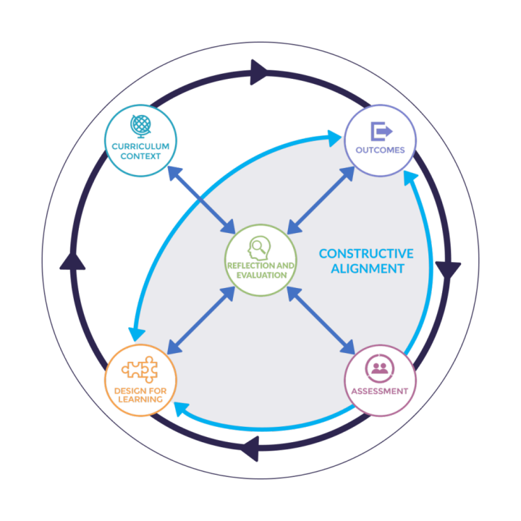
Figure 1: Evaluation of Existing Systems
Identification of Inefficiencies and Gaps
After the heavy technical debt of affected software, Kalori has fallen into a dangerous operational danger: "The Spreadsheet Trap." Depending on Microsoft Excel to manage the reporting and logistics of a 30-store empire is a high-stakes that take a chance that rarely pays off. While spreadsheets are excellent for small-scale tasks, they are not created to handle the big issues of a multi-million-pound retail chain (Gordon and Thompson, 2024). Academic research supports this concern, an outstanding study from the University of Hawaii and various industry examiner suggested that as many as 88% of all spreadsheets contain significant errors. For a business of Kalori’s magnitude, a single broken cell formula or a misplaced decimal point in a master inventory sheet can move to destructive miscalculations issues in financial guessing or predicting and stock purchasing.
This systemic inefficiency is not just a "tech headache" it moves and connect directly to Financial Leakage. When the "Omni channel Disconnect" causes a customer to buy an item online that is not present or available actually in the warehouse, the damage goes far beyond a simple apology. This resistance activates a chain reaction of loss:
Direct Capital Loss: The business loses money on wasted credit card paying fees, shipping logistics, and the administrative cost of processing manual refunds.
Reputational breakdown: Modern shoppers are unforgiving. Industry data from different platforms like Salesforce shows that a wide majority of consumers are less likely to return to a retailer after a “hallucination stock" experience. Trust is hard to earn but incredibly easy to lose.
Operational Strain: Instead of focusing on growth methods or customer involvement, staff are forced into a permanent state of "firefighting" (Farhad, 2024). They spend their days managing inventory issues and calming angry customers.
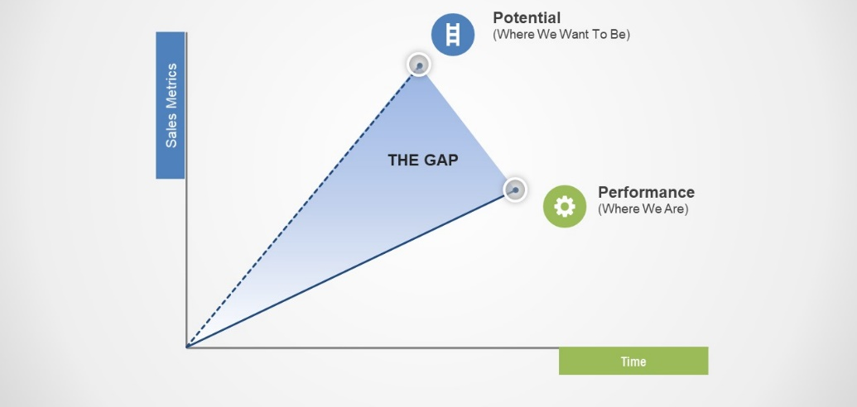
Figure 2: Identification of Inefficiencies and Gaps

Recommended Solution
Proposal: The Integrated Cloud-ERP Solution
To protect Kalori Ltd from its current operational paralysis, the strongest recommendation is the applying of a modern Enterprise Resource Planning (ERP) system (Dmitrova, 2024). Platforms such as Microsoft Dynamics 365 or Oracle NetSuite are not basically "software upgrades", they represent the central nervous system of a modern retail company or enterprise. Unlike the current "island" systems that isolate departments, a modern ERP provides a unified architecture that natively divides the Customer Relationship Management (CRM) and Business Intelligence (BI) modules.
By moving to this unified platform, Kalori make sure that every department from the warehouse floor to the boardroom is looking at the same data in current time (Yildirim and Kaya, 2025). This "Single Source of Truth" effectively turns Kalori into a data-based powerhouse, where the left hand finally knows what the right hand is doing. It replaces the noise of issues coming with the clarity of a coordinated digital ecosystem. This move marks the end of the "Omni channel Disconnect" and the beginning of a combined, high-performance retail method.
Justification: Business Needs & Scalability
In the debate between Cloud-based and On-Premise infrastructure, the decision for Kalori is clear: a "Cloud-First" method is the only logical path forward. The primary worker there is Scalability. Under the current legacy model, opening a new store likely requires a major upfront investment in physical servers, local networking hardware, and manual on-site IT maintenance (Raut, 2025). This creates a "growth tax" that makes growth slow and expensive.
In different way, a Cloud-ERP allows Kalori to scale horizontally with the click of a button. As the business grows from 30 stores to 50 or 100, the infrastructure increases instantly in the digital region. The cloud removes the "hardware bottleneck" that currently check expansion, allowing the company to pay only for the capacity it actually uses. This flexibility is important for a retailer that must manage seasonal peaks, such as Black Friday or the January sales, where system demand can increase ten-fold in a single day.
Beyond internal efficiency, this solution provides a large Challenging Advantage. In the hyper-challenging UK electronics market, consumers no longer view "Click and Collect" or "Current stock checking" as premium features they are baseline expectations. By dividing the e-commerce platform with physical store record through an ERP, Kalori can provide a true Omni channel experience. A customer sitting in a café in London should be able to see that a specific pair of noise-cancelling headphones is available at the nearest branch, buy them on their phone, and pick them up ten minutes later. Without a divided ERP, this level of service is technically impossible to achieve reliably, leaving Kalori vulnerable to more agile challenges like Currys or Amazon.
GDPR Compliance and Cybersecurity
The move to a divided system is not just about profit, it is about The Legal firm. Currently, Kalori’s divided data dissolved across unlocked spreadsheets and isolated databases is a clicking time bomb for GDPR (General Data Protection Regulation) violations (Kubicek et al., 2024). In the UK, the Information Commissioner’s Office (ICO) has the power to tax alternate fines for the mishandling of personal data.
An ERP provides Centralised Data Governance, allowing Kalori to check exactly where customer data is stored, who has accessed it, and how to delete it upon request (Khalid, 2024). It changes a large legal responsibility into a compliant, structured value. Furthermore, the "island" systems currently in use are likely filtered with security issues. A modern Cloud-ERP brings enterprise-grade Cybersecurity to the table. They must authorize features like Multi-Factor Authentication (MFA) and End-to-End Encryption as non-negotiable requirements. These protocols make sure that even if a staff member's password is stolen, the "vault" remains locked. By protecting customer credit card data and personal history through a better process, secured platform, Kalori protects its most valuable untouchable asset: its reputation.
Future-Proofing through Business Intelligence
The true magic of this change occurs in the Business Intelligence (BI) module. For years, Kalori has been "reactive," looking at manual spreadsheets to see what happened weeks ago. This is like trying to move a car while only looking at the rear-view mirror. Business Intelligence moves the script. By using tools like Microsoft Power BI divided within the ERP, management can check trends as they happen (Lindh, 2025). They can see which product lines are slowing down in current time and where the supply chain is likely to break next (Wieland et al., 2023). This allows for Proactive Management, such as moving stock from a slow-moving store to a high-demand area before the weekend rush begins. This is the movement from survival to mastery.

Implementation Plan
A Phased Method: Development, Not Revolution
When increasing a 30-store empire like Kalori Ltd, the desire is to move a switch and go live everywhere at once. However, they must avoid a “Big Bang” launch at all costs, in the world of retail tech, doing everything at once is a recipe for total system pass out. Instead, they propose a method of, three-phase rollout:
Phase 1: Data Cleansing. Before the new engine can roar to life, they must "scrub" the fuel. This includes fixing the errors, duplicates, and broken formulas currently hiding in the legacy spreadsheets. They cannot create a high-tech future on top of "waste" data.
Phase 2: The Pilot Program. They will battle-test the ERP in just 1–2 battleship of stores. This allows them to iron out any "bugs" in a controlled environment without risking the income of the entire chain.
Phase 3: Full Rollout. Once the experiment is a proven success, they scale the system across the remaining 28 stores and the e-commerce platform.
Staff Training: Winning Hearts and Minds
The greatest risk to this project is not the code, it’s the Human Factor. Many IT projects fail simply because staff gets new software frustrating or annoying. To handle this, they will use Lewin’s Three-Step Model:
Unfreeze: Prepare the team for change by explaining why the old spreadsheets are failing them.
Change: Provide hands-on training sessions where staff can explore the new structure or interface.
Refreeze: Managing the new habits by making the ERP the "new normal" for daily tasks, backed by a dedicated support desk.
Risk Analysis: The Safety Net
No relocation is without danger, and the primary risk here is Data Loss. If information vanishes during the move, Kalori loses its history. The reduction method is two-fold:
Frequent Backups: They will take "snapshots" of all data every hour during the changes.
Parallel Running: For the first month, they will run the old systems alongside the new ERP. This "safety buffer" make sure that if the new system shows pauses, the business will not stop.

Conclusion
For Kalori Ltd, the applying of a modern, cloud-divided ERP system is far more than a simple IT upgrade, it is a fundamental survival method. In an area where the UK electronics market is defined by sharp margins and immediate consumer demands, the "Omni channel Disconnect" is a luxury business that can no longer afford. Staying in chain to the "islands" of legacy software and error-based spreadsheets is not just inefficient it is a slow-motion give way of brand reputation and capital.
By managing these digital gaps, Kalori unlocks a future defined by confidence and loyalty. The benefits are transformative: current record checking removes "phantom stock" frustrations, combined customer data fuels deeply personalised shopping experiences, and centralised governance make sure absolute legal safety under strict GDPR regulations. No longer will the staff be "firefighting" manual errors, they will be managed by Business Intelligence to make proactive, data-based decisions that handles the challenges.
This change marks the moment Kalori stops being a collection of waste struggling stores and starts functioning as a single, method, and secure retail value. The road from divided "island" systems to a combined cloud ecosystem is an investment in duration. For Kalori Ltd, the choice is clear: develop the infrastructure today, or become an advisory story of tomorrow.

References
Dmitrova, А. (2024). Analysis of the enterprise management system. [online] Sumdu.edu.ua. Available at: https://essuir.sumdu.edu.ua/items/e0a72a5b-8d50-4420-b066-5c5181a9afad.
Farhad, M.A. (2024). Consumer Data Protection Laws and Their Impact on Business Models in the Tech Industry. Telecommunications Policy, [online] 48(9), pp.102836–102836. doi: https://doi.org/10.1016/j.telpol.2024.102836.
Gordon, I. and Thompson, N. (2024). Delivering Data Capability. pp.199–238. doi: https://doi.org/10.1007/978-3-031-51008-3_5.
Khalid, H. (2024). The Role of Cloud Technologies in Improving Enterprise Data Management: A Case Study of Intelligent Business Applications. Dijlah Journal of Engineering Sciences ISSN: 3078-9664, e-ISSN: 3078-9656, 1(3). Available at: https://journal.duc.edu.iq/index.php/djst/article/view/43.
Kubicek, K., Merane, J., Bouhoula, A. and Basin, D. (2024). Automating Website Registration for Studying GDPR Compliance. doi: https://doi.org/10.1145/3589334.3645709.
Lindh, T. (2025). Using Microsoft Power BI to optimize work load management and maintenance tracking. Theseus.fi. doi: http://www.theseus.fi/handle/10024/906543.
Raut, U. (2025). Migration of Physical Server to Cloud. Theseus.fi. doi: http://www.theseus.fi/handle/10024/905362.
Wieland, A., Stevenson, M., Melnyk, S.A., Davoudi, S. and Schultz, L. (2023). Thinking differently about supply chain resilience: what we can learn from social-ecological systems thinking. International Journal of Operations & Production Management, 43(1), pp.1–21. doi: https://doi.org/10.1108/ijopm-10-2022-0645.
Yildirim, A. and Kaya, M. (2025). Optimizing Enterprise Data Workflows Through Cloud-Based Analytics Platforms: A Study on Performance, Interoperability, and Governance. Annual Compendium of Multidisciplinary Scientific Insights and Technological Frontiers , 15(11), pp.1–14. Available at: http://thesciconsortium.com/index.php/ACMSITF/article/view/Yildirim2025

