

Student Name: | Charles Uzor
Student Number: | 1809185
Module No: | LCMB 7010
Module Title: | Digital Marketing
Lecturer: | Sadeque Shaikh

Statement of Confirmation of Authenticity
By the act of making this submission, the student declares that this is the work of the student named above. The work has not, in whole or in part, been knowingly presented elsewhere for assessment, or where assessment has been built on a previous assessment, this has been identified. Where materials have been used from other sources it has been properly acknowledged. If this statement is untrue, the student acknowledges that an assessment offence has been committed.
Attention is drawn to the plagiarism and unfair practice policies of both the University and of ILM.

Contents
Introduction: 2
Company Background: 3
Marketing and Digital Marketing: 4
Digital Marketing: 4
Benefits of Digital Marketing: 4
Disadvantage of Digital marketing. 5
Analysis of TESCO Digital Marketing Communication Strategy and Digital Assets. 5
Website: 6
E-CMS. Content Management System: 6
Customer Relationship Management System. 6
Email Assets and Marketing 7
Online Groceries Shop: 8
Tesco Loyalty Club Cards 9
Online Payment Platform. 10
Social Media Assets: 10
Facebook: 11
Twitter: 11
YouTube 12
Instagram 13
Pinterest: 14
Tesco App: 15
Impact of Artificial Intelligence on Digital Marketing 17
Why Tesco Should Incorporate AI as Part of Its digital marketing Strategy: 17
Benefits of Artificial Intelligence. 18
Conclusion: 19
References 20

Introduction:

The dawn of the internet has provided an easy avenue for the public to access information freely, which otherwise may have been expensive and difficult to obtain. The internet has also become a media that supports global community development (Bismo, et al., 2019), and the growth in the use of personal computers and smart devices have further increased the demand and consumption of all sorts of information, with everyone including organisations going online to carry out some form of communication using the internet. The expansion in technology advancement have also seen a further development in machine learning. New machines and systems with ability to predict the future and support decision making processes, by extracting insights from large amount of generated dated have been developed (Miklosik, et al., 2019). This has created a huge opportunity for organisations from a marketing perspective, as organisation realise that they need to utilise information technology to be able to attract and reach target customers with important marketing communications, while gaining important information about their customers behaviours. Digital marketing provides organisation the opportunities to effectively communicate with customers who otherwise cannot be reached using conventional methods.

This document will seek to review how Tesco a retail giant in the UK retail space, is represented within the digital space and how the organisation is using its digital platforms to manage its marketing communication and relationship with its customers. An analysis of the organisations digital assets will be conducted, with a view to determine the balance between the internal and external communication structure flow, its information architecture and how the use of digital marketing is impacting the organisations marketing communication strategies.

Company Background:

Tesco is a leading British multinational retail store, with headquarters in United Kingdom, established in the 1919 by Jack Cohen, with its first store opening in 1929 in the east end of London. The organisation predominantly sells food products from its store and has since grown to become one of the leading household retail stores across Europe, with over 5500 stores across Europe, with 3801 of its stores located within the United Kingdom and Ireland (TESCO, 2022). Tesco main competitors are ASDA, Sainsbury’s, and Morrison, and currently have over 28% share of the UK food retail market, with an annual turnover of £53.4B and year on year growth of over 7%. The organisation currently employs over 360,000 people in the UK making it one of the leading employers in the food and retail industry (Tesco, 2021).

Tesco’s growth has been both organic through direct investment and acquisitions, by acquiring other major food retailers, such as its recent merger with bookers, a major UK food wholesaler, allowing it to create sustainable synergy and access to the out of home food market. The organisation has continued to invest in the retail sector and have since expanded their operation into financial and telecom sectors, where it trades as the Tesco Bank and Tesco Mobile. The organisation has committed to building a customer focus business, with a vision of having a shared purpose of serving its customers a little better every day, treating customers how they want to be treated, and having the understanding that every little help make a big difference (TESCO, 2022).

The organisation growth has also been sustained by its vast investment in technology, from launching their first digital assets in the form of the Tesco club loyalty card in 1995, where offers and digital discount vouchers are given to their customers, based on analysis of their purchase information, to the launch of their online sales platform in 2000. The organisation has since embraced the digital age and uses digital communication platforms as base for all its marketing communication strategy, as dependency on technologies continues to grow throughout the group. The organisation recently completed a huge investment in their technology infrastructure, which involves cloud hosting, investing in data centre facilities, and new information security capabilities, strengthening their information technology general controls (Tesco, 2021). The organisation uses other digital technology platforms such social media platforms and other intranet-based systems to engage and communicate with their customers and this form bases of their marketing and communication strategy.

Marketing and Digital Marketing:

Marketing is the process or processes implemented to create awareness for a product or a service. It involves different methods and communication strategies used to increase visibility for a product or service, with the aim of offering same to the end user. The chartered institute of Marketing, defines marketing management as process responsible for identifying, anticipating, and satisfying customer requirements profitably (CIM,2001), (Brassington & Pettitt, 2005). A further definition of marketing was said to be a process of planning and executing the conception, pricing, promotion and distribution of ideas, goods, and services to create exchange and satisfy individual and organisational objectives (AMA Board, 1985).
Marketing is about giving customers what they want and requires planning analysis, resource allocation controls and investments.

Traditional marketing strategies involved the use of print media, television, and radio as a primary means of communicating new promotional ideas to target consumer over the years. However, these methods were found to be very expensive and most often did not reach the target audience and performance of marketing communication campaigns were very difficult to measure. The explosion in technology advancement changed this and have provided new ways of marketing management and communication using the internet. known as e-marketing or digital marketing. Electronic marketing is the use of electronic media such as web, e-mail wireless media, to manage all marketing communications with customers, including using customer database to manage relationships with customers using electronic management systems such as CRM’s (UWTSD , 2022). it helps in identification of customer requirements, provides an avenue through which customer can access what they need using the internet and helps in realising customer satisfaction due to speed of response commonly associated with the use of electronic media.

Digital Marketing:

Digital marketing on the other hand is a very diverse marketing process, used by most organisations for marketing all types of products and services. It involves the application of technologies that are made up of online channel such as web emails, databases, mobile/ wireless media/ social media and other digital based platforms designed to support marketing activities, aimed at successfully wining and retaining customers (Mary & Marla, 2016). Digital marketing has been described as simply achieving marketing objectives through applying digital technologies and media (Chaffey & Ellis-Chadwick,, 2018.).

The evolution of the digitalisation has led to creation of different forms of digital contents which are used to accurately target customers over the internet, with marketing communication materials. Some examples of dominant digital marketing process are, search engine marketing, which entail publishing of marketing material on a web page over the internet, with the web address easily searched using search engines. Social Media marketing involves generating online traffic by directly engaging with target customer over social media platforms with a key benefit of encouraging customer retention. Search engine optimisation is a process of organically generating online traffic from a search engine. Online advertising, where promotions or marketing communications are distributed using online channels. Email marketing is the distribution of communication using specific email addresses usually acquired using customer relationship management systems (CRM).

The use of the different digital platforms plays a huge role in supporting multichannel marketing upon which many organisational digital marketing strategies are developed. As with traditional marketing strategies, it allows for organisations to effectively determine segmentation, targeting and positioning decisions, specifying how to deliver value to their target audience as a proposition of service or product. Integration of digital marketing with other forms of traditional marketing, allows for alignment of business levels strategies, development of clear objectives for brand development, consistency in types of customers who use platforms, differential service proposition for different channels, specify differences between online and offline communication mix and support customer journey through buying process using digital channels ( Chaffey & Ellis-Chadwick, 2016).

Benefits of Digital Marketing:

There are several benefits derived from the use of digital marketing as an integrated marketing strategy for organisations and their customers.

- Digital marketing allows for easily identification of target customers’ needs and wants using the internets as a research tool.
- It allows for tension free purchase of product and services using the internet.
- Provides multi channels of accessing information and evaluation of consumer behaviour
- Supports targeted communication and increase in customer satisfactions as feedback on customer experiences are easily gained.
- Reduced marketing cost as communication are digitally distributed across platforms.
- Consistency in communication standards as information are integrated.
- Increased agility in information management as changes to communication can be made quickly and redistributed.
- Ability to accurately measure impact of marketing outcomes and results across different platforms.
- Widers target audience can be easily reached.

Disadvantage of Digital marketing.

The growth of digitalisation and use of electronic digital platforms present certain challenges to marketers and organisations, some of which range from understanding and adapting to the fast-changing situation of the macro environment, to aligning new strategies to existing marketing objectives.

- Information change happens so quickly requiring constant updating, this increases the chances of communication errors.
- Information can easily go viral and may be difficult to recall. This can be harmful to a brand in a case of scandals.
- Increased amount of noise in the digital space as customers are also subjected to receiving targeted marketing communication from competition.
- Digital platform a prone to glitches and can sometimes fail, which can bring down a whole marketing campaign.

Analysis of TESCO Digital Marketing Communication Strategy and Digital Assets.

An organisation digital marketing communication strategy refers to the processes, tools, and mediums an organisation uses in developing and distribution of its marketing communication. It involves considerations an organisation must make, before deciding the best or most suitable digital assets that will best support their business and marketing objectives. Considerations such as modifications to organisations structure, development of specific system and processes to manage information flow, deciding on support staff requirements, deciding on how to integrate to organisation culture, deciding on skills area for management of digital assets, developing of guiding perception within organisation, are important consideration an organisation must make when developing their digital marketing communication strategy.

Communication is concerned with the exchange of information from one person to another using a medium. This can be digital, written, or verbal and designed to gain some form of response. Communication can be defined as a social interaction through messages, and further defined as the exchange of thoughts information or ideas through a medium, with a view of gaining mutual understanding between the sender of the information and the receiver (Maund, et al., 2017). Communication occurs when a system or medium influences another or leads to a response or a certain behaviour manipulated by different symbols transmitted through different mediums.

Tesco has a strong digital presence and adopts most of the mentioned processes as part of their digital communication structure. The organisational structure shows a dedicated IT team, tasked with managing all their technology infrastructure, which supports all aspects of their digital marketing communication strategy. Tesco digital assets consist of website, e-CMS and CRM software system, social media platforms, intranet systems, digital loyalty cards, digital apps, online payment interface.

Website:

Tesco operates a robust website where it hosts all its digital communication platforms. Its website address which is www.tesco.com uses search engine optimising to draw traffic to the website. Within this website houses an extension of the organisation customer relationship management software (CRM), which is linked to the online sales platform where all the food groceries are displayed.

E-CMS. Content Management System:

Content management systems is a software tool used for creating, editing, and updating documents that can be accessed using different platform such as Intranet, extranet, and the internet. This software present in Tesco’s website allows for easy integration and management of other digital assets such as the Customer relationship management software, social media platforms, and allows for performing certain functionalities within the website such as tracking and monitoring visitors’ activities, link management and editing of content within the web pages.

Customer Relationship Management System.

Customer relationship management system is an enterprise software used to manage interacts and communications with customers. It provides organisations the ability to build and manage customer relationships, in other to streamline processes, improves customer services, generate sales with increased profitability (ICIMS, 2022).
Visitors to the Tesco online stores are encouraged register their personal details in form of “My Account”. Information such email address, full personal contact details with gender, age and payment information are collected. Further marketing communication choice preferences such as Tesco app download, club card sign on, Tesco bank and Tesco mobile are offered, with customer information retention consent, are collected and stored within their secure database.
An online “Help” section with important information covering the organisations products and services, store locations, instore communications and trading policies covering issues such as returns and refunds, with useful links to specific areas of the website, are published on the website under the “Help” banner.
A “Contact us” section with important contact links for visitors to use if they need to directly communicate with Tesco is also published on the website. Direct links to various sections of the Tesco offerings with telephone Numbers, email addresses, and opening times are also published in the relevant sections.
A Store Search Locator that allows customers and visitors to the website to locate Tesco stores across the country is also published, with further breakdown of store sizes, such as superstores with more product and service range offerings, are also communicated in this section.

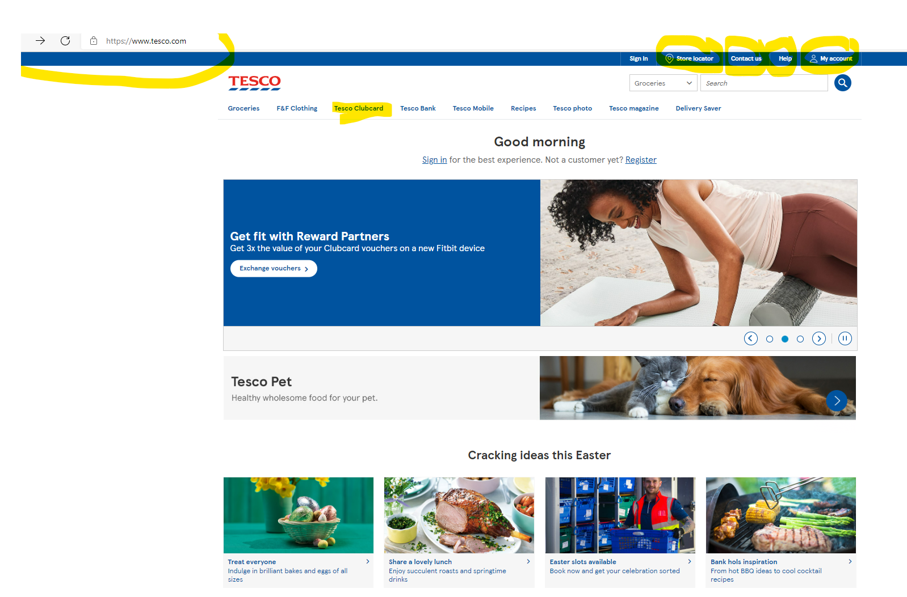
Fig1: Tesco Website Home Page (TESCO, 2022)

Email Assets and Marketing

Email is another important asset that is Present in Tesco’s website as part of the information collected and managed by the CRM software system. The Organisation has different email addresses for every section of its service offering, to help streamline and increase efficiency in communication with its customers. These email accounts are used to send marketing communication directly to their customers and potential customers and receive communications from their customers in forms of enquires and queries. This process is known as out-bound and in-bound email marketing. Email marketing helps in customer acquisition and have been shown to help increase customer retention, used in sales lead generation, increase sales, increase brand awareness, and gather other important data on customers ( Chaffey & Ellis-Chadwick, 2016). Some of the other advantages gained from this asset are

- Relatively inexpensive. The cost of using email marketing is substantially low than conventional marketing communication mediums.
- Encourages direct response as communication is directed to intended target.
- Increased speed of campaign deployment
- Ease of personalising marketing communication to increase chances of response
- Allows for easy integration with other forms of direct media.

Though these benefits are key attraction for organisations to invest in this asset, it has its shortfalls in that it may be difficult to deliver emails to intended targets especial when using rented email addresses. Also, customer communication preference may exclude email and therefore render the email address ineffective.

Online Groceries Shop:

The Tesco Online grocery shop is another key digital marketing communication assets hosted on the Tesco Website. Linked to the organisation Enterprise content management systems, it holds details of all groceries and non-grocery products offered by Tesco. Product images with full description and prices are displayed alongside each product, with images matching exactly what is found in the Tesco store location. Further information on exact location of products in certain stores, are provided for those customers wishing to experience the product before purchase. Personal shopping list can be created and stored within this section and information are automatically stored against the customer’s account. Customers can choose a specific delivery slot and complete their purchase using Tesco online payment system. Customers also have the options of click and collect, where online purchases can be collected directly from store.

Product offers and discount promotions are published on the web page, with exact promotional content published across all digital assets. A major benefit of this assets is the ability for the customer to complete their grocery shopping using the internet from the convince of their home or smart device, knowing that their frequent order list is available at any time. Tesco has the benefit of using this information to create digital marketing communication that specifically targets consumers spending patterns. A downside to this is that customers are limited to the number of products they can view at any one time on the website, when compared to what they can see when in store. However, they have a search option which allows them to search for specific products but must know what they are looking for.

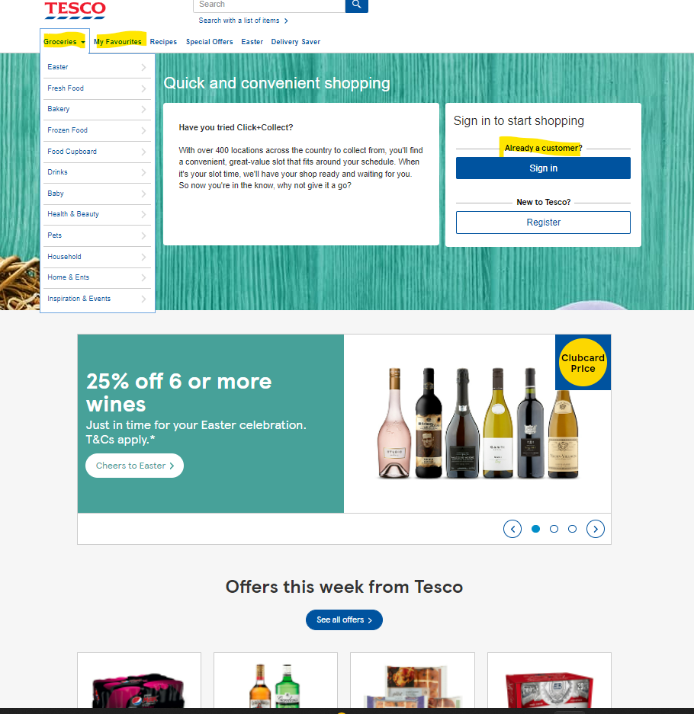
Fig 2. Tesco Online Grocery shop page (TESCO, 2022)

Tesco Loyalty Club Cards

The Tesco Clubcard is another key Digital asset used by Tesco in digital marketing communication. The Clubcard is offered in a form of plastic card with barcodes where customer information is stored, and as a digital App, which can be easily downloaded to the customers handheld mobile devices. The Tesco Clubcard is linked to and managed through the CRM enterprise software. All information relating to the customers purchases activities across Tesco group are collected and stored within the Clubcard. Reward points are awarded at every purchase transaction and promotional marketing communications are generated and sent directly to the customers based on their interest. Other marketing communication and promotions such as paid subscription to Tesco Clubcard Plus are offered within this asset and exclusive higher discounts are directly offered and digitally applied to those customers accounts, who subscribe to the Clubcard Plus.

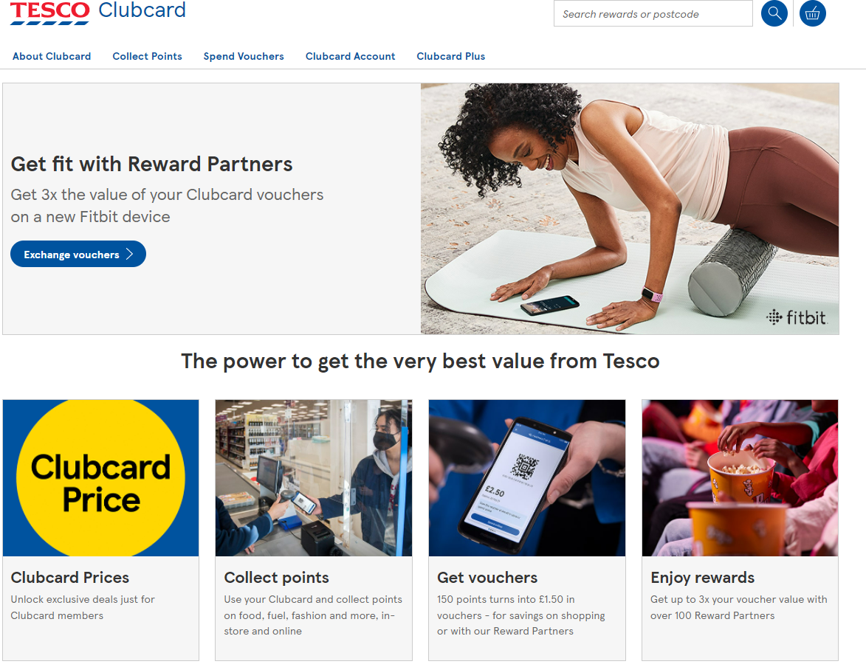
Fig 3. Tesco Clubcard page (TESCO, 2022)

Online Payment Platform.

Online Payment platform is another key communication asset present in Tesco’s Grocery website. This asset is used to process customer shopping payments. Payments cards such as credit and debit card information are entered with customer personal information, these are then processed via a third-party provider who then credits the organisation. Customers information is then saved and can be reused for future purchase and marketing communication.

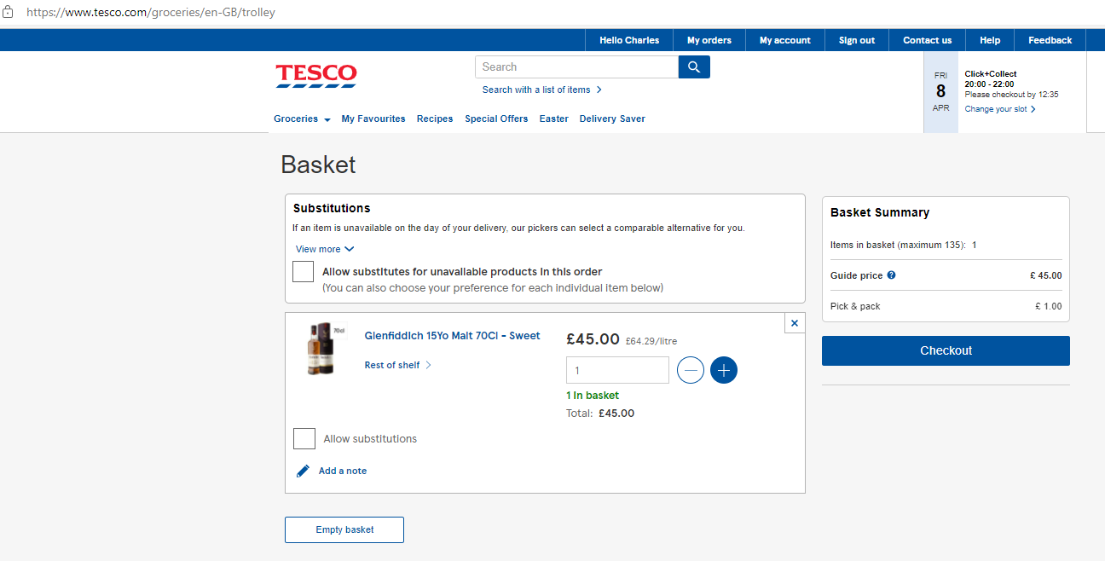
Fig 4 Tesco Online Payment Portal (TESCO, 2022)

Social Media Assets:

Social media is another important digital marketing asset present in Tesco website. This comprise of different social platforms used to engage customers, in other to gain insight and encourage consumer led marketing communication. Social media marketing is the use of social network channels hosted on a website or third party platform, to monitor and facilitate customer interaction and participation in other to encourage positive engagement with an organisation and its brands (Chaffey & Ellis-Chadwick,, 2018.) Tesco has 5 social media platforms which it uses to target and communicate with different demography’s within its customer base.

Facebook:

Tesco own dedicated Facebook page is used to connect directly with its customers who have Facebook accounts. Tesco has over 2.6M followers who have engaged in some form of direct communication with Tesco using this platform (Facebook, 2022). Consumers are encouraged comment on advertisement and give feedback on products and services received. Promotional videos, product photos and posted on this platform and customers are encouraged to leave their thoughts and views as comments. These are later analysed to gain insight on general view about a product or service. Other functionalities such as tag a friend, check in, are used to build a social media community based on common interests. The Facebook page also has an instant message button, where customers can send instant messages in response to a query. Tesco’s official website address is displayed on the Facebook landing page, together with key contact information. Seasonal advertisement campaigns such as the easter egg drive present on the website, were also observed on the Facebook page.

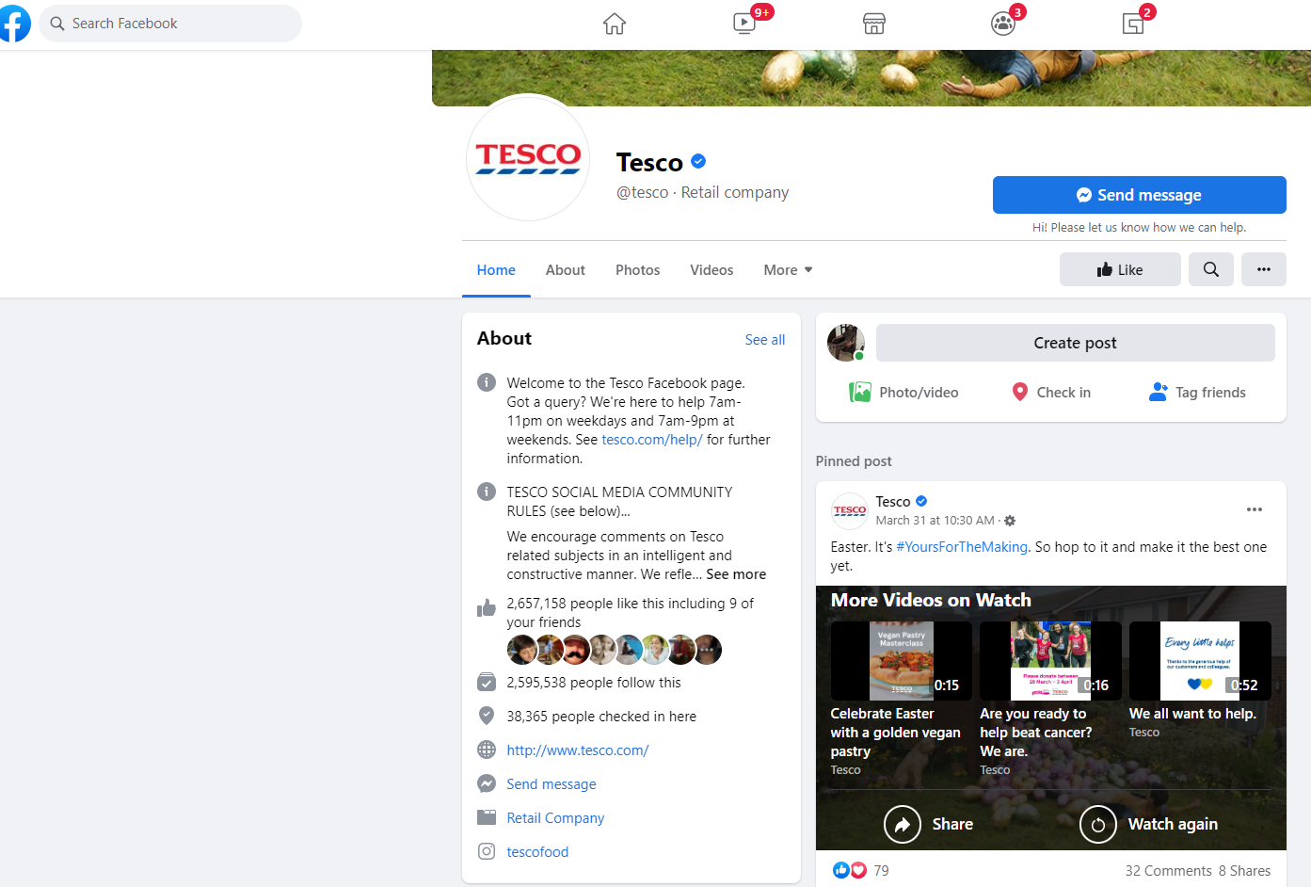
Fig 5 Tesco Facebook Page Source (Facebook, 2022)

Twitter:

Tesco twitter page @tesco was launched in March 2011. The organisation has 700k followers and over 2M twits posted on its page (Twitter, 2022). Twitter is perceived to be used predominantly by middle class individual within the 25-55 age bracket, provides different demography for Tesco to target using this channel. Twitter provides for a more targeted communication channel as it is always manned by a customer services representative. Instant twit messages can be sent directly on Tesco platform and customer can expect a quick response. Cross channel communication can also be observed on the twitter page as similar seasonal promotions running on the website are also seen on the twitter sites. Features such as shopping and product list can be saved against a connected account and Tesco twitter follower can directly place orders through their twitter accounts as their information is already held, creating a further channel of digital marketing.

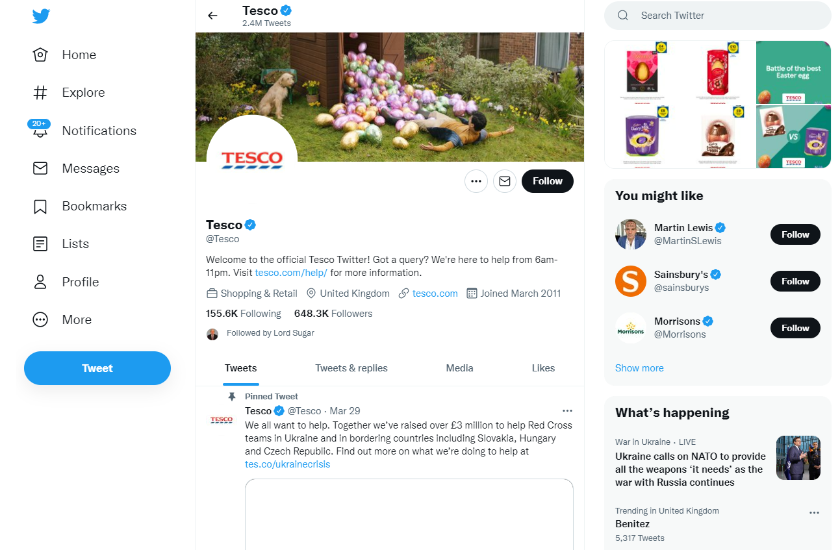
Fig 6 Tesco Twitter page. Source (Twitter, 2022)

YouTube

Another key social media digital Asset Tesco uses in its digital marketing communication is the YouTube social media platform. YouTube is predominantly used for videos and commercial advertisements. Tesco currently has over 200k followers on YouTube and over 400 videos and advertisement campaigns posted (Youtube, 2022). Tesco uses its YouTube platform to Promote food recipes and communicate its social responsibility activities, such are healthy food programmes for schools, where it partnered with Celebrity chefs. The organisation main commercial “every little help’s” campaign can be seen as banner on the YouTube channel, with a Link connecting this to other social media platforms where it has presence.

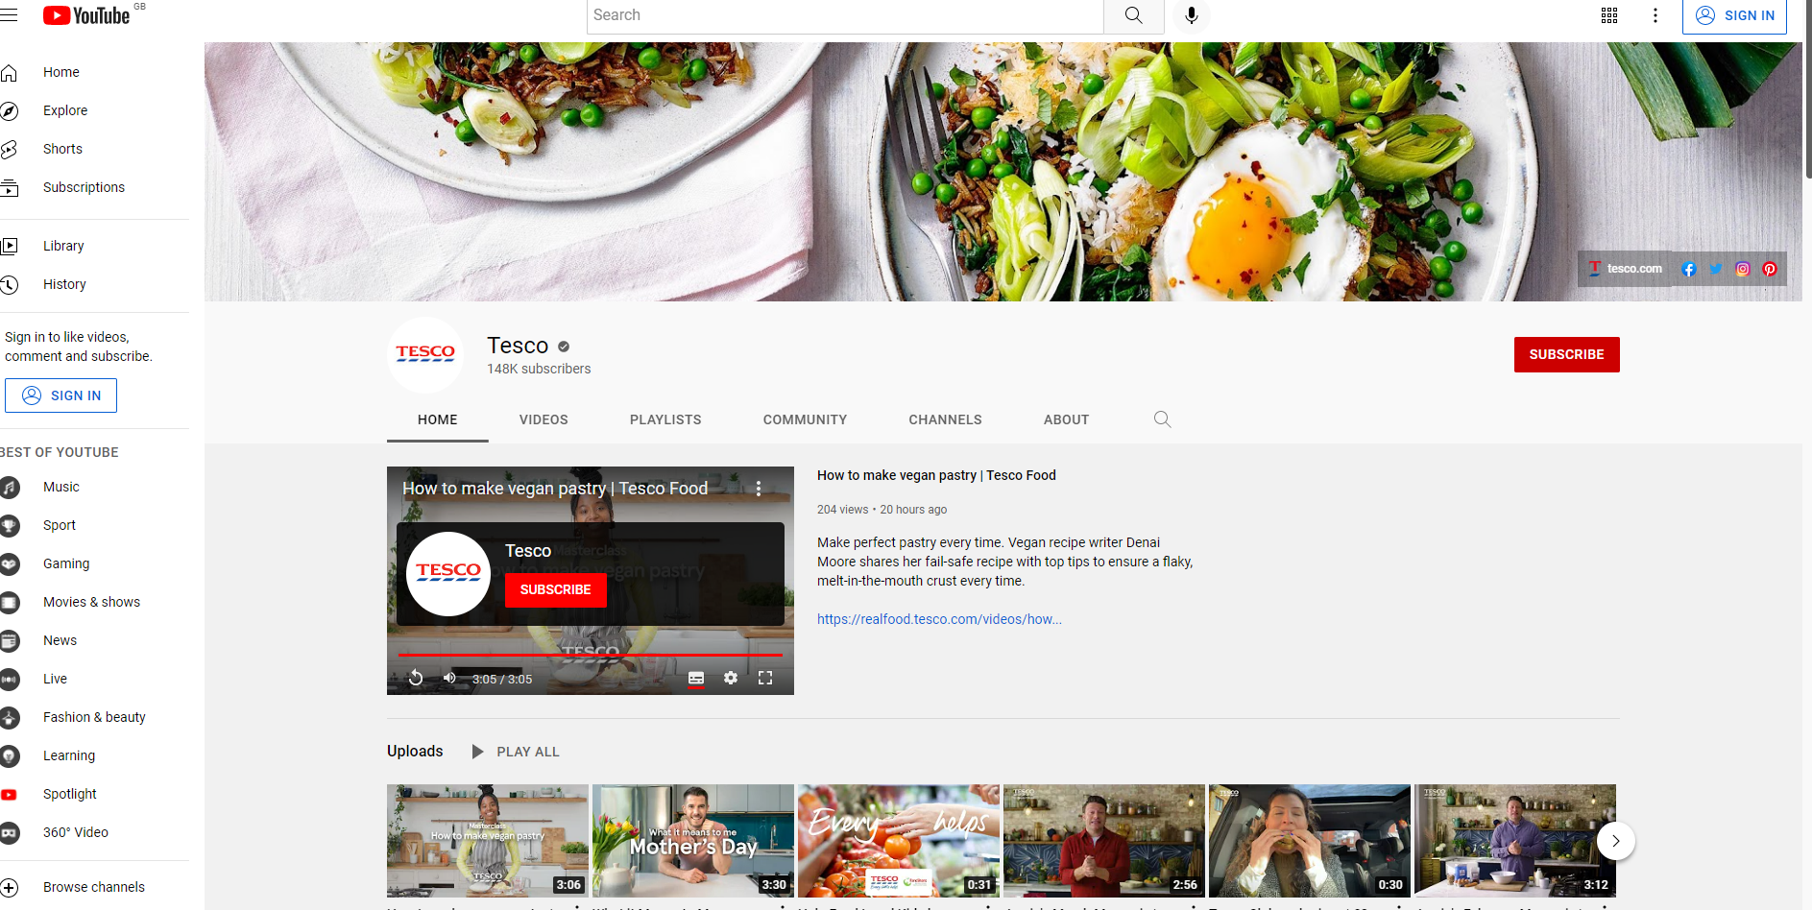

Fig 6 Tesco YouTube Page source (Youtube, 2022)

Instagram

Another key digital marketing asset Tesco uses in marketing communication, is its Instagram social media page. Links to this page can be found on every page Tesco’s website, alongside other social platforms, Tesco has over 500k of its customers following its Instagram page (Instagram, 2022). Tesco has over 3500 Instagram posts which has generated over 4million interaction in the form of likes and comments. Still images of promotional campaigns can be found with embedded hyper-link that take you to view the full image on their web page or video on their YouTube channels. Promotional campaigns found on the main website are also present on the Instagram, allowing customers to easily make a connection to the brand and message. Important email contact addresses are also strategically placed on the Instagram channel, providing an alternative for followers to use should they require faster response on an enquiry.

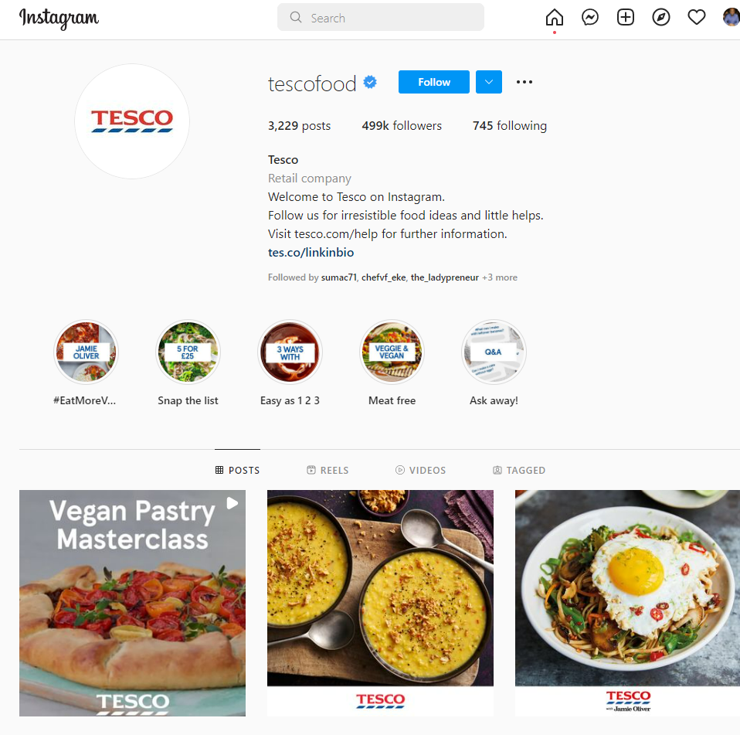
Fig 7 Tesco Instagram Page. Source (Instagram, 2022)

Pinterest:

Pinterest is another digital marketing asset used by Tesco as part of their digital marketing communication strategy. They currently have 200k followers and have over 10million a month on their post (Pinterest, 2022). The organisation uses this platform to promote its food recipes, with over 2000 images of cooked food posted, with Hyperlinks embedded where customers can either chose to download the specific image, recipe, and video straight from the site, or click on the post and the whole recipe needed to make the food will be added to a shopping basket. This provides for ease of shopping and food creation ideas, as visitors to the page can always return for more food ideas, making the page a more resource and interactive page for their customers.

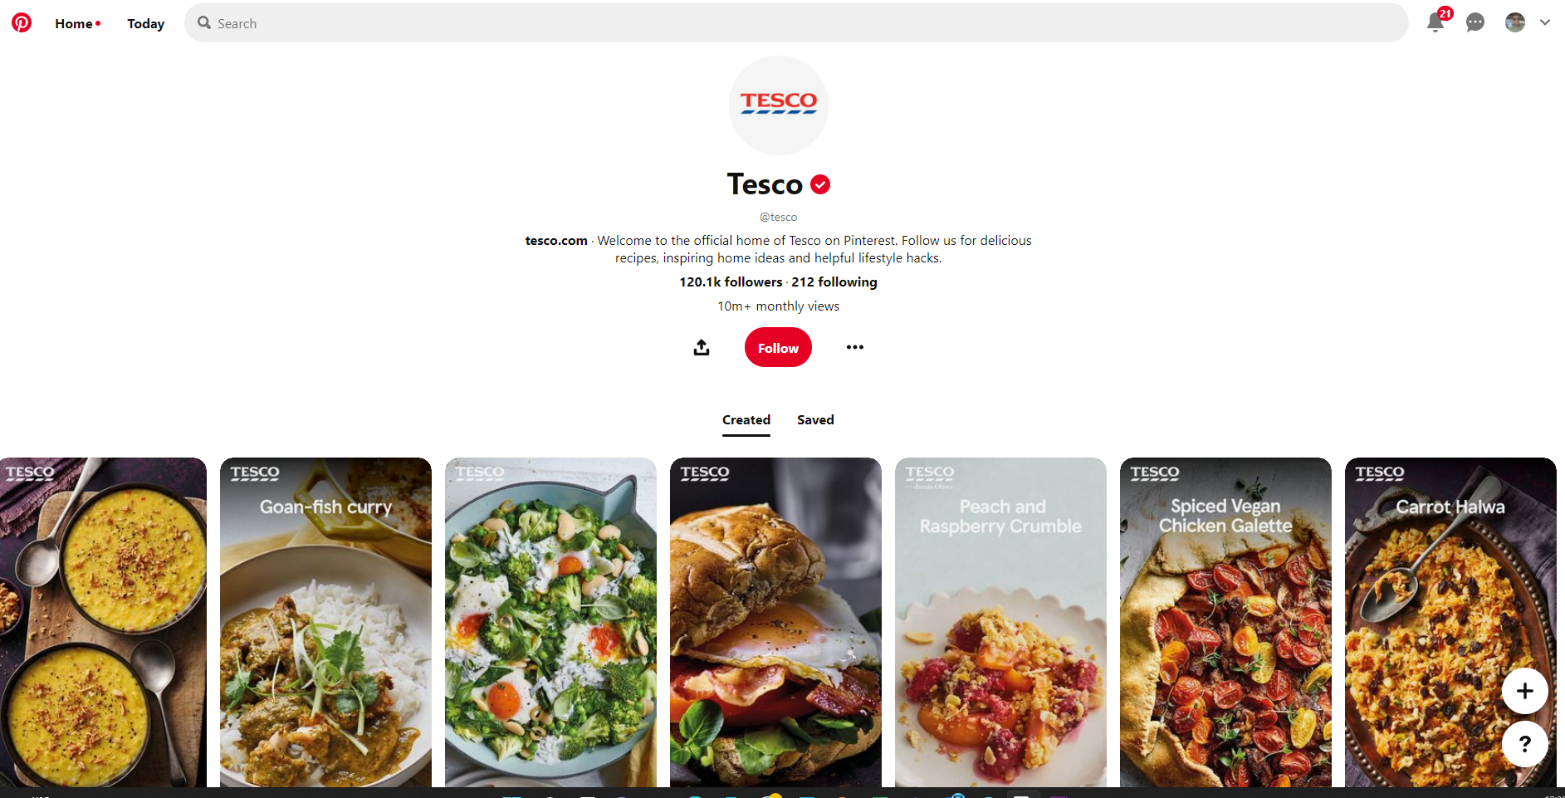
Fig 8 Tesco Pinterest Page. Source (Pinterest, 2022)

Tesco App:

Tesco App is another digital asset the organisation uses as part of digital marketing strategy. The app has been a major hit within its customer and a go-to place to access all of Tesco’s product and service. Visitors to Tesco website can download this app through a link on their website or from third party platforms such as google play store or apple app store. Several features such as Tesco Clubcard and social platforms can all be accessed using the Tesco App. A recent feature launched in 2020 on the app allows customers to scan products while shopping and simply check out using self-checkout, making payments through their smart devices (Shastri, 2022). This has provided a very convenient shopping experience for their customers as it has removed the need for long checkout queues.

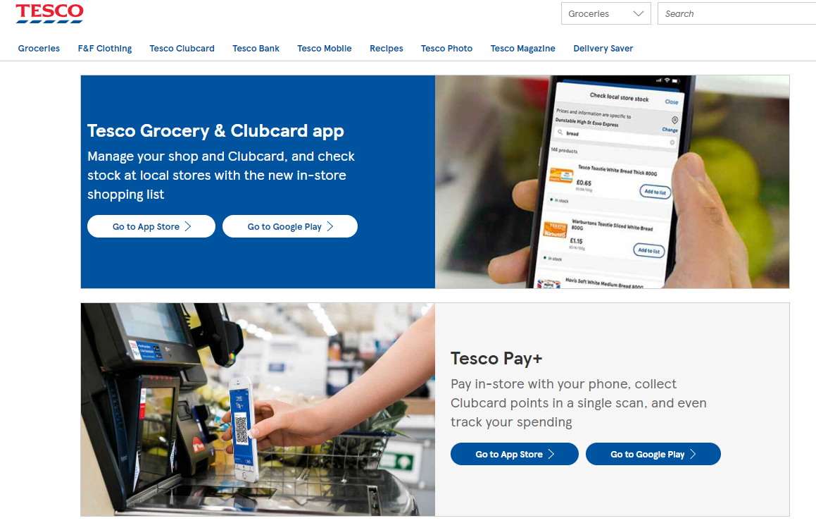
Fig 9 Tesco App. source (Tesco, 2022).

Tesco Digital Marketing Strategy allows for a consistent direction in the organisations online marketing communication activities, in that the flow of information is integrated across all the platforms the organisation uses to communicate with its online and offline customers. Digital marketing strategy is all about innovation, creativity, and uniqueness, that directs an organisation towards developing or achieving an integrated web database, designed to strengthen their value chain and to help with measuring it digital communications activities (Kannan, 2017). Tesco as a retail company has expanded its production offering to include merchandise such as electronics, apparel, sport wears etc. however, the organisation marketing communication have remained consistent to is core offering which is food groceries. Both its offline and digital platforms appear to implement the integrated marketing communication strategy which allows them to position the organisation as the best grocery store in the UK. Integrated marketing communication is a process of strategically combining and coordinating all organisational communication channels with a view of delivering a clear and consistent message about a brand or organisation (Kotler & Armstrong, 2018)

TESCO GROUP STORES

Fig 10. Tesco Integrated communication model

Tesco’s Internal communication structure is hosted within the organisation intranet site, which houses its email management system and is linked to its website and other digital assets, through which it communicates with its customers. Communication flow is predominantly shared on its website and social media channels. Specific channels are dedicated to promoting specific services, such as the “healthy eating range” which Tesco promotes using the Pinterest social media channel, where customers can go to download health food recipe ideas. However, information shared on this channel can also be seem on other digital marketing channel and in stores.

Impact of Artificial Intelligence on Digital Marketing

Artificial intelligence is concerned with the process of applying or using intelligent robots to predict or perform tasks which otherwise would be completed by humans. It is a combination of different technologies working together to enable machines to sense, recognise, act, and learn with human-like level of intelligence. Artificial intelligence allows for easy automation of work processes and uses data analysis to predict or determine the next step or future outcome (Accenture, 2022). Artificial intelligence has been used to enhance marketing activities in that it can help in optimising different marketing activities and tasks, drive marketing conversations, improve customers experience and boost return on investment of marketing campaigns. Artificial intelligent eliminates most of the guesswork involved in customer interaction (Hall, 2019)

Why Tesco Should Incorporate AI as Part of Its digital marketing Strategy:

Machine learning and natural language processing technologies are different forms of Artificial intelligence which are changing the business operations landscape. The growth of data analytics and drive in efficiency, coupled with the need for effective content creation, are important reason for Tesco to incorporate AI as part of its digital marketing strategy. Recent market trend shows that 84% of business executives believe they need to use AI to achieve their business growth (Feldman, 2016). Intelligent machines are known to emulate human intelligence by thinking strategically, abstractly, and creatively with an ability to handle complex task such as data processing in real time, collaboration of machine and human intelligence, can considerably increase organisational efficiency.
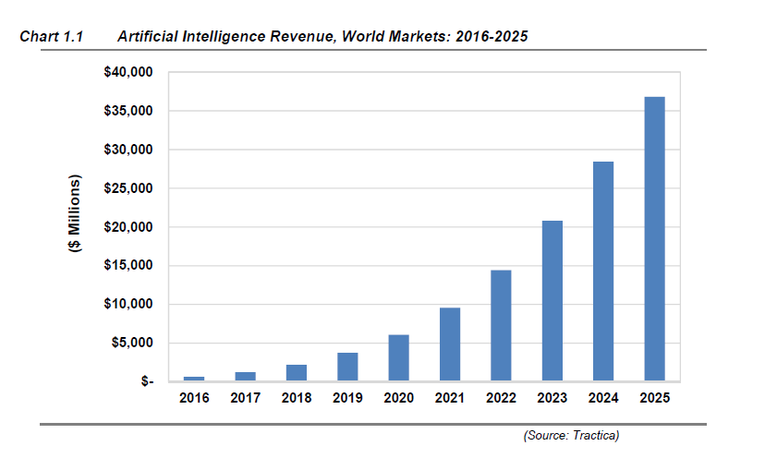
Fig 11. Revenue Growth from AI. Source (Feldman, 2016)

Artificial intelligence can provide a real source of adding business value to Tesco operation. With the amount of data at the organisation’s disposal, automation of business processes such as potential to curate and generate content based on customer behaviour, then place such content in front of the right platform, creating and end to end content strategy mapping becomes a real possibility.
Artificial intelligence can help Tesco improve their business agility and such gain competitive advantage. Ability of machines to self-learn while analysing data from difference sources at the same time, and adapting accordingly with high levels of accuracy, can be invaluable to Tesco. Activities such as digital advertising content and product recommendations, can be automatically generated and personalised with high accuracy and efficiency rates, using complex algorithms and big data. This can lead to increased revenue generation and reduction in costs in operational processes.

Artificial intelligence technologies such as Chatbots are one that can benefit Tesco operation. Chatbot are intelligent computer programmes deployed in organisation websites as first point of contact and used in automating and answering customer queries. It uses preprogramed sets of questions and answers as well as data to guide customers in finding solutions on organisation websites with little or no human intervention. According to a recent Harvard business review, 80% of sales and marketing companies are already using chatbots to improve their customer experience, and over 15% of companies who have adopted such technologies into their business operation, have grown more quickly than their competitors and are better positioned for the futures (Kundariya, 2022).

Artificial Intelligence provides scope for businesses to gain deep insights of their customers using big data analysis. Marketing activities such as segmentation are based on assumption of consumer preferences and are sometimes very difficult to track, the scope of errors using a manual process is increased, as human preferences are known to change quickly. However, Artificial intelligence using big data, can dissect and analyse behavioural and demographic data with a greater degree of efficiency, aligning this with customer personal and demographic information are able to predict future customer behaviour using big data analysis (Hall, 2019).

Benefits of Artificial Intelligence.

Incorporating artificial intelligence into digital marketing processes, can provide several benefits to organisations such Tesco in that it can help:

- Facilitate end to end marking efficiency by eliminating frictions in data analytics and resource utilisation, leading to increased significant cost reduction in operational processes.
- AI can predict customer behaviour and help identify future leads.
- AI can help improve decision making as vast quantities of data can be analysed in real time with high accuracy, while uncovering gaps and opportunities within a market environment more quickly.
- AI can help in deciding best content to create for specific marketing campaigns and how content can be effectively distributed.
- AI can help improve customer experience through providing a superior customer service based on 360-degree insight for hyper personalisation.

While the mentioned benefits remain some of the driving reasons for increased use of AI as found in today’s marketplace, there still remains questions arising from issues of control, Trust and data security as machine can make mistake when it accesses incorrect data. Therefore, there remains the issues of uncertainty when deploying AI in many operational processes.

Conclusion:

Digital Marketing have revolutionised marketing processes as traditional marketing activities such as content creation, pricing and promotions can now be easily produced and distributed across several digital platforms, at the same time at relatively low costs, while accurately targeting customers with personalised promotional communications. The Incorporation of Artificial intelligence to this mix can only further organisation’s ability to improve their customer experience, while maximising the opportunities of increase efficiency and productivity this technology presents. Organisations such as Tesco should look to incorporate AI supported technologies such as Chatbots and predictive AI, alongside its digital marketing strategy, such as influencer marketing, paid search, and email marketing, in other to exploit the opportunities these technologies present.

References

Chaffey, D. & Ellis-Chadwick, F., 2016. Digital Marketing. 6th ed. Harlow: Pearson Education Limited.
Accenture, 2022. Artificial Intelligence. [Online]
Available at: https://www.accenture.com/gb-en/insights/artificial-intelligence-summary-index?c=acn_glb_brandexpressiongoogle_12626059&n=psgs_1221&gclid=EAIaIQobChMIzvii7ayC9wIVSbTtCh3wxAjJEAAYASAAEgL0dvD_BwE
[Accessed 7th April 2022].

AMA Board, 1985. AMA BOARD APPROVES NEW MARKTING DEFINITION.

Bismo, A., Putra, S. & Melysa, M., 2019. Application of Digital marketinmg (social Media and Email Marketing) and Impact on Customer engagement in purchase intention. A case study of Indonesia. International Conference on Information Management and Technology, pp. 109-114.

Brassington , F. & Pettitt, S., 2005. Essentials of Marketing. Harlow: Pearson Education Ltd.

Chaffey & Ellis-Chadwick,, 2018.. Digital Business PDF EBook, : Pearson Education, Limited,.
Facebook, 2022. Tesco. [Online]
Available at: https://www.facebook.com/tesco/?ref=page_internal
[Accessed 7th April 2022].

Feldman, M., 2016. Market for Artificial Intelligence Projected to Hit $36 Billion by 2025. [Online]
Available at: https://www.top500.org/news/market-for-artificial-intelligence-projected-to-hit-36-billion-by-2025/
[Accessed 8th April 2022].

Hall, J., 2019. How Artifical Intelligence is transforming digital marketing , : Forbes Agency council.
ICIMS, 2022. The ICIMS Talent cloud. [Online]
Available at: https://team.icims.com/icims-talent-cloud?vendor=Google_Search&targeting_method=UK_Acquisition_Primelis&asset=Demo-TalentCloud&asset_type=Demo&product_interest=Applicant%20Tracking&mkwid=s_dc&pcrid=580923524858&pmt=e&pkw=crm%20system&pmid=&slid=&adpos=&pt
[Accessed 6th April 2022].

Instagram, 2022. Tesco. [Online]
Available at: https://www.instagram.com/tescofood/
[Accessed 7th April 2022].

Kannan, P. K., 2017. Digital marketing; A framework review and research.

Kotler, P. & Armstrong, G., 2018. Principles of Marketing. Harlow: Pearsons Global Ed.

Kundariya, H., 2022. 2021 digital marketing Trends; the New vs tried and True. [Online]
Available at: https://www.wordstream.com/blog/ws/2021/03/26/digital-marketing-trends-2021
[Accessed 8th April 2022].

Mary, J. P. & Marla, A., 2016. Innovative digital marketing trends, CHENNAI: DMI College of Engineering, Palanchur chennai.

Maund, A., Schriek, M. & Tinkler, P., 2017. Certificate of Higher Education,Skills for the workplace. London: Sage.

Miklosik, A., Kuchta, M., Evans, N. & Zak, S., 2019. Towards the Adoption of machine learning based on analytical tools in digital marketing, Slovakia: University of Bratislava Slovakia.

Pinterest, 2022. Tesco. [Online]
Available at: https://www.pinterest.co.uk/tesco/_created/
[Accessed 7th April 2022].

Shastri, A., 2022. The Digital School. [Online]
Available at: https://iide.co/case-studies/tesco-marketing-strategy/
[Accessed 7th April 2022].

Tesco, 2021. Tesco.com Annual reports. [Online]
Available at: https://www.tescoplc.com/media/757589/tesco_annual_report_2021.pdf
[Accessed 4th April 2022].

TESCO, 2022. Tesco. [Online]
Available at: https://www.tesco.com/
[Accessed 5th April 2022].

Tesco, 2022. Tesco Grocery and Clubcard app. [Online]
Available at: https://www.tesco.com/zones/apps
[Accessed 7th April 2022].

TESCO, 2022. Tesco; Our Businesses. [Online]
Available at: https://www.tescoplc.com/about/our-businesses/
[Accessed 4th April 2022].

Twitter, 2022. Tesco. [Online]
Available at: https://twitter.com/tesco
[Accessed 7th April 2022].
UWTSD , 2022. E-marketing lecture Slids, London: University Of Wales Trinity St Davids.

Youtube, 2022. Tesco. [Online]
Available at: https://www.youtube.com/c/tesco/featured
[Accessed 7th April 2022].

