Powertrain Design & Efficiency
University of Wales Trinity Saint David
School of Engineering
Leighton Coughlin (1802971)
Bsc Automotive Engineering
Powertrain Design and Efficiency – M5X02200
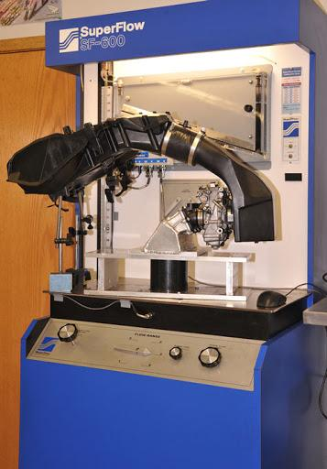
Figure 1

Contents Page
Title Page ………………………………………………………………………………………………. Page 1
Contents Page …………………………………………………………………………………..….. Page 2
List of figures ………………………………………………………………..………………………. Page 3
1. Introduction ………………………………………………..…………..……………………….. Page 4
2. Research …………………………………………………….….……………..………………….. Page 5
2.1. 1.6L Sigma Engine …………………………….………..……..………………….. Page 5
3. Methodology ……………………………………………………………………………….. Page 6-10
3.1. Safe Working Practises …………………….………………….……………….. Page 6
3.2. Steady Flow Test ………………………………….……..………..………….. Page 7-8
3.3. Weights and Measurements ………..………………………………….. Page 9-10
4. Results …………………………………………………………………..…………………….….. Page 11
4.1. Weight and Measurements ….……………………………..…………….. Page 11
4.2. Cam Lobe Results ……………………………..…………….…………….. Page 12-13
4.3. Flow Rate Result …………………………………………..…………..….. Page 14-15
4.4. Flow Co-efficient …………………………………………………….…….. Page 16-18
4.5. Mean Flow Co-efficient …………………………………..…………….. Page 19-21
5. Conclusion ……………………………………………………………………..….…………….. Page 22
6. References ……………………………………………………………………….…..…….. Page 23-24
6.1. Websites …………………………………………………..…..……………..…….. Page 23
6.2. Legislation ………………..…..…………………………………………………….. Page 23
6.3. Technical Papers ……………………………………….………..…..………….. Page 24
6.4. Books ……………..…………………………………………………..…..………….. Page 24
6.5. Figures ………………………………………………………………..…..………….. Page 24
6.5. Other …………………………..……………………………………..…..………….. Page 24
7. Appendices ……………………………………………………………..…………..………. Page 25-30

List of Figures
Figure 1 …………………………….……… SF-600 Flow Testing Intake Assembly - Page 1
Figure 2 …………………………….…………….. 4-cylinder inline Engine Diagram - Page 5
Figure 3 …………………………….…………..…… Photo of the Flow Bench Setup - Page 7
Figure 4 ……………….………….……………..… Photo of Flow Calibration Chart - Page 8
Figure 5 …………..………..…… Photo of Manual Lathe and Camshaft Setup - Page 9
Figure 6 ……..….… Photo of Cylinder Head and Valve Train Components - Page 9
Figure 7 ………………………………………..……… Photo of Cylinder Block Bore - Page 10
Figure 8 ……………………………………….…..…… Table of Measured Weights - Page 11
Figure 9 ………………………………………….……… Table of Measured Lengths - Page 11
Figure 10……………………………… Graph of Valve Lift Against Crank Angle - Page 12
Figure 11 ……….…… Smoothed Graph of Valve Lift Against Crank Angle - Page 13
Figure 12 ……….…… Graph of Flow Against Lift for the Standard Intake - Page 14
Figure 13 …………………..… Graph of Flow Against Lift for the Bare Head - Page 14
Figure 14…..……… Graph of Flow Against Lift for the Flared Intake Port - Page 15
Figure 15 …………………………………………….……… Diagram of Curtain Area - Page 15
Figure 16 …... Graph of Cfm/sq.in. Against Lift for The Standard Intake - Page 16
Figure 17 ………….… Graph of Cfm/sq.in. Against Lift for The Bare Head - Page 17
Figure 18 ………… Graph of Flow Co-efficient vs lift for Standard Intake - Page 17
Figure 19 …………….…… Graph of Flow Co-efficient vs lift for Bare Head - Page 18
Figure 20 …………..… Graph of Flow Co-efficient vs lift for Flared Intake - Page 18
Figure 21 ……… Table to Display Maximum Practical Flow Co-efficient - Page 18
Figure 22 … Graph of Flow Co-efficient Against Crank Angle for Intake - Page 19
Figure 23 …...… Graph of Flow Co-efficient Against Crank Angle for BH - Page 20
Figure 24 … Graph of Flow Co-efficient Against Crank Angle for Flared - Page 20

1. Introduction
There are many ways to improve upon an engine’s design in terms of acceleration, speed and performance. For an Engine to work it operates in four main stages. Intake, compression, combustion and exhaust. All are equally as important as each other however in this report attention is going to be paid to the intake side.

A thorough analysis of the flow characteristics of a 1.6l Ford Sigma engine will be carried out. The aim will be to firstly do some research and collect some data on the engine / cylinder head. Once this is complete use the data collected to calculate certain characteristics. Data such as the weights and size of the valvetrain components will be taken as well as some flow rate tests which will be conducted on the cylinder head and inlet manifold. Three flow rate tests will be conducted in order to determine how well the current inlet port operates as well as how much room there is for improvement. To do this the three flow tests will be a bare cylinder head test, a cylinder head plus the standard intake and the bare cylinder head through a flared intake port

With this data, some characteristics such as the flow coefficient will then be calculated as well as some graphs being produced to enhance the understanding of the engine and how it operates. Using all the data collected and calculated, ways to improve upon the current design then will be discussed.

2. Research

2.1. 1.6 L Ford Sigma Engine
As expressed by the Ford authority website (ford authority, 2020) the 1.6l sigma engine is very similar to the engine picture to the right. A sixteen valve, four-cylinder inline engine with dual overhead camshafts. The engine, also referred to as the Ford Zetec, Zetec SE or Duratec engine, saw its use in many compact and utility vehicles such as the ford focus, puma and fiesta as well as many more. The engine is also naturally aspirated and mounted transversely thus making it perfect for small to medium sized front wheel drive cars.

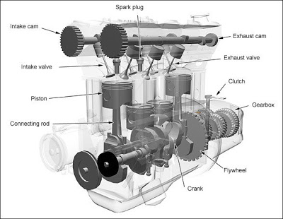

Figure 2

The sigma engine has been praised over the years for its reliability and innovation. When it was first released in 1995 many features such as a plastic inlet manifold or powder metal connecting rods were very seldom seen on high volume production cars at that time. Ford authority (ford authority, 2020) also expresses some manufacturers data about the engine which will later be compared with the actual data taken from the engine. The stroke and bore are given to be 81.4mm and 79mm respectively with a compression ratio of 11 to 1. The valve diameters were also found to be 25 and 30 millimetres for the exhaust and intake valves respectively. The source finally states a maximum power of 123Hp at 6,000 RPM as well as a maximum torque of 118lb-ft @ 4,100 RPM

3. Methodology

3.1. Safe Working Practices
It is extremely important for both the employer and employee to always follow the relevant legislature / guidelines in order to minimise risk. The health and safety executive (HSE, 2009) recommend ensuring the correct PPE is worn. Before entering any workshop, area steel toe cap boots and overalls should be worn to protect the skin and clothing as well as protecting the feet from any falling objects. The correct protective eyewear must always also be worn if there is a risk of any oils or lubricants getting in the eye. For example, when working near a live engine in the dynamometer room. It is also important to remove any loose items of clothing such as jewellery, or a tie. This is in case the items either snag on a piece of equipment or even worse meet a live wire.

As well as your own safety it imperative to ensure that your employer follows the relevant legislation. Regulations such as the workplace regulations (The Workplace Health, Safety and Welfare Regulations 1992) and the COSHH regulations (The Control of Substances Hazardous to Health Regulations 2002) are of extreme importance. The workplace regulations ensure that anyone working has access to a safe, clean, hygienic, well-lit and ventilated workplace as well as access to adequate facilities such as toilets, washing stations and an area for eating meals and resting. Whilst COSHH ensures any gasses, liquids, chemicals, particulates and even harmful bacteria etc are either removed entirely or limited to within a safe working tolerance. Since it is illegal not to adhere to these guidelines the workshop in which the testing was taken place features an excellent ventilation system, multiple sensors to detect any harmful chemicals such as carbon monoxide as well as many checks and procedures in place to ensure accidents and certain tasks are dealt with in a safe and environmentally friendly manor.

3.2. Steady flow test
The steady flow test is often used to study engine flow characteristics during the development stages of an engine. As expressed by one paper, (SAE International, 2001) a flow test can be used for many different purposes. They are especially valuable however when looking at the inlet, exhaust, and combustion chamber design in terms of the flow rate and how the flow behaves inside the cylinder. A flow test in its most basic form involves either sucking or blowing air through a desired pathway. In this case the cylinder head will have air sucked in through the intake port of the cylinder head.

In order to set up this experiment firstly the cylinder head was attached to the flow bench using the adapter plate pictured below. The adapter was bolt fastened to the bench whilst the head was clamped to the adaptor. Some bolts were then attached so that as they were driven in or out of the head the valve would open/close respectively. Two DTI gauges were then attached to the face of the bolt in order to accurately determine the amount of lift achieved by loosening and tightening the bolts. Ensure the gauges meet the surface of the bolt at exactly 90 degrees to ensure accuracy. For the purposes of this test also set the flow direction to intake using the dial located beneath the centre flow scale. Also ensure the first few tests start on range one.
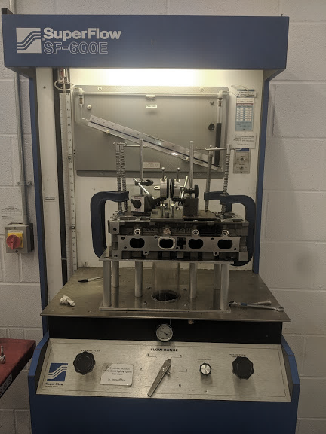
Figure 3

Once this is done it was ensured that both the valves were closed. This is done by loosening both bolts so that each valve becomes turntable by hand. Then the bolts must be hand tightened until it becomes immoveable by hand. At this point the valve begins to open and the force of the spring overcomes the strength of the hand. Then check for any leaks within the system using the flow scale at centre of the machine. Once the valves were closed turn the machine on using the switch on the right and slightly turn the knob on the bottom far right. Turn the knob slowly so that the pressure reading on the manometer located on the left of the machine doesn’t exceed 25cm. This will be the constant pressure for this test. If the flow scale at the centre increases past 0% then there is a leak either in the cylinder head or the apparatus.

Once complete taking results can begin. For the purposes of this test three different cylinder head designs were tested each at 0.5mm increments of valve lift to a max valve lift of 8.5mm. 0.5mm of lift was taken to be two full rotations of the DTI gauge. In order to convert the readings from the machine into the actual data a conversion chart is positioned in the top right of the machine pictured below. This is used in conjunction with the selected range to produce a value for flow rate in l/s. To do this multiply the percentage reading on the centre flow scale by the range value given. Do this for each value of lift to complete the test on each design. Since all tests were done on the same day in the same conditions there was no need to correct the data for changes in air temperature/pressure etc.
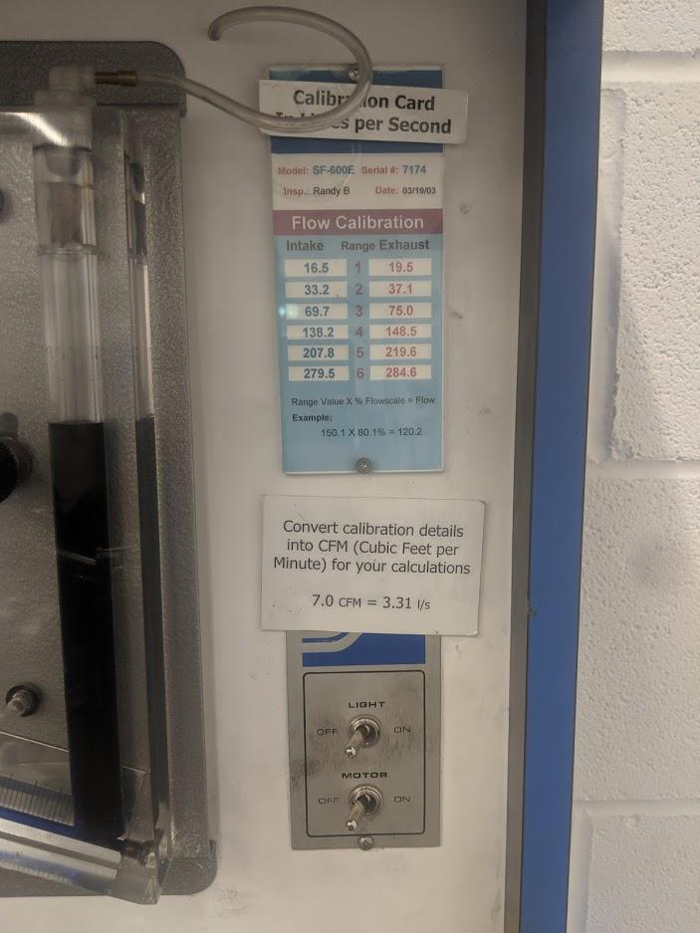
Figure 4

3.3. Weights and Measurements
In order to accurately assess the current system, the cam profile was also measured. To do this a manual lathe was used in conjunction with a DTI gauge to measure the amount of lift in millimetres for every 2 degrees of turn on the cam lobe. To do this the cam shaft was first fastened to the lathe chuck so that it wouldn’t slip. An adaptor plate fastened to the left side of the cam shaft was used. To turn the cam shaft, a hand crank is used in combination with a silver dial positioned between the lathe chuck and the lathe itself. The crank turns the cam whilst the dial reads out degrees of turn.
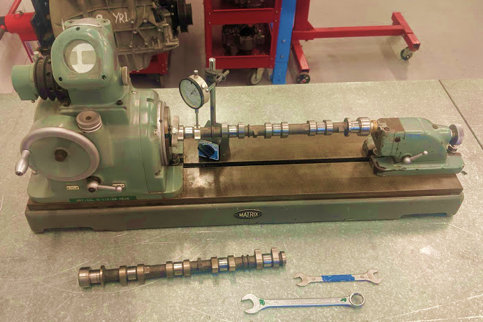

Figure 5

A few other parameters were measured using a weighing scales and a set of Vernier callipers. The first thing measured was the weights of all the components for one of the cylinders. Picture below, this included two collets, an exhaust and an intake poppet valve, the valve spring, the spring retainer and the lifter. In order to ensure the accuracy of the equipment, the equipment needs to be calibrated regularly. One article expresses (Laurila, 2017) To check the scales are working correctly there are many different tests that can be carried out.
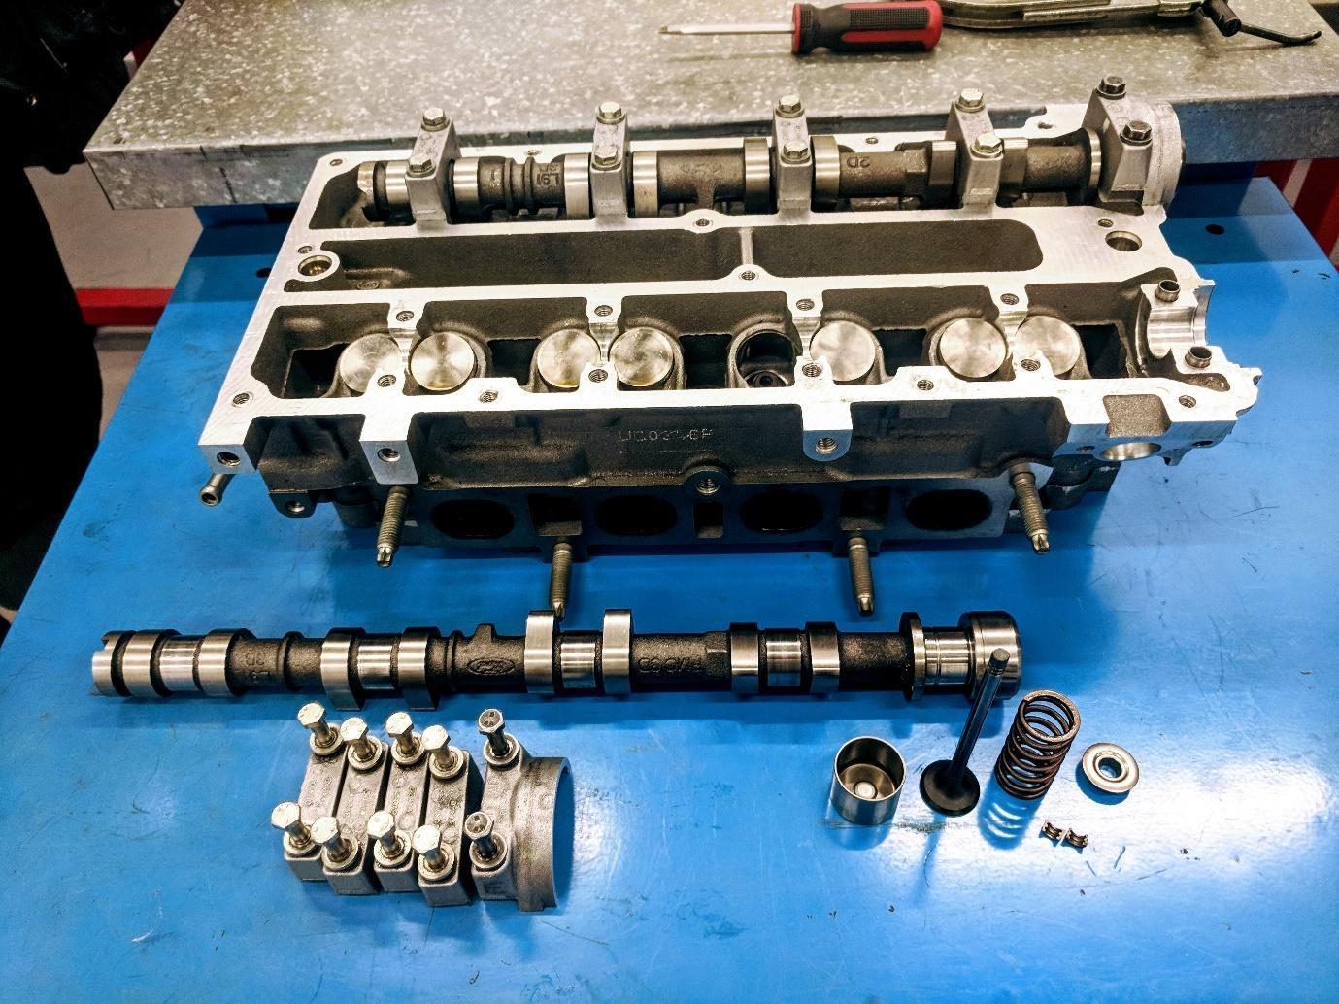

Figure 6

These tests include a repeatability test, eccentricity, test, minimum weight test etc. In this case however only a weighing test was carried out which meant using the scales to measure a set of known weights increasing up to the max weight of the apparatus all the way from the minimum weight detectable. This test can be carried out in the opposite direction also to increase the accuracy of the results. Once the scales and callipers are correctly calibrated each component was weighed and measured two or more times to ensure the measurements were repeatable. The components measured were the exhaust and inlet valve diameters, bore and stroke.
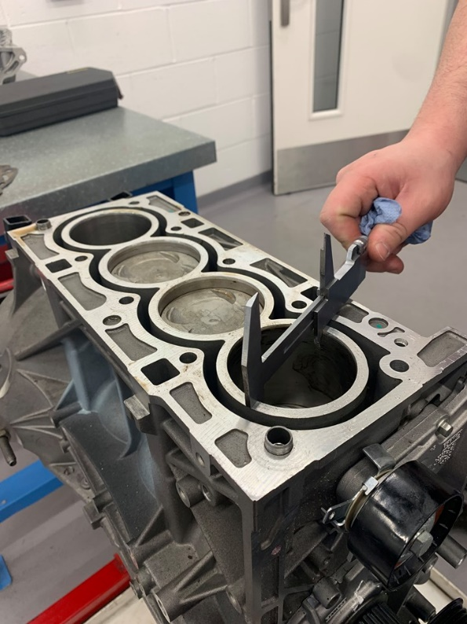

Figure 7

4. Results

4.1. Weights and measurements
The first set of results collected were the weights, which will be used to calculate valve float later. As mentioned above each individual weight was weighed three times each to ensure the correct weight.
Weights (g)
Collet x 2 | 1
Valve | 38x2
Spring | 20.4
Spring Retainer | 7.7
Lifter | 23.8
Measurements (mm)
Exhaust valve Diameter | 25
Inlet valve Diameter | 30
Bore | 79
Stroke | 81.4

Figure 8
Figure 9
Figure 8

The second set of results was the measurements of the valve train components. Vernier Callipers were used to take these measurements. The Bore and stroke of the engine also matches that of the stated measurements provided by ford authority (ford authority, 2020).
The displacement is given to be approximately 1.6 l or 1600cc. The 79mm bore and 81.4mm stroke stated and measured however, both suggest a displacement of 1596. The following formula was used to calculate the displacement:

Piston Displacement = $\frac{π x (\frac{Diameter}{2})^2 x Stroke}{1000}$
398995.9329 = π x (79/2)^2 x 81.4
398995.9329 / 1000 = 398.996cc (3dp)
398.996 x 4 = 1595.984cc

4.2. Cam Lobe Results
As mentioned above some precaution was taken to ensure the accuracy of the results by using a DTI gauge and hand crank lathe. However, the suggested profile is slightly dissimilar from a typical profile. Tommy Parry (parry, 2018) writing on behalf of the Turnology website explains, the peaks and troughs would cause the lifter to lose contact with the cam lobe.

Figure 10

In order to get a profile more like the actual Camshaft, Mazurka Project data smoother was used (AHRC Research, No Date). In order to use this first the data had to be re arranged so that max lift was set to 180 degrees and the data was then input into the website. The smoothed data created was then input into excel to create another graph. All appropriate data can be found in appendices.

Figure 11

As shown above the data pattern isn’t the same as that of a typical cam lobe. Tommy Parry suggests (Parry, 2018) the smoother a finish on the camshaft lobe, the better the chance of the lifter staying in contact with the lobe. Also, a cam lobe is symmetrical whilst the data isn’t. This problem with the data could possibly be caused by a heavily damaged camshaft lobe however is more likely caused by incorrect measuring processes. The accuracy of the data taken will be discussed further in the conclusion.

4.3. Flow Rate Result
The flow rates were firstly converted from percentages to l/s and subsequently CFM. Graphs were then plotted displaying the data’s trendline and trendline formulae. The point at which the lift equals a quarter of the dimeter of the valve was also marked.

Figure 12

Figure 13

Figure 14

As the lift increases past a certain point the amount of flow begins to flat line. This is due to the diameter of the valve opening itself beginning to restrict the airflow rather than the amount of lift from the cam. This value for valve lift for most engines is approximately a quarter of diameter of the valve. One book author, David Vizard (Vizard, 1991) suggests that at this point the curtain area ceases to increase. As shown by the diagram ( below the curtain area is what is created by increasing the lift. Once L = D/4 the flow stops increasing as the size of the inlet port is now the bottle neck and only increasing this will any additional flow be achieved. Currently the engine features valve sizes of 30 mm and 25 mm with a Bore of 79mm. This leaves an Inlet to Exhaust diameter ratio of 6:5

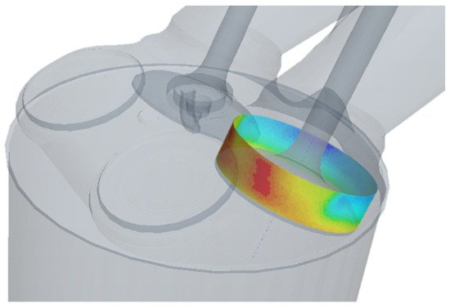

Figure 15

4.4. Flow co-efficient
One study suggests (SAE International, 2012) that the effectiveness of a cylinder head / intake manifold design depends on the volumetric efficiency / flow co-efficient of said engine. The higher the flow co-efficient the less resistance there is for air flowing into the engine and thus a higher volumetric efficiency and improved performance. Firstly, The CFM value obtained from the tests was used to calculate the CFM per sq. in. To do this the thirty-millimetre diameter of the two inlet valves was used to calculate the Total Area which was then converted from mm to sq. in. The following formulae was used:

π $r^{2}$ = Area of a circle
π ${(\frac{30}{2})}^{2}$= 706.85${mm}^{2}$
706.85 x 0.00155 = 1.1${sq.in.}^{2}$ per valve
2 x 1.1 = ${2.2=2.2sq.in.}^{2}$

With a value for the area of both Intake valves, a graph displaying the CFM/sq. inch can now be constructed by dividing the CFM by the Area.
Figure 16

Figure 17

Next the flow co-efficient will be calculated and subsequently displayed on a graph. In order to calculate the flow co-efficient, the following formulae was used:
Figure 16

$\frac{Measured CFM/SqIn.}{Perfect CFM/ SqIn.}$ = Flow co-efficient

As mentioned in the Super flow Notes, (superflow notes, date) at a test pressure of 25 inches of water, the perfect CFM/sq. in. is 138. With this value the flow co-efficient for each increment of lift can be calculated.
Figure 18

Figure 19

Figure 20

Since the max lift of the cam lobe came out to be 7.09mm the maximum practical flow co-efficient came out to be:
Bare head | BH + flared | BH + intake
0.45332586 | 0.44368063 | 0.40027709
Figure 21

4.5. Mean Flow Co-efficient
To determine the mean flow co-efficient firstly a graph of crank angle against flow co-efficient must be plotted. To do this a polynomial trendline was created for the flow co-efficient for the three flow tests. The formula created by the polynomial in turn can be used to create Y values for any given value of X. This allows the 18 points of data created by the flow testing to spread out into an infinite amount of values. However, for this case only 181 data points were needed as the cam shaft was measured every 2 degrees of turn. The three formulae expressed by the trendlines were as follows:

Standard Intake ( y = -0.0015x² + 0.0519x - 0.057 )

Flared Intake Port ( y = -0.0018x² + 0.0612x - 0.0701 )

Bare Head ( y = -0.0017x² + 0.0595x - 0.0658 )

From these formulae an XY table can be created for every value of lift for flow test. The negative constant on the right of all three equations was removed to make the data easier to read. The data is displayed graphically below.
Figure 22

Figure 23

Figure 24

Figure 26

Now that the Flow co-efficient has been calculated over 720 degrees of turn for the crankshaft, the mean flow co-efficient per 4 stroke cycle can be calculated for the bare cylinder head and the bare cylinder head with standard intake. This can then be used to confirm the figures expressed in the research. Due to the degrees of turn being measured in 2 degree increments there is only 360 data points. As expressed by Anne Marie Helmenstine ( Helmenstine 2019 ), the following formulae can be used to calculate the mean:
Mean = $\frac{Sum of all numbers}{The amount of numbers}$
In excel:
=SUM (AB4:AB364)/360
=SUM (AC4:AC364)/360
=SUM (AD4:AD364)/360

This gave a mean flow co-efficient of 0.0250184 for the bare head and 0.02178579 for the bare head plus standard intake and finally the head plus flared port gave a mean flow co-efficient of 0.02562217.

5. Conclusion
In conclusion the Flow test revealed that the standard intake restricts the flow of air to the head massively and in an ideal situation each cylinder would feature its own intake with an individual throttle butterfly instead of one throttle butterfly with an intake manifold and plenum chamber. This would allow the engine to breath much more freely as the thus improving the volumetric efficiency of the engine.

The flared entry port also showed a higher mean flow co-efficient. This was due to the coarse surface of the cylinder head being smoothed out with blue tac. This Improved the flow of the engine however the coarse surface is in place to try and create turbulence within the air fuel mixture therefore a more thorough investigation would be required to accurately determine a weather the flared entry port produced a net gain in performance.

The accuracy of the data collection also could have been improved. Instead of each test being done once for the flow test and the cam lobe measurements, multiple tests needed to take place to establish repeatable data. The data take from the cam lobe could have been skewed slightly due to readings being taken from a non-digital DTI gauge and visual scale for degrees. This can lead to in accuracy due to dials reading slightly different depending on viewing angle. This could have been counteracted by using digital sensors which could much more accurately record each data point. The flow tests are also slightly inaccurate due to the curve not being smooth. This is also down to the 0.5mm increments of lift being done by turning the bolt and subsequent DTI gauge 2 full rotations.

6. References

6.1. Websites
Ford Authority (2020). Ford 1.6L Sigma.
Available at: https://fordauthority.com/fmc/ford-motor-company-engines/ford-sigma-engine-family/ford-1-6l-sigma-engine/ [Accessed 4 Jan. 2020].

Laurilla H. (2017). Weighing scale Calibration – How to Calibrate Weighing Instruments.
Available at: https://blog.beamex.com/weighing-scale-calibration-how-to-calibrate-weighing-instruments [Accessed 4 Jan. 2020].

Parry T. (2018). Comp Cams’ Micro-Surface Enhancement: Add Strength and Power
Available at: https://www.turnology.com/tech-stories/engine/cam-micro-surface-enhancement/ [Accessed 4 Jan. 2020].

AHRC Research (No Date). Mazurka Project Data Smoother.
Available at: http://mazurka.org.uk/cgi-bin/smoother [Accessed 4 Jan. 2020].

Helmenstine A. M. (2019). How to Calculate the Mean or Average.
Available at: https://www.thoughtco.com/how-to-calculate-the-mean-or-average-609546 [Accessed 4 Jan. 2020].

HSE (2009). Health and safety in motor vehicle repair and associated industries.
Available at: https://www.hse.gov.uk/pUbns/priced/hsg261.pdf [Accessed 4 Jan. 2020].

6.2. Legislation
The Workplace Health, Safety and Welfare Regulations 1992
Available at: http://www.legislation.gov.uk/uksi/1992/3004/contents/made [Accessed 4 Jan. 2020].

The Control of Substances Hazardous to Health Regulations 2002
Available at: http://www.legislation.gov.uk/uksi/2002/2677/regulation/7/made [Accessed 4 Jan. 2020].

6.3. Technical Papers
SAE International (2001). SOME CRITICAL TECHNICAL ISSUES ON THE STEADY FLOW TESTING OF CYLINDER HEADS.
Available at: https://saemobilus.sae.org/content/2001-01-1308/ [Accessed 4 Jan. 2020].

SAE International (2012). Improvement of Performance of Single Cylinder Motorcycle Engine by Optimizing the Port Flow Coefficients Through Integrated 1D/3D-CFD Analysis.
Available at: https://saemobilus.sae.org/content/2012-32-0055/ [Accessed 4 Jan. 2020].

6.4. Books
Vizard D. (1991). How to Build and Modify Chevrolet Small-Block V-8 Cylinder Heads
MBI Publishing Company, St. Paul, Minnesota

6.5. Figures
Figure 1
Chauhan D. (2008) Suck, Squeeze, Bang, Blow. Available at: http://dipen-icengine.blogspot.com/2008/ [Accessed 4 Jan. 2020].

Figure 15
Seoul National University (2019) A New Physics-Based Modeling Approach for a 0D Turbulence Model to Reflect the Intake Port and Chamber Geometries and the Corresponding Flow Structures in High-Tumble Spark-Ignition Engines
Available at: https://www.mdpi.com/1996-1073/12/10/1898/htm [Accessed 4 Jan. 2020].

6.6. Other
Super flow Corporation (No Date) SF-110 Flowbench Operator’s Manual.

7. Appendices
Flow Test (percentage) |  |  |  | Flow Test (l/s) |  |  | Flow Test (CFM)
lift (mm) | Bare Head | BH + intake | BH + Flared Port | Bare Head | BH + intake | BH + Flared Port | Bare Head | BH + intake | BH + Flared Port
0 | 0 | 0 | 0 | 0 | 0 | 0 | 0 | 0 | 0
0.5 | 0.46 | 0.42 | 0.445 | 7.59 | 6.93 | 7.3425 | 16.0823 | 14.68384 | 15.55788
1 | 0.76 | 0.695 | 0.79 | 12.54 | 11.4675 | 13.035 | 26.57076 | 24.29826 | 27.6196
1.5 | 0.6 | 0.505 | 0.595 | 19.92 | 16.766 | 19.754 | 42.20809 | 35.52514 | 41.85636
2 | 0.78 | 0.71 | 0.38 | 25.896 | 23.572 | 26.486 | 54.87052 | 49.94624 | 56.12066
2.5 | 0.455 | 0.41 | 0.42 | 31.7135 | 28.577 | 29.274 | 67.1971 | 60.55123 | 62.02809
3 | 0.56 | 0.465 | 0.57 | 39.032 | 32.4105 | 39.729 | 82.70412 | 68.67396 | 84.18098
3.5 | 0.62 | 0.54 | 0.64 | 43.214 | 37.638 | 44.608 | 91.56528 | 79.75041 | 94.519
4 | 0.695 | 0.595 | 0.715 | 48.4415 | 41.4715 | 49.8355 | 102.6417 | 87.87313 | 105.5954
4.5 | 0.75 | 0.675 | 0.38 | 52.275 | 47.0475 | 52.516 | 110.7645 | 99.68801 | 111.2751
5 | 0.79 | 0.71 | 0.39 | 55.063 | 49.487 | 53.898 | 116.6719 | 104.857 | 114.2034
5.5 | 0.415 | 0.37 | 0.42 | 57.353 | 51.134 | 58.044 | 121.5241 | 108.3468 | 122.9883
6 | 0.44 | 0.385 | 0.44 | 60.808 | 53.207 | 60.808 | 128.8449 | 112.7392 | 128.8449
6.5 | 0.445 | 39 | 0.45 | 61.499 | 53.898 | 62.19 | 130.309 | 114.2034 | 131.7731
7 | 0.455 | 0.405 | 0.455 | 62.881 | 55.971 | 62.881 | 133.2373 | 118.5958 | 133.2373
7.5 | 0.46 | 0.41 | 0.46 | 63.572 | 56.662 | 63.572 | 134.7014 | 120.06 | 134.7014
8 | 0.47 | 0.415 | 0.46 | 64.954 | 57.353 | 63.572 | 137.6297 | 121.5241 | 134.7014
8.5 | 0.47 | 0.415 | 0.46 | 64.954 | 57.353 | 63.572 | 137.6297 | 121.5241 | 134.7014

Flow co-efficient (Cf) |  |  | flow rate (cfm/sq.in.)
bare head | BH + intake | BH + flared | bare head | BH + intake | BH + flared
0 | 0 | 0 | 0 | 0 | 0
0.052972 | 0.04836574 | 0.051244652 | 7.310136 | 6.674472 | 7.071762
0.087519 | 0.08003378 | 0.090973652 | 12.077616 | 11.044662 | 12.554364
0.1390253 | 0.11701298 | 0.137866784 | 19.1854953 | 16.1477919 | 19.02561615
0.1807329 | 0.1645133 | 0.184850645 | 24.9411439 | 22.7028361 | 25.50938895
0.2213343 | 0.19944412 | 0.204308607 | 30.5441368 | 27.5232881 | 28.19458778
0.2724115 | 0.22619882 | 0.277275967 | 37.5927837 | 31.2154365 | 38.26408342
0.3015984 | 0.26268249 | 0.311327401 | 41.620582 | 36.2501843 | 42.96318138
0.3380821 | 0.28943719 | 0.347811081 | 46.6553298 | 39.9423327 | 47.9979292
0.3648368 | 0.32835312 | 0.366518782 | 50.3474782 | 45.3127304 | 50.57959185
0.3842948 | 0.34537884 | 0.376164013 | 53.032677 | 47.6622793 | 51.91063375
0.4002771 | 0.35687355 | 0.405099706 | 55.2382385 | 49.24855 | 55.90375942
0.4243902 | 0.3713414 | 0.424390168 | 58.5658432 | 51.2451128 | 58.5658432
0.4292128 | 0.37616401 | 0.434035399 | 59.2313641 | 51.9106337 | 59.89688509
0.438858 | 0.39063186 | 0.438858015 | 60.562406 | 53.9071966 | 60.56240604
0.4436806 | 0.39545447 | 0.44368063 | 61.227927 | 54.5727175 | 61.22792698
0.4533259 | 0.40027709 | 0.44368063 | 62.5589689 | 55.2382385 | 61.22792698
0.4533259 | 0.40027709 | 0.44368063 | 62.5589689 | 55.2382385 | 61.22792698

Flow co-efficient (Cf)
Lift (mm) | bare head | BH + intake | BH + flared | x
0 | 0 | 0 | 0 | 0
0 | 0 | 0 | 0 | 2
0 | 0 | 0 | 0 | 4
0 | 0 | 0 | 0 | 6
0 | 0 | 0 | 0 | 8
0 | 0 | 0 | 0 | 10
0 | 0 | 0 | 0 | 12
0 | 0 | 0 | 0 | 14
0 | 0 | 0 | 0 | 16
0 | 0 | 0 | 0 | 18
0 | 0 | 0 | 0 | 20
0 | 0 | 0 | 0 | 22
0 | 0 | 0 | 0 | 24
0 | 0 | 0 | 0 | 26
0 | 0 | 0 | 0 | 28
0 | 0 | 0 | 0 | 30
0 | 0 | 0 | 0 | 32
0 | 0 | 0 | 0 | 34
0 | 0 | 0 | 0 | 36
0 | 0 | 0 | 0 | 38
0 | 0 | 0 | 0 | 40
0 | 0 | 0 | 0 | 42
0 | 0 | 0 | 0 | 44
0 | 0 | 0 | 0 | 46
0 | 0 | 0 | 0 | 48
0 | 0 | 0 | 0 | 50
0 | 0 | 0 | 0 | 52
0 | 0 | 0 | 0 | 54
0 | 0 | 0 | 0 | 56
0 | 0 | 0 | 0 | 58
0 | 0 | 0 | 0 | 60
0 | 0 | 0 | 0 | 62
0 | 0 | 0 | 0 | 64
0 | 0 | 0 | 0 | 66
0 | 0 | 0 | 0 | 68
0 | 0 | 0 | 0 | 70
0 | 0 | 0 | 0 | 72
0 | 0 | 0 | 0 | 74
0 | 0 | 0 | 0 | 76
0 | 0 | 0 | 0 | 78
0 | 0 | 0 | 0 | 80
0 | 0 | 0 | 0 | 82
0 | 0 | 0 | 0 | 84
0 | 0 | 0 | 0 | 86
0 | 0 | 0 | 0 | 88
0 | 0 | 0 | 0 | 90
0.01 | 0.00059483 | 0.00051885 | 0.000612 | 92
0.01 | 0.00059483 | 0.00051885 | 0.000612 | 94
0.01 | 0.00059483 | 0.00051885 | 0.000612 | 96
0.02 | 0.00118932 | 0.0010374 | 0.001223 | 98
0.02 | 0.00118932 | 0.0010374 | 0.001223 | 100
0.03 | 0.00178347 | 0.00155565 | 0.001834 | 102
0.03 | 0.00178347 | 0.00155565 | 0.001834 | 104
0.04 | 0.00237728 | 0.0020736 | 0.002445 | 106
0.05 | 0.00297075 | 0.00259125 | 0.003056 | 108
0.08 | 0.00474912 | 0.0041424 | 0.004884 | 110
0.15 | 0.00888675 | 0.00775125 | 0.00914 | 112
0.22 | 0.01300772 | 0.0113454 | 0.013377 | 114
0.26 | 0.01535508 | 0.0133926 | 0.01579 | 116
0.29 | 0.01711203 | 0.01492485 | 0.017597 | 118
0.33 | 0.01944987 | 0.01696365 | 0.02 | 120
0.36 | 0.02119968 | 0.0184896 | 0.021799 | 122
0.4 | 0.023528 | 0.02052 | 0.024192 | 124
0.49 | 0.02874683 | 0.02507085 | 0.029556 | 126
0.55 | 0.03221075 | 0.02809125 | 0.033116 | 128
0.63 | 0.03681027 | 0.03210165 | 0.037842 | 130
0.74 | 0.04309908 | 0.0375846 | 0.044302 | 132
0.85 | 0.04934675 | 0.04303125 | 0.05072 | 134
0.98 | 0.05667732 | 0.0494214 | 0.058247 | 136
1.14 | 0.06562068 | 0.0572166 | 0.067429 | 138
1.31 | 0.07502763 | 0.06541485 | 0.077083 | 140
1.5 | 0.085425 | 0.074475 | 0.08775 | 142
1.73 | 0.09784707 | 0.08529765 | 0.100489 | 144
1.95 | 0.10956075 | 0.09550125 | 0.112496 | 146
2.15 | 0.12006675 | 0.10465125 | 0.12326 | 148
2.49 | 0.13761483 | 0.11993085 | 0.141228 | 150
2.78 | 0.15227172 | 0.1326894 | 0.156225 | 152
2.82 | 0.15427092 | 0.1344294 | 0.15827 | 154
3.11 | 0.16860243 | 0.14690085 | 0.172922 | 156
3.46 | 0.18551828 | 0.1616166 | 0.190203 | 158
3.84 | 0.20341248 | 0.1771776 | 0.208466 | 160
4.21 | 0.22036403 | 0.19191285 | 0.225749 | 162
4.62 | 0.23860452 | 0.2077614 | 0.244324 | 164
5.12 | 0.26007552 | 0.2264064 | 0.266158 | 166
5.52 | 0.27664032 | 0.2407824 | 0.282977 | 168
5.95 | 0.29384075 | 0.25570125 | 0.300416 | 170
6.36 | 0.30965568 | 0.2694096 | 0.316423 | 172
6.69 | 0.32196963 | 0.28007685 | 0.328867 | 174
6.89 | 0.32925243 | 0.28638285 | 0.336218 | 176
7.04 | 0.33462528 | 0.2910336 | 0.341637 | 178
7.09 | 0.33639923 | 0.29256885 | 0.343425 | 180
6.9 | 0.329613 | 0.286695 | 0.336582 | 182
6.7 | 0.322337 | 0.280395 | 0.329238 | 184
6.38 | 0.31041252 | 0.2700654 | 0.317188 | 186
6.08 | 0.29891712 | 0.2601024 | 0.305556 | 188
5.55 | 0.27786075 | 0.24184125 | 0.284216 | 190
5.08 | 0.25838912 | 0.2249424 | 0.264444 | 192
4.58 | 0.23685012 | 0.2062374 | 0.242538 | 194
4.19 | 0.21945963 | 0.19112685 | 0.224827 | 196
3.81 | 0.20201763 | 0.17596485 | 0.207043 | 198
3.42 | 0.18360612 | 0.1599534 | 0.18825 | 200
3.05 | 0.16566075 | 0.14434125 | 0.169916 | 202
2.73 | 0.14976507 | 0.13050765 | 0.153661 | 204
2.43 | 0.13454667 | 0.11725965 | 0.138087 | 206
2.14 | 0.11954468 | 0.1041966 | 0.122725 | 208
1.9 | 0.106913 | 0.093195 | 0.109782 | 210
1.71 | 0.09677403 | 0.08436285 | 0.099389 | 212
1.46 | 0.08324628 | 0.0725766 | 0.085515 | 214
1.28 | 0.07337472 | 0.0639744 | 0.075387 | 216
1.12 | 0.06450752 | 0.0562464 | 0.066286 | 218
0.98 | 0.05667732 | 0.0494214 | 0.058247 | 220
0.86 | 0.04991268 | 0.0435246 | 0.051301 | 222
0.75 | 0.04366875 | 0.03808125 | 0.044888 | 224
0.67 | 0.03910187 | 0.03409965 | 0.040196 | 226
0.61 | 0.03566243 | 0.03110085 | 0.036662 | 228
0.56 | 0.03278688 | 0.0285936 | 0.033708 | 230
0.52 | 0.03048032 | 0.0265824 | 0.031337 | 232
0.49 | 0.02874683 | 0.02507085 | 0.029556 | 234
0.45 | 0.02643075 | 0.02305125 | 0.027176 | 236
0.42 | 0.02469012 | 0.0215334 | 0.025386 | 238
0.39 | 0.02294643 | 0.02001285 | 0.023594 | 240
0.35 | 0.02061675 | 0.01798125 | 0.0212 | 242
0.31 | 0.01828163 | 0.01594485 | 0.018799 | 244
0.28 | 0.01652672 | 0.0144144 | 0.016995 | 246
0.22 | 0.01300772 | 0.0113454 | 0.013377 | 248
0.19 | 0.01124363 | 0.00980685 | 0.011563 | 250
0.15 | 0.00888675 | 0.00775125 | 0.00914 | 252
0.12 | 0.00711552 | 0.0062064 | 0.007318 | 254
0.09 | 0.00534123 | 0.00465885 | 0.005493 | 256
0.07 | 0.00415667 | 0.00362565 | 0.004275 | 258
0.06 | 0.00356388 | 0.0031086 | 0.003666 | 260
0.05 | 0.00297075 | 0.00259125 | 0.003056 | 262
0.04 | 0.00237728 | 0.0020736 | 0.002445 | 264
0.03 | 0.00178347 | 0.00155565 | 0.001834 | 266
0.03 | 0.00178347 | 0.00155565 | 0.001834 | 268
0.02 | 0.00118932 | 0.0010374 | 0.001223 | 270
0.02 | 0.00118932 | 0.0010374 | 0.001223 | 272
0.01 | 0.00059483 | 0.00051885 | 0.000612 | 274
0.01 | 0.00059483 | 0.00051885 | 0.000612 | 276
0.01 | 0.00059483 | 0.00051885 | 0.000612 | 278
0 | 0 | 0 | 0 | 280
0 | 0 | 0 | 0 | 282
0 | 0 | 0 | 0 | 284
0 | 0 | 0 | 0 | 286
0 | 0 | 0 | 0 | 288
0 | 0 | 0 | 0 | 290
0 | 0 | 0 | 0 | 292
0 | 0 | 0 | 0 | 294
0 | 0 | 0 | 0 | 296
0 | 0 | 0 | 0 | 298
0 | 0 | 0 | 0 | 300
0 | 0 | 0 | 0 | 302
0 | 0 | 0 | 0 | 304
0 | 0 | 0 | 0 | 306
0 | 0 | 0 | 0 | 308
0 | 0 | 0 | 0 | 310
0 | 0 | 0 | 0 | 312
0 | 0 | 0 | 0 | 314
0 | 0 | 0 | 0 | 316
0 | 0 | 0 | 0 | 318
0 | 0 | 0 | 0 | 320
0 | 0 | 0 | 0 | 322
0 | 0 | 0 | 0 | 324
0 | 0 | 0 | 0 | 326
0 | 0 | 0 | 0 | 328
0 | 0 | 0 | 0 | 330
0 | 0 | 0 | 0 | 332
0 | 0 | 0 | 0 | 334
0 | 0 | 0 | 0 | 336
0 | 0 | 0 | 0 | 338
0 | 0 | 0 | 0 | 340
0 | 0 | 0 | 0 | 342
0 | 0 | 0 | 0 | 344
0 | 0 | 0 | 0 | 346
0 | 0 | 0 | 0 | 348
0 | 0 | 0 | 0 | 350
0 | 0 | 0 | 0 | 352
0 | 0 | 0 | 0 | 354
0 | 0 | 0 | 0 | 356
0 | 0 | 0 | 0 | 358
0 | 0 | 0 | 0 | 360

