LEVEL 4 ASSESSMENT SPECIFICATION

Student name: | Joshua David Hunt | Student ID number: | 1918590
Programme: | Computing (Applied Software Engineering)
Module: | Networks and Cyber Security Essentials
Module code: | ACCA4024 | Contribution to Overall Module Assessment (%): | 50%
Lecturer: | Nitheesh Murugan Kaliyamurthy | Internal Verifier: | Dr Carlene Campbell
Assignment Title: | Synthesize a solution to a potential real life scenario | Word count (or equivalent): | 2000
Submission deadline: | on or before 8th January 2021 (Friday) by 18:00 Hrs | Return date of provisional marks & written feedback:
Submission method: | All written assessments, where practical and possible, must be submitted via Turnitin unless otherwise instructed by the Lecturer. (Please DO NOT put this assessment specification into Turnitin or it will match many similarities with other students’ submissions.)  Alternative submission method (if applicable):  Late submission of the assessment will result in a late penalty mark. Penalties for late submission: Up to one week late, maximum mark of 40%. Over one week late, 0%. Only the Extenuating Circumstances Panel may approve a change to submission dates.
Academic honesty / referencing: | Academic honesty is required. In the main body of your submission you must give credit to authors on whose research and ideas your work is based. Append to your submission a reference list that indicates the books, articles, etc. that you have used, cited or quoted in order to complete this assessment.

L4: Networks and Cybersecurity Essentials (ACCA4024) Final Coursework
“Synthesize a solution to a potential real life scenario”
Abstract
In this paper a review will be conducted of the security processes of the company Chi-Si, including a review of Cyber Security trends, and an overview of their network and potential vulnerabilities along with mitigation for these.
Contents
1. Introduction 1
2. Related Work 2
3. Design and Implementation 4
5. Conclusion 9
6. References 10

1. Introduction
By the close of 2020, there were an estimated near 30 million Internet of Things endpoints in use across the world. With the rapid growth of these endpoints the pace and intensity of attacks will also increase [1]. Alongside this, Trautman and Ormerod estimate that global market spend is estimated to grow from $591.7 billion in 2014 to $1.3 trillion in 2019 with a compound annual growth rate of 17% [1]. Alongside this rapid proliferation in end points and market spend so too do the associated Cyber Security Risks [1]. An industry report by VM Ware Carbon Black estimated that 99% of UK organisations surveyed reported a data breach as a result of a cyber-attack within the last 12 months, with the average organisation having 2.63 breaches in that time [2]. IBM’s 2020 “Cost of Data Breach Report” states that the average cost of a data breach in the UK is $3.86 million U.S Dollars [3]. Despite this clear and growing threat with its attached financial and reputational consequences, the average Cyber Security in the UK in 2019 was just $900,000 according to Hiscox [4]. This demonstrates a disparity between the scale of the problem and the investment committed to mitigating the risks.
The expanding nature of the threat is demonstrated by the fact most organisations will have multiple vectors into their network as devices with network connectivity will include not just PC’s and Laptops, but routers, modems, and mobile phones and Internet of Things items such as printers, security sensors, and fire alarms. The threats to these will be different and require different mitigation. The first part of this report will set the scene on cyber security and types of network threat, before detailing methods of enhancing network security through hardening common weak points in network architecture and improving security policies and education to generate organisational best practice.

2. Related Work
As we saw in the introductory overview, networks are increasingly complex with a range of devices, often from multiple vendors that will interact with each other through the course of an organisation doing business. There are many different kinds of cyber-attacks and for the purposes of this report I will focus on Denial of Service Attacks, session hijacking, phishing, and intelligence gathering. I will then demonstrate how Chi-Si can improve security by 1. Reducing vectors of attack by closing ports 2. Hardening openings that need to be utilised and 3. Segregating the network on a need to use basis.
2.1 Denial of Service
Distributed Denial of Service (DDOS) attacks are a growth area in attacks both from criminal actors and activists targeting organisations through protest [5]. Cisco predict that the total number of DDOS attacks will scale from the 7.9 million seen in 2018 to over 15 million by 2023 [6]. DDOS attacks are a high probability method of attack to a company such as Che-Si as they can be done by anyone from teenagers and young adults, so called ‘script kiddies’, to state actors [7]. They represent a real problem to businesses as they work by launching an overwhelming number of requests to a systems resources so that real customers cannot access Chi-Si’s network or services. Unlike attacks that are intended to enable the attacker to obtain or expand access to a system, denial of service doesn’t provide direct benefit to the hacker; although it can be argued the denial of service itself is a benefit to the hacker [5] they can also be used to mask another attack such as a session hijacking. The effect of a DDOS attack even on a well prepared system architecture can be seen in the 2010 DDOS attack that left the entire population of Burma without access to the internet immediately before its first democratic national election for twenty years [8] or the 2016 attack on the blog of security advocate Brian Krebs who was targeted specifically because of his expertise in the largest DDOS attack of its kind seen at that point [9].
  - 2.2. Session Hijacking
Session hijacking attacks will also be a high risk area for Chi-Si that will have multiple devices communicating with each other. An example of a session hijacking attack will be where an hacker obtains control of a user’s machine, disconnects them from their server and then replaces the users IP address with the assailants own IP and ‘spoofs’ the client’s sequence numbers.
3.2 Phishing
Not all vulnerabilities are system level. In fact; Symantec report that during 2019 74% of Targeted Attacks were phishing in nature – that is attackers attempting to defraud by imitating a trustworthy entity through electronic communication [10]. This kind of attack is typically carried out utilising a business email, and inviting a user to click a link or even just respond with information so the hacking entity can gather intelligence for a future attack.
The same report also found that large numbers of security incidents were in the form of intelligence gathering [10]. The purpose of intelligence gathering might be to find an out of support operating system such as Windows 2003: 67% of UK Firms were still running 5 years after end of support was declared in 2009 and just months before it expired [11]. Equally valid is the threat of a hacker looking to see what ports Chi-Si’s hosts have open to the internet and which they can stage an attack through in the future.

3. Design and Implementation
Using the Cisco Packet Tracer tool I have created an outline Network Architecture for Chi-Si using a basic configuration of switches, routers and PC’s:
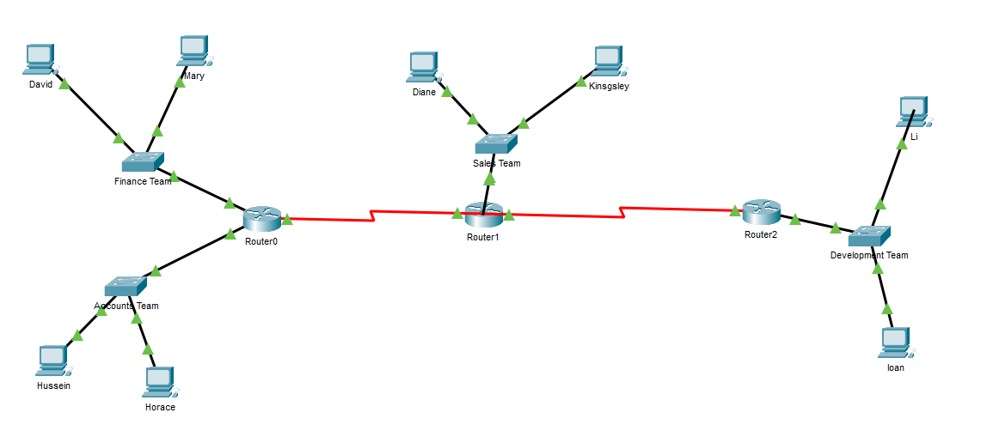
Fig 1: Basic Network Design
The IP addresses have been configured for each of the network devices using the IP Configuration Tool. Here is Kingsley’s PC demonstrating the configuration steps that have been applied:
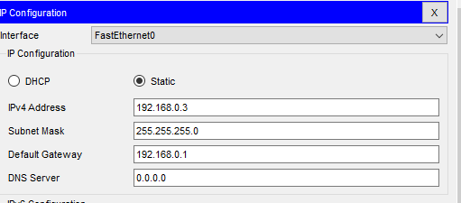
Fig 2: IP Configuration
There is no segregation and each PC can communicate with any other PC on the Network. A scenario can be imagined whereby an attacker sends a phishing email to the sales team which is opened by Kingsley, and the attacker gains access to Kingsley’s machine. Using the nmap tool or a simple ‘broadcast’ within the Command Prompt, will see everyone on the network.
  - 3.1 Weakness to Denial of Service Style Attacks
We can demonstrate Chi-SI’s vulnerability to these using Packet Tracer to launch a Denial of Service style attack by launching several thousand simultaneous pings from Kingsley’s PC to the IP address of Router 2:
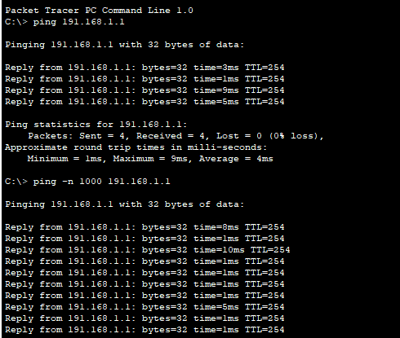
Fig 3: Denial of Service Using Packet Overload
This consumes the resources of the router and will either slow or prevent any other traffic from being routed through to the development team.
3.2 Using Networking Mapping to Reconnoitre a Network
Many attacks will simply be attempts to reconnoitre an organisation and identify vulnerabilities [10] that can either be exploited by Black Hat attackers in the future, or by White Hat hackers who will the notify the organisation involved that a weakness can be found. We can demonstrate this in practice for Chi-Si by using the nmap tool within Ubuntu to scan and identify vulnerabilities. Nmap or ‘Network Mapper’ is an open source tool that can be deployed for network discovery and security auditing that will allow us to discover what hosts, services, packet filters, and firewalls are running on a Network along with the Operating System of any devices.
To do this we use the command nmap localhost to obtain information on the services that are bound to the local host:
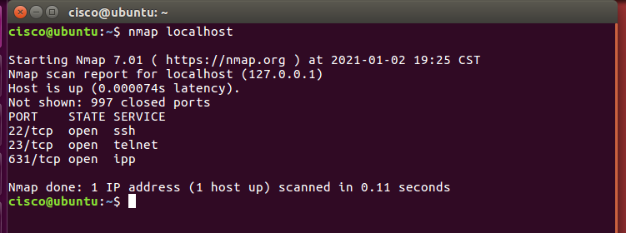
Fig 4: nmap localhost command
Here we can see that there are a number of open ports on the host. We can now also make a scan of the local host IP. First confirming the IP address using the ip addr show command:
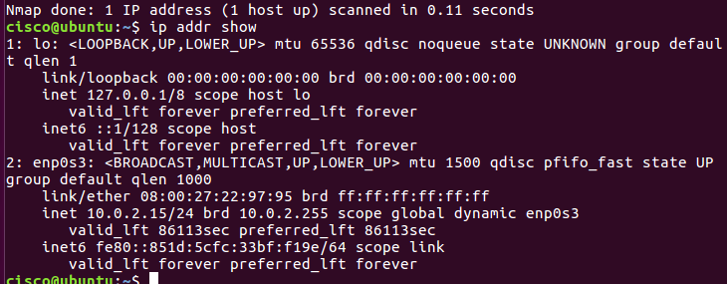
Fig5 : ip addr command

This establishes the IP addresses that our configured on the system. We can now use nmap 127.0.0.1 to scan the host IP address.
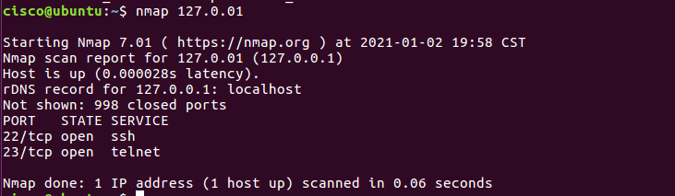
Fig 6: nmap host IP command
We can see there is a difference between the initial scan; now we have Port’s 22 and 23 open using SSH and Telnet respectively. The prospective hacker is now narrowing down the scope of their enquiry into Chi-Si’s Network. The hacker may now want to find more information about the network such as detecting the host version and so will attempt to log in as an Administrator using the sudo command:
Fig 7: sudo command
From here executing the nmap -O localhost command will give us details of the Operating System:
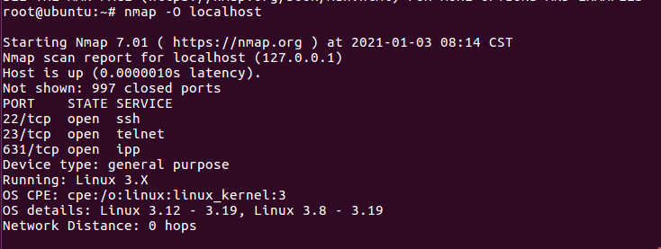
Fig 7: nmap host OS command

Ports 22 and 23 are open and we know the host Operating System. A potential hacker could now use one of these open ports to access the host. Port 23 is the Telnet port, Telnet is a now outdated authentication method with multiple security vulnerabilities [12]. A hacker could open a connection using Port 23 and install a programme or virus within the host machine [12].
4. Mitigation Strategy and Recommendations
  - 4.1 Closing Port 23 (Telnet)
To mitigate the risk around Port 23 I first need to establish what services Chi-Si may be running on the Port. This can be done using the netstat -nalp command on Port 23:
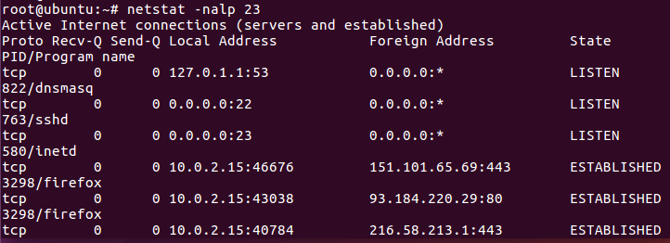
Fig 8: nmap -nalp command
Chi-Si can now see what processes may be affected by closing Port 23. Having reviewed these processes there is nothing critical to business operations that is running on the Port. Therefore Chi-Si may wish to close connections through Port 23 by using the ufw deny command.
Fig 9: Closing Port 23 using ufw deny command
With this simple step we have closed Port 23 and therefore stopped any inbound traffic attempting to exploit the inherent lack of security within the Telnet Port.
  - 4.2 Hardening OpenSSH
Further improvements can be made to the security posture by hardening our SSH. SSH stands for Secure Shell and it is a cryptographic network protocol for operating securely over an unsecured network. The standard TCP Port for SSH is 22 and we identified this in the nmap exercise above. Using the command nano /etc/ssh/sshd_config the configuration can be hardened.
Fig 10. sshd config command
The first step taken is to reduce the log in grace time to 20 seconds. By doing this Chi-Si will reduce their exposure to Denial of Service Attacks where numerous sessions are kept open for an prolonged period of time. Next the ability for all users to log in using the Root has been removed. This is good operational practice as it allows users to act on a minimum privilege basis but it also prevents a potential attacker logging in as an administrator. Finally, a maximum number of log in attempts has been set to 3 which prevents password guessing bots from trying to guess the password:

Fig 11. Setting Maximum Password attempts
  - 4.3 Configure IP ACLs to Mitigate Attacks
We are now going to return to our basic network design from Figure 1 to demonstrate how we an improve security and prevent the kind of attack we demonstrated in section 3. Good operating practice is to apply ACLs on edge routers to mitigate threats based on source and destination IP address. There are more complex ways of segregating traffic on networks such as implementing Software Defined Networking which is gaining increasing popularity in large scale enterprises [13] however, here I want to demonstrate cost effective good practice. 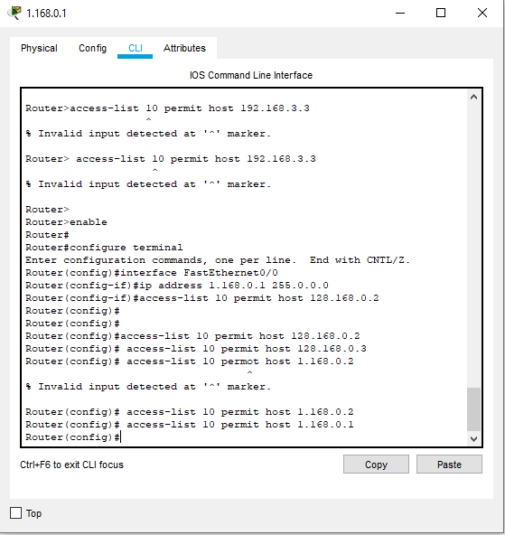
Fig 12: Configuring Router 0 to block all access except from PC’s in Finance and Accounts

5. Conclusion
Through the course of this report it is demonstrated that Chi-Si can deploy a number of strategies to mitigate security risks within their Network, however, this needs to be supported by training to staff on Cyber Awareness as we have seen – most vulnerabilities will be due to human error such as clicking a link within an email which then opens up the network to an attacker. In the Denial of Service Attack demonstration the key opening into the network was a phishing email. As Wang, Li, and Raghav point out; many organisations are over confident when it comes to their potential vulnerabilities to these kind of attacks and education is a crucial component of defence [13].
It has been demonstrated how reconnaissance techniques can be deployed by hackers to gain valuable information about Chi-Si’s Network. However, it has also been demonstrated that this approach can be used by Chi-Si themselves to proactively identify vulnerabilities in their systems and address them without purchasing costly equipment and by using tools available to them within their own systems focussing on an approach of 1. Reducing vectors of attack by closing ports 2. Hardening openings that need to be utilised and 3. Segregating the network using IP ACLs.

6. References

[1] | L. J. Trautman and P. Ormerod, “Industrial Cyber Vulnerabilities: Lessons from Stuxnet and the Internet of Things,” University of Miami Law Review 761, vol. 72, no. 3, pp. 761-827, 2018.
[2] | VM Ware Carbon Black, “https://www.carbonblack.com/,” Carbon Black, June 2020. [Online]. Available: https://www.carbonblack.com/wp-content/uploads/VMWCB-Report-GTR-Extended-Enterprise-Under-Threat-UK.pdf. [Accessed 30th December 2020].
[3] | IBM, “2020 Cost of a Data Breach Report,” IBM, July 2020. [Online]. Available: https://www.ibm.com/security/digital-assets/cost-data-breach-report/#/. [Accessed 30 December 2020].
[4] | Hiscox, “Hiscox Cyber Readiness Report 2019,” Hiscox, January 2019. [Online]. Available: https://www.hiscox.co.uk/sites/uk/files/documents/2019-04/Hiscox_Cyber_Readiness_Report_2019.PDF?awaid=6290&awpid=531979&awpsn=http%3A%2F%2Fwww.pcworld.com&awppt=Editorial+Content&awcid=convert-a-link&awc=6290_1609553337_1f450c3bac85fae29009d0e40bc3c582&u. [Accessed 29 December 2020].
[5] | Sauter and Molly, The Coming Swarm DDoS Actions, Hacktivism, and Civil Disobedience on the Internet, London: Bloomsbury Academic, 2014.
[6] | Cisco, “Cisco Annual Internet Report (2018–2023) White Paper,” Cisco, 9 March 2020. [Online]. Available: https://www.cisco.com/c/en/us/solutions/collateral/executive-perspectives/annual-internet-report/white-paper-c11-741490.html. [Accessed 31 December 2020].
[7] | J. Flood, M. Denihan, A. Keane and F. Mtenzi, “Black hat training of white hat resources: The future of security is gaming,” 2012 International Conference for Internet Technology and Secured Transactions, pp. 488-491, 2013.
[8] | O. A. Hathaway, R. Crootof, P. Levitz, H. Nix, A. Nowlan, W. Perdue and J. Spiegel, “The Law of Cyber-Attack,” California law review, vol. 100, no. 4, pp. 817-885, 2012.
[9] | B. Krebs, “Krebs on Security,” Brian Krebs, 16 September 2016. [Online]. Available: https://krebsonsecurity.com/2016/09/krebsonsecurity-hit-with-record-ddos/. [Accessed 2 January 2021].
[10] | Symantec, “Internet Security Threat Report Volume 24,” Symantec, February 2019. [Online]. Available: https://docs.broadcom.com/doc/istr-24-2019-en. [Accessed 2 January 2020].
[11] | R. Millman, “Time Is Running Out For Windows Server 2003 Migration,” Computer Weekly, pp. 14-16, 25 November 2014.
[12] | J. Klein and K. R. Walcott, “Exploiting Telnet Security Flaws in the Internet of Things,” in Advances in Information and Communication Proceedings of the 2019 Future of Information and Communication Conference (FICC), Volume 2, San Francisco , 2020.
[13] | J. Wang, Y. Li and R. Raghav, “Overconfidence in Phishing Email Detection,” Journal of the Association for Information Systems, vol. 17, no. 11, pp. 759-783, 2016.

6. Table of Figures

Figure Number | Item
1 | Basic Network Design
2 | IP Configuration
3 | Denial of Service Using Packet Overload
4 | nmap localhost command
5 | ip addr command
6 | nmap host IP command
7 | sudo command
8 | nmap -nalp command
9 | Closing Port 23 using ufw deny command
10 | sshd config command
11 | Setting Maximum Password attempts
12 | Configuring Router 0 to block all access except from PC’s in Finance and Accounts

