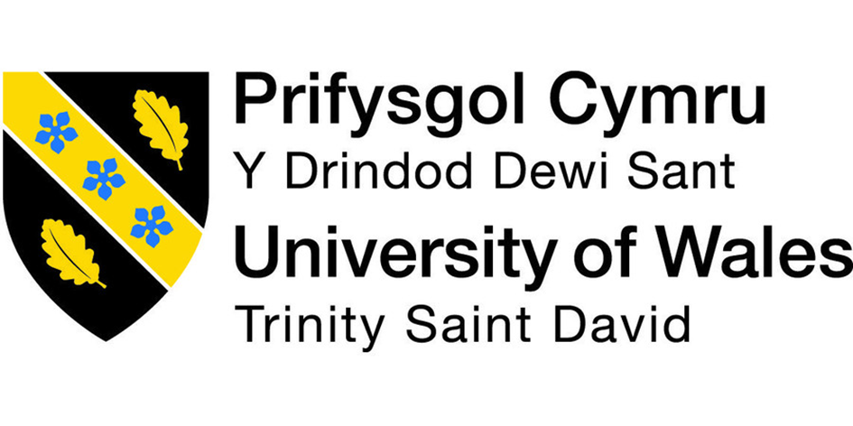

Student Name: Kitti Takacs
Student Number: 1906398
Lecture Name: Winifred Soribe
Module Title: Developing Workplace Critical Thinking
Modul No: BMSW5101_LON

Tartalom
1.0 Introduction 4
1.1 The idea of critical thinking 4
2.0 Beliefs, attitudes and values on the workplace behavior critically assess 5
2.1 Clarify the difference between attitudes, beliefs and values 5
2.2 Clarify the effect of workplace behaviour and attitude 6
2.2 The impact of beliefs, values and attitudes on own workplace behaviour critically assess 8
3.0 Management theory related to my role and critically assess effect on your own beliefs, values and attitudes. 9
3.1 My position, duties in the workplace 9
3.2 Management theories 10
System theories 10
Contingency theory 11
Bureaucratic management theory 12
Scientific management 12
3.3 Management theories in my workplace 14
Scientific management theory 14
Systems Theory 14
Contingency Management Theory 14
3.4 How management theories impact on my own beliefs, attitudes and values in workplace 15
4.0 Conclusion 15Reference 16

Introduction

The content of this essay is based on my workplace, called Dental Smiles London. In this essay I will use critical thinking and I will critically assess the impact of attitudes, beliefs, and values in my workplace environment. I will also write about some management theories which is related to my workplace. I am a manager at a dental surgery called Pentonville Road Dental. Pentonville Road Dental part of the three other branches under Dental Smiles London Company. Dental Smiles London has contract with National Health Care. National Health Care is one of the biggest free health care providers in the world. Pentonville road dental is a fully private practice and specialized for ortho treatment, such as Invisalign.

1.1 The idea of critical thinking

Critical thinking is about problem, subject or any content. The thinker is able to improve the quality or value of her or his thinking by competently analysing, measuring and rebuilding it.
The main part of critical thinking and tutoring in 1941, Edward Glaser said about critical thinking for example “The ability to think critically, as conceived in this volume, involves three things: ( 1 ) an attitude of being disposed to consider in a thoughtful way the problems and subjects that come within the range of one's experiences, (2) knowledge of the methods of logical inquiry and reasoning, and (3) some skill in applying those methods. ( Edward M. Glaser, An Experiment in the Development of Critical Thinking, Teacher’s College, Columbia University, 1941)
John Maxwell said “As you begin changing your thinking, start immediately to change your behavior. Begin to act the part of the person you would like to become. Take action on your behavior. Too many people want to feel, then take action. This never works.” (Maxwell, 2010)

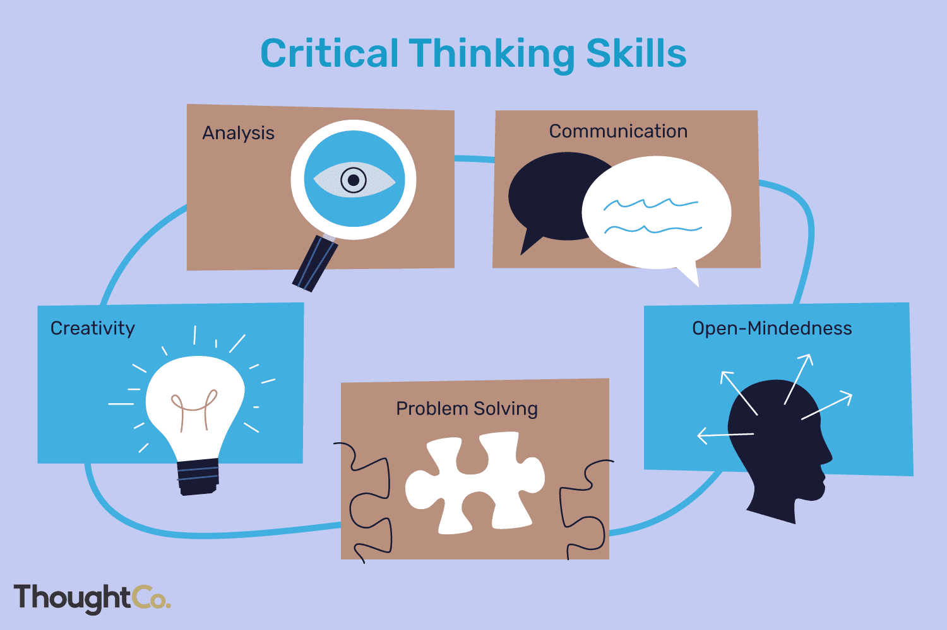

Critical thinkers must be honest and open minded to be able to find solution. The first step for the thinker is to find that, what is actually the cause of the problem and what area of the business’s problem is it. The process of this journey is absolute personalised, self-guided program. The thinker needs to find the problem, analyse the issues and find out how to solve the problems quickly. This process looks like an easy process but to be able to analyse the problem you need to be able to find the right problem to solve it.
Critical thinking raw material for example openness, organization or planning, strategic thinking, decision making, creativity or problem solving.

Beliefs, attitudes and values on the workplace behavior critically assess

2.1 Clarify the difference between attitudes, beliefs and values

Every human has their own set of attitudes, beliefs and values inherently since the day we are born. Being in a higher position, managing staff and dealing with client with different attitudes, beliefs or values you always need to be prepared to be ready for the professional values.
It is always a good practice to think on our own attitudes, beliefs and values and try to take it to consideration and make decisions. Able to solve or assess different problems in the work place, you should have a better understanding of basic happenings on a daily basis. Any arguments in the workplace, easier to solve, if we know the problem and also know the person attitude.
Showing what is the different between beliefs, attitudes and values.

Beliefs
Beliefs is idealism’s by a person past influences. Beliefs can be based on realistic views such as mathematics, science or it can be based on religious belief or many more. Beliefs encourage people to be differentiate, teaching us what is right and what is wrong. Depending on which beliefs the person holds. Belief can come from different sources for example religion, education or a person’s own experiences. The possible belief sits with the person until they take it as truth and ad it as a part of their separate belief system. Every single person assesses and search for reasons or evidence for these possible beliefs in their own way. Once a person takes the belief as a truth, they are willing to defend, it can be the beginning of the new belief.

Values

People make their own choices and decisions based on what kind of values are more important in they’re life. The values are born based on beliefs, which they can achieve from long term experiences and what kind of values they prefer or what vales are able to provide them advantages. Value come from belief which means if the person is able to commit, grow and realize what is important which helps the person to make their own decision. Values have different types which consist of different categories, for example job satisfaction, family and happiness or wealth as well. As a person who must make any decision needs to be clear minded, responsible behavior and must have a clear vision to be able to make decent decision.

Attitudes

Those features which appear in the attitudes people are using in they’re daily life which they are influenced by indirectly or behaviors, manners, customs and more. People are judged by their attitudes through their manners and their interactions with other humans to determine if good or a bad personality they have. Attitudes are very important in any companies. If the person has a good attitude will help to change the work atmosphere also it can go wrong if someone attitude is not right.
All in all beliefs, attitudes and values are create the person character. This charm is able to help the person to grow in the workplace or even in the person’s personal life. People bring their own unique attitude, values and beliefs from the parents, family, friends.

"Thinking is skilled work. It is not true that we are naturally endowed with the ability to think clearly and logically - without learning how, or without practicing. People with untrained minds should no more expect to think clearly and logically than people who have never learned and never practiced can expect to find themselves good carpenters, golfers, bridge players, or pianists." (Mander, 1892)

2.2 Clarify the effect of workplace behaviour and attitude

Customer satisfaction
Customers in a business organization is almost measured as one of the biggest investors, they are almost always only satisfied with a perfect service. Dental Smiles London has very strong beliefs about happy and satisfied customers. The company offer discounts and many different opportunities to the client to help meat the expectation. To run a successful business you must have a very good customer service team. Dental Smiles London has many opportunities and extra training on how to deal with different and also difficult customers. If you are able to explain to the customer calmly and effectively then the response from the customer is that they are more likely to come back again. As Mac Duke The Strategist said –
“Your marketing plan is not as important as how you plan to invest in the happiness of your customers.”

Organizational performance

Organizational performance has three detailed parts of outcomes, shareholders return, product market performance and financial performance. The workplace attitudes and beliefs refer to the organizational presentation by the employees of an organization in many different ways for example, enticing new customers so that you are able to help promote future services. Dental smiles London offer customers possible discounts if they are able to bring new customers into the business. Such as contact details will help the organization to provide 10% discount for the customers company and make them feel a bit special. This will help the company to grow and build more relationships with patients.

Interpersonal skills

Interpersonal skills or also we can call them as people skills, emotional intelligence or soft skills. All these skills are related to how we communicate and interact with other people. For example, when someone is hiring, interpersonal skills are one the most important skills. It is very important to be able to have a good relationship and get along well with customers or colleagues. Interpersonal skills also involve kindness of behavior, problem solving and many more.
“Interpersonal skills are like database management systems: being a good listener is about routing incoming requests to an appropriate service handler.” ― John Alejandro King a.k.a. The Covert Comic

Corporate image

Corporate image, or reputation, describes the manner in which a company, its activities, and its products or services are perceived by outsiders. In a competitive business climate, many businesses actively work to create and communicate a positive image to their customers, shareholders, the financial community, and the general public. A company that mismanages or ignores its image is likely to encounter a variety of problems. "Reputation problems grow like weeds in a garden," Davis Young wrote in his book Building Your Company's Good Name. "Direct and indirect costs escalate geometrically." (Young, 1996)

2.2 The impact of beliefs, values and attitudes on own workplace behaviour critically assess

Workplace behaviour contains acts like controlled environment of working safely, serving of the best capabilities from the workers, employee and employer a bit better relationship, safety and security management particularly for the women workers, guaranteeing freedoms to the employees, better customer service.
According to Kolb’s learning cycle (1984), the information increased by providing his jobs through the whole life perfectly can’t be effective if that is imposed to the practical life. If all of this experiences are implemented, applied in the workplace rare circumstances solutions, the person are able to remember for their good jobs. Since I am a manager of a dental practice called Dental Smiles London, I can suggest that management of any new person who joined us to be factual to their words, in their performance and communications building. The marketer should develop their experienced skills from their real life so that they can contribute to the promotion of their business. They should encourage beliefs and thoughts only for doing welfare for the society wherein they serve for making a business and profit for their company. I prefer to face to face challenges coming to me in every time by way of the customers. As per I can remember, a family of one of the patient wanted to be true to there faith collecting the products on behalf. Only their daughter refused and then I realised that In this situation I have to respect both the father and mother of a patient in having values of trust and To never underestimate the child also. I only managed with them with honesty and asked them to be very honest in daily life cordially. Some people believe that everything happens from different Gods for one reason or another; other claims for their misdeed in life of sufferings indeed.
Beliefs, attitudes and values are the three standings, that are a very important object existing in the personality, character of our life’s. The person reflects these three things in most daily life activities like convincing someone to buy new products or materials, managing the employees, interacting with dental technicians, looking for new patient, etc. The manager of an office treats the other factors like trade union representatives, workers in the industry, developers of their sites, engineer of their technological sector as his belief he holds. As a manager I have learnt more knowledge with some occasions that happened with me treating dealing with the customers. I would like to say that, I treat the customers as if they are my family member or how I would like to be treated. When you are able to get someone’s respect you have their support and loyalty.
There is a control of realising own values and beliefs all time. The client’s opinions are always the first. As a manager I need to make sure the patients view on any kind of issues related to the practice I manage. To guarantee the workplace behaviour is almost always positive I need to communicate and help with employees. It is always a massive importance of letting the employees to able to have an opinion in important decision making, or policy making for the dental practise or customer service. I need to listen their opinion and consider. I’m never tried to consider the values and beliefs.
The working environment with happiness regularly impact the development of the organization. A respectable working environment grows by the beliefs, values, and attitudes held by the employees and the employers. Every single action made by the employees in the practice is impacted by her or his values, beliefs and attitudes. For example, if an employee holds any belief that every single performance of her or his doings and responsibilities in the site is respectful in his Belief, he or she is unquestionable to perform more promisingly. Because every employee should deserves a work place of acceptance and open-mindedness. I practice good behaviour in daily life as much as I can, and also try to show respectable attitudes towards the my staff and colleagues and also bosses in the practice. I have knowledgeable connections with my staff and their jobs and attitudes are involving me.. I found out sometimes some of them telling a lie, or trying to use the situation to their own benefit.. So, values and attitudes support one’s dignity, respects and value within any business environment or even in personal life. Generally, the truthful enthusiastic employees are treated with respect but the misguided employees are treated a bit unfriendly. Sometimes then there may happen information gaps with the receptionist of the practice. Well, this is reasonable explanation to avoid responsibilities but if there is any susceptibility to pretend not having information can not be avoided such bad mentality as this can causes a big sufferings to the other factors related to the business like suppliers. These kind of mentality’s or behaviours cannot be removed immediate. I try to meet them and help to understand me with a easier mindset for the better in their honest performances. If they are able to focus and drive you it will be a possibility to have successful days. I arrange several raining to and meetings to inform them in the real potentials they should stand in their doings they achieve in a daily basis in the practice. Many training programs like customer service, helping with the soe softer, formal and informal emails and many more tests. As a manger in dental smiles London in a daily basis I rely on Adrienne Rich quote which say:
“Responsibility to yourself means refusing to let others do your thinking, talking, and naming for you; it means learning to respect and use your own brains and instincts; hence, grappling with hard work.” (Rich, 1995) this is a short definition of my beliefs.

3.0 Management theory related to my role and critically assess effect on your own beliefs, values and attitudes.

3.1 My position, duties in the workplace
I am pleased to be a dental practice manager in central London. My goal to meet our patient high level of expectations. I am absolutely passionate to be able to take care of our patient’s , help them and explain any and all treatments available or payment plans. I believe if you treat everyone equally and also in high standard patients will lose all fear to come in any dental practice and we can create a nice relationship. My job is to make sure everyone happy in the practice because if my employers have any problems it can create more problems. For examples, the way in how to speak with a patient who is afraid of the dentist sometimes can be a bit difficult, but these patients don’t want to be difficult but if you are in pain sometimes, they can say something rude or obnoxious. I am also responsible for the paperwork, data analysing and the bills. One of my main responsibility is to deal with the complaints. I believe this is the hardest part of my job. Any complaint when it arrives, I need to investigate into the matter. Sometimes even if you believe your employees did everything accordingly you still can receive some. When I look into it, I will take it in to consideration and try to solve the problem. As a manager my key duties in the office can be carried in many different ways like, dealing with complaints, greeting customers, answering emails, calling companies to provide invoices and many more.

3.2 Management theories

System theories

General Systems Theory is a name which has come into use to describe a level of theoretical model-building which lies somewhere between the highly generalized constructions of pure mathematics and the specific theories of the specialized disciplines. Mathematics attempts to organize highly general relationships into a coherent system, a system however which does not have any necessary connections with the "real" world around us. It studies all thinkable relationships abstracted from any concrete situation or body of empirical knowledge. (Boulding, 1956)
Dr. William Edwards Deming said that bad system will beat a good person every time (Deming, 1993). Bad system will beat a good person but also everyone. As you see on the diagram system theories about input, system and output.
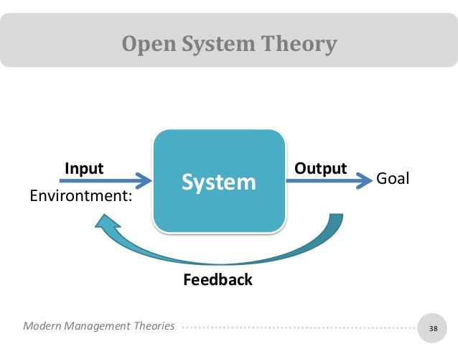

Source: pinterest

Contingency theory

Contingency theory is a better model of recognising the organizational controlling the power and success of the plans those they accepted. This model was created in the mid-1960s by Fred Fiedler. The model helps states that there is no on best style of leadership. Fred Fiedler believed the situations specify the leader effectiveness.
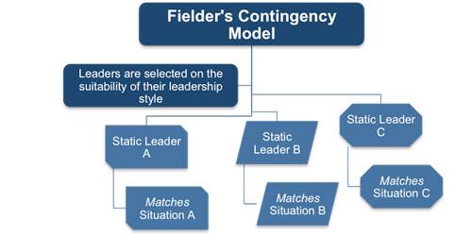
Source: Pinterest
Fred Fiedler show on this model what he believed that can not be just one type of good leader it always the situation, system and problems are changing. On the diagram shows three different type of leaders three different type of situation.

Bureaucratic management theory
One of the most significant theorists in modern organizational theory, Max Weber (1864-1920), he is the 'inventor of the bureaucratic management theory.' Weber was a German sociologist and political economist. He was able to analyzed two types of methodologies by that time. Weber’s theory of the bureaucratic management has two important elements. The first one is involving an organization into a hierarchy and the other one is when the organization are overseen by obviously defined rational-legal decision-making rules. Both of these elements help the organization to achieve their goals. Max Weber said in his book, Social economic problems do not exist everywhere that an economic event plays a role as cause or effect - since problems arise only where the significance of those factors is problematical and can be precisely determined only through the application of methods of social-economics. (Weber, 1904)

Scientific management
Scientific management was founded by the American mechanical engineer Frederick Taylor (1911). Scientific management also called Taylorism. The truth about Taylorism that we are able to divide the work process into details. This will help to improve efficiency, higher profit and agreement between employers and employees. Taylor supported these measures “time and motion” which means examining, analyzing work process. Many theories of management provide the best way to manage the employees and possessions to accomplish productivity and efficiency. These also include the administrative management theory by Henry Fayol, and the bureaucratic management by Weber. Also, the Human relations movement and behavioral management of Maslow. Frederick (1911) also said “Perhaps the most prominent single element in modern scientific management is the task idea. The work of every workman is fully planned out by the management at least one day in advance, and each man receives in most cases complete written instructions, describing in detail the task which he is to accomplish, as well as the means to be used in doing the work. And the work planned in advance in this way constitutes a task which is to be solved, as explained above, not by the workman alone, but in almost all cases by the joint effort of the workman and the management. This task specifies not only what is to be done but how it is to be done and the exact time allowed for doing it. (TAYLOR, 1911)

3.3 Management theories in my workplace

Scientific management theory
Scientific management produced radical thoughts for the time such as employee training. As a manager in dental practice, I do use scientific management theory. Often, we have trainings for employees to improve they are skills and to be able to provide better customer service. This theory sometimes a bit called not worker friendly as this theory based on from botanists and chemists, such as investigation, observation, combination, rationality, and logic. Frederick said – “Hardly a competent workman can be found who does not devote a considerable amount of time to studying just how slowly he can work and still convince his employer that he is going at a good pace.” (TAYLOR, 1911) I believe as a manager this way of thinking can help to achieve more for the company and driving employees into this thinking.

Systems Theory
Systems theory is a very important theory in healthcare, without system can not be managed. This theory combines many different factors. Allows us to recognise how the factors can affect the skills of the employees. Also, how can change the values, beliefs and attitude in the work environment. I like using this theory as I can monitor all factors and prove the employee’s performances. System theory is a very useful to help improve the company and achieve goals. Dental Smiles London as a healthcare provider must have a system theory as we are dealing with patient’s health. Able to manage customer expectation I must lead my team to improve they attitude, values and beliefs.

Contingency Management Theory

Contingency management theory is helps test our service. Every dental practice has the same product such as Invisalign. Paul Kurtz said that “I believe that a person should take an affirmative outlook. There are always problems in life, old and new, uncertainties, and unexpected contingencies. The optimal way to deal with this is not to give up in despair, but to move ahead using the best intelligence and resources that we have to overcome adversity.” (Kurtz, 1994) This is how I try to lead my team. I believe move forward not give up because always have the option to improve or achieve the goals.

3.4 How management theories impact on my own beliefs, attitudes and values in workplace
Dental Smiles London is based in central London and I would like to confirm as to be one of the best dental practices. The company providing high valued service and options to patient. Management system able to develop high customer service. This point is my value. I would like to grow the company and achieve more open new practice and help patent to find the best service.
Importance I believe to hire employees who cares about the client and also who shared my values about how important the customer. I believe I got the best values from my father who always encouraged me to do better to be better, listen different beliefs as they can become my beliefs.
Attitudes are the hardest part of my position. As each person has a different attitude and to find the way to understand and manage, I believe it is hard. The communication is the key for everything if you can apply high standard communication it will help the employees to understand the business more. Also it helps encouraging the employees for a standard behaviour which help to improve the service.

4.0 Conclusion
My conclusion is that all three management theories are the basis of management. I believe all theories can help improve management skills and run a successful company in all fields. We must consider about science and technology because as the time passes and we have to grow with the market globally. I am sharing my experiences as a dental practice manager. I believe learning this subject has helped me more to lead my team. All beliefs, values and attitude are very important to run a successful business. Attitude the most common problem in dental smiles London as we need to have the highest expectation. My generation I believe forgot about work relationship and friendship. Most of my team members need to realize that we are here to work and to spend time. All beliefs I believe depend on personality and a can do attitude. I believe if I am going to do something no matter what do it with your best knowledge and your best ability.

Reference

Boudon, Raymond. (2018). Origin of values. 2nd Ed. Transaction Publishers. New Jersey.
Critical Thinking, (2018) Concept of critical thinking. Available at:
http://www.criticalthinking.org/pages/defining-critical-thinking/766. [Accessed on: April 18, 2018]
Caramela, S. (2018) The management theory of Max Weber. Available at: https://www.business.com/articles/management-theory-of-max-weber/. [Accessed on: 12 April 2018]

David, T. O. (2010) The contingency theory of management accounting: achievement and prognosis. New York:Pergamon Press Ltd

Lumen (2018) Scientific Management. Available at: https://courses.lumenlearning.com/wm-principlesofmanagement/chapter/scientific-management/. [Accessed on: April 19, 2018]

Mele, C. (2009) A Brief Review of Systems Theories and Their Managerial Applications. Boston: Sage Publication

McQuerry, L. (20180 How Do Negative & Positive Attitudes Affect the Workplace? Available at: http://smallbusiness.chron.com/negative-positive-attitudes-affect-workplace-21287.html. [Accessed on: 19 April 2018]

Perry, G.L. (2018) Human Relations Management Theory Basics. Available at: https://www.business.com/articles/human-relations-management-theory-basics/. [Accessed on: 19 April 2018]
John Alejandro King a.k.a. The Covert Comic (goodreads.com)
Young, Davis. Building Your Company's Good Name: How to Create and Project the Reputation Your Organization Wants and Deserves. AMACOM, 1996.
Deming, W. Edwards (1993). The New Economics for Industry, Government, and Education. Boston, Ma: MIT Press. p. 132.
Max Weber (1904) The Protestant Ethic and the Spirit of Capitalism
UKEssays. November 2018. Scientific management definition. [online]. Available from: https://www.ukessays.com/essays/management/scientific-management-definition.php?vref=1 [Accessed 5 January 2021].
TAYLOR, F. W. (1911). The principles of scientific management. New York, Harper & Brothers.
Toward a new enlightenment : the philosophy of Paul Kurtz
Paul Kurtz ; edited with an introduction by Vern L. Bullough and Timothy J. Madigan
Transaction Publishers, c1994
Everyone Communicates, Few Connect: What the Most Effective People Do Differently, Thomas Nelson –2010
Of Woman Born: Motherhood as Experience and Institution by Adrienne Rich Published April 17th 1995 by W. W. Norton Company (first published October 1st 1976)

