The representation of disability (physical or mental) in either Greek or roman literature and art.

Disability today is thought of as beingg ‘a physical or mental condition that limits [people’s] movements, senses, or activities’. In ancient times, people’s perception of disability, what it actually was and how people dealt with it, was different to how we perceive it today, and we as scholars are still trying to understand in what ways the two society’s think alike and differently. In this essay, I will focus on ancient Greek literature with some examples of some art, and will discuss more fully the perception of disability between the mortal man and the divine.
In Latin, the word for disability does not directly translate however the word ‘debilitas’ meaning weakness or feebleness is more accurate to what we believe the Greeks perceived as a disability. From looking at textual evidence and from art, we can see that the Ancient way of thinking about the disabled varied a lot. One way was the way they dealt with disabled children. This is a topic of much debate to scholars as it involves the theory of the Greek people leaving their children who happened to be deformed out in the wild, with their fates to be determined by the gods because of their deformity or disability. A good example of this in Greek literature is the Story of Oedipus where he as a baby is mutilated and left out to die. Rose however poses a contradictory theory that the practice of exposure was not as common as some modern historians believe. She suggests that the word ‘Oedipus’ actually translates to ‘swollen-foot.’ And that due to his ankles being pieced at birth people have mistaken the fact that his father wanted him dead for the reason only that he was disabled, whereas he was purposely mutilated so he could die. While evidence for this practice is apparent, for example Lee shows evidence from Soranus, who in turn describes the way a midwife examines a newborn child, including their ability to cry or the look and use of all four limbs, there are still those who believe that there is not enough evidence to prove that the children were left out to die because of this disability There is also the discussion of what the ancient Greeks would have believed to be ‘disability’ there is for example deaf and blind references throughout ancient Greece’s history, but this would in turn have been hard for the average Greek parent to pick up on until later in the child’s life, where the child would have been too old to have their fates left to the gods also mentions how Plato and Aristotle again both supply us evidence of exposure even though it may be ambiguous, many believe it to be talking about exposure of infants. ‘… when they chance to be deformed, will be put away in some mysterious place, as they should be’ As well as this we also see that though mythology there are numerous cases of children being deformed and left out in the wild. Zeus, Oedipus, Perseus, Asclepius and others. My point here that the general attitude of the Greek people was that as long as the disability did not hinder them, then it was more acceptable. As in the cases of babies, as long as the baby’s fate was left to divine intervention we can see that this became an accepted practice. Through text and art we see disability or exposure of infants though depiction of the divine and those connected to the divine.
For the next part of the essay I will focus more on pieces of art that in literature and look at how disability, in regards to the divine, in perceived and shown compared to a mortal man. The First example I will look at is that of the Greek God Haephstus, god of the Forge. He was the Son of Hera and the myths shows him being thrown out of Olympus to earth because he was born with a crippled foot.

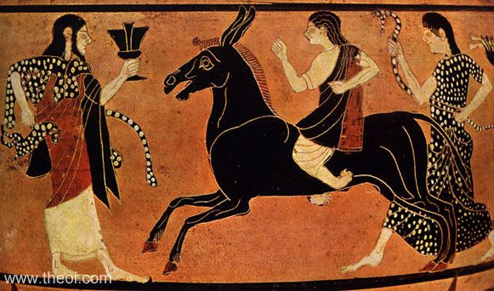

Figure 1

In Figure one we can see Haephstus is depicted standing before Dionysus, riding a mule, legs ending in shriveled feet, portrayed as backwards as in common in a lot of images of Hephaestus, for example figure two depicts a backwards foot and hunched figure . Figure 1 is a depiction, where Dionysus intoxicated Hephaestus when he was in a rage is the depiction of the return of Hephaestus to Olympus. Figure two also shows a depiction of Hephaestus with a backwards twisted foot. In my opinion, although these pictures and depiction look grotesque to us, the Greeks did not perceive it as a hindering disability. Hephaestus Is god of the forge, not god of disability. He creates some of the most powerful weapon or items for the Greek heroes and other Gods, the shield of Achilles being one of them. This demonstrates how the Greek people saw disability as only a bad thing if it stopped the person from carrying out their trade, as in the case of Hephaestus he achieved amazing things despite his so called ‘disability’.
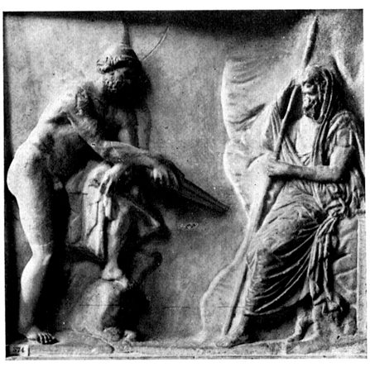
In the case of Oedipus as shown in figure 2, this relief depicts Oedipus standing in front of the blind prophet Tiresias. Here it is not the upcoming disability that I will be discussing but Tiresias. Although he is blind, which we would classify as having a disability, he has the gift of foresight. He tells prophecy’s, and this is a gift that the Greeks would have deemed a high honor, as it was a connection to the divine. His disability is not hindering his ability to prophecies and thus the attitude towards him seems to be the same as if he was a prophet with literal sight. This seems to be the overall Greek attitude regarding disability.
In conclusion, Although the western idea and the ancient Greeks idea of what disability was vastly different, the way the Greeks deal with it seems to be in the attitude of it is only classed as a disability if It what we as modern day attitude would more accurately call an impairment. Some scholars have stated ‘disability exists as it is situated in the larger social context, while impairment is a biological condition.’ Through depiction in art and through literature we can see how this statement rings true, and a ‘disability’ is only classed as a bad thing If it hinders you.
Figure 2

Bibliography

English oxford dictionary, availalable at: https://en.oxforddictionaries.com/definition/disability

Penrose jr, 2015, the discourse of disability in ancient Greece, Classical world, vol 8.

Hooks L, 1920, The exposure of infants at Athens, Transactions and Proceedings of the American Philological Association, The Johns Hopkins University Press

Rose M, 2003, The staff of Oedipus: transforming disability in Ancient Greece, University Michigan Press

Lees C, 2008, learning from silence- Disabled in roman Antiquity, accessed at https://www.academia.edu/11459903/Learning_from_Silence_Disabled_Children_in_Roman_Antiquity_in_Arctos_42_2008_p._85-122?auto=download

Bury M, 2011, handbook of disability studys, sage publications,

Images
Figure 1, k7.8 the return of hephaestus, 530BC, https://www.bing.com/images/search?view=detailV2&ccid=5YQUgr%2b4&id=0E083827C86776235574097C72CB02A5F8E7E3FD&thid=OIP.5YQUgr-4qb-bW4lj3K52MQEsCw&q=Hephaestus+Greek+Vase+Painting&simid=608024855390064410&selectedIndex=0&ajaxhist=0

Figure 2, Oedipus Tiresias, https://www.bing.com/images/search?view=detailV2&ccid=bOuPlFSz&id=6D688B2CF8B265EBC3635DAB2B47ED7376550414&thid=OIP.bOuPlFSzAVylnMJCocKPQgEsEp&q=+blind+oedipus+greek+pottery&simid=608049753351326407&selectedIndex=71&ajaxhist=0

Oxford dictionary
Penrose Jr, 2015, 504
Hooks, 1920
Rose, 2003, 29
Lees, 2008, ch.2
Hook, 1920
Hook,1920, 140
Bury, 2001, 11

