
Manufacturing design & technology
Technical Report

July 3, 2023
University of Wales Trinity Saint David

Abstract
The following report is split into two sections, the first section of this report is to redesign a current subtractive manufactured part into an additive manufactured part by using various design for additive manufacturing techniques. These techniques were a finite element analysis (FEA), a topology optimisation study and a generative design simulation.
The FEA was carried out on the current model and on the generative design model, with the latter yielding better stress and displacement figures relative to the mass of the model, which was reduced by 35.2% in the generative design simulation. This simulation proved that the current model was using too much material in its manufacturing process and once the material used was changed to a Titanium alloy, similar material properties were achieved with less mass.
The topology optimisation study confirmed that the current model was using too much material as there was quite a substantial amount of material that can be removed without compromising the integrity of the part. As mentioned, the generative design also yielded similar results to the topology study, removing a large amount of material, and still producing relatively low stress and displacement values.
The second part of the report is to redesign a 3D printed portable wind turbine so that it can be mass produced, with some 1000-2000 units to be made per week. A quality function deployment (QFD) and a design specification were written to ascertain the customer requirements, the main points being the manufacturability of the turbine and the ease of assembly.
These requirements were met in the form of design changes, which were redesigning the fins and fin housing so that they were poka-yoked and consolidating the three parts that make up the main body of the fan into one body. The manufacturing process chosen for mass producing the wind turbines is injection moulding, this was chosen as it produces accurate parts at a high rate and a relatively low cost. The wind turbine was also designed in an environmentally friendly way and will be produced using the recyclable plastic polypropylene.

Table of Contents
Abstract 1
Introduction 3
Main Findings 5
1. Design for Additive Manufacturing 5
1.1 Background Information 5
1.2 Finite Element Analysis 6
1.3 Topology Optimisation 10
1.4 Generative Design 12
1.5 Constraints 15
1.6 Conclusion 16
2. High Volume Production – Portable Wind Turbine Redesign 17
2.1 Background Information 17
2.2 Concept Design 17
2.3 Manufacturing Process 21
2.4 Design and Development Work 22
2.5 Conclusion 27
Bibliography 28

Introduction

Additive manufacturing (AM) is a relatively new technology and a new way of manufacturing a wide variety of components across many sectors of engineering. Unlike subtractive manufacturing, which is a more traditional group of methods of removing material from a block or billet to achieve the desired shape, AM provides almost unlimited design freedom within the capabilities of any given AM machine or process. AM achieves this design freedom by building the parts layer by layer, allowing for complex and complicated designs to be built accurately and reliably. Dilberoglu (2017) states that additive manufacturing is an essential ingredient in the Industry 4.0 era.
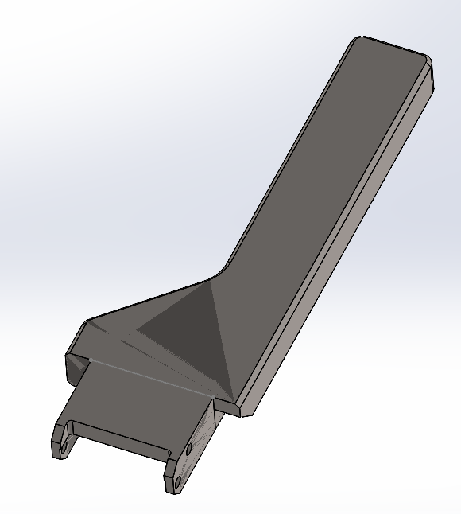
Section one of the main findings of this report shows a door handle from an AM metal 3D printer, which is typically made using a subtractive manufacturing process. The door handle, shown in Figure 1, will be redesigned to be made using the additive manufacturing process known as metal powder bed fusion.

Figure 1 (Rowland-Jones, 2023)

Various tools have been used in the redesign of this handle including generative design, finite element analysis and topology optimisation. Design for additive manufacturing (DfAM) principles have also been applied to the redesign, ensuring that build structures and mass optimisation has been considered to ensure that the new design is strong whilst also using a little material as possible.
Section two of the main findings focusses on redesigning a portable wind turbine, that is currently 3D printed, for mass production. As AM is still a relatively new manufacturing technique, the speed of production of parts is not yet as fast as other processes, such as injection moulding. Jung (2023) agrees with this statement, stating that current AM capabilities can only supply slow rates of production.
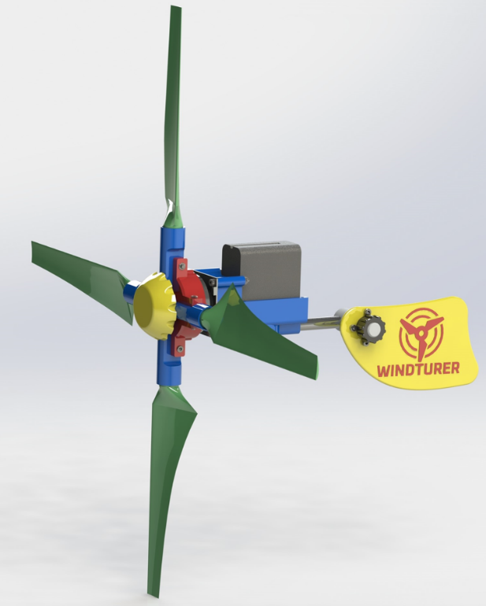
The portable wind turbine, shown in Figure 2, will have individual components redesigned to optimise mass production. The manufacturing process used to mass produce these wind turbines will not be additive, it will instead be injection moulded into its individual components and assembled.

Figure 2 (UWTSD, 2023)

A quality function deployment and an FMEA has been carried out on the wind turbine to determine a priority list of what the stakeholders want in terms of a redesign for mass production, and to foresee any potential hazards or faults with the new design.

Main Findings

1. Design for Additive Manufacturing

1.1 Background Information

The product chosen to apply Design for Additive Manufacturing (DfAM) principles to is a door handle that is fitted to an additive manufacturing (AM) machine from Renishaw. The part is currently made in house within Renishaw’s machine shop, using the subtractive manufacturing method of machining from an aluminium block. It is later anodised before being sent to the AM department to fit them to the RenAM500 machine. Figure 3 shows the handles placement on the machine:
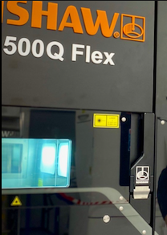

Figure 3 (Metal AM, 2022)

As can be seen, the handle is part of an assembly and is attached to the door handle keeper via a locking shaft near the bottom of the handle. There are two of these handles per AM machine and currently, around four machines a month are being built so the door handle is of relatively low volumes of production.
The method of additive manufacturing chosen is powder bed fusion, which is the method used in the RenAM500 machines that this door handle is a part of. The principle of powder bed fusion is using high powered lasers to melt fine metal powders into desired geometries. The 3D element of powder bed fusion comes from the build plate moving up and down to create layers of fused powder. Each layer is a slice of 3D CAD data, with each one having a thin, even layer of metal powder which is then melted in specific areas by the lasers (Renishaw, 2023).
The specific machine that will be used is called the RenAM500Q model from Renishaw. This machine has four 500W lasers and an automated powder recirculation system that automatically sieves out oversized, unwanted powder particles and recirculates the useable powder back into the build chamber. This machine was chosen due to its fast build capabilities and its production of high-quality parts. Butcher (2019) was involved in a case study where it was found that the RenAM500 gas flow characteristics aided in the production parts to be of a higher quality. This will ensure that the door handles will be printed to a very high-quality standard and will be built to last.

1.2 Finite Element Analysis
The 3D model of the door handle was imported into SolidWorks, a 3D CAD software, and was put through a finite element analysis (FEA). Roylance (2001) states that stress problems can be solved numerically due to the advancement of FEA. In this instance, FEA will be used to show where the stresses are found when a load is applied to the model. Figure 4 shows where the door handle models fixture points are. This is determined by the design of the handle and is where the handle is fastened to the latch. The fixture points are important to get in the right place as this is potentially where a lot of the stress is going to be found when the load is applied to the model.

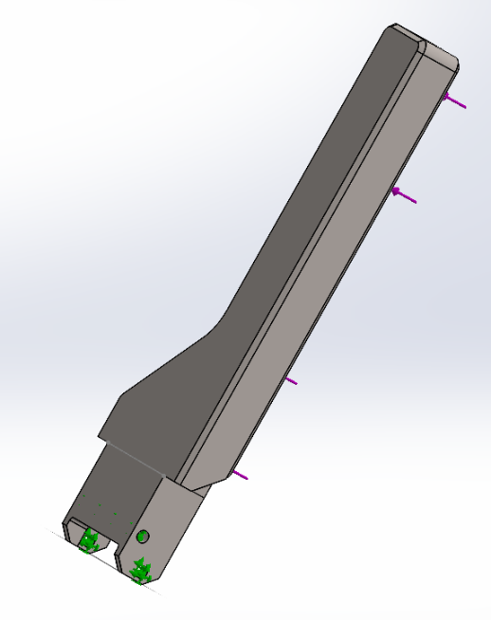

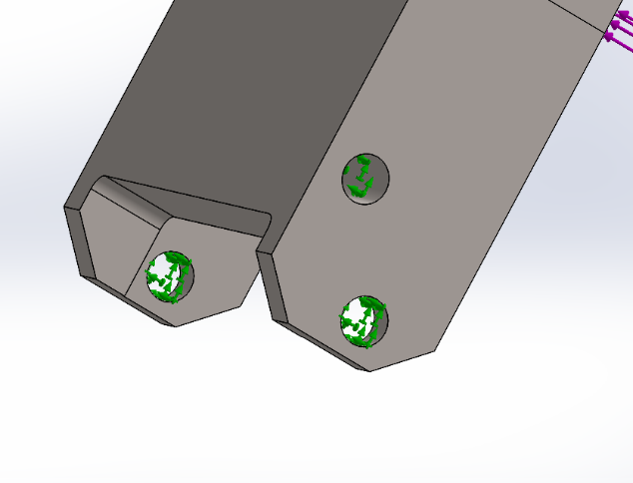

Figure 4 (Rowland-Jones, 2023)

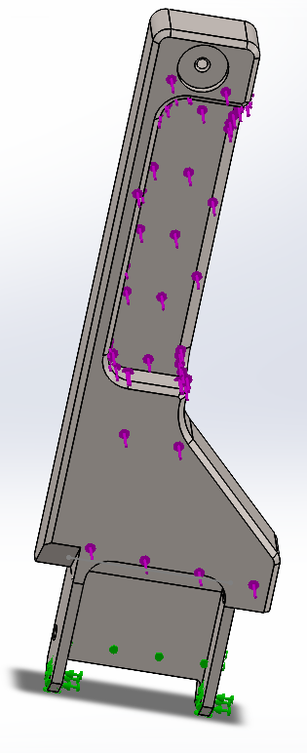
The specified load for this simulation is 98.1N which was calculated from multiplying 10 (kg) by 9.81 (m/s^2 acceleration due to gravity). This load was applied to the rear of the handle, as shown in Figure 5, as that is the area that the user will pull when opening the door of the machine:

Figure 5 (Rowland-Jones, 2023)

The chosen material for this simulation is 7075 aluminium, as this is the grade used in the current subtractive manufacturing process within Renishaw. This grade of aluminium is lightweight and strong and is relatively easy to machine compared to titanium and other metals, with the overall mass of the Aluminium handle being 0.40343kg.
As this was a static simulation, it took up less processing power, therefore a very fine mesh could be used. Generally, a coarse mesh would give less accurate results and conversely, a fine mesh will give more accurate, more robust results (SolidWorks, 2021). Figure 6 shows the door handle after having FEA applied to it:

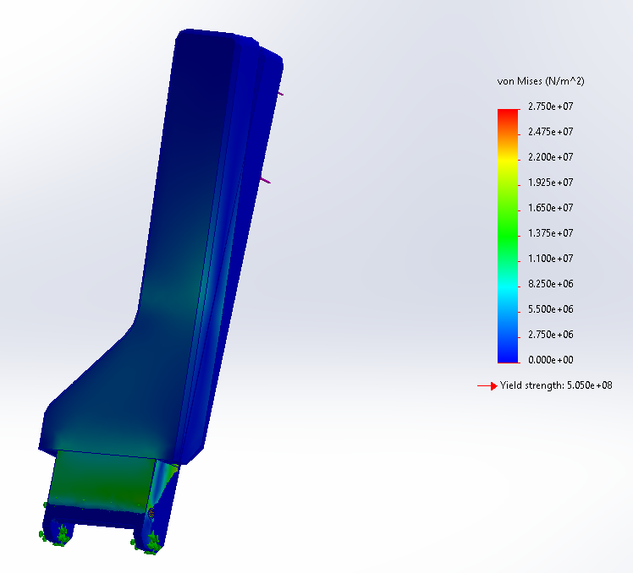

Figure 6 (Rowland-Jones, 2023)

As seen, the stress that will be applied to the door handle is no more than a maximum of 27.5x10^6 N/m^2, or 27.5 MPa, which is a relatively low value considering the ultimate tensile strength of 7075 aluminium is 570x10^6 N/m^2, or 570 MPa (SolidWorks, 2023). Figure 6 also shows a yield strength value of 505x10^6 N/m^2 or 505 MPa which is the maximum yield strength of 7075 aluminium. Figure 7 shows the maximum displacement of the door handle with 98.1N of force applied to it:

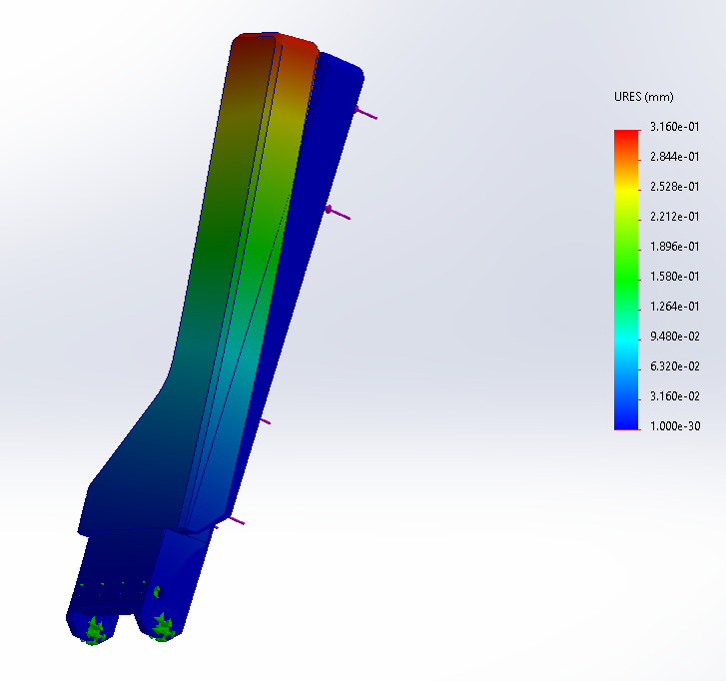

Figure 7 (Rowland-Jones, 2023)

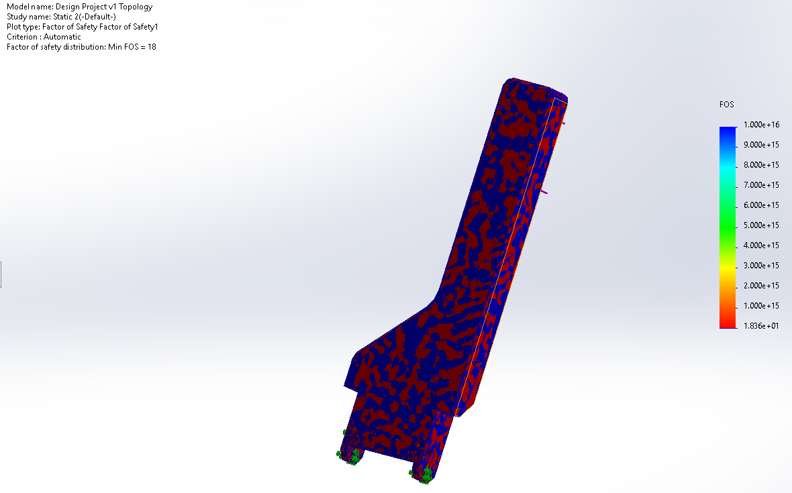
As seen, the maximum displacement is 0.316mm which is a very small number and will not affect the performance or function of the door handle and the displacement is not as extreme as the visual representation shown in Figure 7. The factor of safety of the door handle is shown in Figure 8:

Figure 8 (Rowland-Jones, 2023)
As seen in Figure 8, the factor of safety is 18 which is unnecessarily high and suggests that too much material has been used and the door handle has perhaps been overengineered. This overuse of materials leads to a higher cost per part and a less efficient manufacturing process. The high factor of safety would lead to topology optimisation.

1.3 Topology Optimisation
SolidWorks also possesses the ability to put parts through a topology optimisation study which is a simulation that visually represents which areas of a given part can be removed without compromising the part. Ribeiro (2021) confirms this statement, saying that topology optimisation is computationally representing structural materials’ optimal layouts. In order for the function of the handle to remain, the bottom part of the model was removed, as shown in Figure 9:
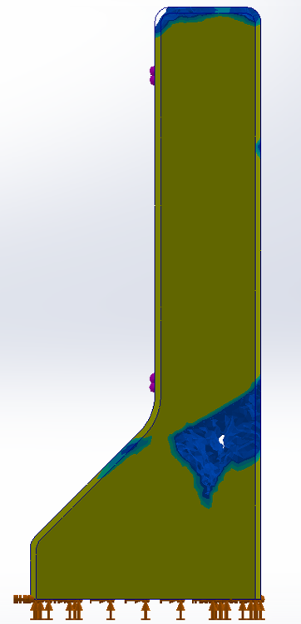
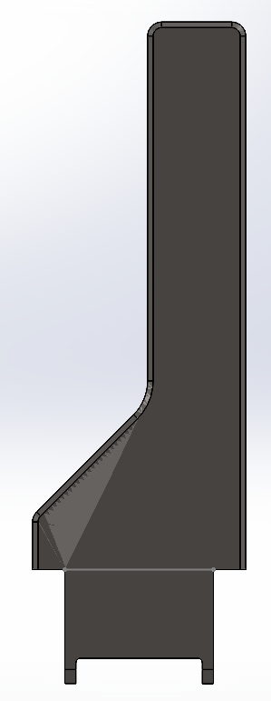

Figure 9 (Rowland-Jones, 2023)

The image on the left in Figure 9 shows the results of the topology study with the same characteristics as the FEA study, with the force set as 98.1N. The goal of the study was to minimise mass by 20%. The study was run again at 30% and 50% mass reduction which can be visually represented by Figures 10 and 11:

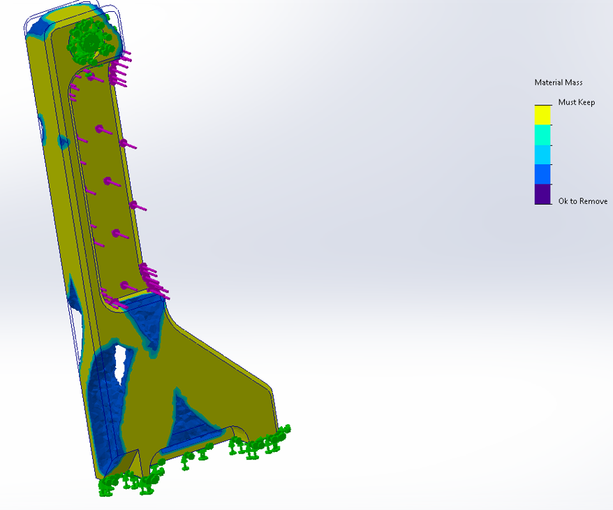
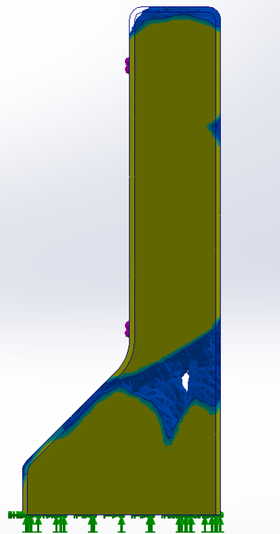

Figure 10 (Rowland-Jones, 2023)

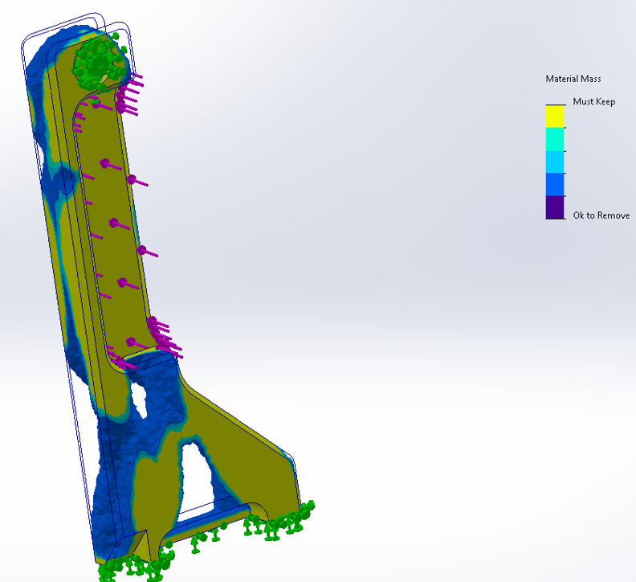
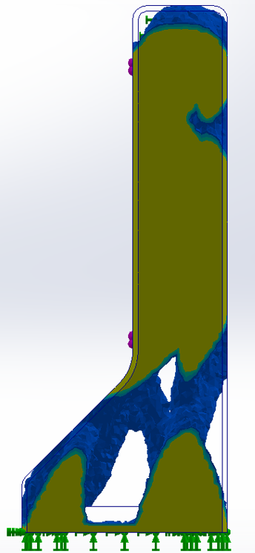

Figure 11 (Rowland-Jones, 2023)

As seen, a lot of material can be removed from the model and still be able to function correctly to the environment it would be subjected to, with each iteration removing 0.080686kg, 0.121029kg and 0.201715kg of mass respectively. This further confirms that too much material is being used when manufacturing this part. This overuse of material is not a sustainable building practice and adds to the impact it has on the environment (Sustainability Guide, 2023).

1.4 Generative Design
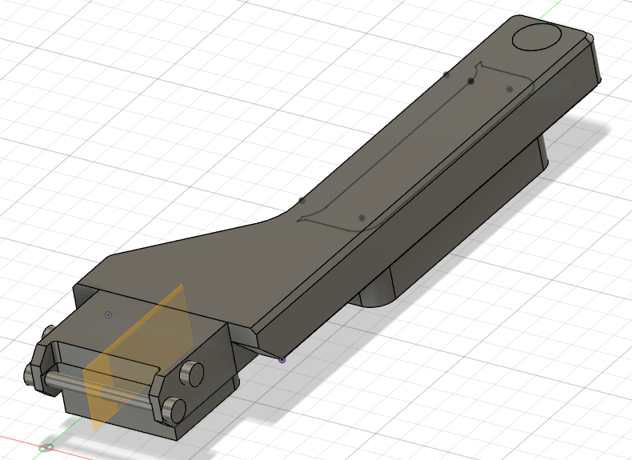
Autodesk offer a software package called Fusion 360 which has the capabilities of putting a part through generative design, which gives a visual representation of what a part could look like as an additive manufactured part. This is another tool to show how a part can be structurally optimised using a CAD software. Buonamici (2020) agrees, stating that generative design solutions are capable of dealing with structural optimisation problems. To use generative design effectively, one must first set the correct conditions, otherwise the generative design may affect the function of the part and render it unusable. Figure 12 shows the part in the software, with the addition of added bodies to aid with the generative design simulation:

Figure 12 (Rowland-Jones, 2023)

As shown by the red circles in Figure 12, these bodies have been added to act as obstacle geometries. This will ensure that the overall shape of the handle will be avoided by the generative design simulation, they represent a space that will not have material generated during the simulation (Autodesk, 2023). These obstacle geometries are the red sections that can be seen in Figure 13:

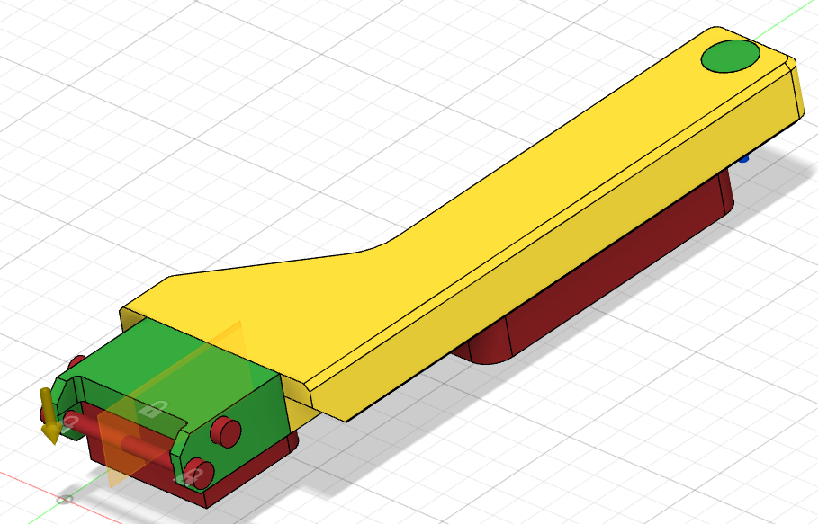
Figure 13 (Rowland-Jones, 2023)

The green areas in Figure 13 represent the preserved geometries, these are the parts of the model that will not be a part of the simulation and will remain the same. As mentioned, the red areas are the obstacle geometries, and the yellow areas are the areas where the simulation will take place. The same amount of force, 98.1N, was applied in the same direction as the FEA and topology study.
The material chosen for this generative design simulation was Ti-6Al-4V titanium alloy. This material was chosen as it is lightweight, has excellent mechanical properties which can be manipulated depending on the post-processing of the part, and can be anodised to give an anti-corrosive property and the black coloured finish required of the handle. Liu (2019) confirms these material properties and adds that this specific alloy represents almost half the total market share of titanium products used in the world today. Titanium is one of the more expensive powder types, with a cost of £64 per kg, but as this is an in-house Renishaw build with a low volume demand, the material properties outweigh the cost. Generative design took a lot of processing power and took considerably longer to simulate compared to FEA and topology optimisation. The finished simulation can be seen in Figure 14:

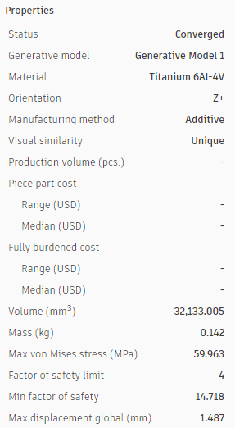
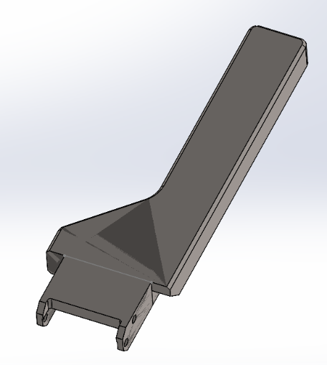
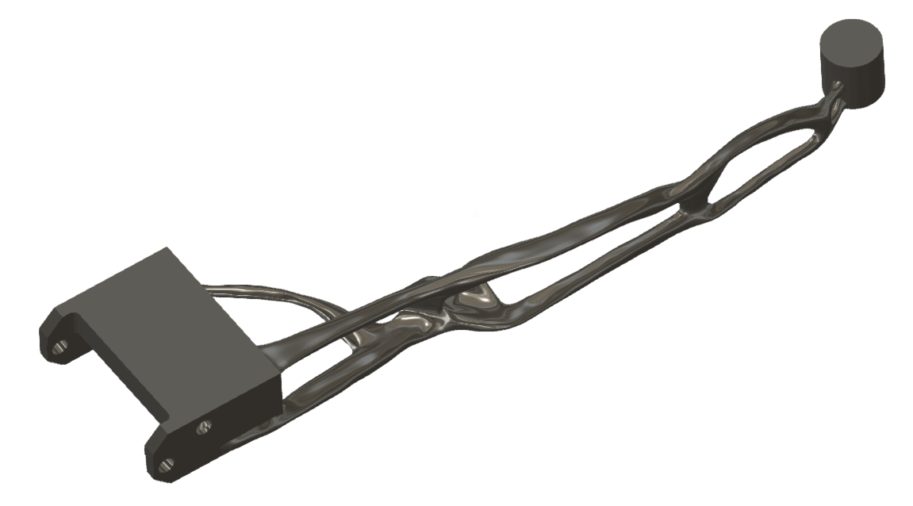

Figure 14 (Rowland-Jones, 2023)

As seen on the left in Figure 14, the generative design simulation is very different to the original model on the right. The first point to note is the mass, 0.142kg, which is a 35.2% mass reduction from the original model. The maximum von Mises stress in the generative design model is 59.963x10^6 N/m^2 or 59.963 MPa compared to the 27.5x10^6 N/m^2 or 27.5 MPa. This is a relative increase as the ultimate tensile strength of Ti-6Al-4V titanium alloy is 936x10^6 N/m^2 or 936 MPa (Baufeld, 2009) which is almost double the ultimate tensile strength of 7075 aluminium.
The generative design model has a factor of safety of 14 which is still very high, but due to the low force being applied to the handle and the material properties of titanium, it would be very difficult to bring that number down. Interestingly, a side-by-side view of the generative design and the topology optimisation study shows certain similarities between them, as shown in Figure 15:

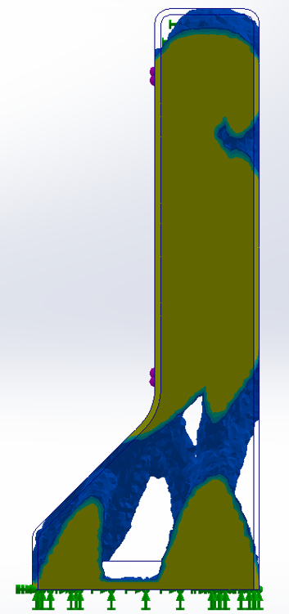
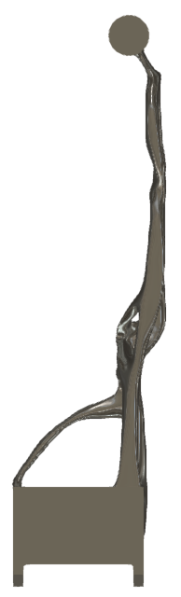

Figure 15 (Rowland-Jones, 2023)

As shown in red, the bottom part of the model has material removed at a large scale, suggesting that this area has a large amount of waste material. Conversely as shown in blue, the upper part of the handle has a large amount of material removed in the generative design but has largely stayed the same in the topology study.

1.5 Constraints
As with any type of manufacturing, there are several disadvantages to additive manufacturing and specifically powder bed fusion, some points being:
- Hazardous materials
- The need of support structures
- Long build times
- Porosity
- Structural weakness due to layer build
(Engineering Product Design, 2023)

Most metal powders are hazardous to health and to the environment and must be used with caution and disposed of in the correct way. Hall (2023) states that through multiple manufacturing sources, it is concluded that AM metal powders can cause skin and lung diseases. Hall also stated how important engineering controls are when it comes to handling these powders. Arrizubieta (2020) also states that metal powders are dangerous and affirms that the disposal of these powders must be done in the correct way to minimise the environmental impact.
Support structures are very important in powder bed fusion as it allows the user to build complex geometries with overhanging structures. The supports act as a brace between the part being built and the substrate plate it’s being built onto (Bobbio, 2017). They also allow the user to print at more extreme angles, allowing more space to build multiple parts at one time, thus increasing efficiency and output. The disadvantage of needed support structures is that it uses more material per build and must be manually removed during post-processing.
Depending on the complexity of the part, powder fusion bed 3D printing can be a very slow process, even with Renishaw’s multi-laser rapid prototyping AM machine, large and complex builds take up to 48 hours to print. These current limitations of AM results in the process not being a feasible option for a mass-produced part.
Porosity occurs in parts of the build that are subjected to a lack-of-fusion characteristic, where the powder does not fully fuse and leaves pores in the material (Promoppatum, 2022). It also leads to weaknesses in the printed part and may affect the overall function of the build. Porosity could occur during a build if the powder layer is too thick for the laser to fuse. Powder bed fusion also introduces structural weaknesses due to the nature of layer-based manufacturing (Engineering Product Design, 2023). To try and reduce the structural weakness, the RenAM500 machine prints each layer at a 120⁰ offset from the previous layer.

1.6 Conclusion
When appropriate design for additive manufacturing principles were applied to the top door handle, it yielded good results in terms of mass reduction and material properties. The finite element analysis shows that the handle uses too much material and could be designed to be leaner. This was further proven by the topology study and the generative design simulation.
Using a titanium alloy, the material properties of the handle design were improved and allowed for material to be removed from the design without compromising the strength and factor of safety of the part.

2. High Volume Production – Portable Wind Turbine Redesign

2.1 Background Information
A portable wind turbine that currently has parts that are 3D printed is due to be mass produced, with initial estimates suggesting that between 1000 and 2000 turbines will need to be manufactured per week to equal the demand.
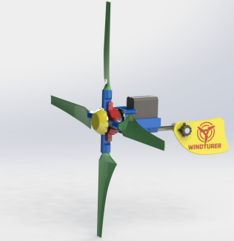
In order for the turbine to be mass produced, it is pertinent that the company moves away from additive manufacturing and looks towards other ways of manufacturing, such as injection moulding. Further work is also required to optimise the manufacturability of the turbine. This will allow for faster and more efficient assembly processes and to be able to hit the new targets. Figure 16 shows the original design of the wind turbine:

Figure 16 (UWTSD, 2023)

2.2 Concept Design
One of the first items to consider when designing a product is what the end user or stakeholder’s requirements are. If a designer does not have a clear goal or a list of requirements to work towards, they could easily design and build a product that is not fit for purpose, leading to a loss of time and money. It is also important to consistently have the correct information from the stakeholders so as to always be up to date with what the stakeholders require, as highlighted in a case study by Bailetti (1995).

With this in mind, a quality function deployment (QFD) was written to ascertain the functional requirements of the turbine were. The purpose of a QFD is to translate the customer requirements into technical, functional requirements for the designer to work to. QFDs are split into two matrixes, one detailing the customer requirements with an importance weighting next to it, and the other matrix describes the technical requirements necessary to achieve the customer needs. Figure 17 shows part of the QFD written for the portable wind turbine:
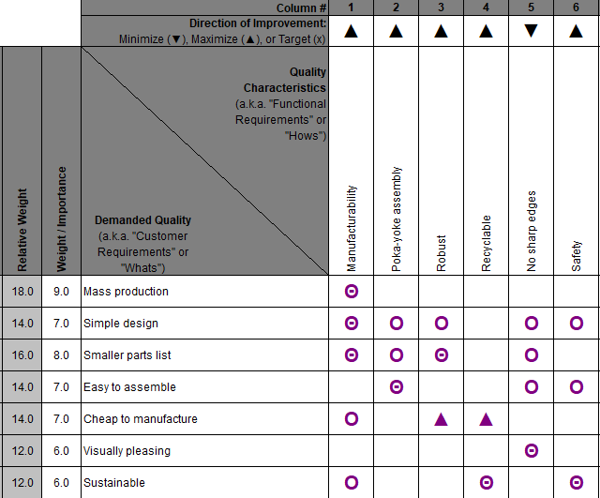
Figure 17 (Rowland-Jones, 2023)

As shown, the horizontal requirements come from what the customer needs from the new design and the vertical requirements are the technical requirements needed to fulfil the customer needs. The icons in between the two matrixes show whether the customer requirements and functional requirements have any sort of relationship (Johnson, 2003).

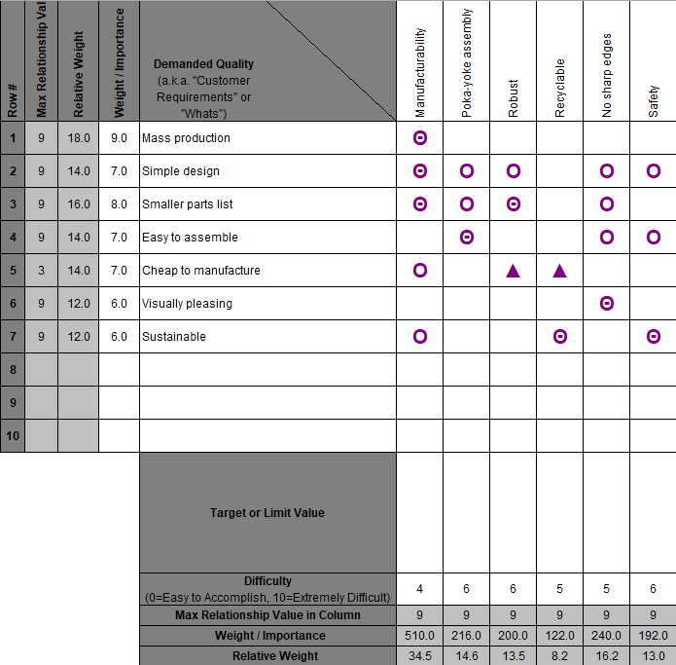
For example, the customer requirement ‘Mass production’ has a strong relationship with the functional requirement ‘Manufacturability’ and is shown by the Θ symbol. The other two symbols are Ο and ▲ which mean a moderate relationship and a weak relationship respectively, furthermore no symbol means no relationship. After each of the different relationships are determined, each requirement is given an importance rating based on the weighting given by the customer and the relationship between the two sets of requirements. The importance rating from the turbine QFD can be seen in Figure 18:

Figure 18 (Rowland-Jones, 2023)

As shown, the manufacturability requirement is the most important specification to be worked on in the new design, with the weighting of 510, over double that of the next highest. The other variable that is captured during a QFD is how each functional requirement correlate with each other. This is visualised in Figure 19:

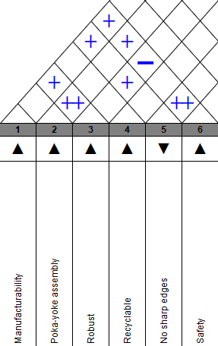

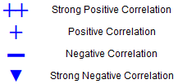

Figure 19 (Rowland-Jones, 2023)

As shown, each requirement was compared with the others to determine whether they have a positive or negative correlation with each other. For example, the ‘no sharp edges’ requirement has a strong positive relationship with ‘safety’ as the more sharp edges you remove, the safer the product.
The information from the QFD will give a more accurate portrayal of the requirements when writing a design specification at the early stages of a design project. There are typically four sections in a design specification:
- Market requirements
- Life in service requirements
- Production requirements
- Conformance requirements
(Morgan, 2023)

The information from the QFD can be applied to each of the four areas stated above, using ‘visually pleasing’ from the horizontal matrix in the QFD in Figure 18. This requirement fits into the market section of a design specification as the appearance of the product is one of the main marketing strategies. ‘Mass production’ and ‘smaller parts list’ would feature in the production requirements section, as they directly affect the manufacturing and assembly of the turbine.
The life in service section of the design specification would include the ‘robust’ and ‘recyclable’ requirements as the more robust the product is, the less service maintenance is required. It is also important to consider using materials that can easily be recycled, Lamberti (2020) adds that an accumulation of microplastics is already evident in marine ecosystems which can cause irreparable damage, so designing with end-of-life recycling in mind is crucial.
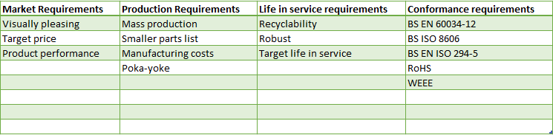
Requirements covered in the conformance section of the design specification include BS EN 60034-12 rotating electrical machines, BS ISO 8606 plastics and BS EN ISO 294-5 plastics – injection moulding (bsi, 2023). The turbine will also have to be compliant to the Restriction of Hazardous Substances (RoHS) and Waste Electrical and Electronic Equipment (WEEE) legislations which state that no hazardous substances can be used in the manufacturing process and that the product is disposed of and recycled in the correct way (gov.uk, 2023). A full list of the design specifications can be found in Figure 20:

Figure 20 (Rowland-Jones, 2023)

2.3 Manufacturing Process
The company that currently produces the portable wind turbine has requested that their current manufacturing process of 3D printing parts and assembling them is changed, opting for a more efficient process capable of mass producing the turbine so that 1000 to 2000 units are made each week. The company also wants the turbine to be optimised so that it takes less parts to assemble it and that it is modified to improve the aesthetics.

The main body of the turbine, along with the fins and centre piece will be injection moulded using a polypropylene (PP) thermoplastic. This manufacturing method was chosen as it is an industry standard process of mass-producing plastic parts, Chen (1999) adds that the main benefits of injection moulding are high production rates, excellent quality parts and a very long mould life.
The cost of the tooling required for injection moulding the turbine is £11,232 (Ferreira, 2023), the turbine will need three moulds to produce the body, the fins, and the centre piece. This brings the total tooling cost to £33,696. Therefore, if 1000 units were produced a week and they sold for £5 each, it would take under seven weeks to recoup the cost and start making a profit. One could argue that the retail price of this product will be more than £5, so it will take even less time to recoup the cost of tooling.
This manufacturing method also allows the process to be more flexible when it comes to the aesthetics and ergonomics or the turbine. Different coloured thermoplastics can be used easily to make the product in most colours to improve customisability. The use of thermoplastics in this application would yield a smoother finish and would get rid of any risk of cutting assembly staff, making this process meet the safety requirements listed in the QFD and the design specification. With this added safety benefit, the tooling cost recoup time and the fact that is a steady and proven manufacturing method, injection moulding is a viable and preferable method of manufacturing.

2.4 Design and Development Work

2.4.1 DFMEA
To try and limit the amount of failure modes from the use of the portable wind turbines, a design failure modes and effects analysis (DFMEA) was written. Bongiorno (2001) adds that an FMEA is a risk identification and mitigation strategy in the early stages of product development. In the DFMEA, each function of the turbine was noted, along with any potential failure modes and the effects of the failure modes. These failure effects were individually scored with a severity rating from 0-10 with 10 being the most severe, with the potential causes of the failures next to that. The causes are all given an occurrence rating from 0-10, with 10 being most likely to occur. There is also a column for current controls with a detection rating next to that, ranging from 0-10 with 10 being least likely to detect the failure. The severity, occurrence and detection ratings are then multiplied together to give a risk priority number (RPN). The RPNs from each function of the turbine offer a priority list to work towards for the designer. Figure 21 shows the DFMEA written for the portable wind turbine:

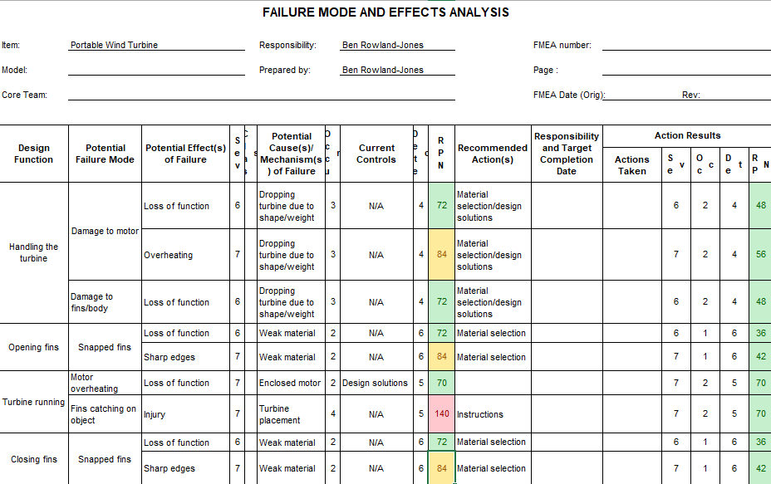
Figure 21 (Rowland-Jones, 2023)
As shown, the highest RPN was 140 for the placement of the turbine and its ability to injure the user when in operation. This number is reduced with the addition of instructions to the user explaining how to properly place the turbine and how to use it safely. After this action, the occurrence rating and therefore the RPN was reduced to 70.
Another large RPN was the sharp edges that can be caused by breaking the fins when opening/closing them, with a figure of 84. This number is reduced by the material selection, which will ensure that the material will be more robust and will therefore bring the occurrence and RPN of that function down to 42.

2.4.2 Design Changes
The redesigning of the portable wind turbine was done computationally on the 3D CAD software, SolidWorks. Various tools were used in the software such as the sketch function, extrude, extrude cut and combine. Two parts of the wind turbine have been redesigned to further meet the design specification, with one part being redesigned to use less parts during manufacturing and one part being redesigned to poka-yoke the assembly process.
Consolidating parts is a key concept when trying to streamline a manufacturing process and reducing product cost, Yang (2017) adds that part consolidation minimises assembly operations and prolongs the service life. For these reasons, consolidating parts in the wind turbine is essential when moving towards mass production as the time and money it takes to produce a single unit is decreased due to the fact that it will take less tooling to injection mould the body and less time to assemble the turbine. Figure 22 shows an exploded view of the main body parts that have been consolidated, and where they are in the overall assembly:

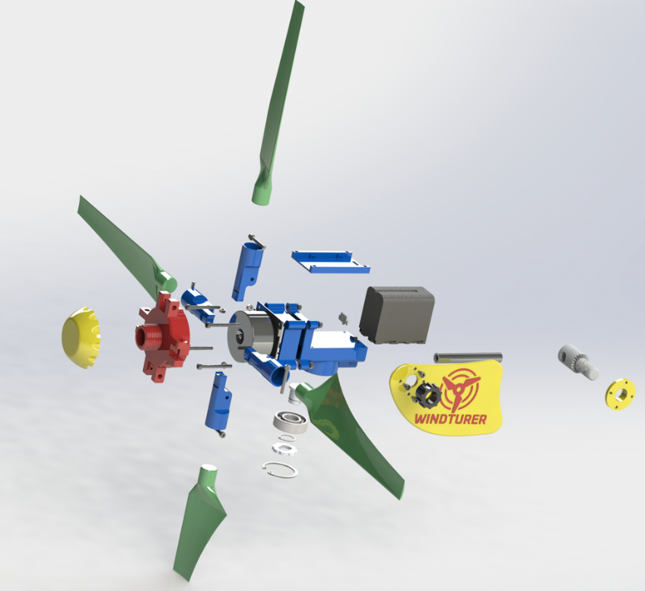
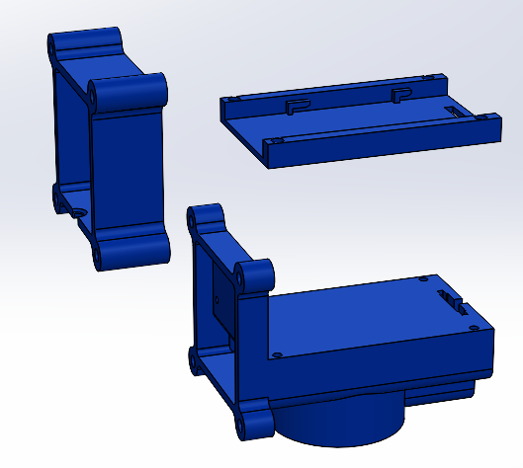

Figure 22 (Rowland-Jones, 2023)

As shown, these three parts can be consolidated into one part which will ensure that production costs will be reduced, and the turbine will be more robust due to having less parts to potentially come loose or break down. This will also mean that more individual parts will be able to fit into one injection mould die, thus potentially saving money on tooling expenses. The combine tool was used in SolidWorks to achieve the consolidation of parts and the body is shown in Figure 23:

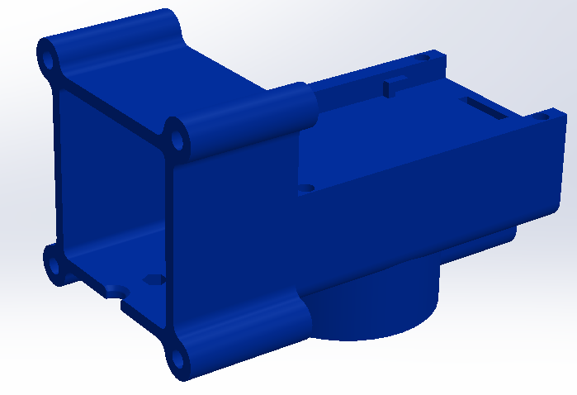
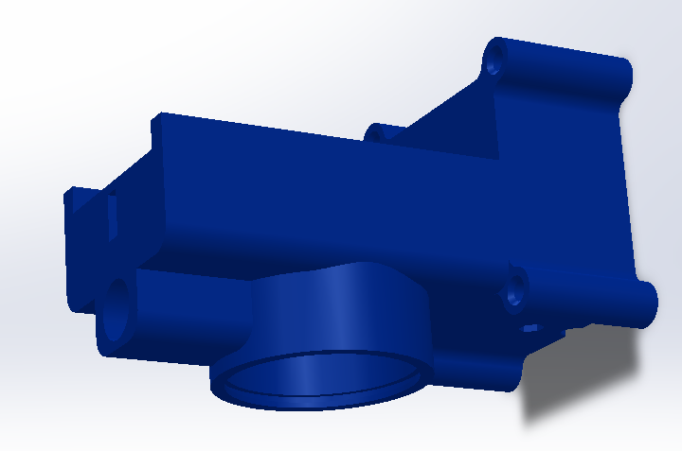

Figure 23 (Rowland-Jones, 2023)

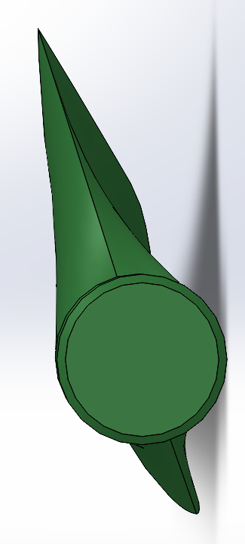
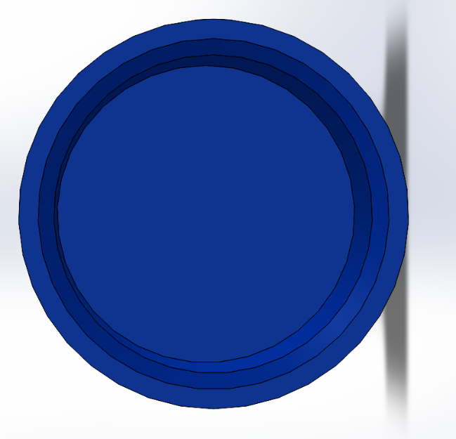
The second redesigned part is on the fan fins and fin housings, with a small tab added to the fin housing and a recess added to the fan fin in order to poka-yoke the assembly of the fan. This is important as if the fins are connected the wrong way around, it will have an affect on how much power is generated by the wind turbine. Figure 24 shows the fin housing and the fin respectively before the alterations were made:

Figure 24 (Rowland-Jones, 2023)

As shown, the fin can be installed into the housing in any orientation around the 360⁰, which can lead to a loss of function and customer dissatisfaction. To add the recess to the fin, a sketch was drawn on the bottom part of the fin and was then cut extruded into the body. Figure 25 shows the sketch that was cut extruded and the final design of the fin:
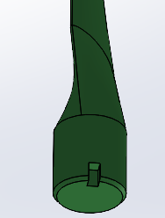
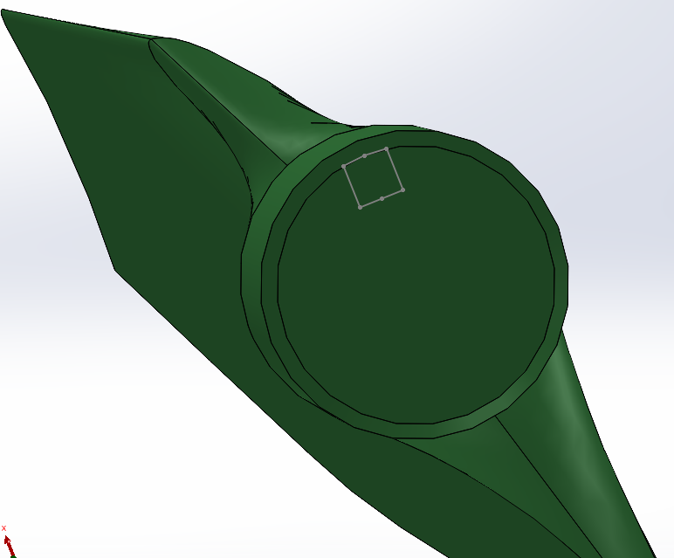

Figure 25 (Rowland-Jones, 2023)

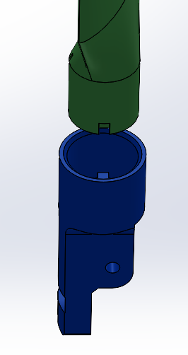
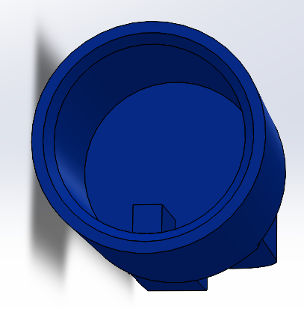
The tab that was added to the housing also started off with a sketch on the bottom of the part, which was then extruded down the inside of the housing body. This tab was on the corresponding side as the recess that was added to the fin, which meant that the only time that the fin could be installed into the housing was when it was in the correct orientation. This removed the risk of accidently fitting the fins in the wrong orientation and makes the assembly process more robust. Figure 26 shows the tab added to the housing in the left image, whilst on the right it shows the fin and housing lining up correctly:

Figure 26 (Rowland-Jones, 2023)

2.4.3 Environmental Considerations
Designing with environmental considerations in mind is crucial to sustainability and to the protection of the planets eco-systems. Santos-Reyes (2001) states that consumer concerns about environmental impact have called for a more stringent regulation of product end-of-life considerations.
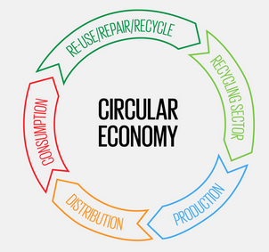
With this in mind, the method of Design for Circularity (DfC) was used when redesigning the portable wind turbine. DfC is a method of designing with the product end-of-life and recyclability in mind, as shown in Figure 27:

Figure 27 (World Design Organisation, 2020)

Polypropylene (PP) is a recyclable plastic that Meran (2008) states contributes to 45% of the world’s plastic production in his journal article about recycling plastics. The fact that it is a recyclable plastic works into the DfC method and will ensure that the impact that producing the wind turbines has on the environment is minimised due to the recyclability of the materials used.

2.5 Conclusion
By applying standard design tools such as DFMEA, QFD and a design specification, the portable wind turbine was redesigned for mass production. The QFD and design specification gave the designer requirements to work towards to ensure that the turbine conformed to the customer needs.
The main body parts were consolidated in to one body to save on tooling costs and to make the assembly process easier and more efficient. The fins and fin housings were poka-yoked to ensure that they were not assembled in the incorrect orientation which would have an affect on the function of the product.
The manufacturing process was to be done via injection moulding, which is an efficient way of mass-producing plastic parts accurately. Polypropylene was the chosen material for production because of its recyclability properties.

Bibliography
Arrizubieta, J. I., 2020. Study of the Environmental Implications of Using Metal Powder in Additive Manufacturing and Its Handling. Metals.
Autodesk, 2023. Obstacle Geometry. [Online] Date Accessed: 29/05/2023
Available at: https://help.autodesk.com/view/fusion360/ENU/?guid=GD-OBSTACLE-GEOM
Bailetti, A. J., 1995. Integrating customer requirements into product designs. Journal of Product Innovation Management.
Baufeld, B., 2009. Mechanical properties of Ti-6Al-4V specimens produced by shaped metal deposition. Sci Technol Adv Mater .
Bobbio, L. D., 2017. Characterization of the strength of support structures used in powder bed fusion additive manufacturing of Ti-6Al-4V. Additive Manufacturing.
Bongiorno, J., 2001. Use FMEAs to improve your product development process. PM Network.
bsi, 2023. Standards Development. [Online] Date Accessed: 12/06/2023
Available at: https://standardsdevelopment.bsigroup.com/search?Term=8606
Butcher, D., 2019. Validated Computational Modelling Techniques for Simulating Melt Pool Ejecta In Laser Powder Bed Fusion Processing. Texas ScholarWorks: University of Texas Libraries.
Chen, Y.-M., 1999. Cost-effective design for injection molding. Robotics and Computer-Integrated Manufacturing.
Dilberoglu, U. M., 2017. The Role of Additive Manufacturing in the Era of Industry 4.0. Procedia Manufacturing.
Engineering Product Design, 2023. Powder Bed Fusion. [Online] Date Accessed: 06/06/2023
Available at: https://engineeringproductdesign.com/knowledge-base/powder-bed-fusion/
EOS, 2023. EOS Titanium Ti64 Grade 5 Material Data Sheet. [Online] Date Accessed: 14/05/2023
Available at: https://www.eos.info/03_system-related-assets/material-related-contents/metal-materials-and-examples/metal-material-datasheet/titan/ti64/material_datasheet_eos_titanium_ti64_grade5_en_web.pdf
Ferreira, W., 2023. How much does Injection Moulding cost?. [Online] Date Accessed: 29/06/2023
Available at: https://get-it-made.co.uk/resources/how-much-injection-moulding-costs
gov.uk, 2023. Regulations: restriction of hazardous substances (RoHS). [Online] Date Accessed: 03/06/2023
Available at: https://www.gov.uk/guidance/rohs-compliance-and-guidance
Hall, S., 2023. RR1195: Exposure to Metal Powders in Additive Manufacturing, Buxton: Health & Safety Executive.
Johnson, C. N., 2003. QFD Explained. Back To Basics.
Jung, S., 2023. Is Additive Manufacturing an Environmentally and Economically Preferred Alternative for Mass Production?. Environmental Science & Technology.
Lamberti, F. M., 2022. Recycling of Bioplastics: Routes and Benefits. Journal of Polymers and the Environment .
Liu, S., 2019. Additive manufacturing of Ti6Al4V alloy: A review. Materials & Design.
Meran, C., 2008. Examination of the possibility of recycling and utilizing recycled polyethylene and polypropylene. Materials & Design.
Metal AM, 2022. GKN Aerospace adds Renishaw RenAM 500Q Flex at its Global Technology Centre. [Online] Date Accessed: 03/06/2023
Available at: https://www.metal-am.com/gkn-aerospace-adds-renishaw-renam-500q-flex-at-its-global-technology-centre/
Morgan, R., 2023. Design Specification and the Kano Model of Quality, Swansea: s.n.
Promoppatum, P., 2022. Quantification and prediction of lack-of-fusion porosity in the high porosity regime during laser powder bed fusion of Ti-6Al-4V. Journal of Materials Processing Technology.
Renishaw, 2023. What is metal additive manufacturing?. [Online] Date Accessed: 02/05/2023
Available at: https://www.renishaw.com/en/what-is-metal-additive-manufacturing--15240
Ribeiro, T. P., 2021. Topology Optimisation in Structural Steel Design for Additive Manufacturing. Applied Sciences.
Rowland-Jones, B., 2023. Door Handle Generative Design, Pontyclun: s.n.
Rowland-Jones, B., 2023. Door Handle Topology, Pontyclun: s.n.
Rowland-Jones, B., 2023. Top Door Handle, Pontyclun: s.n.
Rowland-Jones, B., 2023. Top Door Handle FEA, Pontyclun: s.n.
Rowland-Jones, B., 2023. Turbine Body Exploded View, Pontyclun: s.n.
Rowland-Jones, B., 2023. Turbine Design Specification, Pontyclun: s.n.
Rowland-Jones, B., 2023. Wind Turbine DFMEA, Pontyclun: s.n.
Rowland-Jones, B., 2023. Wind Turbine QFD, Pontyclun: s.n.
Rowland-Jones, B., 2023. Wind Turbine Redesign, Pontyclun: s.n.
Roylance, D., 2001. Finite Element Analysis. Saylor.
Santos-Reyes, D., 2001. A design for the environment methodology to support an environmental management system. Integrated Manufacturing Systems.
SolidWorks, 2021. Meshing. [Online] Date Accessed: 18/05/2023
Available at: https://help.solidworks.com/2021/english/SolidWorks/cworks/c_meshing.htm
SolidWorks, 2023. 7075 Aluminium Material Properties, s.l.: s.n.
Sustainability Guide, 2023. Materials & Parts. [Online] Date Accessed: 18/05/2023
Available at: https://sustainabilityguide.eu/ecodesign/materials-parts/
UWTSD, 2023. Portable Wind Turbine, Swansea: s.n.
UWTSD, 2023. Portable Wind Turbine, Swansea: s.n.
World Design Organisation, 2020. Designing Towards Circular Economy. [Online] Date Accessed: 22/05/2023
Available at: https://wdo.org/designing-towards-circular-economy/
Yang, S., 2017. A Generic Sustainability Assessment Model towards Consolidated Parts Fabricated by Additive Manufacturing Process. Procedia Manufacturing.

