
Student Name: Bianca Vili
Student ID: 2210551
Module: Community Care and Management of Longer-term Conditions
Module Code : LCHS 7003
Lecturer : Dr Aishat Bakre
(Arora, 2021)

Living Well with Cardiovascular Disease
Information Booklet

Contents
1. What is cardiovascular disease (CVD) 3
Prevalence: 3
Definition 3
2. Risk Factors 4
Wider Factors: 4
Modifiable and non-modifiable Factors 5
Physical, Psychological and Social Implications of CVD 6
Physical Impact: 6
Psychological Impact: 6
Social Impact 7
Broader Implications: 8
Treatment and Support 8
Finding Risk Early 8
Lifestyle Support 9
Pharmacological Treatment 9
Cardiac Rehabilitation 9
Procedures and Devices 9
Transition between Services 9
Theoretical Perspective for Improved Outcome of CVD management 11
UK Model: Person-centred care and The House of Care 11
What is House of Care: 11
House of Care Model for CVD Management 12
Strengths of HoC model in CVD management: 12
Limitations: 13
The Chronic Care Model (CCM) 15
Political Health and Social Care Agendas 16
NHS 10-year Plan 16
NHS Health Checks 17
Elective Care Reform 2025 17
The Modern Service Framework 17
Local Agendas: Integrated Care Systems (ICSs) 19
How ICS Prevent and Manage CVD 19
Recommendations 21
Final Word: 22
Reference list 24

What is cardiovascular disease (CVD)
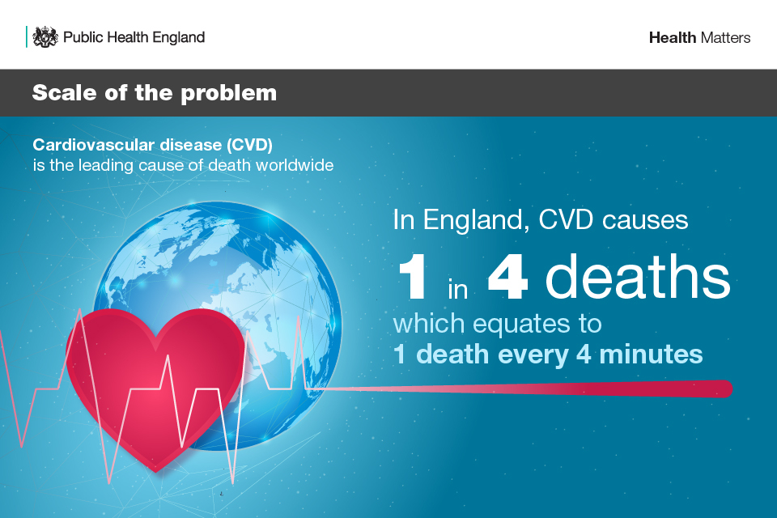
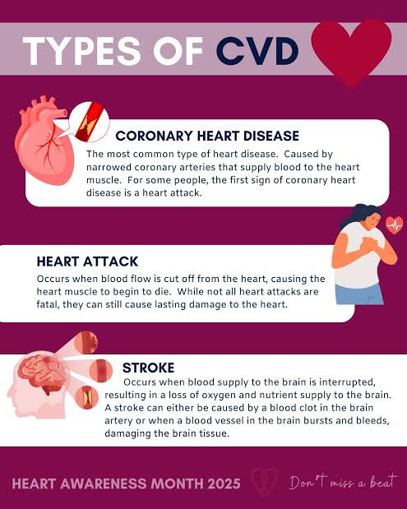
(Public Health England, 2019).

Prevalence:
An estimated 19.8 million people died in 2022 from CVD worldwide. This figure represents 32% of global deaths. Out of these 85% deaths are due to heart attack and stroke (World Health Organization, 2025). In the UK 25% of deaths are caused by CVD (British heart foundation, 2024). Approximately 7.6 million people live with CVD in UK. NHS has invested heavily in managing and treating CVD. In 2019/20 the hospital admissions due to CVD in England are over 500,000 (Ayre, 2024).

Definition
Cardiovascular Disease (CVD), a group of conditions that has harmful impact on heart and blood vessels (NHS, 2022). It is a long-term chronic condition as it affects for long duration and has slow progression. The World Health Organization (WHO), lists CVD as the leading cause of death globally. CVDs can be prevented by addressing behavioural and environmental factors such as tobacco use, obesity, physical inactivity, unhealthy diet and harmful use of alcohol. The most crucial aspect is to detect the cardiovascular disease as early as possible to maintain appropriate management with medicine and life style modification (World Health Organization, 2025).
(World Health Organization, 2023)
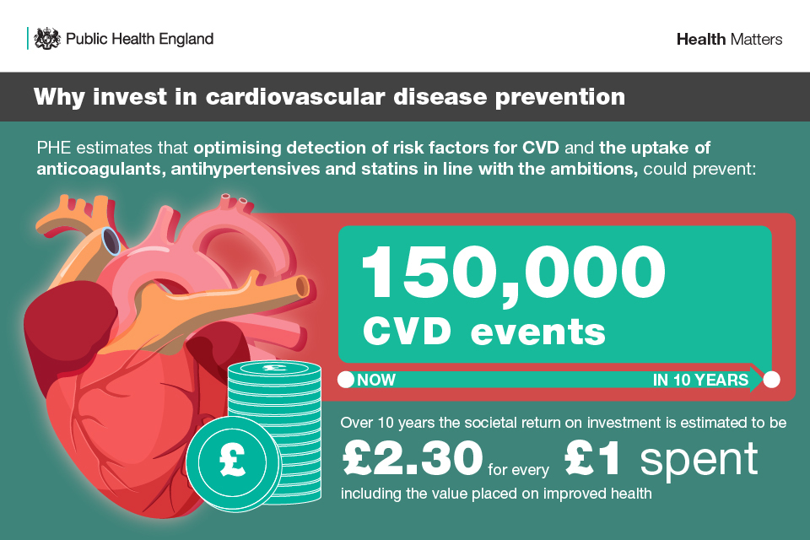
(Public Health England, 2019).

Risk Factors
Risks raise a person’s chance of developing a disease. Much of these factors are preventable. Nearly every adult at least has one risk factor and it is associated with age. As a person age risk goes up. As CVD is most common after the age of 50. Men have slightly higher risk but in women CVD is the leading cause of death and disability. In UK, Black African, African Caribbean and South Asian people are more likely than White Europeans to develop high- blood pressure and Type 2 Diabetes the major contributing factor of CVD (The Heart Research Institute, 2023).

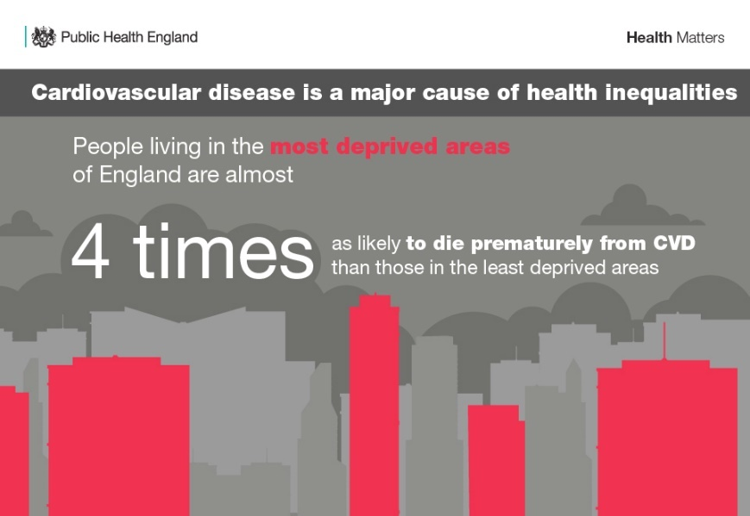
Wider Factors:
Poverty and working conditions also impact risk factors. NHS aims to target health inequalities to reduce the impact and burden of long-term conditions. The WHO model of chronic care for chronic conditions also stresses aligning policies across sectors such as education. work and agriculture to improve health (Grover and Joshi, 2014).
(Public Health England, 2019).

Modifiable and non-modifiable Factors
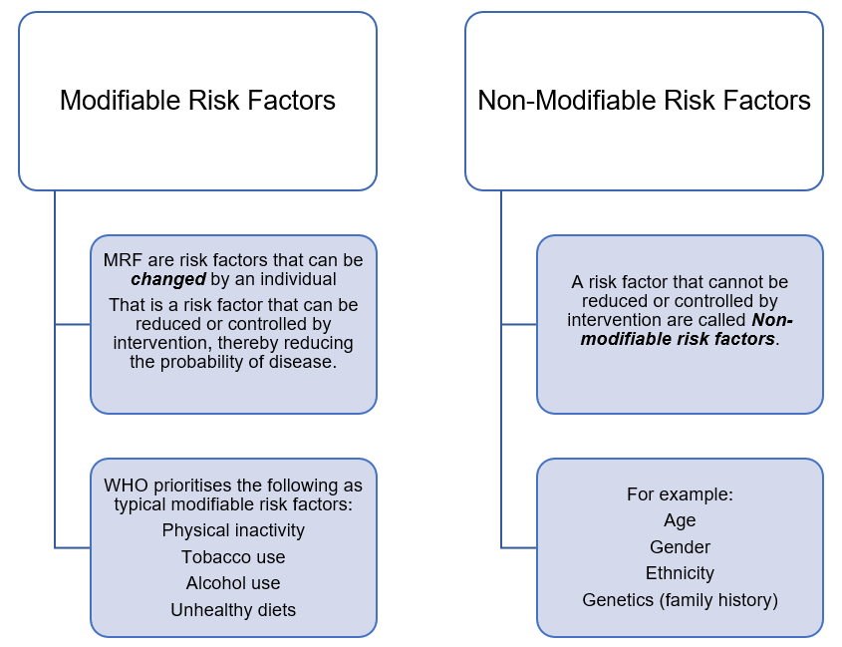

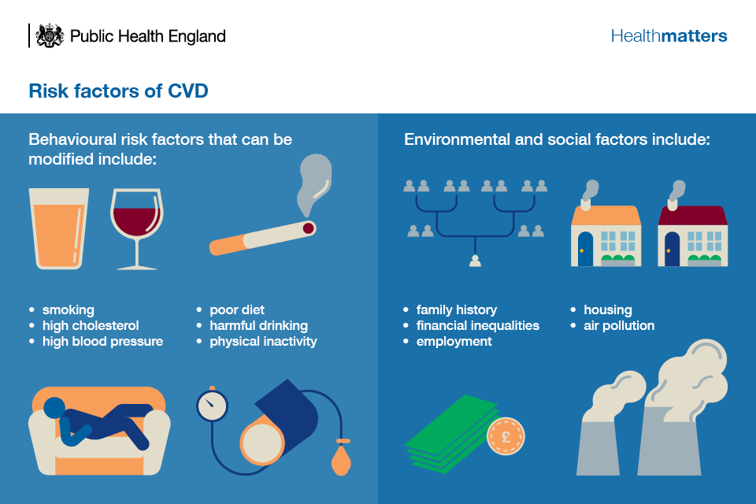
(Public Health England, 2019).

Physical, Psychological and Social Implications of CVD
Living with a long-term condition not only impact the body. Its mental and social impact and broader impact on families is far more critical. Long term conditions put a huge pressure on the health and care system of any country. In Uk the ageing population, rising demand for healthcare due to comorbidities and life expectancy among population are major contributor of this pressure (Goodwin et al., 2010)

Physical Impact:
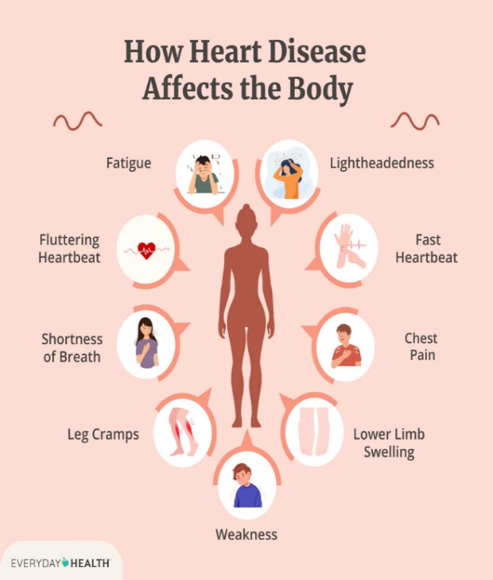
Symptoms like chest pain, breathlessness, fatigue, dizziness and swelling drastically impact the quality of life of an individual. These factors limit the activities, mobility and productivity of an individual. CVD is the biggest cause of hospitalisation and mortality rate. In case of stroke, it is also the major cause of disease related disabilities (Lui et al., 2023). CVD is largely associated with polypharmacy, comorbidity and change in renal and lever function of an individual. This leads to higher visits to primary healthcare (Noemí Villén et al., 2022).
(Everyday Health, 2025)

Psychological Impact:
There is a profound link between CVD and mental wellbeing. Research has shown that heart and mental health are not separate domains but deeply interconnected. CVDs can cause mental health issues like anxiety, stress and depression. Care and management of CVD require a holistic approach that will address physical and mental health issues at the same time as poor mental health can make CVDs drastically worse (Borkowski and Borkowska, 2024). People with long-term conditions are two or three times more likely to have mental health problems than the general population (Centers for Disease Control and Prevention, 2024).
- Evidence has proven that mental disorders like depression, anxiety and PTSD can develop after stroke or heart attack (Abed, Kloub and Moser, 2014).
- Depression is two to three times more common in CVD.
- In UK 7.4 million people living with CVD and around four million of them experience mental health issues (Kettle, 2019).
- Rates are higher in hospitalised patients. Between 35% to 70% of people in hospital with chronic heart failure have depressive disorders.
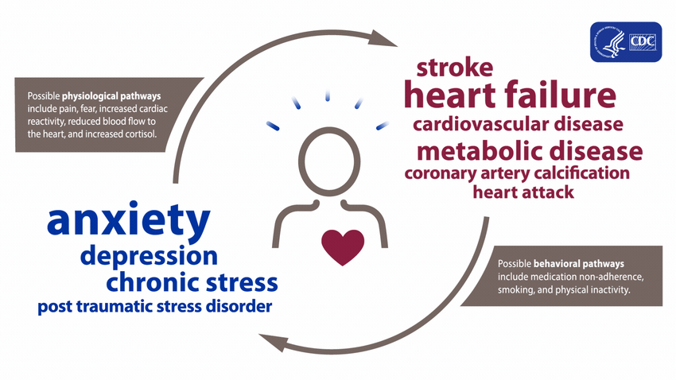
- Low mood also has a huge impact on disease management. It is linked to inactivity, quitting tobacco and diet changes during rehabilitation phase (Naylor et al., 2012).

(Centers for Disease Control and Prevention, 2024)

Social Impact
The burden of disease has a deep social impact. CVD related morbidity and mortality have huge effect not only on healthcare systems but on the quality-of-life QoL of the patient. The loss of productivity and indirect cost has a major negative impact on the patient and the society as a whole (Pereira and Pereira, 2020). Despite substantial advancement in medicine CVD remains a major social and economic challenge. With an ageing population CVD is expected to increase, posing further challenge for patient management (ESC, 2026).
Another important aspect of CVD management and social and environmental factors is the social determinants of health. Social Determinants of health do not act alone, they interact across areas of life and their impact build up over time. Reducing inequalities means tackling structural, institutional and environmental barriers to heart health. Greater social disadvantage such as poverty, low education and poor housing is linked to more CVD risk factors and worse outcomes (Jilani et al., 2021).

Broader Implications:
Cardiac conditions are long-term, progressive and often unpredictable, so many people need ongoing care, mostly from family members. Carer’s role matters for patient outcome in medicine management; symptoms check and emotional support. Family also coordinates with healthcare professionals (Kitko et al., 2020). Care giving burden has several parts: psychological, social physical and financial strain. Time is also an important component of giving care to a chronic heart patient’s care. Repeated hospital stays and uncertainty about future can cause burnout, anxiety, isolation and financial stress (Gheiasi, Rouhbakhsh and Siahkali, 2026). Nearly 3 million people in UK are balancing unpaid care with paid jobs. In 2026, 1.1 million people have left work to care roles and 1.2 million unpaid carers live in poverty (Carers UK, 2023). It also impacts the quality of care the carer is providing to the patient. The government Action Plan commits to better recognition and support for unpaid carers. This plan will improve recognition, referring to services and access to health services, employment and education support (Department of Health and Social Care, 2026).

Treatment and Support

Finding Risk Early
- NHS health Check for adults in England aged 40-70
- Risk Tools such as QRISK that will help in estimating the chance for heart attack or stroke
- NHS Long Term Plan to target early prevention (NHS, 2023).
- NICE guidelines on preventing cardiovascular disease have updated their recommendations for managing cholesterol. Many people now qualify for the cholesterol lowering treatment. The focus has shifted towards assessing lifetime CVD risk, starting treatment early and lowering cholesterol to specific target levels rather than simply starting treatment without regular adjustments. This change has important implications for primary care. The Flow chart highlights the pathway of prevention and treatment in primary care (Williams, Round and Jones, 2024).

Lifestyle Support
- NHS stop smoking services, a balanced diet and regular physical activity, reduced alcohol and weight management.
- Supports self-management, education and programmes on health coaching (NHS, 2020).

Pharmacological Treatment
- Statins to lower cholesterol
- Blood pressure medicines (ACE inhibitors, calcium channel blockers)
- Antiplatelets (Aspirin and anticoagulant to reduce clotting)
- Heart failure medicines to reduce stress on heart (NHS, 2022).

Cardiac Rehabilitation
Supervised exercise, education and emotional support after heart attack, surgery or diagnosis. NHS Long-Term Plan 2019 offers programmes for patients with heart problems. NHS aims to prevent up to 150, 000 heart attacks, stroke and dementia cases by 2029 (Balogun, 2026).

Procedures and Devices
- Angioplasty and stent top open blocked arteries
- Coronary Artery Bypass graft surgery
- Pacemakers and implantable defibrillators (British Heart Foundation, 2019).

Transition between Services
A nurse-led transitional care package for helping patients to prepare for discharge and self-management (NICE, 2018).
The Government is developing a new Cardiovascular Disease Modern Service Framework and planned to publish it in 2027. The framework will target evidence led and clinically informed approaches to prevention, treatment and care (Balogun, 2026).
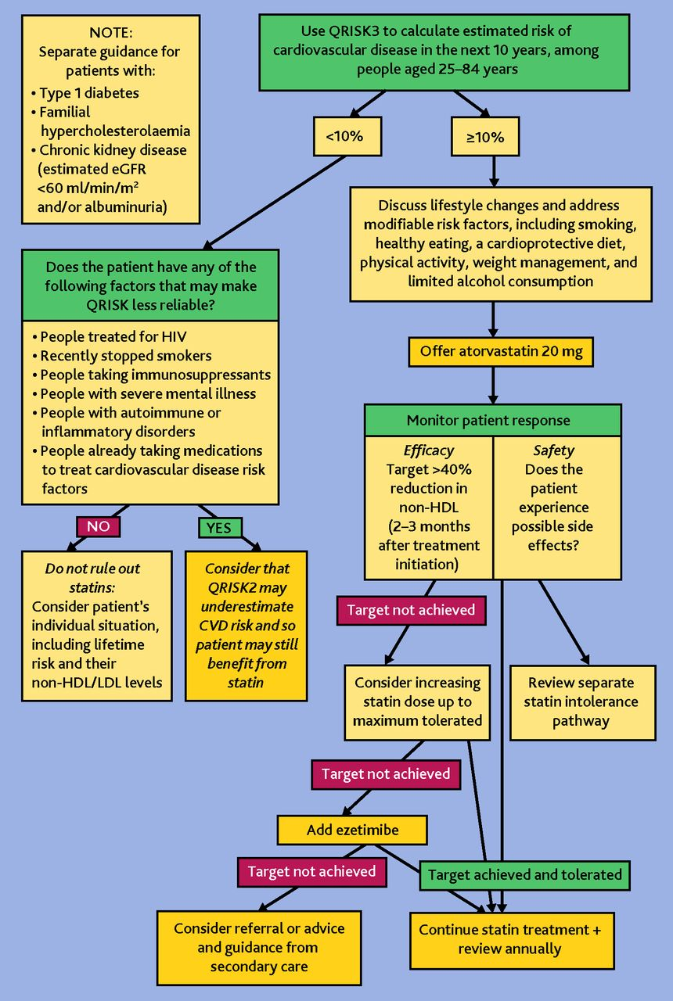

Flowchart to show NICE recommended approach to primary prevention and treatment of CVD (Williams, Round and Jones, 2024).

Theoretical Perspective for Improved Outcome of CVD management
Models of care are the plans for how services should be organised around people with long-term conditions. This section will look at one UK model and one international model to evaluate care and management of CVD patients. Long-Term CVD management is a continuous person-centred approach that aims to control symptoms and risk factors, prevent complications. Improve quality of life and reduce premature mortality. In UK this involves collaboration between patients, GPs, nurses, pharmacists, dietitians, specialist services and wider NHS organisations (NHS, 2019)

UK Model: Person-centred care and The House of Care

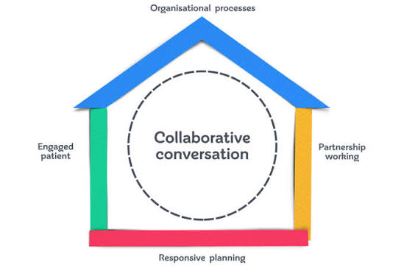
What is House of Care:
The HoC is a framework for supporting people with LTCs. It emphasises that effective management depends on patients being actively involved in their care, supported by prepared healthcare professionals and an organisation that enables coordinated services (British Heart Foundation, 2015).
(British Heart Foundation, 2015)


The model has four main components

House of Care Model for CVD Management
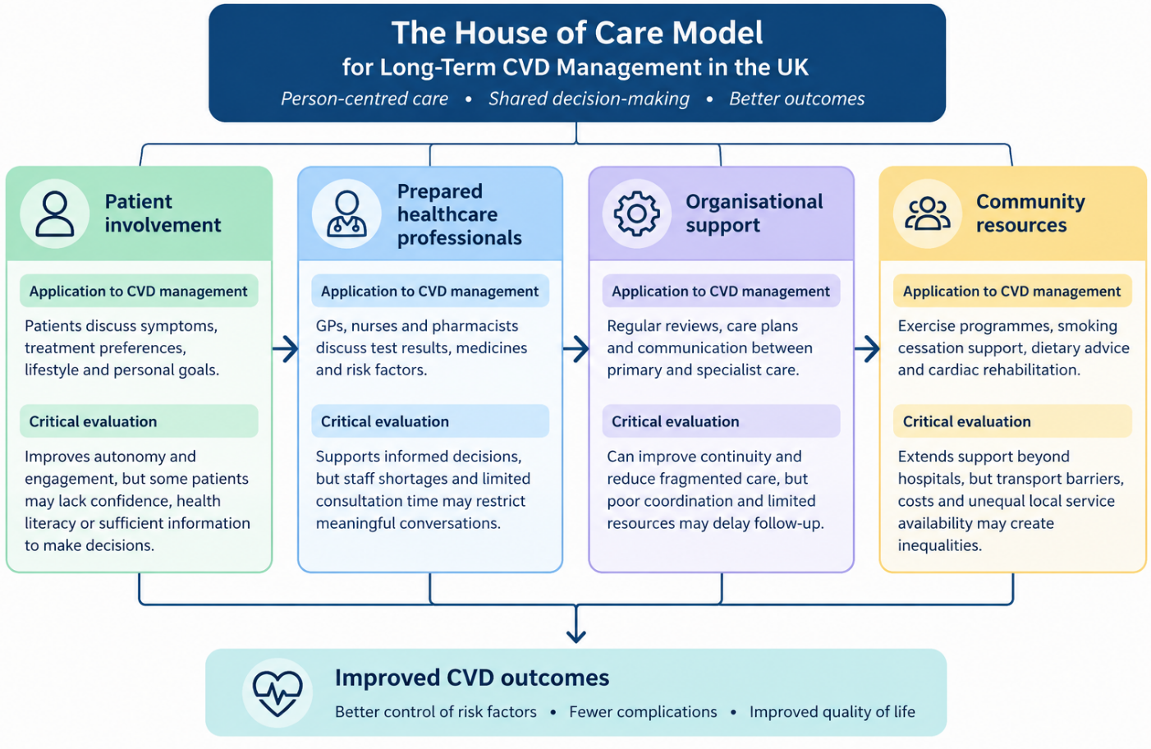
The British Heart Foundation developed its House of Care programme to explore how person-centred care and care planning could improve support for people with heart and circulatory diseases. The programme ran across five health communities with a population of 50,000 people or more. from 2015 to 2018. Its approach built on the year of Care programme, originally developed for diabetes management (British Heart Foundation, 2015). The flow chart shows how HoC is applied to CVD management.
Source: Author based on British Heart Foundation (2015).

Strengths of HoC model in CVD management:
- It considers physical, psychological and emotional wellbeing rather than focusing only on cardiovascular symptoms or test results. It is crucial to improve confidence, Quality of Life of the patient and his independence.
- Care and Support planning moves away from traditional, paternalistic model of healthcare. It now champions a collaborative partnership. Patients contribute their experiences and challenge they face while living with CVD. Clinical experts provide professional help. This approach helps in developing realistic care plans that are easy to follow.
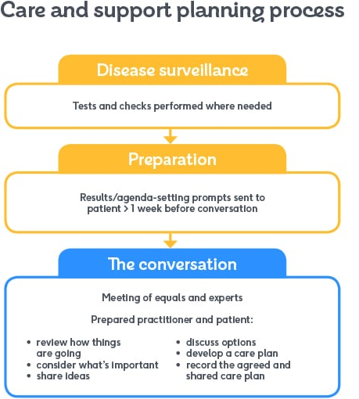

(British Heart Foundation, 2015).

- Regular reviews ad agreed goals can support medication adherence, blood pressure control, cholesterol management, smoking cessation and physical activity.
- The model encourages proactive care rather than relying on hospital admissions or appointments with worsening condition. The BHF identifies integrated support as a way to improve wellbeing and reducing unnecessary and preventable hospitalisation.
(British Heart Foundation, 2015; Coulter et al., 2016).

Limitations:
- Patients with limited knowledge, language barriers and cognitive difficulties or low confidence may struggle to engage and participate. Therefore, offering shared decision making does not automatically ensure equal involvement.
- The model requires trained staff, time, reliable follow up and accessible community services. Without these resources the approach may be difficult to implement.
- Poverty, disability and unsuitable environments may limit a patient’s ability to follow lifestyle choices hence self-management can be beneficial but cannot imply full responsibility on the patient to control disease.
- The BHF programme was independently evaluated but based on five communities did not establish that same outcome occurs across UK settings. The care plan alone cannot improve outcome unless accessible services and continuing professional support is for all.
(Watt, 2013; British Heart Foundation, 2015).


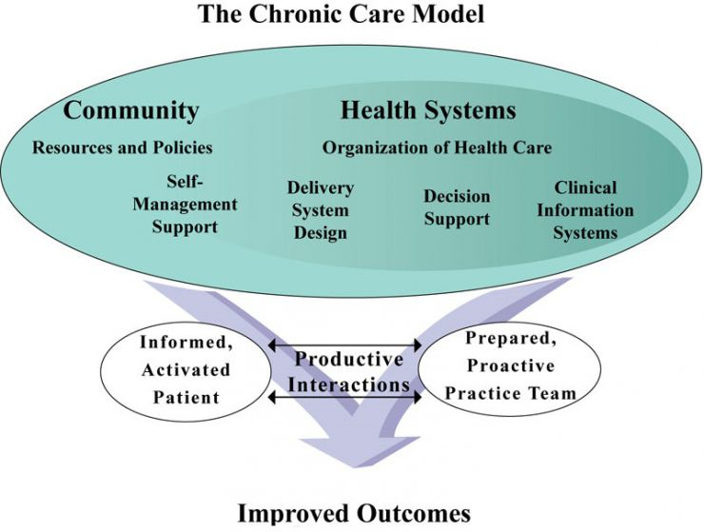

The Chronic Care Model (CCM)
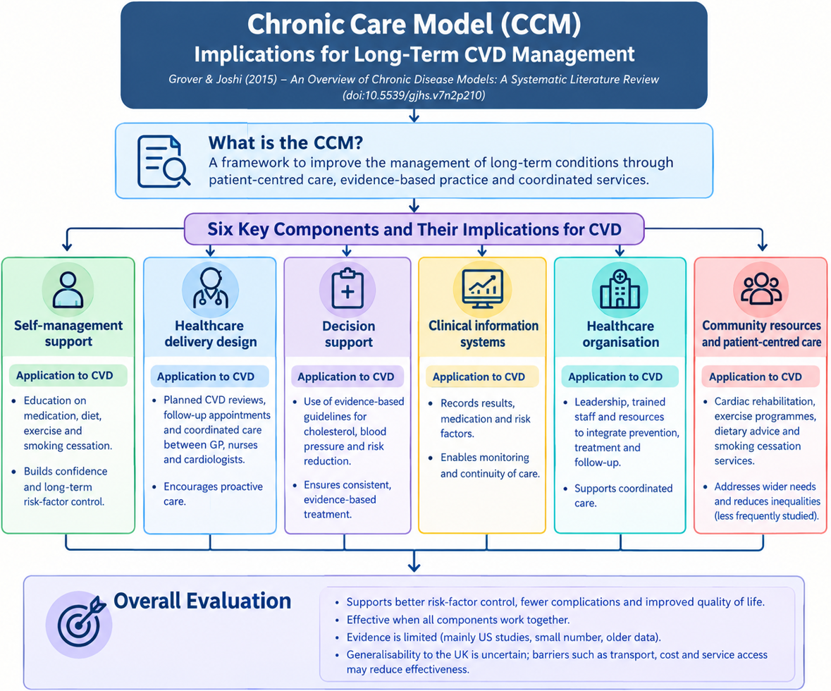
The CCM is developed in USA by Wagner and colleagues in 1990s. this model provides guidance for shifting from an acute, episodic health system to one suited to chronic disease, with proactive patient-centred, evidence-based approach (Grover and Joshi, 2014)
Source: Author based on Grover and Joshi (2014)
The Tuscany Heart Failure Programme and CCM:
This programme ran in 2010 in Tuscany. In this programme 1761 patients with coronary heart failure with 3522 match controls over four years. Deaths were 18% lower in the programme group and planned hospital admissions rates are higher. Hospital admissions suggest that GPs were more aware of patient’s condition and target concerns by using hospital pathways. The limitations and gaps show that broader implication and effectiveness cannot be determined as it only focused on heart failure and not other heart related issues, multimorbidity is ignored and the study only captures death rates not quality of life and overall outcome of patients (Francesconi et al., 2019).
Strengths and Limitations:
There is substantial improvement in process measure and clinical outcomes after the implication of CCM regarding diabetes, CVD and COPD Greater use of CCM enables patients to engage in more self-management behaviours. So far, the systematic reviews done on CCM found that improved processes do not always lead to improved long-term outcomes. Clinical information systems were the hardest element to implement and that time pressure and data collection burden were major challenges. Most of the studies found on the model are USA based and done on diabetes management so CVD specific evidence was limited (Grover and Joshi, 2014).

Political Health and Social Care Agendas
Cardiovascular disease (CVD) remains one the leading causes of premature mortality. Annually 33,000 premature deaths from heart disease and stroke in people under the age of 75. This not only drives health inequalities and significant income loss but also exert pressure on NHS that can be avoidable (DHSC, 2026) The national agenda of CVD management focuses on prevention, early diagnosis and timely interventions. However, evidence suggests that policy ambitions have not always translated into consistent improvements. (Merritt, 2025). The Darzi report 2024 highlights the gap between NHS ambitions and service performance.

NHS 10-year Plan
Promotes three shifts
- Hospital to community
- Analogue to digital
- Sickness to prevention
Community based prevention and digital monitoring may reduce avoidable admission and improve access. However, benefits depend on workforce capacity, digital inclusion and effective coordination between primary, community and hospital services (NHS England, 2019).

NHS Health Checks
Supports early identification of cardiovascular risk factors and workplace programmes. Wider implications tackle smoking and obesity. Prevention offers opportunities to reduce long-term disease burden. However National Audit Office (NA0, 2024) reported fewer than half of eligible people attended an NHS Health Check (NHS, 2023) highlighting weakness in reach, commissioning and engagement with high-risk groups.
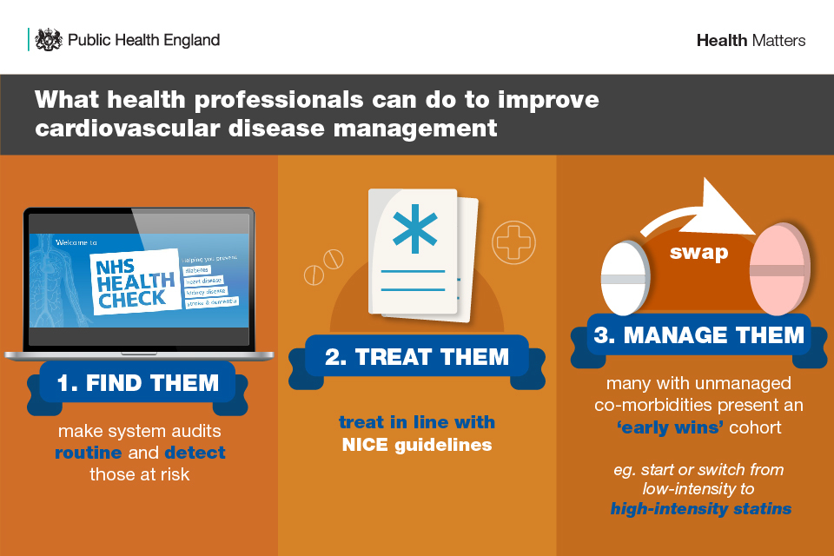
(Public Health England, 2019).

Elective Care Reform 2025
Seeks to improve diagnostic pathways through earlier specialist input and standardised pathways for common outpatient presentation. earlier assessment may improve efficiency and reduce unnecessary investigation, but standardisation must not compromise individual assessment to address waiting lists without sufficient diagnostic capacity (NHS England, 2025).
The Modern Service Framework
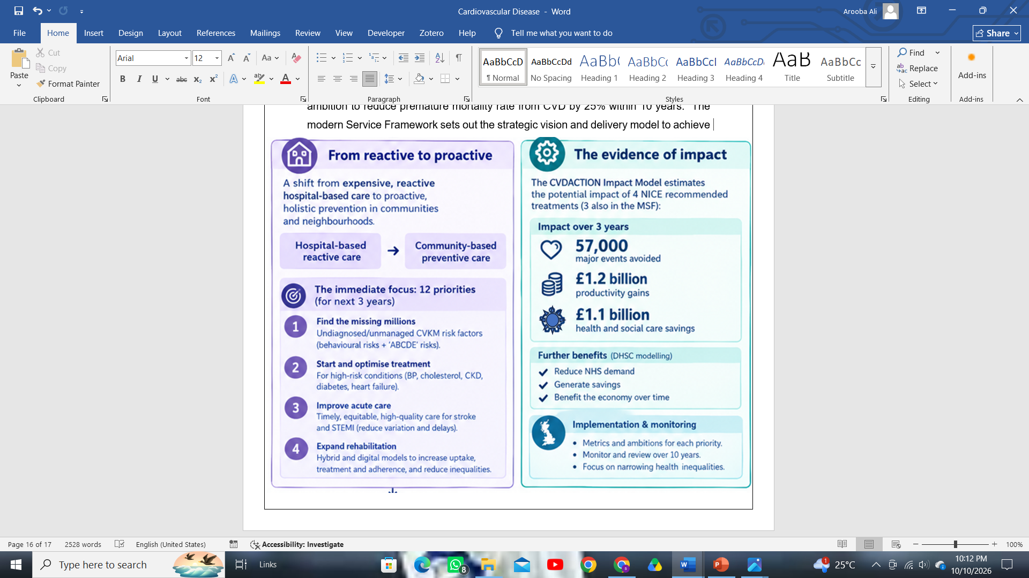
The government of UK has set a bold ambition to reduce premature mortality rate from CVD by 25% within 10 years. The modern Service Framework sets out the strategic vision and delivery model to achieve the target. Central to CVF MSF is holistic approach with a strong focus on reducing inequalities by tackling conditions and risks that cluster together and share common causes like high blood pressure, high cholesterol, diabetes, obesity and smoking. The model aims to save thousands of lives and more sustainable NHS (DHSC, 2026).


(DHSC, 2026)

Source: (Merritt, 2025a)

Local Agendas: Integrated Care Systems (ICSs)


How ICS Prevent and Manage CVD
- GP records, community screening and blood pressure checks identify early risks like hypertension, high cholesterol and atrial fibrillation.
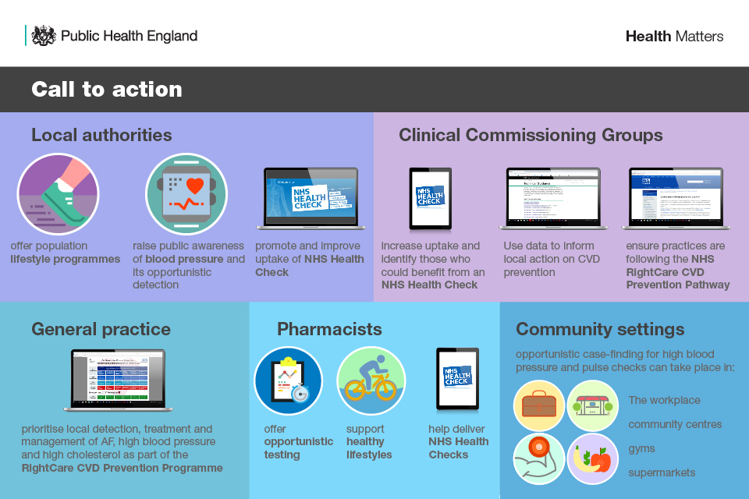
- Support GPs to provide appropriate treatment and regular monitoring and life style modification advice.
- Work with councils and public health teams to advocate health promotions like smoking cessation, fighting obesity and other health risks.
(Public Health England, 2019).

- Provide accessible community services for disadvantaged groups.
- Coordinate GPs, pharmacists, nurses, hospitals and voluntary organisations for preventive and long-term management.

Critical Analysis: ICSs can improve CVD prevention by coordinating healthcare and community services. However, success depends on adequate funding, effective information sharing and equitable access to services (Naylor, Luca Tiratelli and Raleigh, 2025).

Recommendations

Person Centred Care:
- There is need to replace single condition guidelines with whole person care. This will reduce the risk of over treatment and medicine interaction for multiple long-term conditions.
- Use Medication reviews when CVD coexist with kidney disease and diabetes, weighing guidelines benefit against treatment burden.
- Use shared decision making on statins and risk, tailored to person’s values
- Combine health coaching, peer support and social prescribing for diet and mental health concerns.
- Use one shared plan across GPs, cardiology and community teams to address fragmentation.
- Form a multidisciplinary psycho-cardio team so that cardiology, mental health and primary care work together.
- Screen systematically for anxiety and depression using validated tools.
- Offer evidence-based psychological treatment such as CBT
(ESC, 2025; NHS England, 2024; Care Quality Commission, 2024).
End of Life Care
- Offer palliative care in heart failure and clarify when to refer since confusion about timing and unclear prognosis hinder the end-of-life care being offered to many patients.
- Provide one-to-one-time multidisciplinary input and hospice access where appropriate.
- Improve recognition of dying, symptom control. Out of hours service and communication
- Train professionals in end-of-life conversation like through simulation
- Offer every one a holistic assessment and care plan reviewing the change in condition covering spiritual psychological social and physical needs. Use advance care planning to refuse treatment and lasting Power of Attorney under Mental Capacity Act 2005.
- Make care plans electronically available that include resuscitation wishes, available to out of hours and emergency services.
- Create locality wide registers and a single point of access for services as in Marie Curie’s Delivering Choice.
(British Heart Foundation, 2020; Department of Health, 2008; Social Care Institute for Excellence, 2024).
Self- Management:
- There is need to offer structured self-management education and health coaching to build knowledge, skills and confidence such as symptom monitoring and medicine adherence. Skill building is more appropriate approach to know what to do when symptoms occur than education alone.
- Peer support and social prescribing is needed to connect patients to peer groups and link workers for emotional and practical support to reduce anxiety, and social isolation resulting from CVD diagnosis and long-term effects.
- A supportive self-management care plan must be agreed upon to target personalised goals by healthcare professionals, that should be reviewed regularly rather than left to the patients. Self-monitoring of blood pressure and weight and symptoms supports heart failure care.
- Involvement of community and family influence adherence and monitoring, there is also an acute need of trained community volunteers or coaches to improve hypertension self-care.
- People are usually left unanswered after angioplasty and heart surgery. Offering a Cognitive behavioural programme can help people with mild CVD to take control of their condition.
(Riegel et al., 2017; NHS, 2024; Bethge et al., 2023).

Final Word:
Cardiovascular disease is highly preventable long-term condition. Yet it is still the leading cause of premature deaths world wide and has grave physical, social and psychological impacts on an individual’s quality of life. Although Uk has progressed in management and prevention of CVDs by focusing on prevention and personalised care to improve self-management of the condition yet there are gaps in local service delivery, rehabilitation, preventive strategies and self- management support. It involves many challenges and barriers including health inequalities, access to services and carer involvement and low funding. This booklet will help in understanding the cardiovascular disease burden and that how personalised care and accountability can turn good policies into effective outcomes for people with CVD in UK.

Reference list
Abed, M.A., Kloub, M.I. and Moser, D.K. (2014) “Anxiety and adverse health outcomes among cardiac patients: A biobehavioral model,” The Journal of cardiovascular nursing, 29(4), pp. 354–63. Available at: https://doi.org/10.1097/JCN.0b013e318292b235.
Arora, D.P. (2021) What is cardiovascular disease (CVD): Symptoms & causes, Maxhealthcare.in. Max Healthcare. Available at: https://www.maxhealthcare.in/blogs/what-is-cardiovascular-disease (Accessed: October 6, 2026).
Arshi, A., Vriend, M., Chantzi, F. and Finch, D. (2026) Health as an economic asset Unlocking the economic potential of the UK’s working-age population, https://www.health.org.uk/sites/default/files/upload/publications/2026/Health_Foundation_Health%20as%20an%20economic%20asset_2026.pdf. The Health Foundation.
Ayre, R. (2024) Cardiovascular diseases: Coronary heart disease, hypertension, and other common conditions, Primary Care 24. Available at: https://primarycare24.org.uk/news/2024/11/29/cardiovascular-diseases/ (Accessed: October 8, 2026).
Balogun, B. (2026) Reducing levels of premature deaths from heart disease and stroke - house of commons library, House of Commons Library. Available at: https://commonslibrary.parliament.uk/research-briefings/cbp-10927/ (Accessed: October 9, 2026).
Bernard, S., Brody, E. and Lohr, K. (2007) Healthcare delivery models for heart failure , https://www.health.org.uk/reports-and-analysis/reports/healthcare-delivery-models-for-heart-failure. The Health Foundation.
Bethge, M., Friederike Thome-Soós, Luka Marko Rašo, Weier, L. and Dieter Benninghoven (2023) “Cognitive-behavioral rehabilitation in patients with cardiovascular diseases: A randomized controlled trial (CBR-cardio, DRKS00029295),” 23(1). Available at: https://doi.org/10.1186/s12872-023-03272-1.
Borkowski, P. and Borkowska, N. (2024) “Understanding mental health challenges in cardiovascular care,” Cureus, 16(2). Available at: https://doi.org/10.7759/cureus.54402.
British Heart Foundation (2015) Person-centred care and the House of Care, British Heart Foundation. Available at: https://www.bhf.org.uk/for-professionals/healthcare-professionals/innovation-in-care/person-centred-care-and-the-house-of-care (Accessed: October 9, 2026).
British Heart Foundation (2019) Coronary bypass surgery, Bhf.org.uk. Available at: https://www.bhf.org.uk/informationsupport/treatments/coronary-bypass-surgery (Accessed: October 9, 2026).
British Heart Foundation (2020) End of life care, Bhf.org.uk. British Heart Foundation. Available at: https://www.bhf.org.uk/informationsupport/heart-matters-magazine/wellbeing/end-of-life-care (Accessed: October 11, 2026).
British heart foundation (2024) British Heart Foundation, British Heart foundation. Available at: https://www.bhf.org.uk/ (Accessed: October 8, 2026).
British Heart Foundation (2024) New government commit heart disease action plan, Bhf.org.uk. British Heart Foundation. Available at: https://www.bhf.org.uk/what-we-do/news-from-the-bhf/news-archive/2024/july/new-government-commit-heart-disease-action-plan (Accessed: October 10, 2026).
BrJCardiol (2023) Inspiring change within the NHS to improve collaborative working and patient care across cardiovascular disease, bjcardio.co.uk. Available at: https://bjcardio.co.uk/2023/11/inspiring-change-within-the-nhs-to-improve-collaborative-working-and-patient-care-across-cardiovascular-disease/ (Accessed: October 11, 2026).
Care Quality Commission (2024) Regulations for service providers and managers, Cqc.org.uk. Available at: https://www.cqc.org.uk/guidance-regulation/providers/regulations-service-providers-and-managers/health-social-care-act/regulation-9 (Accessed: October 11, 2026).
Carers UK (2023) Key facts and figures, Carers UK. Available at: https://www.carersuk.org/policy-and-research/key-facts-and-figures/ (Accessed: October 9, 2026).
CDC (2022) About chronic diseases, Centers for Disease Control and Prevention. Available at: https://www.cdc.gov/chronicdisease/about/index.htm (Accessed: October 8, 2026).
Centers for Disease Control and Prevention (2024) About heart disease and mental health, Heart Disease. Available at: https://www.cdc.gov/heart-disease/about/about-heart-disease-and-mental-health.html (Accessed: October 8, 2026).
Coulter, A., Kramer, G., Warren, T. and Salisbury, C. (2016) “Building the house of care for people with long-term conditions: The foundation of the House of Care Framework,” British Journal of General Practice, 66(645), pp. 288–290. Available at: https://doi.org/10.3399/bjgp16x684745.
Department of Health (2008) End of life care strategy promoting high quality care for all adults at the end of life “how people die remains in the memory of those who live on”. Available at: https://assets.publishing.service.gov.uk/media/5a7ae925ed915d71db8b35aa/End_of_life_strategy.pdf (Accessed: October 11, 2026).
Department of Health and Social Care (2026) Millions of unpaid carers to get recognition and earlier support, GOV.UK. Available at: https://www.gov.uk/government/news/millions-of-unpaid-carers-to-get-recognition-and-earlier-support (Accessed: October 9, 2026).
DHSC (2026) Cardiovascular disease (CVD) modern service framework (MSF): a cardiovascular-kidney-metabolic approach - the strategic vision and delivery model (accessible version), https://www.gov.uk/government/publications/cardiovascular-disease-modern-service-framework/cardiovascular-disease-cvd-modern-service-framework-msf-a-cardiovascular-kidney-metabolic-approach-the-strategic-vision-and-delivery-model-acc. GOV.UK .
Dixon, A. and Roberts, S. (2013) Delivering better services for people with long-term conditions, The King’s Fund. Available at: https://www.kingsfund.org.uk/insight-and-analysis/reports/better-services-people-long-term-conditions (Accessed: October 9, 2026).
ESC (2025) Person-centred strategies for managing comorbid mental and cardiovascular disease, Escardio.org. Available at: https://www.escardio.org/communities/councils/cardiology-practice/education/cardiopractice/person-centred-strategies-for-managing-comorbid-mental-and-cardiovascular-disease/ (Accessed: October 11, 2026).
ESC (2026) Health economics - burden of CVD, Escardio. Available at: https://www.escardio.org/data-science/public-health-data/health-economics-burden-cvd/ (Accessed: October 9, 2026).
Everyday Health (2025) Heart disease: Types and symptoms, EverydayHealth.com. Available at: https://www.everydayhealth.com/heart-disease/types-symptoms/ (Accessed: October 8, 2026).
Francesconi, P., Ballo, P., Profili, F., Policardo, L., Roti, L. and Zuppiroli, A. (2019) “Chronic care model for the management of patients with heart failure in primary care,” Health Services Insights, 12, p. 117863291986620. Available at: https://doi.org/10.1177/1178632919866200.
Fuat, A., Gale, C., Lloyd, G., Williams, H., Moore, J., Lobban, T., Kunadian, V. and Hussain, W. (2023) “Inspiring change within the NHS to improve collaborative working and patient care across CVD,” British Journal of Cardiology [Preprint]. Available at: https://doi.org/10.5837/bjc.2023.s10.
Gheiasi, S.F., Rouhbakhsh, M. and Siahkali, S.R. (2026) “Caregiving burden and perceived stress in family caregivers of cardiac patients,” BMC nursing, 25(1), p. 600. Available at: https://doi.org/10.1186/s12912-026-04712-x.
Goodwin, N., Curry, N., Naylor, C., Ross, S. and Duldig, W. (2010) Managing people with long-term conditions. Available at: https://assets.kingsfund.org.uk/f/256914/x/a76c8db537/gp_inquiry_managing_long_term_conditions_2010.pdf (Accessed: October 8, 2026).
Grover, A. and Joshi, A. (2014) “An overview of chronic disease models: A systematic literature review,” Global Journal of Health Science, 7(2), pp. 210–227. Available at: https://doi.org/10.5539/gjhs.v7n2p210.
HQIP (2026) CVDPREVENT (national audit of cardiovascular disease prevention in primary care), workstream 3 - HQIP, HQIP. Available at: https://www.hqip.org.uk/our-programmes/cvdprevent/ (Accessed: October 11, 2026).
Jilani, M.H. et al. (2021) “Social determinants of health and cardiovascular disease: Current state and future directions towards healthcare equity,” Current Atherosclerosis Reports, 23(9), pp. 1–11. Available at: https://doi.org/10.1007/s11883-021-00949-w.
Kettle, L. (2019) Over half living with heart and circulatory diseases have experienced sadness, anxiety and depression, Bhf.org.uk. Available at: https://www.bhf.org.uk/what-we-do/news-from-the-bhf/news-archive/2019/july/sadness-depression-and-anxiety-experienced-by-those-with-heart-and-circulatory-diseases (Accessed: October 9, 2026).
Kitko, L. et al. (2020) “Family caregiving for individuals with heart failure: A scientific statement from the American heart association,” Circulation, 141(22). Available at: https://doi.org/10.1161/cir.0000000000000768.
Lui, J.N.M. et al. (2023) “Impact of new cardiovascular events on quality of life and hospital costs in people with cardiovascular disease in the United Kingdom and United States,” Journal of the American Heart Association, 12(19). Available at: https://doi.org/10.1161/jaha.123.030766.
Merritt, E.C. (2025a) Cardiovascular disease: What is the government doing about England’s leading cause of premature death?, House of Lords Library. Available at: https://lordslibrary.parliament.uk/cardiovascular-disease-what-is-the-government-doing-about-englands-leading-cause-of-premature-death/ (Accessed: October 10, 2026).
Merritt, E.C. (2025b) Tobacco and Vapes Bill: HL Bill 89 of 2024–25, House of Lords Library. Available at: https://lordslibrary.parliament.uk/research-briefings/lln-2025-0019/ (Accessed: October 10, 2026).
NAO (2024) Progress in preventing cardiovascular disease - NAO report, National Audit Office (NAO). Available at: https://www.nao.org.uk/reports/progress-in-preventing-cardiovascular-disease/ (Accessed: October 10, 2026).
Naylor, C., Luca Tiratelli and Raleigh, V. (2025) Shifting to prevention: How integrated care systems can tackle cardiovascular disease, The King’s Fund. Available at: https://www.kingsfund.org.uk/insight-and-analysis/long-reads/shifting-prevention-integrated-care-systems-tackle-cardiovascular-disease#why-cardiovascular-disease-prevention-should-be-prioritised-- (Accessed: October 10, 2026).
NHS (2019) NHS year of care, Yearofcare.co.uk. Available at: https://www.yearofcare.co.uk/ (Accessed: October 9, 2026).
NHS (2020) Better Health, nhs.uk. NHS. Available at: https://www.nhs.uk/better-health/ (Accessed: October 9, 2026).
NHS (2022) Cardiovascular disease, NHS. NHS. Available at: https://www.nhs.uk/conditions/cardiovascular-disease/ (Accessed: October 8, 2026).
NHS (2023) NHS health check, nhs.uk. Available at: https://www.nhs.uk/tests-and-treatments/nhs-health-check/ (Accessed: October 9, 2026).
NHS (2024) Self-management - the heart manual, The Heart Manual. Available at: https://services.nhslothian.scot/theheartmanual/patientpage/self-management/ (Accessed: October 11, 2026).
NHS England (2019) The NHS long term plan, www.england.nhs.uk. NHS England. Available at: https://www.england.nhs.uk/publication/the-nhs-long-term-plan/ (Accessed: October 10, 2026).
NHS England (2022) What Are Integrated Care systems?, NHS England. Available at: https://www.england.nhs.uk/integratedcare/what-is-integrated-care/ (Accessed: October 11, 2026).
NHS England (2024) Person-centred care, NHS England. Available at: https://www.hee.nhs.uk/our-work/person-centred-care (Accessed: October 11, 2026).
NHS England (2025) NHS England » Reforming elective care for patients, England.nhs.uk. Available at: https://www.england.nhs.uk/publication/reforming-elective-care-for-patients/ (Accessed: October 10, 2026).
NICE (2018) Chapter 35 discharge planning emergency and acute medical care in over 16S: Service delivery and organisation NICE guideline 94. Available at: https://www.nice.org.uk/guidance/ng94/evidence/35.discharge-planning-pdf-172397464674 (Accessed: October 9, 2026).
Noemí Villén, Roso-Llorach, A., Gallego-Moll, C., Danes-Castells, M., Fernandez-Bertolin, S., Troncoso-Mariño, A., Monteagudo, M., Amado, E. and Concepción Violán (2022) “Polypharmacy patterns in multimorbid older people with cardiovascular disease: Longitudinal study,” 7(6), pp. 141–141. Available at: https://doi.org/10.3390/geriatrics7060141.
Pereira, E. and Pereira, H. (2020) “Socioeconomic impact of cardiovascular disease,” Revista Portuguesa de Cardiologia (English edition), 39(5), pp. 253–254. Available at: https://doi.org/10.1016/j.repce.2020.10.006.
Public Health England (2019) Health matters: Preventing cardiovascular disease, GOV.UK. Available at: https://www.gov.uk/government/publications/health-matters-preventing-cardiovascular-disease/health-matters-preventing-cardiovascular-disease (Accessed: October 9, 2026).
Riegel, B. et al. (2017) “Self‐care for the prevention and management of cardiovascular disease and stroke,” Journal of the American Heart Association, 6(9). Available at: https://doi.org/10.1161/jaha.117.006997.
Social Care Institute for Excellence (2024) Lasting power of attorney, SCIE. Available at: https://www.scie.org.uk/mca/practice/representing-the-person/lasting-power-of-attorney/ (Accessed: October 11, 2026).
The Heart Research Institute (2023) Risk factors for heart disease • Heart Research Institute, Heart Research Institute UK. Available at: https://www.hriuk.org/health/learn/risk-factors/risk-factors-for-cardiovascular-disease (Accessed: October 8, 2026).
The King’s Fund (2022) Cardiovascular disease in England: Supporting leaders to take actions, The King’s Fund. Available at: https://www.kingsfund.org.uk/insight-and-analysis/reports/cardiovascular-disease-england (Accessed: October 10, 2026).
Watt, G. (2013) “Looking beyond ‘the house of care’ for long term conditions,” BMJ, 347(nov19 3), pp. f6902-f6902. Available at: https://doi.org/10.1136/bmj.f6902.
Williams, E., Round, T. and Jones, N.R. (2024) “Cardiovascular disease — Risk assessment and reduction: NICE 2023 update for GPs,” British Journal of General Practice, 74(748), pp. 523–526. Available at: https://doi.org/10.3399/bjgp24x739905.
World Health Organization (2023) “How much do you know about #cardiovascular diseases? #CVDs are a group of disorders of the heart and blood vessels,” Facebook. Available at: https://www.facebook.com/WHONigeria/videos/1388270062104032/ (Accessed: October 8, 2026).
World Health Organization (2025) Cardiovascular diseases (CVDs), World Health Organization. Available at: https://www.who.int/news-room/fact-sheets/detail/cardiovascular-diseases-(cvds) (Accessed: October 8, 2026).

