Student Name :Esteri Paloka
Programme : CertHE Computing Skills for Workplace
Module : Computer Architecture and Operating Systems
Module Code: ACCA4022
Submission date : 24/07/2026

Table of Contents
Introduction 3
Key Functions of General Purpose Operating Systems 4
2.1 Process Management 5
2.2 Memory Management 6
2.3 File and Directory Management 7
2.4 Device Management 8
2.5 User Management and Security 9
2.6 Networking 10
3. Windows Command Line Interface (CLI) 11
3.1 Process Management 11
3.2 File and Directory Management 13
3.3 Network Testing and Monitoring 16
3.4 User Management 18
3.5 Task Scheduling 19
4 Windows Batch Script 1 – Greeting the User 20
4 Windows Batch Script 2 – Simple Calculator 21
5. Linux Bash Script 1 – Greeting the User 22
5.2 Linux Bash Script 2 – Simple Calculator 23
Conclusion 24
References 25

Introduction

Operating systems are an essential part of modern computers because they manage the hardware and allow users to run applications and complete different tasks. They control important functions such as processes, memory, files, connected devices, user accounts and network connections.[1] , [3]
For example, the Windows memory manager controls how physical and virtual memory are allocated to programs, while the file system allows applications to store and retrieve files in an organised way. [3]
This report explains the main functions of general-purpose operating systems using examples from Windows and Linux. It also demonstrates the use of command-line interface (CLI) tools, including Windows Command Prompt and Linux Bash. Although graphical interfaces are commonly used for everyday tasks, command-line tools provide more control and allow users to manage files, navigate directories and perform system tasks more efficiently. [4] , [5]
The report also includes Windows and Linux commands for process management, file and directory management, network testing, user management and task scheduling. In addition, it examines Windows Batch and Linux Bash scripts to show how repetitive tasks can be automated. Bash scripts contain a series of commands that are executed together, making them useful for automating routine system tasks. [5]

Key Functions of General Purpose Operating Systems
General-purpose operating systems are designed to manage a computer's hardware and software while allowing users to perform a variety of everyday tasks. They act as a bridge between the user and the computer's hardware, making it possible to run applications, store files, connect to the internet and use devices such as printers, keyboards and monitors. Some of the most common examples of general-purpose operating systems are Microsoft Windows, Linux and macOS. Although each operating system has its own features and user interface, they all perform the same core functions to help the computer run efficiently and securely .[1], [2]

2.1 Process Management
One of the most important functions of an operating system is process management. A process is any program or application that is currently running on a computer, such as Microsoft Word, Google Chrome or Spotify. The operating system manages these processes by deciding how the computer's processor (CPU) is shared between them. It gives processing time to each program, allowing multiple applications to run at the same time without making the system unstable or unresponsive [2], [3], [5].
In Windows, process management can be monitored using Task Manager, which displays all active applications, background processes and system resource usage. Users can see how much CPU, memory, disk and network resources each process is using, making it easier to identify programs that are slowing down the computer or have stopped responding. If necessary, users can also end an unresponsive process directly from Task Manager [4].

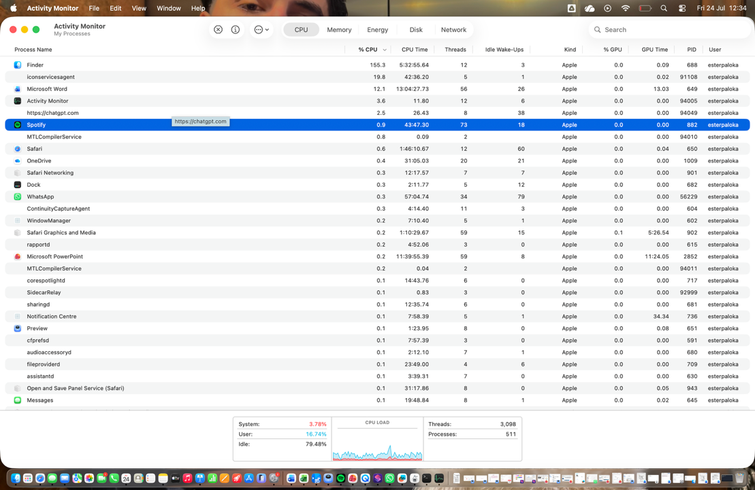
Picture 1: macOS Activity Monitor displaying running processes and CPU usage

2.2 Memory Management
Memory management is another important function of an operating system. It controls how the computer's Random Access Memory (RAM) is used by different programs. When an application is opened, the operating system allocates enough memory for it to run properly. Once the application is closed, the memory is released and becomes available for other programs. This allows multiple applications to run at the same time while maintaining good system performance. [2], [3], [5]
If the computer starts to run out of RAM, the operating system uses virtual memory, which temporarily stores data on the storage drive. Although virtual memory is slower than RAM, it helps prevent the computer from freezing or crashing when many programs are running. It also improves system stability by preventing applications from accessing memory assigned to other programs. [2], [3]

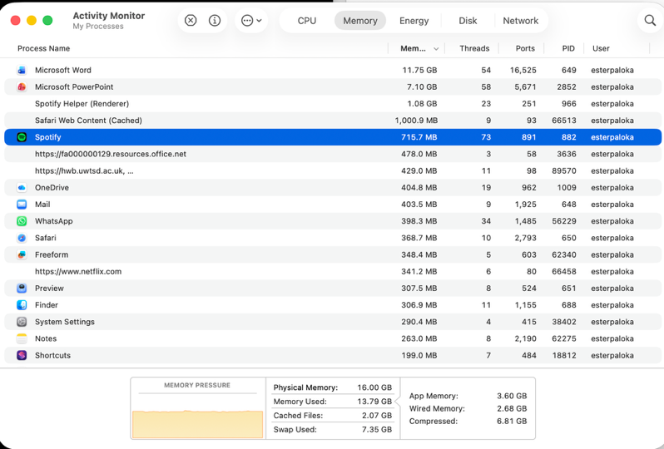

Picture 2 : macOS Activity Monitor displaying memory usage , memory pressure and running processes .

2.3 File and Directory Management
File and directory management is another important function of an operating system. It allows users to create, organise, store, copy, move and delete files and folders. The operating system uses a file system to keep track of where data is stored and ensures that files can be accessed quickly and securely. Different operating systems use different file systems, such as NTFS in Windows and ext4 in many Linux distributions. [2], [3]
The operating system also controls file permissions, which determine who can view, edit or delete files. This helps protect important data from unauthorised access and accidental changes. In Windows, users manage files using File Explorer, while Linux users can perform the same tasks using a graphical file manager or command-line tools such as ls, cp, mv and rm . [2], [3]
Overall, file and directory management helps users organise their data efficiently while protecting files through permissions and file systems. [2], [3], [5]
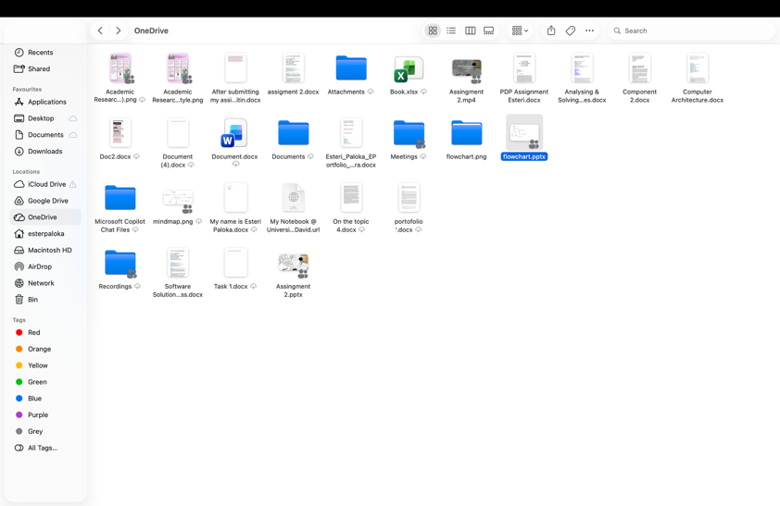
Picture 3. macOS Finder demonstrating file and directory management.

2.4 Device Management
Device management is another essential function of an operating system. It allows the operating system to communicate with hardware devices such as keyboards, printers, monitors, storage drives and network adapters. The operating system uses device drivers to ensure that each hardware component works correctly. It also manages hardware resources between different applications, helping the system run efficiently and reliably . [2] ,[3]

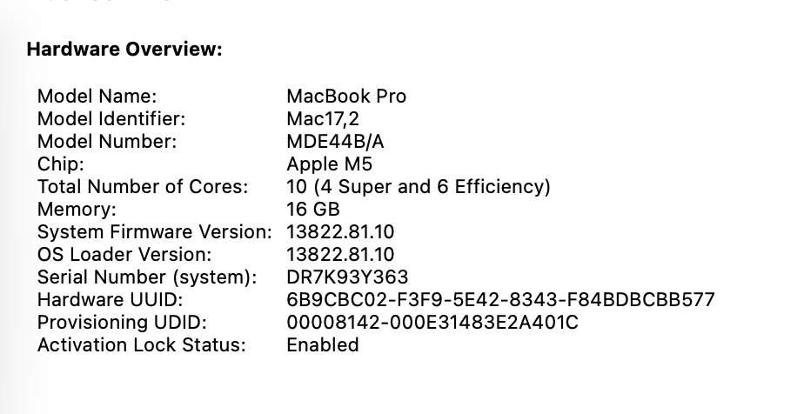

Picture 4. macOS System Information displaying installed hardware devices.

2.5 User Management and Security
User management and security are essential functions of an operating system because they help protect both the computer and its data. The operating system allows different users to have separate accounts, each with their own passwords, settings and permissions. This ensures that only authorised users can access sensitive files or make changes to the system. Security features such as user authentication, encryption and built-in firewalls also help protect the computer from unauthorised access, malware and other cyber threats .[1], [2], [3]

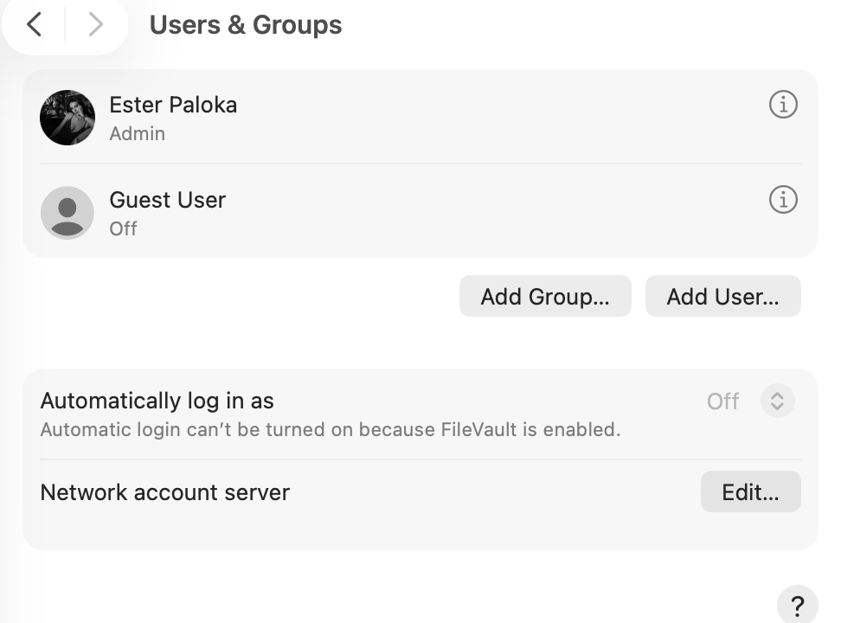

Picture 5. macOS Users & Groups settings showing user account management.

2.6 Networking
Networking is another important function of an operating system. It allows computers to connect to local networks and the internet, enabling users to share files, access online services and communicate with other devices. The operating system manages network connections, monitors data transfer and supports communication using standard network protocols. It also includes security features, such as firewalls, to help protect data and prevent unauthorised access. [1], [2]

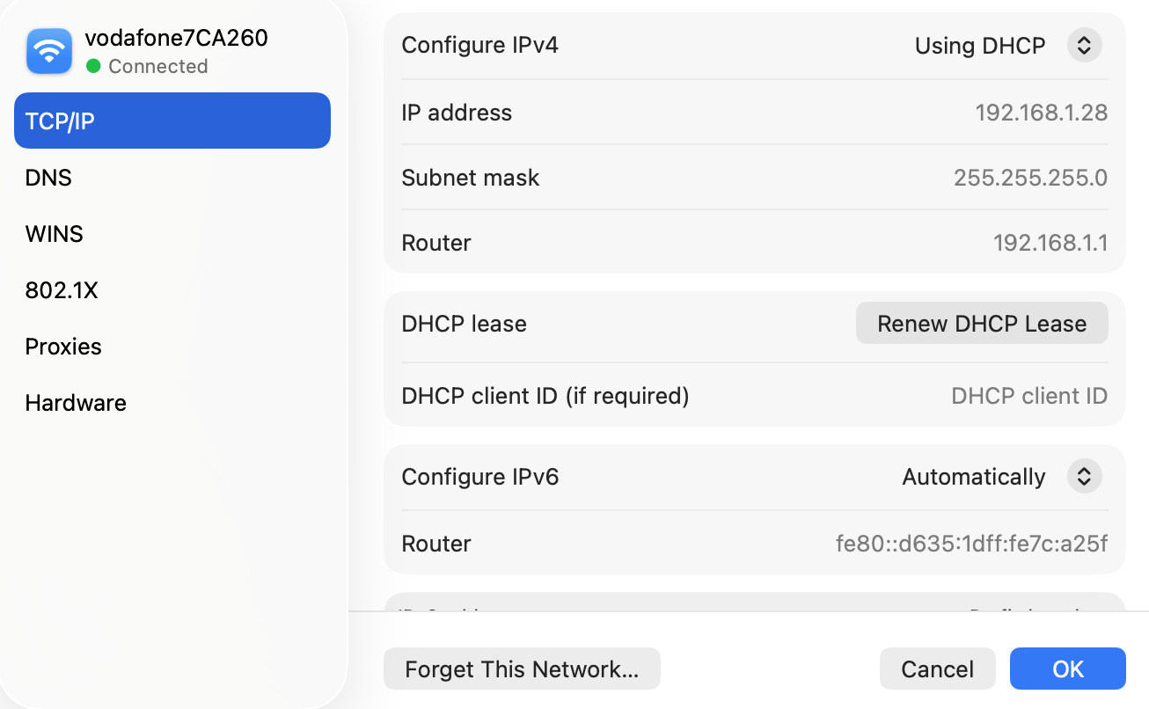

Picture 6. macOS Network settings displaying the current network connection and configuration.

3. Windows Command Line Interface (CLI)
The Windows Command Line Interface (CLI), also known as Command Prompt (CMD), is a text-based interface that allows users to interact with the operating system by typing commands instead of using a graphical interface. It is commonly used to manage files, troubleshoot problems, configure system settings and perform administrative tasks. Many tasks can be completed more quickly using the CLI than the graphical user interface (GUI), making it an important tool for both everyday users and administrators.

3.1 Process Management
Process management commands allow users to view and manage programs that are currently running on a Windows computer. They can be used to identify active processes, check their Process ID (PID) and stop applications that are frozen or not responding. Two commonly used Windows commands for this purpose are tasklist and taskkill. [4]

tasklist command :
The tasklist command displays all processes currently running on the computer. It shows information such as the process name, Process ID (PID) and memory usage. This command is useful for checking which applications and background services are currently active. [4]
Example:
tasklist
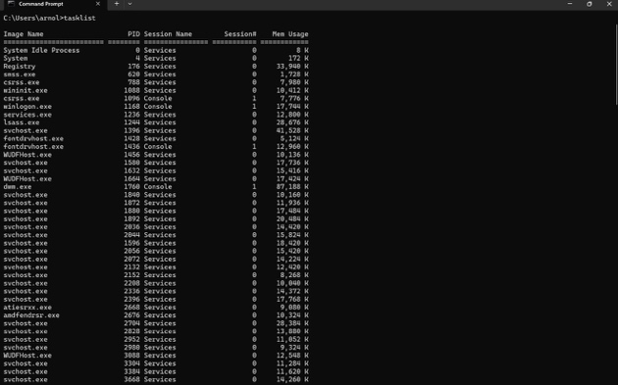

- This command shows programs and background processes currently running on the computer.

taskkill command :
The taskkill command is used to stop a running process. It is often used when a program has frozen or is not responding. The command can stop a process using either its process name or its Process ID (PID). [4]
Example:
Taskkill / IM notepad.exe / F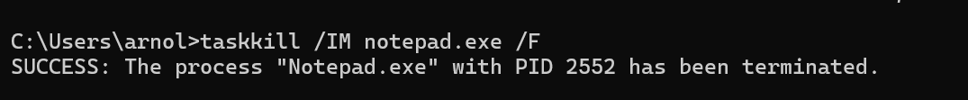
- This command forcefully closes Notepad if it is currently running.

3.2 File and Directory Management
File and directory management commands allow users to create, view, copy and organise files and folders using Command Prompt. These commands are useful for managing files without using File Explorer and can make everyday tasks quicker and more efficient. [4]

dir command :
The dir command displays the files and folders in the current directory. It allows users to quickly view the contents of a folder, including file names, file sizes and the date each file was last modified. [4]
Example:
dir
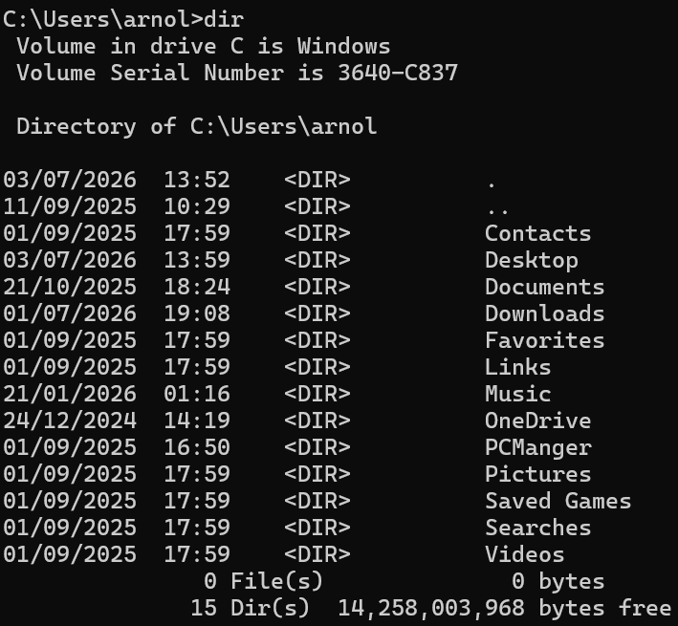

- This command lists all files and folders in the current directory .

cd command :
The cd (Change Directory) command is used to move between folders in Command Prompt. It allows users to navigate the computer's directory structure without using File Explorer. This command is useful for accessing files and folders in different locations [4].
Example:
cd Documents
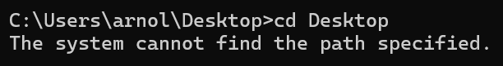
- This command changes the current directory. If the specified folder exists, Command Prompt opens that folder. If the path is incorrect, an error message such as "The system cannot find the path specified" is displayed.

mkdir command
The mkdir (Make Directory) command is used to create a new folder in the current directory. It is a simple but useful command that helps users organise their files by creating new folders through Command Prompt instead of using File Explorer [4].
Example:
mkdir Coursework
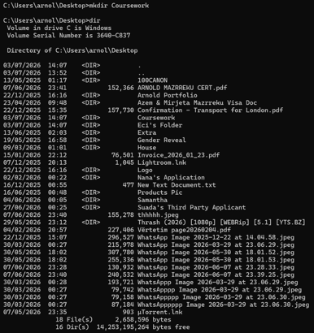
- This command creates a new folder called Coursework in the current directory . If the folder is created successfully , it can be used to store files and other folders .

copy command
The copy command is used to duplicate a file from one location to another. It allows users to create a copy without changing the original file. This command is useful for creating backups or organising files into different folders [4].
Example:
copy Report.docx BackupReport.docx
- This command creates a copy of the file Report.docx and saves it as BackupReport.docx . The original file remains unchanged.

Note: Equivalent functionality has been demonstrated using macOS because a Windows device was not available during completion of this assignment.

3.3 Network Testing and Monitoring

Network testing and monitoring commands help users check whether a computer is connected to a network and identify connection problems. They are commonly used to display network information and test communication between computers or websites [4].

Note: Equivalent functionality has been demonstrated using macOS because a Windows device was not available during completion of this assignment.

ipconfig command:

The ipconfig command displays the computer's current network configuration, including the IP address, subnet mask and default gateway. It is commonly used to troubleshoot network connection problems [4].
Example :

ipconfig

- This command displays the current network configuration of the computer .

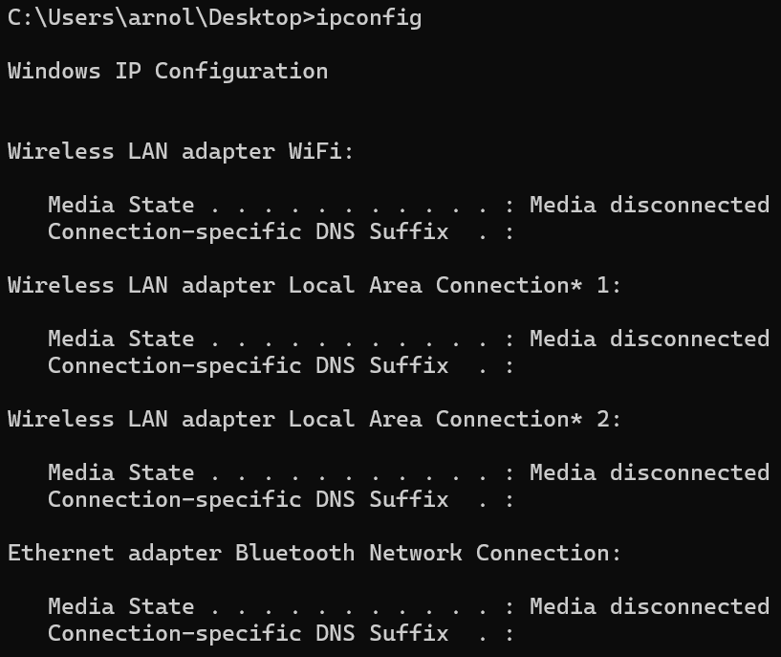

ping command:

The ping command is used to test whether a computer can communicate with another device or website over a network. It also measures the time it takes for data to travel between the two locations [4].
Example:

ping google.com

- This command check whether the computer can successfully connect to Google’s server.
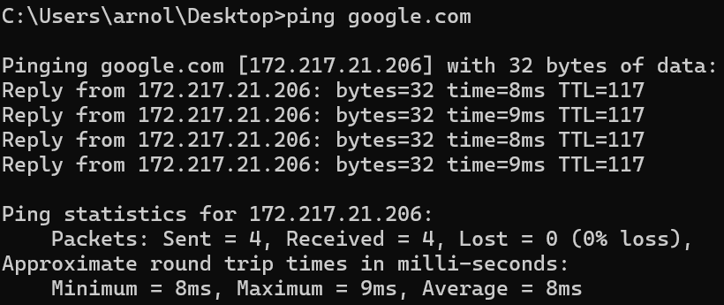

3.4 User Management
User management commands help users and administrators manage user accounts on a Windows computer. They can be used to identify the current user and display information about all user accounts on the system .[4]
whoami command :
The whoami command displays the username of the person currently logged into the computer. It is useful for confirming which user account is being used. [4]
Example:
whoami
- This command displays the username of the current user.

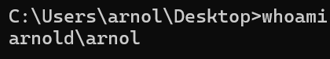

net user command:
The net user command displays a list of user accounts on the computer. It can also be used to create , modify and delete user accounts by using additional options.
Example:
net user
- This command displays all user accounts available on the computer.

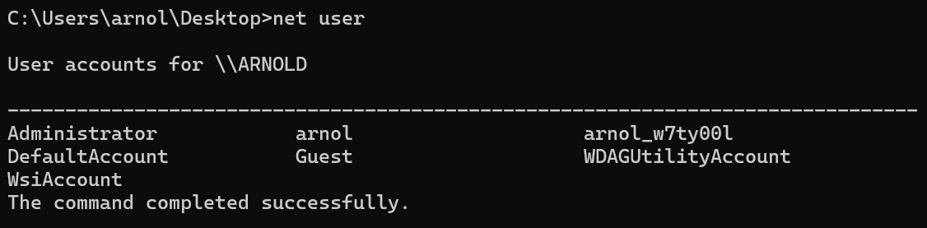

3.5 Task Scheduling

Task scheduling commands allow users to automate tasks, so they run automatically at a specific time or date. This helps reduce repetitive work and improve system efficiency. In Windows, the schtasks command is commonly used to create, manage and view scheduled tasks .[4]

schtasks command :
The schtasks command is used to create, display and manage scheduled tasks in Windows. It is useful for automating tasks, such as running programs or scripts at a specific time [4].
Example:

schtasks

- This command displays information about scheduled tasks on the computer.

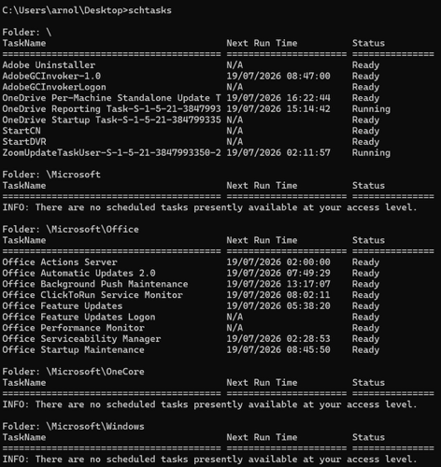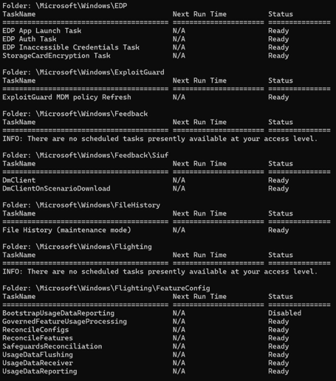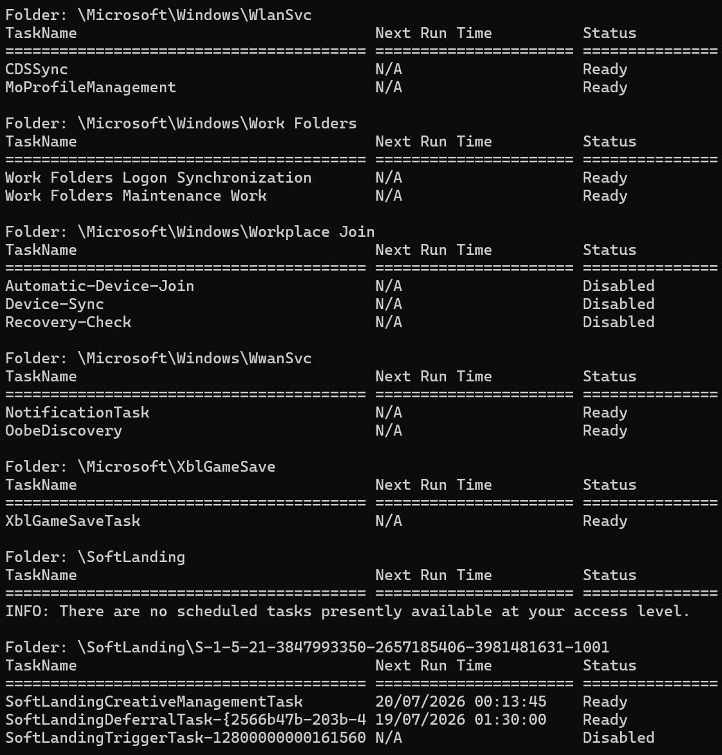

4 Windows Batch Script 1 – Greeting the User
This Batch script asks the user to enter their name and then displays a personalised greeting. It demonstrates the use of variables and user input, which are common features of Batch scripting [4].

@echo off
set/p name=Enter your name:
echo Hello, %name%! Welcome to Windows Batch scripting.
pause

- @echo off hides the commands while the script runs.
- set /p asks the user to enter their name and stores it in a variable called
- echo displays a personalised greeting.
- pause keeps the window open until the user presses a key.

Note: Equivalent functionality has been demonstrated using macOS because a Windows device was not available during completion of this assignment.

4 Windows Batch Script 2 – Simple Calculator
This Batch script asks the user to enter two numbers and then adds them together. It demonstrates the use of variables, user input and a simple mathematical operation in a Windows Batch script .[4]

@echo off
set /p num1=Enter the first number:
set /p num2=Enter the second number:
set /a total=%num1%+%num2%
echo the total is %total%
pause

- set /p asks the user to enter two numbers.
- set /a performs the mathematical calculation by adding the two numbers together.
- echo displays the result on the screen.
- pause keeps the Command Prompt window open until the user presses a key.

Note: Equivalent functionality has been demonstrated using macOS because a Windows device was not available during completion of this assignment.

5. Linux Bash Script 1 – Greeting the User
This Bash script asks the user to enter their name and then displays a personalised greeting. It demonstrates the use of variables and user input in a Linux Bash script [5].

#!/bin/bash
echo "Enter your name:"
read name
echo "Hello, $name! Welcome to Linux Bash scripting."

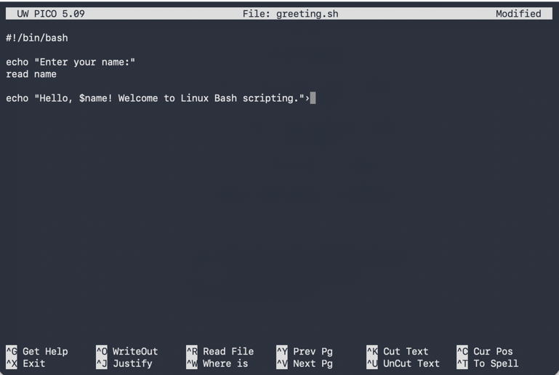

- read stores the user’s input in the variable
- echo displays messages on the screen , including the personalised greeting.

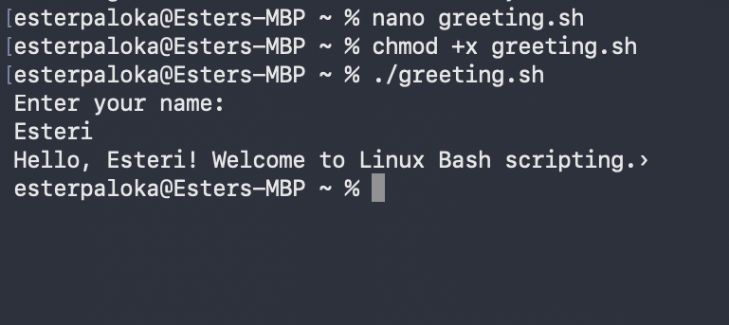

5.2 Linux Bash Script 2 – Simple Calculator
This Bash script asks the user to enter two numbers and displays their total. It demonstrates the use of variables, user input and arithmetic operations in a Linux Bash script [5].

#!/bin/bash

echo "Enter the first number:’'
read num1

echo "Enter the second number:”
read num2

total=$((num1 + num2))

echo "The total is $total"

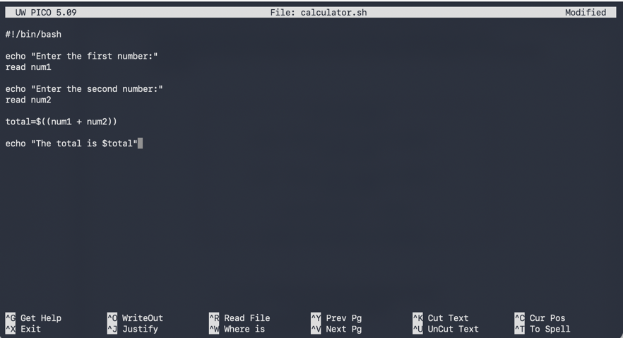
- read stores the number entered by the user.
- $ (( )) performs the addition.
- echo displays the result.
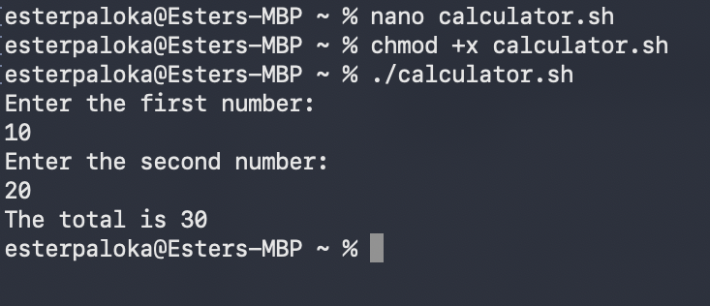

Conclusion

In conclusion, this assignment has demonstrated the main functions of operating systems and the importance of command line interfaces in both Windows and Linux. By exploring different commands and creating simple Batch and Bash scripts, I developed a better understanding of how operating systems manage files, users, processes and automation. Overall, this assignment has improved my practical skills and increased my confidence in using command-line tools for everyday computing tasks. This assignment also improved my confidence in using both graphical and command-line tools. I learned that command-line interfaces allow many administrative tasks to be completed more efficiently and that scripting can automate repetitive work, making operating systems more powerful and easier to manage.

References

[1] R. H. Arpaci-Dusseau and A. C. Arpaci-Dusseau, Operating Systems: Three Easy Pieces. Madison, WI, USA: Arpaci-Dusseau Books, 2023. [Online]. Available: https://pages.cs.wisc.edu/~remzi/OSTEP/. [Accessed: Jul. 19, 2026].
[2] A. Videla, Introduction to Operating Systems: Principles and Practice. [Online]. Available: https://os.alvarop.dev/. [Accessed: 19 July 2026].
[3] OpenStax, Introduction to Computer Science. [Online]. Available: https://openstax.org/books/introduction-computer-science/pages/6-2-fundamental-os-concepts. [Accessed: 19 July 2026].
[4] Microsoft, "Windows Commands," Microsoft Learn. [Online]. Available: https://learn.microsoft.com/windows-server/administration/windows-commands/windows-commands. [Accessed: 19 July 2026].
[5] GNU Project, Bash Reference Manual. [Online]. Available: https://www.gnu.org/software/bash/manual/. [Accessed: 19 July 2026].

