What is the role of the designer in the 21st Century and how might this role change in the next 10 years? Discuss your ideas with reference to two of the practitioners or thinkers discussed in your lecture strand.

Adele Murphy

P150554

Surface Pattern Design

Word count: 1,987

Julia Lockheart

This work explores the effect of mass production in relation to the processes within the fashion industry and the conditions in which factory employees are put in. Focusing on how methods have changed from how they were in the 20th century where the process was mainly carried out by hand, to the 21st century where a lot of embroidery and fashion is generally mass produced by machinery, with some still being hand made. The whole industry is still changing and I will explore what the future may hold for the industry of fashion and textiles.
The fashion industry has been taken over by machinery and has resulted in less products being hand crafted. Richard Sennett described thus machinery as “a friendly tool or an enemy replacing work of the human hand.” (Sennett, 2008:81). By this he is implying that in some cases machinery can be used to aid craftsmen in the production of their products, this therefore enables them to make the production process faster, although in some cases they have become an enemy by replacing the craftsmen themselves, this is due to the fact that machinery is becoming so intelligent that it may be becoming more efficient than the “human judgement.” (Sennett, 2008:81).
“The seduction of CAD lies in its speed” (Sennett, 2008:81). CAD (Computer Aided Design) allows designers to produce artwork more efficiently and work that is more precise and in some cases higher quality. This is especially important in industries where businesses have to mass produce a lot of their products so that they can sell as much as possible. However, although machinery and technology have taken over a large portion of the fashion industry in the 21st century, there were craftsmen that fought against the up rise of the machinery and the “rigorous perfection” (Sennett, 2008:84) of the process and the products produced. These craftsmen became an “emblem of human individuality” (Sennett, 2008:84) which meant that they prised themselves on creating unique pieces that do include some flaws and differences within them, from one product to the next. This puts a whole new value onto the artwork that is produced, as it allows the customer or viewer to have a deeper connection with the work, due to the fact that they can see that it has been handmade and that no two is the same. Designers in the 21st century should take on this mind set and embrace the fact that humans make mistakes and that is okay, in fact in some cases those imperfections can transform the product for the better and allows the viewer or customer to connect to what makes a human, a human.
Malcolm McCullough explains that when it comes down to determine the difference between, a designer who uses technology to produce their work and a designer who creates their work by hand, that there are actually many similarities. McCullough also describes that by wanting to embrace the use of our hands doesn’t automatically mean that you have to completely abandon the use of technology (McCullough, 2010). One difference between the two methods is, that a designer who uses computer aided design does not look at their hands but at a screen, whereas an artisan who creates their work using only their hands will be looking towards their hands which is where the physical making is taking place (McCullough, 2010). However, the computer user still wouldn’t be able to produce their work without the use of their hands, in the words of McCullough, “his or her hands are performing sophisticated and unprecedented set of actions” (McCullough, 2010:310). Just like in a lot of traditional handmade works, those actions are “quick, small and repetitive” (McCullough, 2010:310).
Still, in the 21st century the word ‘craft’ is tied down to the process of handcrafted works, the future holds new meanings to this word as craft doesn’t just relate to the sole use of ones’ hands whilst stripping away all use of technology, it can also include the craftsmanship of designers who use the aid of high technology to create their designs. “The proposal of craft in the electronic medium is something of a paradox” (McCullough, 2010:311). This means that even though some still may not agree with the fact that ‘craft’ can be both the production of small scale, hand crafted works and computer aided works, doesn’t mean that in the future it would not be more widely accepted.
Commercial production of embroidery can range from computerised production by the masses to “tiny sweatshops in the third world where children hand stitch embroidery for a pittance.” (Townsend & Briggs-Goode, 2011:129). Reports of the conditions that these sweatshop workers are in are horrifying (Globallabourrights.org, 2015) (Globallabourrights.org, 2014). An example of how severe and dangerous these conditions are can be understood through reports of the incident that happened in Bangladesh, where a Primark factory collapsed with thousands of workers inside (Gayle, 2013). However, Primark shockingly did not suffer any decline in their revenue intake as a result of this major incident, in fact in following months after the collapse of the factory the retailer had a large increase in sales (BBC News, 2013). This shows that even a catastrophic incident like this still doesn’t affect many customers minds, they still continue to shop from the companies who run these factories, which means that as long as the company is getting business they won’t have the need to change the way they produce their products. This also portrays that the risk that those workers take just to get the smallest amount of pay is extraordinary, also how much danger big retail companies such as Primark are willing to put their workers in so that they are able to have cheaper production costs for their garments. The affects that this type of mass production has leads to some fashion designers having an ethical approach to the manufacturing of their products, ensuring that the customers are aware of this because, in some cases customers are more likely to buy a product if they know it has been manufactured in a fair and safe environment. It is so shocking that the conditions of sweatshops have not changed much in about 100 years, however:

At various points over the past century the power of the sweatshop to depress the wages and living conditions of workers throughout the industry has been reduced and even neutralised by the power of workers to defend themselves and of government to regulate the industry. (Howard, 2007:32).

This is demonstrating that the appalling conditions that the sweatshop employees work in is become more widely noticed, both the workers and outsiders are standing up for human rights, fair pay and most importantly safe working conditions. However, a main reason for a lot of the employees working in these sweatshops is because they are desperate and will do anything just to have enough money to survive.
The industrial revolution had a huge impact on the mass production of textiles and more harshly on artisans who worked on a small scale. (Davies and Sigthorsson, 2013). The rise in technological advances meant that it became easier and cheaper to import raw materials such as cotton and therefore decreased to production costs of textiles, however new machinery such as cotton mills meant that those small-scale artisans found it hard to keep up with the demand, as the machines that were being developed could create textiles much faster and much cheaper than if they were all to be produced by hand (Davies and Sigthorsson, 2013). Technology is always evolving and there are constant advances in the world of textiles. The industrial revolution gave way to a whole new world of possibilities, it led to machinery being made that produced work that could not have been hand crafted, including; laser cutting, digital printing, Computer Aided Design (CAD) and digital embroidery, which allows a more precise and seamless end result compared to hand sewn embroidery.
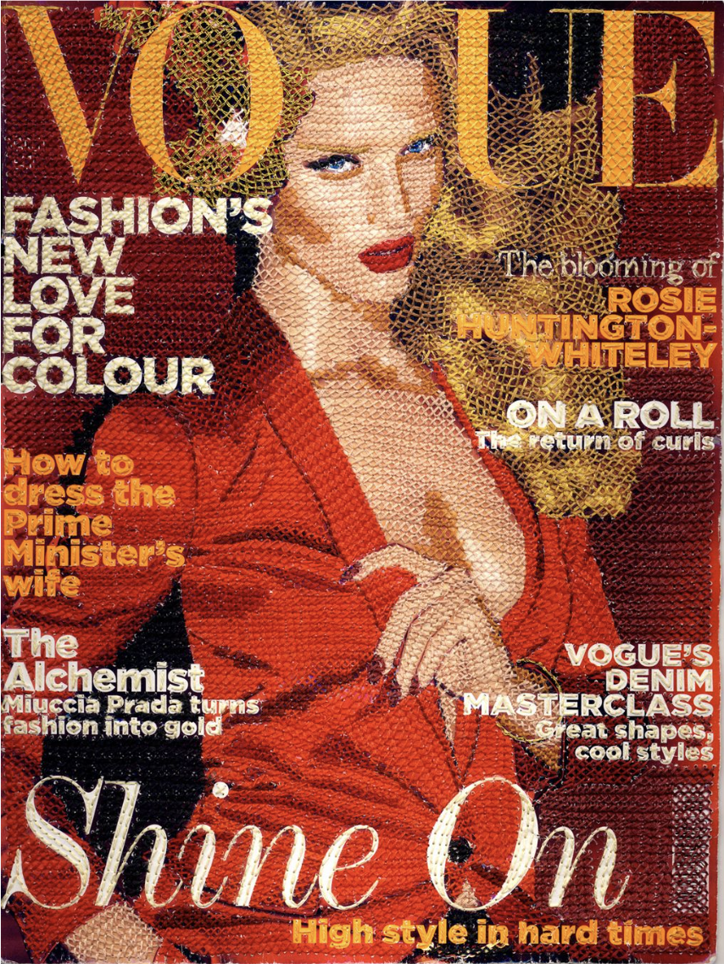
The technique of embroidery has many pre-conceived connotations such as it being old fashioned and outdated, however in recent years embroidery has been evolving and many textile designers are experimenting with the process and combining other techniques with it to create amazing pieces of artwork. One artist who has put their own twist on embroidery is Inge Jacobsen, some of her projects include magazine covers being stitched over giving them a very unique look, these are called ‘Threaded covers.’ Jacobsen sewed covers of vogue magazines and she stated that the work she produces connects “two feminine past times” (vogue.co.uk, 2011) those of which include embroidery and fashion. The reason for stitching over magazine covers such as Vogue and Chanel is so that she can create handmade, one off pieces of work that can’t be replicated, as a contrast to the mass-produced covers that can be reproduced over and over again. Hand embroidery allows the person who is receiving the artwork to have a one of a kind piece which also gives a sense of luxury and adds more personal value to the artwork.
In the 21st century, designers tend to take more time and effort in ensuring that the production of their products is fair and ethical. This is because customers have become much more aware of how some companies treat their workers and how unsafe those working environments can be, resulting in some customers becoming more loyal to companies that openly state their ethical production methods such as the company Fairtrade (fairtrade.org.uk). By allowing customers to have a wider understanding of the effects of sweatshops and workers being paid unfairly, it therefore results in bigger companies changing the way they manufacture to suit the consumer’s needs and wants, as if customers and consumers withdraw from purchasing from such companies then they will have no business so will be forced to adapt their ways of working.
The future of fashion holds so many possibilities, if technology continues to evolve at its current rate then the future may bring even faster and even more efficient machinery, which in turn will aid designers in making their desired products and artworks in a fraction of the time. Also, if more high technology machinery is produced then it could result in less factories, as the machinery could take the place of the workers and therefore less workers would be forced to stay in unsafe working conditions, this in turn would reduce the risk of harm to the employees. However, even though it may reduce the number of factories it could mean that those who worked in the factories would no longer have a job, so therefore would no longer be able to provide for their families. Along with new technology comes new experimentations and explorations between a variety of different techniques and mediums, creating new and in some cases unusual pieces of work which transpires inspiration for new and up and coming designers. Building a great future with flourishing design and creativity is all about “improving what is already there” (Rennie, 2005:42). It is about constantly pushing the boundaries and being open to new ideas and concepts that may occur. Lawrence Lessing believes that “a degree of openness is necessary for a technology to grow and develop” (Rennie, 2005:44). Designers also hold the power to change people’s opinions and outlooks on different situations, so it is crucial that the role of the designer in the future is to create positive mind sets and to create awareness of those who are less fortunate than ourselves, because if designers continue to ignore the basic human needs and rights then everyone else will follow suit and the conditions will worsen with time. Carrying on from the 21st century it is extremely important to remember to have a creative and open mind set towards the world that surrounds us, whilst using our skills to help create a kinder atmosphere where craftsmanship and design can be used to bring joy and give a sense of belonging.

Bibliography:

Alexander, E (2011) ‘All Sewn Up’. Vogue magazine. Accessed from:
http://www.vogue.co.uk/gallery/vogue-magazine-cross-stitched-designs-inge-jacobsen [Accessed on: 8th December 2017]

BBC News (2013) Primark sales jump by a quarter. Accessed from: http://www.bbc.co.uk/news/business-21055646 [Accessed on: 6th December 2017]

Davies, R and Sigthorsson, G. (2013) Introducing the creative industries. Steele, M. London. SAGE Publications Ltd. [Accessed on: 12th December 2017]

Gayle, D. (2013) ‘Bangladesh factory death toll could reach1,400: Primark says it will compensate families of killed and injured’. Mail Online. Accessed from:
http://www.dailymail.co.uk/news/article-2317012/Primark-factory-collapse-Death-toll-Bangladesh-set-jump-1-400.html [Accessed on: 30th November 2017]

Globallabourrights.org (2015) Dirty toys made in China. Institute for global labour and human rights. Accessed from: http://www.globallabourrights.org/reports/dirty-toys-made-in-china [Accessed on: 6th December 2017]

Globallabourrights.org (2014) Corruption and greed: Alianza fashion sweatshops in Guatemala. Institute for global labour and human rights. Accessed from: http://www.globallabourrights.org/reports/alianza-guatemala-2014 [Accessed on: 6th December 2017]

McCullough, M (2010) ‘Abstracting Craft: The Practiced Digital Hand’ in Adamson, G (eds.) The Craft Reader. Berg. PP 310 – 316. [Accessed on: 10th December 2017]

Rennie, E (2005) ‘Creative World’ in Hartley, J (eds.) Creative Industries. Blackwell Publishing Ltd. PP 42 – 54. [Accessed on: 13th December 2017]

Sennett, R (2008) The Craftsman. London. Penguin Books Ltd.
[Accessed on: 10th December 2017]

http://www.fairtrade.org.uk [Accessed on: 9th December 2017]

